VISVESVARAYA TECHNOLOGICAL UNIVERSITY
"JNANASANGAMA", BELAGAVI- 590 018



UI UX

A Project based Assignment Report on

“COFFEE MOVEMENT”
(A cafe online website)
Submitted in partial fulfillment of the requirement for completion of assignment for the academics

BACHELOR OF ENGINEERING
in
COMPUTER SCIENCE AND ENGINEERING

by

ABHISHEK PATIL 1AY22CS009

Under the guidance of
Mrs.BHAVYASHREE SP
Assistant Professor
Department of CS & E



DEPARTMENT OF COMPUTER SCIENCE AND ENGINEERING
ACHARYA INSTITUTE OF TECHNOLOGY
(Affiliated to Visvesvaraya Technological University, Belagavi)
Acharya Dr. Sarvapalli Radhakrishnan Road, Soladevanahalli,
Bangalore – 560 107
2022-2023

ACHARYA INSTITUTE OF TECHNOLOGY
(Affiliated to Visvesvaraya Technological University, Belagavi)
Acharya Dr. Sarvapalli Radhakrishnan Road, Soladevanahalli,
Bangalore – 560 107

DEPARTMENT OF COMPUTER SCIENCE AND ENGINEERING



CERTIFICATE

Certified that the Project work entitled “TITLE”, carried out by Mr./Ms ABHISHEK PATIL, 1AY22CS009 are bonafide students of Acharya Institute of Technology, in partial fulfillment for the award of Bachelor of Engineering in Computer Science and Engineering of the Visvesvaraya Technological University, Belgaum during the year 2022-23. It is certified that all corrections/ suggestions indicated for Internal Assignment have been incorporated in the Report. The project has been approved as it satisfies the academic requirements in respect of Project work prescribed for the academics.

Assignment No. | Date | Page No. | Sig. of Staff Member | Sig. of Student

……………………… ..……………………..……….
Staff in Charge Head of the Department

UI/UX Design Report:

Introduction:

The purpose of this report is to outline the process and tools used in the creation of an online cafe website prototype using Figma. The online cafe website project aimed to design a user-friendly interface that showcases the cafe's offerings and facilitates online ordering and reservations.
About the UI Tool Used:
Figma was chosen as the primary design tool due to its collaborative features, versatility in prototyping, and ease of use. Its cloud-based nature allowed for real-time collaboration among team members and facilitated easy sharing of design iterations and prototypes.

About the project:
The project involved designing a responsive website for a fictional cafe named "Coffee Movement". The website needed to cater the desktop users, offering a seamless experience for browsing the menu and placing orders.
Screenshots of Front End:
Home page:


About us:
"About Us" information in any project typically refers to a section or page that provides background, mission, values, and a brief history of the entity or organization behind the project. It serves as a way to introduce the project to stakeholders, clients, customers, or visitors, conveying key information about who the organization is, what it stands for, and what it aims to achieve.
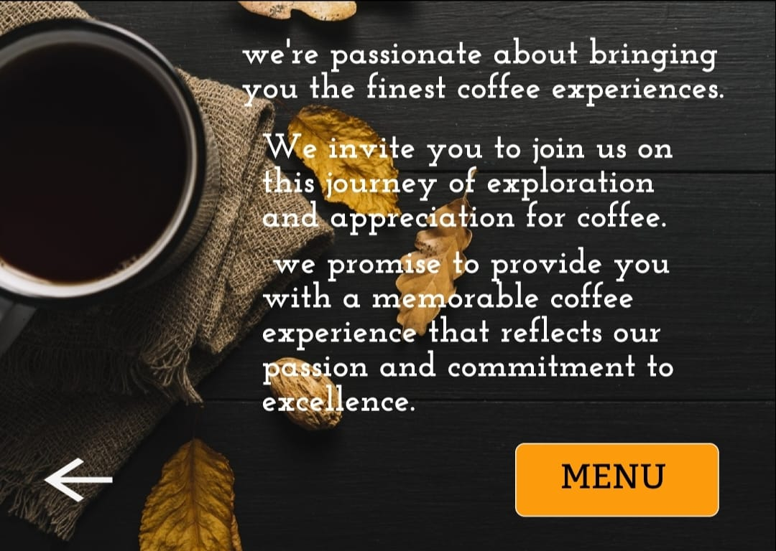
Access to Menu:
In an online cafe project, the "menu list" specifically refers to the digital representation of food and beverage items available for customers to view, select, and potentially order through the cafe's website.
Detailed breakdown of what the menu list entails in this context:
Digital Format: The menu list is presented in a digital format, accessible via the cafe's website or mobile application. It allows customers to browse offerings without physically visiting the cafe.
Items and Descriptions: Each item on the menu list is accompanied by a detailed description, including ingredients, preparation method, and any relevant information (e.g., dietary restrictions, allergens).

Prices and Variants: The menu list displays prices for each item and may include options for different variants or customizations (e.g., size, toppings, sides).
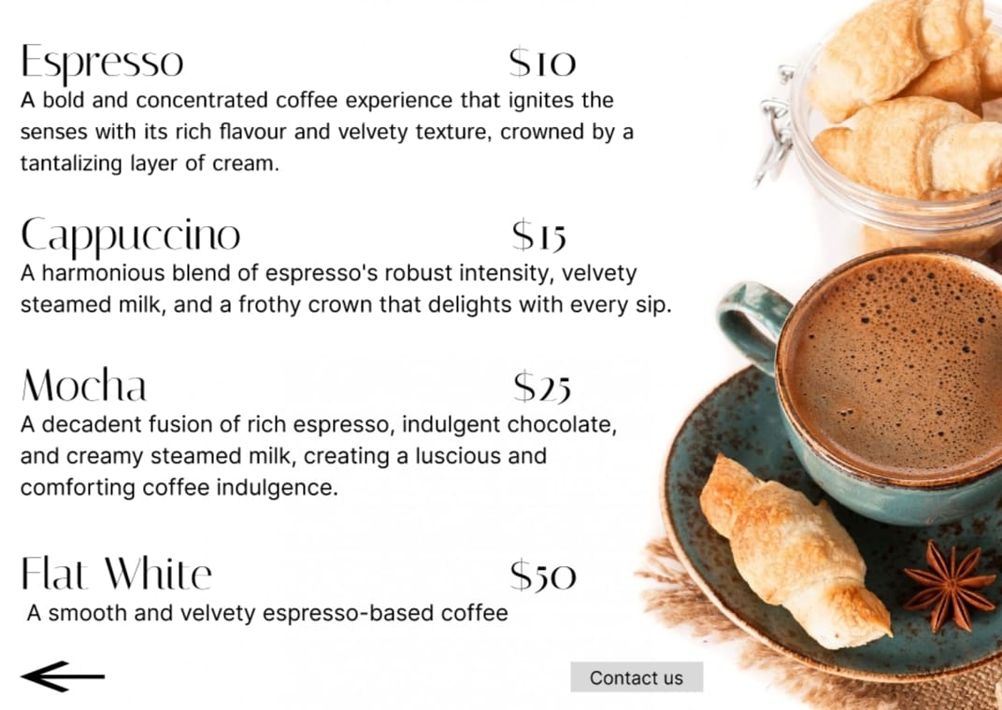

Contact Support:
In an online cafe project, "contact support" refers to the mechanism or resources available for customers to reach out to the cafe's customer service team or support staff for assistance, inquiries, or issue resolution.
Channels of Communication: It includes various channels through which customers can contact support, such as:
Phone: Providing a dedicated phone number for customers to call and speak directly with a support representative.
Email: Offering an email address where customers can send detailed inquiries or issues for a written response

Hours of Operation: Clearly stating the hours during which support services are available to ensure customers know when to expect a response or assistance.
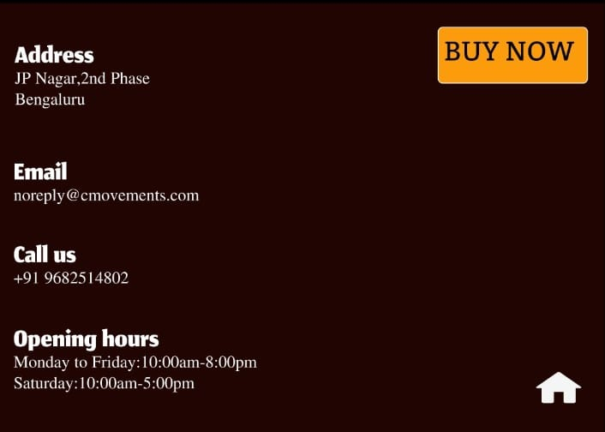

Website Design:
The design employs a clean, modern aesthetic with a focus on usability:
• Consistent Color Scheme: Ensures visual harmony across the site.
• Responsive Design: Adapts to various screen sizes for an optimal user experience on all devices.
• Interactive Elements: Buttons and hover effects enhance user engagement.
• Typography: Readable fonts and appropriate text spacing improve readability.

Conclusion:

Creating the online cafe website prototype using Figma was a comprehensive process that involved thorough research, meticulous planning, and iterative design. Figma proved to be an invaluable tool, allowing for efficient collaboration, prototyping, and responsive design implementation. The resulting prototype reflects a user-centered design approach tailored to meet the needs of Coffee Movement target audience.

Figma Design Link:

https://www.figma.com/proto/4M38tUeiFCtmqfhcDK5YWH/Coffee?node-id=2-8&t=mZWW23UB9Qvp9zmy-1

