What is Angular CLI?

[Angular CLI](https://github.com/angular/angular-cli) is a command line tool that can aid in creating new Angular projects from scratch or adding various elements to an existing Angular application.

This tool will create a new project that is ready to run immediately. It will create all needed plumbing to get everything up and running in a matter of minutes, generating an application structure that is based on best practices for an Angular project. When adding new elements, it will create these elements in the appropriate directory structure, generate source code, and in some cases add code to other elements within the project so that the new elements can be used wherever needed.

Prerequisites

In order to install Angular CLI, the following should be installed in the development environment:

* [node](https://nodejs.org/en/) (at least version 4.0)
* [npm](https://www.npmjs.com/) (at least version 3.0)

Installation

Installing Angular CLI Globally by typing the follow command:

|  |
| --- |
| **npm install -g @angular/cli** |

This will globally install angular-cli. This will allow for the use of all the ng commands.

Create New Project

To create a new projectng new  can be used.

Issue the following command to create a new project called my-project.

|  |
| --- |
| **ng new my-project** |

This will cause several things to happen:

* directory my-project will be created
* directory structure and source files will be generated
* any needed dependencies will be installed
* TypeScript will be configured
* Karma test runner will be configured
* Protractor end-to-end test runner will be configured
* environment files will be created

Here is a screenshot of the project structure that was generated:

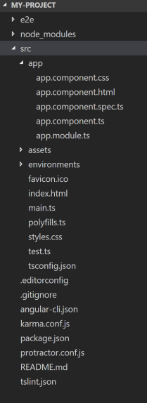

The purpose of this article is not to go into all the files that are generated but there are a few keys files to point out:

* src/app directory: This directory contains source code, css, and html files. This is where most of the work will be done.
* app.module.ts: Main NgModule for the application. Everything must belong to a module (even other modules).
* main.ts: Bootstraps your application.
* index.html: Main html file for your application.

Run Application

Change to the my-project directory and run the following:

|  |
| --- |
| ng serve |

Then open a browser and point it to http://localhost:4200/. The following

Note: Running ng serve from the command line will not return control back to the command prompt. This will detect changes that are made to the project, recompile the project, and then refresh the web page.

Adding Other Elements

To add other elements to your application, either ng generate or ng g command can be used. There are many elements that can be created, but only the following elements will be covered in this article:

* class
* interface
* enumeration
* component
* service
* module
* pipe

In order to use Angular CLI to add these elements to your application, go to the my-project directory and issue the following commands.

Note: After issuing commands, Angular CLI will display files that are generated and where they are created at.

Create A Class

To create a new class, run the following:

|  |
| --- |
| **ng g class my-class-a** |

This will create a file called my-class-a.ts under the src/app directory. Notice that it will add .ts after the name provided.

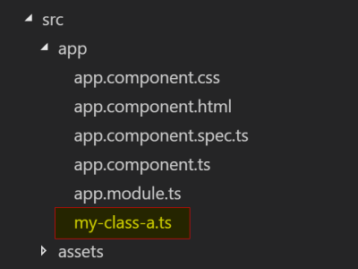

This file is a basic class file with no decorators generated. It will export a class called MyClassA (removes dashes and uses camel case).

my-class-a.ts

|  |  |
| --- | --- |
| 1  2 | export class MyClassA {  } |

Create An Interface

To create a new interface, run the following:

|  |
| --- |
| **ng g interface my-interface-a** |

This will create a file called my-interface-a.ts under the src/app directory. Notice that it will add .ts after the name provided.

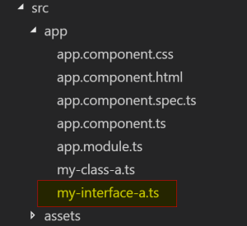

This file is a basic interface file with no decorator generated. It will export a class called MyInterfaceA (removes dashes and uses camel case).

my-interface-a.ts

|  |  |
| --- | --- |
| 1  2 | export interface my-interface-a  } |

Create An Enumeration

To create a new enumeration, run the following:

|  |
| --- |
| **ng g enum my-num** |

This will create a file called my-enum.enum.ts under the src/app directory. Notice that it will add .enum.ts after the name provided.

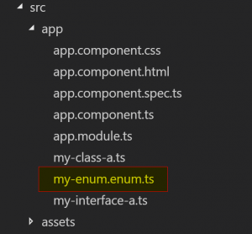

This file is a basic enumeration file with no decorator generated. It will export a class called MyEnum (removes dashes and uses camel case).

my-enum.enum.ts

|  |  |
| --- | --- |
| 1  2 | export enum MyEnum {  } |

Creating a class, interface, or enumeration are basic constructs and could be created manually just as easily, but the CLI will format them according to best practices. Now on to things that need a little more to them.

**[See Also:](https://keyholesoftware.com/2017/10/02/react-v16-0-release-overview-and-migration/" \t "_blank)****[React v16.0 Release Overview and Migration](https://keyholesoftware.com/2017/10/02/react-v16-0-release-overview-and-migration/" \t "_blank)**

Create A Component

To create a new component, run the following:

|  |
| --- |
| ng g component my-component-a |

This will do several things:

* create a directory called my-component-a under src/app directory
* generate four files under that directory
  + my-component-a.component.css
    - Contains any css that would be needed for this component
    - Optional file that is pointed to by the component.ts file
  + my-component-a.component.html
    - Contains any html that would be needed for this component
    - Optional file that is pointed to by the component.ts file
    - html could be contained within the component.ts file, if desired
  + my-component-a.component.spec.ts
    - unit test skeleton for this component
  + my-component-a.component.ts
    - exports a class called MyComponentAComponent
    - implements an interface called OnInit
    - generates empty function called ngOnInit for OnInit interface
    - generates empty constructor function
    - decorates class with @Component
      * add selector for component, app-my-component-a
      * adds templateUrl, points to generated html file for component
      * adds styleUrls array, points to generated css file for component
* modifies app.module.ts file, added MyComponentAComponent to declarations (every component has to belong to a module)

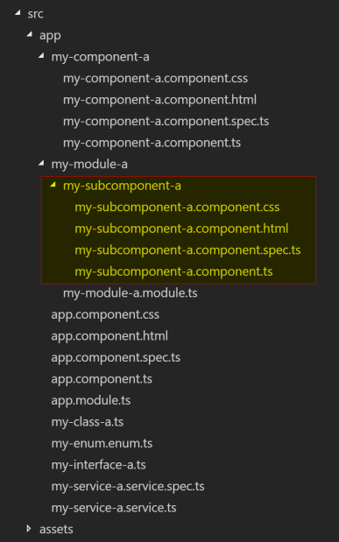

my-component-a.component.ts

|  |  |
| --- | --- |
| 1  2  3  4  5  6  7  8  9  10  11  12  13  14  15 | import { Component, OnInit } from '@angular/core';    @Component({    selector: 'app-my-component-a',    templateUrl: './my-component-a.component.html',    styleUrls: ['./my-component-a.component.css']  })  export class MyComponentAComponent implements OnInit {      constructor() { }      ngOnInit() {    }    } |

app.module.ts

|  |  |
| --- | --- |
| 1  2  3  4  5  6  7  8  9  10  11  12  13  14  15  16  17  18  19  20  21  22 | import { BrowserModule } from '@angular/platform-browser';  import { NgModule } from '@angular/core';  import { FormsModule } from '@angular/forms';  import { HttpModule } from '@angular/http';    import { AppComponent } from './app.component';  import { MyComponentAComponent } from './my-component-a/my-component-a.component';    @NgModule({    declarations: [      AppComponent,      MyComponentAComponent    ],    imports: [      BrowserModule,      FormsModule,      HttpModule    ],    providers: [],    bootstrap: [AppComponent]  })  export class AppModule { } |

Create A Service

To create a new service, run the following;

|  |
| --- |
| **ng g service my-service-a** |

This will generate a couple of files under the src/app directory:

* my-service-a.service.spec.ts
  + unit test skeleton for this service
* my-service-a.service.ts
  + exports a class called MyServiceAService
  + generates empty constructor function
  + decorates class with @Injectable

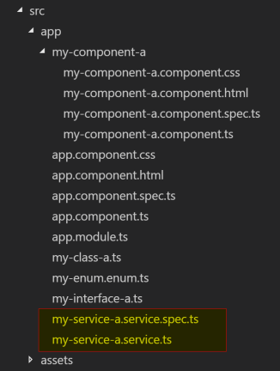

my-service-a.service.ts

|  |  |
| --- | --- |
| 1  2  3  4  5  6  7  8 | import { Injectable } from '@angular/core';    @Injectable()  export class MyServiceAService {      constructor() { }    } |

Create A Module

To create a new module, run the following:

|  |
| --- |
| ng g module my-module-a |

This will do a couple things:

* create a directory my-module-a under src/app
* generate a file under that directory called my-module-a.module.ts
  + exports a class name MyModuleAModule
  + decorates that class with @NgModule

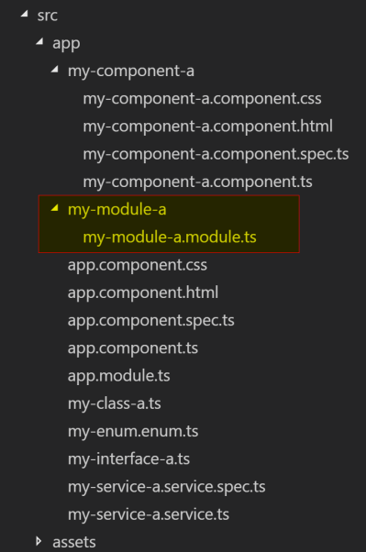

my-module-a.module.ts

|  |  |
| --- | --- |
| 1  2  3  4  5  6  7  8  9  10 | import { NgModule } from '@angular/core';  import { CommonModule } from '@angular/common';    @NgModule({    imports: [      CommonModule    ],    declarations: []  })  export class MyModuleAModule { } |

Create Component In A Module

Components can be added to generated module by changing to the module directory:

|  |
| --- |
| cd src/app/my-module-a |
| ng g component my-subcomponent-a |

or by prefixing the module name to the front of the new component name:

|  |
| --- |
| ng g component my-module-a/my-subcomponent-a |

This will do several things:

* create a directory my-subcomponent-a under the src/app/my-module-a directory
* generate all the component files under this directory (see Create a component section for description of files)
* add MySubcomponentAComponent to the my-module-a.module.ts file



my-module-a.module.ts

|  |  |
| --- | --- |
| 1  2  3  4  5  6  7  8  9  10  11 | import { NgModule } from '@angular/core';  import { CommonModule } from '@angular/common';  import { MySubcomponentAComponent } from './my-subcomponent-a/my-subcomponent-a.component';    @NgModule({    imports: [      CommonModule    ],    declarations: [MySubcomponentAComponent]  })  export class MyModuleAModule { } |

This same pattern can be used for a class, interface, enum, service, or even another module.