**Abhishek Rajput**

**2100290120007**

**Experiment – 2**

**Output – 1**

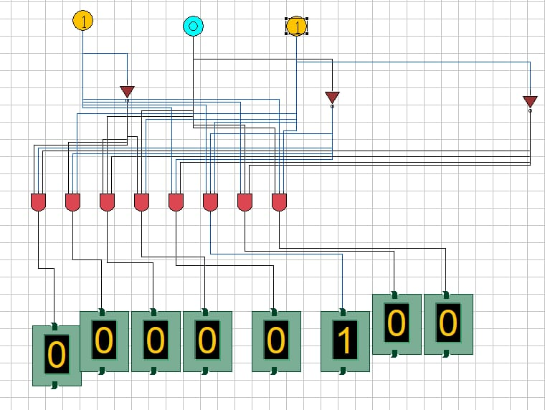

Output - 2

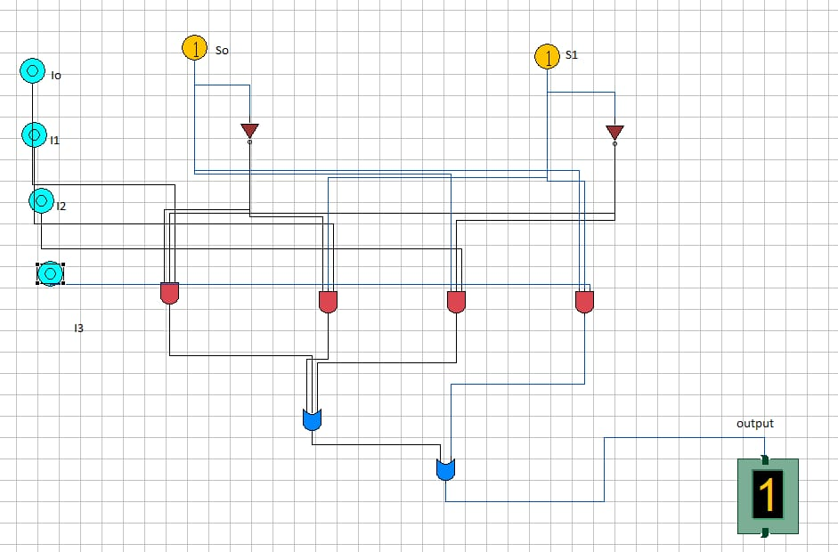

**Output – 3**

