DS Lab KCS351 - A1

## **22 Sep 2022 - Linked List Application - Polynomial Representation**

ABHISHEK RAJPUT

2100290120007

22-09-2022

TOPIC :

## **Program for Circular Linked List Primitive Operations**

// ABHISHEK RAJPUT

//2100290120007

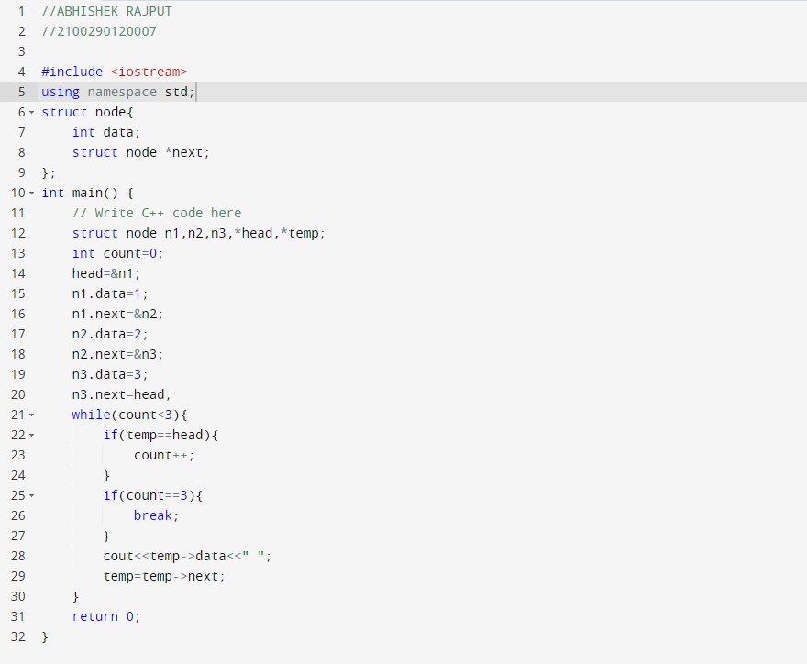

**OUTPUT**

