[ Online Retail Sales Dashboard ]
Abhishek Rathi
# Project Overview
The dataset is the Online Retail Dataset from the UCI Machine Learning Repository. It contains transactions from a UK-based online retail business specializing in giftware and home decor products. The business primarily serves wholesale customers who purchase products in bulk.
The Online Retail Sales Dashboard was developed to analyze retail transaction data and generate actionable business insights. The project focuses on sales performance, customer behavior, product performance, and geographical revenue distribution using SQL and Tableau.
The objective was to transform raw retail transaction data into an interactive dashboard that enables decision-makers to monitor key business metrics and identify growth opportunities.

# Tools used
- Microsoft Excel
- MySQL
- Tableau Public
# Key Information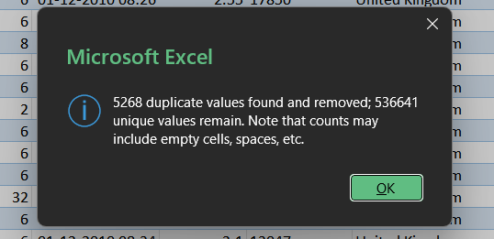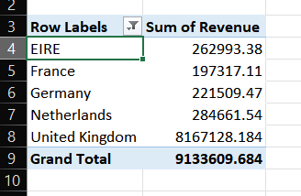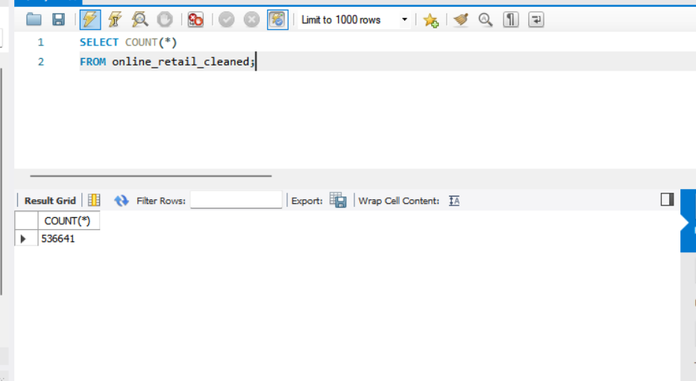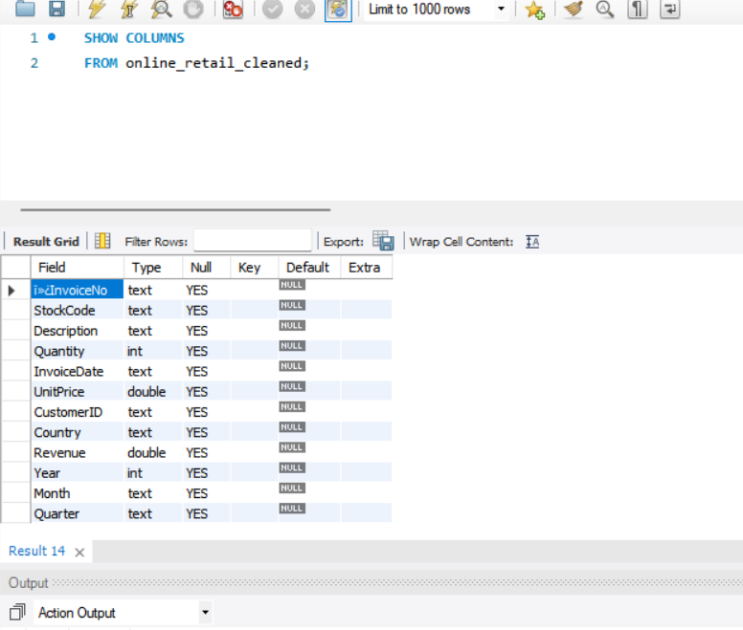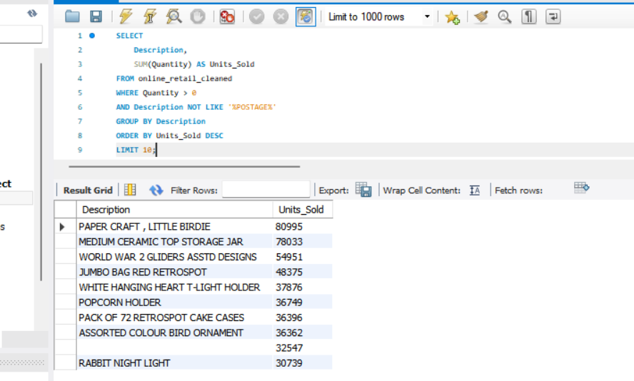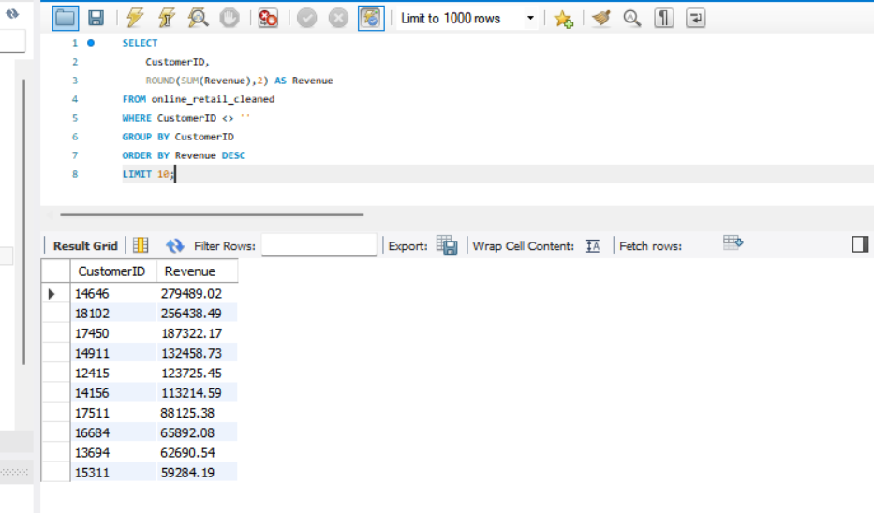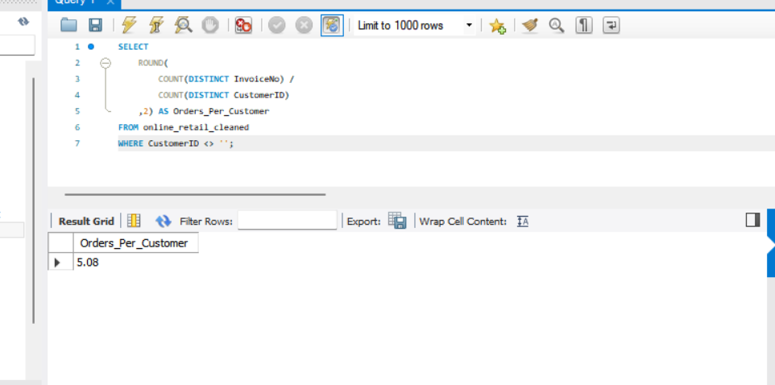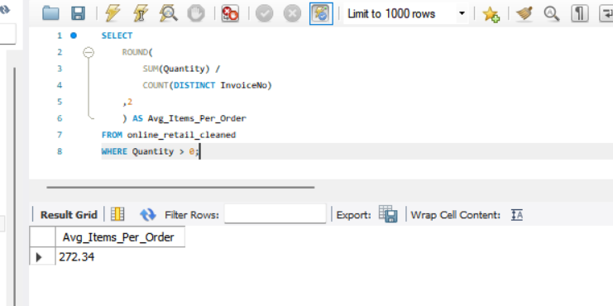# Dataset Information
The dataset contains online retail transaction records including:
- Invoice Number
- Product Description
- Quantity Sold
- Unit Price
- Revenue
- Customer ID
- Invoice Date
- Country
Dataset Size
- Orders: 25,900
- Customers: 4,372
- Total Revenue: $9.73 Million
# Project Workflow
1. Data Cleaning
Data was cleaned and prepared using SQL.
Tasks performed:
- Removed null values
- Handled duplicate records
- Created date-related fields:
  - Month
  - Quarter
  - Year
- Calculated Revenue field
Revenue Formula:
Revenue = Quantity * UnitPrice
2. SQL Analysis
Several SQL queries were created to extract business insights.
Total Revenue
SELECT ROUND(SUM(Revenue),2)
FROM online_retail_cleaned;
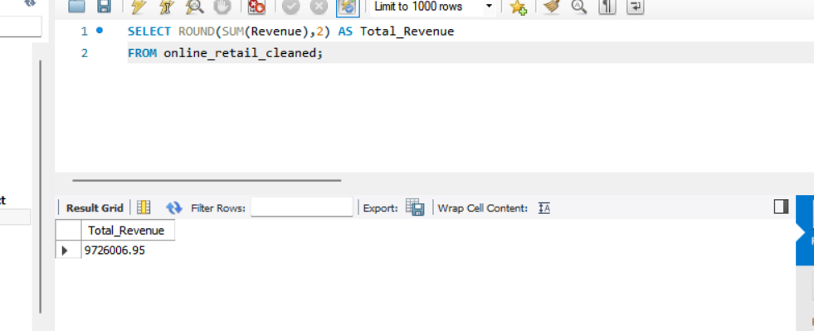
Total Orders
SELECT COUNT(DISTINCT InvoiceNo)
FROM online_retail_cleaned;
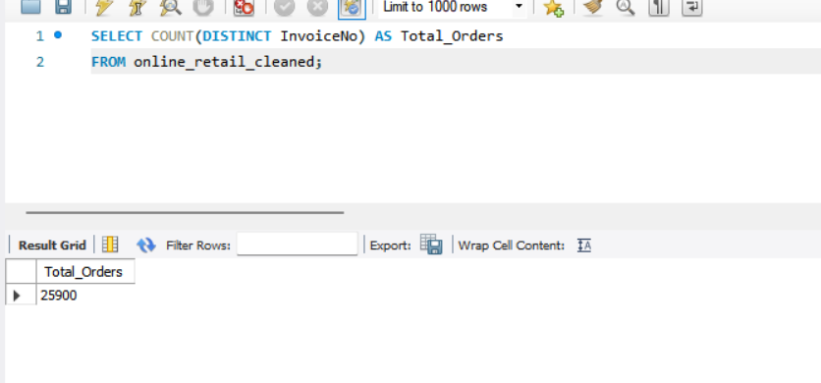
Total Customers
SELECT COUNT(DISTINCT CustomerID)
FROM online_retail_cleaned;
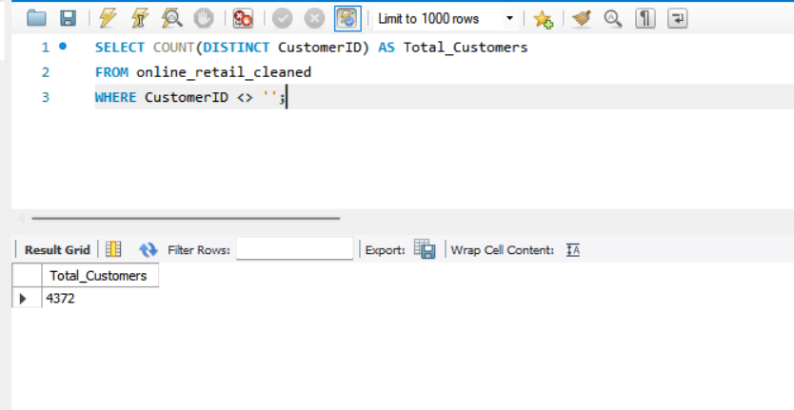
Average Order Value (AOV)
SELECT ROUND(
SUM(Revenue) /
COUNT(DISTINCT InvoiceNo),2
)
AS AOV
FROM online_retail_cleaned;
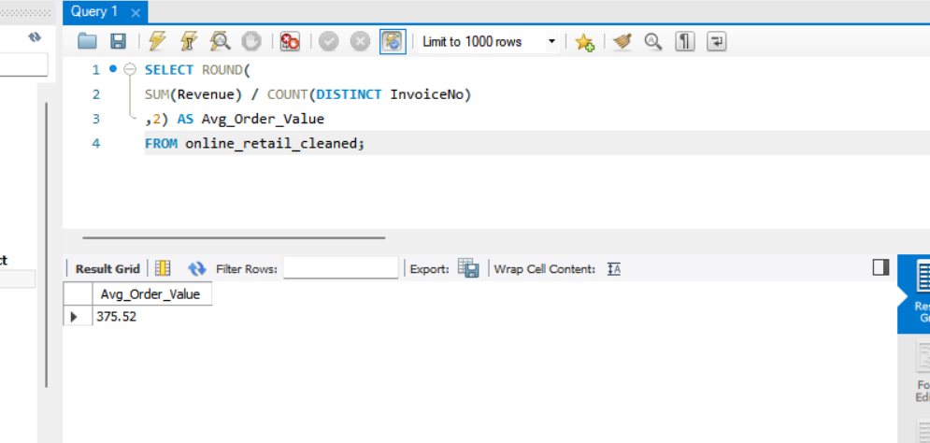
Revenue by Quarter
SELECT Quarter,
ROUND(SUM(Revenue),2) AS Revenue
FROM online_retail_cleaned
GROUP BY Quarter
ORDER BY Revenue DESC;
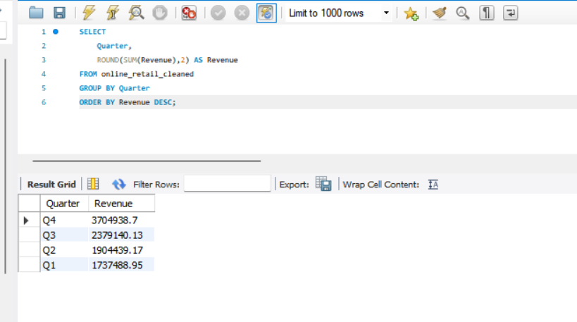
Revenue by Country
SELECT Country,
ROUND(SUM(Revenue),2) AS Revenue
FROM online_retail_cleaned
GROUP BY Country
ORDER BY Revenue DESC
LIMIT 10;
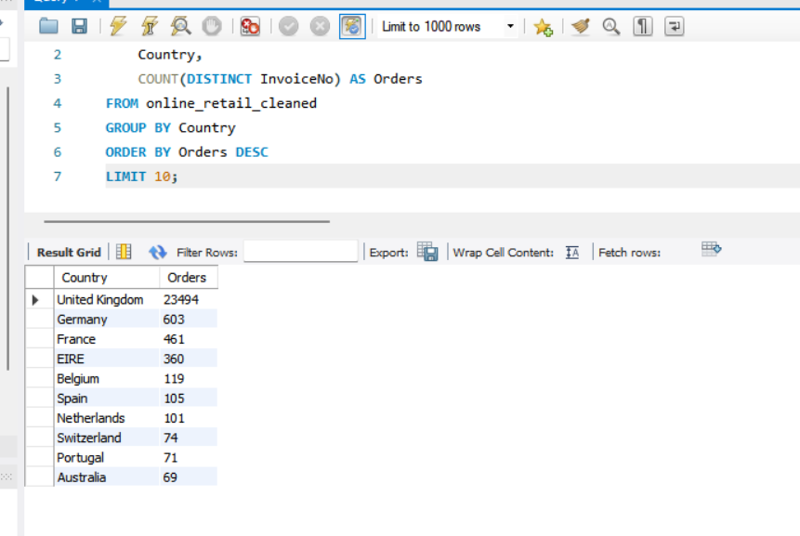
Top Products by Revenue
SELECT Description,
ROUND(SUM(Revenue),2) AS Revenue
FROM online_retail_cleaned
GROUP BY Description
ORDER BY Revenue DESC
LIMIT 10;
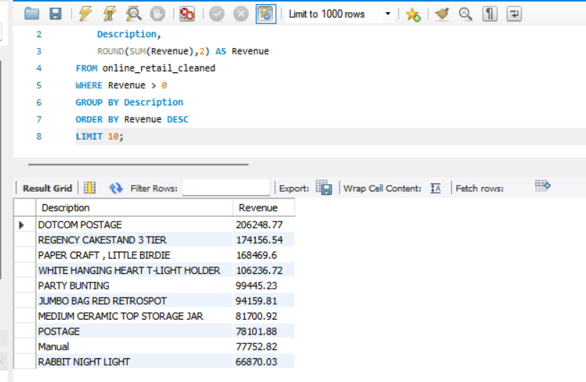
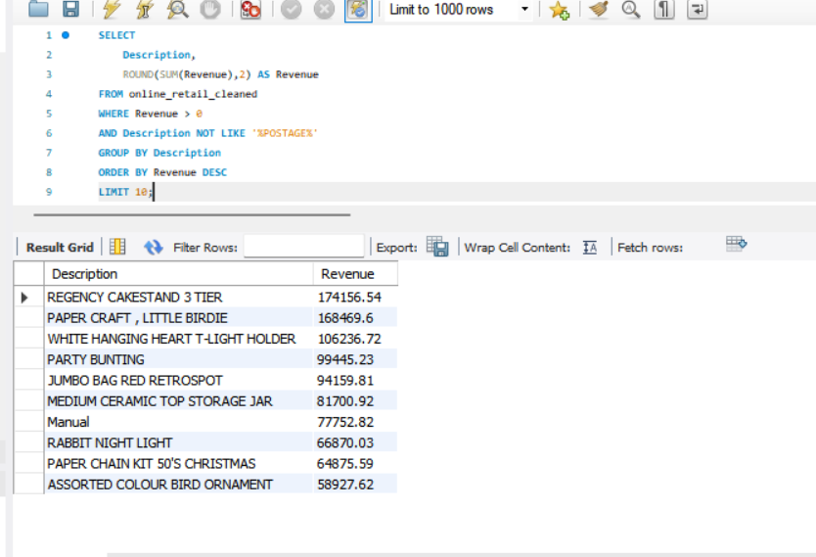
# Dashboard Components
KPI Cards
The dashboard includes four key performance indicators:
KPI | Value
Revenue | $9.73M
Orders | 25,900
Customers | 4,372
AOV | $375.5
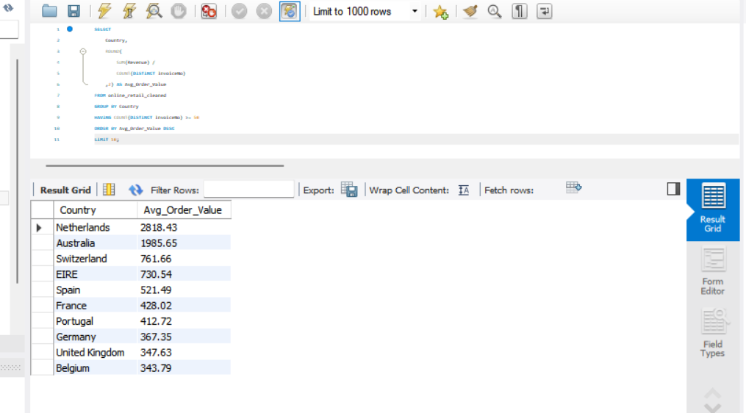
Revenue Trend Analysis
Revenue increased significantly during the final months of the year, indicating strong year-end sales performance.
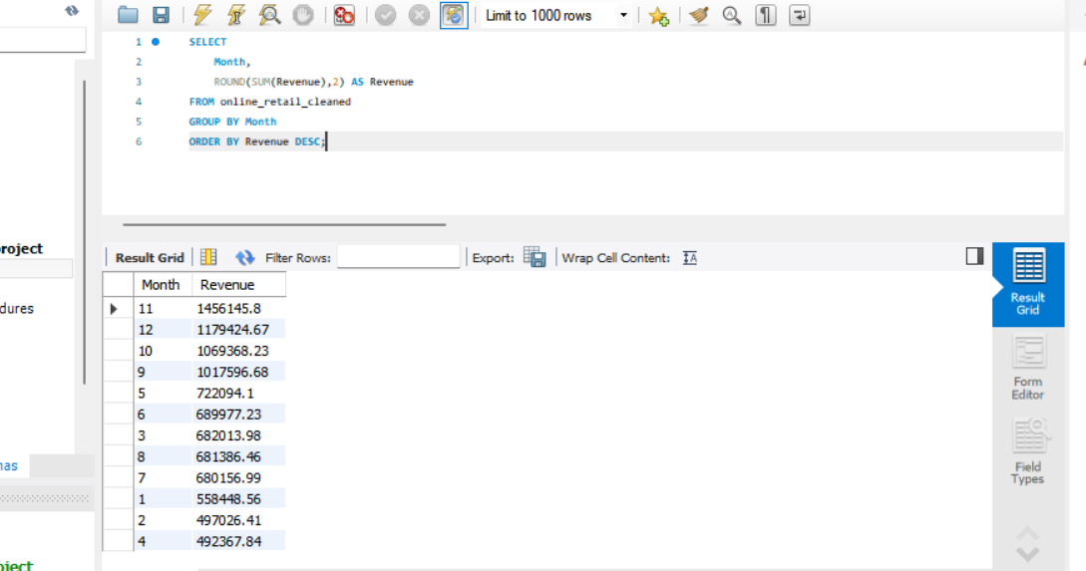
Revenue by Quarter
Q4 generated the highest revenue among all quarters.
Quarter | Revenue
Q4 | $3.70M
Q3 | $2.38M
Q2 | $1.90M
Q1 | $1.74M

Country Revenue Analysis
Top Revenue Contributors:
Country | Revenue
United Kingdom | $8.17M
Netherlands | $284K
EIRE | $263K
Germany | $222K
France | $197K
The United Kingdom contributes the majority of overall sales revenue.
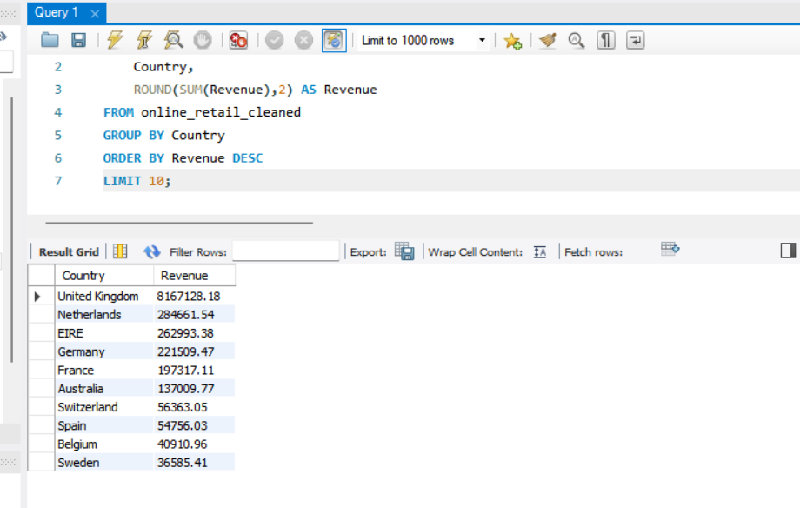
Top Products Analysis
Top Product:
DOTCOM POSTAGE
Revenue:
$206,245
A small group of products contributes a significant portion of total revenue.



# Key Business Insights
[1] Q4 is the strongest revenue-generating quarter.
[2] The United Kingdom dominates total sales revenue.
[3] Revenue shows strong growth towards the end of the year.
[4] A few products generate disproportionately high revenue.
[5] The business serves a customer base of more than 4,000 customers and processes over 25,000 orders.
# Business Recommendations
Increase Marketing Efforts During Q4
Since Q4 produces the highest revenue, promotional campaigns should be intensified during this period. Inventory and promotional budgets should therefore be increased before October to maximize seasonal demand.
Expand High-Performing Markets
Focus expansion strategies on countries with strong revenue contributions.
Promote Top Products
Top-performing products should receive priority in inventory planning and marketing campaigns.
Improve Customer Retention
With over 4,000 customers, loyalty programs can increase repeat purchases and lifetime customer value.
# Conclusion
This project demonstrates the complete analytics workflow:
- Data Cleaning using SQL
- Business Analysis using SQL
- KPI Development
- Interactive Dashboard Design using Tableau
- Business Insight Generation
The dashboard provides stakeholders with a centralized view of sales performance, customer activity, geographical trends, and product performance, enabling data-driven decision making.
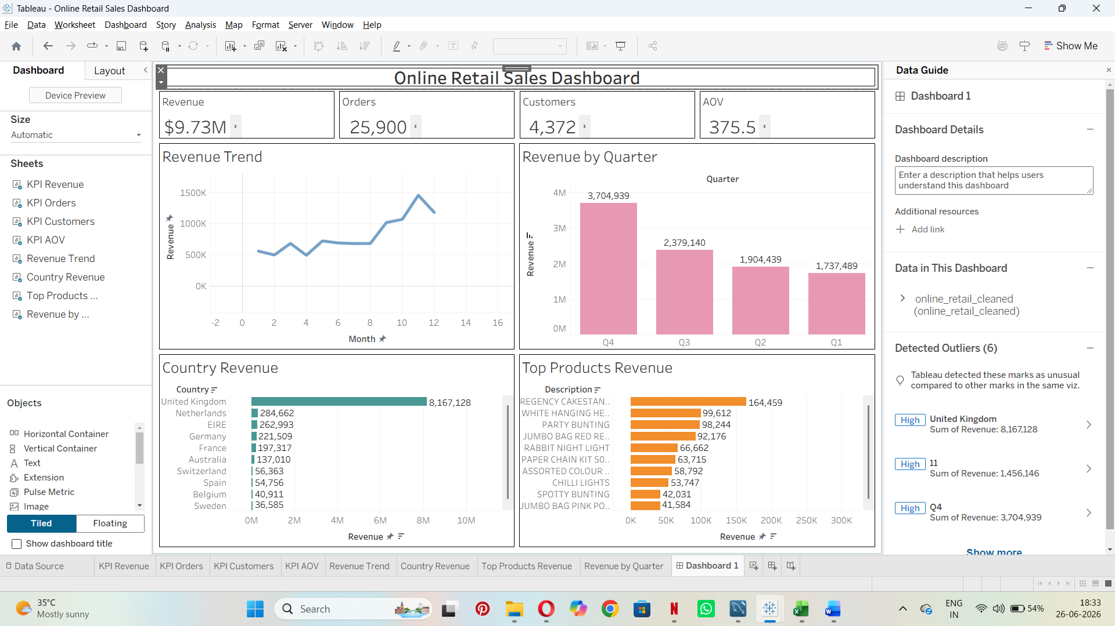
# Learnings
While working on this dataset. I got more familiar with all the 3 tools- excel, MySQL and tableau. Learnt data cleaning, used new queries to get the desired output and built a semi-interactive dashboard. Learnt how to gather insights and then generate business recommendations.

# Portfolio Summary
Project: Online Retail Sales Dashboard
Tools: MySQL, Tableau Public, Excel
Domain: Retail Analytics / Business Intelligence
Skills Demonstrated: SQL, Data Cleaning, KPI Analysis, Data Visualization, Dashboard Development, Business Analytics

------------------------------------------------ THANK YOU --------------------------------------------------

