Flight Heat Map

1. Below screen shows Number of flights in particular state. Light Green Color for single flight, Red for 2 or more flights

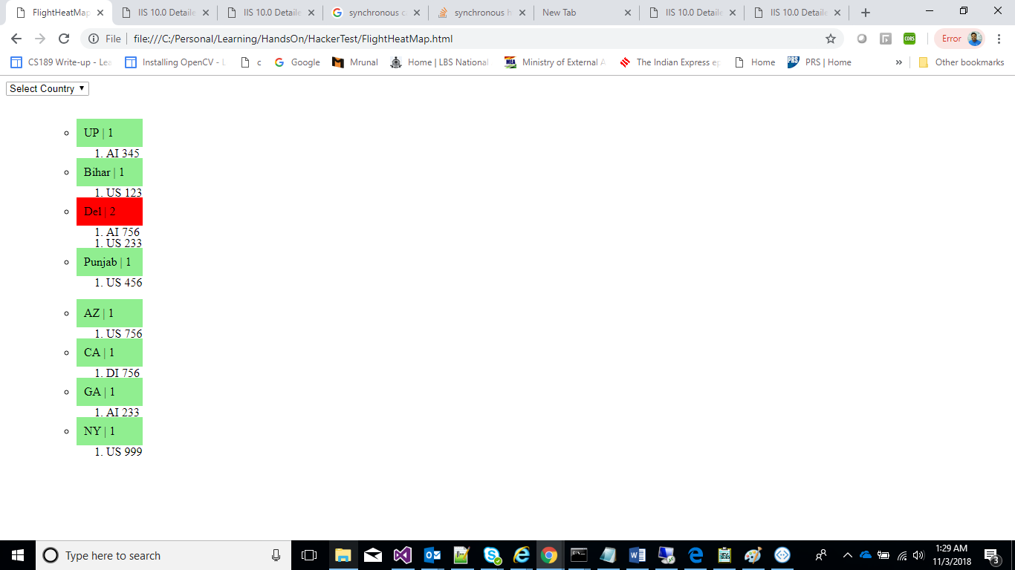

1. Below screen shot shows user can select Country Name from combo box and flights heat map will show for the selected country

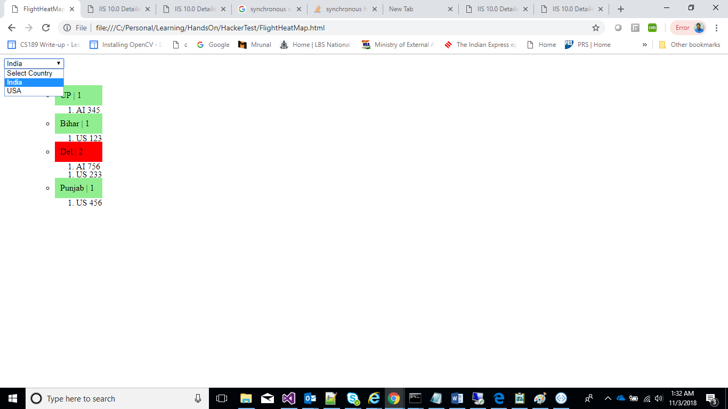

1. An error message will be displayed when service is down

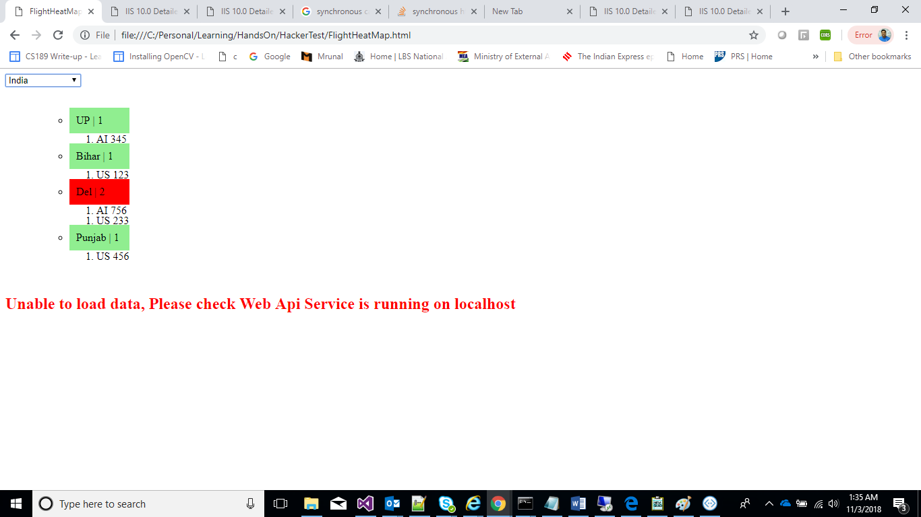

1. Gf
2. gfd