Python Experiment 6

Q.1 Write a python program to find the Hash of the file

import hashlib

file = (r"C:\\Users\Pranav Choudhary\Desktop\Student.csv")

BLOCK_SIZE = 65536

file_hash = hashlib.sha1()

with open(file, 'rb') as f:

fb = f.read(BLOCK_SIZE)

while len(fb) > 0:

file_hash.update(fb)

fb = f.read(BLOCK_SIZE)

print (file_hash.hexdigest())

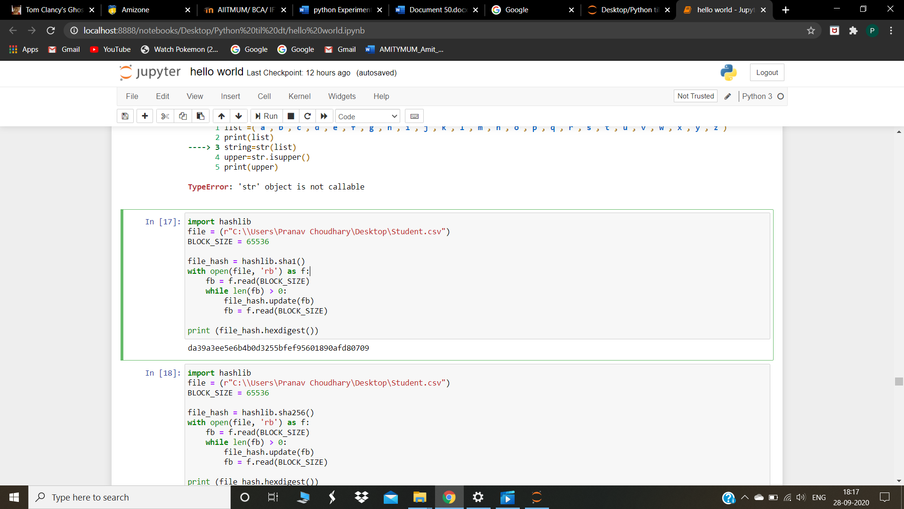

Q2.Write a python program to read a file line by line and store the contents in a (i) variable (ii) list

file=open(r"C:\Users\Pranav Choudhary\Desktop\hash.txt","w")

l=input("Enter sentences to save in file")

file.write(l)

file.close()

file=open(r"C:\Users\Pranav Choudhary\Desktop\hash.txt","r")

lis=list(file.read())

file.close()

file=open(r"C:\Users\Pranav Choudhary\Desktop\hash.txt","r")

lis=file.read()

print("Variables :" ,l,"\n List : ",lis)

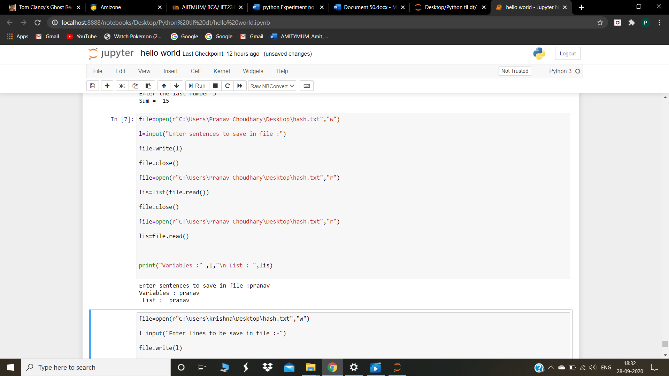

Q3.  Write a Python program to remove newline characters from a file

file=open(r"C:\Users\Pranav Choudhary\Desktop\char.txt","w")

ip=input("Enter lines to be saved in file :")

file.write(ip)

ip=input(" ")

file.write(l)

ip=input(" ")

file.write(ip)

file.close()

file=open(r"C:\Users\Pranav Choudhary\Desktop\char.txt","r",newline='')

ip=file.read()

print(ip)

