Screenshot of the *running VM instance* from the cloud console.

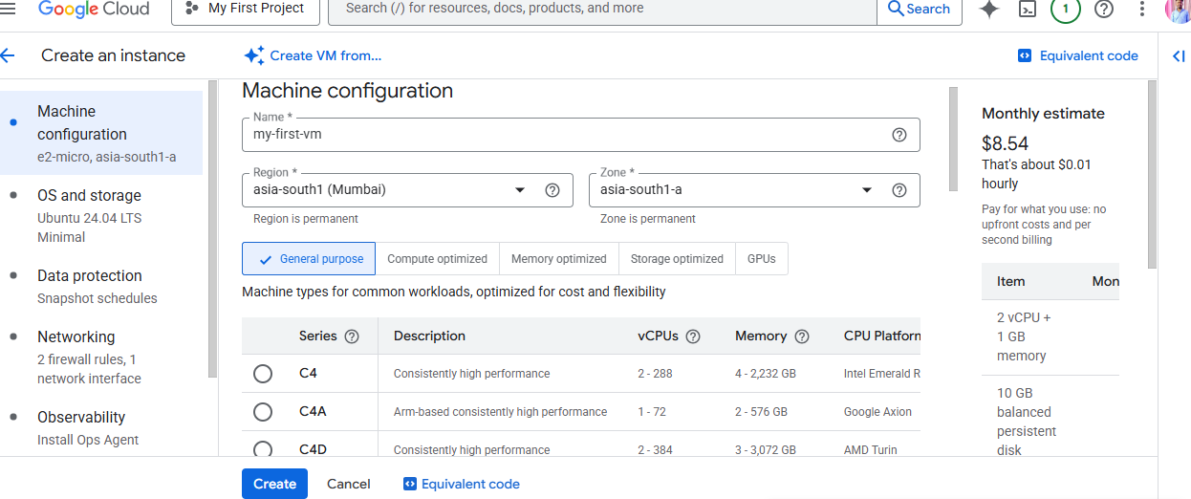

Screenshot of *terminal access* after connecting via SSH

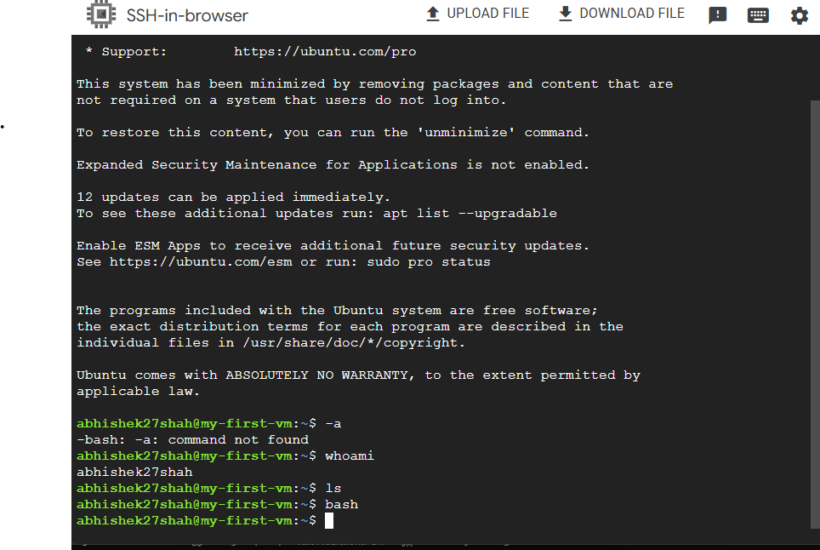

A short note (2–3 lines) describing your VM configuration (OS, region, machine type).

I created a VM instance on Google Cloud using **Ubuntu 22.04 LTS**, **e2-micro** machine type in the **asia-south1 (Mumbai)** region. Connected via SSH and verified system info using Linux commands.