**20CSE446 - IOT Project Report**

Abhishek Sharma - 21001

Jayaraj - 21026

Kuralamudhan - 21033

**Abstract**

The "**Smart Stick**" prototype addresses the needs of visually impaired individuals by integrating cutting-edge technology. It incorporates an ultrasonic sensor for obstacle detection and a SOS button for emergency alerts. Data from the ultrasonic sensor is transmitted to ThingSpeak in real-time for monitoring, while the SOS button triggers alerts through the Blynk cloud. Additionally, an Android application offers caregivers real-time tracking and communication features, enhancing safety and accessibility for visually impaired users. By seamlessly combining these elements, the project aims to provide a comprehensive solution that enhances the independence and security of visually impaired individuals while offering peace of mind to caregivers. Through continuous development and refinement, this innovative prototype has the potential to significantly improve the quality of life for its users, demonstrating the power of technology in addressing real-world challenges faced by marginalized communities.

**Introduction**

Visually impaired individuals encounter significant challenges in safely navigating their surroundings, with obstacles and hazards posing constant risks to their mobility and safety. Traditional mobility aids like white canes provide only limited assistance, leaving users vulnerable to accidents and collisions. These challenges are further exacerbated by the lack of real-time assistance and communication tools for visually impaired individuals and their caregivers.

The problem statement revolves around the fundamental issue of ensuring the safety and independence of visually impaired individuals in navigating their environment. Despite the availability of some mobility aids, there remains a gap in providing comprehensive solutions that address the dynamic nature of obstacles and hazards encountered in real-time situations. This gap highlights the critical need for innovative solutions that leverage modern technology to enhance the mobility and safety of visually impaired individuals. This solution should not only detect obstacles and hazards in real-time but also provide mechanisms for immediate communication and assistance in emergency situations. Moreover, it should prioritize user-friendly interfaces and accessibility features to ensure usability for individuals with varying degrees of visual impairment.

In response to these challenges, our project aims to develop an innovative solution, the "Smart Stick" prototype, which integrates advanced technologies such as ultrasonic sensors and cloud-based communication platforms. By leveraging modern technology, our solution seeks to enhance the mobility, safety, and independence of visually impaired individuals while providing peace of mind to caregivers. Through the development of this comprehensive solution, we aspire to bridge the gap in assistive technology and empower visually impaired individuals to navigate their environment with confidence and autonomy.

**Project Description**

At the heart of our project lies the development of a revolutionary "Smart Stick" prototype designed to revolutionize the mobility assistance landscape for visually impaired individuals. This groundbreaking solution integrates state-of-the-art technologies to offer comprehensive support to users navigating their surroundings. Central to the prototype is an ultrasonic sensor, meticulously engineered to detect obstacles obstructing the user's path with unparalleled accuracy and efficiency. The sensor continually gathers data on the environment, which is seamlessly transmitted to ThingSpeak, a cloud-based platform. This facilitates real-time monitoring and analysis of the user's surroundings, providing invaluable insights to both the user and caregivers.

Moreover, the Smart Stick prototype features an intuitive SOS button, strategically integrated into its design. In times of emergency, users can effortlessly activate the SOS button, initiating immediate alerts through the Blynk cloud. Caregivers and relevant authorities are promptly notified, enabling swift responses to potential crises. This multifaceted approach to mobility assistance ensures that visually impaired individuals can navigate their environment with confidence and security, while caregivers can remotely monitor their well-being. By harnessing cutting-edge technology, our project aims to redefine the standards of mobility aid, fostering independence and safety for visually impaired individuals worldwide.

**Methodology**

The methodology employed in this project encompasses a MERN stack architecture, comprising React Native for the development of the Android application, Express.js for the backend, MongoDB for database storage, and Node.js for serverside operations. The hardware setup of the smart stick involves connecting the ultrasonic sensor and SOS button to an ESP8266 microcontroller, facilitating data processing and communication functionalities.

*Software Methodology:*

We embraced a MERN stack architecture to develop the software components of our project:

* React Native: Utilized for building the Android application, providing a native and intuitive user interface.
* Express.js: Employed as the backend framework to handle server-side logic and API endpoints.
* MongoDB: Chosen as the database system for its flexibility and scalability, storing user and sensor data securely.
* Node.js: Used to execute server-side operations and ensure seamless communication between the frontend and backend components.

*Hardware Methodology:*

* Component Integration: Connecting the ultrasonic sensor and SOS button to the ESP8266 microcontroller, establishing the core hardware components.
* Data Processing: Implementing algorithms on the microcontroller to process data from the ultrasonic sensor, interpreting distance measurements and identifying obstacles.
* Communication: Configuring the microcontroller to communicate with external platforms such as ThingSpeak for real-time data transmission and the Blynk cloud for SOS alerts.
* Integration Testing: Conducting thorough testing to ensure seamless interaction between the hardware components and software modules.

*Algorithm:*

* Obstacle Detection: Utilizing data from the ultrasonic sensor, the algorithm calculates distances to objects in the user's path. It employs threshold values to identify obstacles and trigger alerts when necessary.
* Emergency Alert System: Upon activation of the SOS button, the algorithm initiates immediate alerts via the Blynk cloud, notifying designated caregivers or authorities of the user's distress situation.

By integrating advanced algorithms with cutting-edge technologies, our methodology ensures the effective functionality and reliability of the Smart Stick prototype, empowering visually impaired individuals to navigate their surroundings with confidence and safety.

**Schematic Diagram**

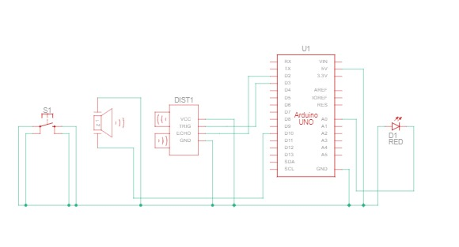

**Wokwi**

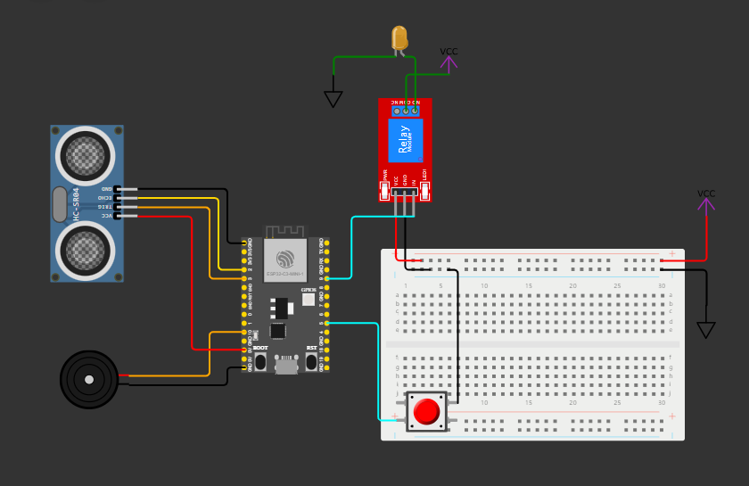

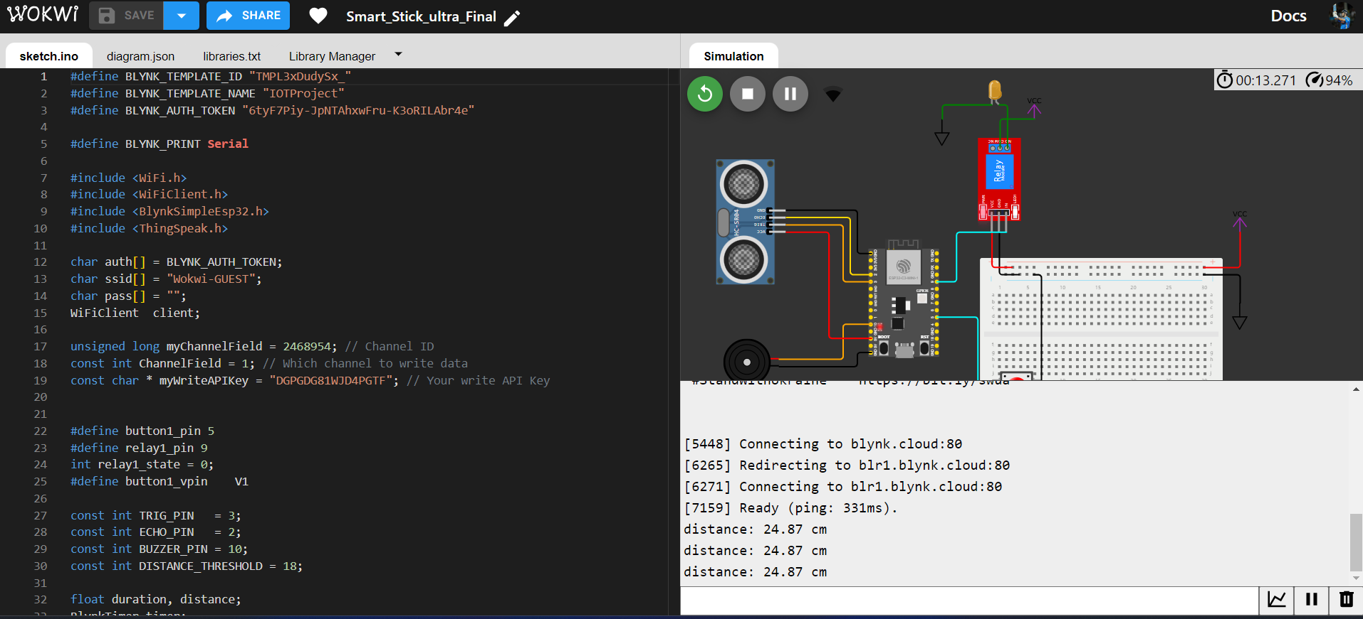

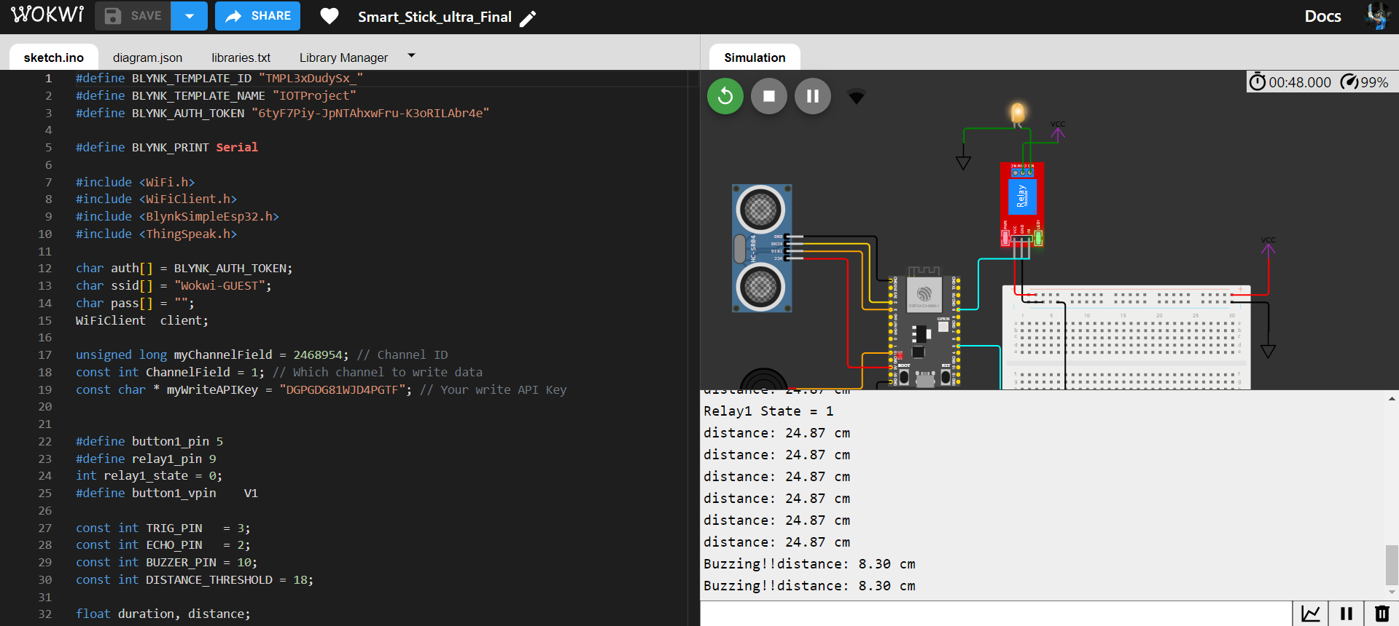

**Components**

* *Ultrasonic sensor:* Responsible for detecting obstacles in the user's path.
* *Buzzer:* Buzzing sound when the distance is below the threshold.
* *SOS button:* Allows users to trigger emergency alerts.
* *ESP8266 microcontroller:* Facilitates data processing and communication with cloud platforms.
* *Blynk cloud:* Enables the transmission of SOS alerts to caregivers or authorities.
* *ThingSpeak platform:* Provides a cloudbased solution for realtime monitoring and analysis of ultrasonic sensor data.
* *Android smartphone:* Utilized for realtime tracking and communication features through the developed application.

**Source Code**

Refer to: <https://github.com/LastAirbender07/Smart_Stick_Prototype>

#define BLYNK_TEMPLATE_ID " XXXXXXXX "

#define BLYNK_TEMPLATE_NAME "IOTProject"

#define BLYNK_AUTH_TOKEN " XXXXXXXX "

#define BLYNK_PRINT Serial

#include <WiFi.h>

#include <WiFiClient.h>

#include <BlynkSimpleEsp32.h>

#include <ThingSpeak.h>

char auth[] = BLYNK_AUTH_TOKEN;

char ssid[] = "Wifi-name";

char pass[] = "wifi-pass";

WiFiClient client;

unsigned long myChannelField = 1234567;

const int ChannelField = 1;

const char * myWriteAPIKey = " XXXXXXXX ";

#define button1_pin 5

#define relay1_pin 9

int relay1_state = 0;

#define button1_vpin V1

const int TRIG_PIN = 3;

const int ECHO_PIN = 2;

const int BUZZER_PIN = 10;

const int DISTANCE_THRESHOLD = 18;

float duration, distance;

BlynkTimer timer;

BLYNK_CONNECTED() {

Blynk.syncVirtual(button1_vpin);

}

BLYNK_WRITE(button1_vpin) {

relay1_state = param.asInt();

digitalWrite(relay1_pin, relay1_state);

}

void setup()

{

Serial.begin(115200);

pinMode(button1_pin, INPUT_PULLUP);

pinMode(relay1_pin, OUTPUT);

digitalWrite(relay1_pin, HIGH);

pinMode(TRIG_PIN, OUTPUT);

pinMode(ECHO_PIN, INPUT);

pinMode(BUZZER_PIN, OUTPUT);

Blynk.begin(auth, ssid, pass);

WiFi.mode(WIFI_STA);

ThingSpeak.begin(client);

}

unsigned long previousMillis = 0;

const long interval = 2000;

void loop()

{

if (WiFi.status() != WL_CONNECTED) {

Serial.print("Attempting to connect to SSID: ");

Serial.println(ssid);

while (WiFi.status() != WL_CONNECTED)

{

WiFi.begin(ssid, pass);

Serial.print(".");

delay(5000);

}

Serial.println("\nConnected.");

}

unsigned long currentMillis = millis();

Blynk.run();

timer.run();

if (currentMillis - previousMillis >= interval) {

previousMillis = currentMillis;

ultra();

}

listen_push_buttons();

}

void listen_push_buttons(){

if(digitalRead(button1_pin) == LOW){

delay(200);

control_relay(1);

Blynk.virtualWrite(button1_vpin, relay1_state);

}

}

void control_relay(int relay){

if(relay == 1){

relay1_state = !relay1_state;

digitalWrite(relay1_pin, relay1_state);

Serial.print("Relay1 State = ");

Serial.println(relay1_state);

delay(50);

}

}

void ultra(){

digitalWrite(TRIG_PIN, HIGH);

delayMicroseconds(10);

digitalWrite(TRIG_PIN, LOW);

duration = pulseIn(ECHO_PIN, HIGH);

distance = (0.034 * duration)/2;

if(distance < DISTANCE_THRESHOLD){

digitalWrite(BUZZER_PIN, HIGH);

Serial.write("Buzzing!!");

}

else

digitalWrite(BUZZER_PIN, LOW);

ThingSpeak.writeField(myChannelField, ChannelField, distance, myWriteAPIKey);

Serial.print("distance: ");

Serial.print(distance);

Serial.println(" cm");

}

**Results**

The implemented smart stick prototype successfully detects obstacles using the ultrasonic sensor and transmits the collected data to ThingSpeak for realtime monitoring. The SOS button functionality effectively triggers alerts via the Blynk cloud, ensuring timely response to emergencies. Furthermore, the Android application offers comprehensive realtime tracking and communication features, contributing to enhanced accessibility and safety for visually impaired users.

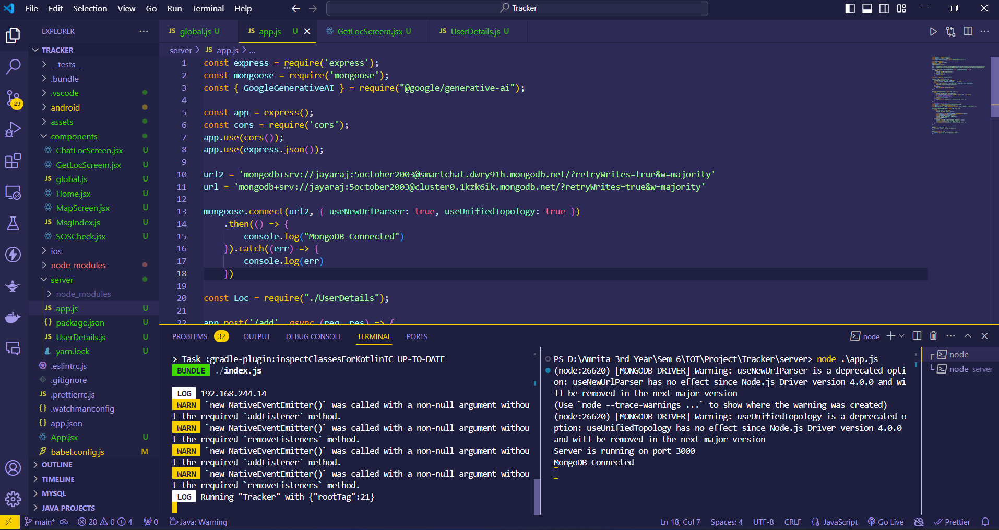

|  |  |  |  |
| --- | --- | --- | --- |
|  |  |  |  |

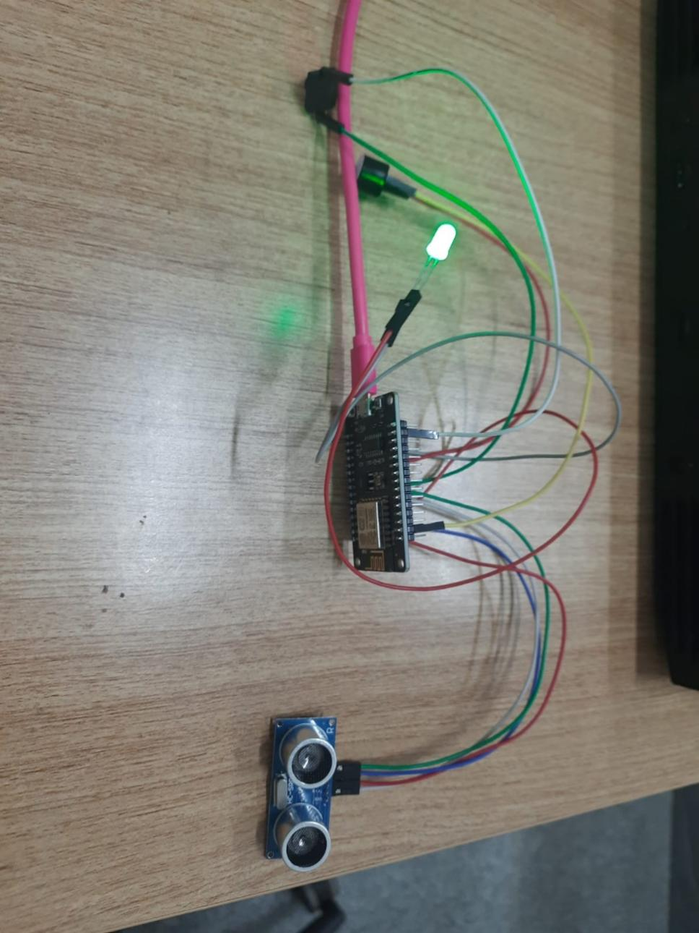

**Conclusion**

The development of the "Smart Stick" prototype represents a significant step towards addressing the mobility challenges faced by visually impaired individuals. By harnessing the power of modern technology, we have created a comprehensive solution that not only enhances safety and accessibility but also provides peace of mind for both users and caregivers. Moving forward, continuous refinement and optimization of the hardware and software components will further improve functionality and user experience, ensuring the ongoing success and impact of the project.