**CodroidHub Summer Training**

**Title:-**

BREAK statement in Python

CONTINUE statement in Python

FUNCTIONS in Python

PRE-DEFINED FUNCTIONS in Python

USER-DEFINED FUNCTIONS in Python

FUNCTION WITH PARAMETERS in Python

DEFAULT ARGUEMENT FUNCTION in Python

RECURSIVE FUNCTION in Python

CLASS AND OBJECT in Python

**BREAK STATEMENT IN PYTHON**

***break statement in***[***Python***](https://www.geeksforgeeks.org/python-programming-language/)*is used to bring the control out of the loop when some external condition is triggered. break statement is put inside the loop body (generally after if condition).  It terminates the current loop, i.e., the loop in which it appears, and resumes execution at the next statement immediately after the end of that loop. If the break statement is inside a nested loop, the break will terminate the innermost loop.*

*EXAMPLE:*

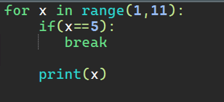

*OUTPUT:*

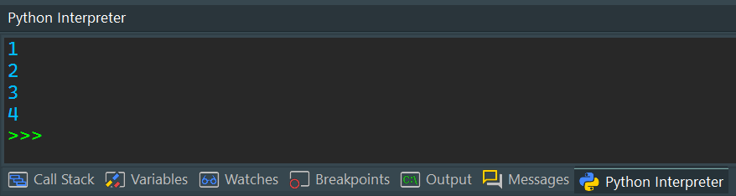

[***Key takeaways***](https://www.coursera.org/tutorials/python-break#key-takeaways)

* *Break is a loop control statement along with continue and pass.*
* *You can use break to exit for loops and while loops.*
* *Break only exits the innermost loop in a nested loop.*
* *You can’t use break to exit an if statement unless the if statement is inside of a loop.*

**Continue Statement in Python**

[***Python***](https://www.geeksforgeeks.org/python-programming-language/)***Continue statement****is a loop control statement that forces to execute the next iteration of the loop while skipping the rest of the code inside the loop for the current iteration only, i.e. when the continue statement is executed in the loop, the code inside the loop following the continue statement will be skipped for the current iteration and the next iteration of the loop will begin.*

*EXAMPLE:*

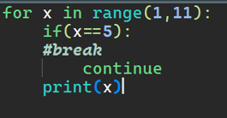

*OUTPUT:*

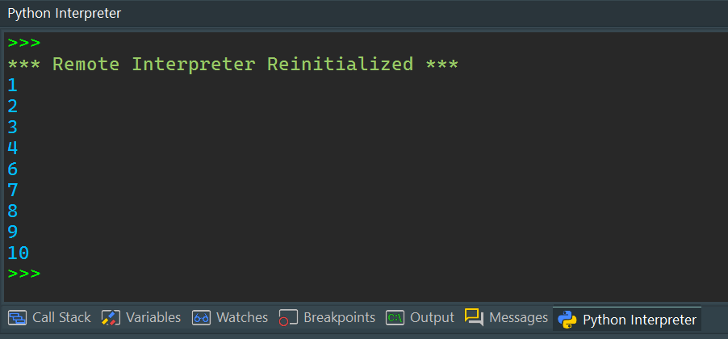

*When the condition x == 5 becomes True, the continue statement gets executed. The remaining code in the loop is skipped only for that iteration. That’s why Iteration: 5 is missing from the above output.*

*Therefore, the continue statement works opposite to the break statement. Instead of terminating the loop, it forces it to execute the next iteration of the loop.*

**FUNCTIONS IN PYTHON**

*A collection of related assertions that carry out a mathematical, analytical, or evaluative operation is known as a function. An assortment of proclamations called Python Capabilities returns the specific errand. Python functions are necessary for intermediate-level programming and are easy to define. Function names meet the same standards as variable names do. The objective is to define a function and group-specific frequently performed actions. Instead of repeatedly creating the same code block for various input variables, we can call the function and reuse the code it contains with different variables.*

***Creating a Function***

*In Python a function is defined using the def keyword.*

***Calling a Function***

*To call a function, use the function name followed by parenthesis.*

*EXAMPLE*

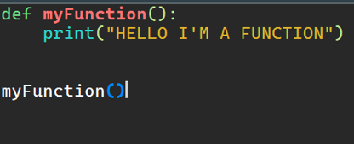

*OUTPUT:*

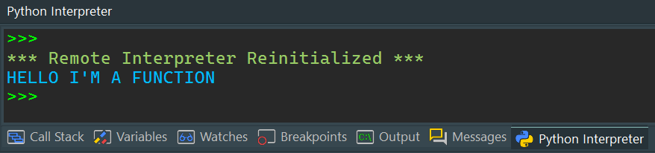

**PRE-DEFINED FUNCTIONS IN PYTHON**

*A predefined function is a function that has already been written in the programming language and can be used by the programmer. A function will return a value that can be stored in a variable or sometimes in a conditional statement*

*There are many pre-defined or built in functions in python. Total there are 68 built in functions in python programming. For example: print(), list(), abs(), ascii(),all(), any(), max(), min() & many more.*

*EXAMPLE:*

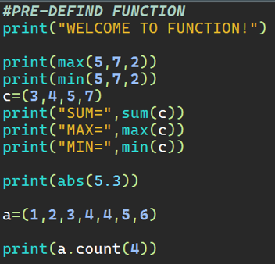

*OUTPUT:*

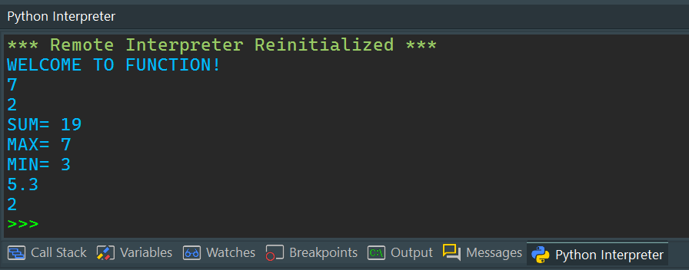

**USER-DEFINED FUNCTIONS IN PYTHON**

*All the functions that are written by any of us come under the category of user-defined functions. Below are the steps for writing user-defined functions in*[*Python*](https://www.geeksforgeeks.org/python-programming-language/)*.*

* *In Python, a*[*def keyword*](https://www.geeksforgeeks.org/python-def-keyword/)*is used to declare user-defined functions.*
* *An indented block of statements follows the function name and arguments which contains the body of the function.*

*EXAMPLE:*

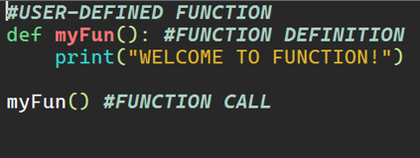

*OUTPUT:*

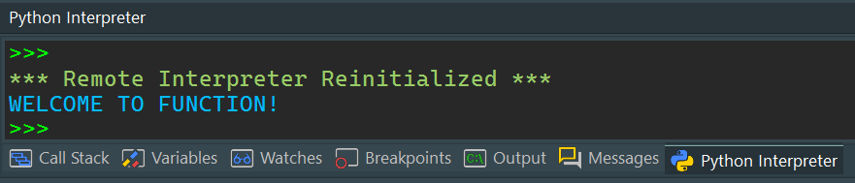

**FUNCTION WITH PARAMETERS IN PYTHON**

*If you have experience in C/C++ or Java then you must be thinking about the return type of the function and data type of arguments. That is possible in Python as well .*

*EXAMPLE:*

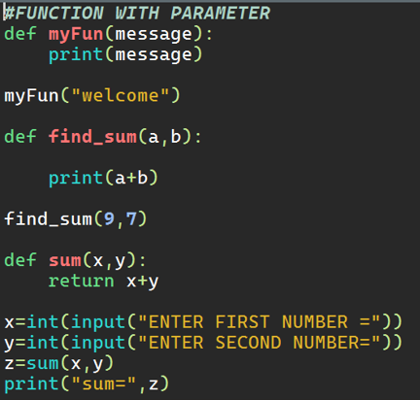

*OUTPUT:*

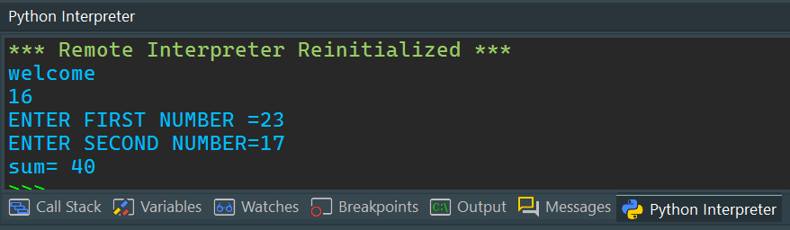

*Let us make a program to calculate simple interest using user defined function.*

*EXAMPLE:*

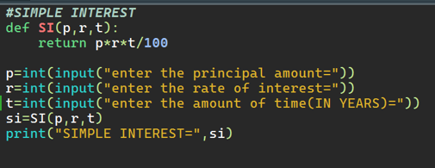

*OUTPUT:*

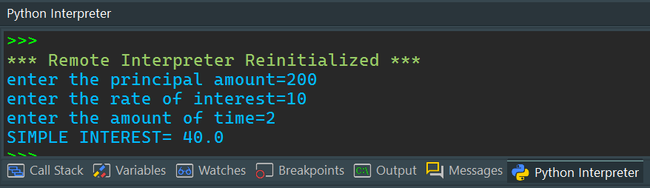

**DEFAULT ARGUMENT FUNCTION IN PYTHON**

*Python allows function arguments to have default values.*

*If the function is called without the argument, the argument gets its default value.*

*Python has a different way of representing syntax and default values for function arguments. Default values indicate that the function argument will take that value if no argument value is passed during the function call. The default value is assigned by using the assignment(=) operator of the form keyword name=value.*

*EXAMPLE:*

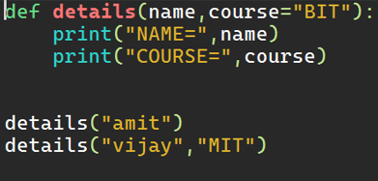

*OUTPUT:*

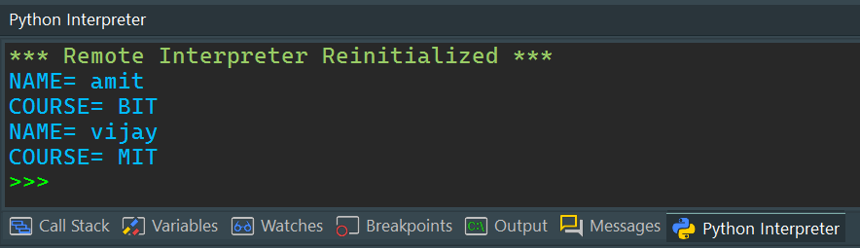

**RECURSIVE FUNCTION IN PYTHON**

*The term*[*Recursion*](https://www.geeksforgeeks.org/recursion/#:~:text=The%20process%20in%20which%20a,%20can%20be%20solved%20quite%20easily.)*can be defined as the process of defining something in terms of itself. In simple words, it is a process in which a function calls itself directly or indirectly.*

***Advantages of using recursion***

* *A complicated function can be split down into smaller sub-problems utilizing recursion.*
* *Sequence creation is simpler through recursion than utilizing any nested iteration.*
* *Recursive functions render the code look simple and effective.*

*Let us solve a problem of finding a factorial of a number using recursion.*

*EXAMPLE:*

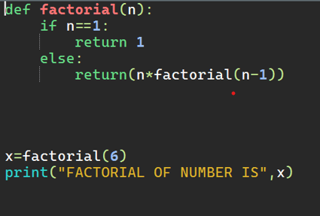

*OUTPUT:*

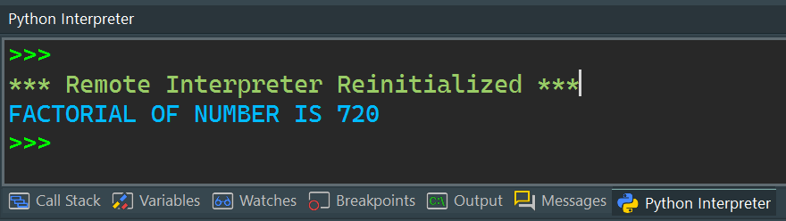

**CLASS AND OBJECT IN PYTHON**

*A collection of related assertions that carry out a mathematical, analytical, or evaluative operation is known as a function. An assortment of proclamations called Python Capabilities returns the specific errand. Python functions are necessary for intermediate-level programming and are easy to define. Function names meet the same standards as variable names do. The objective is to define a function and group-specific frequently performed actions. Instead of repeatedly creating the same code block for various input variables, we can call the function and reuse the code it contains with different variablesEXAMPLE:* 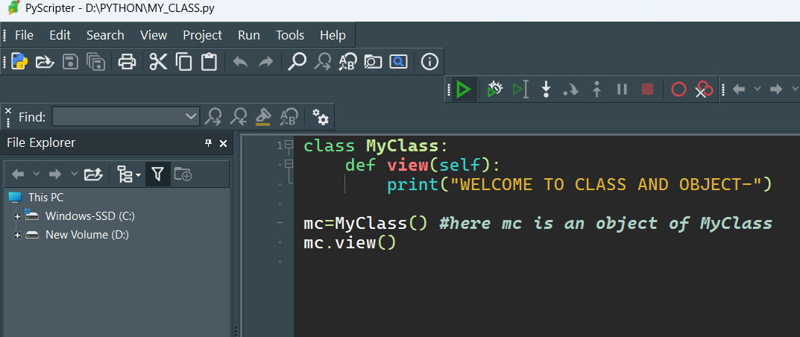

*OUTPUT:* 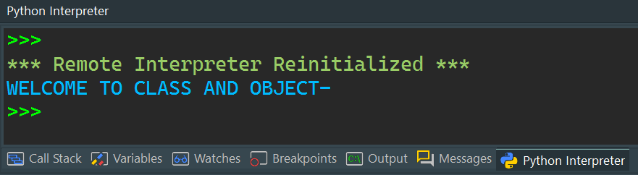

***Object of Python Class***

*In*[*Python programming*](https://www.geeksforgeeks.org/courses/search?query=python)*an Object is an instance of a Class. A class is like a blueprint while an instance is a copy of the class with actual values. It’s not an idea anymore, it’s an actual dog, like a dog of breed pug who’s seven years old. You can have many dogs to create many different instances, but without the class as a guide, you would be lost, not knowing what information is required.*

*An object consists of:*

* ***State:****It is represented by the attributes of an object. It also reflects the properties of an object.*
* ***Behaviour:****It is represented by the methods of an object. It also reflects the response of an object to other objects.*
* ***Identity:****It gives a unique name to an object and enables one object to interact with other objects.*

*EXAMPLE OF CONSTRUCTOR:*

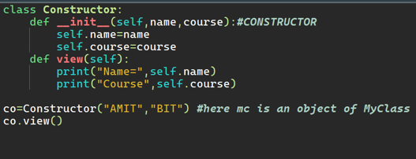

*OUTPUT:*

