**STUDENT MANAGEMENT PROJECT (DBMS)**

1. **TABLES**

1. Student_official table

**create table student_official**(

 roll_no varchar(20), sectionId varchar(20), deptId varchar(20), semester varchar(20), join_year int, pass_year int,

 CONSTRAINT "PK_roll_no_student_official" PRIMARY KEY (roll_no),   CONSTRAINT "FK_deptId_student_official" FOREIGN KEY (deptId) REFERENCES department(deptId),

 CONSTRAINT "FK_sectionId_student_official" FOREIGN KEY (sectionId) REFERENCES section(sectionId)

)

**Select** * from student_official

Order by roll_no;

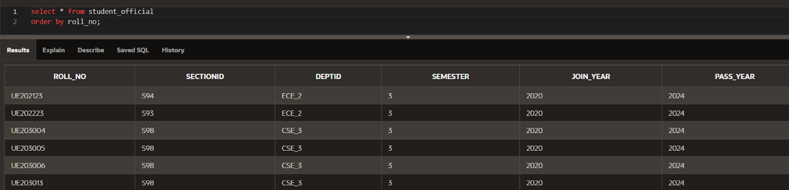

1. Student_personal table

**CREATE TABLE student_personal**(

 last_name VARCHAR(20), first_name VARCHAR(20), date_of_birth date, roll_no varchar(10), email varchar(20),city varchar(20), state_student varchar(20), phone_number varchar(12),

 CONSTRAINT "FK_roll_no_student_personal" FOREIGN KEY (roll_no) REFERENCES student_official(roll_no)

);

**select** * from student_personal

Order by roll_no;

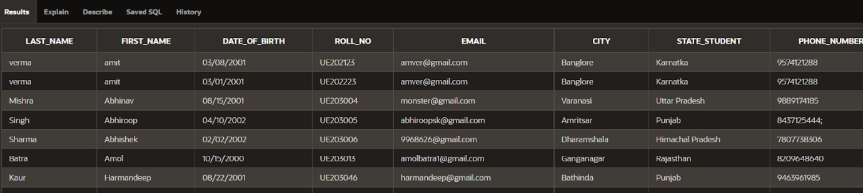

1. Results table

**create table results** (

    roll_no varchar(20), sem1 int, sem2 int, sem3 int, sem4 int, final_cgpa int,

    CONSTRAINT "FK_roll_no_results" FOREIGN KEY (roll_no) REFERENCES student_official(roll_no));

**select** * from results

Order by roll_no;



1. Department table

**CREATE TABLE department**(

    deptId VARCHAR(20), dept_name VARCHAR(50)

);

**Select** * from department;

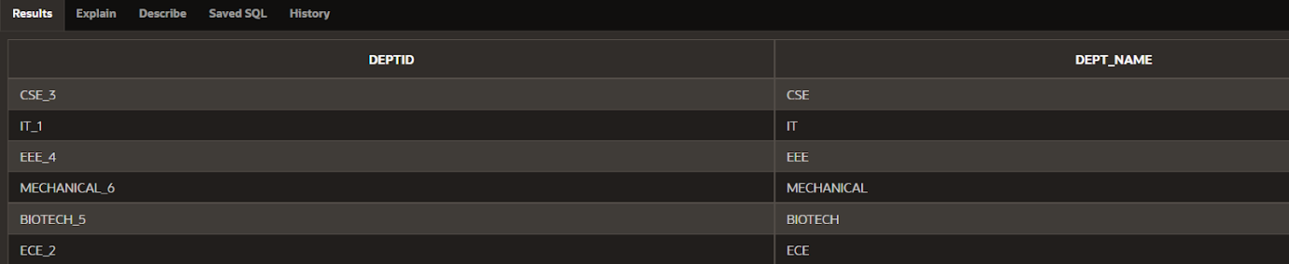

1. Course table

**CREATE TABLE course**(

    courseId varchar(20), course_name varchar(40), facultyID varchar(20) , deptId varchar(20),

    CONSTRAINT "PK_courseId_course" PRIMARY KEY (courseID),

    CONSTRAINT "FK_deptId_course" FOREIGN KEY (deptId) REFERENCES department(deptId)

);

**Select** * from course;

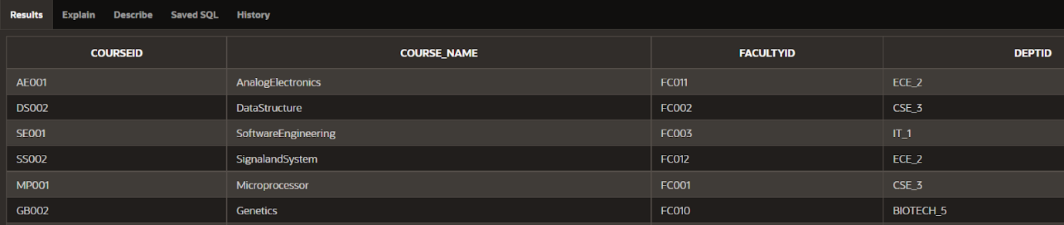

1. Exam table

**CREATE TABLE exam** (

deptId VARCHAR(20), examId varchar(20), exam_name varchar(40),courseId varchar(20),

    CONSTRAINT "PK_examId_exam" PRIMARY KEY (examId),

    CONSTRAINT "FK_deptId_exam" FOREIGN KEY (deptId) REFERENCES department(deptId)

);

**Select** * from exam;

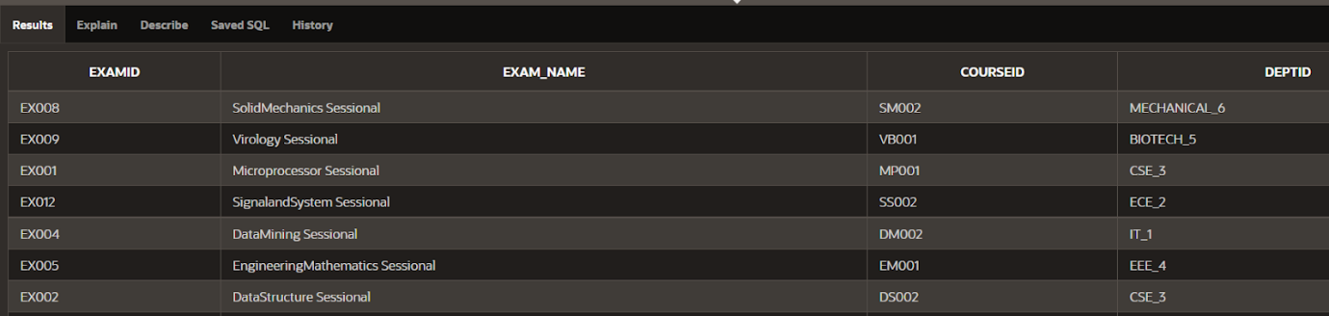

1. Section table

**create table section** (

    sectionId varchar(20), section_name VARCHAR(20), deptId varchar(20), no_of_students int,

    CONSTRAINT "PK_sectionId_section" PRIMARY KEY (sectionId),

    CONSTRAINT "FK_deptId_section" FOREIGN KEY (deptId) REFERENCES department(deptId)

);

**Select** * from section

Order by sectionId;

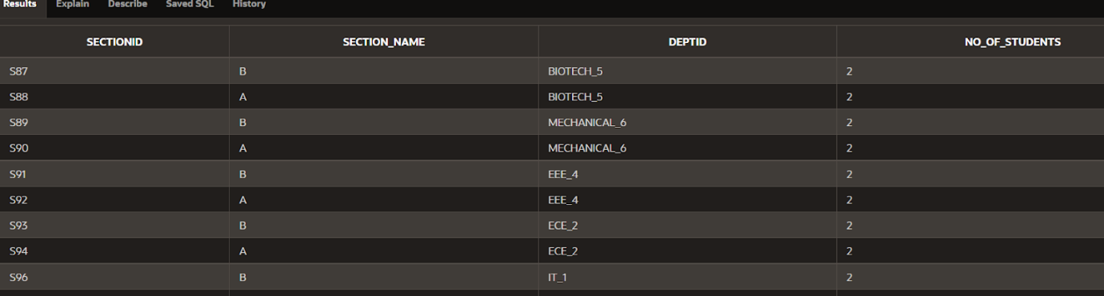

**2.   OPERATORS AND FUNCTIONS :**

**Aggregate functions :**

Sum() :

SELECT SUM(NO_OF_STUDENTS) AS TotalNoOfStudents FROM SECTION;

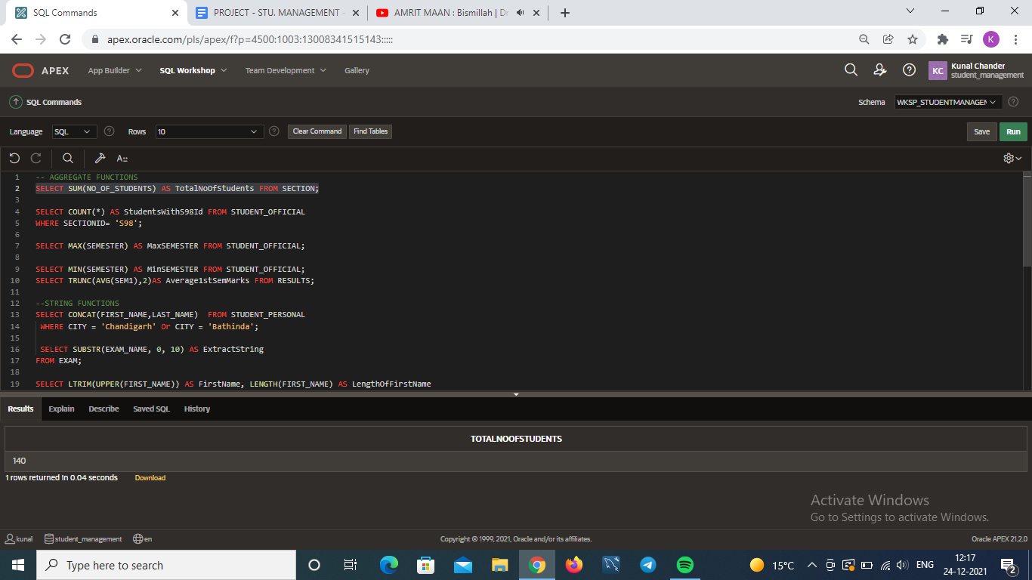

Count() :

SELECT COUNT(*) AS StudentsWithS98Id FROM STUDENT_OFFICIAL

WHERE SECTIONID= 'S98';

Max():

SELECT MAX(SEMESTER) AS MaxSEMESTER FROM STUDENT_OFFICIAL;



Min():

SELECT MIN(SEMESTER) AS MinSEMESTER FROM

STUDENT_OFFICIAL;

Avg():

SELECT AVG(SEM1) AS AVERAGE_SEM1_MARKS FROM RESULTS;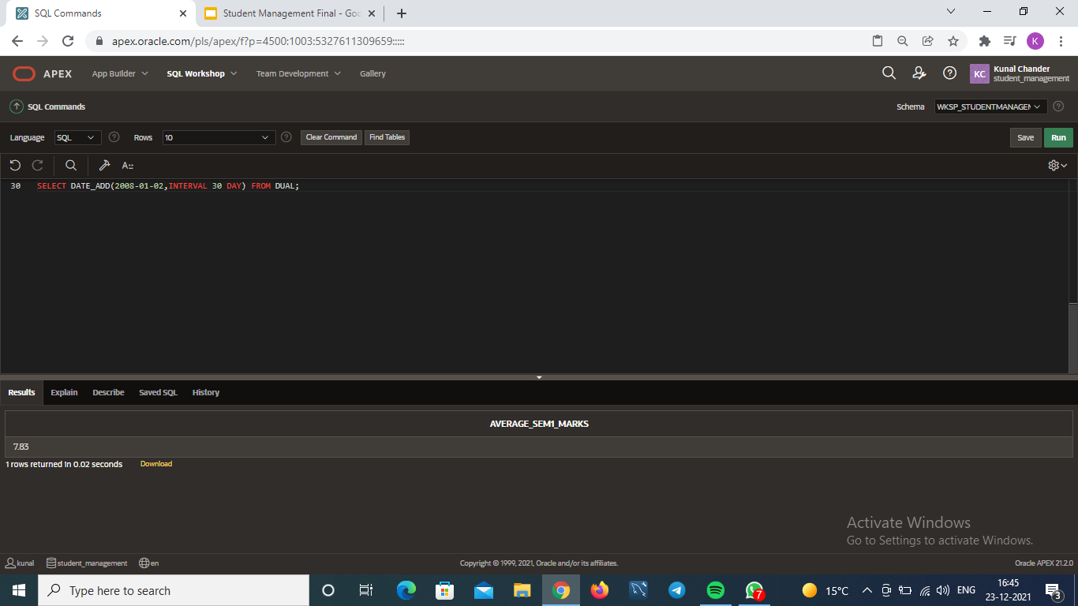

**String functions :**

Concat():

SELECT CONCAT(FIRST_NAME,LAST_NAME)  FROM STUDENT_PERSONAL

WHERE CITY = 'Chandigarh' Or CITY = 'Bathinda';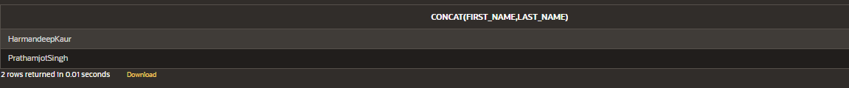

Substr():

SELECT SUBSTR(EXAM_NAME, 0, 10) AS ExtractString

FROM EXAM;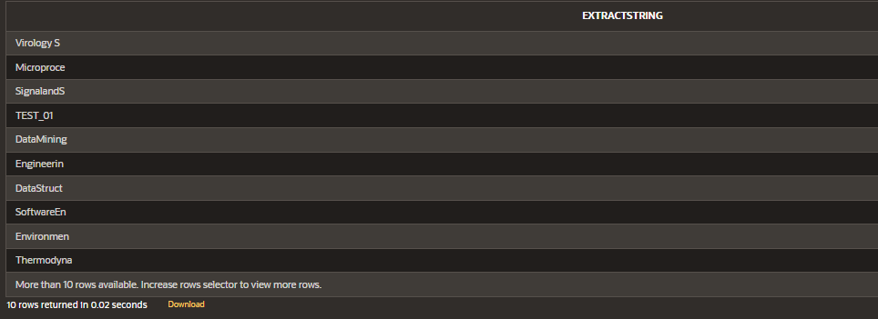

Ltrim(),Upper(),Length():

SELECT LTRIM(UPPER(FIRST_NAME)) AS FirstName, LENGTH(FIRST_NAME) AS LengthOfFirstName

FROM STUDENT_PERSONAL;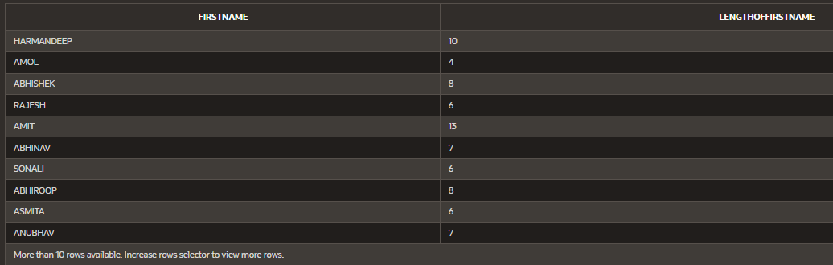

Initcap():

SELECT INITCAP ('this is student management system') AS CAPITALS FROM DUAL;

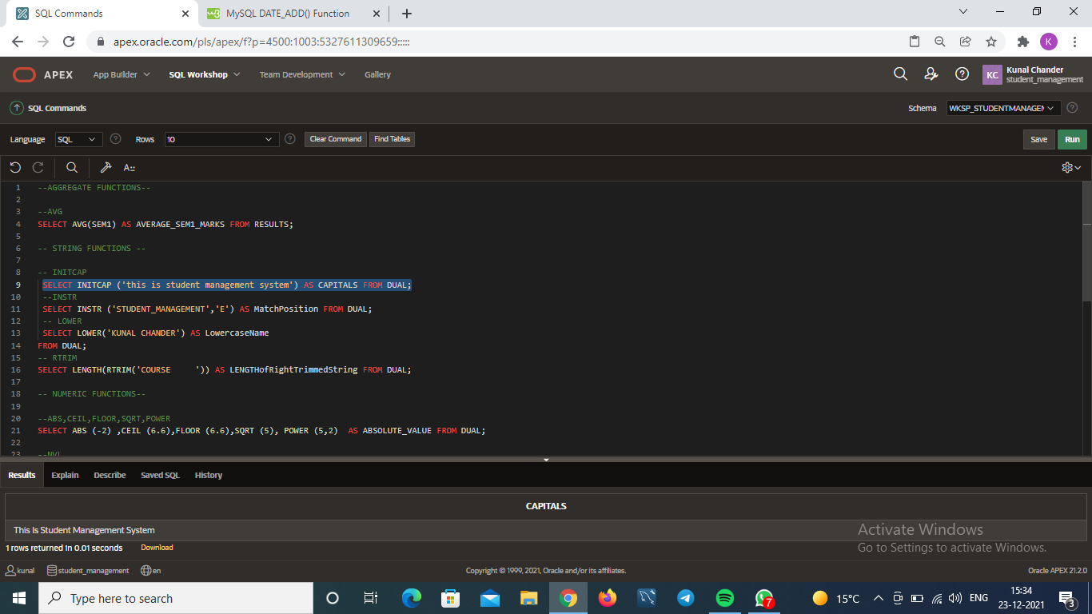

Instr():

SELECT INSTR ('STUDENT_MANAGEMENT','E') AS MatchPosition FROM DUAL;

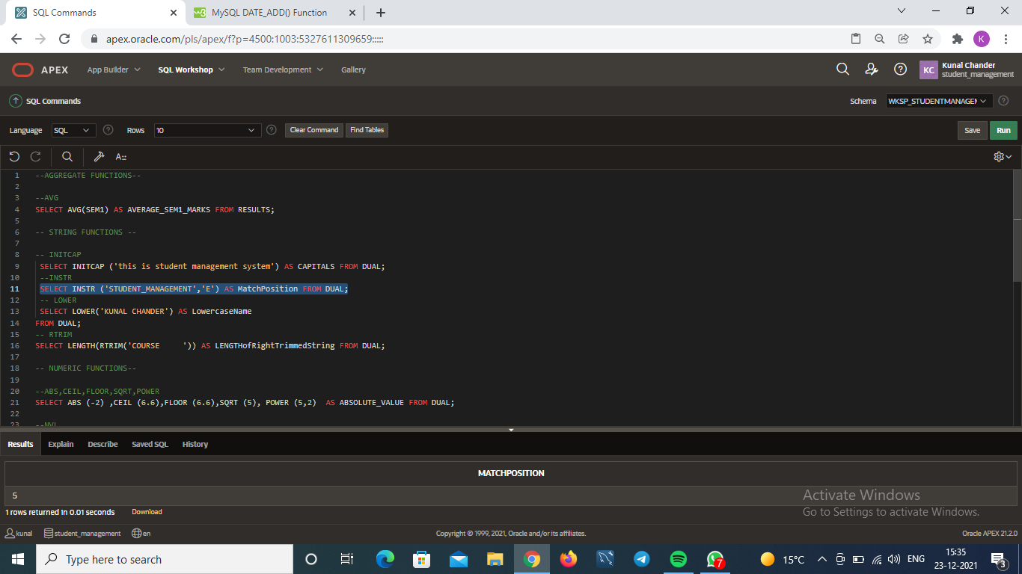

Lower():

SELECT LOWER('KUNAL CHANDER') AS LowercaseName

FROM DUAL;

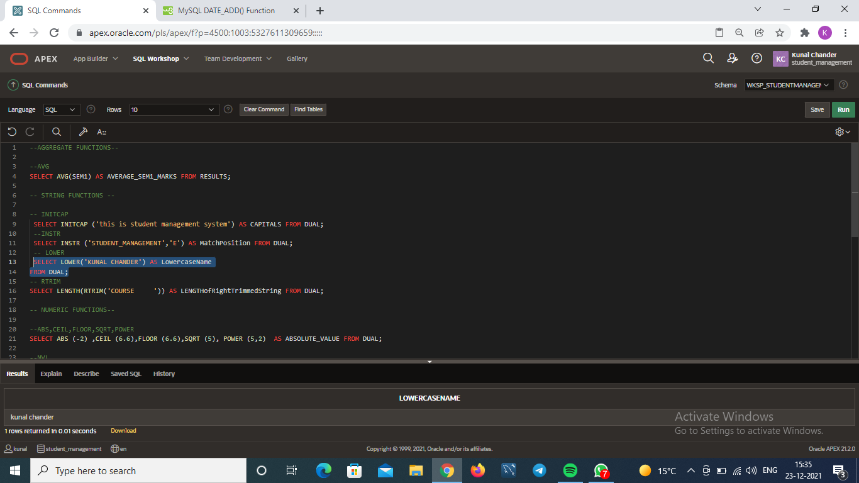

Rtrim():

SELECT LENGTH(RTRIM('COURSE     ')) AS LENGTHofRightTrimmedString FROM DUAL;

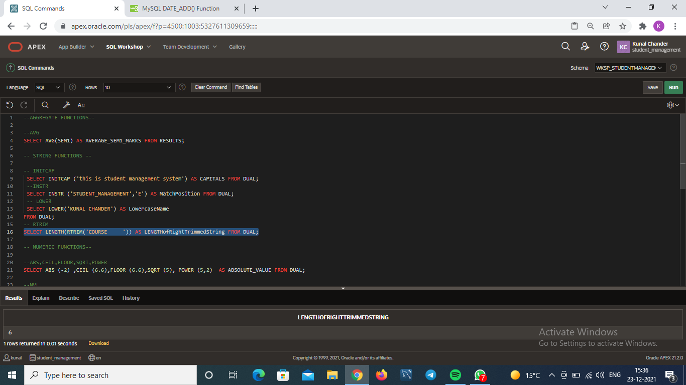

**Numeric functions :**

Round():

SELECT ROLL_NO, ROUND(FINAL_CGPA,1) FROM RESULTS;

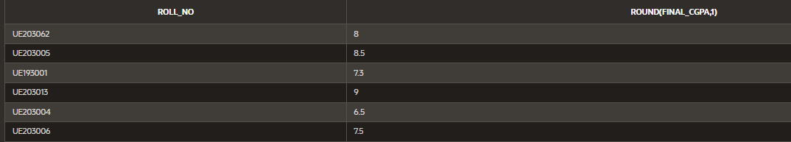

Trunc():

SELECT TRUNC(AVG(SEM1),2)AS Average1stSemMarks FROM RESULTS;



Abs(),Ceil(),Floor(),Sqrt(),Power():

SELECT ABS (-2) ,CEIL (6.6),FLOOR (6.6),SQRT (5), POWER (5,2)  AS ABSOLUTE_VALUE FROM DUAL;

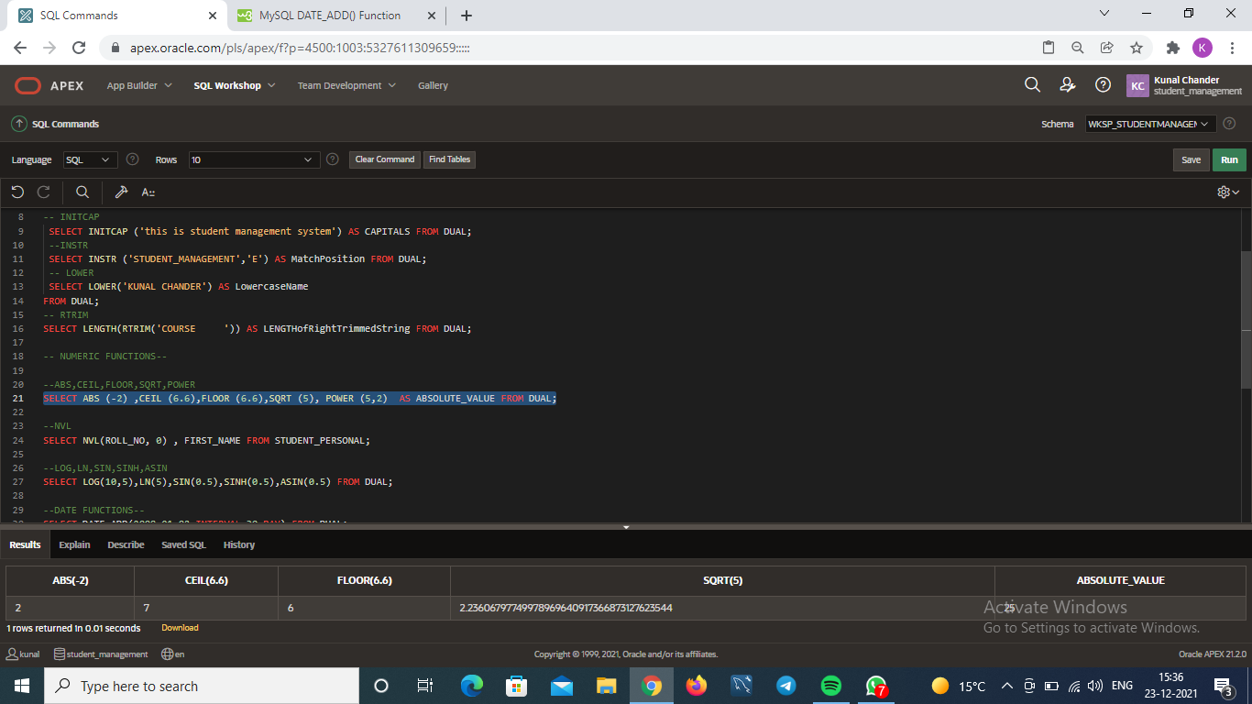

Nvl():

SELECT NVL(ROLL_NO, 0) , FIRST_NAME FROM STUDENT_PERSONAL;

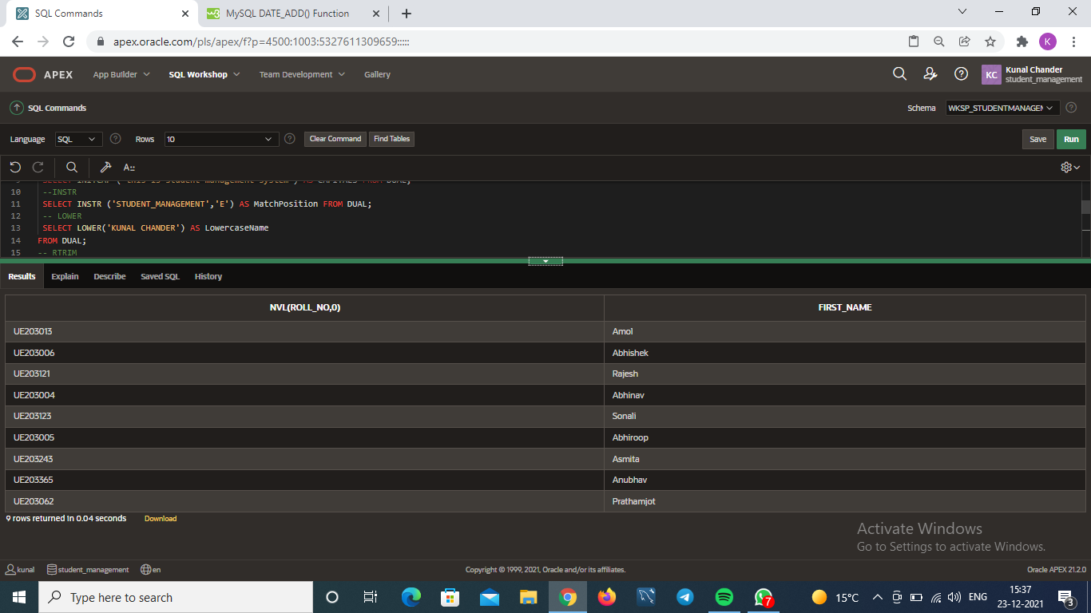

Log(),Ln(),Sin(),Sinh(),Asin():

SELECT LOG(10,5),LN(5),SIN(0.5),SINH(0.5),ASIN(0.5) FROM DUAL;

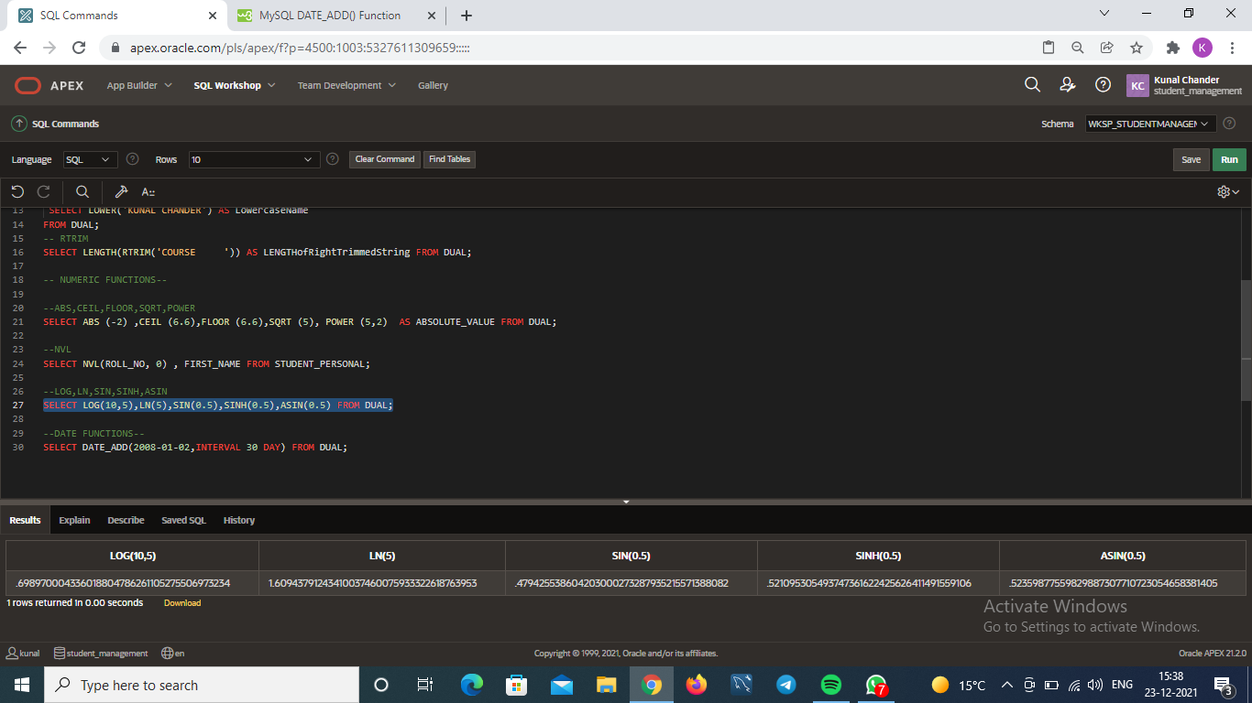

**Date functions :**

Extract():

SELECT FIRST_NAME, EXTRACT(YEAR FROM DATE_OF_BIRTH) FROM STUDENT_PERSONAL;

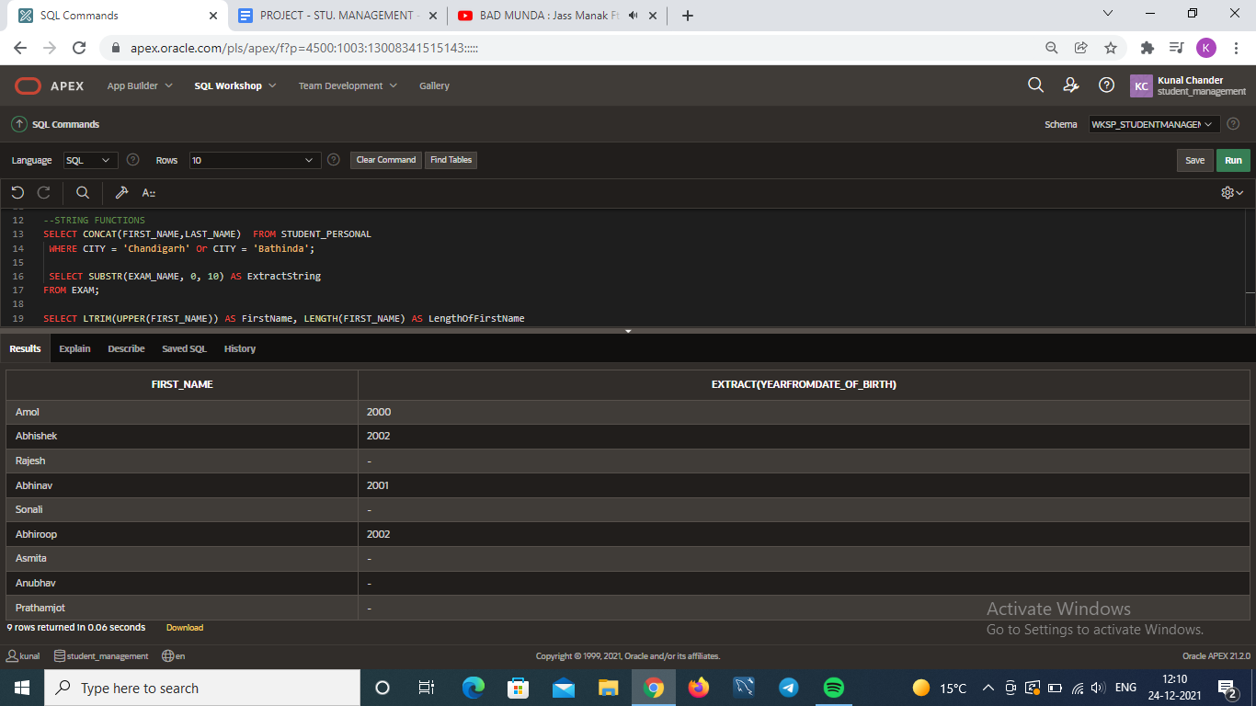

Current_date():

SELECT CURRENT_DATE FROM dual;

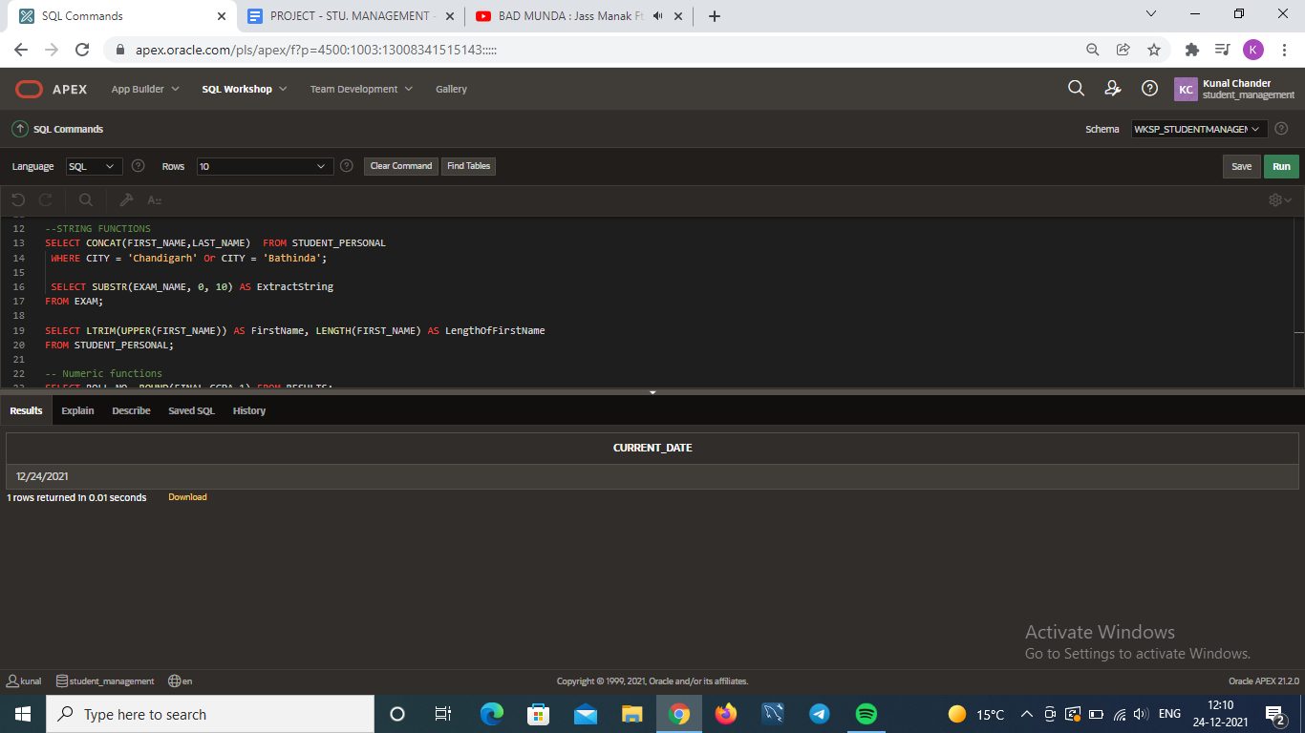

1. **Order by ,group by , having :**

Order by :

Select * from student_official

Order by roll_no;

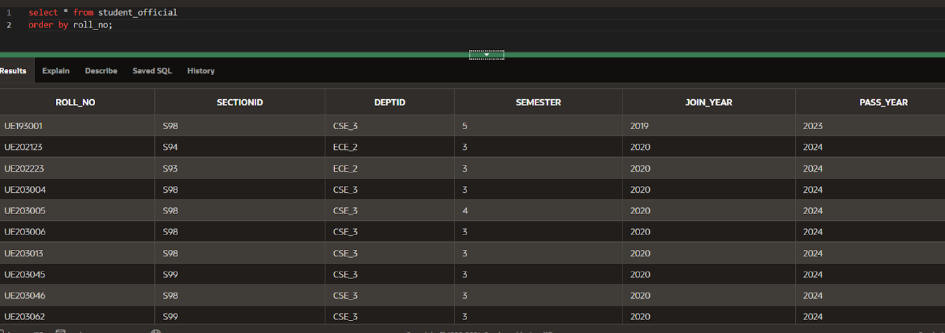

         Group by :

      select deptId ,count(*)

      from student_official

      group by deptId;

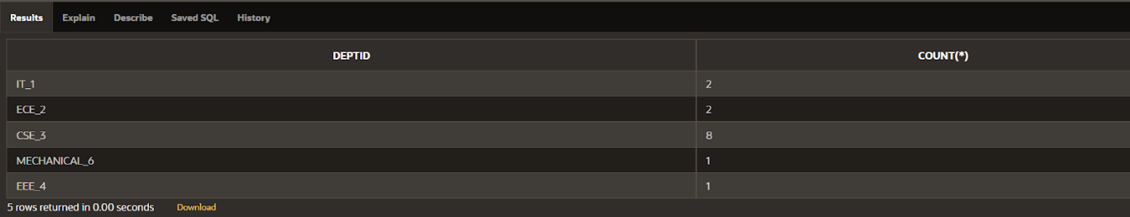

         Having :

      select deptId ,count(*)

      from student_official

      group by deptId

      having count(*)>1;

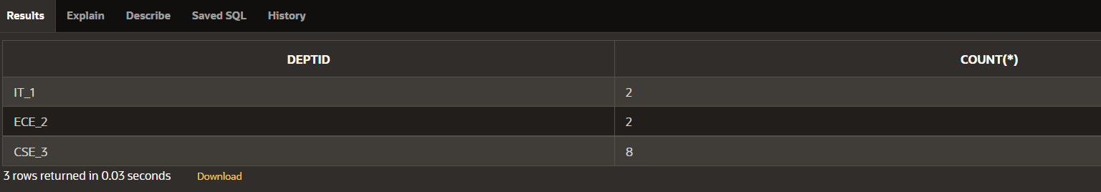

1. **JOINS:**

1. **NATURAL JOIN**

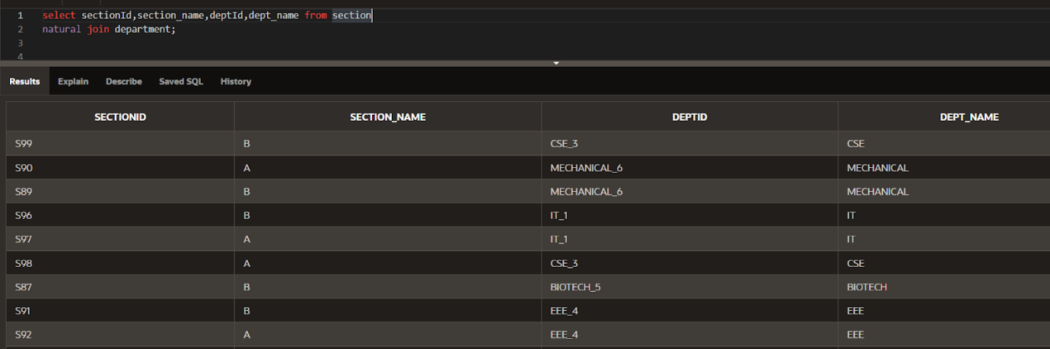

1. **CROSS JOIN**

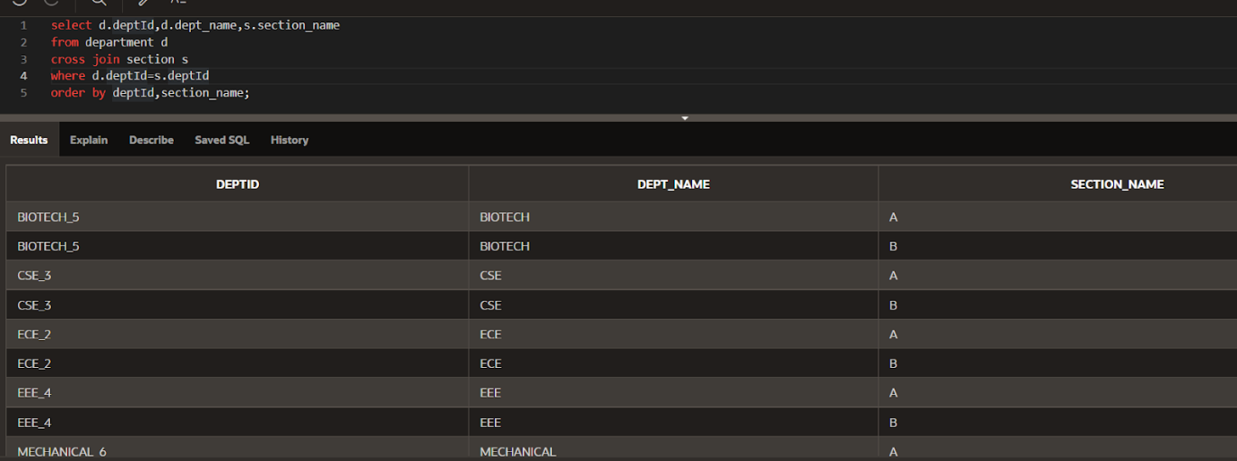

1. **INNER JOIN**

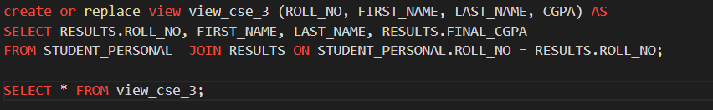



1. **LEFT JOIN**

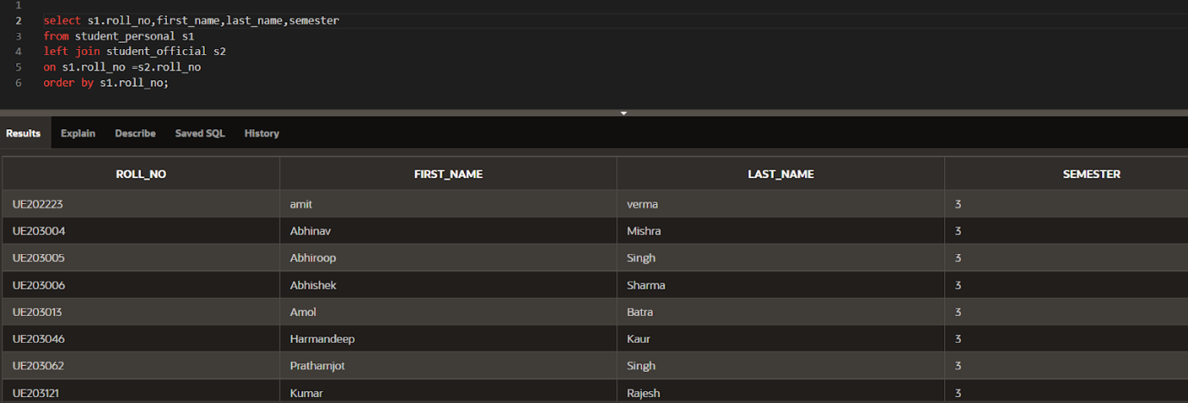

1. **RIGHT JOIN**

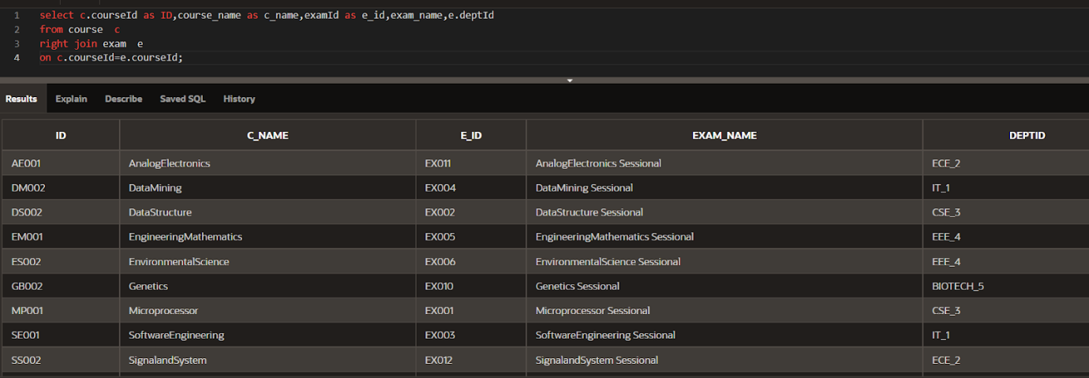

1. **FULL JOIN**

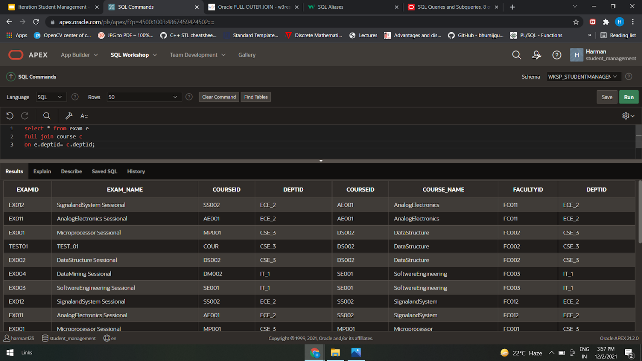

1. **VIEWS :**

**VIEW FROM SINGLE TABLE:**

create view stu_details

as

select roll_no,first_name,last_name,email,phone_number

from student_personal;

**MULTI-TABLE VIEW :**

CREATE OR REPLACE VIEW "STUDENT_INFO" ("ROLL_NO", "FIRST_NAME", "LAST_NAME", "SEMESTER", "JOIN_YEAR", "PASS_YEAR") AS

  select s1.roll_no,first_name,last_name,semester,join_year,pass_year

from student_official s1,student_personal s2

where s1.roll_no= s2.roll_no

order by s1.roll_no;

1. **VIEWS AND JOINS**

**create** or replace view stu_info

as

select s1.roll_no,first_name,last_name,semester,deptId

from student_personal s1

left join student_official s2

on s1.roll_no=s2.roll_no

order by s1.roll_no;

**select** * from stu_info;

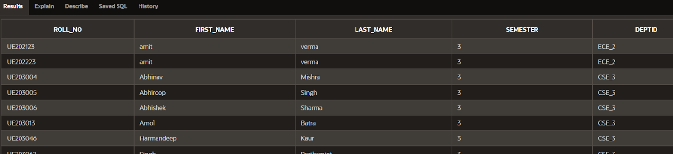

**create** or replace VIEW stu_bysec as

 select s.roll_no,semester,sec.sectionID,section_name,sec.deptId

 from student_official s

 full join section sec

 on s.sectionId=sec.sectionId

 order by sec.section_name;

**select** * from stu_bysec;

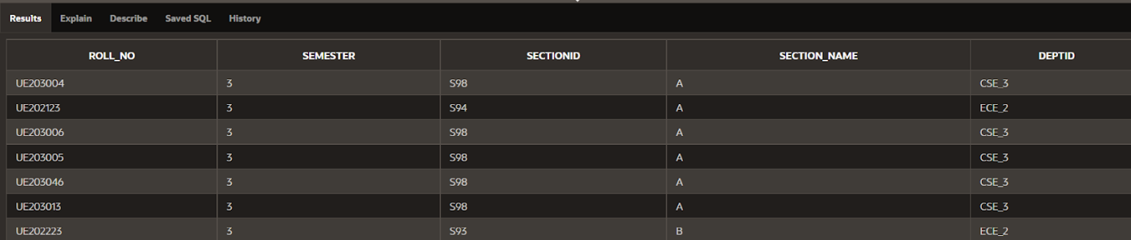

**CREATE** OR REPLACE VIEW student_by_department(DEPARTMENT_ID, NO_OF_STUDENTS) AS

SELECT DEPTID, COUNT(*)

FROM STUDENT_OFFICIAL

GROUP BY DEPTID;

**Select** * from student_by_department;

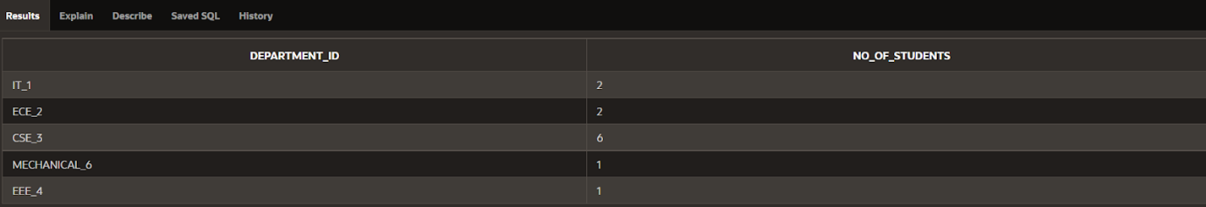

**create** or replace view view_cse_3 (ROLL_NO, FIRST_NAME, LAST_NAME, CGPA) AS

SELECT RESULTS.ROLL_NO, FIRST_NAME, LAST_NAME, RESULTS.FINAL_CGPA

FROM STUDENT_PERSONAL  JOIN RESULTS ON STUDENT_PERSONAL.ROLL_NO = RESULTS.ROLL_NO;

**SELECT** * FROM view_cse_3;



**create** or replace FORCE EDITIONABLE VIEW stu_dept as

 select roll_no,d.deptId,dept_name

 from student_official s

 full join department d

 on s.deptId=d.deptId

 order by d.deptId;

**select** * from stu_dept;

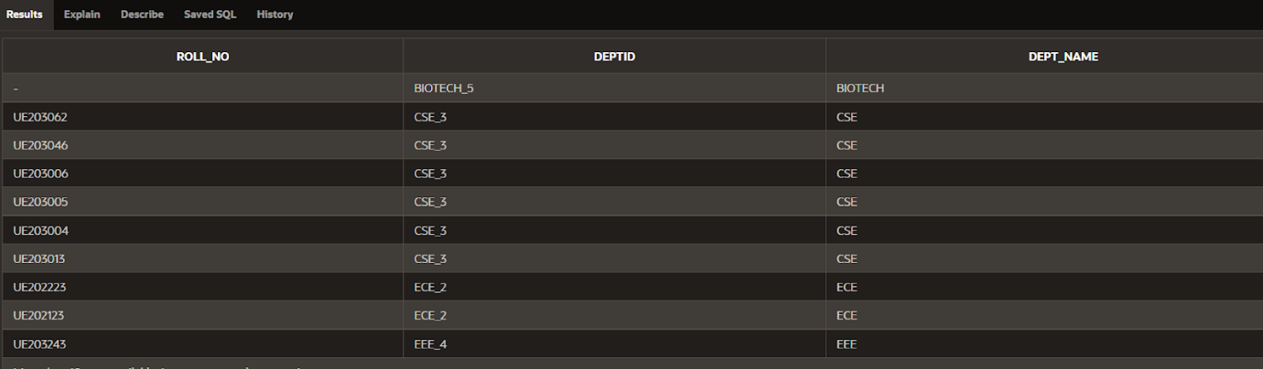

1. **INDEX**

**SINGLE-COLUMN INDEX :**

**create index** semester_idx

on student_official(semester);

(on semester column of table student_official)

(FOR queries regarding semester)

**COMPOSITE INDEX:**

**UNIQUE INDEX:**

1. **SEQUENCE :**

1. **TRIGGERS:**

create or replace trigger trigger_student_personal_delete_before

BEFORE DELETE on student_personal

begin

dbms_output.put_line('Data in student_personal table successfully deleted');

End;

create or replace trigger trigger_student_personal_insert_after

after insert on student_personal

begin

dbms_output.put_line('Data successfully inserted into student_personal table  ');

end;

create or replace trigger trigger_student_personal_update_date_of_birth

after update of date_of_birth

on student_personal

referencing OLD as old

NEW as new

for each row

begin

dbms_output.put_line('Data in student_personal table successfully updated');

dbms_output.put_line('Old dob: '|| :OLD.date_of_birth);

dbms_output.put_line('NEW dob: '|| :NEW.date_of_birth);

End;

create or replace trigger trigger_student_personal_update_email

after update of email

on student_personal

referencing OLD as old

NEW as new

for each row

begin

dbms_output.put_line('Data in student_personal table successfully updated');

dbms_output.put_line('Old email: '|| :OLD.email);

dbms_output.put_line('NEW email: '|| :NEW.email);

end;

create or replace trigger trigger_student_personal_update_first_name

after update of first_name

on student_personal

referencing OLD as old

NEW as new

for each row

begin

dbms_output.put_line('Data in student_personal table successfully updated');

dbms_output.put_line('Old first_name: '|| :OLD.first_name);

dbms_output.put_line('NEW first_name: '|| :NEW.first_name);

End;

create or replace trigger trigger_student_personal_update_last_name

after update of last_name

on student_personal

referencing OLD as old

NEW as new

for each row

begin

dbms_output.put_line('Data in student_personal table successfully updated');

dbms_output.put_line('Old l_name: '|| :OLD.last_name);

dbms_output.put_line('NEW l_name: '|| :NEW.last_name);

End;

create or replace trigger trigger_student_personal_update_phone_number

after update of phone_number

on student_personal

referencing OLD as old

NEW as new

for each row

begin

dbms_output.put_line('Data in student_personal table successfully updated');

dbms_output.put_line('Old phn: '|| :OLD.phone_number);

dbms_output.put_line('NEW phn: '|| :NEW.phone_number);

end;

create or replace trigger trigger_student_personal_update_state_student

after update of state_student

on student_personal

referencing OLD as old

NEW as new

for each row

begin

dbms_output.put_line('Data in student_personal table successfully updated');

dbms_output.put_line('Old state: '|| :OLD.state_student);

dbms_output.put_line('NEW state: '|| :NEW.state_student);

end;

1. **AUDIT TRAIL**

1. **RECORDS:**

1. **FUNCTIONS**

1. FUNCTION TO FIND NUMBER OF STUDENTS HAVING CGPA GREATER THAN GIVEN CGPA

create or replace FUNCTION studentsGreaterThan (

    cg RESULTS.FINAL_CGPA%TYPE

)

RETURN NUMBER

IS

    temp_stuCount NUMBER:=0;

    temp RESULTS.FINAL_CGPA%TYPE;

BEGIN

    SELECT COUNT(*) INTO temp_stuCount FROM RESULTS

    WHERE cg >= (

        SELECT FINAL_CGPA FROM RESULTS

    );

    IF temp_stuCount = NULL THEN

        temp_stuCount := 0;

    end if;

    RETURN temp_stuCount;

END;

-- using function to get number of students having cgpa greater than entered number n

declare

n number;

BEGIN

 n:= :n;

    dbms_output.put_line(studentsGreaterThan(n));

end;

After insertion in results insert ss here

1. FUNCTION TO FIND NUMBER OF STUDENTS HAVING CGPA LESSER THAN GIVEN CGPA

create or replace FUNCTION studentsLessThan (

    cg RESULTS.FINAL_CGPA%TYPE

)

RETURN NUMBER

IS

    temp_stuCount NUMBER:=0;

    temp RESULTS.FINAL_CGPA%TYPE;

BEGIN

    SELECT COUNT(*) INTO temp_stuCount FROM RESULTS

    WHERE cg < (

        SELECT FINAL_CGPA FROM RESULTS

    );

    IF temp_stuCount = NULL THEN

        temp_stuCount := 0;

    end if;

    RETURN temp_stuCount;

END;

-- using function to get number of students having cgpa lesser than entered number n

declare

n number;

BEGIN

 n:= :n;

    dbms_output.put_line(studentsLessThan(n));

end;

After insertion in results insert ss here

1. **PACKAGE/PROCEDURE**

a. Student Official Operations Pack

create or replace package student_official_pack as

PROCEDURE student_official_insert(

            v_roll_no  IN VARCHAR2,

            v_sectionId IN VARCHAR2,

            v_deptId  IN VARCHAR2,

            V_semester IN VARCHAR2,

            v_join_year IN int,

            v_pass_year IN int

           );

procedure search_by_roll_no_in_student_official(r_no in varchar2);

procedure delete_student_official_data(

        v_roll_no in varchar2);

procedure update_student_official_sectionID(

        v_roll_no in varchar2,

        v_sectionID in varchar2);

procedure update_student_official_deptID(

        v_roll_no in varchar2,

        v_deptID in varchar2);

procedure update_student_official_semester(

        v_roll_no in varchar2,

        v_semester in varchar2);

end student_official_pack;

create or replace package body student_official_pack

as PROCEDURE student_official_insert(

            v_roll_no  IN VARCHAR2,

            v_sectionId IN VARCHAR2,

            v_deptId  IN VARCHAR2,

            V_semester IN VARCHAR2,

            v_join_year IN int,

            v_pass_year IN int

           )

           is

           BEGIN INSERT into student_official

           values(v_roll_no,v_sectionId,v_deptId,V_semester,v_join_year,v_pass_year);

END student_official_insert;

procedure search_by_roll_no_in_student_official(r_no in varchar2)

        is

        v_roll_no varchar2(20);

        v_sectionID varchar2(20);

        v_deptID varchar2(10);

        v_semester varchar2(20);

        v_join_year int;

        v_pass_year int;

        begin

        select roll_no into v_roll_no from student_official where roll_no=r_no;

        select sectionID into v_sectionID from student_official where roll_no=r_no;

        select deptID into v_deptID from student_official where roll_no=r_no;

        select semester into v_semester from student_official where roll_no=r_no;

        select join_year into v_join_year from student_official where roll_no=r_no;

        select pass_year into v_pass_year from student_official where roll_no=r_no;

        dbms_output.put_line(v_roll_no||'  '||v_sectionID||' '||v_deptID||'  '||v_semester||'  '||v_join_year||'  '||v_pass_year);

        IF SQL%NOTFOUND THEN

            RAISE_APPLICATION_ERROR(-1000,'Invalid Roll no.');

        END IF;

end search_by_roll_no_in_student_official;

procedure delete_student_official_data(

        v_roll_no in varchar2)

        is

        begin

        delete from student_official

        where roll_no=v_roll_no;

        IF SQL%NOTFOUND THEN

            RAISE_APPLICATION_ERROR(-1001,'Invalid Roll no.');

        END IF;

        end delete_student_official_data;

procedure update_student_official_sectionID(

        v_roll_no in varchar2,

        v_sectionID in varchar2)

        is

        invalid_official_sectionID exception;

        begin

        if (v_sectionID != 'S99' or v_sectionID != 'S90' or v_sectionID != 'S89' or v_sectionID != 'S96' or v_sectionID != 'S97' or v_sectionID != 'S98'

        or v_sectionID != 'S87' or v_sectionID != 'S91' or v_sectionID != 'S92' or v_sectionID != 'S94' or v_sectionID != 'S93' or v_sectionID != 'S88')

        then

    raise invalid_official_sectionID;

end if;

        update student_official

        set sectionID=v_sectionID

        where roll_no=v_roll_no;

        IF SQL%NOTFOUND THEN

            RAISE_APPLICATION_ERROR(-1004,'Error');

        END IF;

        exception

    when invalid_official_sectionID then

    dbms_output.put_line('Section Id does not exist');

        end update_student_official_sectionID;

procedure update_student_official_deptID(

        v_roll_no in varchar2,

        v_deptID in varchar2)

        is

        invalid_official_deptId exception;

        begin

        if (v_deptID != 'CSE_3' or v_deptID != 'IT_1' or v_deptID != 'EEE_4' or v_deptID != 'MECHANICAL_6' or v_deptID != 'BIOTECH_5' or v_deptID != 'ECE_2') then

    raise invalid_official_deptId;

end if;

        update student_official

        set deptID=v_deptID

        where roll_no=v_roll_no;

        IF SQL%NOTFOUND THEN

            RAISE_APPLICATION_ERROR(-1003,'Error');

        END IF;

        exception

    when invalid_official_deptId then

    dbms_output.put_line('Department Id does not exist');

        end update_student_official_deptID;

procedure update_student_official_semester(

        v_roll_no in varchar2,

        v_semester in varchar2)

        is

        begin

        update student_official

        set semester=v_semester

        where roll_no=v_roll_no;

        IF SQL%NOTFOUND THEN

            RAISE_APPLICATION_ERROR(-1003,'Error');

        END IF;

        end update_student_official_semester;

end student_official_pack;

b. Student Personal Operations Pack

create or replace package student_personal_operations_pack as

   PROCEDURE student_insert(

            v_last_name     IN VARCHAR2,

            v_first_name  IN VARCHAR2,

            v_date_of_birth IN date,

            v_roll_no  IN VARCHAR2,

            v_email  IN VARCHAR2,

            v_city  IN VARCHAR2,

            v_state_student IN VARCHAR2,

            v_phone_number  IN VARCHAR2

           );

    procedure search_by_roll_no(r_no in varchar2);

    procedure delete_stu_data(

        v_roll_no in varchar2);

    procedure update_stu_name(

        v_roll_no in varchar2,

        v_last_name in varchar2,

        v_first_name in varchar2);

    procedure update_stu_email(

        v_roll_no in varchar2,

        v_email in varchar2);

    procedure update_stu_phn(

        v_roll_no in varchar2,

        v_phn in varchar2);

    procedure update_state_student(

        v_roll_no in varchar2,

        v_state_student in varchar2);

procedure update_city(

        v_roll_no in varchar2,

        v_city in varchar2);

procedure update_date_of_birth(

        v_roll_no in varchar2,

        v_date_of_birth in varchar2);

end student_personal_operations_pack;

create or replace package body student_personal_operations_pack as

   PROCEDURE student_insert(

            v_last_name     IN VARCHAR2,

            v_first_name  IN VARCHAR2,

            v_date_of_birth IN date,

            v_roll_no  IN VARCHAR2,

            v_email  IN VARCHAR2,

            v_city  IN VARCHAR2,

            v_state_student IN VARCHAR2,

            v_phone_number  IN VARCHAR2

           )

        is

        BEGIN

            INSERT INTO student_personal values(v_last_name,v_first_name,v_date_of_birth,v_roll_no,v_email,v_city,v_state_student,v_phone_number);

    END student_insert;

    procedure search_by_roll_no(r_no in varchar2)

        is

        v_fname varchar2(20);

        v_lname varchar2(20);

        v_date date;

        v_rollno varchar2(10);

        v_email varchar2(20);

        v_phone varchar2(12);

        v_state_student VARCHAR2(20);

        begin

        select first_name into v_fname from student_personal where roll_no=r_no;

        select last_name into v_lname from student_personal where roll_no=r_no;

        select date_of_birth into v_date from student_personal where roll_no=r_no;

        select roll_no into v_rollno from student_personal where roll_no=r_no;

        select email into v_email from student_personal where roll_no=r_no;

        select phone_number into v_phone from student_personal where roll_no=r_no;

        select state_student into v_state_student from student_personal where roll_no=r_no;

        dbms_output.put_line(v_rollno||'  '||v_fname||' '||v_lname||'  '||v_date||'  '||v_email||'  '||v_phone||'  '||v_state_student);

        IF SQL%NOTFOUND THEN

            RAISE_APPLICATION_ERROR(-1000,'Error');

        END IF;

    end search_by_roll_no;

    procedure delete_stu_data(

        v_roll_no in varchar2)

        is

        begin

        delete from student_personal

        where roll_no=v_roll_no;

        IF SQL%NOTFOUND THEN

            RAISE_APPLICATION_ERROR(-1001,'Error');

        END IF;

        end delete_stu_data;

    procedure update_stu_name(

        v_roll_no in varchar2,

        v_last_name in varchar2,

        v_first_name in varchar2)

        is

        begin

        update student_personal

        set last_name=v_last_name,first_name=v_first_name

        where roll_no=v_roll_no;

        IF SQL%NOTFOUND THEN

            RAISE_APPLICATION_ERROR(-1002,'Error');

        END IF;

        end update_stu_name;

    procedure update_stu_email(

        v_roll_no in varchar2,

        v_email in varchar2)

        is

        begin

        update student_personal

        set email=v_email

        where roll_no=v_roll_no;

        IF SQL%NOTFOUND THEN

            RAISE_APPLICATION_ERROR(-1003,'Error');

        END IF;

        end update_stu_email;

    procedure update_stu_phn(

        v_roll_no in varchar2,

        v_phn in varchar2)

        is

        begin

        update student_personal

        set phone_number=v_phn

        where roll_no=v_roll_no;

        IF SQL%NOTFOUND THEN

            RAISE_APPLICATION_ERROR(-1004,'Error');

        END IF;

        end update_stu_phn;

    procedure update_state_student(

        v_roll_no in varchar2,

       v_state_student in varchar2)

        is

        begin

        update student_personal

        set state_student=v_state_student

        where roll_no=v_roll_no;

        IF SQL%NOTFOUND THEN

            RAISE_APPLICATION_ERROR(-1005,'Error');

        END IF;

        end update_state_student;

procedure update_city(

        v_roll_no in varchar2,

        v_city in varchar2)

is

        begin

        update student_personal

        set city=v_city

        where roll_no=v_roll_no;

        IF SQL%NOTFOUND THEN

            RAISE_APPLICATION_ERROR(-1005,'Error');

        END IF;

        end update_city;

procedure update_date_of_birth(

        v_roll_no in varchar2,

        v_date_of_birth in varchar2)

is

        begin

        update student_personal

        set date_of_birth=v_date_of_birth

        where roll_no=v_roll_no;

        IF SQL%NOTFOUND THEN

            RAISE_APPLICATION_ERROR(-1005,'Error');

        END IF;

        end update_date_of_birth;

end student_personal_operations_pack;

c. Exam Operations Pack

create or replace package BODY exam_operations_pack as

PROCEDURE exam_insert(

            v_deptId IN VARCHAR2,

            v_examId  IN VARCHAR2,

            v_exam_name IN VARCHAR2,

            v_courseId  IN VARCHAR2

           )

IS

BEGIN

INSERT INTO exam

values(    v_deptId,

         v_examId ,

            v_exam_name,

            v_courseId );

END exam_insert;

PROCEDURE search_by_examId(ex_id in varchar2)

IS

v_deptId VARCHAR2(20);

v_examId   VARCHAR2(20);

v_exam_name  VARCHAR(40);

v_courseId   VARCHAR2(20);

BEGIN

SELECT deptId INTO v_deptId FROM exam WHERE examId =ex_id;

SELECT examId INTO v_examId FROM exam WHERE examId =ex_id;

SELECT exam_name INTO v_exam_name FROM exam WHERE examId =ex_id;

SELECT courseId INTO v_courseId FROM exam WHERE examId =ex_id;

dbms_output.put_line(v_examId || '  ' || v_deptId ||'  ' ||   v_exam_name ||'  ' || v_courseId);

IF SQL%NOTFOUND THEN

            RAISE_APPLICATION_ERROR(-1001,'Error'); --Error code might need to be changed

    END IF;

END search_by_examId;

PROCEDURE delete_exam_data(v_examId in varchar2)

IS

BEGIN

DELETE FROM exam

WHERE examId = v_examId;

IF SQL%NOTFOUND THEN

            RAISE_APPLICATION_ERROR(-1001,'Error');

        END IF;

END delete_exam_data;

PROCEDURE update_deptId(v_examId in varchar2,v_deptId  IN varchar2)

IS

BEGIN

UPDATE exam

SET deptId = v_deptId WHERE examId =V_examId;

IF SQL%NOTFOUND THEN

            RAISE_APPLICATION_ERROR(-1001,'Error');

        END IF;

END update_deptId;

PROCEDURE update_exam_name(v_examId in varchar2,v_exam_name  IN varchar2)

IS

BEGIN

UPDATE exam

SET exam_name = v_exam_name WHERE examId =V_examId;

IF SQL%NOTFOUND THEN

            RAISE_APPLICATION_ERROR(-1001,'Error');

        END IF;

END update_exam_name;

PROCEDURE update_courseId(v_examId in varchar2,v_courseId  IN varchar2)

IS

BEGIN

UPDATE exam

SET courseId= v_courseId WHERE examId =V_examId;

IF SQL%NOTFOUND THEN

            RAISE_APPLICATION_ERROR(-1001,'Error');

        END IF;

END update_courseId;

END exam_operations_pack;

d. Section Operations Pack

CREATE OR REPLACE PACKAGE SECTION_OPERATIONS_PACK AS

   -- Adds a record

   PROCEDURE insert_section(p_sectionid in  SECTION.SECTIONID%type,

   p_section_name in SECTION.SECTION_NAME%type,

   p_deptid in SECTION.DEPTID%TYPE,

   p_no_of_students in SECTION.NO_OF_STUDENTS%TYPE);

   -- Deletes a record

   PROCEDURE delete_section(p_sectionid in SECTION.SECTIONID%TYPE);

   --Update the section table

   PROCEDURE update_section_name(p_sectionid in SECTION.SECTIONID%type,

    p_section_name in SECTION.SECTION_NAME%type);

  PROCEDURE update_no_of_students(p_sectionid in SECTION.SECTIONID%type,

    p_no_of_students in SECTION.NO_OF_STUDENTS%type);

END SECTION_OPERATIONS_PACK;

-- PACKAGE BODY

CREATE OR REPLACE PACKAGE BODY SECTION_OPERATIONS_PACK AS

   PROCEDURE insert_section (p_sectionid in SECTION.SECTIONID%type,

      p_section_name in SECTION.SECTION_NAME%type,

      p_deptid in SECTION.DEPTID%TYPE,

      p_no_of_students in SECTION.NO_OF_STUDENTS%TYPE)

   IS

   BEGIN

      INSERT INTO SECTION (SECTIONID,SECTION_NAME,DEPTID,NO_OF_STUDENTS)

         VALUES(p_sectionid, p_section_name,p_deptid, p_no_of_students);

   END insert_section;

   PROCEDURE delete_section(p_sectionid in SECTION.SECTIONID%type) IS

   BEGIN

      DELETE FROM SECTION

      WHERE SECTIONID = p_sectionid;

      IF SQL%NOTFOUND THEN

            dbms_output.put_line('Invalid Section ID');

        END IF;

   END delete_section;

   PROCEDURE update_section_name (p_sectionid  in SECTION.SECTIONID%type,

    p_section_name in SECTION.SECTION_NAME%type)

    IS BEGIN

    UPDATE SECTION SET SECTION_NAME = p_section_name

    WHERE SECTIONID = p_sectionid;

    IF SQL%NOTFOUND THEN

            dbms_output.put_line('Invalid Section ID');

        END IF;

    END update_section_name;

     PROCEDURE update_no_of_students (p_sectionid  in SECTION.SECTIONID%type,

    p_no_of_students in SECTION.NO_OF_STUDENTS%type)

    IS BEGIN

    if (p_no_of_students > 60) then

    dbms_output.put_line('No. of students should not exceed to 60');

    else

    UPDATE SECTION SET NO_OF_STUDENTS = p_no_of_students

    WHERE SECTIONID = p_sectionid;

    IF SQL%NOTFOUND THEN

            dbms_output.put_line('Invalid Section ID');

        END IF;

    end if;

    END update_no_of_students;

END SECTION_OPERATIONS_PACK;

/

e. Course Operations Pack

CREATE OR REPLACE PACKAGE COURSE_OPERATIONS_PACK AS

 PROCEDURE insert_course(p_courseid in  COURSE.COURSEID%type,

   p_course_name in COURSE.COURSE_NAME%type

   ,p_facultyid in COURSE.FACULTYID%TYPE,

   p_deptid in COURSE.DEPTID%TYPE

   );

    PROCEDURE delete_course(p_courseid in COURSE.COURSEID%TYPE);

     PROCEDURE update_course_name(p_courseid in COURSE.COURSEID%type,

    p_course_name in COURSE.COURSE_NAME%type);

      PROCEDURE update_deptid (p_courseid in COURSE.COURSEID%type,

    p_deptid in COURSE.DEPTID%type);

    END COURSE_OPERATIONS_PACK;

--PACKAGE BODY

CREATE OR REPLACE PACKAGE BODY COURSE_OPERATIONS_PACK AS

PROCEDURE insert_course(p_courseid in  COURSE.COURSEID%type,

   p_course_name in COURSE.COURSE_NAME%type

   ,p_facultyid in COURSE.FACULTYID%TYPE,

   p_deptid in COURSE.DEPTID%TYPE

   )

   IS BEGIN

   INSERT INTO COURSE (COURSEID,COURSE_NAME,FACULTYID,DEPTID)

   VALUES (p_courseid,p_course_name,p_facultyid,p_deptid);

   END insert_course;

PROCEDURE delete_course(p_courseid in COURSE.COURSEID%TYPE)

    is begin

    DELETE FROM COURSE

    WHERE COURSEID = p_courseid;

    IF SQL%NOTFOUND THEN

          dbms_output.put_line ('Invalid Course ID');

        END IF;

    end delete_course;

PROCEDURE update_course_name(p_courseid in COURSE.COURSEID%type,

    p_course_name in COURSE.COURSE_NAME%type)

    is begin

    update COURSE SET COURSE_NAME = p_course_name

    where COURSEID = p_courseid;

     IF SQL%NOTFOUND THEN

          dbms_output.put_line ('Invalid Course ID');

        END IF;

    end update_course_name;

    PROCEDURE update_deptid (p_courseid in COURSE.COURSEID%type,

    p_deptid in COURSE.DEPTID%type)

    is invalid_deptId exception;

     begin

    if (p_deptid != 'CSE_3' or p_deptid != 'IT_1' or p_deptid != 'EEE_4' or p_deptid != 'MECHANICAL_6' or p_deptid != 'BIOTECH_5' or p_deptid != 'ECE_2') then

    raise invalid_deptId;

end if;

    update COURSE SET DEPTID = p_deptid

    where COURSEID = p_courseid;

     IF SQL%NOTFOUND THEN

          dbms_output.put_line ('Invalid Course ID');

        END IF;

        exception

    when invalid_deptId then

    dbms_output.put_line('Department Id does not exist');

    end update_deptid;

END COURSE_OPERATIONS_PACK;

f. Result Operations Pack

create or replace package result_operations_pack as PROCEDURE student_result_insert(

            v_roll_no  IN VARCHAR2,

            v_sem1 IN int,

            v_sem2 IN int,

            v_sem3 IN int,

            v_sem4 IN int,

            v_final_cgpa IN int

           );

procedure search_by_roll_no_in_results(r_no in varchar2);

procedure delete_results_data(

        v_roll_no in varchar2);

procedure update_results_sem1(

        v_roll_no in varchar2,

        v_sem1 in varchar2);

procedure update_results_sem2(

        v_roll_no in varchar2,

        v_sem2 in varchar2);

procedure update_results_sem3(

        v_roll_no in varchar2,

        v_sem3 in varchar2);

procedure update_results_sem4(

        v_roll_no in varchar2,

        v_sem4 in varchar2);

end result_operations_pack;

create or replace package body result_operations_pack as

PROCEDURE student_result_insert(

            v_roll_no  IN VARCHAR2,

            v_sem1 IN int,

            v_sem2 IN int,

            v_sem3 IN int,

            v_sem4 IN int,

            v_final_cgpa IN int

           )

           is

           BEGIN INSERT into results

           values(v_roll_no,v_sem1,v_sem2,v_sem3,v_sem4,v_final_cgpa);

END student_result_insert;

procedure search_by_roll_no_in_results(r_no in varchar2)

        is

        v_roll_no varchar2(20);

        v_sem1 int;

        v_sem2 int;

        v_sem3 int;

        v_sem4 int;

        v_final_cgpa int;

        begin

        select roll_no into v_roll_no from results where roll_no=r_no;

        select sem1 into v_sem1 from results where roll_no=r_no;

        select sem2 into v_sem2 from results where roll_no=r_no;

        select sem3 into v_sem3 from results where roll_no=r_no;

        select sem4 into v_sem4 from results where roll_no=r_no;

        select final_cgpa into v_final_cgpa from results where roll_no=r_no;

        dbms_output.put_line(v_roll_no||'  '||v_sem1||' '||v_sem2||'  '||v_sem3||'  '||v_sem4||'  '||v_final_cgpa);

        IF SQL%NOTFOUND THEN

            RAISE_APPLICATION_ERROR(-1000,'Error');

        END IF;

end search_by_roll_no_in_results;

procedure delete_results_data(

        v_roll_no in varchar2)

        is

        begin

        delete from results

        where roll_no=v_roll_no;

        IF SQL%NOTFOUND THEN

            RAISE_APPLICATION_ERROR(-1001,'Error');

        END IF;

        end delete_results_data;

procedure update_results_sem1(

        v_roll_no in varchar2,

        v_sem1 in varchar2)

        is

        begin

        update results

        set sem1=v_sem1

        where roll_no=v_roll_no;

        IF SQL%NOTFOUND THEN

            RAISE_APPLICATION_ERROR(-1003,'Error');

        END IF;

        end update_results_sem1;

procedure update_results_sem2(

        v_roll_no in varchar2,

        v_sem2 in varchar2)

        is

        begin

        update results

        set sem2=v_sem2

        where roll_no=v_roll_no;

        IF SQL%NOTFOUND THEN

            RAISE_APPLICATION_ERROR(-1003,'Error');

        END IF;

        end update_results_sem2;

procedure update_results_sem3(

        v_roll_no in varchar2,

        v_sem3 in varchar2)

        is

        begin

        update results

        set sem3=v_sem3

        where roll_no=v_roll_no;

        IF SQL%NOTFOUND THEN

            RAISE_APPLICATION_ERROR(-1003,'Error');

        END IF;

        end update_results_sem3;

procedure update_results_sem4(

        v_roll_no in varchar2,

        v_sem4 in varchar2)

        is

        begin

        update results

        set sem4=v_sem4

        where roll_no=v_roll_no;

        IF SQL%NOTFOUND THEN

            RAISE_APPLICATION_ERROR(-1003,'Error');

        END IF;

        end update_results_sem4;

end result_operations_pack;

g. Department Operations Pack

CREATE OR REPLACE PACKAGE department_operations_pack AS

PROCEDURE department_insert(v_deptId  IN varchar2,v_dept_name  IN varchar2);

PROCEDURE search_by_deptId(departmentId IN varchar2);

PROCEDURE delete_dept_data(v_deptId in varchar2);

PROCEDURE update_dept_name(v_deptId in varchar2,v_dept_name  IN varchar2);

end department_operations_pack ;

create or replace PACKAGE BODY  department_operations_pack AS

PROCEDURE department_insert(v_deptId  IN varchar2,v_dept_name  IN varchar2)

IS

BEGIN

INSERT INTO department

values(v_deptId,v_dept_name);

END department_insert;

PROCEDURE search_by_deptId(departmentId IN varchar2)

IS

v_deptId VARCHAR(20);

v_dept_name VARCHAR(50);

BEGIN

SELECT deptId INTO v_deptId FROM department WHERE deptId = departmentId;

SELECT dept_name INTO v_dept_name FROM department WHERE deptId = departmentId;

dbms_output.put_line( v_deptId || ' ' || v_dept_name);

IF SQL%NOTFOUND THEN

            RAISE_APPLICATION_ERROR(-1000,'Error');--Errorcode might need to be changed

END IF;

END search_by_deptId;

PROCEDURE delete_dept_data(v_deptId in varchar2)

IS

BEGIN

 delete from department

        where deptId=v_deptId;

IF SQL%NOTFOUND THEN

            RAISE_APPLICATION_ERROR(-1001,'Error'); --Errorcode might need to be changed

END IF;

END delete_dept_data;

PROCEDURE update_dept_name(v_deptId in varchar2,v_dept_name  IN varchar2)

IS

BEGIN

UPDATE department

Set dept_name = v_dept_name WHERE deptId = v_deptId;

IF SQL%NOTFOUND THEN

            RAISE_APPLICATION_ERROR(-1002,'Error');--Errorcode might need to be changed

 END IF;

END  update_dept_name;

END department_operations_pack;

**DEMONSTRATION:**

#INSERTION USING PACKAGE

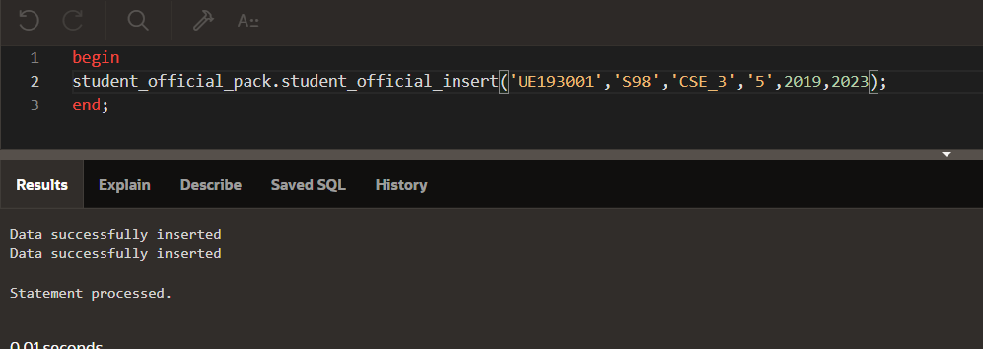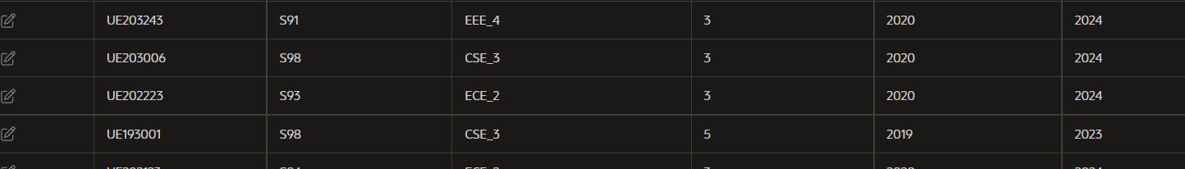

#SEARCHING USING PACKAGE

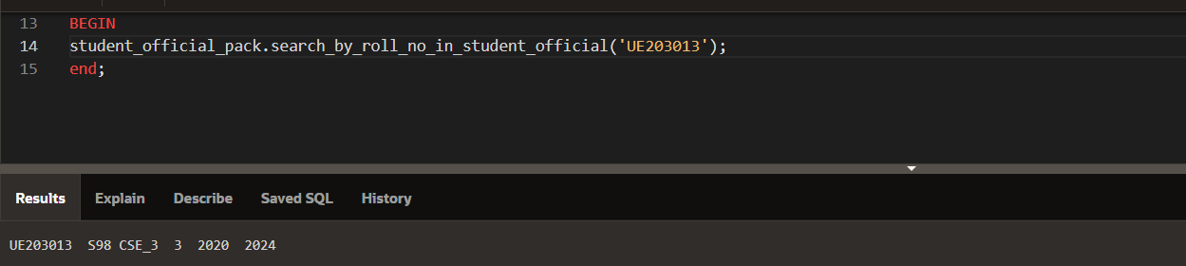

#EXCEPTION HANDLING SS

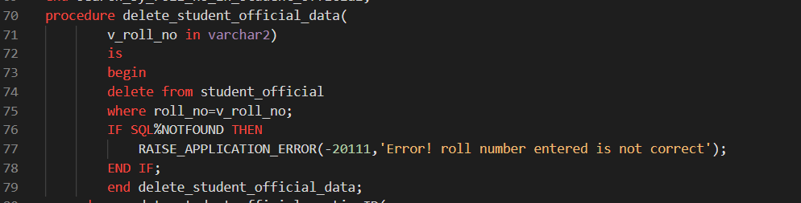

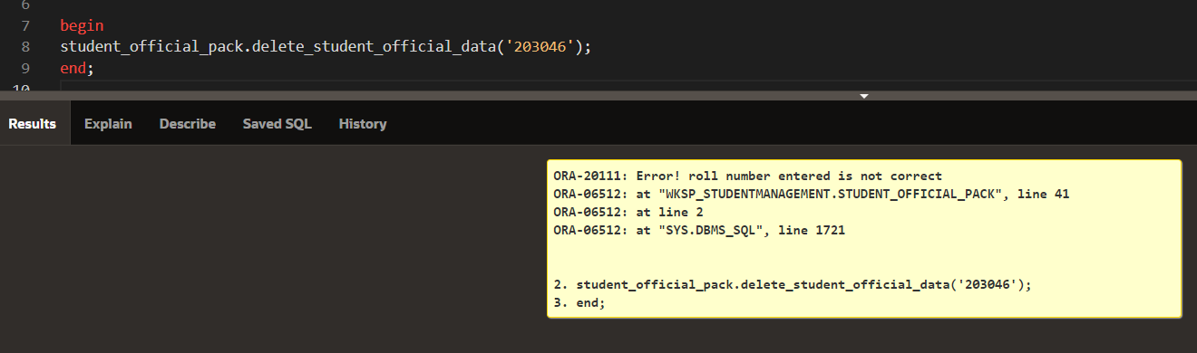

#UPDATION(EXAM NAME) AND DELETION USING PACKAGE

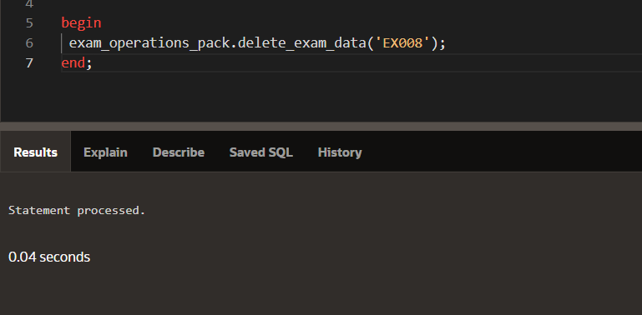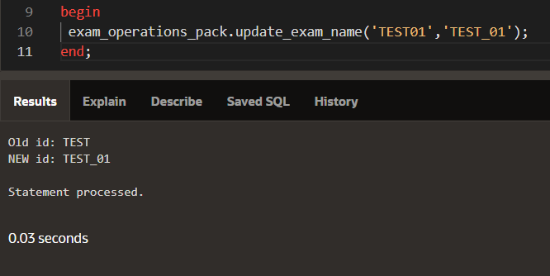

#EXAM TABLE AFTER UPDATION AND DELETION

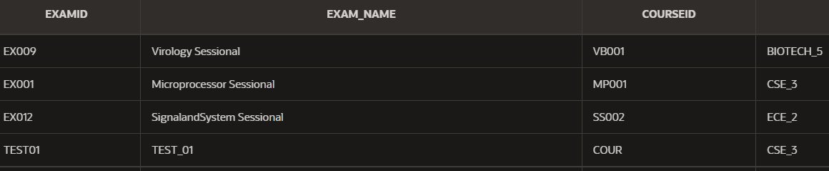

#updating deptid to new deptid which don’t exist

#EXCEPTION HANDLING SS

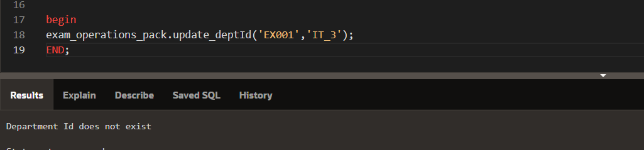

#SEARCHING

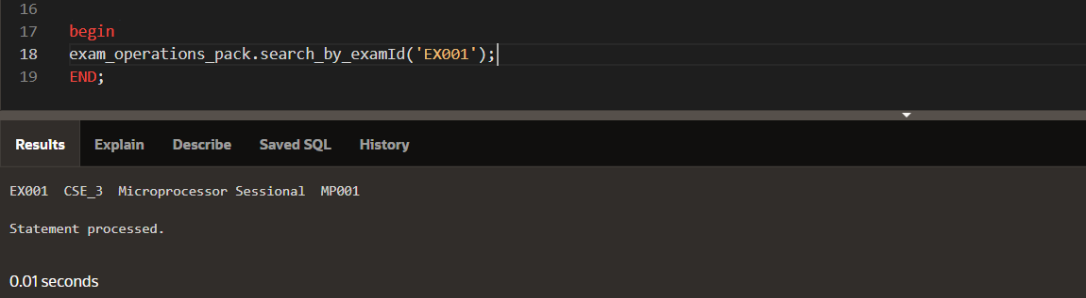

1. **CURSOR**

**Implicit Cursor:**

We have used inbuilt cursor (sql) and used to attributes like %FOUND, %NOTFOUND to handle errors in procedures

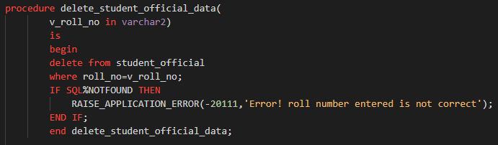

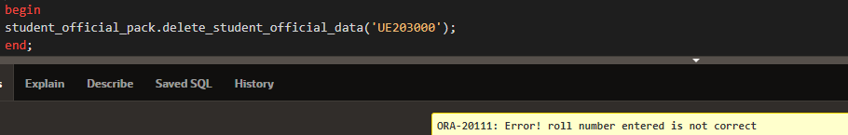

**Explicit Cursor:**

**We have used explicit cursor in the query to obtain official details of students given their roll numbers. We have avoided much use of cursors as it slows down the performance of query due to row by row processing**.

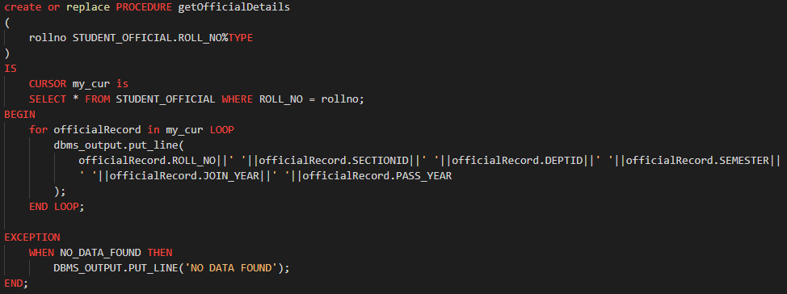

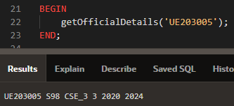

1. **SOME other QUERIES**

A.

create or replace PROCEDURE getOfficialDetails

(

    rollno STUDENT_OFFICIAL.ROLL_NO%TYPE

)

IS

    TYPE of_rec IS TABLE OF STUDENT_OFFICIAL%ROWTYPE;

    officialRecord of_rec;

BEGIN

    SELECT * BULK COLLECT INTO officialRecord FROM STUDENT_OFFICIAL WHERE ROLL_NO = rollno;

    IF officialRecord.count = 0 THEN

        dbms_output.put_line('NO DATA FOUND');

    ELSE

        for i in 1..officialRecord.count LOOP

            dbms_output.put_line(

                officialRecord(i).ROLL_NO||' '||officialRecord(i).SECTIONID||' '||officialRecord(i).DEPTID||' '||officialRecord(i).SEMESTER||' '||officialRecord(i).JOIN_YEAR||' '||officialRecord(i).PASS_YEAR

            );

        END LOOP;

    END IF;

END;

Output of query:

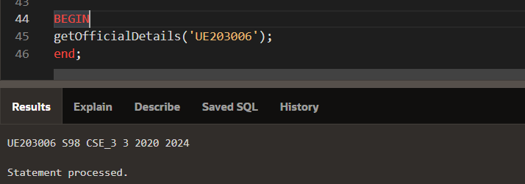

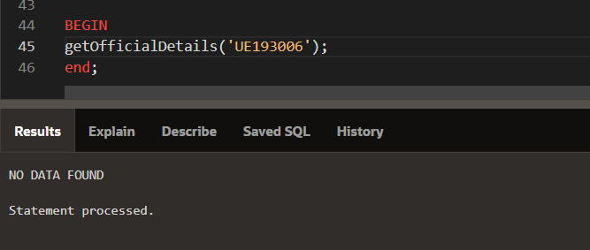

B.

create or replace PROCEDURE **getStudentOfficialByDeptName** (

    d_name DEPARTMENT.DEPT_NAME % TYPE

)

IS

    TYPE my_record IS TABLE OF STUDENT_OFFICIAL%ROWTYPE;

    rec1 my_record;

    temp_d_id DEPARTMENT.DEPT_NAME%TYPE;

BEGIN

    SELECT DEPTID INTO temp_d_id FROM DEPARTMENT WHERE

    DEPT_NAME = d_name;

    SELECT * BULK COLLECT INTO rec1 FROM STUDENT_OFFICIAL

    WHERE DEPTID = temp_d_id;

        --output line required

end;

OUTPUT SS OF QUERY:

C.

create or replace PROCEDURE get_students_by_section (

    sectionid SECTION.SECTIONID%TYPE

)

IS

    TYPE temp_rec IS RECORD

    (

        f_name STUDENT_PERSONAL.FIRST_NAME%type,

        l_name STUDENT_PERSONAL.LAST_NAME%TYPE,

        r_no STUDENT_OFFICIAL.ROLL_NO%TYPE,

        email_id STUDENT_PERSONAL.EMAIL%TYPE

    );

    TYPE getStudentsBySection IS TABLE OF temp_rec;

    get_student getStudentsBySection;

BEGIN

    select FIRST_NAME, LAST_NAME, STUDENT_OFFICIAL.ROLL_NO, EMAIL BULK COLLECT INTO get_student FROM STUDENT_OFFICIAL JOIN STUDENT_PERSONAL

    ON STUDENT_OFFICIAL.ROLL_NO = STUDENT_PERSONAL.ROLL_NO

    where sectionId = sectionid;

    dbms_output.put_line('First_Name                Last_Name               Roll_no             Email');

    for i in 1..get_student.count LOOP

        dbms_output.put_line(get_student(i).f_name||' '||get_student(i).l_name||' '||get_student(i).r_no||' '||get_student(i).email_id);

    END LOOP;

end;

OUTPUT OF QUERY:

DATA IN STUDENT OFFICIAL IS WRONG FOR SOME ROLL NO (FIRST NAME AND LAST NAME INTERCHANGED )

D.

create or replace PROCEDURE get_student_by_first_letter

(

    alphabet VARCHAR2

)

is

    TYPE studentPersonalRecord is TABLE OF STUDENT_PERSONAL%ROWTYPE;

    rec1 studentPersonalRecord;

BEGIN

    SELECT * BULK COLLECT INTO rec1

    FROM STUDENT_PERSONAL WHERE FIRST_NAME LIKE (alphabet||'%');

    FOR i in 1..rec1.count LOOP

        dbms_output.put_line(rec1(i).FIRST_NAME||' '||rec1(i).LAST_NAME||' '||rec1(i).ROLL_NO||' '||rec1(i).PHONE_NUMBER);

    END LOOP;

END;

OUTPUT OF QUERY:

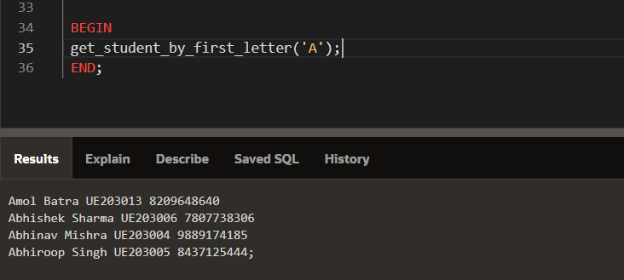

E.

create or replace PROCEDURE getPersonalDetails

(

    rollno STUDENT_PERSONAL.ROLL_NO%TYPE

)

IS

    TYPE per_rec IS TABLE OF STUDENT_PERSONAL%ROWTYPE;

    personalRecord per_rec;

BEGIN

    SELECT * BULK COLLECT INTO personalRecord FROM STUDENT_PERSONAL WHERE ROLL_NO = rollno;

    for i in 1..personalRecord.count LOOP

        dbms_output.put_line(

            personalRecord(i).LAST_NAME||' '||personalRecord(i).FIRST_NAME||' '||personalRecord(i).ROLL_NO||' '||personalRecord(i).EMAIL||' '||personalRecord(i).CITY||' '||personalRecord(i).STATE_STUDENT||' '||personalRecord(i).PHONE_NUMBER

        );

    END LOOP;

END;

OUTPUT OF QUERY:

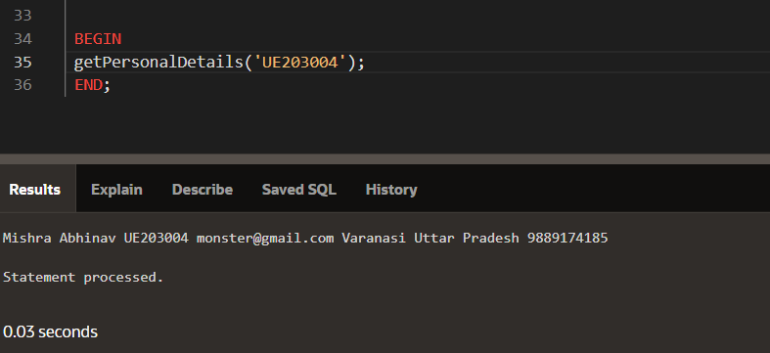

vv