***About Air New-Zealand***

* What was Air New-Zealand ?
* Company size (Financial, Employees, Stakeholders and Investors etc.)
* What was their revenue model ?

Air New Zealand Limited is a New Zealand public company, deriving revenue from the provision of international and domestic air transportation services. The company employs approximately 7,840 full-time equivalent people, operates in New Zealand, Australia, Asia, the United Kingdom and North America, and is administered from its head office in Auckland.

The company is listed on the NZX under the code AIR and on the ASX under the code AIZ.

Air New Zealand is a mixed ownership model company, with the New Zealand Government retaining a majority interest of shares, and the remainder owned by private investors.

Air New Zealand Limited is an international and domestic air carrier that transports passengers and cargo on scheduled airline services within, to or from New Zealand, with domestic destinations and international destinations in operation to Australia, the Pacific, Asia, North America and the United Kingdom.

Air New Zealand operates Air Nelson and Mount Cook Airlines, with both operations focused on domestic flights within New Zealand.

The company also offers a range of engineering, maintenance and air transport consultancy services

At a glance, data from Planespotters.net indicates that Air New Zealand has a fleet of 104 aircraft - at least at the time of this article's publication. The aircraft types and quantities are as follows:

29x ATR-72-600

23x De Havilland Canada DHC-8-300

18x Airbus A320-200

Six Airbus A320neo

Seven Airbus A321neo

Seven Boeing 777-300ER

14x Boeing 787-9

Our global network of passenger and cargo services centres on New Zealand. Before COVID-19, we flew more than 17 million passengers every year, with 3,400 flights per week.

Our driving purpose is all about people. We're here to 'Enrich our country by connecting New Zealanders to each other and New Zealand to the world'.

Until the impact of COVID-19, we have been profitable throughout the economic cycle. We delivered positive earnings from 2003 to 2019. We paid dividends to our shareholders every year since 2005. As the world slowly returns to normal, we expect our business to do the same.

In good times and bad, we have kept a disciplined approach to capital allocation. It underpins our ability to generate strong returns, even in difficult times.  
We have a credit rating of Baa2 from Moody's, with a stable outlook. This places us amongst the top airlines in the world

***About Current Scenario***

* Key competitors
* Position of Air New-Zealand in market compared to other competitors
* Market Size and Position

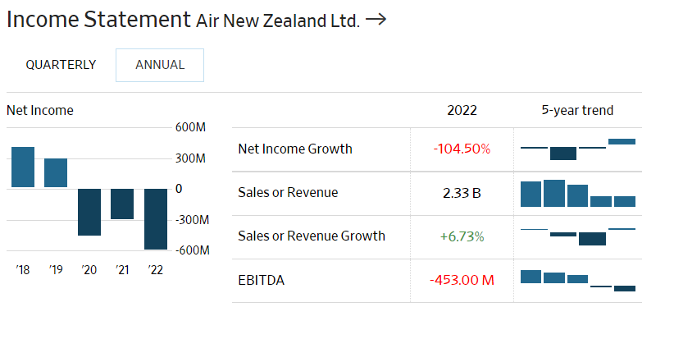

**6. Vistara**

**Tata SIA Airlines Limited**, operating as **Vistara**, is an Indian full-service airline, based in Gurgaon, with its hub at Indira Gandhi International Airport. The carrier, a joint venture between[Tata Sons](https://indiancompanies.in/companies-owned-by-tata-group/)and Singapore Airlines, commenced operations on 9 January 2015 with its inaugural flight between Delhi and Mumbai.

* Market Share: **4.7%**

The airline had carried more than two million passengers by June 2016 and as of May 2019, has a 4.7% share of the domestic carrier market, making it the 6th largest domestic airline. The airline serves twenty-four destinations with a fleet of Airbus A320 and Boeing 737-800NG aircraft.

**5. AirAsia (India) Limited**

- Advertisement -

AirAsia (India) commenced operations on 12th June 2014. With 29 A320 aircraft, AirAsia flies to 21  destinations as on January 2020. AirAsia India is a Joint Venture between **TATA Sons Private Limited (51%) and AirAsia Investment Limited(49%)**.

* Market Share:**5%**
* 29 aircraft
* 21 destinations across India
* 1400+ weekly flights
* Over 8.9 million customers in FY19

Into its fifth year of operations, AirAsia (India) has ambitions to connect more Tier II and Tier III cities within the large Indian subcontinent and a longer-term view of going international.

**4. GoAir**

GoAir the Fourth largest airline in India with an 8.4% passenger market share. **GoAir** is an Indian low-cost airline based in Mumbai, India. It is owned by the Indian business conglomerate Wadia Group.

* Market Share: **9%**

It commenced operations in November 2005 and operates a fleet of Airbus A320 aircraft in an all-economy configuration. As of September 2019, the airline operates over 230 daily flights to 30 destinations, including 24 domestic and 6 international destinations, from its hubs at Mumbai, Delhi, Bangalore, Kolkata, and Kannur.

**3. Air India**

Air India, the premier flight carrier of India is one of the most extensive flight service provider in India.

* Revenue: Rs 23,900 Cr.
* Market Share: **13.4%**.
* [Employees](https://indiancompanies.in/companies-by-number-of-employees-in-india-list/): 20,956

Air India Air Transport Services Limited (AIATSL) is a fully owned subsidiary of Air India Limited, formed with an aim to provide unified Ground Handling services (Ramp, Passenger & Baggage and Cargo Handling) at most of the airports in India under the brand name ‘Air India Airport Services’.

**Alliance Air**

Alliance Air *Connecting India* (A wholly owned Subsidiary of Air India Limited) operates air services to 43 destinations with a fleet of 18 ATR 72-600 (70/72 Seater) aircraft. Flights are operated mostly to Tier-2 and Tier-3 Cities or those which link these cities to the metro hubs.

* Market Share: **1.1%**

Alliance Air operates flights to 43 destinations in India namely Agra, Ahmedabad, Allahabad, Bengaluru, Belagavi, Bhavnagar, Bhubaneswar, Bhuj, Bikaner, Coimbatore, Chandigarh, Delhi, Dehradun, Dimapur, Diu, Dharamshala, Goa, Gorakhpur, Guwahati, Gulbarga (Kalaburagi), Hyderabad, Imphal, Jabalpur,Jagdalpur, Jaipur, Jharsuguda, Kandla, Kochi, Kolhapur, Kolkata, Kullu, Lilabari, Ludhiana, Madurai, Mumbai, Mysuru, Nashik, Pantnagar, Passighat, Pathankot, Pune, Raipur, Tezpur.

* **Total number of flights per week: 360**
* **Number of flights per day: 51**
* **Number of departures per week: 539**
* **Number of departures per day: 77**
* **Total number of stations: 43**

**2. SpiceJet Ltd**

SpiceJet is India’s second-largest Airline Company in India in terms of domestic passenger volume and the largest in terms of regional connectivity. **SpiceJet Limited** is an Indian low-cost airline headquartered in Gurgaon, India. It is the second-largest airline in the country by a number of domestic passengers carried, with a market share of 13.6% as of March 2019.

* Revenue: Rs **9,121** **Cr.**
* Market Share: **13.7 %**
* Employees: **8,556**
* Market Cap:  **7,505** Cr.
* [Promoter holding](https://indiancompanies.in/high-promoter-holding-stocks-company-list/): **60.00** %

The airline operates 312 daily flights to 55 destinations, including 47 Indian and 7 international destinations from its hubs at Delhi, Kolkata, Mumbai, and Hyderabad.

**1.**[**Interglobe Aviation**](https://indiancompanies.in/interglobe-aviation-limited-indigo/)**Ltd**

[IndiGo](https://indiancompanies.in/interglobe-aviation-limited-indigo/) is India’s largest passenger airline with a market share of 42.2 %. The company primarily operates in India’s domestic air travel market as a low-cost carrier with a focus on our three pillars – offering low fares, being on-time and delivering a courteous and hassle-free experience.

* Revenue: Rs **31,405 Cr.**
* Market Share: **44 %**
* Employees: **23,531**
* Market Cap: Rs **65,159 Cr.**
* Stock P/E: **49.04**
* [Dividend](https://indiancompanies.in/highest-dividend-paying-stocks-in-india-2021-yield-nse/) Yield: **0.29** %
* ROE: **-3.26** %
* Promoter holding: **74.89** %
* Debt to equity: **0.35**
* Price to book value: **9.38**

Indigo is the largest Airline Companies in India with Highest Marketshare. Since inception in August 2006, grown from a carrier with one plane to a fleet of 240 aircraft today.  IndiGo has a total destination count of 82 with 60 domestic destinations and 22 International.

 This includes seven destinations: Silchar, Shirdi, and Mysore in India, Yangon in Myanmar,  Riyadh in Saudi Arabia, Hanoi and Ho Chi Minh City in Vietnam, which are open for sale. Twelve codeshare destinations beyond Istanbul on Turkish Airlines are also open for sale. They include, Athens (ATH), Budapest (BUD), Brussels (BRU), Tel Aviv (TLV) , Malta (MLA), Paris (CDG) , Dublin (DUB), Copenhagen (CPH) , Prague (PRG), Vienna (VIE), Zurich (ZRH) and Amsterdam (AMS).

India is expected to overtake China and the United States as the world's third-largest air passenger market in the next ten years, by 2030, according to the International Air Transport Association (IATA). Further, the rising demand in the sector has pushed the number of airplanes operating in the sector. The number of airplanes is expected to reach 1,100 planes by 2027.

India’s passenger* traffic stood at 188.89 million in FY22 and 76.47 million in the first quarter of FY 2022-23. In FY22, airports in India pegged the domestic passenger traffic to be 166.8 million, a 58.5% YoY increase, and international passenger traffic to be 22.1 million, a 118% YoY increase, as compared to FY 2020-21.

Between FY16 and FY22, freight traffic increased at a CAGR of 2.52% from 2.70 MMT to 3.14 MMT. In the first quarter of FY 2022-23, freight traffic stood at 0.81 MMT.

***Do Failure Mode Analysis about Air New-Zealand entering Indian Market***

*(Do Profitability framework study, Understand their revenue model and Customer acquisition strategies )*

* Estimated Market Size
* Competitors in Market
* PR or Media reputation
* Socioeconomic causes
* Business Decisions to cope up with the market demand
* Estimate the  Breakeven Period

***What could be done differently ?***

* Imagine you are a key decision maker for Air New-Zealand, What strategy would you recommend to make the Air New-Zealand acquire huge market share and be Profitable