Project Report: Blood Bank Analytics Dashboard

1. Introduction
This project is a Blood Bank Analytics Dashboard developed as part of a Python Summer Training program. It serves as a demonstration of data manipulation, analysis, and visualization concepts in Python. The application is built with a modular structure and features a console-based interactive menu.

2. Technologies Used
- Python: Core programming language.
- Pandas: Data manipulation and aggregation.
- NumPy: Numerical operations.
- Matplotlib: Data visualization (bar charts, pie charts, histograms).

3. Code Implementations (Screenshots)
Below are the screenshots of the code modules that power the application.

Module: main.py
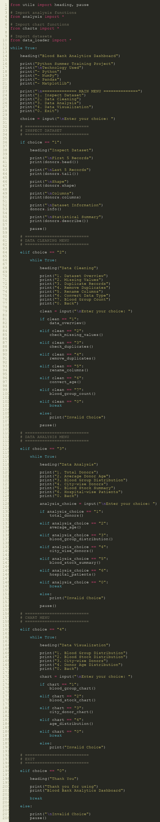

Module: analysis.py
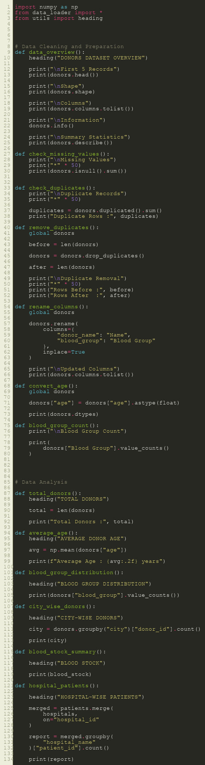

Module: charts.py
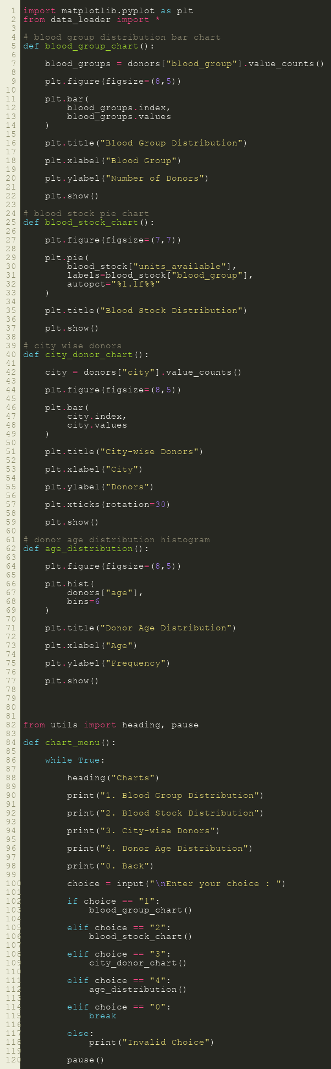

Module: data_loader.py
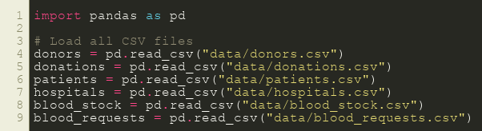

4. Data Visualizations (Matplotlib Charts)
The following charts are generated using Matplotlib to visualize the dataset metrics.

Blood Group Distribution
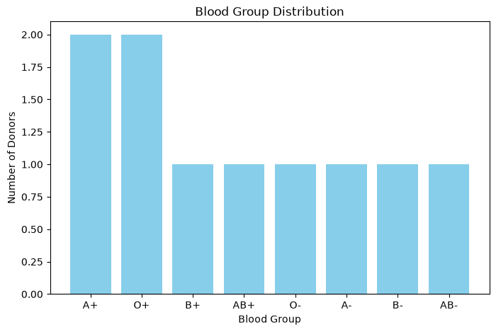

Blood Stock Distribution
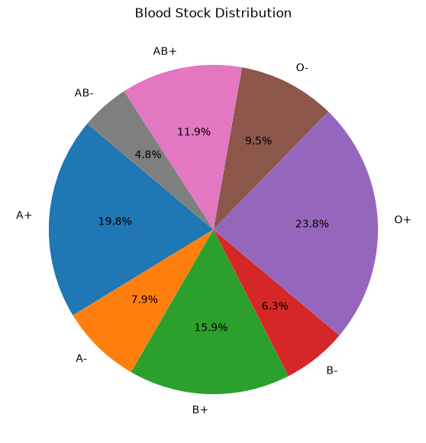

City-wise Donors
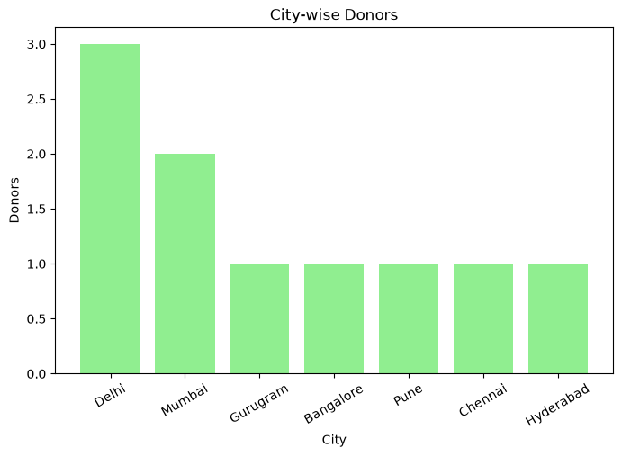

Donor Age Distribution
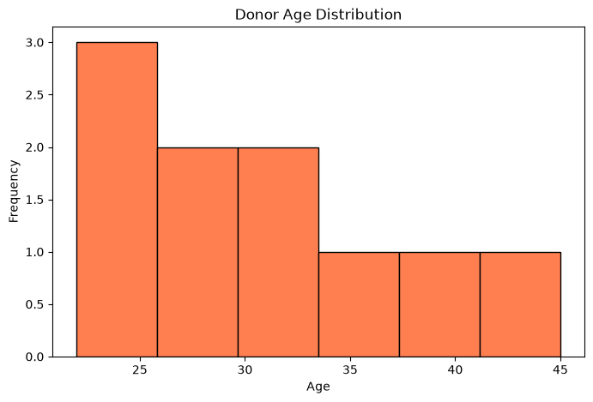

5. Conclusion
This project successfully applies Python programming concepts to solve a real-world data analytics problem. The modular architecture ensures the code is clean and readable, while Pandas and Matplotlib effectively handle data manipulation and visualization.

