**PRACTICAL 1**

Q1. Write a program to implement to create a simple web service that converts the temperature from Fahrenheit to Celsius and vice versa.

1. Go to **File -> New Project**. Select **Java Web in categories** and **Web Application in Projects. Click on Next** to create web based project.

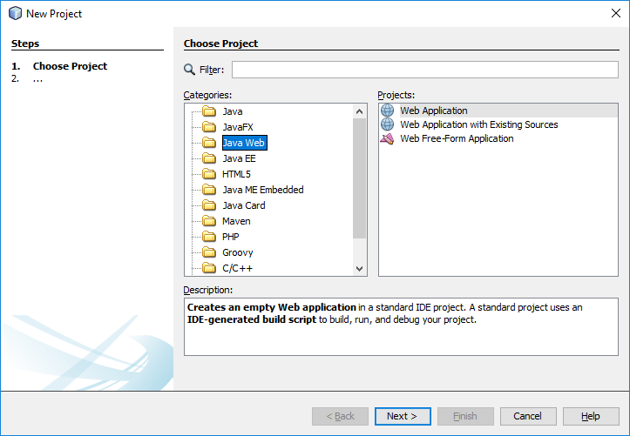

1. Enter a project name whatever you want and then click on **Next**. On next page click **Finish**.

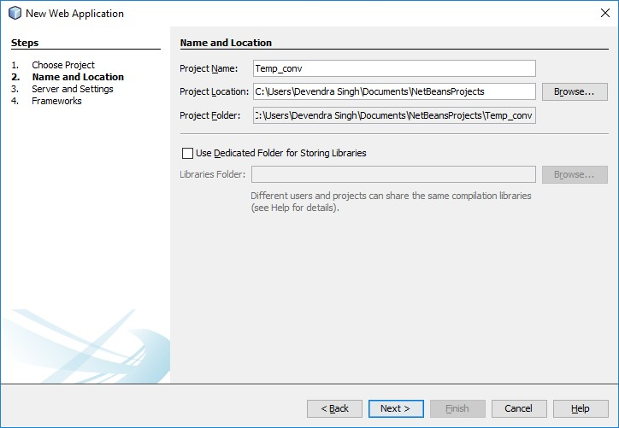

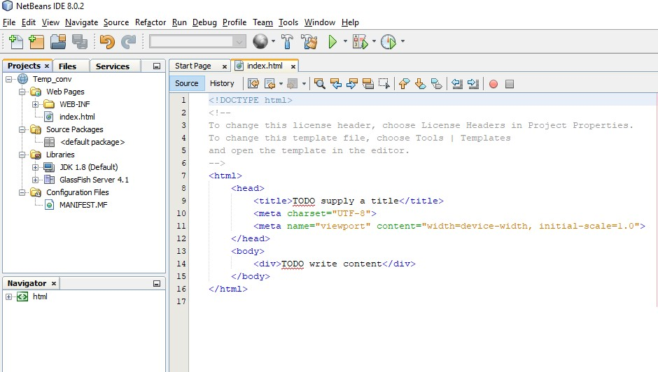[**3.** After completion of project creation process a window will appear like below.](https://e-next.in/)

**4.** Create web service.

Right click on Project -> New -> Web Service

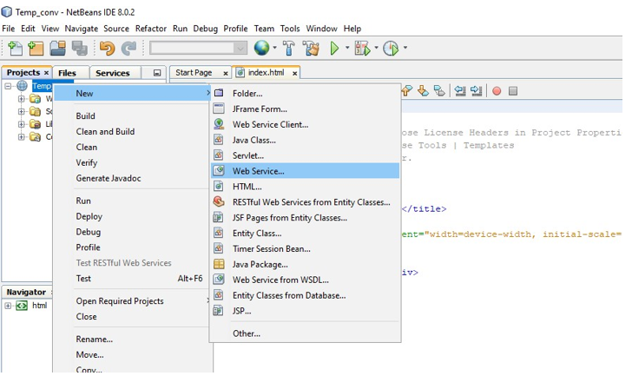

**5**. **Enter a Web Service Name and package name** and **then click on Finish** to create a Web Service.

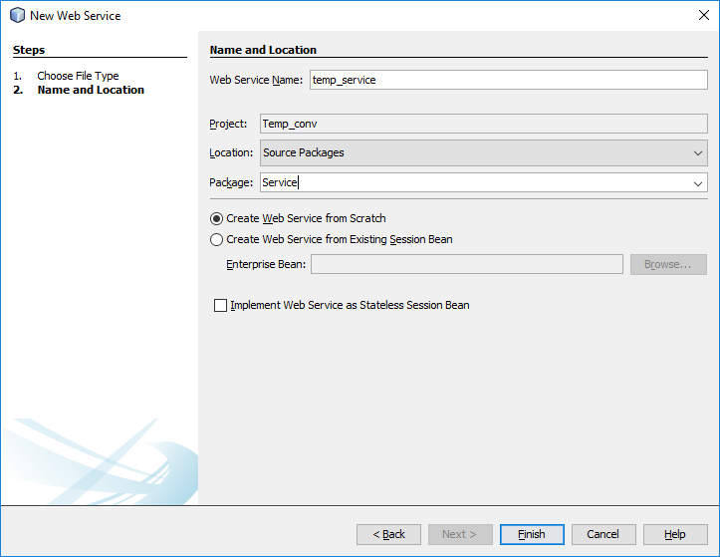

**6.** As you can see in following pic; In **Source Packages** there is a package **Service** which contains the service file **temp_service.java**. Open this file by double click on it, So that we can add two operation that will convert temperature from celcious to farhenheit and vice-versa.

Go to design mode by click on **Design**.

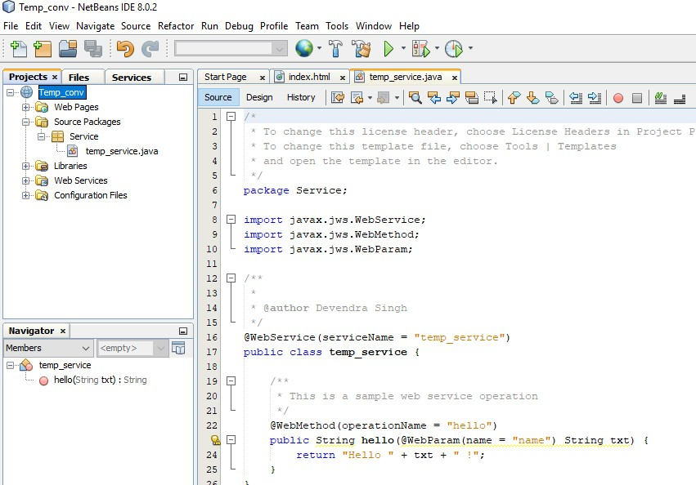

[**7. Click on Add Operation** to add operation.](https://e-next.in/)

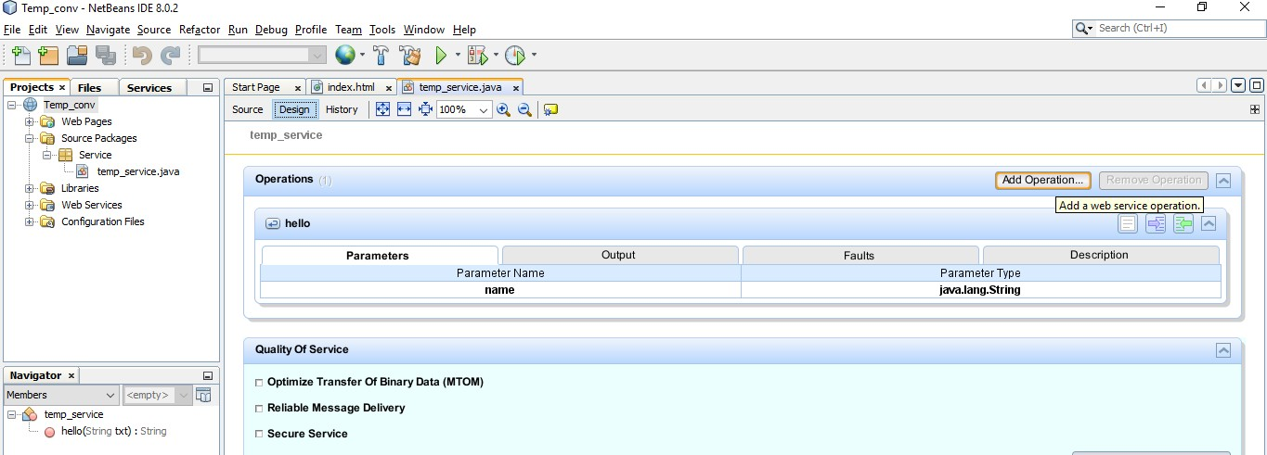

**8.** Give Operation name **F_to_C** and return type as **Double**. So, this method will return value in Double data type. After that click on **Add** button to give parameters for method. Give its name as **f** and type as **Double** and then click on **OK** button. Your one operation is now successfully created.

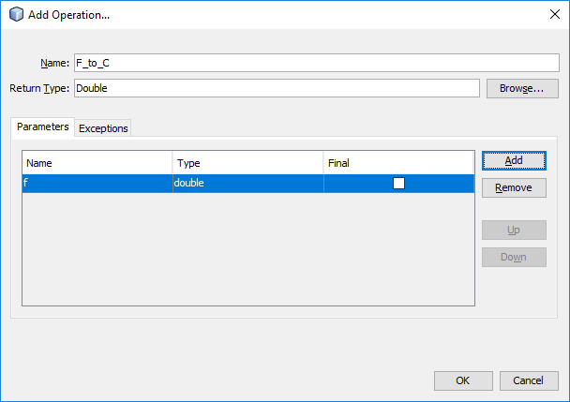

**9.** **Repeat step 7 & 8** to create second operation. But this time replace some above entered data with following data.

**F_to_C -> C_to_F**

**F -> c**

**10.** Now go to source mode by click on **Source** and **delete the selected** segment of code. Because it is default operation and we don’t need this.

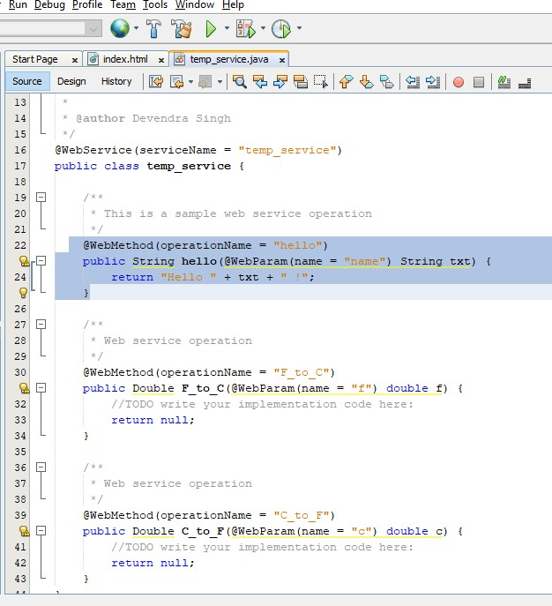

**11. Now replace the selected area with following code** to convert Fahrenheit to Celsius.

**Double c = (f-32) * 5/9;**

**return c;**

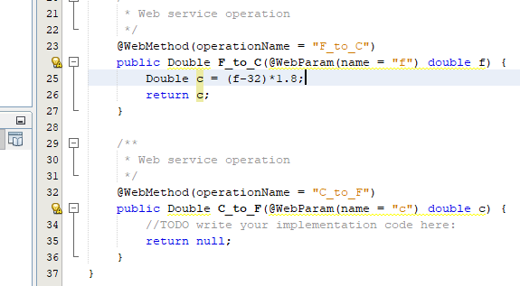

**12.** Now **replace the selected area with following code** to convert Celsius to Fahrenheit and then press Ctrl+S to save.

**Double f = (c*9/5) + 32;**

**return f;**

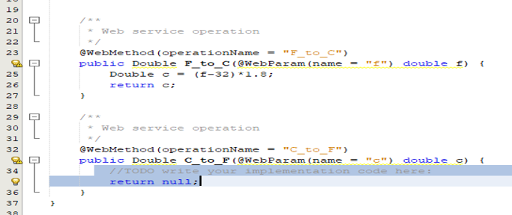

[**13.**Now **right click on project name** and **click on Deploy** to deploy your project.](https://e-next.in/)

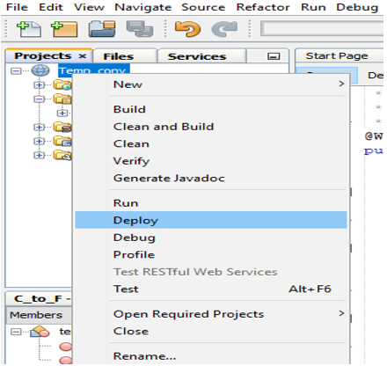

**14.** To test your web service follow the following process as in picture.

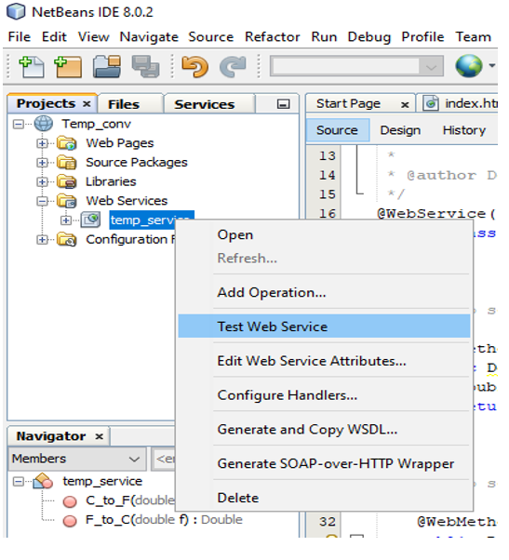

**15.** Following window will open in in browser. Now if you will enter a numeric data into first box and you will click on first button it will convert the entered data into Celsius

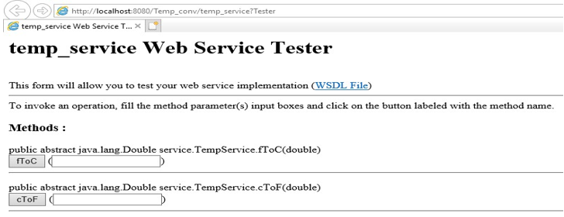

**16.** Selected value in Celsius of 56.

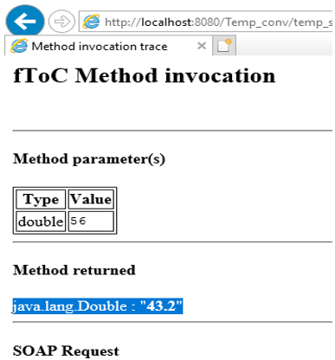

Q2. Write a program to implement to create a simple web service that converts the Revenue from Rupees to Doller and vice versa.

Q3. Write a program to convert the data from centimeter to meter.

Q4. Write a program to convert the data from kilometer to meter.

Q5. Write a program to convert the data from days to hours.

Q6. Write a program to convert the data from feet to inches.

Q7. Write a program to convert the data from centimeter to millimeter.