**A**

**PROJECT REPORT**

**ON**

**“ Tour And Travel Management System ”**

Submitted By

**Mr.Varpe Abhishek Sanjay**

**Mr.Varpe Nikhil Babasaheb**

Guided By

Mr.Kawade S.N

In partial fulfillment of the award of the degree

of

**T.Y.B.Sc. (Computer Science)**

**of**

**S.N. Arts, D.J.Malpani Commerce & B.N Sarda Science College Sangamner**

**DURING ACADEMIC YEAR**

2022-2023



**SHIKSHANPRASARAKSANSTHA’S** Ph. (02425) 225893 (0)

SANGAMNER NAGARPALIKA ARTS,Resi- 225164 (R)

D.J. MALPANI COMMERCE & Fax – (02425) 225893

B.N. SARDA SCIENCE COLLEGE (Id No. PU/AN/ASC/03/1961)

SANGAMNER- 422605 Dist – A.NAGAR

•NAAC Re-accredited College (A+ Grade)

“Spread knowledge unto the last” • Pune University Best College

E-mail: – [sangamnercollege@rediffmail.com](mailto:sangamnercollege@rediffmail.com) Award 2002-03

[www.sangamnercollege.edu.in](http://www.sangamnercollege.edu.in) •DBT Star College, DST-FIST

Date: / /

***CERTIFICATE***

**This** **certificate is awarded to *Mr. Varpe Abhishek Sanjay and***

***Mr. Varpe Nikhil Babasaheb* of T.Y.B.Sc. (Computer Science) in appreciation of his meritorious performance as practical requirement of B.Sc. Computer Science by Savitribai Phule Pune University during academic Year 2022 - 2023.**

***Project Guide* *Head of Department***

***Internal Examiner External Examiner***

**INDEX**

|  |  |
| --- | --- |
| **Sr.No.** | **Title** |
| 1. | Acknowledgement. |
| 2. | Introduction. |
| 3. | Objectives of System |
| 4. | Preliminary Investigation |
| 5. | Feasibility Study:  1)Operational Feasibility  2)Technical Feasibility  3)Economical Feasibility |
| 6. | Requirement Analysis. |
| 7. | Data Dictionary |
| 8. | Entity Relationship diagram |
| 9. | Data flow Diagram |
| 10. | UML  1)Class diagram  2)Use case diagram  3)Sequence diagram  4)Collaboration diagram  5)Deployment diagram |
| 11. | Coding |
| 12. | Input/output Screens |
| 13. | Future Enhancement |
| 14. | Advantages |
| 15. | Conclusion |
| 16. | Bibliography |

**ACKNOWLEDGEMENT**

A few words of gratitude to be inserted with project “**Tour And Travel Management System”**. It is our earnest duty to express our thanks to all those who contributed directly or indirectly to our project.

Firstly we would like to thank **S. N. Arts, D. J. Malpani Commerce & B. N. Sarda Science College, Sangamner and Department of Computer Science** for giving us an opportunity. Thanks to **Prof.Laddha R. S. Vice Principal, Head of Department** for his encouragement and valuable guidance.

We would like to thank **Mr**.**Kawade S.N. , Mrs Talnikar H.V. & Mrs Gite D.P.,** who initiated us to complete this project and guided us timely. It’s our privilege to express our gratitude to **all staff members &non-Teaching Staff members** for their excellent suggestions and active co-ordination.

And last but not least, we would like to thank all **our friends** for their support and the timely help.

Yours Sincerely,

Mr. Varpe Abhishek Sanjay

Mr. Varpe Nikhil Babasaheb

**T.Y.B.Sc.(Computer Science)**

**Introduction**

* The Tour and travel deals with the online system designed for booking the of tourist places as per the requirements and convenience of the customers or tourist.
* The customer can easily book the place for tourism by just logging to the website.
* The primary objective of tour and travel management system is to streamline the travel booking process, improve customer experience, and increase operational efficiency.
* The system typically includes features such as booking management system, online payment processing, customer relationship management and reporting.
* It provides free of cost search and booking appointment’s. And proves beneficial for both customers and businesses.
* The system provides various services which makes the customer’s relief and get satisfied.

**OBJECTIVES OF SYSTEM**

* The system provides proper security and reduces the manual work.
* The proposed system will help the user to reduce the workload and mental conflict.
* The proposed system helps the user to work user friendly and he can easily do his jobs.
* The application has login feature enabling data security.
* To facilitate easy retrieval of data and information.
* It enhances speed of work and accuracy.
* Periodical notification.
* Reduction of paper work.
* To pass information more quickly.
* The main aim of this system is to create the database in short time period and search the information about user or service provider in short time.

**PRELIMINARY INVESTIGATION**

Preliminary Investigation implies that which methods are applied to make research & by which means information is collected regarding services or about us. Generally used methods for collecting the information are:-

* **Interview**
* **Observations**

All the methods are equally important.

1. **Interviews:-**
2. We visited agency of tour and travel and the owner of agency.
3. We understood the requirements of the customer’s and understood the requirements of them and also the manual work of booking tourist places.
4. We made interaction with the customers.
5. Asked the owner and customers about the ideas or requirement they want in the software.

**2)Questionnaire's-**

We conducted the survey by asking the questions as follows:

1. How long did it take to make acknowledge after the customer have arrived?
2. Did your service provider start your appointment on time?
3. Did you feel your service provider understood the customer’s need?
4. How is your overall experience of travel agaency?
5. Which services you offered?

**FEASIBILITY STUDY**

**1) TECHNICAL FEASIBILITY STUDY:-**

* This developed system has technically feasible because the technology needed for the proposed system is available.
* The proposed system is integrated within the organization is easy.
* The proposed system needs no new equipment’s installed at the user end.
* Technically this system is very much safe and sound.
* The system does not need extra hardware to run the given project.

**2) ECONOMIC FEASIBILITY STUDY:-**

We had developed this software without any cost and no any extra charges are required for the system. If you want to visit our website we do not have any extra charges only internet is required.

So in this way this website is economically feasible

**3) OPERATIONAL FEASIBILITY STUDY:-**

* As system is very much user friendly so user of the system can easily work and interact with the system. i.e. no need of expert person to handle this system.
* This system will fit with current operation if reconstruction is needed it is easy using technical person.

**REQUIREMENT ANALYSIS**

**Technical Requirements**

**Operating system:**

Linux

**Server Requirement:**

The recommended minimum requirements are:

PHP (Codeigniter-4)

Postgres

Apache

**Browser Requirement**:

Firefox 4+

Google Chrome 10+

Opera 10+

Internet Explorer 11+ (9, 10 Limited Support)

Microsoft Edge

**Development Environments**

If developing a traditional web application that is to be accessed via the browser, the recommended approach is to deploy it to a web server and access it via  [http://](https://en.wikipedia.org/wiki/Hypertext_Transfer_Protocol)  or  [https://](https://en.wikipedia.org/wiki/HTTPS)  rather than  file://. Web server software is available free of charge for all operating systems. On Mac OS and Linux,  [**Apache**](https://httpd.apache.org/)is a popular option**.**

**Data Dictionary**

1. **Admin:**

|  |  |  |  |
| --- | --- | --- | --- |
| **Field** | **Type** | **Size** | **Constraints** |
| id | integer |  | Primary key |
| name | varchar | 50 | Not null |
| email | varchar | 50 | Not null |
| pass | varchar | 50 | Not null |
| phone | varchar | 50 | Not null |
| address | varchar | 50 | Not null |
| gender | varchar | 50 | Not null |

**2. Customer:**

|  |  |  |  |
| --- | --- | --- | --- |
| **Field** | **Type** | **Size** | **Constraints** |
| id | Int |  | Primary key |
| name | varchar | 30 | Not null |
| email | varchar | 50 | Not null |
| pass | varchar | 50 | Not null |
| phone | varchar | 50 | Not null |
| address | varchar | 50 | Not null |
| gender | varchar | 50 | Not null |

**3**. **Package:**

|  |  |  |  |
| --- | --- | --- | --- |
| **Field** | **Type** | **Size** | **Constraints** |
| id | Int |  | Primary key |
| name | varchar | 50 | Not null |
| description | varchar | 50 | Not null |
| destinations | varchar | 50 | Not null |
| members | varchar | 50 | Not null |
| price | varchar | 50 | Not null |
| Start_date | varchar | 50 | Not null |
| End_date | varchar | 50 | Not null |

**5.Payment:**

|  |  |  |  |
| --- | --- | --- | --- |
| **Field** | **Type** | **Size** | **Constraints** |
| id | Int | Not null | Primary key |
| Due_date | Da |  | Not null |
| Grand_total | Int | 30 | Not null |
| Paid_amount | Int | 30 | Not null |
| Pending_amount | Int | 300 | Not null |

**ER Diagram**

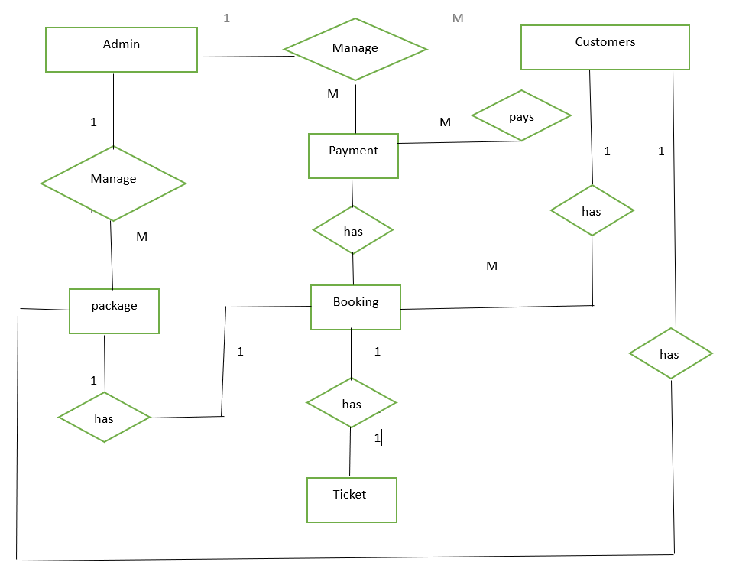

**Data Flow Diagram**

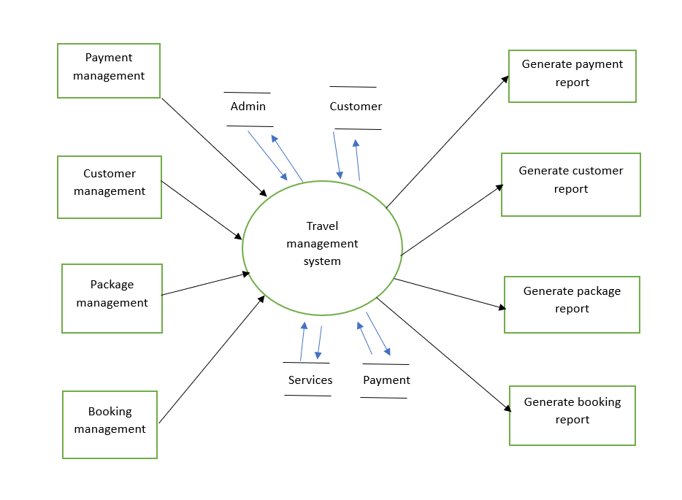

**UML DIAGRAM’S**

1. **Class Diagram:**

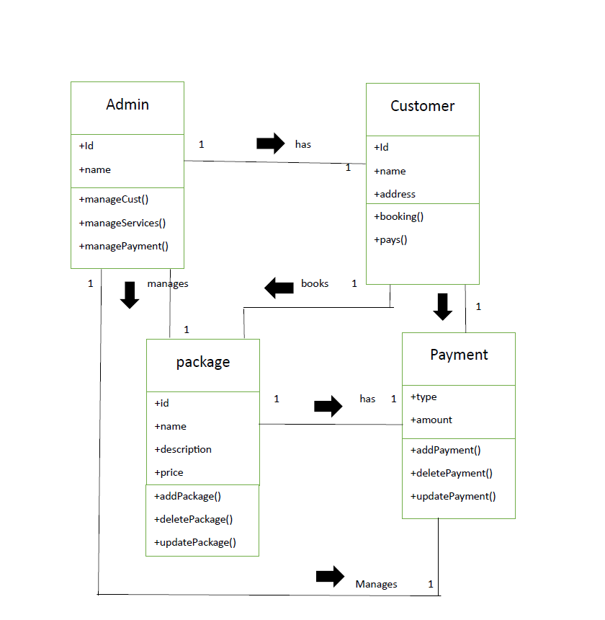

1. **Use-case Diagram:**

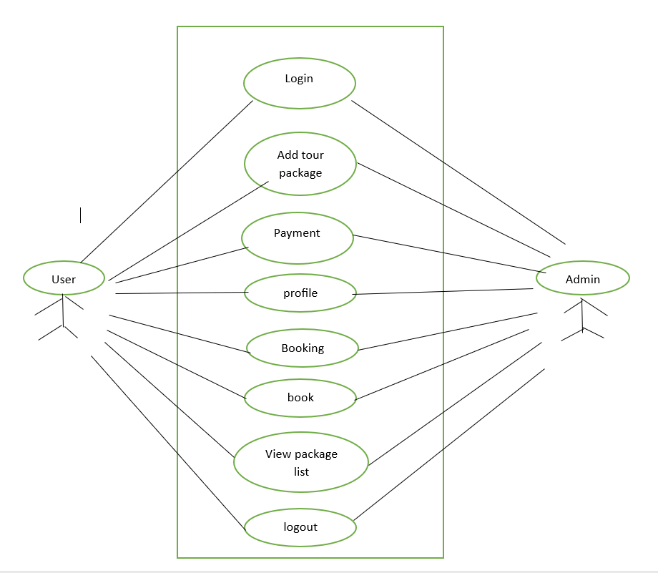

**3**.**Sequence Diagram:**

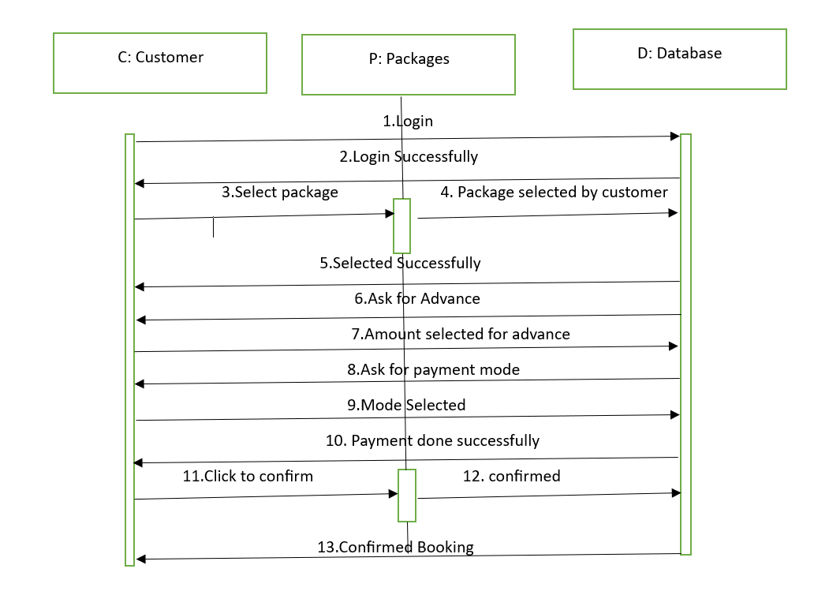

**4.Collaboration Diagram:**

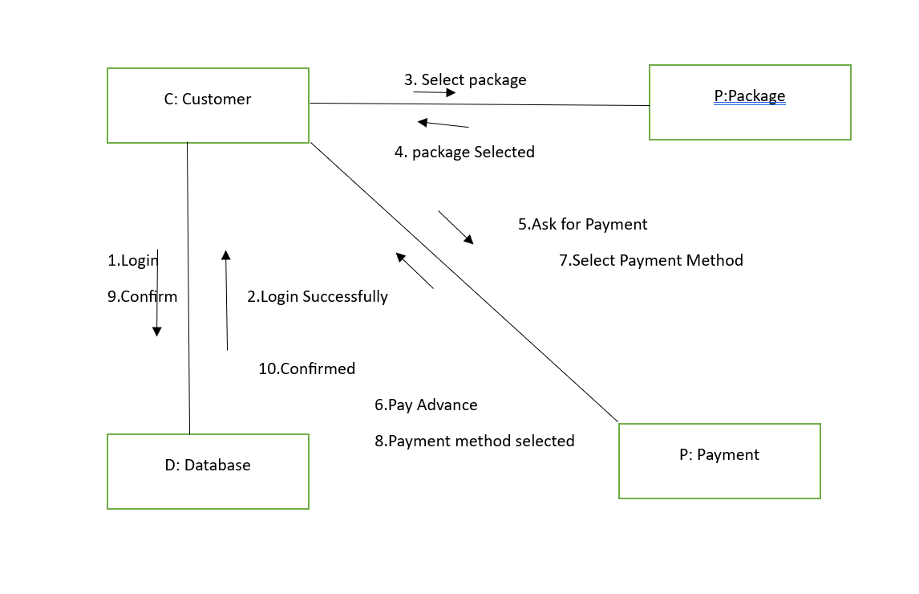

**5.Deployment Diagram:**

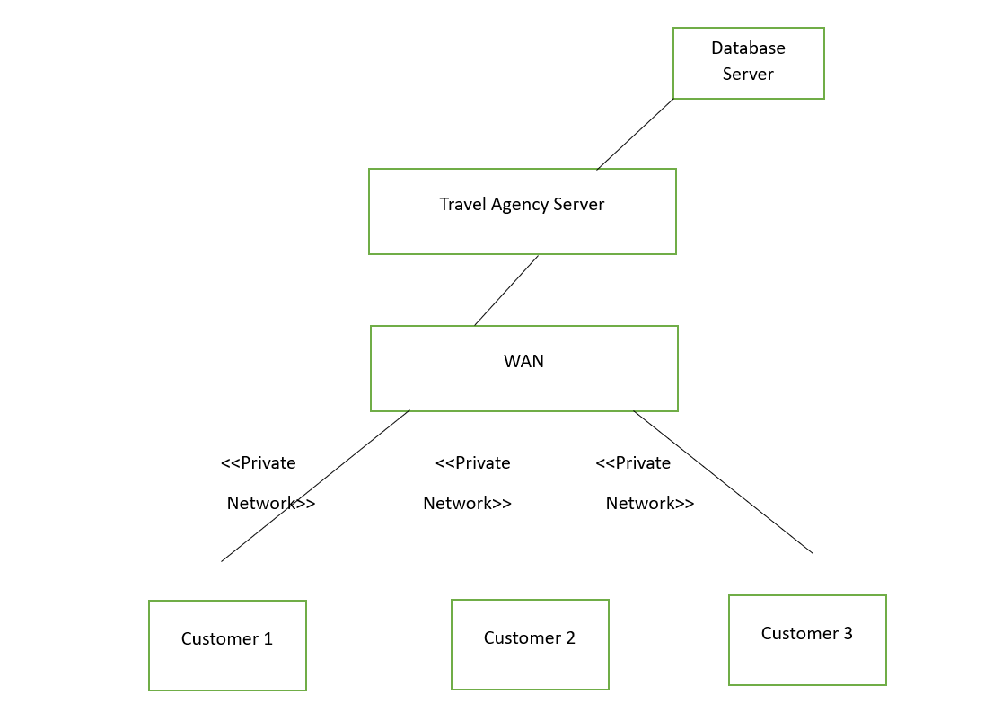

**Coding**

**Registration.php**

<!doctype html>

<html lang="en">

<head>

<title>User Registration and Login in Codeigniter 4</title>

<meta charset="utf-8">

<meta name="viewport" content="width=device-width, initial-scale=1, shrink-to-fit=no">

<!-- bootstrap 5 CSS -->

<link href="https://cdn.jsdelivr.net/npm/bootstrap@5.0.0-beta3/dist/css/bootstrap.min.css" rel="stylesheet" integrity="sha384-eOJMYsd53ii+scO/bJGFsiCZc+5NDVN2yr8+0RDqr0Ql0h+rP48ckxlpbzKgwra6" crossorigin="anonymous">

<link rel="stylesheet" href="https://cdn.jsdelivr.net/npm/bootstrap-icons@1.4.1/font/bootstrap-icons.css">

</head>

<body>

<div class="container-fluid py-4">

<div class="row mt-4">

<div class="col-xl-6 col-lg-6 col-md-12 col-sm-12 col-12 m-auto">

<?php

if (session()->getFlashdata('success')) : ?>

<div class="alert alert-success alert-dismissible">

<button type="button" class="btn-close" data-bs-dismiss="alert">&times;</button>

<?php echo session()->getFlashdata('success') ?>

</div>

<?php elseif (session()->getFlashdata('failed')) : ?>

<div class="alert alert-danger alert-dismissible">

<button type="button" class="btn-close" data-bs-dismiss="alert">&times;</button>

<?php echo session()->getFlashdata('failed') ?>

</div>

<?php endif; ?>

<?php $validation = \Config\Services::validation(); ?>

<form action="<?= base_url('register') ?>" method="post">

<?= csrf_field() ?>

<div class="card">

<div class="card-header">

<h5 class="card-title">Registration </h4>

</div>

<div class="card-body p-5">

<div class="form-group">

<label for="name" class="form-label">Name</label>

<input type="text" class="form-control <?php if ($validation->getError('name')) : ?>is-invalid<?php endif ?>" name="name" id="name" placeholder="Name" value="<?php echo set_value('name'); ?>" />

<?php if ($validation->getError('name')) : ?>

<div class="invalid-feedback">

<?= $validation->getError('name') ?>

</div>

<?php endif; ?>

</div>

<div class="form-group pt-3">

<label for="email"> Email </label>

<input type="text" class="form-control <?php if ($validation->getError('email')) : ?>is-invalid<?php endif ?>" name="email" placeholder="Email" value="<?php echo set_value('email'); ?>" />

<?php if ($validation->getError('email')) : ?>

<div class="invalid-feedback">

<?= $validation->getError('email') ?>

</div>

<?php endif; ?>

</div>

<div class="form-group pt-3">

<label for="password"> Password </label>

<input type="password" class="form-control <?php if ($validation->getError('password')) : ?>is-invalid <?php endif ?>" name="password" placeholder="Password" value="<?php echo set_value('email'); ?>" />

<?php if ($validation->getError('password')) : ?>

<div class="invalid-feedback">

<?= $validation->getError('password') ?>

</div>

<?php endif; ?>

</div>

<div class="form-group pt-5 d-flex justify-content-between align-items-center">

<button type="submit" class="btn btn-success">Register</button>

<p class="d-flex justify-content-between align-items-center m-0"> Already registered? <a href="<?= base_url('login') ?>" class="nav-link"> Login </a> </p>

</div>

</div>

</div>

</form>

</div>

</div>

</div>

<script src="https://cdn.jsdelivr.net/npm/bootstrap@5.0.0-beta3/dist/js/bootstrap.bundle.min.js" integrity="sha384-JEW9xMcG8R+pH31jmWH6WWP0WintQrMb4s7ZOdauHnUtxwoG2vI5DkLtS3qm9Ekf" crossorigin="anonymous"></script>

</body>

</html>

**login.php**

<!doctype html>

<html lang="en">

<head>

<title>User Registration and Login in Codeigniter 4</title>

<meta charset="utf-8">

<meta name="viewport" content="width=device-width, initial-scale=1, shrink-to-fit=no">

<!-- bootstrap 5 CSS -->

<link href="https://cdn.jsdelivr.net/npm/bootstrap@5.0.0-beta3/dist/css/bootstrap.min.css" rel="stylesheet" integrity="sha384-eOJMYsd53ii+scO/bJGFsiCZc+5NDVN2yr8+0RDqr0Ql0h+rP48ckxlpbzKgwra6" crossorigin="anonymous">

<link rel="stylesheet" href="https://cdn.jsdelivr.net/npm/bootstrap-icons@1.4.1/font/bootstrap-icons.css">

</head>

<body>

<div class="container-fluid py-4">

<div class="row mt-4">

<div class="col-xl-6 col-lg-6 col-md-12 col-sm-12 col-12 m-auto">

<?php $validation = \Config\Services::validation(); ?>

<form action="<?= base_url('login') ?>" method="post">

<?= csrf_field() ?>

<div class="card">

<div class="card-header">

<h5 class="card-title">Login </h4>

</div>

<div class="card-body p-5">

<div class="form-group pt-3">

<label for="email"> Email </label>

<input type="text" class="form-control <?php if ($validation->getError('email')) : ?>is-invalid<?php endif ?>" name="email" placeholder="Email" value="<?php echo set_value('email'); ?>" />

<?php if ($validation->getError('email')) : ?>

<div class="invalid-feedback">

<?= $validation->getError('email') ?>

</div>

<?php endif; ?>

</div>

<div class="form-group pt-3">

<label for="password"> Password </label>

<input type="password" class="form-control <?php if ($validation->getError('password')) : ?>is-invalid <?php endif ?>" name="password" placeholder="Password" value="<?php echo set_value('email'); ?>" />

<?php if ($validation->getError('password')) : ?>

<div class="invalid-feedback">

<?= $validation->getError('password') ?>

</div>

<?php endif; ?>

</div>

<div class="form-group pt-5 d-flex justify-content-between align-items-center">

<button type="submit" class="btn btn-success">Login</button>

<p class="d-flex justify-content-between align-items-center m-0"> Not have an account? <a href="<?= base_url('register') ?>" class="nav-link"> Register </a> </p>

</div>

</div>

</div>

</form>

</div>

</div>

</div>

<script src="https://cdn.jsdelivr.net/npm/bootstrap@5.0.0-beta3/dist/js/bootstrap.bundle.min.js" integrity="sha384-JEW9xMcG8R+pH31jmWH6WWP0WintQrMb4s7ZOdauHnUtxwoG2vI5DkLtS3qm9Ekf" crossorigin="anonymous"></script>

</body>

</html>

**Home:**

<?= $this->extend('Layout/header') ?>

<?= $this->section('content') ?>

<section class="home">

<div class="swiper home-slider">

<div class="swiper-wrapper">

<div class="swiper-slide slide" style="background:url(images/home-slide-1.jpg) no-repeat">

<div class="content">

<span>explore, discover, travel & Enjoy</span>

<h3>travel arround the world</h3>

<a href="package" class="btn">discover more</a>

</div>

</div>

<div class="swiper-slide slide" style="background:url(images/home-slide-2.jpg) no-repeat">

<div class="content">

<span>explore, discover, travel & Enjoy</span>

<h3>discover the new places</h3>

<a href="package" class="btn">discover more</a>

</div>

</div>

<div class="swiper-slide slide" style="background:url(images/home-slide-3.jpg) no-repeat">

<div class="content">

<span>explore, discover, travel & Enjoy</span>

<h3>make your tour worthwhile</h3>

<a href="package" class="btn">discover more</a>

</div>

</div>

</div>

<div class="swiper-button-next"></div>

<div class="swiper-button-prev"></div>

</div>

</section>

<section class="services">

<h1 class="heading-title"> our services </h1>

<div class="box-container">

<div class="box">

<img src="images/icon-1.png" alt="">

<h3>adventure</h3>

</div>

<div class="box">

<img src="images/icon-2.png" alt="">

<h3>tour guide</h3>

</div>

<div class="box">

<img src="images/icon-3.png" alt="">

<h3>trekking</h3>

</div>

<div class="box">

<img src="images/icon-4.png" alt="">

<h3>camp fire</h3>

</div>

<div class="box">

<img src="images/icon-5.png" alt="">

<h3>off road</h3>

</div>

<div class="box">

<img src="images/icon-6.png" alt="">

<h3>camping</h3>

</div>

<div class="box">

<img src="images/icon-6.png" alt="">

<h3>camping</h3>

</div>

</div>

</section>

<section class="home-about">

<div class="image">

<img src="images/about.jpg" alt="">

</div>

<div class="content">

<h3>about us</h3>

<p> The best tourism advisor or guidance website.Tourism is travel for pleasure or business; also the theory and practice of touring, the business of attracting, accommodating, and entertaining tourists, and the business of operating tours.[2] The World Tourism Organization defines tourism more generally, in terms which go "beyond the common perception of tourism as being limited to holiday activity only", as people "travelling to and staying in places outside their usual environment for not more than one consecutive year</p>

<a href="about" class="btn">read more</a>

</div>

</section>

<section class="home-packages">

<h1 class="heading-title"> our packages </h1>

<div class="box-container">

<div class="box">

<div class="image">

<img src="images/img-1.jpg" alt="">

</div>

<div class="content">

<h3>Taj Mahal Agra</h3>

<p>Shah Jahan in memory of his favourite wife, the Taj Mahal is the jewel one of the universally admired masterpieces of the heritage.!</p>

<a href="book" class="btn">book now</a>

</div>

</div>

<div class="box">

<div class="image">

<img src="images/bhan1.jpg" alt="">

</div>

<div class="content">

<h3>Bhandardara Lake</h3>

<p>Bhandardara Lake Is The Creation Of Bhandardara Dam.It Is 2 Hrs Journey From Igatpuri.The Road To Bhandardara Dam...!</p>

<a href="login" class="btn">book now</a>

</div>

</div>

<div class="box">

<div class="image">

<img src="images/lona.jpg" alt="">

</div>

<div class="content">

<h3>Lonavala - Hill Station Tour From Mumbai</h3>

<p>The way to visit the ancient rock temples.Lonavala to take in the views and fresh air!</p>

<a href="login" class="btn">book now</a>

</div>

</div>

</div>

<div class="load-more"> <a href="package" class="btn">load more</a> </div>

</section>

<section class="home-offer">

<div class="content">

<h3>upto 50% off</h3>

<p>Get 50 % off on to visit any top destinations on our website offer till valid upto on 15 feb 2023..!</p>

<a href="login" class="btn">book now</a>

</div>

</section>

<?= $this->endSection('content') ?>

**package.php:**

<?= $this->extend('Layout/header') ?>

<?= $this->section('content') ?>

<div class="heading" style="background:url(images/header-bg-2.png) no-repeat">

<h1>packages</h1>

</div>

<section class="packages">

<h1 class="heading-title">top destinations</h1>

<div class="box-container">

<div class="box">

<div class="image">

<img src="images/img-1.jpg" alt="">

</div>

<div class="content">

<h3>Taj Mahal Agra</h3>

<p>Shah Jahan in memory of his favourite wife, the Taj Mahal is the jewel one of the universally admired masterpieces of the heritage.!</p>

<a href="login" class="btn">book now</a>

</div>

</div>

<div class="box">

<div class="image">

<img src="images/bhan1.jpg" alt="">

</div>

<div class="content">

<h3>Bhandardara Lake</h3>

<p>Bhandardara Lake Is The Creation Of Bhandardara Dam.It Is 2 Hrs Journey From Igatpuri.The Road To Bhandardara Dam...!</p>

<a href="login" class="btn">book now</a>

</div>

</div>

<div class="box">

<div class="image">

<img src="images/lona.jpg" alt="">

</div>

<div class="content">

<h3>Lonavala - Hill Station Tour From Mumbai</h3>

<p>The way to visit the ancient rock temples.Lonavala to take in the views and fresh air!</p>

<a href="login" class="btn">book now</a>

</div>

</div>

<div class="box">

<div class="image">

<img src="images/kedar.jpg" alt="">

</div>

<div class="content">

<h3>Kedarnath Mandir, Uttarakhand</h3>

<p>Located on Uttarakhand near Mandakini River, Kedarnath Temple is a highly esteemed Shiva Temple this Shiva shrine is counted among the four destinations of Chardham Yatra of Uttarakhand along with Yamunotri, Gangotri and Badrinath.!</p>

<a href="login" class="btn">book now</a>

</div>

</div>

<div class="box">

<div class="image">

<img src="images/marude.jpg" alt="">

</div>

<div class="content">

<h3>Murudeshwara Temple, Karnataka</h3>

<p>The temple of Murudeshwara is located in Bhatkal Taluk of Uttara Kannada district of Karnataka. Located at a hill top which is surrounded by the water of the Arabian Sea, the temple is a 20 storied building.!</p>

<a href="login" class="btn">book now</a>

</div>

</div>

<div class="box">

<div class="image">

<img src="images/adhi.jpg" alt="">

</div>

<div class="content">

<h3>The Adiyogi statue</h3>

<p>The Adiyogi statue is a 34-metre tall (112 ft),45-metre long (147 ft) and 25-metre wide (82 ft) steel statue of Shiva with Thirunamam at Coimbatore,Tamil Nadu.It is recognized by the Guinness World Records as the "Largest Bust Sculpture” in the world. !</p>

<a href="login" class="btn">book now</a>

</div>

</div>

<div class="box">

<div class="image">

<img src="images/manali.jpg" alt="">

</div>

<div class="content">

<h3>Manali, Himachal Pradesh</h3>

<p>Manali is a high-altitude Himalayan resort town in India’s northern Himachal Pradesh state.Set on the Beas River,it’s a gateway for skiing in the Solang Valley and trekking in Parvati Valley. It is most interesting place.!</p>

<a href="login" class="btn">book now</a>

</div>

</div>

<div class="box">

<div class="image">

<img src="images/holly.jpg" alt="">

</div>

<div class="content">

<h3>The Holy City of Varanasi</h3>

<p>Varanasi is one of the oldest still inhabited cities in the world. A major pilgrimage center for Hindus, this holy city has long been associated with the mighty Ganges River, one of the faith's most important religious symbols.!</p>

<a href="login" class="btn">book now</a>

</div>

</div>

<div class="box">

<div class="image">

<img src="images/red.jpg" alt="">

</div>

<div class="content">

<h3>The Red Fort, New Delhi</h3>

<p>Built by Shah Jahan in 1648 as the magnificent crescent-shaped Red Fort in New Delhi, named after the stunning red sandstone used in its construction, covers a vast area of more than two square kilometers, all of it surrounded by a large moat.!</p>

<a href="login" class="btn">book now</a>

</div>

</div>

<div class="box">

<div class="image">

<img src="images/beach.jpg" alt="">

</div>

<div class="content">

<h3>The Beaches of Goa</h3>

<p>Destination for those seeking a great beach holiday, Goa's beautiful Arabian Sea, has only recently been discovered by tourists from overseas. Goa's more than 60 miles of coastline is home to some of the world's loveliest beaches as well as India's famous king cobras, and some 200 species of birds.!</p>

<a href="login" class="btn">book now</a>

</div>

</div>

<div class="box">

<div class="image">

<img src="images/jodh.jpg" alt="">

</div>

<div class="content">

<h3>Mehrangarh Fort Jodhpur</h3>

<p>Dominating the old city of Jodhpur, the massive Mehrangarh Fort, one of the largest fortifications in India, was built in the 15th century to safeguard the people of the famous "Blue City." Jodhpur is still known by this name, which is derived from its indigo-colored houses!</p>

<a href="login" class="btn">book now</a>

</div>

</div>

<div class="box">

<div class="image">

<img src="images/mysor.jpg" alt="">

</div>

<div class="content">

<h3>Mysore Palace Karnataka</h3>

<p>The sprawling city of Mysore is a delight to explore thanks to its eclectic mix of fine old colonial architecture; regal Indian palaces; and lush, well-manicured gardens. While those inclined towards shopping will enjoy spending time in the city's famous silk !</p>

<a href="login" class="btn">book now</a>

</div>

</div>

</div>

<div class="load-more"><span class="btn">load more</span></div>

</section>

<script src="https://unpkg.com/swiper@7/swiper-bundle.min.js"></script>

<script src="js/script.js"></script>

<?= $this->endSection() ?>

**Book:**

<?= $this->extend('Layout/header') ?>

<?= $this->section('content') ?>

<div class="heading" style="background:url(images/header-bg-3.png) no-repeat">

<h1>book now</h1>

</div>

<section class="booking">

<h1 class="heading-title">book your trip!</h1>

<form action="book_form.php" method="post" class="book-form">

<div class="flex">

<div class="inputBox">

<span>name :</span>

<input type="text" placeholder="enter your name" name="name">

</div>

<div class="inputBox">

<span>email :</span>

<input type="email" placeholder="enter your email" name="email">

</div>

<div class="inputBox">

<span>phone :</span>

<input type="number" placeholder="enter your number" name="phone">

</div>

<div class="inputBox">

<span>address :</span>

<input type="text" placeholder="enter your address" name="address">

</div>

<div class="inputBox">

<span>where to :</span>

<input type="text" placeholder="place you want to visit" name="location">

</div>

<div class="inputBox">

<span>how many :</span>

<input type="number" placeholder="number of guests" name="guests">

</div>

<div class="inputBox">

<span>arrivals :</span>

<input type="date" name="arrivals">

</div>

<div class="inputBox">

<span>leaving :</span>

<input type="date" name="leaving">

</div>

</div>

<input type="submit" value="submit" class="btn" name="send">

</form>

</section>

<?= $this->endSection('content') ?>

**Header:**

<meta charset="UTF-8">

<meta http-equiv="X-UA-Compatible" content="IE=edge">

<meta name="viewport" content="width=device-width, initial-scale=1.0">

<title>home</title>

<link rel="stylesheet" href="https://unpkg.com/swiper@7/swiper-bundle.min.css" />

<link rel="stylesheet" href="https://cdnjs.cloudflare.com/ajax/libs/font-awesome/5.15.4/css/all.min.css">

<link rel="stylesheet" href="css/style.css">

</head>

<body>

<section class="header">

<a href="home.php" class="logo">Dream travel.</a>

<nav class="navbar">

<a href="home">home</a>

<a href="about">about</a>

<a href="package">package</a>

<a href="register">User Login</a>

<a href="login">Admin Login</a>

</nav>

<div id="menu-btn" class="fas fa-bars"></div>

</section>

<?= $this->renderSection('content') ?>

<section class="footer">

<div class="box-container">

<div class="box">

<h3>quick links</h3>

<a href="home.php"> <i class="fas fa-angle-right"></i> home</a>

<a href="about.php"> <i class="fas fa-angle-right"></i> about</a>

<a href="package.php"> <i class="fas fa-angle-right"></i> package</a>

<a href="book.php"> <i class="fas fa-angle-right"></i> book</a>

</div>

<div class="box">

<h3>extra links</h3>

<a href="#"> <i class="fas fa-angle-right"></i> ask questions</a>

<a href="#"> <i class="fas fa-angle-right"></i> about us</a>

<a href="#"> <i class="fas fa-angle-right"></i> privacy policy</a>

<a href="#"> <i class="fas fa-angle-right"></i> terms of use</a>

</div>

<div class="box">

<h3>contact info</h3>

<a href="#"> <i class="fas fa-phone"></i> 9623736678 </a>

<a href="#"> <i class="fas fa-phone"></i> +111-222-3333 </a>

<a href="#"> <i class="fas fa-envelope"></i> varpenikhil5179@gmail.com </a>

<a href="#"> <i class="fas fa-map"></i> Kanoli, Sangamner - 422605 </a>

</div>

<div class="box">

<h3>follow us</h3>

<a href="#"> <i class="fab fa-facebook-f"></i> facebook </a>

<a href="#"> <i class="fab fa-twitter"></i> twitter </a>

<a href="#"> <i class="fab fa-instagram"></i> instagram </a>

<a href="#"> <i class="fab fa-linkedin"></i> linkedin </a>

</div>

</div>

<div class="credit"> created by <span>mr. Devmanus</span> | all rights reserved! </div>

</section>

**Footer:**

<section class="footer">

<div class="box-container">

<div class="box">

<h3>quick links</h3>

<a href="home.php"> <i class="fas fa-angle-right"></i> home</a>

<a href="about.php"> <i class="fas fa-angle-right"></i> about</a>

<a href="package.php"> <i class="fas fa-angle-right"></i> package</a>

<a href="book.php"> <i class="fas fa-angle-right"></i> book</a>

</div>

<div class="box">

<h3>extra links</h3>

<a href="#"> <i class="fas fa-angle-right"></i> ask questions</a>

<a href="#"> <i class="fas fa-angle-right"></i> about us</a>

<a href="#"> <i class="fas fa-angle-right"></i> privacy policy</a>

<a href="#"> <i class="fas fa-angle-right"></i> terms of use</a>

</div>

<div class="box">

<h3>contact info</h3>

<a href="#"> <i class="fas fa-phone"></i> 9623736678 </a>

<a href="#"> <i class="fas fa-phone"></i> +111-222-3333 </a>

<a href="#"> <i class="fas fa-envelope"></i> varpenikhil5179@gmail.com </a>

<a href="#"> <i class="fas fa-map"></i> Kanoli, Sangamner - 422605 </a>

</div>

<div class="box">

<h3>follow us</h3>

<a href="#"> <i class="fab fa-facebook-f"></i> facebook </a>

<a href="#"> <i class="fab fa-twitter"></i> twitter </a>

<a href="#"> <i class="fab fa-instagram"></i> instagram </a>

<a href="#"> <i class="fab fa-linkedin"></i> linkedin </a>

</div>

</div>

<div class="credit"> created by <span>mr. Devmanus</span> | all rights reserved! </div>

</section>

<script src="https://unpkg.com/swiper@7/swiper-bundle.min.js"></script>

<script src="js/script.js"></script>

</body>

</html>

**Input/Output Screens**

**Registeration page:**

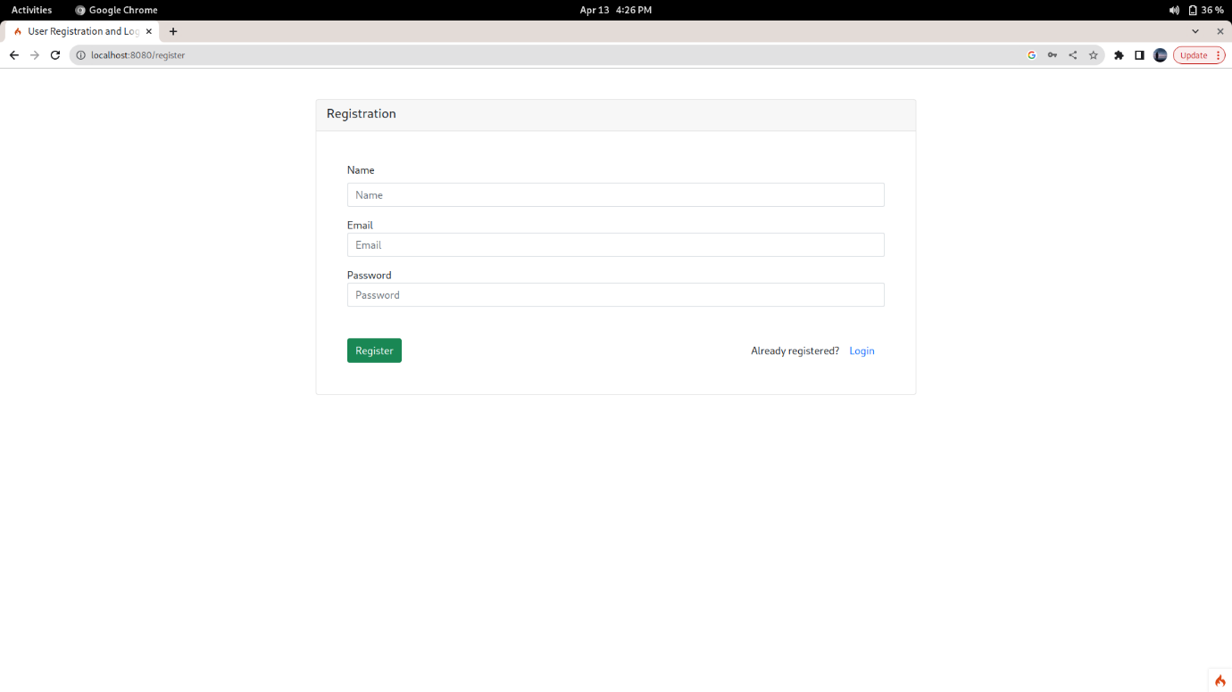

**Login page:**

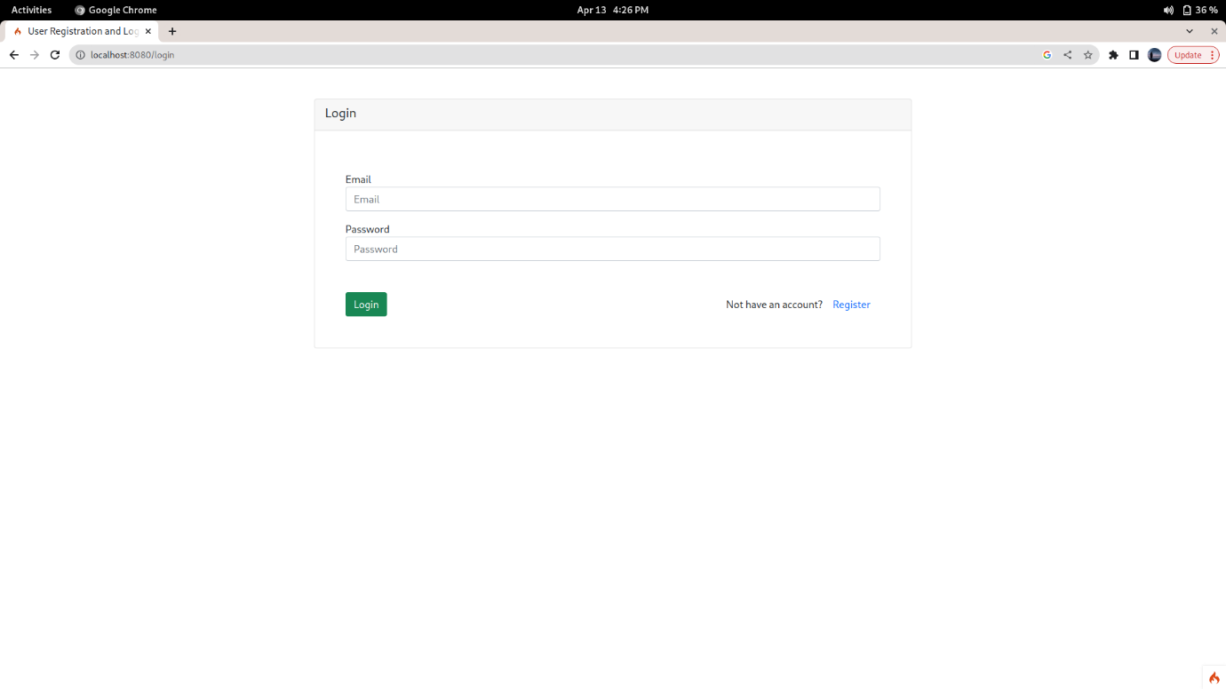

**Home page:**

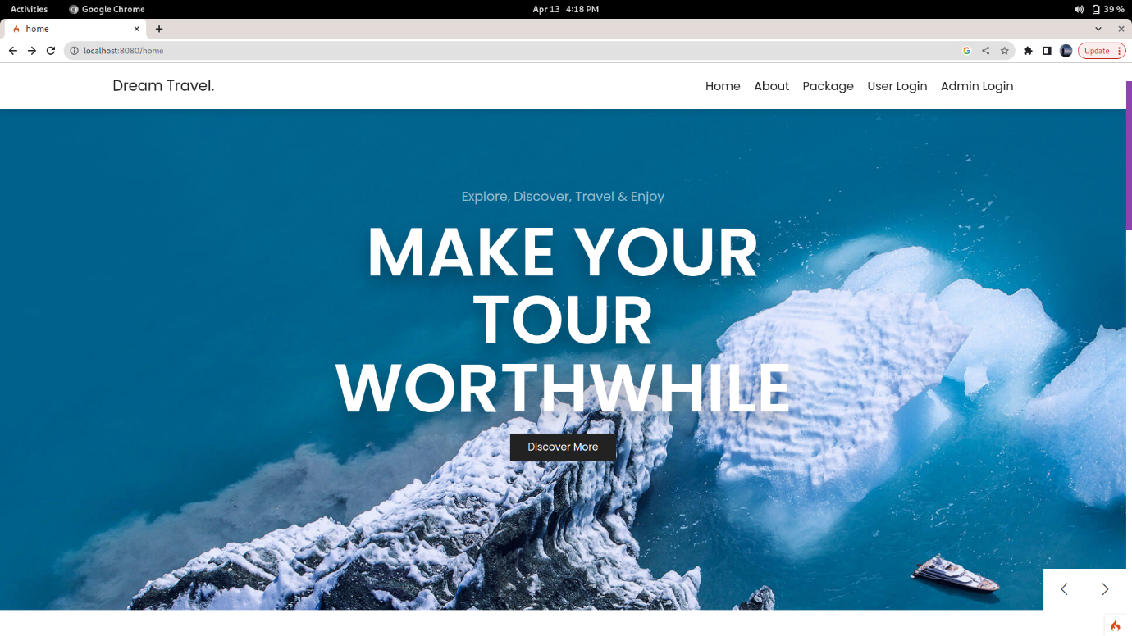

**Admin Dashboard page:**

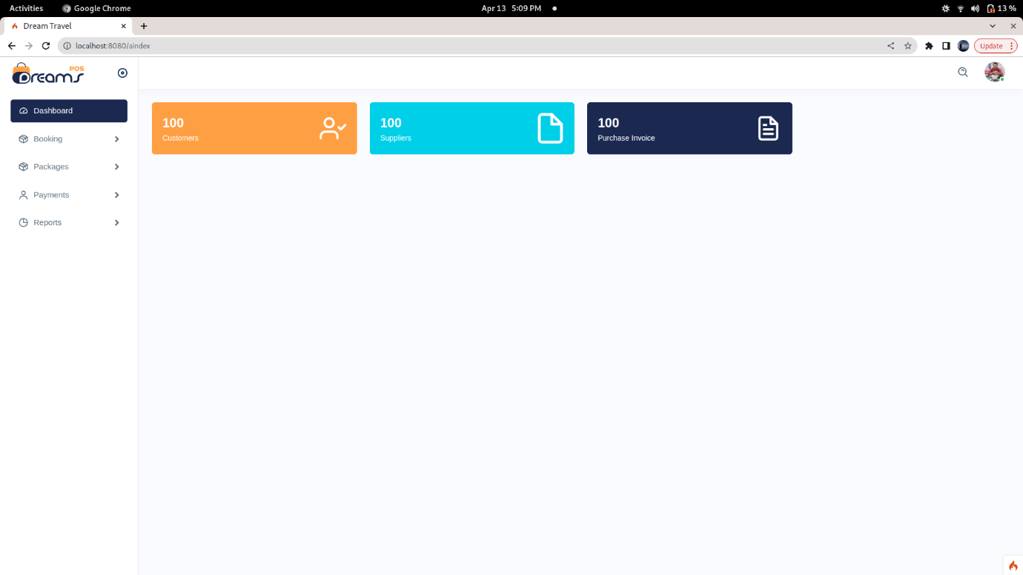

**User Dashboard page:**

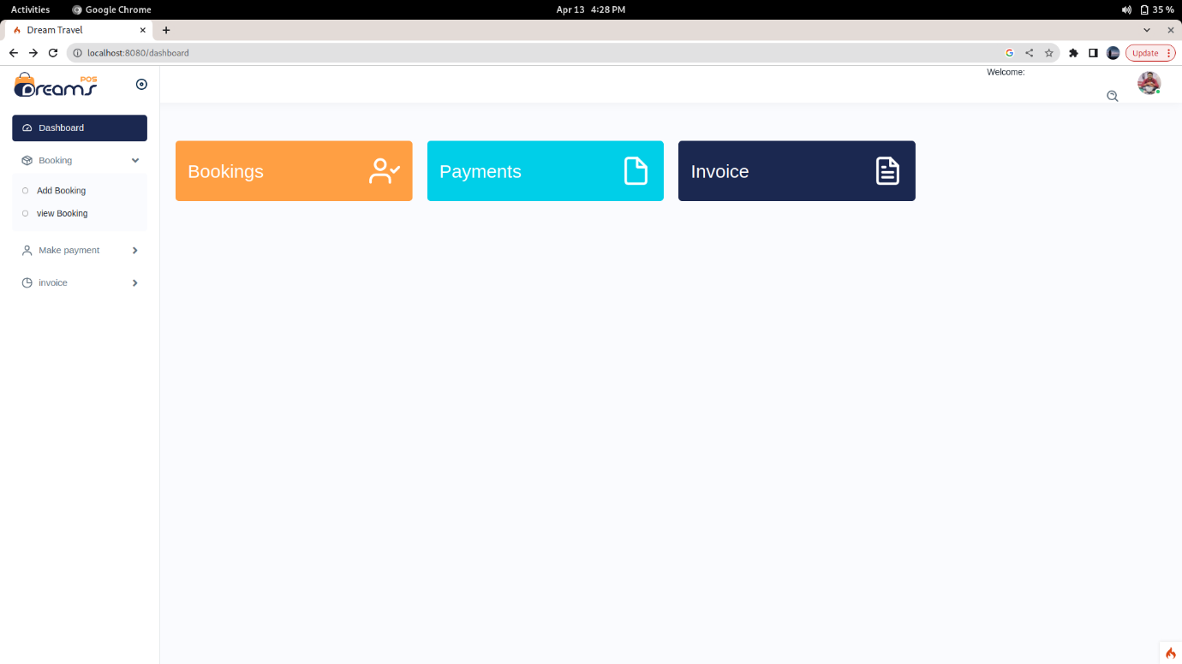

**Booking page:**

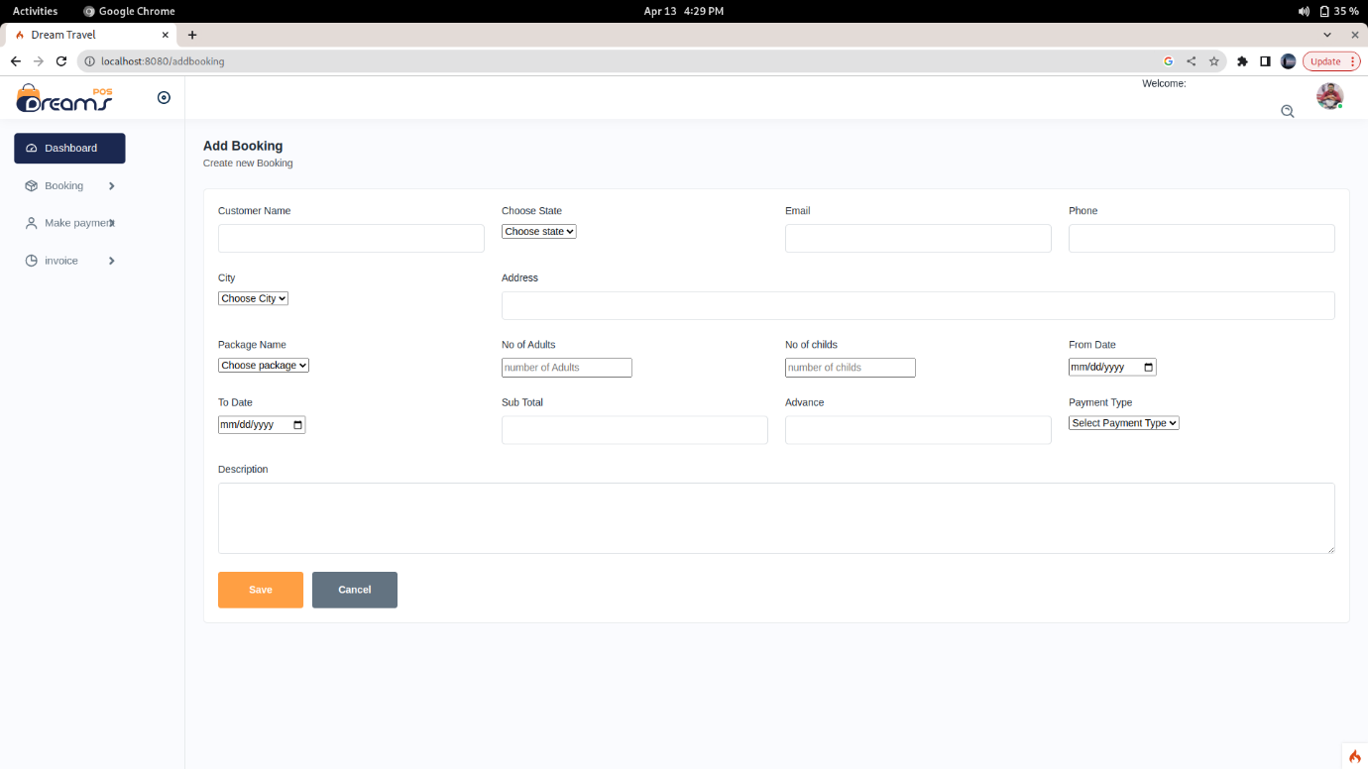

**Packages page:**

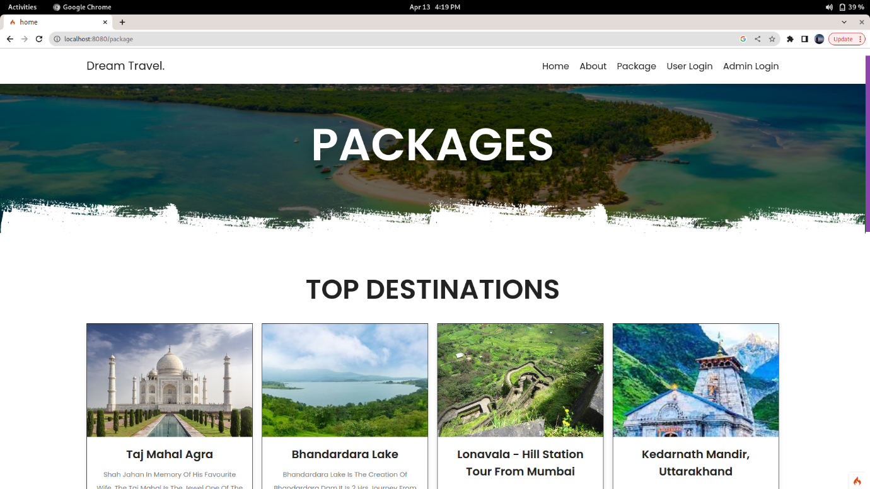

**Payment page:**

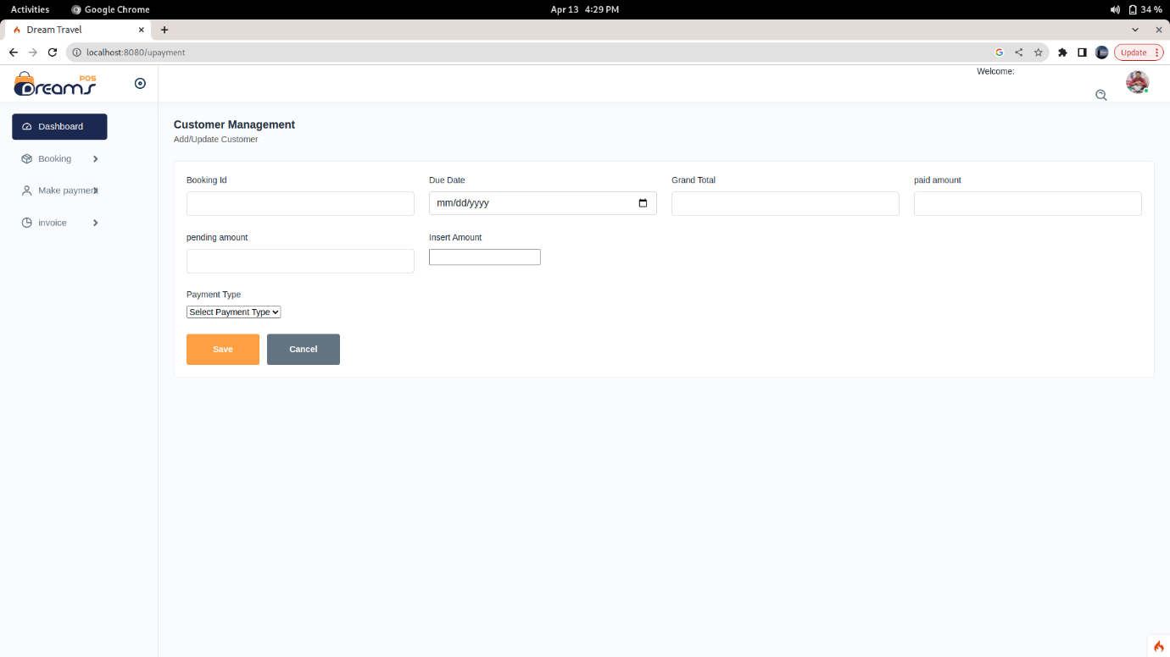

**FUTURE ENHANCEMENT**

User

Services

has

provide

1

M

M

1

M

M

1. In future we can add payment gateway.
2. More Graphical & colors can be extended in future.
3. The system is design for multiuser. i.e. user search services as it’s requirement using the URL

**ADVANTAGES**

* 1. The system is user friendly.
  2. Using this system paperwork will be minimized.
  3. Using given system the particular cost is maintained.
  4. Booking the service is easy.
  5. Easy to find a particular service and its cost.
  6. Using system it is not a time consuming process.

**CONCLUSION**

In organization or in travel agency other small level tourism booking points all reporting were managed by using paper which was very complicated job for owner & also searching the records was the time consuming job.

To avoid all these problem this project is very helpful. Our project helps them in reducing the time required for searching the records. In our project records can be searched easily.

**BIBLIOGRAPHY**

On-line resources -

<https://www.w3resource.com>

<https://www.w3schools.com/>

<https://forum.joomla.org/>

<http://php.net/>

<https://www.tutorialspoint.com>

Books:

1. Programming PHP By Rasmus Lerdorf and Kevin Tatroe, O'Reilly publication

2. Beginning PHP 5 , Wrox publication

3. PHP web sevices, Wrox publication

4. AJAX Black Book, Kogent solution

5. Mastering PHP , BPB Publication

6. PHP cookbook, O'Reilly publication

7. PHP for Beginners, SPD publication