1) Write a Program of an abstract class that has abstract and non-abstract methods .

Source Code:

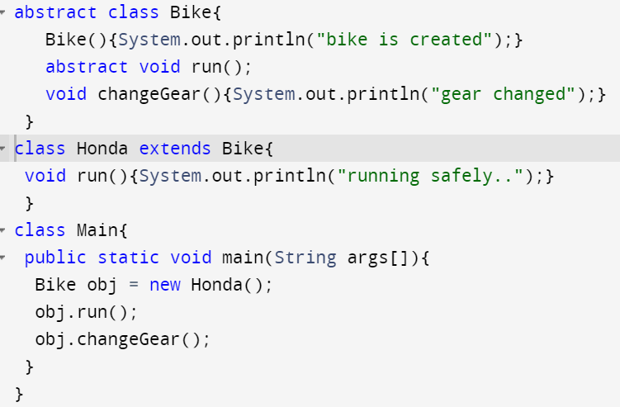

Output:

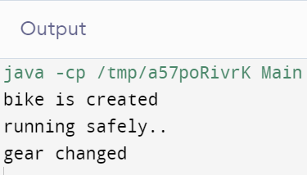

2)Write a Java Program to Demonstrate the working of Interface.

SourceCode:

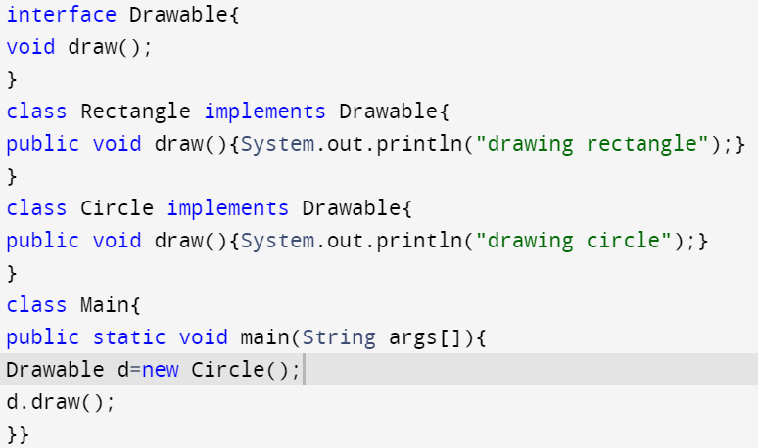

Output:

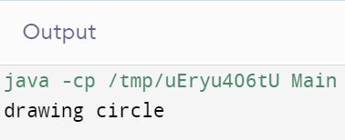

3)Write a Program to show an Abstract class can extend only one class or one abstract class at a time

SourceCode:

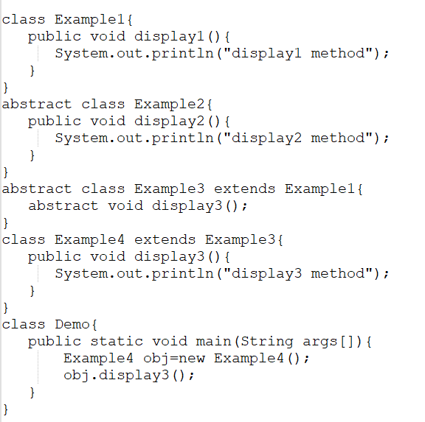

Output:

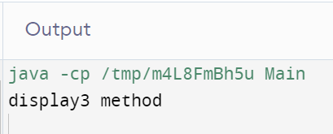

4)Write a Program to show an Interface can Extend any Number of Interfaces at a Time.

SourceCode:

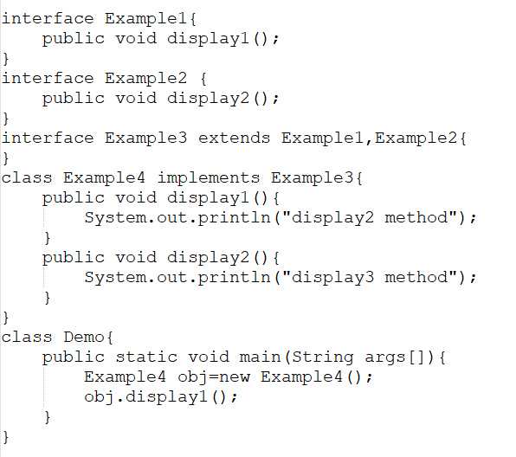

Output:

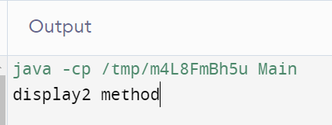

5)Write a Program to show that **Interfaces can be extended only by interfaces. Classes has to implement them instead of extend.**

**SourceCode:**

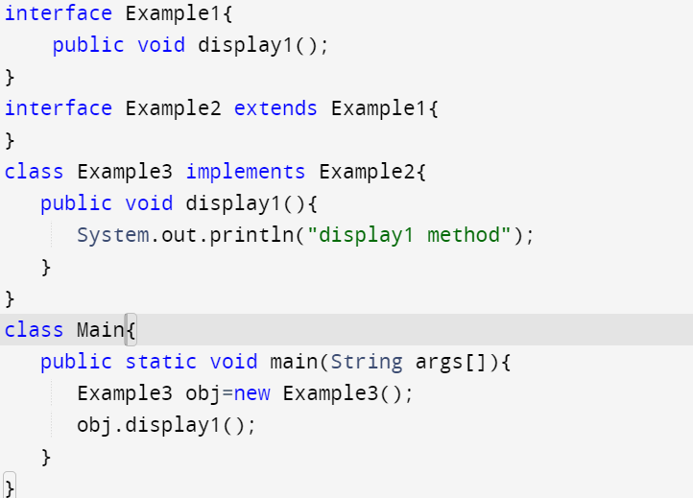

Output:

