LabAssignment_2.2 07/12/22, 11:10 PM

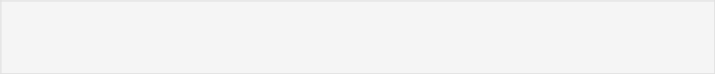

In [9]:

**import** pandas **as** pd

df **=** pd**.**read_csv('SmokingDataSet.csv')

df**.**head()

|  |  |  |  |  |  |  |  |  |  |
| --- | --- | --- | --- | --- | --- | --- | --- | --- | --- |
| Out[9]: | | gender | age | hypertension | heart_disease | ever_married work_type | | Residence_type |  |
|  |  |  |  |  |  |  |  |  |  |
| 0 | | Male | 67.0 | 0 | 1 | Yes | Private | Urban |  |
|  | |  |  |  |  |  |  |  |  |
|  | 1 | Male | 80.0 | 0 | 1 | Yes | Private | Rural |  |
|  |  |  |  |  |  |  |  |  |  |
| 2 | | Female | 49.0 | 0 | 0 | Yes | Private | Urban |  |
|  |  |  |  |  |  |  |  |  |  |
|  | 3 | Female | 79.0 | 1 | 0 | Yes | Self- | Rural |  |
|  | employed |  |
|  |  |  |  |  |  |  |  |  |
|  |  |  |  |  |  |  |  |  |  |
| 4 | | Male | 81.0 | 0 | 0 | Yes | Private | Urban |  |



In [10]:

df**.**info()

|  |  |  |  |  |
| --- | --- | --- | --- | --- |
| <class 'pandas.core.frame.DataFrame'> | | | |  |
| RangeIndex: 4981 entries, 0 to 4980 | | | |  |
| Data | columns (total 11 columns): | | |  |
| # | Column | Non-Null Count | | Dtype |
| --- | ------ | -------------- | | ----- |
| 0 | gender | 4981 | non-null | object |
| 1 | age | 4981 | non-null | float64 |
| 2 | hypertension | 4981 | non-null | int64 |
| 3 | heart_disease | 4981 | non-null | int64 |
| 4 | ever_married | 4981 | non-null | object |
| 5 | work_type | 4981 | non-null | object |
| 6 | Residence_type | 4981 | non-null | object |
| 7 | avg_glucose_level | 4981 | non-null | float64 |
| 8 | bmi | 4981 | non-null | float64 |
| 9 | smoking_status | 4981 | non-null | object |
| 10 | stroke | 4981 | non-null | int64 |

dtypes: float64(3), int64(3), object(5)

memory usage: 428.2+ KB



In [11]:

Out[11]:

In [12]:

objectList **=** list(df**.**select_dtypes(include**=**'object'))

objectList

['gender', 'ever_married', 'work_type', 'Residence_type', 'smoking_status ']

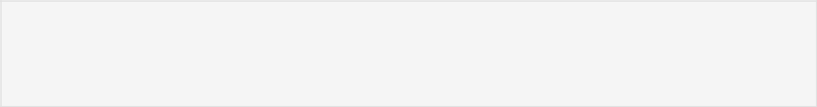

**from** sklearn **import** preprocessing

**for** i **in** objectList:

Encoder **=** preprocessing**.**LabelEncoder()

df[i]**=** Encoder**.**fit_transform(df[i])



In [13]:

df**.**isnull()**.**sum()

http://localhost:8888/nbconvert/html/Documents/MTECH(DSA)/MyLabWork/AML_Lab/LabAssignment_2.2.ipynb?download=false Page 1 of 3

LabAssignment_2.2 07/12/22, 11:10 PM

|  |  |  |
| --- | --- | --- |
| Out[13]: | gender | 0 |
|  | age | 0 |
|  | hypertension | 0 |
|  | heart_disease | 0 |
|  | ever_married | 0 |
|  | work_type | 0 |
|  | Residence_type | 0 |
|  | avg_glucose_level | 0 |
|  | bmi | 0 |
|  | smoking_status | 0 |
|  | stroke | 0 |
|  | dtype: int64 |  |



In [14]:

In [15]:

1. **=** df**.**drop(columns**=**['stroke'],axis**=**1)
2. **=** df['stroke']



**from** imblearn.over_sampling **import** RandomOverSampler

over_sampler **=** RandomOverSampler(sampling_strategy**=**'minority')

x,y **=** over_sampler**.**fit_resample(x,y)



In [16]:

In [17]:

**from** sklearn.model_selection **import** train_test_split

x_train, x_test, y_train, y_test **=** train_test_split(x, y, test_size**=**0.20,

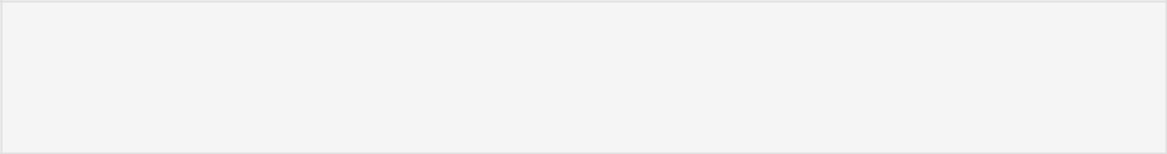

**from** sklearn **import** svm

model_svm **=** svm**.**SVC()

model_svm**.**fit(x_train,y_train)

y_pred **=** model_svm**.**predict(x_test)



In [18]:

**from** sklearn.metrics **import** confusion_matrix cm_log **=** confusion_matrix(y_test,y_pred) cm_log

Out[18]:

In [19]:

array([[648, 299],

[152, 795]])



**from** sklearn.metrics **import** roc_auc_score, roc_curve **import** matplotlib.pyplot **as** plt

**def** plot_roc_curve(y_test,y_pred):

fpr, tpr, thresholds **=** roc_curve(y_test,y_pred)

plt**.**plot(fpr, tpr)

plt**.**xlabel('False Positive Rate')

plt**.**ylabel('True Positive Rate')

plot_roc_curve(y_test,y_pred)

print(f'model(SVM) AUC score: {roc_auc_score(y_test, y_pred)}')

model(SVM) AUC score: 0.7618796198521647

http://localhost:8888/nbconvert/html/Documents/MTECH(DSA)/MyLabWork/AML_Lab/LabAssignment_2.2.ipynb?download=false Page 2 of 3

LabAssignment_2.2 07/12/22, 11:10 PM

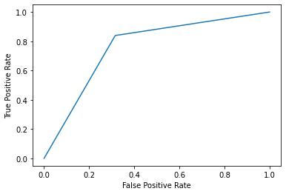

http://localhost:8888/nbconvert/html/Documents/MTECH(DSA)/MyLabWork/AML_Lab/LabAssignment_2.2.ipynb?download=false Page 3 of 3