Group Profile Maker Checker

  - List View – Search Screen

    - Maker Selection Criteria
As soon as the User Clicks on the Group Maker option of menu, selection criteria appears, where the user can enter fields for Searching

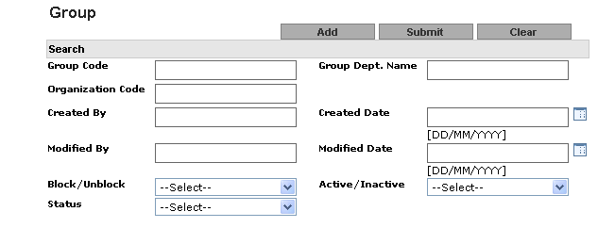

The Following are the fields in the selection Criteria:

Parameter Name | Data-Type | Mandatory/Optional/Conditional | Enable | Insert Allowed | Update Allowed | Field Type | Description
Group Code | A(20) | O | Y | Y | N | Text Field | Use can enter free text for Group Code
Group Dept.Name | A(32) | O | Y | Y | N | Text Field | Use can enter free text for Group Dept. name
Organization Code | A(8) | O | Y | Y | N | Text Field | Use can enter free text for Group Dept. name
Created By | A(21) | O | Y | Y | N | Text Field | Use can enter free text for created by
Created date | D | O | Y | Y | N | Popup
Modified By | A(21) | O | Y | Y | N | Text Field | Use can enter free text for Modified by name
Modified date | D | O | Y | Y | N | Popup
Block/Unblock | A(15) | O | Y | N | N | Drop down | User can search the Block/Unblock group
Active/Inactive | A(15) | O | Y | N | N | Drop down | User can search the Active/Inactive group
Status | A(15) | O | Y | N | N | Drop down | User can select Status:  - Authorized  - Modified  - New  - Deleted  - Modification Rejected  - New Rejected  - Deletion Rejected

    - Group Maker Select List

After entering filter criteria the user clicks on the “Submit” button. The system will display the
Group record along with the following fields in the list based on the filter criteria:

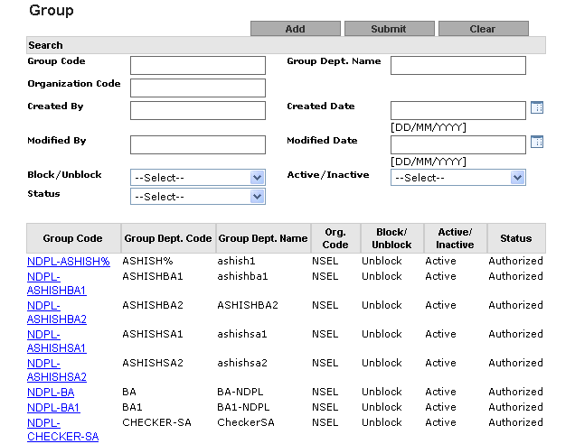

 | Field Name | Description
1 | Group Code | This will be a hyper link. While clicking on this hyperlink, a user can view the record’s details and then can perform further action on that record, such as Modify, Delete.
2 | Group Dept. Code | Group Department Code
3 | Group Dept. Name | Group Name
4 | Org. Code | Organization Code
5 | Block/Unblock | Block/Unblock flag
6 | Active/ Inactive | Active/ Inactive flag
7 | Status | Record status

  - Group Maker View
Click on the hyper Link in Group Code Field of select List. The View Screen is displayed, which shows the details of this Group Code as

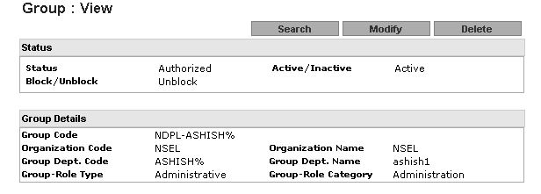

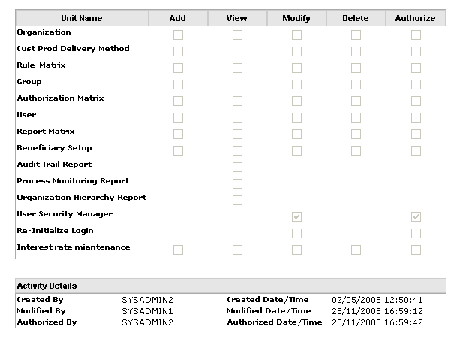

This screen has four parts as:
Status
Sr No. | Field Name | Field Type | Description
1 | Status | Label | Display the current status of Group Like authorized, New etc.
2 | Active/Inactive | Label | Display the current Active/Inactive status
3 | Block/Unblock | Label | Display the current Block/Unblock status

Group Details
Sr No. | Field Name | Field Type | Description
1 | Group Code | Label | Display Group Code
2 | Organization Code | Label | Display Organization Code
3 | Organization Name | Label | Display Organization Name
4 | Group Dept. Code | Label | Display Group Dept. Code
5 | Group Dept. Name | Label | Display Group Dept. Name
6 | Group - Role Type | Label | Display Group - Role Type
7 | Group-Role Category | Label | Display Group-Role Category
8 | Organization Code | Label | Display Organization Code

Access Matrix
Sr No. | Field Name | Field Type | Description
1 | Organization | Check Box | User can view ADD,VIEW,MODIFY,DELETE,AUTHORIZE access rights
2 | Cust Prod Delivery Method | Check Box | User can view ADD,VIEW,MODIFY,DELETE,AUTHORIZE access rights
3 | Rule Matrix | Check Box | User can view ADD,VIEW,MODIFY,DELETE,AUTHORIZE access rights
4 | Group | Check Box | User can view ADD,VIEW,MODIFY,DELETE,AUTHORIZE access rights
5 | Authorization Matrix | Check Box | User can view ADD,VIEW,MODIFY,DELETE,AUTHORIZE access rights
6 | User | Check Box | User can view ADD,VIEW,MODIFY,DELETE,AUTHORIZE access rights
7 | Report Matrix | Check Box | User can view ADD,VIEW,MODIFY,DELETE,AUTHORIZE access rights
8 | Beneficiary Setup | Check Box | User can view ADD,VIEW,MODIFY,DELETE,AUTHORIZE access rights
9 | Audit Trail report | Check Box | User can view VIEW access rights
10 | Process Monitoring Report | Check Box | User can view VIEW access rights
11 | Organization Hierarchy Report | Check Box | User can view VIEW access rights
12 | User security manger | Check Box | User can select MODIFY,AUTHORIZE access rights
13 | Re-Initialize Login | Check Box | User can view MODIFY,AUTHORIZE access rights
14 | LM-Interest Rate | Check Box | User can view ADD,VIEW,MODIFY,DELETE,AUTHORIZE access rights

Activity Details
Sr No. | Field Name | Field Type | Description
1 | Created By | label | Created by Login ID
2 | Created date /Time | label | Created on date time
3 | Modified By | label | Authorize by Login ID
4 | Modified date/Time | label | Authorize on date time
5 | Authorize By | label | Authorize by Login ID
6 | Authorize Date/Time | label | Authorize on date time

  - Group - Maker: Add
On Click of Add on the Maker Selection Criteria, the following Frame gets opened for bank user.
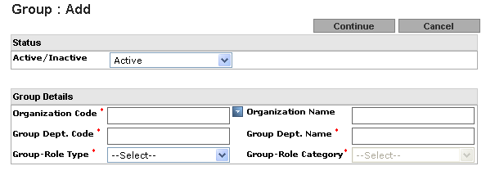
Please enter the following fields and press continue
Parameter Name | Data-Type | Mandatory/Optional/Conditional | Enable | Insert Allowed | Update Allowed | Field Type | Description
Active/Inactive | A(20) | O | Y | Y | N | Text Field | Use can enter free text for Group Code.
Organization Code | A(30) | M | Y | N | N | Popup | User can select the Organization code as shown below in popup screen.
Organization Name | A(50) | O | N | N | N | Text Field | Organization Name populate based on selected Organization Code
Group Dept. Code | A(10) | M | Y | Y | N | Text Field | User can enter Maximum 10 digit group dept.code.
Group Dept. Name | A(50) | M | Y | Y | N | Text Field | User can enter Maximum 50 digit group dept. name.
Group Role Type | A(30) | M | Y | N | N | Drop down List | User can select Group role Type and can create SA and BA as mentioned in group’s Role Type/Category table.
Group role Category | A(30) | M | Y | N | N | Drop down List | User can select Group role Type and can create SA and BA as mentioned in group’s Role Type/Category table.

Organization Code Popup
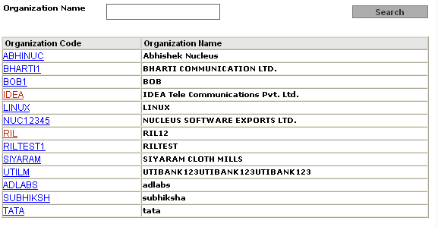

On Click of Continue, if the fields are not entered, then the following kind of message is displayed, to
Inform the user, of the fields not entered

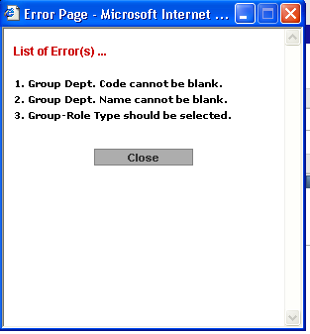

If the Fields are added, the on Click of Continue, the following is shown

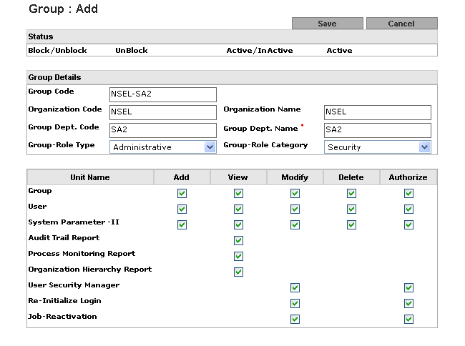

User will add Group defines access rights based on Group Role Type and Role category If
Access Matrix for SA user
Sr No. | Field Name | Field Type | Description
1 | Group | Check Box | User can select ADD,VIEW,MODIFY,DELETE,AUTHORIZE access rights
2 | User | Check Box | User can select ADD,VIEW,MODIFY,DELETE,AUTHORIZE access rights
3 | System parameter | Check Box | User can select ADD,VIEW,MODIFY,DELETE,AUTHORIZE access rights
4 | Audit Trail report | Check Box | User can select VIEW access rights
5 | Process Monitoring Report | Check Box | User can select VIEW access rights
6 | Organization Hierarchy Report | Check Box | User can select VIEW access rights
7 | User security manger | Check Box | User can select ADD,VIEW,MODIFY,DELETE,AUTHORIZE access rights
8 | Re-Initialize Login | Check Box | User can select VIEW access rights
9 | Job-Reactivation | Check Box | User can select VIEW access rights

  - Group Maker-Modify : User cam modify Status and access Right in modified Group case and rest
Remain non editable.

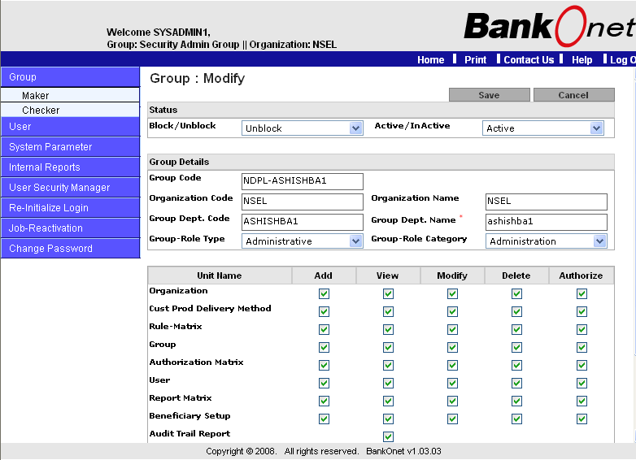

  - Maker: Delete
The user shall be allowed to delete a group using delete functionality on the view screen (once a Group is deleted, it cannot be restored). During the delete process, system will check if there are dependencies, such as if group is used in Authorization Matrix or User Maintenance or Report Matrix, the system will not allow user to delete group and message will show as shown in screen below.
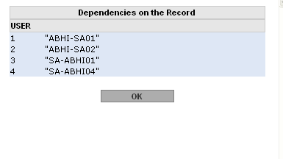

  - Group Checker:
Changes made to the existing group record or newly created group shall be effective in the system after the Checker has authorized it. Once the record has been rejected, the Checker cannot view them either.
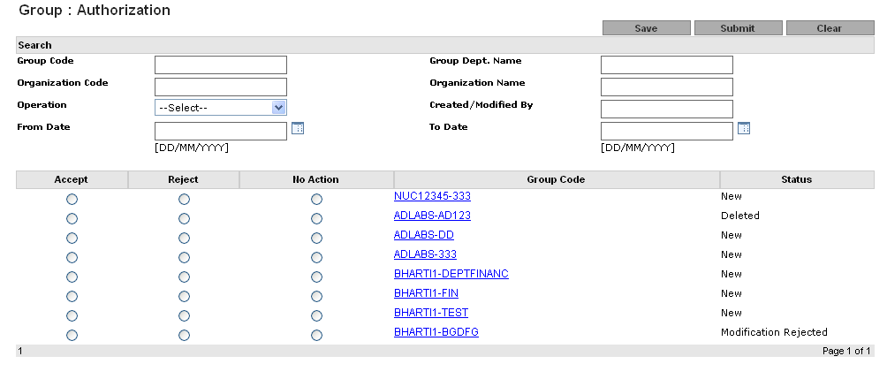 After entering the filter criteria the user shall click on the “Submit” button to list the group records. The group records along with the following fields in a list will be populated based on filter criteria: -

Seq Number |  | Field Name |  | Description
 | 1 | Accept | This will be an option where Authorizer can Accept the record as an authorizer
 | 2 | Reject | This will be an option where Authorizer can Reject the record
 | 3 | No-Action | This will be an option where Authorizer does not want to perform any action on the modified record.
 | 4 | Group Code |  | This will be a hyperlink. While clicking on this hyperlink, user can view the record’s operation detail.
 | 5 | STATUS |  | Record status
.

