Organization Maker Checker

  - List View – Search Screen

    - Maker Selection Criteria

As soon as the User Clicks on the organization Maker option of menu, selection criteria screen appears, where the user can enter fields for Searching

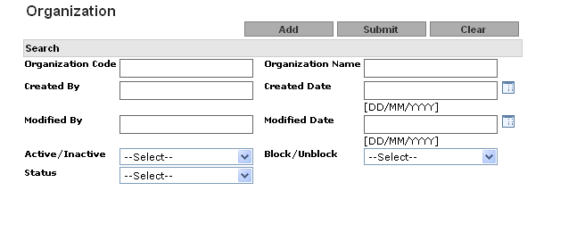

The Following are the fields in the selection Criteria:

Parameter Name | Data-Type | Mandatory/Optional/Conditional | Enable | Insert Allowed | Update Allowed | Field Type | Description
Organization Code | A(8) | O | Y | Y | N | Text Field | User can enter free text for Organization Code.  Organization code cannot contain special characters.
Organization Name | A(255) | O | Y | Y | N | Text Field | User can enter free text for Organization name.  Organization name cannot contain special characters.
Created By | A(21) | O | Y | Y | N | Text Field | User can enter free text for created by.  Created By cannot contain special characters.
Created date | D | O | Y | Y | N | Popup | Created date format should be DD/MM/YYYY
Modified By | A(21) | O | Y | Y | N | Text Field | User can enter free text for Modified by name.  Modified By cannot contain special characters
Modified date | D | O | Y | Y | N | Popup | Modified date format should be DD/MM/YYYY
Block/Unblock | A(15) | O | Y | N | N | Drop down | User can search the Block/Unblock group
Active/Inactive | A(15) | O | Y | N | N | Drop down | User can search the Active/Inactive group
Status | A(15) | O | Y | N | N | Drop down | User can select Status:  - Authorized  - Modified  - New  - Deleted  - Modification Rejected  - New Rejected  - Deletion Rejected

    - Organization Maker Select List

After entering filter criteria the user clicks on the “Submit” button. The system will display the organization record along with the following fields in the list based on the filter criteria:

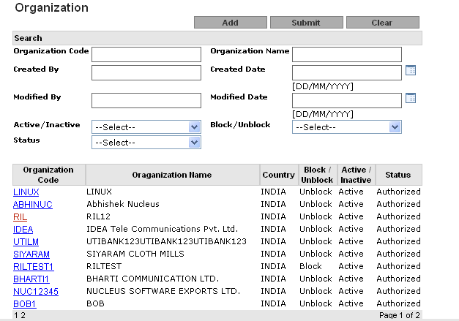

Field Description

Seq Number | Field Name | Description
1 | Organization Code | This will be a hyperlink. While clicking on this hyperlink, a user can view the record’s detail.
2 | Organization Name | Organization Name
3 | Country | Country
4 | Block/Un-Block Status | Block/Un-Block Status
5 | Active/Inactive Status | Active/Inactive Status
6 | Status | New/Authorization Status

  - Organization Maker View

Click on the organization code hyper link in the List view. The View Screen is displayed; this screen shows the details of this organization code as

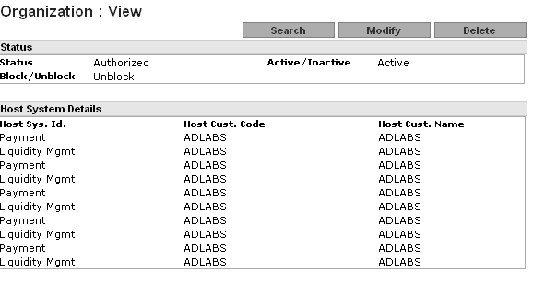
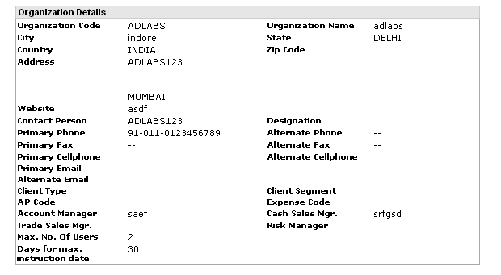
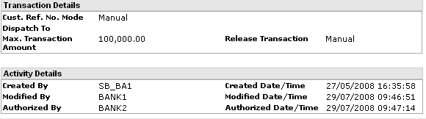

This screen has five parts as:
Status
Sr No. | Field Name | Field Type | Description
1 | Status | Label | Display the current status of Group Like authorized, New etc.
2 | Active/Inactive | Label | Display the current Active/Inactive status
3 | Block/Unblock | Label | Display the current Block/Unblock status

Host System Details

Sr No. | Field Name | Field Type | Description
1 | Host Cust. Code | Label | Display Host customer code (Display cash@will organization code)
2 | Host Cust. Name | Label | Display Host customer name(Display cash@will organization name)
3 | Host Sys. Id. | Label | Display Host system id(product selected for organization)

Organization Details

Sr No. |  | Field Name | Field Type |  | Description
1 | Organization Name |  |  | Label |  | Display Organization name
2 | Organization Code |  |  | Label |  | Display Organization code
3 | Website |  |  | Label |  | Display organization website
4 | Contact Person |  |  | Label |  | Display organization contact person
5 | Designation |  |  | Label |  | Display designation of contact person
6 | Primary Phone |  |  | Label |  | Display primary phone number
7 | Alternate Phone |  |  | Label |  | Display alternate phone number
8 | Primary Fax |  |  | Label |  | Display primary fax number
9 | Alternate Fax |  |  | Label |  | Display alternate fax number
10 | Primary Cell phone |  |  | Label |  | Display primary cell number
11 | Alternate Cell Phone |  |  | Label |  | Display alternate cell number
12 | Primary Email |  |  | Label |  | Display primary email address
13 | Alternate Email |  |  | Label |  | Display alternate email address
14 | Client type |  |  | Label |  | Display client type
15 | Client Segment |  |  | Label |  | Display client segment
16 | AP code |  |  | Label |  | Display AP code
17 | Expense code |  |  | Label |  | Display Expense code
18 | Account Manager |  |  | Label |  | Display account manager
19 | Cash Product Sales Manager |  |  | Label |  | Display cash product sales manager
20 | Trade Sales Manager |  |  | Label |  | Display trade sales manager
21 | Risk Manager |  |  | Label |  | Display risk manager
22 | Maximum Number of Users |  |  | Label |  | Display maximum number of users
23 | Days for maximum Instruction Date. (Note: for any system i.e. payments or collection) |  |  | Label |  | Display maximum instruction date
24 | Address |  |  | Label |  | Display address of organization
25 | City |  |  | Label |  | Display city
26 | State |  |  | Label |  | Display state
27 | Country |  |  | Label |  | Display country
28 | Zip Code |  |  | Label |  | Display zip code

Transactional Details

Sr No. |  | Field Name | Field Type |  | Description
1 | Maximum Transaction Amount (Note: for any system i.e. payments or collection) |  |  | Label |  | Displays maximum amount that the user can withdraw on single instance.
2 | Dispatch To |  |  |  |  | Display the dispatch to information.
3 | Customer Reference Number Mode (Note: for any system i.e. payments) |  |  |  |  | Display mode in which you want organization to generate the customer reference number.
4 | Release Transaction (Note: for any system i.e. payments ) |  |  |  |  | Display release transaction information-system only support manual release.

Activity Details

Sr No. | Field Name | Field Type | Description
1 | Created By | label | Created by Login ID
2 | Created date /Time | label | Created on date time
3 | Modified By | label | Modified by Login ID
4 | Modified date/Time | label | Modified on date time
5 | Authorize By | label | Authorize by Login ID
6 | Authorize Date/Time | label | Authorize on date time

If an organization is blocked any User attached to that organization will not be able to login into the system. If an organization is inactive it will not be visible in the application anywhere.

  - Organization - Maker: Add

On Click of Add on the Maker Selection Criteria, the following Frame gets opened for BA and CA user.

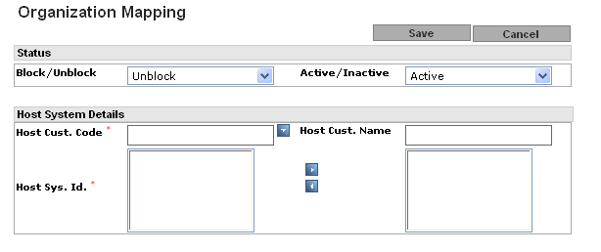
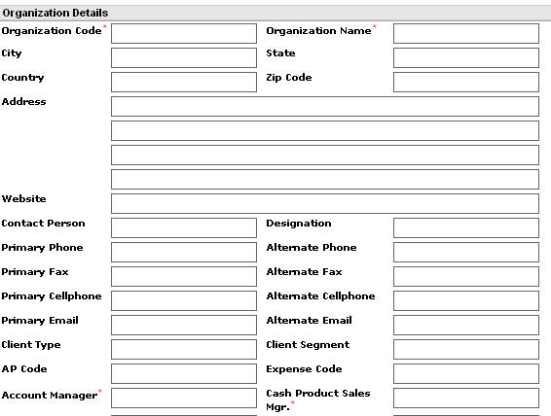
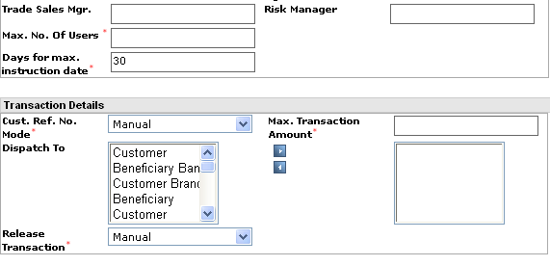

Field Description

Parameter Name | Data-Type/Size | Enable | Insert  Allowed | Update Allowed | Mandatory/ Optional | Field Type | Description/  Validation
Host Customer Code | A(30) | N | N | N | M | Populated from the LOV | Customer Code in host system. (This will populate from cash@will).
Host Customer Name | A(255) | N | N | N | M | Populated from the LOV (attached with Host Customer Code) | Based on customer code in host system populate from. cash@will.
Host System ID | A(15) | N | N | N | M | Text Area/Automatically populated when user select the Host Customer Code. | Based on customer selection Mode comes(Payments, Collection, Liquidity management)
Block / Unblock | A(1) | Y | N | N | O | Drop-Down | Block/Unblock
Active/Inactive | A(1) | Y | N | N | O | Drop-Down | Active/Inactive
Organization Code | A (5) | Y | Y | N | M | Text-Field | Unique Organization Code, which is required to be entered by user
Organization Name | A(255) | N | N | N | M | Text-Field | Organization’s Name will be Host customer name
Website | A(255) | Y | Y | Y | O | Text-Field | Website Address.
Contact Person | A(150) | N | N | N | O | Non editable Text-Field | Name of Contact Person. This shall be auto-populated when Maker selects Host Customer Code.
Designation | A(100) | Y | Y | Y | O | Text-Field | Designation of Contact Person
Primary Phone | A(50) | N | N | N | O | Non editable Text-Field | Primary Phone Number. This shall be auto-populated when Maker selects Host Customer Code.
Alternate Phone | A(50) | N | N | N | O | Non editable Text-Field | Alternative Phone Number. This shall be auto-populated when Maker selects Host Customer Code.
Primary Fax | A(50) | N | N | N | O | Non editable Text-Field | Primary Fax Number. This shall be auto-populated when Maker selects Host Customer Code.
Alternate Fax | A(50) | N | N | N | O | Non editable Text-Field | Alternative Fax Number. This shall be auto-populated when Maker selects Host Customer Code.
Primary Cell phone | A(50) | N | N | N | O | Non editable Text-Field | Primary Cell Number. This shall be auto-populated when Maker selects Host Customer Code.
Alternate Cell Phone | A(50) | N | N | N | O | Non editable Text-Field | Alternative Fax Number. This shall be auto-populated when Maker selects Host Customer Code.
Primary Email | A(100) | N | N | N | O | Non editable Text-Field | Primary Email Address. This shall be auto-populated when Maker selects Host Customer Code.
Alternate Email | A(100) | N | N | N | O | Non editable Text-Field | Alternative Email Address. This shall be auto-populated when Maker selects Host Customer Code.
Client type | A(20) | N | N | N | O | Text Field | Client type
Client Segment | A(20) | Y | Y | Y | O | Text Field | Client Segment.
AP code | A(10) | Y | Y | Y | O | Text Field
Expense code | A(10) | Y | Y | Y | O | Text Field
Account Manager | A(150) | Y | Y | Y | M | Text-Field | Name of Account Manager.
Cash Product Sales Manager | A(150) | Y | Y | Y | M | Text-Field | Name of Cash Product Sales Manager.
Trade Sales Manager | A(150) | Y | Y | Y | O | Text-Field | Name of Trade Product Sales Manager.
Risk Manager | A(150) | Y | Y | Y | O | Text-Field | Name of Risk Manager
Maximum Number of Users | N(8) | Y | Y | Y | M | Text-Field | Allow configuring maximum number of users for organization.
Days for maximum Instruction Date. (Note: for any system i.e. payments or collection) | N(3) | Y | Y | Y | M | Text-Field | Bank-Admin can define the days for maximum future Instruction Date, where user (belonging to the organization) will not be allowed to mention the Instruction Date more than Current Date + Days mentioned in this field. The default value shall be 30 days. This shall be applicable for Payment Transaction only
Address | A(100) | N | N | N | O | Non editable Text-Field | Organization’s Address Field-1. This shall be auto-populated when Maker selects Host Customer Code.
City | A(100) | Y | Y | Y | O | Text-Field | Organization’s City
State | A(100) | N | N | N | O | Non editable Text-Field | Organization’s State. This shall be auto-populated when Maker selects Host Customer Code.
Country | A(2) | N | N | N | O | Non editable Text field | Country Code for Organization’s Address. This shall be auto-populated when Maker selects Host Customer Code.
Zip Code | A(6) | N | N | N | O | Non editable Text-Field | Zip Code for Organization’s Address. This shall be auto-populated when Maker selects Host Customer Code.
Maximum Transaction Amount (Note: for any system i.e. payments or collection) | N(15)(13,2) | Y | Y | Y | M | Text-Field | BankONet will facilitate assignment of the maximum transaction amount for that organization.  All the users belonging to that organization will not be able to initiate the payment for more than configured Max. Txn. Amount. This is applicable at transaction level only.
Dispatch To | A(2) | Y | N | N | O | Multi-selection List  This field will be available for Payment only.  This will allow Bank-Admin to Select predefined Dispatch To values from the list.  User can select none or multiple (all) values from the available list. | This will allow Bank-Admin to Select predefined Dispatch To values from the list.
Customer Reference Number Mode (Note: for any system i.e. payments) | A(1) | Y | N | N | M | Drop-Down | If “Automatic” is selected in Organization Maintenance, then this organization shall use automatic reference number.  If “Manual” is selected in organization maintenance, then this organization shall use manual reference number.  (Domain values could be:  “A” – Automatic  “M” – Manual)
Release Transaction (Note: for any system i.e. payments ) | A(1) | Y | N | N | M | Drop-Down | BankONet shall facilitate the customer to configure the mode for releasing the transaction to the host system. It can be configured as Automatic or Manual.  (Domain values could be:  “A” – Automatic  “M” – Manual)

Host customer code LOV

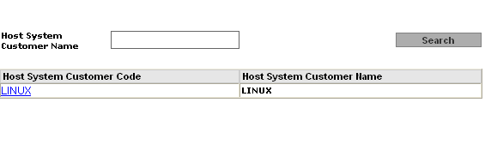
If the mandatory fields are not entered, then the following kind of message is displayed, to inform the user, of the fields not entered

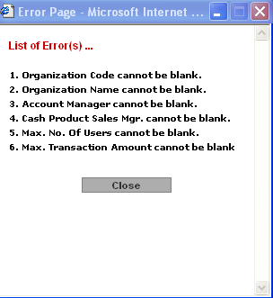

When you click on save button after adding mandatory fields, record will get save.

  - Organization Maker-Modify:

This screen allows modification of details of an existing organization.
User is not allowed to modify “Organization Code”, “State”, “Country”, “Zip Code”, “Contact Person”, “Primary Cell”,” Alternate Cell “, “Primary Phone”,” Alternate Phone “, “Primary Fax”,” Alternate Fax “and “Address” fields.

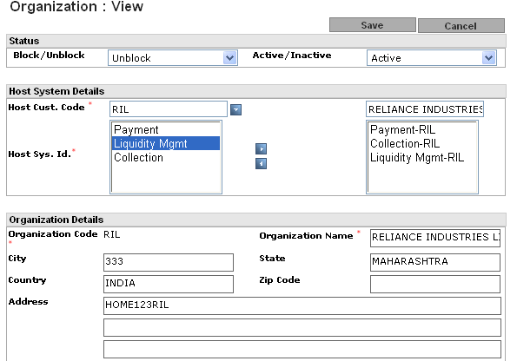
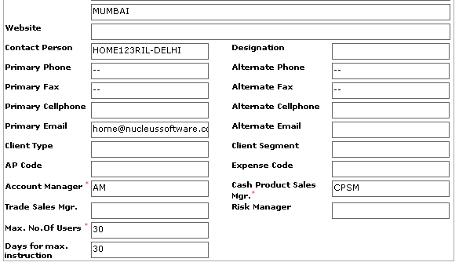
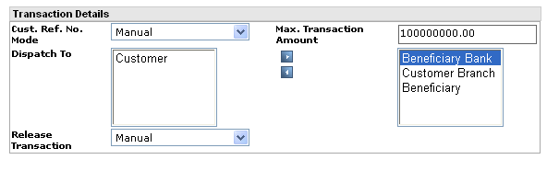

  - Maker: Delete

This allows deletion of an organization record.
Once record of an organization is deleted, it cannot be restored. When Maker is deleting record of an organization, the system shall check its dependency on the Rule Matrix and Organization Association. If there is any dependency, the system will not allow the Maker to delete record of the organization and message will show as shown in screen below.

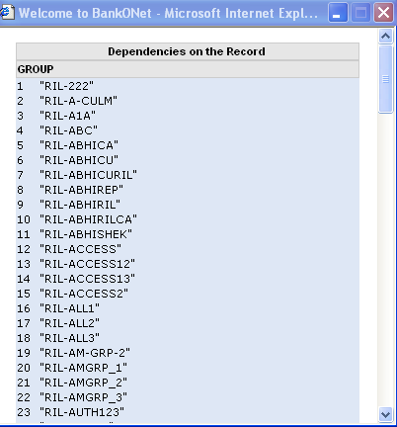

Note: System shall pull the information of the organization that is common with Cash@will. This will ensure data consistency. . If a Organization is Inactive it will not be visible in the application anywhere i.e. In case a Organization is Inactive, while making a Group this Organization will not be visible in the Organization Code pop up while adding a Group.

  - Organization Checker:

Once an organization record is added/modified/deleted by a Maker, the changes made would be effective only when Checker has authorized it. Checker is provided with the functionality to authorize or reject such kind of changes to the organization record. Once the records have been rejected he cannot view the rejected record. The system shall provide the following filter criteria for Checker Listing: -

  - Operation (like: New, Modify, Delete, New Rejected, Modify Rejected & Delete Rejected)
  - Created/Modify By
  - From Date
  - To Date
  - Organization Code
  - Organization Name

Checker Screen look like

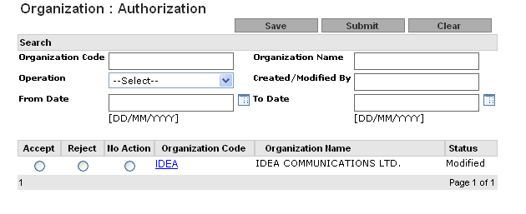

After entering filter criteria, the user clicks on the “Submit” button. The system will display organization records along with following fields in the listing based on filter criteria:

The Following are the fields in the selection Criteria:

Parameter Name | Data-Type | Mandatory/Optional/Conditional | Enable | Insert Allowed | Update Allowed | Field Type | Description
Organization Code | A(8) | O | Y | Y | N | Text Field | User can enter free text for Organization Code.  Organization code cannot contain special characters.
Organization Name | A(255) | O | Y | Y | N | Text Field | User can enter free text for Organization name.  Organization name cannot contain special characters.
Created/Modified By | A(21) | O | Y | Y | N | Text Field | User can enter free text for created/ Modified by.  Created/ Modified By cannot contain special characters.
From date | D | O | Y | Y | N | Popup | Created date format should be DD/MM/YYYY
To date | D | O | Y | Y | N | Popup | Modified date format should be DD/MM/YYYY
Status | A(15) | O | Y | N | N | Drop down | User can select Status:  - Authorized  - Modified  - New  - Deleted  - Modification Rejected  - New Rejected  - Deletion Rejected

List view Filed Description

Seq Number | Field Name | Description
1 | Accept | This will be an option where Authorizer can Accept the record as an authorizer
2 | Reject | This will be an option where Authorizer can Reject the record
3 | No-Action | This will be an option where Authorizer does not want to perform any action on the modified record.
4 | Organization Code | This will be a hyper link. While clicking on this hyperlink, user can view the record’s operation detail.  Such as:  In case of Modification, user can view pre-modification and post modification comparison.  In case of New, user can view record details only.  In case of Delete, user can view record details only.
5 | Organization Name | Organization Name
6 | Status | Status of the record.

Note: Once authorizer selects all the appropriate action (like “Accept/Reject/No-Action”) then he/she is required to click on “Save” button to authorize all the desired records.

