Question1- Create a new git repository of your choice and clone it in your local drive byusing github desktop

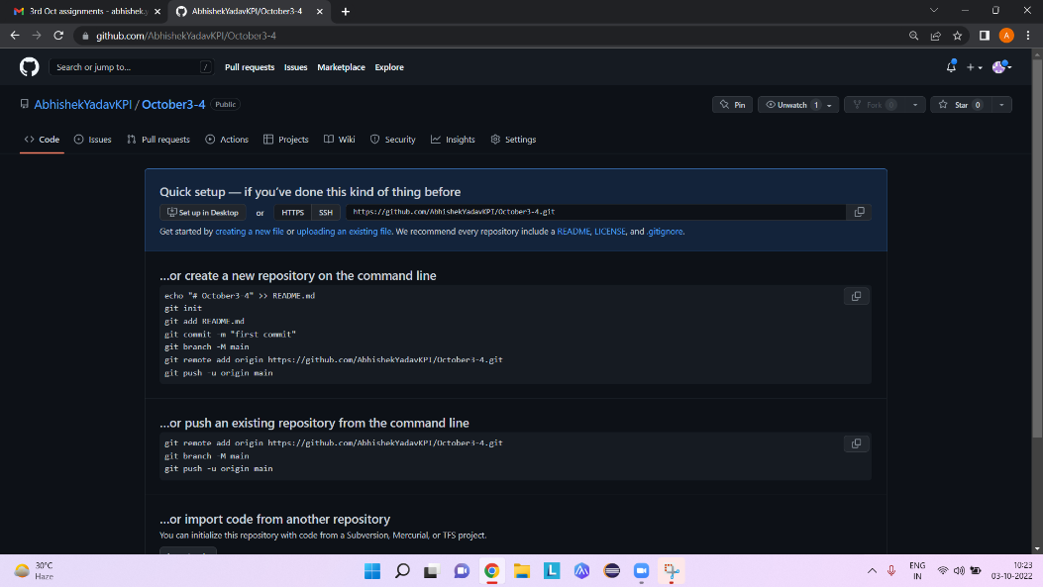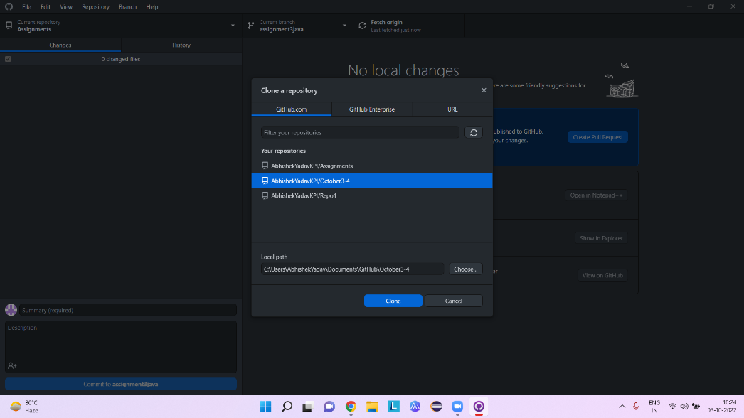

* Question 4 is implemented in books package
* In question 5, diamond problem cannot be solved without the use of interfaces.