**Load Dispatch Balancer**

**Starting the Application**

Step 1: Setup Database in the MySQL Workbench

Set up the connection & database in the MySQL workbench. Copy the database url.

Step 2: Configure the Database in the application.properties file  
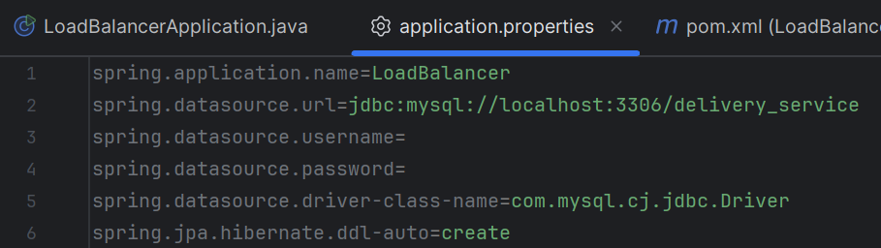

After setting up the connection and the database, configure the url of the connection with the username and password as shown in above image

Step 3: Run Unit Tests

Run the unit tests to ensure that everything is in check.

Go to test/com/example/LoadBalancer/Tests/DeliveryServiceTest.java

Run this test using an IDE of your choice, in this case it was IntelliJ.  
  
Ensure all 4 test cases in this case have passed like in the image shown below.

Step 4: Run the application

Go to com/example/LoadBalancer/LoadBalancerApplication.java and run the application with any IDE of your choosing or you can convert the application to a jar file and directly start running the application. If you choose to run the application from the IDE itself you can start the application as shown below.

**Using the API’s**

You can use a tool like postman to test the api’s directly.

1. Input Delivery Orders

Endpoint: POST /api/dispatch/orders

Request Body:

Response Body:

1. Input Fleet Details

Endpoint: POST /api/dispatch/vehicles

Request Body:

Response Body:

1. Retrieve Dispatch plan

Endpoint: GET /api/dispatch/plan

Response:

