BUAN 6312: Applied Econometrics and Time Series Analysis

FINAL PROJECT PAPER

**ESTIMATING DEMAND OF AIRLINE TICKETS**



**Submitted by: Group 3**

Claire Rosenbluth

Akshat Bhandari

Anushka Dube

Pushkar Nagpal

Abhishek Arya

Vipin

Sai Gagan Shakamuri

**INTRODUCTION**

The aviation industry is constantly changing, Continued growth in passenger numbers and flight operations will require increased investment in airport and aircraft capacity. But even with this new investment, peak hour congestion and the environmental impact of air travel remain issues. Aviation is obviously a field full of externalities. Another development in the airline industry is the trend towards forming alliances. According to the literature, these partnerships can be beneficial to passengers, but still require some form of aviation authority approval. Therefore, in liberalized air transport, aviation authorities play an important role in protecting the public from excessive noise and protecting consumers from the "excessive" use of market power

The dataset under consideration covers the period 1997-2000, a key period preceding the notable events of the bursting of the ``tech bubble'' in 2001 and the subsequent recession. This temporal focus allows us to capture the dynamics of the airline industry in the years leading up to the severe recession, and provides a valuable opportunity to investigate air passenger behavior in response to changing conditions. Significance of this era. The late 1990s ushered in a period of significant growth, characterized by economic prosperity and technological progress. However, this period was not immune to the pressing challenges that emerged in the early 2000s. The anticipation and likelihood of a “tech bubble” bursting and recession provide a unique perspective for investigating airline passenger responses to ticket price fluctuations during critical economic transitions.

**OBJECTIVE**

Our primary objective focuses on quantifying air passenger price elasticities and identifying time trends over the years prior to the 2001 recession. The key measure is price elasticity, which reflects the sensitivity of air passengers to changes in ticket prices. By focusing on specific time periods, we aim to reveal how this sensitivity changes as a country approaches recession.

Our research aims to answer the following fundamental questions: Through thorough econometric analysis, we aim to provide nuanced insights into demand trends within the airline industry and reveal the complexity of passenger behavior in times of economic change. The following sections of this report describe the methodology used for the analysis, details of the dataset, and the implications of the results. Through this study, we aim to provide valuable insights into the understanding of demand elasticity in the airline industry, especially in the context of economic precursors to recession.

**LITERATURE REVIEW**

**Price Elasticities of Demand for Passenger Air Travel: A Meta-Analysis**

With a thorough meta-analysis, the paper "Price Elasticities of Demand for Passenger Air Travel: A Meta-Analysis" advances our knowledge of demand elasticity in the aviation sector. Using meta-analytical techniques, the authors compare and contrast a large number of empirical research in order to find similarities and differences in the variables affecting pricing elasticities. This method makes it possible to investigate in-depth how sensitive airline customers are to fluctuations in ticket costs. The meta-analysis offers a valuable foundation for our own inquiry by combining findings from other investigations, which guides our methodological decisions and results interpretation.

**The Effect of Concentration on Price: Analysis of the Airline Industry**

The Effects of Concentration on Prices: Airline Industry Analysis Another related study, ``The Effects of Concentration on Prices: Airline Industry Analysis,'' examines the effects of market concentration on pricing in the US domestic airline industry. The authors treat each route as a separate market and use panel data to control for unobserved effects specific to each market through a fixed effects approach. This research provides valuable insight into the relationship between market structure and pricing strategies, and provides a framework for understanding how industry trends impact ticket prices. Considering the lessons from this analysis, we would like to consider market concentration as a potential influencing factor on air passenger price elasticity in our own research. Integrating these important studies with a literature review informs approaches to estimating demand, examining trends in air passenger price elasticities, and contextualizing the 2001 recession. In order to provide a foundation for our research, we draw on the methods and insights of previous researchers.

Based on the results of the meta-analysis, our study follows a panel data approach using a fixed-effects model. This methodological choice allows us to account for unobserved heterogeneity among entities in our dataset and provides a robust framework for analyzing the dynamics of airline ticket demand. Panel data allows us to capture variation over time and between different companies, providing a more comprehensive understanding of the factors that influence price elasticity

Our approach also takes into account the impact of an impending recession by incorporating this economic context into our analysis, we aim to assess how airline passengers' sensitivity to price changes changed in the years leading up to the 2001 recession. This temporal aspect increases the relevance and applicability of our findings and makes it possible to draw meaningful conclusions about the influence of economic conditions on the elasticity of demand.

**DATA DESCRIPTION**

The dataset [airfare.dta](https://www.reed.edu/economics/parker/s10/312/Asgns/Data/airfare.dta) contains data for airfares, number of passengers, distance, and the market share of the largest carrier for each of the top 1149 city-pair markets within the contiguous 48 states for the fourth quarters of 1997, 1998, 1999, and 2000. The data are from the Domestic Airline Fares Consumer Report published by the U.S. Department of Transportation. The city pairs in the sample account for about 75 percent of total within-48-state passenger trips. This dataset is taken from the collection published with the Wooldridge text and the assignment is a greatly expanded version of one of his empirical exercises.

Our objective is to study the passenger price elasticity by evaluating this time-series data leading to the 2001 recession. Our **dependent variable** thus, is **passen** representing the number of passengers on the flight.

**Independent Variables -**

dist: Distance(in miles), fare: Average one-way fare , bmktshr: Bulk market share

**Variables of Interest -**

Year, Passen, Fare

**Summary Statistics –**

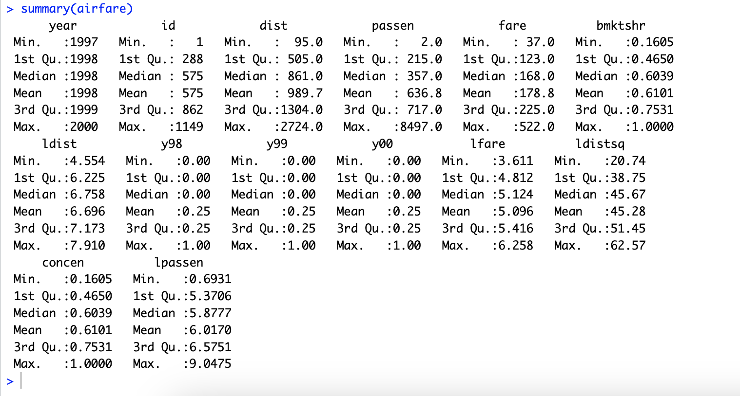

**EMPIRICAL METHOD**

**Variation in Panel Data**:

Panel data, covering the period 1997-2000, involves observations on multiple entities (airlines, presumably) over several years. In this context, entities could be considered as cross-sections. Variation can arise from both observed factors (such as different airline characteristics, routes, etc.) and unobserved factors (such as airline-specific strategies, management decisions, etc.)

**Interest in Observing Variation Across Time:**

Despite controlling for cross-sectional variation, there is still an interest in understanding how air passenger behavior changes over time, especially in the years leading up to the 2001 recession. This temporal aspect allows for the examination of trends, patterns, and responses to changing economic conditions, including the anticipation of the "tech bubble" bursting and the subsequent recession.

**One-Way Individual Fixed Effects Model Selection:**

To address the challenges posed by observed and unobserved cross-sectional variation while preserving the ability to observe temporal changes, a one-way individual fixed effects model is chosen. In this model, individual-specific effects (possibly related to each airline) that remain constant over time are controlled for. This helps isolate time-varying effects, allowing for a more accurate estimation of the impact of ticket prices on air passenger demand.

The one-way individual fixed effects model is well-suited for this scenario because it accounts for individual heterogeneity while still enabling the investigation of how passenger behavior responds to changing economic conditions over time. By controlling for individual-specific characteristics, the model aims to provide insights into the general trends and variations in air passenger demand that are not solely attributed to the characteristics of individual airlines.

$$lpassen= β_{0}+β_{1}lfare+β_{2}bmktshr+β_{3}1998+β_{4}1999+β_{5}2000+β_{6}bmktshr*1998+β_{7}bmktshr*1999+β_{8}bmktshr*2000+β_{9}lfare*1998+β_{10}lfare*1999+β_{10}lfare*2000$$

**R Code:**

plm = plm(lpassen ~ lfare + bmktshr + factor(year) + bmktshr*factor(year) + lfare*factor(year), data = airfare, model = "within", effect = "individual", index = c("id", "year")); summary(plm)

Oneway (individual) effect Within Model

Call:

plm(formula = lpassen ~ lfare + bmktshr + factor(year) + bmktshr *

factor(year) + lfare * factor(year), data = airfare, effect =

"individual", model = "within", index = c("id", "year"))

Balanced Panel: n = 1149, T = 4, N = 4596

Residuals:

Min. 1st Qu. Median 3rd Qu. Max.

-1.68801084 -0.04774039 0.00019224 0.04833972 1.84668895

Coefficients:

Estimate Std. Error t-value Pr(>|t|)

lfare -1.136302 0.023359 -48.6456 < 2.2e-16 ***

bmktshr 0.178099 0.042950 4.1467 3.455e-05 ***

factor(year)1998 0.326391 0.077818 4.1943 2.807e-05 ***

factor(year)1999 0.398368 0.077363 5.1493 2.761e-07 ***

factor(year)2000 0.436063 0.079772 5.4663 4.921e-08 ***

bmktshr:factor(year)1998 -0.014304 0.031396 -0.4556 0.6487116

bmktshr:factor(year)1999 -0.041355 0.031498 -1.3130 0.1892834

bmktshr:factor(year)2000 -0.100518 0.031521 -3.1889 0.0014411 **

lfare:factor(year)1998 -0.053740 0.013979 -3.8443 0.0001231 ***

lfare:factor(year)1999 -0.053081 0.013893 -3.8208 0.0001354 ***

lfare:factor(year)2000 -0.035085 0.014290 -2.4553 0.0141276 *

---

Signif. codes: 0 ‘***’ 0.001 ‘**’ 0.01 ‘*’ 0.05 ‘.’ 0.1 ‘ ’ 1

Total Sum of Squares: 128.1

Residual Sum of Squares: 69.443

R-Squared: 0.4579

Adj. R-Squared: 0.27504

F-statistic: 263.847 on 11 and 3436 DF, p-value: < 2.22e-16

**Test comparing OLS and PLM**

ols = lm(lpassen ~ lfare + bmktshr + factor(year) + bmktshr*factor(year) + lfare*factor(year), data = airfare); summary(ols)

plm = plm(lpassen ~ lfare + bmktshr + factor(year) + bmktshr*factor(year) + lfare*factor(year), data = airfare, model = "within", effect = "individual", index = c("id", "year")); summary(plm)

pFtest(plm, ols)

F test for individual effects

data: lpassen ~ lfare + bmktshr + factor(year) + bmktshr * factor(year) + ...

F = 140.96, df1 = 1148, df2 = 3436, p-value < 2.2e-16

alternative hypothesis: significant effects

^^ Conclusion: plm model is better

**Results**

Oneway (individual) effect Within Model

Call:

plm(formula = lpassen ~ lfare + factor(year) + lfare * factor(year),

data = airfare, effect = "individual", model = "within",

index = c("id", "year"))

Balanced Panel: n = 1149, T = 4, N = 4596

Residuals:

Min. 1st Qu. Median 3rd Qu. Max.

-1.70665437 -0.04704961 0.00013775 0.04757085 1.85316352

Coefficients:

Estimate Std. Error t-value Pr(>|t|)

lfare -1.138434 0.023023 -49.4483 < 2.2e-16 ***

factor(year)1998 0.316859 0.069643 4.5498 5.556e-06 ***

factor(year)1999 0.368459 0.069176 5.3264 1.066e-07 ***

factor(year)2000 0.343979 0.072011 4.7768 1.856e-06 ***

lfare:factor(year)1998 -0.053290 0.013669 -3.8985 9.863e-05 ***

lfare:factor(year)1999 -0.052374 0.013559 -3.8627 0.0001142 ***

lfare:factor(year)2000 -0.029289 0.013966 -2.0972 0.0360449 *

---

Signif. codes: 0 ‘***’ 0.001 ‘**’ 0.01 ‘*’ 0.05 ‘.’ 0.1 ‘ ’ 1

Total Sum of Squares: 128.1

Residual Sum of Squares: 69.941

R-Squared: 0.45401

Adj. R-Squared: 0.27069

F-statistic: 408.637 on 7 and 3440 DF, p-value: < 2.22e-16

**INTERPRETATION**

* Model R-squared: 0.45
* All coefficients are statistically significant at the 5% level
* 10% increase in *fare*, 11.4% decrease in *passen*
* Passengers are becoming more inelastic over time
* Passenger travel increases until 1999 and then decreases, compared to 1997
  + 1998: 37.3%
  + 1999: 44.6%
  + 2000: 41.1%

**CONCLUSION**

**Inelasticity increasing over time:**

Our analysis shows a gradual increasing trend in air passenger inelasticity from 1997 to 2000. This suggests reduced responsiveness to changes in ticket prices, which is important for an effective pricing strategy

**Decrease in passenger numbers in 2000:**

It is noteworthy that passenger numbers declined in 2000. Although the dataset ends in 2000, it is important to have data from 2000 onwards to investigate the factors behind this decline and assess its impact

**Request Post-2000 Data for Recession Analysis:**

To enhance our study, obtaining data beyond 2000 is essential. Accessing information during and after the 2001 recession would allow us to analyze the impact on travel demand, providing insights into pricing strategies and passenger preferences during economic downturns.

**Recommendations for Future Research**

Given these conclusions, we recommend extending the analysis to his post-2000 period. This will contribute to a more comprehensive understanding of air passenger behavior, especially in the face of economic challenges, and provide actionable insights for industry participants

**REFERENCES**

1.Brons, Martijn & Pels, Eric & Nijkamp, P. & Rietveld, Piet. (2001). “Price elasticities of demand for passenger air travel: A meta-analysis.” Journal of Air Transport Management.

2.Kwon, Jiyoung. (2003). “The Effect of Concentration on Price: Analysis of the Airline Industry” Michigan State University.

3.World Bank Open Data. (n.d.). United States . United States | World Bank Open Data. <https://data.worldbank.org/country/united-states?view=chart>. Accessed November 23, 2023.