SUPPLEMENTARY MATERIALS
Section A. Data collection instruments and thematic coding

Contents. Tables S1-S2 and Figure S1.
Item | Contents
Figure S1 | A2 paper map used for participatory mapping
Table S1 | Interview questionnaire
Table S2 | Thematic coding framework

Supplementary Figure S1. A2 paper chart of the Indian Ocean, with land areas and latitude and longitude clearly demarcated.
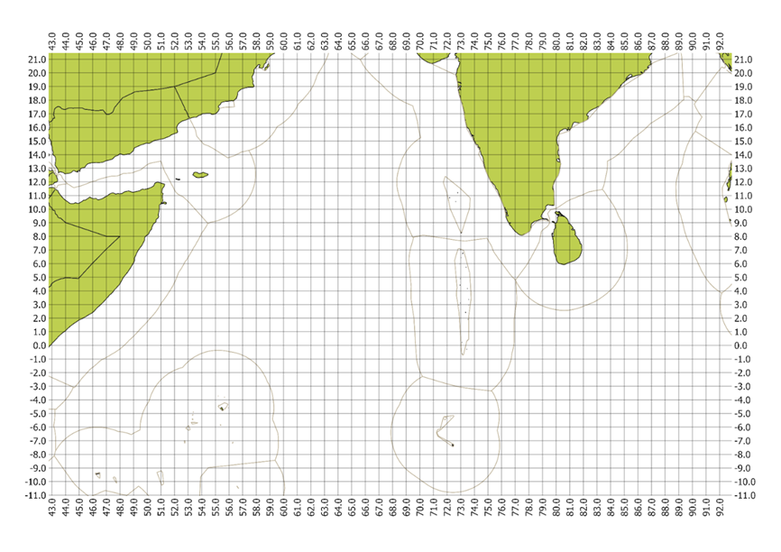

Supplementary Table S1. Specific questions asked of fishers during the interview.
Sr no. | Question | Response | Data type | Justification | Analysis type
a. Fishing experience
1 | Which harbour(s) are you operating from? | Open ended | Categorical | Objective 1 | Descriptive stats (frequency, proportions)
2 | What is your main occupation? [only one option allowed] |  | Categorical | Objective 2 | Frequency analysis, cross-tab with spatial variables
  Fisher
  Skipper
  Other
  Don’t want to answer
3 | What is your fishing experience? | ……………………………(in yrs) | Numerical | Objective 2&3 | Descriptive stats (mean, median, std), correlation
- Vessel Characteristics (Now I will be asking some questions about the vessel you mainly work at or own)
4 | What is the length (approximately) of the fishing vessel? | Length in feet:  ________________ | Numerical | Objective 1&2 | Descriptive stats, regression variable
5 | Is your boat registered? If yes, ask the next question | Yes/No | Categorical | Objective 2&3 | Frequency, cross-tab with effort patterns
6 | What are your main gear types (indicate 1 and 2 for primary and secondary gear type) |  | Categorical | Objective 2 & 3 | Frequency, cross-tab with spatial distribution
  Long-line
  Nets
  Other (please specify)
7 | Which type of fishery licence does the vessel have? | Answer with a tick | Categorical | Objective 2&3 | Descriptive stats, correlation with spatial extent
  High seas operation licence
  Local water operation
  Don’t want to answer
8 | What % of time do you fish in the High Seas? | ________________% | Continuous | Objective 1 & 3 | Descriptive stats, correlation with drivers
9 | What % of time do you fish in local waters? | ________________% | Continuous | Objective 1 | Descriptive stats, correlation with drivers
10 | What % of time do you fish in other countries' waters? | ________________% | Continuous | Objective 1 & 3 | Descriptive stats, correlation, potential regression variable
11 | Please select all that are installed | Answer with a tick | Categorical (Multiple Selection) | Objective 2&3 | Frequency analysis, Technology Index question
  Technology | YES | NO | Don’t know what it is
  VMS
  AIS
  Odaku
  Other (specify)
  Don’t want to answer
12 | How often is AIS transmitting on your fishing trips? | Answer with a tick | Categorical (ordinal) | Objective 2 & 3 | Frequency analysis, factor in Technology Index
  On every trip (100%)
  Occasionally (75%)
  Sometimes (50%)
  Rarely (25%)
  Never (0%)
13 | How often is VMS transmitting on your fishing trips? | Answer with a tick | Categorical (ordinal) | Objective 2 & 3 | Descriptive stats, correlation with spatial metrics
  On every trip (100%)
  Occasionally (75%)
  Sometimes (50%)
  Rarely (25%)
  Never (0%)
- Driving factors
Socio-economic
14 | What are your average costs per fishing trip? | _______________(₹) | Continuous | Objective 2 | Descriptive stats, input for net benefit
15 | What proportion of your total fishing costs? |  | Numerical | Objective 2 | Net-benefit analysis under: how changes in fuel cost impact net benefits and fishing decisions.
  %
  Fuel
  Maintenance
  Food
  Ice
  Crew wages
  Others (specify)
16 | Do you receive fishing subsidies? | Yes/No | Binary | Objective 2 | Frequency, correlation with net benefit
17 | Please specify what are the main subsidies you receive? |  | Categorical /Numerical | Objective 2 | Descriptive stats, factor in net benefit.
   | Amount (per ltr/person) | Quantity (one trip)
  Fuel
  Wages
  Other (please specify)
18 | What proportion of fishing costs do these subsidies cover? | ________________% | Numerical | Objective 2 | Descriptive stats, scenario analysis
19 | What is the system of profit distribution in your boat? |  | Numerical | Objective 2 | Descriptive stats, correlation with spatial patterns
  Owner share (%)
  Crew share (%)
  Captain share (%)
20 | What are the average earnings of the vessel per trip ? | ________________(₹) | Continuous | Objective 2 | Descriptive stats, net benefit calculation
Spatial management and policy
21 | Are you aware of regulations prohibiting fishing in foreign waters? | Yes/No | Binary | Objective 2 & 3 | Frequency, factor in compliance analysis
22 | How much do you agree with the following:  Regulations prohibiting fishing in other countries' waters impact my choice of fishing location | - Strongly Disagree  - Disagree  - Neither Agree nor Disagree  - Agree  - Strongly Agree  - I Don’t Know | Categorical (ordinal) | Objective 2&3 | Score calculation, correlation with spatial patterns
23 | Currently, how likely do you think it is to get caught if you cross into another country’s waters? |  | Categorical (ordinal) | Objective 2&3 | Score, correlation with foreign waters effort
  Very likely
  Likely
  Unlikely
  Very unlikely
  I don't know
24 | What is the likelihood of facing negative consequences (e.g., fines, boat seizure) for fishing illegally in other countries' waters? |  | Categorical (ordinal) | Objective 2&3 | Score, correlation with illegal fishing behaviour
  Very likely
  Likely
  Unlikely
  Very unlikely
  I don't know
25 | What percentage of your friends fish in foreign waters? | - Most of them (75-100%)  - About half of them (50-75%)  - Some of them (25-50%)  - A few of them (1-25%)  - None of them (0%) | Categorical | Objective 2&3 | Frequency, correlation with foreign waters fishing
26 | How has the likelihood of negative consequences changed in the last 5 years? |  | Categorical | Objective 2&3 | Descriptive narrative context
  Strongly Increased
  Slightly increased
  Stayed the same
  Slightly decreased
  Strongly decreased
27 | How has the likelihood of negative consequences changed during covid 19? |  | Categorical |  | Drivers influential during covid period
  Strongly Increased
  Slightly increased
  Stayed the same
  Slightly decreased
  Strongly decreased
28 | If it has changed, why? | Open ended | Qualitative | Objective 2&3 | Qualitative analysis, narrative support
29 | What % of people you know have been caught whilst illegally fishing in foreign waters? | ____% | Continuous | Objective 2&3 | Descriptive stats, correlation with compliance/effort
Target species & Bycatch
30 | What percentage of your total catch is from the following groups (choose one range for each) |  | Numerical | Objective 2&3 | Descriptive stats, Target Species Index calculation
  Range | Example species group (based on pilot data)
  % | Sharks/rays
  % | Cephalopods
  % | Large pelagics (e.g., tuna, billfish)
  % | Coral reef species (e.g., groupers, snappers)
  % | Crustaceans
31 | Have these proportions changed over the last 5 years, if yes, why? | Open ended | Qualitative | Objective 2 & 3 | Thematic coding
32 | Have these proportions changed during covid, if yes, why? | Open ended | Qualitative |  | Changes in catch proportion during covid
33 | Do you target the following species groups? |  | Categorical | Objective 2&3 | Frequency, factor in  Target Species Contribution Index
  Yes/No/Sometimes | Sharks
  Yes/No/Sometimes | Rays
34 | What is the proportion of bycatch on average in your fishing trips? |  | Categorical (ordinal) | Objective 2&3 | Frequency analysis
  On every trip (100%)
  Occasionally (50-75%)
  Sometimes (25-50%)
  Rarely (0-25%)
  Never (0%)
Technological
35 | To what extent do you communicate amongst fishers to navigate to the fishing location? | - On every trip (100%)  - Occasionally (75%)  - Sometimes (50%)  - Rarely (25%)  - Never (0%) | Categorical (ordinal) | Objective 2&3 | Frequency analysis, correlation with spatial behaviour

Supplementary Table S2. Coding framework used to identify factors influencing spatial behaviour of fishers.
Theme | Code | Description | Justification
Economic | Livelihood needs | Any description of income stability, household dependence, and long-term well-being which shape their spatial fishing choices, including trade-offs they make between economic gain, effort, and sustaining their livelihoods under changing conditions. | Fishers’ spatial and behavioral choices are influenced by their priorities and trade off different forms of well-being—material and relational—when deciding how to cope and adapt to changing fisheries conditions (Andrews et al., 2021; Ran et al., 2014; Salas and Gaertner, 2004).
Economic | Market dynamics | Any mention of how fish prices change with demand, export needs, festivals, ban seasons, middlemen control, or the number of boats landing fish. It includes statements about timing fishing trips to earn better prices. | Higher fish prices strongly shape where fishers go. Studies show that when markets reward valuable species, fishers travel farther or take greater risks to reach profitable grounds. They also time their trips to periods of better sales, sometimes earning several times more by targeting high-value areas (Girardin et al., 2016; Tsikliras and Polymeros, 2014; Watson et al., 2022)
 | Running costs | Any reference to rising fishing costs influencing their decisions, including mentions of increasing fuel, chemical, food, or trip expenses; descriptions of high-cost long-distance trips. | Fishing costs play a central role in shaping spatial decisions in mixed fisheries, as gillnetters weigh the expense of reaching distant grounds against expected gains. They adjust their choice of area and target combination when travel becomes too expensive or when seasonal conditions make certain trips financially harder to justify (Andersen et al., 2012).
Environmental | Seasonality and Monsoon | Any description of fishers moving to areas where bans are not active in a particular season, species-specific seasons, monsoon, seasonal availability/visibility of fish, lunar and temperature in that time period etc. | Seasonal patterns create predictable cycles in fish availability, fishing access, and operational safety. Understanding these cycles helps explain recurring peaks in fishing effort and the spillover effects when fishing areas are during a specific season (Birkenbach et al., 2020; Ni and Sandal, 2019; Robinson et al., 2014).
Environmental | Targeting strategies | Any reference of shifts in target species and fishing grounds, and how boat size, engine power, or gear type limit or enable fishing in deeper, distant, or rough areas. It includes choices driven by habitat needs, sea conditions, and gear performance. | Fishers move to areas where target species are most available and switch species to keep income steady. Their vessel size and gear also set clear limits on depth and distance, creating predictable patterns in where different métiers can safely and effectively operate (Collins et al., 2021; Pavlowich & Kapuscinski, 2017;Poos et al., 2010; Monroy et al., 2010).
Environmental | Environmental cues | Any reference of how fishers follow environmental signs: like birds, dolphins, water colour, currents, or fronts, to locate fish. It also includes choosing grounds shaped by depth features such as reefs, ridges, or reef mounds that attract prey and predators and guide where gear is set. | Environmental cues help fishers find fish faster by reducing search time and increasing expected catch, allowing them to shift quickly from exploring to exploiting productive areas. Ocean features like fronts, water colour, and temperature strongly guide location choice, while underwater structures such as reefs and seamounts concentrate prey and predators, creating reliable hotspots that repeatedly draw fishers (Baird and Webster, 2020; Kerry et al., 2022; Funk et al., 2019; Watson et al., 2018)
Social | Past experiences | Includes references to returning to familiar, named, or historically successful fishing grounds based on experience, habit. Also captures recognition that these places usually, but not always, yield fish. | Fishers develop regular patterns in how they search for fish based on their past experiences and mental maps of the ocean. These patterns help them learn faster where to find fish and create predictable core areas where they regularly fish (Lima et al., 2017; Berkström et al., 2019).
Social | Perceptions of catch | Any reference of how fishers move farther offshore when local grounds feel empty or catches drop. It also includes leaving or avoiding areas because too many boats are present, competition reduces catch, or LED fishing by others lowers their chances, pushing them to search for less crowded and more productive zones. | As nearshore catches decline, fishers must travel farther to maintain their catch, often shifting offshore as local stocks weaken. Competition from other boats also pushes fishers toward less congested areas. LED fishing adds further pressure by reducing available fish and lowering catches for others over time, intensifying displacement (Guillen and Maynou, 2016; Solomon and Ahmad, 2016; Poos and Rijnsdorp, 2007; Wilson et al., 2019).
Social | Social networks | Any reference of peer communications, in-trip updates, and owner-led destination choices; include switching grounds on other fishers’ information. | Social connections help fishers coordinate their search efforts and move together toward temporary fishing hotspots (Turner et al., 2014; Joo et al., 2020).
Social | Socio-ecological shock | Any mention of how the pandemic, lockdowns, travel restrictions, market or supply‐chain disruptions or fears of infection influenced decisions about where to fish. | Covid (and associated mobility/market disruptions) altered where and how fishing vessels operated by reducing effort, limiting offshore operations, and redistributing fishing grounds (Russo et al., 2021; He et al., 2021).
Technological | Charts/GPS/AIS/Nav apps | Any reference of instrumental navigation and planning: using charts/GPS to read depth and record locations, AIS to see borders/other boats, saving/returning to coordinates; include “noting” features. | Technology such as satellite-based PFZ advisories and steadily improving onboard equipment now directly guides fishers toward productive grounds, reducing search time, increasing catch, and shaping where they choose to fish (Eigaard et al., 2014; Tummala et al., 2008).
Regulatory | Spatial regulations | Any reference about how fear of fines, past penalties, and increased patrolling shapes where fishers go, including avoiding restricted waters and boundary areas. It also covers concerns about needing the correct licenses or permits, the risks of being stopped without them, and relying on licensed boats to fish safely and legally. | Fisher spatial behavior is driven by a calculated trade-off between the potential economic gains of illegal intrusion and the perceived probability of detection and sanctions (Sutinen and Kuperan, 1999; Arias and Sutton, 2013). When enforcement is perceived as weak or sporadic, the "deterrence effect" fails, leading to increased cross-border encroachment ((Petrossian, 2015).

SUPPLEMENTARY MATERIALS
Section B. Fishing-distance modelling
Exploratory summaries, exhaustive model selection, model averaging, diagnostics, influence analysis, and robust inference
Unit of analysis: individual fisher | n = 148 | R 4.3.1
Contents. Tables S3-S12, Figures S2-S5, and Supplementary File S1.
Item | Contents
S3 | Descriptive statistics, missingness, and category frequencies
S4 | Categorical cross-tabulations used to inspect sparse combinations
S5 | Generalised variance inflation factors for the global model
S6 | Global Gaussian and Gamma comparison and exhaustive-search summary
S7 | Ten supported Gaussian models selected using the strict ΔAICc < 2 rule
S8 | Full model-averaged coefficients and summed model weights
S9 | Residual and assumption diagnostics for the global and supported models
S10 | Cook's-distance union and influential-observation sensitivity analysis
S11 | Classical, HC3, and pairs-bootstrap model-averaged inference
S12 | Pairs-bootstrap model-weight stability
Figures S2-S5 | Exploratory and model-averaged diagnostic figures
File S1 | Fishing-distance modelling data and reproducible analysis outputs

Supplementary tables
Supplementary Table S3. Descriptive statistics, missingness, and category frequencies for the response and variables examined during data exploration.

Panel A. Continuous variables
Variable | Unit | n | Missing | Mean | SD | Min | Q1 | Median | Q3 | Max | Analysis status
Average fishing distance | km | 148 | 0 | 852.87 | 527.39 | 36.06 | 386.98 | 867.33 | 1210.51 | 2376.54 | Response
Fishing experience | years | 148 | 0 | 26.28 | 9.17 | 3.00 | 20.00 | 25.00 | 33.50 | 48.00 | Retained
Vessel length | m | 148 | 0 | 18.53 | 2.24 | 10.67 | 17.60 | 19.20 | 19.81 | 25.91 | Retained
Income per trip | USD | 148 | 0 | 10073.42 | 6183.14 | 1142.98 | 5195.34 | 9351.62 | 13507.90 | 31172.07 | Excluded: correlated with cost
Cost per trip | USD | 148 | 0 | 5376.83 | 3594.24 | 519.53 | 2597.67 | 4416.04 | 7273.48 | 15586.03 | Retained
Number of mapped fishing grounds | count | 148 | 0 | 2.24 | 1.06 | 1.00 | 2.00 | 2.00 | 3.00 | 7.00 | Explored; not retained

Note. Income was excluded after its strong correlation with cost per trip was identified (Spearman rho = 0.88). The number of mapped fishing grounds was explored but not retained in the candidate models.

Panel B. Categorical and binary variables
Variable | Level | n | Percent | Missing | Analysis status
Departure site | A | 117 | 79.1 | 0 | Retained
Departure site | B | 11 | 7.4 | 0 | Retained
Departure site | C | 20 | 13.5 | 0 | Retained
AIS installed | No | 38 | 25.7 | 0 | Retained
AIS installed | Yes | 110 | 74.3 | 0 | Retained
VMS installed | No | 10 | 6.8 | 0 | Retained
VMS installed | Yes | 138 | 93.2 | 0 | Retained
Navigation-app use | No | 35 | 23.6 | 0 | Retained
Navigation-app use | Yes | 113 | 76.4 | 0 | Retained
Targets sharks | No | 84 | 56.8 | 0 | Retained
Targets sharks | Yes | 64 | 43.2 | 0 | Retained
Subsidy access | No | 66 | 44.6 | 0 | Retained
Subsidy access | Yes | 82 | 55.4 | 0 | Retained
Top species group | Cephalopods | 27 | 18.2 | 0 | Retained
Top species group | Coral reef | 10 | 6.8 | 0 | Retained
Top species group | Large pelagic | 102 | 68.9 | 0 | Retained
Top species group | Sharks | 9 | 6.1 | 0 | Retained
Communication with other fishers | Every trip | 126 | 85.1 | 0 | Retained
Communication with other fishers | Less than every trip | 22 | 14.9 | 0 | Retained
Regulatory awareness | Fully aware | 132 | 89.2 | 0 | Retained
Regulatory awareness | Not fully aware | 16 | 10.8 | 0 | Retained
Original seven-category gear type | Gillnet | 2 | 1.4 | 0 | Replaced by binary indicators
Original seven-category gear type | Handline | 11 | 7.4 | 0 | Replaced by binary indicators
Original seven-category gear type | Longline | 16 | 10.8 | 0 | Replaced by binary indicators
Original seven-category gear type | Longline + gillnet | 13 | 8.8 | 0 | Replaced by binary indicators
Original seven-category gear type | Longline + gillnet + handline | 37 | 25.0 | 0 | Replaced by binary indicators
Original seven-category gear type | Longline + gillnet + handline + boat seine | 4 | 2.7 | 0 | Replaced by binary indicators
Original seven-category gear type | Longline + handline | 65 | 43.9 | 0 | Replaced by binary indicators
Bycatch-cleaning frequency | Never | 57 | 38.5 | 0 | Retained as ordered factor
Bycatch-cleaning frequency | Infrequent | 76 | 51.4 | 0 | Retained as ordered factor
Bycatch-cleaning frequency | Every trip | 15 | 10.1 | 0 | Retained as ordered factor
Gillnet use | No | 92 | 62.2 | 0 | Retained binary indicator
Gillnet use | Yes | 56 | 37.8 | 0 | Retained binary indicator
Handline use | No | 31 | 20.9 | 0 | Retained binary indicator
Handline use | Yes | 117 | 79.1 | 0 | Retained binary indicator
Longline use | No | 13 | 8.8 | 0 | Retained binary indicator
Longline use | Yes | 135 | 91.2 | 0 | Retained binary indicator
Boat-seine use | No | 144 | 97.3 | 0 | Excluded (four Yes observations)
Boat-seine use | Yes | 4 | 2.7 | 0 | Excluded (four Yes observations)

Note. Percentages use n = 148 as the denominator. The original seven-category gear variable was replaced by binary gear indicators. Boat-seine use was excluded because only four fishers reported it.
Supplementary Table S4. Categorical cross-tabulations used to assess associations and sparsely represented combinations. Cells are n (row percentage).

Panel A. AIS installed by VMS installed
AIS installed | No | Yes | Total
No | 3 (7.9%) | 35 (92%) | 38 (100%)
Yes | 7 (6.4%) | 103 (94%) | 110 (100%)
Total | 10 (6.8%) | 138 (93%) | 148 (100%)

Panel B. AIS installed by navigation-app use
AIS installed | No | Yes | Total
No | 6 (16%) | 32 (84%) | 38 (100%)
Yes | 29 (26%) | 81 (74%) | 110 (100%)
Total | 35 (24%) | 113 (76%) | 148 (100%)

Panel C. VMS installed by navigation-app use
VMS installed | No | Yes | Total
No | 2 (20%) | 8 (80%) | 10 (100%)
Yes | 33 (24%) | 105 (76%) | 138 (100%)
Total | 35 (24%) | 113 (76%) | 148 (100%)

Panel D. Departure site by top species group
Departure site | Cephalopods | CoralReef | LargePelagic | Sharks | Total
A | 18 (15%) | 10 (8.5%) | 80 (68%) | 9 (7.7%) | 117 (100%)
B | 5 (45%) | 0 (0%) | 6 (55%) | 0 (0%) | 11 (100%)
C | 4 (20%) | 0 (0%) | 16 (80%) | 0 (0%) | 20 (100%)
Total | 27 (18%) | 10 (6.8%) | 102 (69%) | 9 (6.1%) | 148 (100%)

Panel E. Departure site by original seven-category gear type
Departure site | G1 | G2 | G3 | G4 | G5 | G6 | G7 | Total
A | 2 (1.7%) | 11 (9.4%) | 13 (11%) | 13 (11%) | 37 (32%) | 4 (3.4%) | 37 (32%) | 117 (100%)
B | 0 (0%) | 0 (0%) | 3 (27%) | 0 (0%) | 0 (0%) | 0 (0%) | 8 (73%) | 11 (100%)
C | 0 (0%) | 0 (0%) | 0 (0%) | 0 (0%) | 0 (0%) | 0 (0%) | 20 (100%) | 20 (100%)
Total | 2 (1.4%) | 11 (7.4%) | 16 (11%) | 13 (8.8%) | 37 (25%) | 4 (2.7%) | 65 (44%) | 148 (100%)

Note. G1 = Gillnet; G2 = Handline; G3 = Longline; G4 = Longline + gillnet; G5 = Longline + gillnet + handline; G6 = Longline + gillnet + handline + boat seine; G7 = Longline + handline.

Supplementary Table S4 (continued). Categorical cross-tabulations.

Panel F. Shark targeting by top species group
Targets sharks | Cephalopods | CoralReef | LargePelagic | Sharks | Total
No | 18 (21%) | 3 (3.6%) | 58 (69%) | 5 (6.0%) | 84 (100%)
Yes | 9 (14%) | 7 (11%) | 44 (69%) | 4 (6.3%) | 64 (100%)
Total | 27 (18%) | 10 (6.8%) | 102 (69%) | 9 (6.1%) | 148 (100%)

Panel G. Shark targeting by original seven-category gear type
Targets sharks | G1 | G2 | G3 | G4 | G5 | G6 | G7 | Total
No | 2 (2.4%) | 10 (12%) | 7 (8.3%) | 4 (4.8%) | 10 (12%) | 3 (3.6%) | 48 (57%) | 84 (100%)
Yes | 0 (0%) | 1 (1.6%) | 9 (14%) | 9 (14%) | 27 (42%) | 1 (1.6%) | 17 (27%) | 64 (100%)
Total | 2 (1.4%) | 11 (7.4%) | 16 (11%) | 13 (8.8%) | 37 (25%) | 4 (2.7%) | 65 (44%) | 148 (100%)

Note. G1 = Gillnet; G2 = Handline; G3 = Longline; G4 = Longline + gillnet; G5 = Longline + gillnet + handline; G6 = Longline + gillnet + handline + boat seine; G7 = Longline + handline.

Supplementary Table S4 (continued). Categorical cross-tabulations.

Panel H. Top species group by original seven-category gear type
Top species group | G1 | G2 | G3 | G4 | G5 | G6 | G7 | Total
Cephalopods | 0 (0%) | 4 (15%) | 3 (11%) | 2 (7.4%) | 5 (19%) | 0 (0%) | 13 (48%) | 27 (100%)
CoralReef | 0 (0%) | 0 (0%) | 1 (10%) | 1 (10%) | 1 (10%) | 0 (0%) | 7 (70%) | 10 (100%)
LargePelagic | 1 (1.0%) | 5 (4.9%) | 11 (11%) | 9 (8.8%) | 28 (27%) | 4 (3.9%) | 44 (43%) | 102 (100%)
Sharks | 1 (11%) | 2 (22%) | 1 (11%) | 1 (11%) | 3 (33%) | 0 (0%) | 1 (11%) | 9 (100%)
Total | 2 (1.4%) | 11 (7.4%) | 16 (11%) | 13 (8.8%) | 37 (25%) | 4 (2.7%) | 65 (44%) | 148 (100%)

Note. G1 = Gillnet; G2 = Handline; G3 = Longline; G4 = Longline + gillnet; G5 = Longline + gillnet + handline; G6 = Longline + gillnet + handline + boat seine; G7 = Longline + handline.

Panel I. Regulatory awareness by bycatch-cleaning frequency
Regulatory awareness | Never | Infrequent | Every trip | Total
Fully aware | 48 (36%) | 73 (55%) | 11 (8.3%) | 132 (100%)
Not fully aware | 9 (56%) | 3 (19%) | 4 (25%) | 16 (100%)
Total | 57 (39%) | 76 (51%) | 15 (10%) | 148 (100%)

Supplementary Table S4 (continued). Categorical cross-tabulations.

Panel J. Top species group by longline use
Top species group | No | Yes | Total
Cephalopods | 4 (15%) | 23 (85%) | 27 (100%)
CoralReef | 0 (0%) | 10 (100%) | 10 (100%)
LargePelagic | 6 (5.9%) | 96 (94%) | 102 (100%)
Sharks | 3 (33%) | 6 (67%) | 9 (100%)
Total | 13 (8.8%) | 135 (91%) | 148 (100%)

Panel K. Top species group by gillnet use
Top species group | No | Yes | Total
Cephalopods | 20 (74%) | 7 (26%) | 27 (100%)
CoralReef | 8 (80%) | 2 (20%) | 10 (100%)
LargePelagic | 60 (59%) | 42 (41%) | 102 (100%)
Sharks | 4 (44%) | 5 (56%) | 9 (100%)
Total | 92 (62%) | 56 (38%) | 148 (100%)

Supplementary Table S4 (continued). Categorical cross-tabulations.

Panel L. Top species group by handline use
Top species group | No | Yes | Total
Cephalopods | 5 (19%) | 22 (81%) | 27 (100%)
CoralReef | 2 (20%) | 8 (80%) | 10 (100%)
LargePelagic | 21 (21%) | 81 (79%) | 102 (100%)
Sharks | 3 (33%) | 6 (67%) | 9 (100%)
Total | 31 (21%) | 117 (79%) | 148 (100%)

Panel M. Top species group by boat-seine use
Top species group | No | Yes | Total
Cephalopods | 27 (100%) | 0 (0%) | 27 (100%)
CoralReef | 10 (100%) | 0 (0%) | 10 (100%)
LargePelagic | 98 (96%) | 4 (3.9%) | 102 (100%)
Sharks | 9 (100%) | 0 (0%) | 9 (100%)
Total | 144 (97%) | 4 (2.7%) | 148 (100%)

Supplementary Table S5. Generalised variance inflation factors for the global Gaussian predictor set.
Variable | GVIF or VIF | df | GVIF^(1/(2×df))
Departure harbour | 2.455 | 2 | 1.252
Fishing experience | 1.444 | 1 | 1.202
Vessel length | 1.367 | 1 | 1.169
Trip cost | 1.967 | 1 | 1.402
AIS | 2.053 | 1 | 1.433
VMS | 1.147 | 1 | 1.071
Navigation apps | 1.335 | 1 | 1.155
Shark targeting | 1.918 | 1 | 1.385
Subsidy | 1.300 | 1 | 1.140
Top species group | 1.591 | 3 | 1.080
Communication | 1.264 | 1 | 1.124
Regulatory awareness | 1.265 | 1 | 1.125
Gillnet | 1.615 | 1 | 1.271
Handline | 1.565 | 1 | 1.251
Longline | 1.418 | 1 | 1.191
Bycatch frequency | 2.510 | 2 | 1.259
Note. All adjusted values were below 1.5. The maximum was 1.433 for AIS in the global model; the maximum across the ten supported models was 1.211.
Supplementary Table S6. Global distributional comparison and scope of the Gaussian candidate-model search.

Panel A. Global Gaussian and Gamma models
Family | Link | Converged | LogLik | df | AICc | ΔAICc | Minimum fitted (km)
Gaussian | identity | Yes | -1105.807 | 22 | 2263.710 | 0.000 | 262.9
Gamma | log | Yes | -1107.480 | 22 | 2267.056 | 3.345 | 279.8

Panel B. Candidate-set summary
Item | Result
Complete observations | 148
Candidate predictors | 16
Gaussian additive subsets evaluated | 65,536
Supported-set rule | Strictly ΔAICc < 2
Supported Gaussian models | 10
Best-model AICc | 2228.984
Largest ΔAICc retained | 1.982
Model averaging | Full averaging with weights renormalised across the supported set
Note. The Gaussian identity model had the lower global-model AICc (difference = 3.345) and no negative fitted values. The exhaustive all-subsets search was therefore conducted for the Gaussian identity model.

Model selection and model averaging
The global Gaussian linear model contained all 16 candidate explanatory variables. We fitted all 65,536 (2¹⁶) possible additive combinations of these predictors and ranked the resulting models using the corrected Akaike information criterion (AICc). For each model, ΔAICc was calculated as the difference between its AICc and that of the highest-ranked model. Models with ΔAICc < 2 were considered well supported by the data, resulting in a supported set of ten models (Supplementary Table S7).
Rather than basing inference on a single highest-ranked model, estimates were averaged across the ten supported models following a full model-averaging approach (Grueber et al., 2011). Each model was assigned an Akaike weight representing its relative support within the supported set. The weight for model (i) was calculated as:
$w_{i} = \frac{exp(-0.5Δ_{i})}{\sum_{r=1}^{R}{exp(-0.5Δ_{r})}}$
where Δᵢ is the model’s ΔAICc and R is the number of supported models. When a predictor was absent from a particular model, its coefficient was assigned a value of zero before averaging. This full, or zero-method, averaging accounts for both uncertainty in the coefficient estimate and uncertainty regarding whether the predictor should be included in the model. The resulting estimate for each predictor therefore represents its weighted contribution across the complete supported model set rather than only across models in which it appeared.
Coefficients were retained on their original measurement scales. Trip cost was rescaled so that its coefficient represented the estimated change in average fishing distance associated with a USD 1,000 increase in cost per trip. Full model-averaged coefficients and their uncertainty estimates are presented in Supplementary Table S8.
Supplementary Table S7. Gaussian identity models retained by the strict ΔAICc < 2 rule and their renormalised model-averaging weights.
Model (ID) | Predictors | df | AICc | ΔAICc | Weight
M1 (12425) | trip cost; departure harbour; handline; longline | 7 | 2228.984 | 0.000 | 0.179
M2 (8329) | trip cost; departure harbour; longline | 6 | 2229.050 | 0.065 | 0.173
M3 (137) | trip cost; departure harbour | 5 | 2229.833 | 0.848 | 0.117
M4 (4233) | trip cost; departure harbour; handline | 6 | 2230.109 | 1.125 | 0.102
M5 (8345) | trip cost; fishing experience; departure harbour; longline | 7 | 2230.553 | 1.569 | 0.082
M6 (12441) | trip cost; fishing experience; departure harbour; handline; longline | 8 | 2230.763 | 1.778 | 0.073
M7 (8333) | trip cost; communication; departure harbour; longline | 7 | 2230.808 | 1.823 | 0.072
M8 (8841) | trip cost; departure harbour; shark targeting; longline | 7 | 2230.877 | 1.892 | 0.069
M9 (153) | trip cost; fishing experience; departure harbour | 6 | 2230.954 | 1.969 | 0.067
M10 (12937) | trip cost; departure harbour; shark targeting; handline; longline | 8 | 2230.966 | 1.982 | 0.066
Note. Every supported model contained trip cost and departure harbour. The weights shown here sum to 1.000 across the ten supported models.
Supplementary Table S8. Full model-averaged coefficients and summed model weights for the supported Gaussian set.

Panel A. Full model-averaged coefficients
Term | Estimate (km) | Unconditional SE | Classical 95% CI | p-value
Intercept | 468.0 | 194.6 | 86.6 to 849.4 | 0.016
Trip cost (+USD 1,000) | 55.0 | 11.7 | 32.0 to 78.0 | <0.001
Harbour B (vs A) | -348.2 | 150.3 | -642.8 to -53.6 | 0.021
Harbour C (vs A) | -392.9 | 124.2 | -636.3 to -149.5 | 0.002
Handline (Yes vs No) | 54.7 | 87.6 | -117.1 to 226.5 | 0.532
Longline (Yes vs No) | 162.4 | 152.3 | -136.2 to 461.0 | 0.286
Fishing experience (+1 year) | -0.8 | 2.4 | -5.5 to 4.0 | 0.756
Communication (< every trip) | -4.9 | 33.0 | -69.6 to 59.9 | 0.883
Shark targeting (Yes vs No) | -6.6 | 36.8 | -78.7 to 65.5 | 0.858

Panel B. Summed model weights
Term | Summed model weight
Trip cost | 1.000
Departure harbour | 1.000
Longline | 0.714
Handline | 0.420
Fishing experience | 0.222
Shark targeting | 0.136
Communication | 0.072
Note. Full model averaging assigns a coefficient of zero when a term is absent from a component model. Trip cost is reported per USD 1,000; the fitted models used cost in USD. Reference harbour = A. The classical intervals are retained for transparency; robust inference is reported in Supplementary Table S11.

Model diagnostics
Model assumptions were assessed for the global model and for each of the ten supported models. Residual plots were examined to identify departures from normality, unequal residual variance, nonlinearity and other systematic patterns. These graphical assessments were supplemented with three formal diagnostic tests. The Shapiro–Wilk test was used to assess whether model residuals departed substantially from a normal distribution. The Breusch–Pagan test was used to examine whether residual variance changed systematically across fitted values. The Ramsey RESET test was used to identify possible misspecification of the functional form, including omitted nonlinear relationships. Diagnostic results for the global and supported models are reported in Supplementary Table S9.

Assessment of influential observations
The influence of individual observations was evaluated using studentised residuals, leverage values, Cook’s distance, DFFITS and DFBETAs. These measures capture different forms of influence: studentised residuals identify observations with unusually large residuals; leverage measures how unusual an observation’s predictor values are; Cook’s distance and DFFITS assess the effect of an observation on overall model estimates and fitted values; and DFBETAs quantify its effect on individual regression coefficients.
Cook’s distance was used as the primary criterion for identifying observations requiring additional examination. An observation was flagged when its Cook’s distance exceeded (4/n), where (n) was the number of observations included in the model, in at least one of the supported models. The union of observations identified across the supported models formed the set used for the subsequent sensitivity analysis. Flagged observations were not automatically treated as errors and were retained in the primary analysis because unusual or influential observations may represent genuine variation within the sampled fleet. Model-specific residual and influence summaries are reported in Supplementary Table S9; the Cook’s-distance union and sensitivity analysis are reported in Supplementary Table S10; and model-averaged residual diagnostics are shown in Supplementary Figure S5.
Supplementary Table S9. Residual, assumption, and influence diagnostics for the global and supported Gaussian models.

Panel A. Model-specific diagnostics
Model | Shapiro-Wilk p | Breusch-Pagan p | RESET p | Max |studentised residual| | Max Cook's D | Cook flags | Minimum fitted (km)
Global | <0.001 | 0.028 | 0.184 | 3.73 | 0.133 | 8 | 262.9
M1 | 0.001 | 0.035 | 0.037 | 3.66 | 0.213 | 4 | 313.9
M2 | <0.001 | 0.034 | 0.202 | 3.73 | 0.256 | 5 | 315.0
M3 | <0.001 | 0.019 | 0.570 | 3.71 | 0.316 | 3 | 313.7
M4 | <0.001 | 0.022 | 0.095 | 3.64 | 0.253 | 3 | 312.7
M5 | <0.001 | 0.037 | 0.108 | 3.66 | 0.223 | 6 | 295.2
M6 | 0.001 | 0.038 | 0.023 | 3.60 | 0.190 | 5 | 301.5
M7 | <0.001 | 0.050 | 0.121 | 3.71 | 0.212 | 4 | 314.8
M8 | <0.001 | 0.031 | 0.161 | 3.73 | 0.213 | 4 | 313.6
M9 | <0.001 | 0.028 | 0.345 | 3.62 | 0.262 | 5 | 285.9
M10 | <0.001 | 0.030 | 0.029 | 3.65 | 0.182 | 4 | 312.8

Panel B. Descriptive model-averaged residual diagnostics
n | RMSE (km) | Shapiro-Wilk p | BP p vs averaged fitted | Max |standardised residual| | Minimum fitted (km) | Negative fitted
148 | 430.0 | 0.002 | 0.769 | 3.42 | 323.1 | 0
Note. For Shapiro-Wilk, Breusch-Pagan, and RESET tests, p < 0.05 indicates evidence against the respective null hypothesis. Residual normality was rejected for the global model and all ten supported models; homoscedasticity was rejected for the global model and nine supported models. RESET was significant for M1, M6, and M10. The Breusch-Pagan test based on the single model-averaged fitted vector is descriptive and does not replace the component-model tests. Cook's-distance threshold = 4/148 = 0.0270.

Sensitivity analysis
To determine whether influential observations materially affected the findings, the flagged observations were excluded in a separate sensitivity analysis. The same ten supported model formulas were refitted using the reduced dataset. AICc values and Akaike weights were then recalculated because removing observations could alter the relative support assigned to the models. Full model-averaged coefficients were subsequently recalculated using the revised weights and the same zero-method averaging procedure.
The sensitivity results were compared with the primary analysis in terms of the direction and magnitude of the coefficients, their uncertainty and the relative weights assigned to the supported models. This analysis was used only to evaluate the robustness of the conclusions; estimates from the complete dataset remained the primary results. The results of the sensitivity analysis are presented in Supplementary Table S10.
Supplementary Table S10. Cook's-distance union across supported models and sensitivity to the flagged observations.

Panel A. Observations exceeding Cook's distance 4/n in at least one supported model
Analysis-row ID | Supported models flagging row | Maximum Cook's D
22 | 7 | 0.085
95 | 3 | 0.052
102 | 7 | 0.062
103 | 1 | 0.031
115 | 10 | 0.279
121 | 10 | 0.316
144 | 5 | 0.038

Panel B. Original analysis (n = 148) versus Cook-union sensitivity analysis (n = 141)
Term | Original estimate | Original 95% CI | Sensitivity estimate | Sensitivity 95% CI | Zero-crossing conclusion changed
Intercept | 468.0 | 86.6 to 849.4 | 344.6 | 76.4 to 612.9 | No
Trip cost (+USD 1,000) | 55.0 | 32.0 to 78.0 | 46.5 | 27.0 to 66.0 | No
Harbour B (vs A) | -348.2 | -642.8 to -53.6 | -709.1 | -978.1 to -440.2 | No
Harbour C (vs A) | -392.9 | -636.3 to -149.5 | -464.2 | -675.7 to -252.6 | No
Handline (Yes vs No) | 54.7 | -117.1 to 226.5 | 12.2 | -73.8 to 98.2 | No
Longline (Yes vs No) | 162.4 | -136.2 to 461.0 | 361.1 | 103.0 to 619.2 | Yes
Fishing experience (+1 year) | -0.8 | -5.5 to 4.0 | -0.1 | -2.6 to 2.4 | No
Communication (< every trip) | -4.9 | -69.6 to 59.9 | -0.1 | -48.9 to 48.6 | No
Shark targeting (Yes vs No) | -6.6 | -78.7 to 65.5 | -47.5 | -191.8 to 96.9 | No
Note. Flagged analysis-row IDs were 22, 95, 102, 103, 115, 121, and 144. They were retained in the primary analysis and removed only for this sensitivity analysis. The same ten originally supported model specifications were refitted and reweighted after exclusion; the all-subsets search was not rerun. Only the longline interval changed from crossing zero to excluding zero.

Bootstrap confidence intervals
Uncertainty in the model-averaged estimates was evaluated using a nonparametric pairs-bootstrap procedure. Complete observations were sampled with replacement to produce 2,000 bootstrap datasets of the same size as the original complete-case dataset. A random seed of 20260919 was used to make the procedure reproducible.
Within each bootstrap dataset, the same ten supported model formulas identified from the original dataset were refitted. AICc values and Akaike weights were recalculated within each bootstrap sample, allowing the relative support assigned to the models to vary among resamples. Full model-averaged coefficients were then calculated using the bootstrap-specific model weights, with coefficients set to zero when predictors were absent from a model.
The complete search across all 65,536 possible models was not repeated within every bootstrap sample. Keeping the supported model set fixed ensured that the bootstrap analysis evaluated uncertainty in the estimates and in the relative weighting of the supported models, rather than repeatedly defining a different candidate set. The distributions of the 2,000 model-averaged estimates were used to calculate 95% bootstrap confidence intervals. An association was not interpreted as clearly supported when its confidence interval included zero.

HC3 robustness analysis
As an additional check on the uncertainty estimates, heteroscedasticity-consistent HC3 covariance estimates were calculated. HC3 adjusts coefficient uncertainty for possible unequal residual variance and gives greater correction to observations with high leverage. HC3 covariance estimates were calculated for the supported models and incorporated into the calculation of model-averaged uncertainty. These results were treated as a supporting robustness analysis, whereas the bootstrap confidence intervals were used for the primary interpretation. The comparison of classical, HC3 and bootstrap uncertainty estimates is provided in Supplementary Table S11, and bootstrap model-weight stability is reported in Supplementary Table S12.
Supplementary Table S11. Comparison of classical, HC3, and pairs-bootstrap model-averaged inference.
Term | Point estimate | Classical 95% CI | HC3 95% CI | Bootstrap 95% CI | Bootstrap p | Bootstrap interval
Intercept | 468.0 | 86.6 to 849.4 | 117.1 to 818.9 | 141.4 to 818.4 | 0.006 | Excludes zero
Trip cost (+USD 1,000) | 55.0 | 32.0 to 78.0 | 33.9 to 76.1 | 33.0 to 74.5 | <0.001 | Excludes zero
Harbour B (vs A) | -348.2 | -642.8 to -53.6 | -809.9 to 113.5 | -726.5 to 144.3 | 0.141 | Crosses zero
Harbour C (vs A) | -392.9 | -636.3 to -149.5 | -603.8 to -182.0 | -616.2 to -202.8 | <0.001 | Excludes zero
Handline (Yes vs No) | 54.7 | -117.1 to 226.5 | -111.7 to 221.1 | -8.8 to 270.4 | 0.131 | Crosses zero
Longline (Yes vs No) | 162.4 | -136.2 to 461.0 | -125.9 to 450.7 | -2.2 to 464.0 | 0.057 | Crosses zero
Fishing experience (+1 year) | -0.8 | -5.5 to 4.0 | -5.7 to 4.2 | -9.9 to 1.3 | 0.471 | Crosses zero
Communication (< every trip) | -4.9 | -69.6 to 59.9 | -65.6 to 55.9 | -72.7 to 13.8 | 0.529 | Crosses zero
Shark targeting (Yes vs No) | -6.6 | -78.7 to 65.5 | -76.5 to 63.4 | -145.0 to 28.6 | 0.568 | Crosses zero
Note. The point estimate is the full model-averaged estimate from the original data. HC3 intervals use heteroscedasticity-consistent covariance estimates. Pairs-bootstrap percentile intervals are based on 2,000 successful resamples of complete observations (seed = 20260919); in each resample, the same ten supported model specifications were refitted and their AICc weights recalculated. The bootstrap did not repeat the 65,536-model search. The bootstrap intervals are the primary uncertainty intervals. Relative to the classical interval, the HC3 and bootstrap intervals changed only the Harbour B zero-crossing conclusion among non-intercept terms.
Supplementary Table S12. Stability of supported-model weights across 2,000 pairs-bootstrap resamples.
Model | Original weight | Bootstrap mean | Bootstrap SD | 2.5th percentile | Median | 97.5th percentile | Proportion top-weighted
M1 | 0.179 | 0.150 | 0.111 | 0.012 | 0.118 | 0.444 | 0.198
M2 | 0.173 | 0.119 | 0.087 | 0.003 | 0.106 | 0.315 | 0.180
M3 | 0.117 | 0.083 | 0.086 | 0.000 | 0.051 | 0.301 | 0.115
M4 | 0.102 | 0.096 | 0.107 | 0.000 | 0.061 | 0.408 | 0.111
M5 | 0.082 | 0.090 | 0.079 | 0.003 | 0.070 | 0.301 | 0.049
M6 | 0.073 | 0.107 | 0.107 | 0.016 | 0.072 | 0.424 | 0.059
M7 | 0.072 | 0.084 | 0.101 | 0.002 | 0.058 | 0.350 | 0.067
M8 | 0.069 | 0.090 | 0.102 | 0.002 | 0.061 | 0.393 | 0.075
M9 | 0.067 | 0.081 | 0.104 | 0.000 | 0.045 | 0.383 | 0.093
M10 | 0.066 | 0.102 | 0.105 | 0.010 | 0.068 | 0.372 | 0.052
Note. All 2,000 planned bootstrap repetitions completed successfully. No single model dominated the bootstrap distribution; M1 was top-weighted in 19.75% of repetitions.

Statistical software
All analyses were performed in R version 4.3.1 (R Core Team, 2023). Model ranking and model averaging were conducted using the MuMIn package (version 1.47.5). The lmtest package (version 0.9-40) was used for the Breusch–Pagan and Ramsey RESET tests, and the sandwich package (version 3.1-1) was used to calculate HC3 heteroscedasticity-consistent covariance estimates.

Supplementary figures
Supplementary Figure S2. Boxplots of the six continuous variables examined during data exploration. The response is labelled Distance travelled in the source plot.
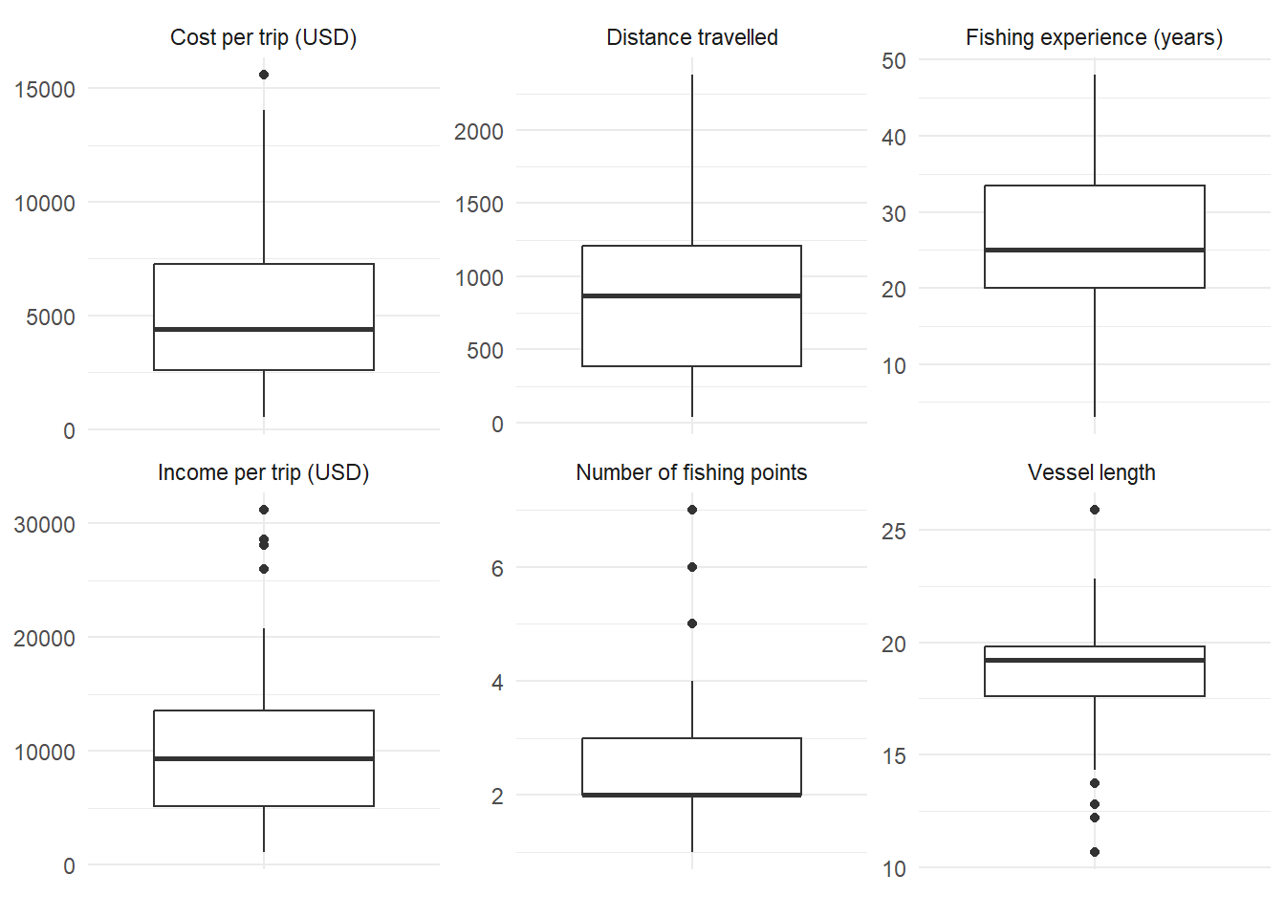

Supplementary Figure S3. Distribution of average fishing distance. Bars show the histogram, the solid line is the kernel-density estimate, and the dashed line is a normal density with the observed mean and standard deviation.
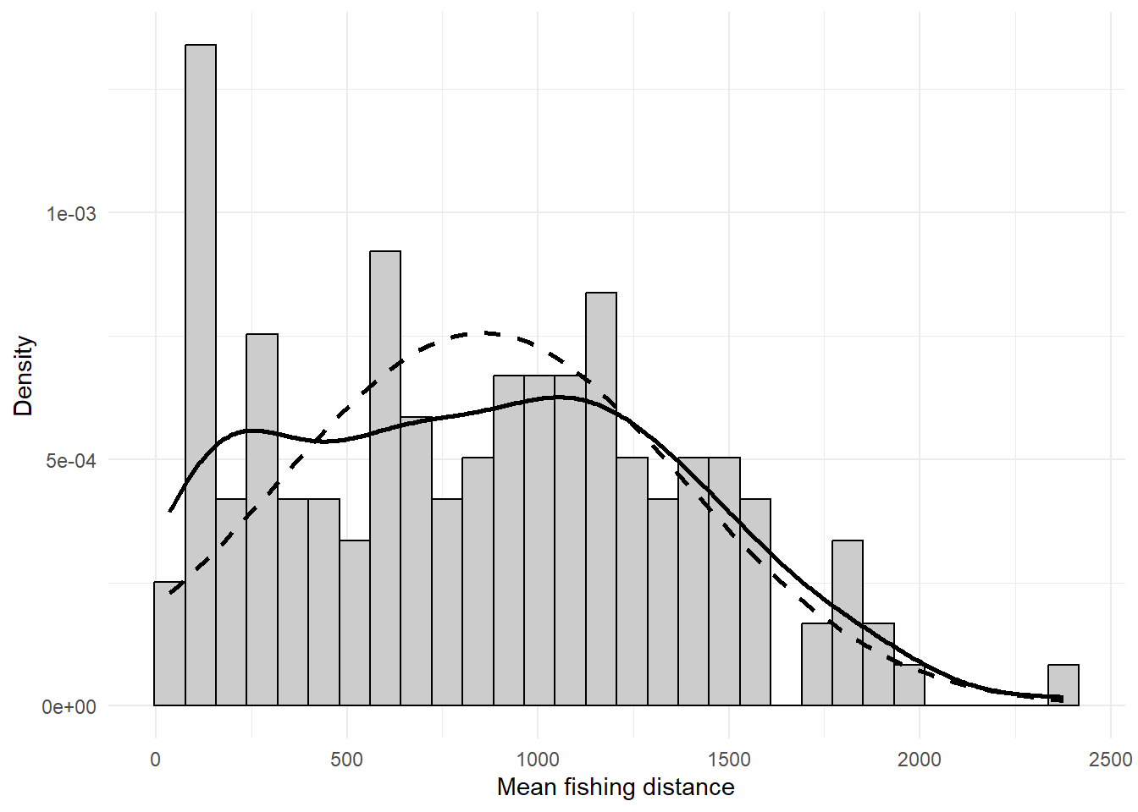

Supplementary Figure S4. Spearman correlation matrix and correlogram for continuous explanatory variables examined during data exploration.
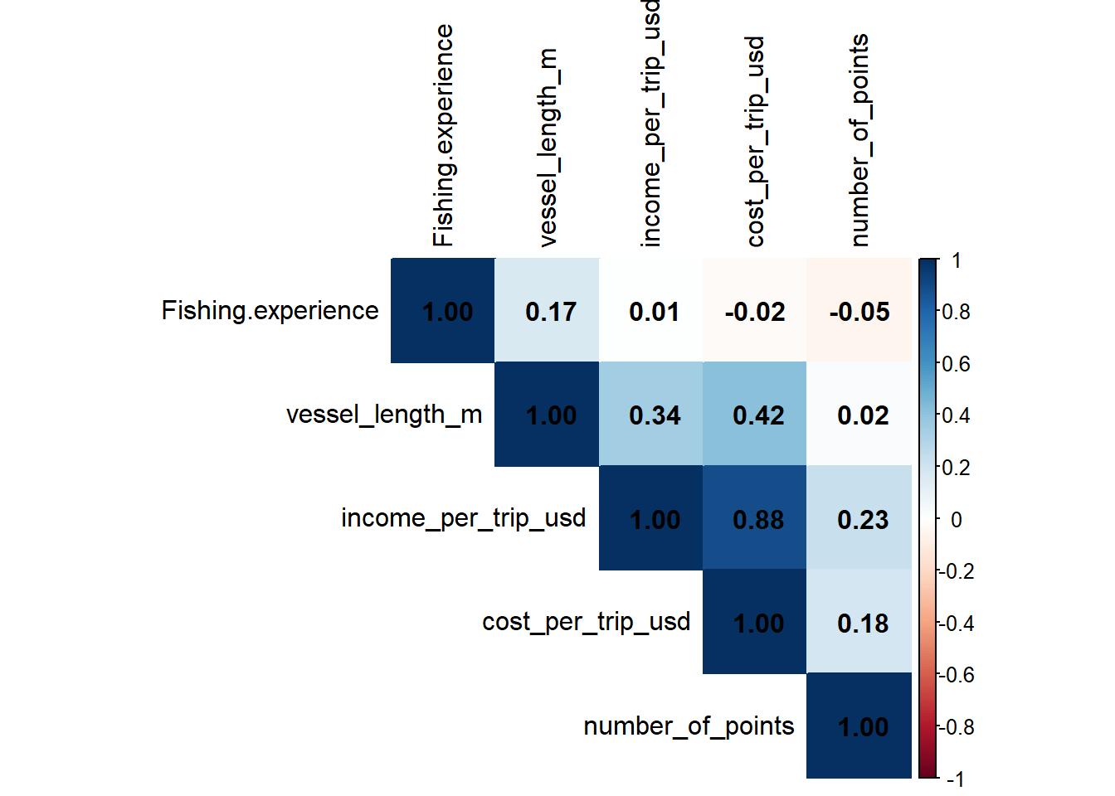

Supplementary Figure S5. Model-averaged residual diagnostics: residuals versus fitted values, normal Q-Q plot, scale-location plot, and residual histogram. Upper-tail Q-Q departures agree with the formal normality tests; robust intervals are reported in Supplementary Table S11.
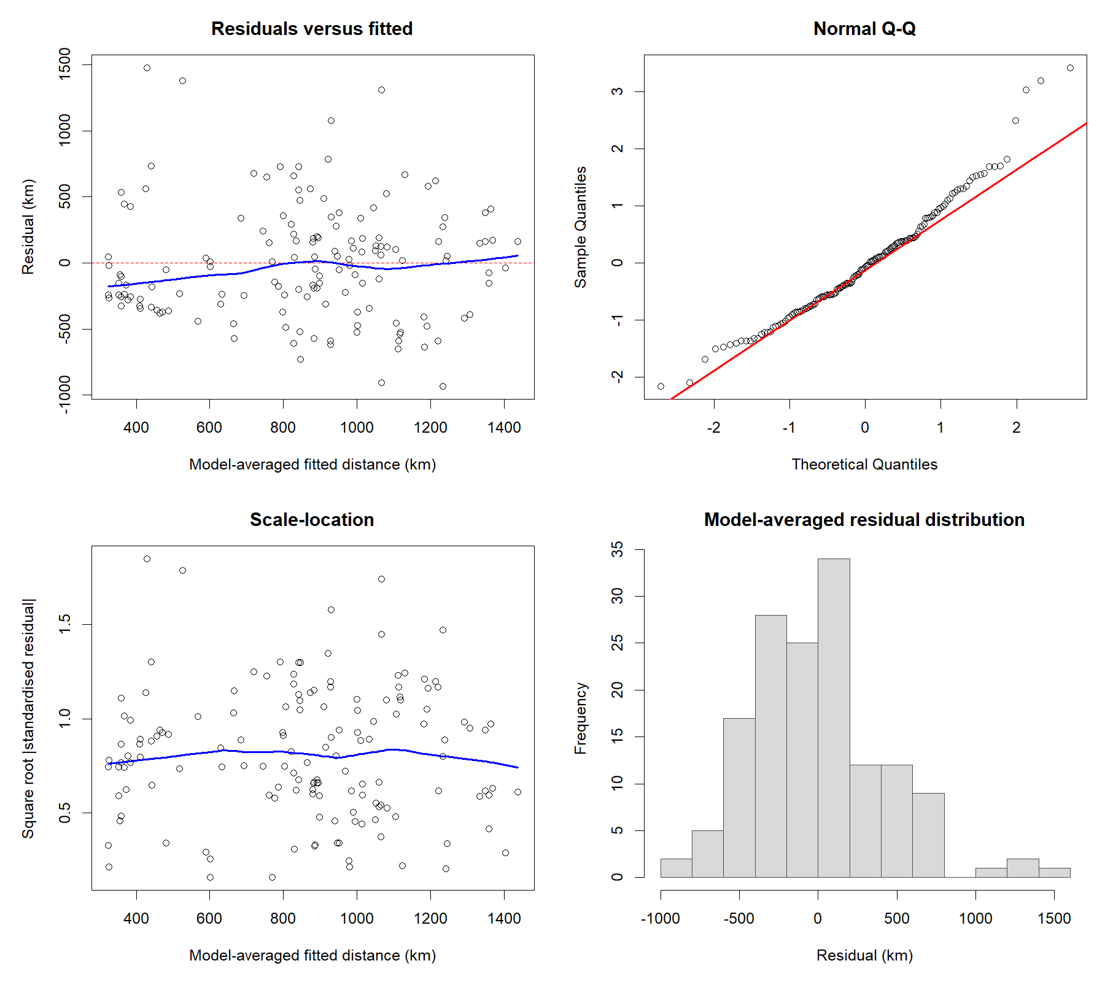
SUPPLEMENTARY MATERIALS
Section C. PAM cluster analysis
Active-variable coding, cluster selection, profiles, and bootstrap stability
Individual fishers | n = 148 | Gower dissimilarity | R 4.6.1

Contents. Tables S13-S19, Figure S6, and Supplementary File S2.
Item | Contents
S13 | Active-variable coding, data type and distribution
S14 | Two- versus three-cluster silhouette comparison
S15 | Continuous profiles of candidate solutions
S16 | Categorical profiles of candidate solutions
S17 | Bootstrap Jaccard stability
S18 | Final two-cluster continuous profile
S19 | Final two-cluster categorical profile
Figure S6 | Average silhouette width for k = 2-10
File S2 | PAM cluster-analysis data and reproducible analysis outputs

Supplementary tables
Supplementary Table S13. Coding, data type and overall distribution of variables used actively in the cluster analysis.
Role | Variable | Data type | Coding or unit | Overall distribution (n = 148)
Response | Average fishing distance | Continuous | km | Mean 852.87; SD 527.39; range 36.06-2,376.54
Explanatory | Fishing experience | Continuous | years | Mean 26.28; SD 9.17; range 3-48
Explanatory | Vessel length | Continuous | m | Mean 18.53; SD 2.24; range 10.67-25.91
Explanatory | Cost per trip | Continuous | USD | Mean 5,376.83; SD 3,594.24; range 519.53-15,586.03
Explanatory | Departure site | Nominal categorical | A; B; C | A: 117 (79.1%); B: 11 (7.4%); C: 20 (13.5%)
Explanatory | AIS installed | Binary nominal | No; Yes | No: 38 (25.7%); Yes: 110 (74.3%)
Explanatory | VMS installed | Binary nominal | No; Yes | No: 10 (6.8%); Yes: 138 (93.2%)
Explanatory | Navigation-app use | Binary nominal | No; Yes | No: 35 (23.6%); Yes: 113 (76.4%)
Explanatory | Targets sharks | Binary nominal | No; Yes | No: 84 (56.8%); Yes: 64 (43.2%)
Explanatory | Subsidy access | Binary nominal | No; Yes | No: 66 (44.6%); Yes: 82 (55.4%)
Explanatory | Top species group | Nominal categorical | Cephalopods; coral reef; large pelagic; sharks | 27 (18.2%); 10 (6.8%); 102 (68.9%); 9 (6.1%)
Explanatory | Communication with other fishers | Binary nominal | Every trip; less than every trip | 126 (85.1%); 22 (14.9%)
Explanatory | Regulatory awareness | Binary nominal | Fully aware; not fully aware | 132 (89.2%); 16 (10.8%)
Explanatory | Gillnet use | Binary nominal | No; Yes | No: 92 (62.2%); Yes: 56 (37.8%)
Explanatory | Handline use | Binary nominal | No; Yes | No: 31 (20.9%); Yes: 117 (79.1%)
Explanatory | Longline use | Binary nominal | No; Yes | No: 13 (8.8%); Yes: 135 (91.2%)
Explanatory | Bycatch-cleaning frequency | Ordered categorical | Never < infrequent < every trip | 57 (38.5%); 76 (51.4%); 15 (10.1%)

Note. All 17 variables were active and equally weighted. Continuous variables were range-standardised automatically by Gower dissimilarity. The three gear indicators were non-exclusive.

Supplementary Table S14. Silhouette comparison of the two- and three-cluster PAM solutions.
Cluster solution | Mean silhouette | Median silhouette | Negative silhouette (n) | Negative silhouette (%)
2 clusters | 0.245 | 0.258 | 8 | 5.41
3 clusters | 0.234 | 0.232 | 11 | 7.43

Note. Higher silhouette widths indicate stronger within-cluster cohesion and between-cluster separation. Negative values indicate observations that may fit another cluster more closely.

Supplementary Table S15. Continuous profiles of the two- and three-cluster PAM solutions.

Panel A. Two-cluster solution
Cluster | Sample size | Mean distance | Fishing experience | Vessel length (m) | Cost per trip (USD)
Cluster 1 | 80.0 | 1007.03 | 27.91 | 18.76 | 6920.85
Cluster 2 | 68.0 | 671.51 | 24.37 | 18.26 | 3560.34

Panel B. Three-cluster solution
Cluster | Sample size | Mean distance | Fishing experience | Vessel length (m) | Cost per trip (USD)
Cluster 1 | 62.0 | 991.43 | 28.48 | 18.66 | 6500.05
Cluster 2 | 44.0 | 963.46 | 24.43 | 19.11 | 6895.64
Cluster 3 | 42.0 | 532.47 | 24.98 | 17.74 | 2127.62

Note. Values are cluster-specific means, except sample size.

Supplementary Table S16. Categorical profiles of the two- and three-cluster PAM solutions.

Panel A. Two-cluster solution
Variable | Category | Cluster 1 | Cluster 2
AIS | No | 1 (1.2%) | 37 (54.4%)
AIS | Yes | 79 (98.8%) | 31 (45.6%)
Departure site | A | 80 (100.0%) | 37 (54.4%)
Departure site | B | 0 (0.0%) | 11 (16.2%)
Departure site | C | 0 (0.0%) | 20 (29.4%)
Top species group | Cephalopods | 11 (13.8%) | 16 (23.5%)
Top species group | Coral reef | 7 (8.8%) | 3 (4.4%)
Top species group | Large pelagic | 55 (68.8%) | 47 (69.1%)
Top species group | Sharks | 7 (8.8%) | 2 (2.9%)
VMS | No | 5 (6.2%) | 5 (7.4%)
VMS | Yes | 75 (93.8%) | 63 (92.6%)
Communication with other fishers | Every trip | 62 (77.5%) | 64 (94.1%)
Communication with other fishers | Less than every trip | 18 (22.5%) | 4 (5.9%)
Navigation-app use | No | 22 (27.5%) | 13 (19.1%)
Navigation-app use | Yes | 58 (72.5%) | 55 (80.9%)
Regulatory awareness | Fully aware | 70 (87.5%) | 62 (91.2%)
Regulatory awareness | Not fully aware | 10 (12.5%) | 6 (8.8%)
Subsidy access | No | 20 (25.0%) | 46 (67.6%)
Subsidy access | Yes | 60 (75.0%) | 22 (32.4%)
Targets sharks | No | 21 (26.2%) | 63 (92.6%)
Targets sharks | Yes | 59 (73.8%) | 5 (7.4%)
Gillnet use | No | 30 (37.5%) | 62 (91.2%)
Gillnet use | Yes | 50 (62.5%) | 6 (8.8%)
Handline use | No | 23 (28.8%) | 8 (11.8%)
Handline use | Yes | 57 (71.2%) | 60 (88.2%)
Longline use | No | 6 (7.5%) | 7 (10.3%)
Longline use | Yes | 74 (92.5%) | 61 (89.7%)

Note. Values are within-cluster frequencies and percentages, n (%). Blank source cells are shown as 0 (0.0%).
Supplementary Table S16 (continued). Categorical profiles of the candidate solutions.

Panel B. Three-cluster solution
Variable | Category | Cluster 1 | Cluster 2 | Cluster 3
AIS | No | 1 (1.6%) | 2 (4.5%) | 35 (83.3%)
AIS | Yes | 61 (98.4%) | 42 (95.5%) | 7 (16.7%)
Departure site | A | 62 (100.0%) | 42 (95.5%) | 13 (31.0%)
Departure site | B | 0 (0.0%) | 2 (4.5%) | 9 (21.4%)
Departure site | C | 0 (0.0%) | 0 (0.0%) | 20 (47.6%)
Top species group | Cephalopods | 8 (12.9%) | 8 (18.2%) | 11 (26.2%)
Top species group | Coral reef | 5 (8.1%) | 4 (9.1%) | 1 (2.4%)
Top species group | Large pelagic | 44 (71.0%) | 30 (68.2%) | 28 (66.7%)
Top species group | Sharks | 5 (8.1%) | 2 (4.5%) | 2 (4.8%)
VMS | No | 5 (8.1%) | 2 (4.5%) | 3 (7.1%)
VMS | Yes | 57 (91.9%) | 42 (95.5%) | 39 (92.9%)
Communication with other fishers | Every trip | 49 (79.0%) | 37 (84.1%) | 40 (95.2%)
Communication with other fishers | Less than every trip | 13 (21.0%) | 7 (15.9%) | 2 (4.8%)
Navigation-app use | No | 16 (25.8%) | 16 (36.4%) | 3 (7.1%)
Navigation-app use | Yes | 46 (74.2%) | 28 (63.6%) | 39 (92.9%)
Regulatory awareness | Fully aware | 55 (88.7%) | 35 (79.5%) | 42 (100.0%)
Regulatory awareness | Not fully aware | 7 (11.3%) | 9 (20.5%) | 0 (0.0%)
Subsidy access | No | 10 (16.1%) | 32 (72.7%) | 24 (57.1%)
Subsidy access | Yes | 52 (83.9%) | 12 (27.3%) | 18 (42.9%)
Targets sharks | No | 7 (11.3%) | 35 (79.5%) | 42 (100.0%)
Targets sharks | Yes | 55 (88.7%) | 9 (20.5%) | 0 (0.0%)
Gillnet use | No | 18 (29.0%) | 33 (75.0%) | 41 (97.6%)
Gillnet use | Yes | 44 (71.0%) | 11 (25.0%) | 1 (2.4%)
Handline use | No | 16 (25.8%) | 11 (25.0%) | 4 (9.5%)
Handline use | Yes | 46 (74.2%) | 33 (75.0%) | 38 (90.5%)
Longline use | No | 3 (4.8%) | 8 (18.2%) | 2 (4.8%)
Longline use | Yes | 59 (95.2%) | 36 (81.8%) | 40 (95.2%)

Note. Values are within-cluster frequencies and percentages, n (%). Blank cells in the source outputs have been represented as 0 (0.0%). Bycatch-cleaning frequency was active in clustering but was not included in the source profile exports.

Supplementary Table S17. Bootstrap Jaccard stability of the two- and three-cluster solutions.
Cluster solution | Cluster | Mean Jaccard | Median Jaccard | 2.5th percentile | 97.5th percentile
2 clusters | Cluster 1 | 0.850 | 0.871 | 0.446 | 1.000
2 clusters | Cluster 2 | 0.834 | 0.834 | 0.519 | 1.000
3 clusters | Cluster 1 | 0.747 | 0.720 | 0.392 | 1.000
3 clusters | Cluster 2 | 0.558 | 0.529 | 0.246 | 1.000
3 clusters | Cluster 3 | 0.826 | 0.846 | 0.524 | 1.000

Note. Based on 1,000 bootstrap resamples. Percentile columns are the 2.5th and 97.5th percentiles of the bootstrap Jaccard coefficients.
Supplementary Table S18. Continuous characteristics of the retained two-cluster solution.
Cluster | Sample size | Mean distance | Fishing experience | Vessel length (m) | Cost per trip (USD)
Cluster 1 | 80.0 | 1007.03 | 27.91 | 18.76 | 6920.85
Cluster 2 | 68.0 | 671.51 | 24.37 | 18.26 | 3560.34

Note. Values are cluster-specific means, except sample size.

Supplementary Table S19. Categorical characteristics of the retained two-cluster solution.
Variable | Category | Cluster 1 | Cluster 2
AIS | No | 1 (1.2%) | 37 (54.4%)
AIS | Yes | 79 (98.8%) | 31 (45.6%)
Departure site | A | 80 (100.0%) | 37 (54.4%)
Departure site | B | 0 (0.0%) | 11 (16.2%)
Departure site | C | 0 (0.0%) | 20 (29.4%)
Top species group | Cephalopods | 11 (13.8%) | 16 (23.5%)
Top species group | Coral reef | 7 (8.8%) | 3 (4.4%)
Top species group | Large pelagic | 55 (68.8%) | 47 (69.1%)
Top species group | Sharks | 7 (8.8%) | 2 (2.9%)
VMS | No | 5 (6.2%) | 5 (7.4%)
VMS | Yes | 75 (93.8%) | 63 (92.6%)
Communication with other fishers | Every trip | 62 (77.5%) | 64 (94.1%)
Communication with other fishers | Less than every trip | 18 (22.5%) | 4 (5.9%)
Navigation-app use | No | 22 (27.5%) | 13 (19.1%)
Navigation-app use | Yes | 58 (72.5%) | 55 (80.9%)
Regulatory awareness | Fully aware | 70 (87.5%) | 62 (91.2%)
Regulatory awareness | Not fully aware | 10 (12.5%) | 6 (8.8%)
Subsidy access | No | 20 (25.0%) | 46 (67.6%)
Subsidy access | Yes | 60 (75.0%) | 22 (32.4%)
Targets sharks | No | 21 (26.2%) | 63 (92.6%)
Targets sharks | Yes | 59 (73.8%) | 5 (7.4%)
Gillnet use | No | 30 (37.5%) | 62 (91.2%)
Gillnet use | Yes | 50 (62.5%) | 6 (8.8%)
Handline use | No | 23 (28.8%) | 8 (11.8%)
Handline use | Yes | 57 (71.2%) | 60 (88.2%)
Longline use | No | 6 (7.5%) | 7 (10.3%)
Longline use | Yes | 74 (92.5%) | 61 (89.7%)

Note. Values are within-cluster frequencies and percentages, n (%). Bycatch-cleaning frequency was active in clustering but was not included in the source profile export.

Supplementary figure
Supplementary Figure S6. Average silhouette width for PAM solutions containing two to ten clusters. The retained two-cluster solution is highlighted.
