**DBMS MINI-PROJECT**

**Online Job Portal**

**Problem Statement –**

Generate a Database Management System for Jobseekers.

**Abstract -**

As more companies are recruiting students for jobs virtually, especially during the pandemic, there is a need for an online Job Portal to connect both job seekers and companies for the recruitment process.

The Job Portal would help boost a person’s job seeking efforts and company’s hiring process. The application will allow users to search and apply for jobs offered by different companies.

**Functional Requirements –**

Frontend : HTML, CSS, Javascript, Bootstrapt

Backend: Flask, MYSQL

Language: Python3, sql

OS : Windows , Linux, Mac

**Features -**

* Job seekers will be able to register and login to the portal.
* Job seekers can create and update their academic profile.
* Job seekers would also be able to upload their resume on the website.
* Job seekers can search and apply for multiple job vacancies posted by various companies. They can see all the details for a particular job on the website.
* Job seekers can view all the jobs they have applied for in their profile.
* Applicants will be able to view their interviews scheduled by companies on the portal.
* Applicants can see their result status declared by the companies for the jobs they had applied for.
* Job seekers can also view their account details and account summary.

**ENTITY – RELATIONSHIP DIAGRAM –**

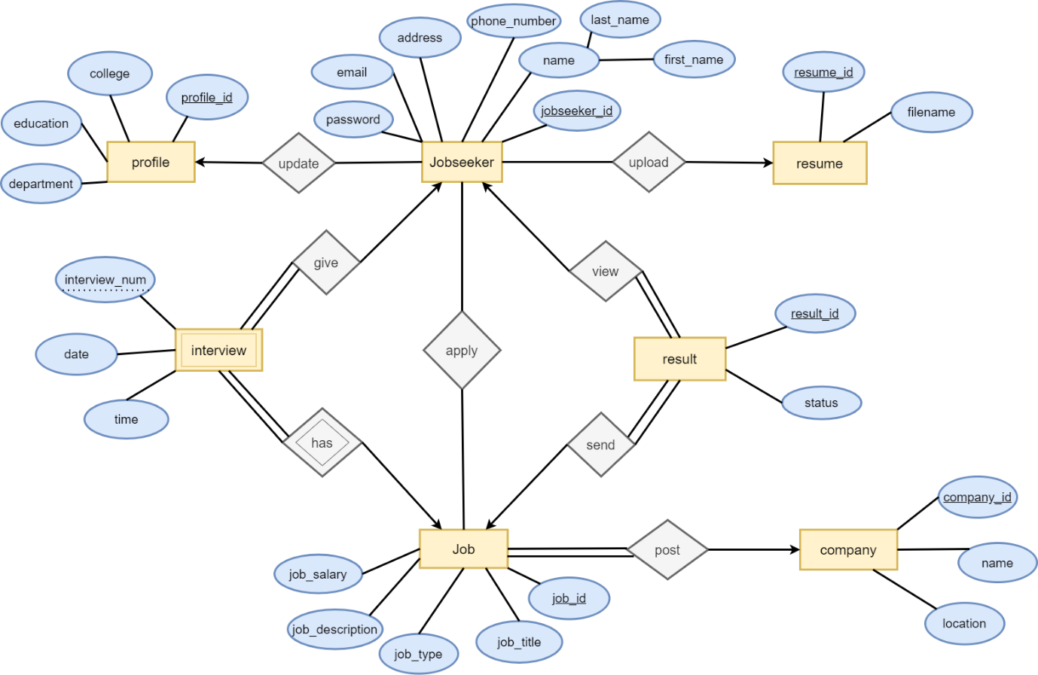

**SCHEMA –**

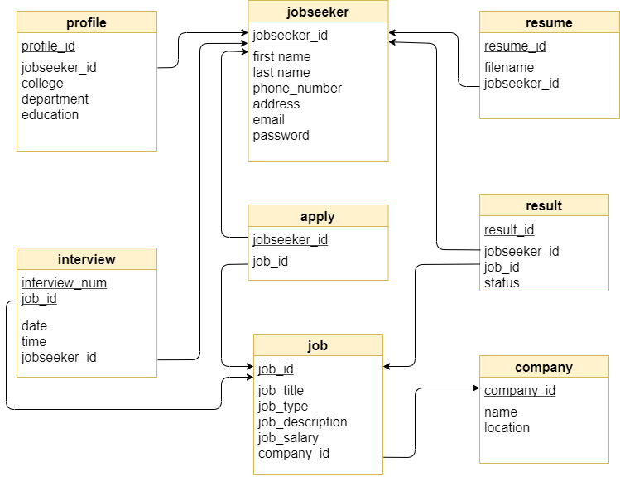

**Functional Dependencies –**

* (jobseeker) jobseeker_id -> (jobseeker) first_name, last_name, phone_number, address, email, password
* (company) company_id -> name, location
* (profile) profile_id -> (profile) jobseeker_id, college, department, education
* (resume) resume_id -> (resume) jobseeker_id, filename
* (interview) interview_num, job_id -> (interview)date, time, jobseeker_id
* (result) result_id -> (result)jobseeker_id, job_id, status
* (job) job_id -> job_title, job_type, job_description, job_salary, company_id