NEXUS
AI-Powered Research & Innovation Copilot
Hackathon • iNSIGHTS Track
Turn an Idea into an Implementation-Ready Project in Minutes

PPT 1 — Title

NEXUS
AI-Powered Research & Innovation Copilot
Tagline: “From Idea → Evidence → Execution”
Theme: Search Less. Solve More. with iNSIGHTS Layer 2
Team Name: [Your Team Name]
Team ID: [Team ID]
College: Ajeenkya D Y Patil School of Engineering, Pune
Visual suggestion: Student enters an idea → NEXUS → ready project.

PPT 2 — Problem & Existing Gap

Students Have Ideas. But Building Them Is Hard.
A student with a project idea currently has to search across Google, GitHub, Research Papers, YouTube, Kaggle and Documentation.
- Information is scattered across multiple platforms.
- Finding reliable and relevant resources takes hours.
- Students don't know whether their idea already exists.
- Research papers are difficult to convert into practical solutions.
- AI may provide answers without reliable evidence.
- After research, students still need to manually create the architecture and roadmap.

Existing Gap
- Google — Gives links, not project guidance.
- Chatbots — Give answers, but with limited verification.
- GitHub — Provides code without research context.
- Research platforms — Provide research without execution.
Core Gap: No single platform takes students from Idea → Research → Innovation → Execution.

PPT 3 — Proposed Solution

Meet NEXUS
NEXUS is an AI Research & Innovation Copilot that converts a simple project idea into a validated and implementation-ready project.
Example input: “Build an AI solution to reduce food waste in college hostels.”
- Problem Validation — Checks whether the problem is real and worth solving.
- Deep Research — Searches trusted web sources, papers and existing solutions.
- Innovation Discovery — Identifies limitations and unexplored opportunities.
- Project HUB — Generates architecture, tech stack, APIs, datasets and roadmap.
- AI Agent — Tracks progress and assists the team during development.
One-line idea: NEXUS doesn't just research your idea — it tells you what to build and how to build it.

PPT 4 — How NEXUS Works
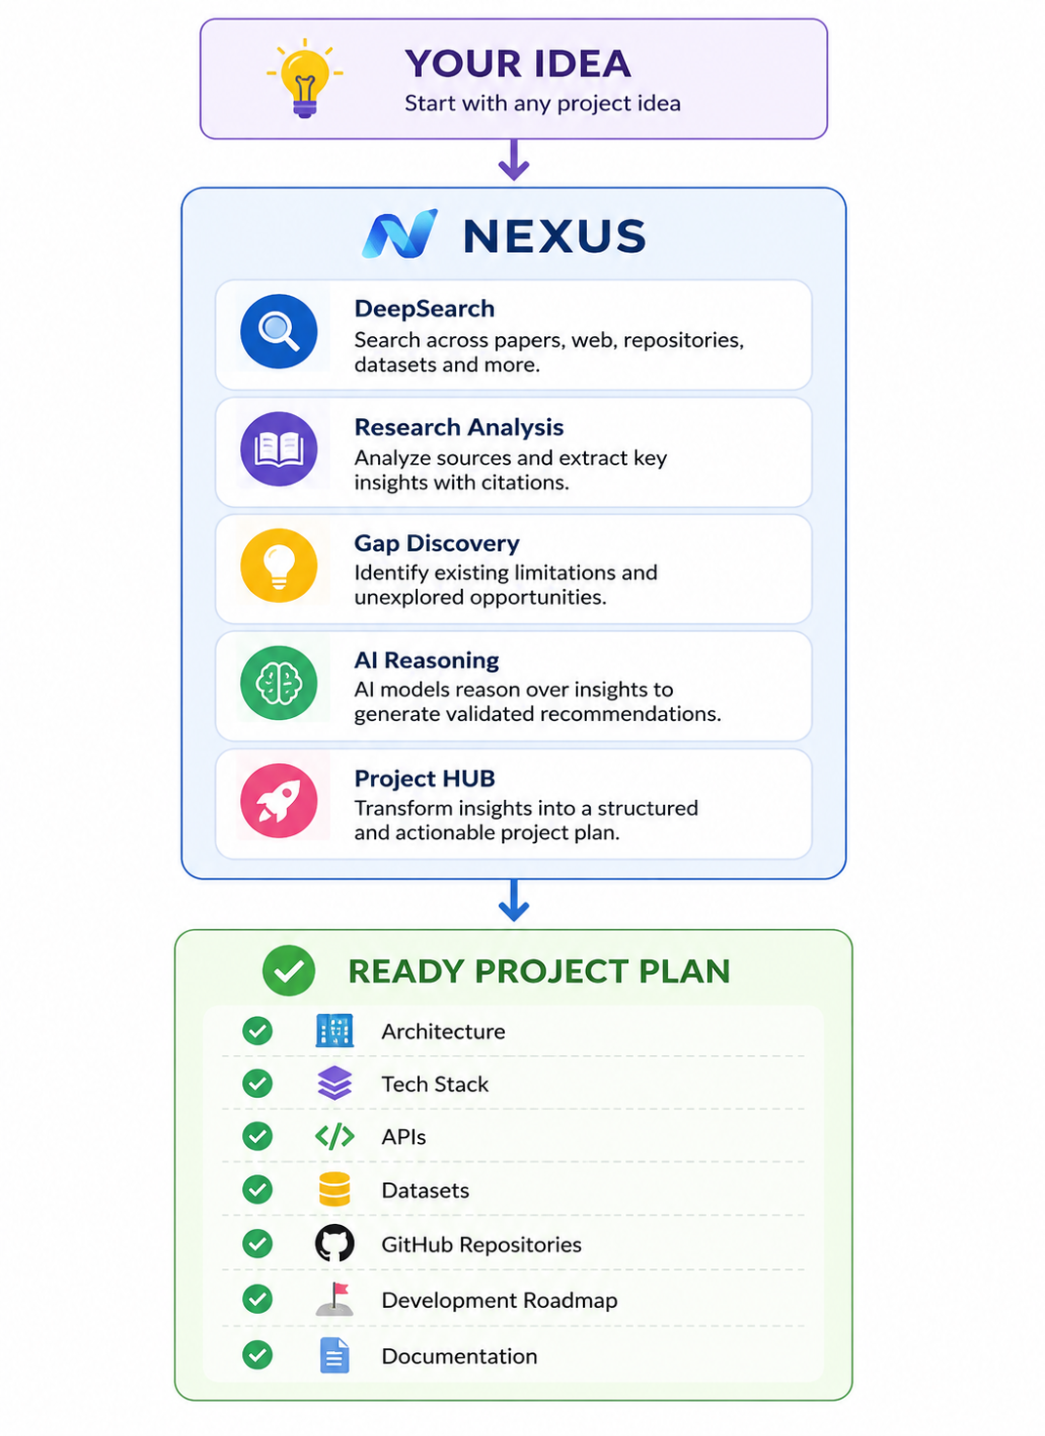

Tech Stack
- React — Dashboard
- FastAPI + Python — Backend
- LangChain / LlamaIndex — RAG & Research
- PostgreSQL + MongoDB — Data
- ChromaDB / FAISS — Vector Search
- Docker — Deployment
- Telegram / WhatsApp API — AI Agent

PPT 5 — Key Features & Innovation

01 — DeepSearch
Searches multiple trusted sources and creates citation-backed research.

02 — Research Gap Finder
Compares existing solutions and discovers opportunities for innovation.

03 — Project HUB
Automatically creates Architecture • Tech Stack • APIs • Datasets • Roadmap • Timeline.

04 — Evidence Score
Every important AI recommendation contains Source + Confidence + Reason, helping students understand why it was recommended.

05 — AI Project Agent
Telegram/WhatsApp agent reminds, tracks, helps and updates.
Main Innovation: Research that directly converts into executable project decisions.

PPT 6 — Impact & Feasibility

Without NEXUS
Idea → Search Everywhere → Confusion → Research → Planning → Development
Time: Hours / Days

With NEXUS
Idea → NEXUS → Ready Project Plan
Time: Minutes

Impact
- Students — Build better academic projects.
- Hackathon Teams — Validate ideas faster.
- Researchers — Discover research gaps.
- Developers — Find relevant technologies and resources quickly.

Why It Is Feasible
- Built using existing AI/RAG technology.
- Uses trusted APIs and public research sources.
- Modular backend architecture.
- Docker-based deployment.
- Can start as an MVP and scale later.
Future Scope: College Integration • Team Collaboration • Multilingual Research • Mentor Dashboard

PPT 7 — Demo & Conclusion

One Idea → Complete Project
User enters: “AI system to reduce food waste in college hostels.”
- Problem Validated ✓
- Research Sources: 34
- Relevant Papers: 12
- GitHub Repositories: 8
- Datasets: 4
- Innovation Opportunity: Predict food demand using historical consumption + attendance patterns.
- Recommended Stack: React • FastAPI • Python • PostgreSQL
- Project Roadmap: Research → Dataset → Model → Backend → Dashboard → Testing

Final Pitch
Students shouldn't spend days figuring out how to start a project.
NEXUS turns research into action.
Search Less. Solve More. Build Faster.

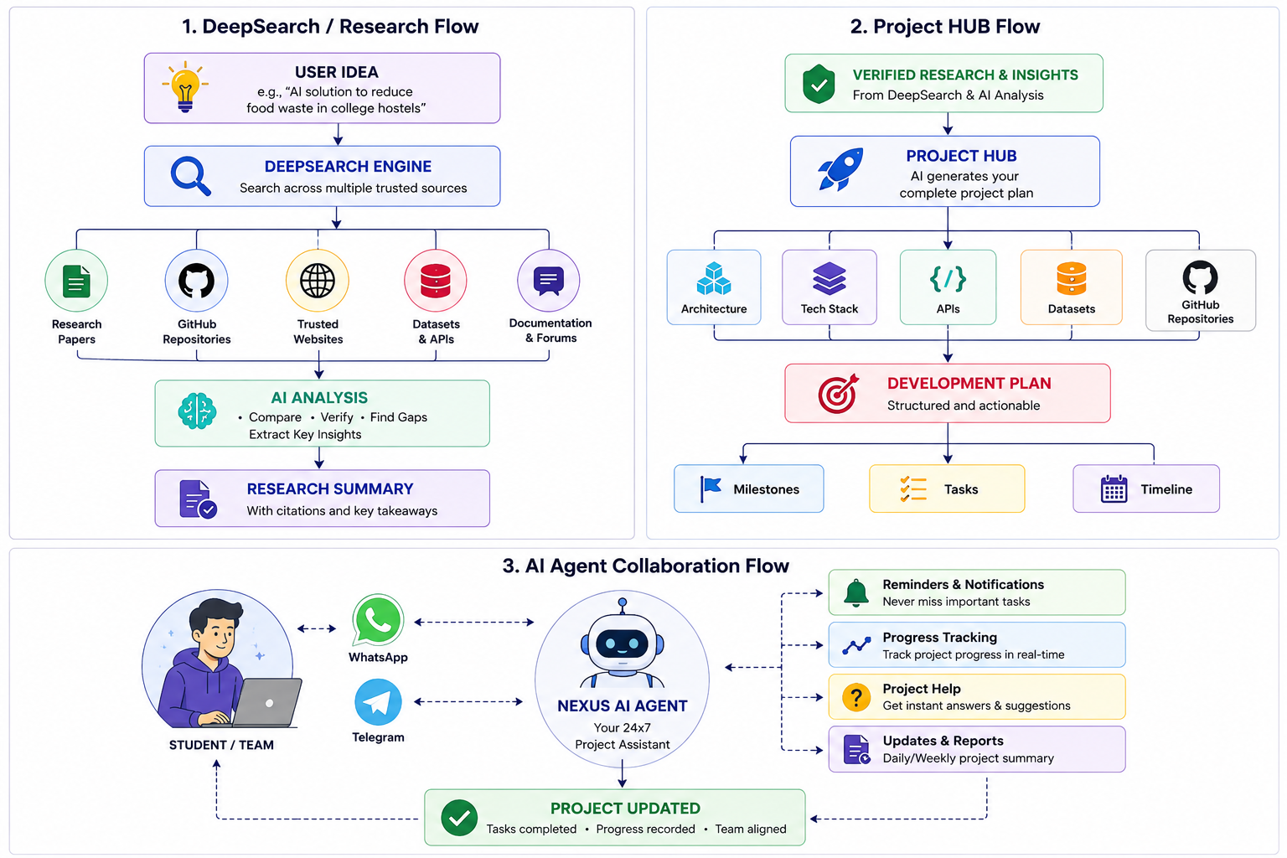

Recommended PPT Visual Style
- Use a white/light background with a purple accent.
- Keep one main idea per slide.
- Use maximum 4–5 important points visibly on each slide.
- Use rounded cards and simple icons.
- Prefer product screenshots/mockups over complicated diagrams.
- Keep diagrams simple enough for judges to understand within a few seconds.
- Use large headings and plenty of empty space.

