What is AWS Lambda?

Run Code Without Servers

Introduction

Imagine you own a food stall. You only pay rent when customers show up and buy food. When there are no customers, you pay nothing. No rent, no electricity bill, no staff wages. Sounds like a dream, right?
That is exactly what AWS Lambda does, but for your code.
AWS Lambda is a service from Amazon Web Services (AWS) that lets you run your code without setting up or managing any servers. You just write your code, upload it, and Lambda takes care of everything else. It runs when it needs to, and you only pay for the time it actually runs.

What is a Server, and Why Do We Want to Avoid It?

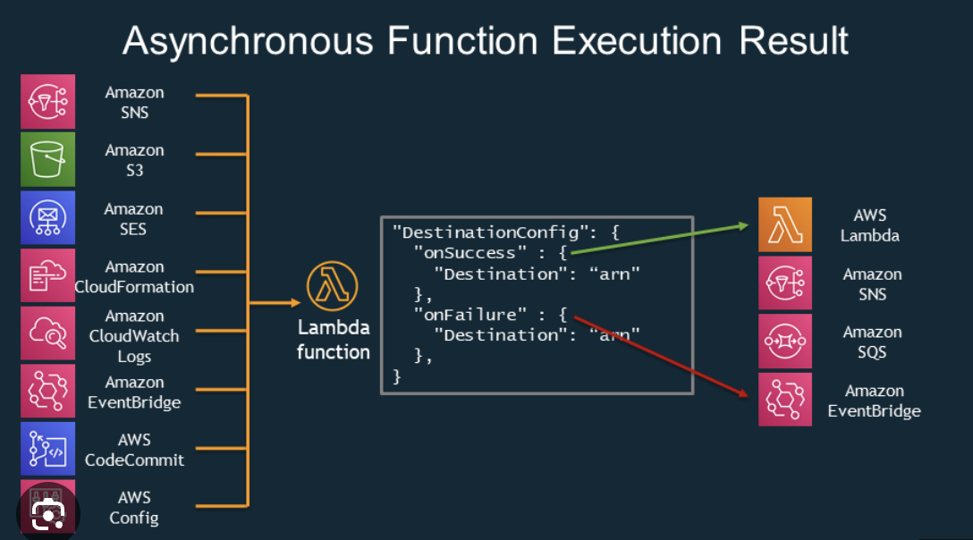

Before we understand Lambda, let us quickly understand the problem it solves.
Traditionally, when you build a website or an app, you need a server. A server is basically a computer that runs 24/7, waiting for someone to use your app. Here is the issue with that:
- You pay for the server even when nobody is using your app.
- You have to set it up, maintain it, update it, and fix it when it breaks.
- If your app suddenly gets a lot of users, your server might crash.
AWS Lambda solves all of these problems. No server to set up. No server to manage. You just write the code and Lambda handles the rest.

So How Does AWS Lambda Actually Work?
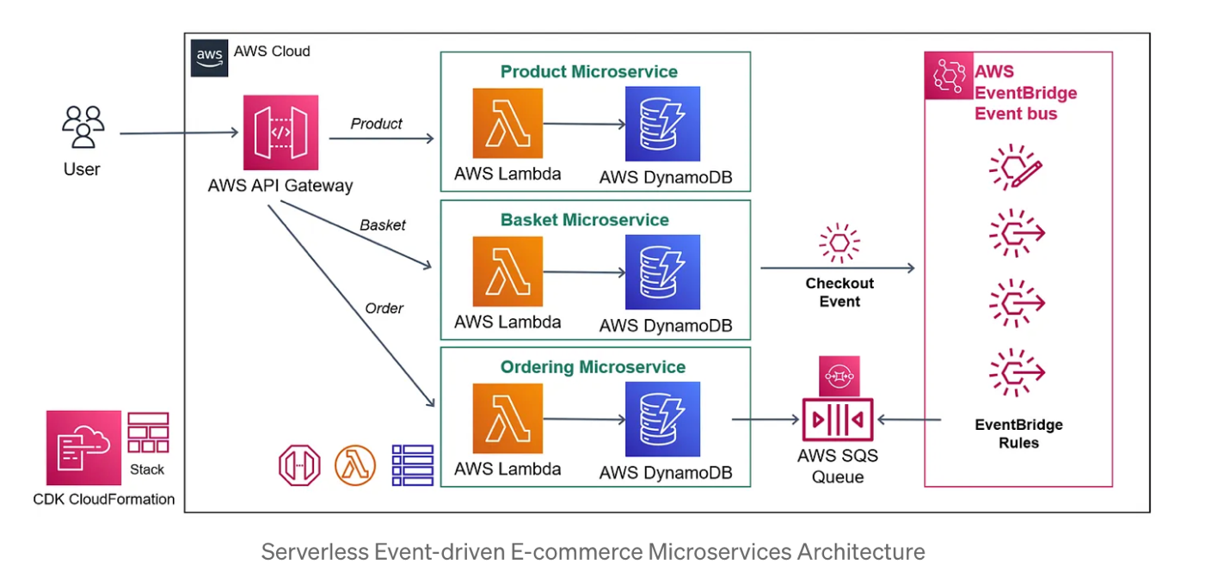

Think of Lambda like a light switch. When you flip the switch, the light turns on. When you flip it off, the light turns off. You are not paying for electricity when the light is off.
Lambda works the same way:
- Something triggers your code (a button click, a file upload, a timer, etc.)
- Lambda wakes up and runs your code.
- Once the job is done, Lambda goes back to sleep.
- You are charged only for the time your code was actually running.
That tiny moment when your code runs is called a function invocation. Your code in Lambda is called a Lambda function.

A Real-Life Example

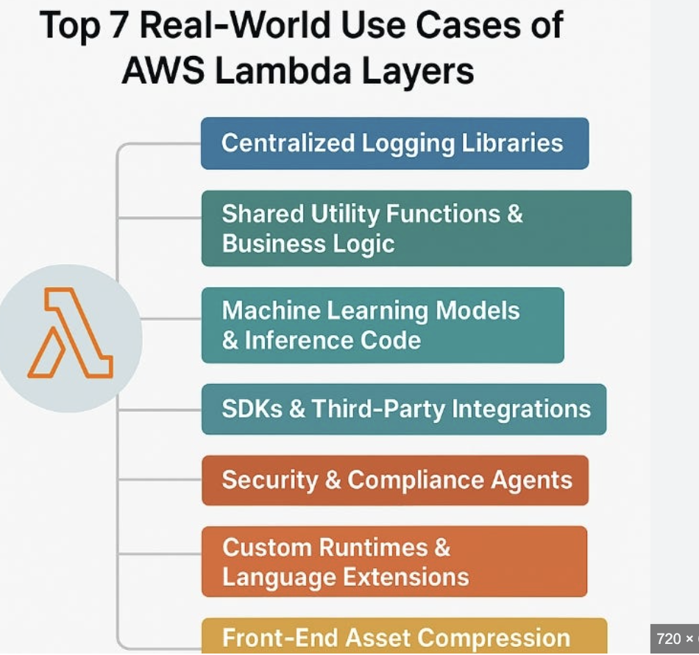

Let us say you build a website where users can upload their profile pictures. Every time a user uploads a photo, you want to automatically resize it to a smaller thumbnail. Here is how you would use Lambda for this:
- User uploads a photo to your website.
- The photo goes into AWS S3 (Amazon’s file storage service).
- S3 triggers your Lambda function automatically.
- Lambda resizes the image and saves the thumbnail.
- Lambda goes back to sleep, and you are charged only for those few milliseconds.
You did not set up a single server. You did not worry about what happens if 10,000 users upload photos at the same time. Lambda scales automatically to handle all of them.
What Can Trigger a Lambda Function?

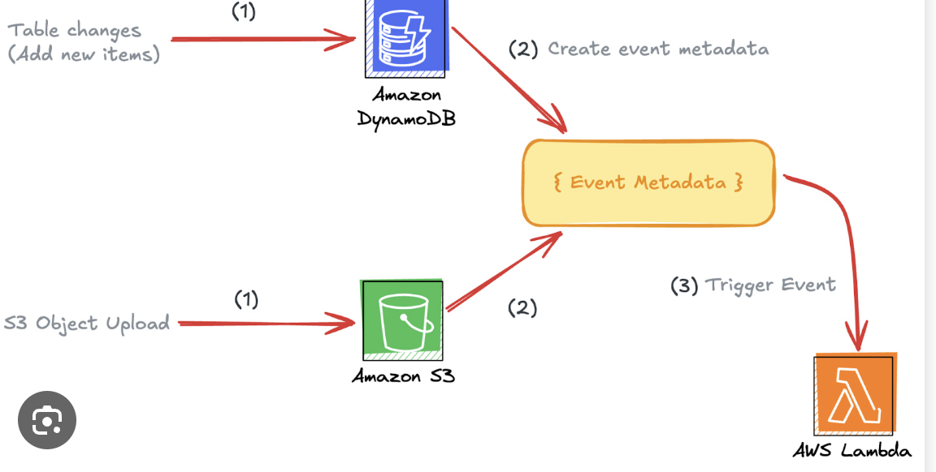

Lambda can be triggered by many different events inside AWS. Here are some common ones:
- API Gateway: Someone visits a URL or submits a form on your website.
- S3: A file is uploaded to your storage bucket.
- DynamoDB: A change happens in your database.
- CloudWatch Events: A timer goes off (like a cron job).
- SNS / SQS: A message is sent or queued.

What Languages Does Lambda Support?
You can write your Lambda functions in many popular programming languages:
- Python
- JavaScript (Node.js)
- Java
- C# (.NET)
- Go
- Ruby
So no matter which language you are comfortable with, chances are Lambda supports it.

How Much Does It Cost?

This is where Lambda really shines. AWS gives you a very generous free tier:
- 1 million free function calls every single month.
- 400,000 GB-seconds of compute time for free every month.
For most small apps and side projects, you will likely never pay a single rupee (or dollar) for Lambda. And even after the free tier, the pricing is extremely low — you pay only for the milliseconds your code runs.

Benefits of Using AWS Lambda

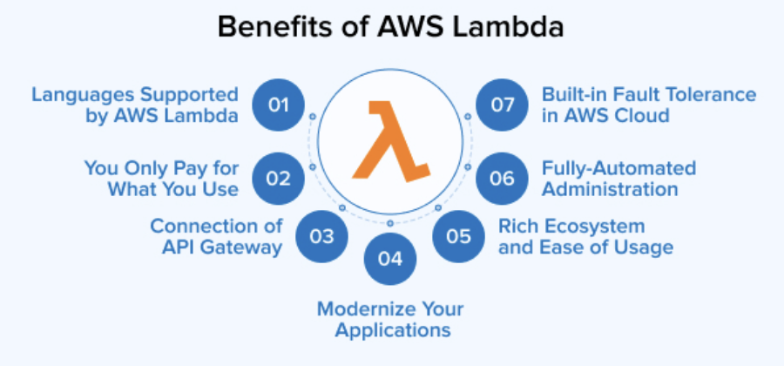

- No server management: AWS handles everything behind the scenes. You just focus on your code.
- Automatic scaling: Whether you have 1 user or 1 million users, Lambda scales instantly.
- Pay only for what you use: No idle costs. You only pay when your function actually runs.
- Fast to get started: You can have a Lambda function running in minutes.
- Works well with other AWS services: Lambda connects easily with S3, DynamoDB, API Gateway, and many more.
When Should You NOT Use Lambda?

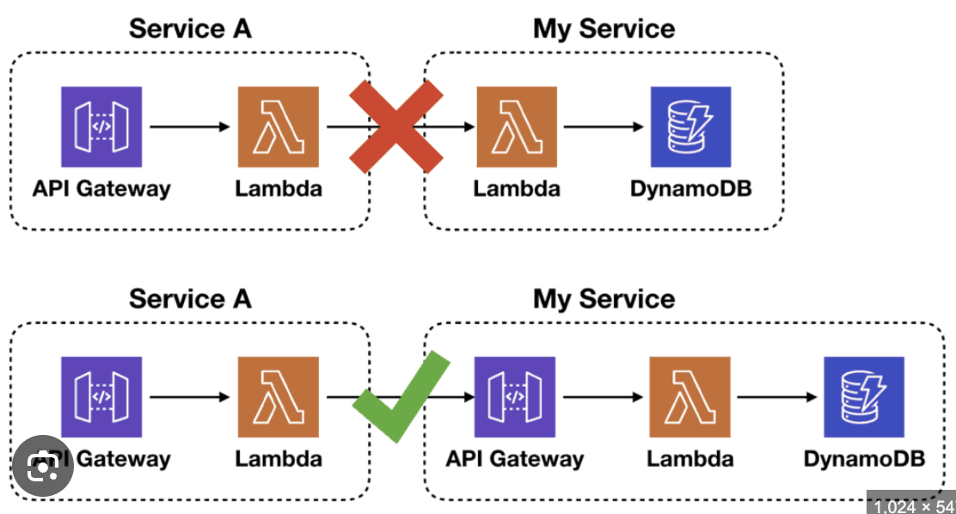
Lambda is great, but it is not always the right tool. Avoid it when:
- Your task takes more than 15 minutes to complete. Lambda has a maximum timeout of 15 minutes.
- You need to run a constantly active app like a chat server.
- Your code needs a lot of memory or heavy computation for a long time.
For those cases, you would look at services like EC2 or ECS. But for most short, event-driven tasks, Lambda is perfect.

Conclusion

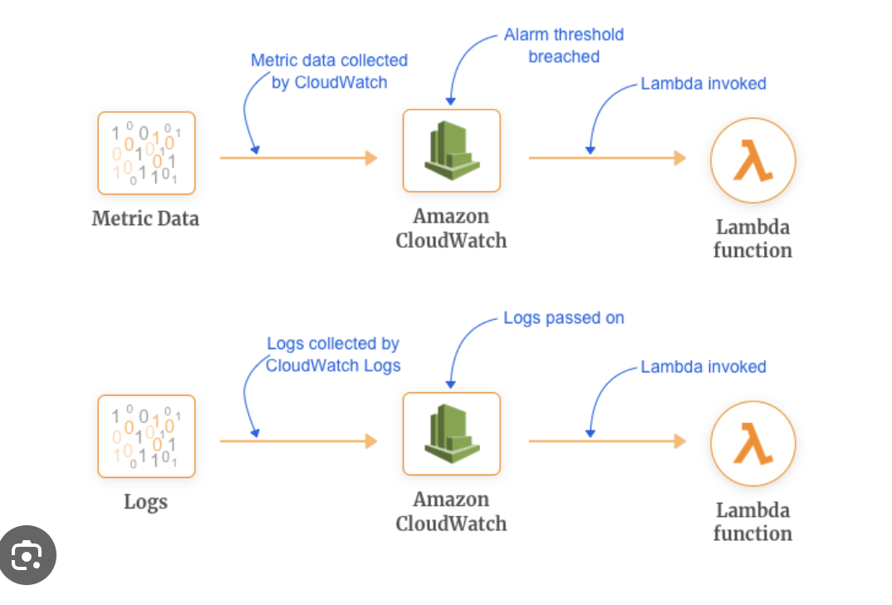
AWS Lambda changed the way developers build and deploy software. Instead of worrying about servers, infrastructure, and scaling, you can focus entirely on writing code that solves problems.
If you are just getting started with cloud computing, Lambda is one of the best places to begin. It is simple, cheap, powerful, and used by companies of all sizes — from startups to Netflix and Airbnb.
Give it a try. Sign in to your AWS account, head to the Lambda console, and write your first function. You will be amazed at how quickly you can build something useful without ever touching a server.

Written by
Rithika.s
24BCE2984

