CUSTOMER REVIEWS FOR PRODUCT RECOMMENDATION USING MACHINE LEARNING

**Abhisheik J M1 , Shishira S Jois 2 ,Ashish K Pastay 3 , Chiranthan P 4, Samara Mubeen 5**

1,2,3,4,Students , Department Of IS&E, JNNCE, Shivamogga, Karnataka, India,

email : [karunadu4@gmail.com](mailto:karunadu4@gmail.com) , [shishirasjois7@gmail.com](mailto:shishirasjois7@gmail.com), [pastayashish@gmail.com](mailto:pastayashish@gmail.com), [chiranthanp.smg@gmail.com](mailto:chiranthanp.smg@gmail.com)

5Assistant Professor, Department Of IS&E , JNNCE, Shivamogga,Karnataka,India

email : [samaramubeen@jnnce.ac.in](mailto:samaramubeen@jnnce.ac.in)

***ABSTRACT-*** **Online Shopping is an upcoming trend than the traditional way of doing shopping. The branded products are obtained at a reasonable cost at the doorstep. Henceforth the focus of this paper is to classify customer reviews as either recommendable or non-recommendable using Natural Language Processing (NLP) techniques. This provides an excellent option for customers to filter out “good” and “bad” reviews, the problem with this system is that there can be a lack of authenticity in terms of providing ratings and ordering reviews. There are two end goals of this research work: to automatically classify reviews using the reviews/ratings and to showcase the classified reviews using WorldCloud**

**The main aim of the analysis is to identify the polarity of the data on the Web and classify them. As Sentiment analysis or opinion, mining is one of the major tasks of NLP; Sentiment analysis has gained much attention in recent years. This project aims to tackle the problem of sentiment polarity categorization, which is one of the fundamental problems of sentiment analysis. Data used in this study are online product reviews collected from the E-commerce websites namely Amazon or Flipkart. Experiments for review-level categorization are performed with promising outcomes.**

**Keywords: E-commerce, Natural Language Processing, Sentimental Analysis, Recommendation system**

1. INTRODUCTION

Today, digital reviews play a pivotal role in enhancing global communications among consumers and influencing consumer-buying patterns. E-commerce giants like Amazon, Flipkart, etc. provide a platform for consumers to share their experiences and provide real insights about the performance of the product to future buyers. In order to extract valuable insights from a large set of reviews, classification of reviews into positive and negative sentiments is required. Sentiment Analysis is a computational study to extract subjective information from the text. An increasingly prevalent trend in the sale of goods is the shift to E-commerce or online shopping. Numerous, if not most, traditional “brick and mortar” stores have online shops where consumers can place orders of many of the same products, they would find at the physical store locations. As this trend continues (often to the disdain of in-store workers), these locations have become simple “showrooms” where customers can see and touch the product, but actually plan to order it online where it may be cheaper, more varied in size, or color, or simply more convenient to have shipped rather than brought home. Aside from convenience and competition, the largest benefit to customers is arguably the availability of firsthand reviews and feedback from other shoppers. “What do the reviews say?” and “How many stars did it get?” are questions that online consumer factor into their purchasing decisions. In addition to the customer benefit, companies making the products being sold also benefit from the online availability of such reviews. They can incorporate the feedback of their customers into future product iterations with the end goal of increasing sales. For these reasons, it is of high importance to strive for the best quality and most accurate reviews. One way to judge the quality and accurate reviews is by their helpfulness to other readers, which is where this project focuses.

The sentiment is an attitude, thought, or judgment prompted by feeling. Sentiment analysis, which is also known as opinion mining, studies people’s sentiments towards certain entities. From a user’s perspective, people are able to post their own content through various social media, such as forums, micro-blogs, or online social networking sites. From a researcher’s perspective, many social media sites release their application programming interfaces (APIs), prompting data collection and analysis by researchers and developers. However, those types of online data have several flaws that potentially hinder the process of sentiment analysis. The first flaw is that since people can freely post their own content, the quality of their opinions cannot be guaranteed. The second flaw is that the ground truth of such online data is not always available. Ground truth is more like a tag of a certain opinion, indicating whether the opinion is positive, negative, or neutral.

Currently, one of the most popular multi-categories online shops is Flipkart.com. With many products in many different departments, it has become a hugely popular option for online shoppers. This popularity increases the number of customer reviews which in turn adds to the site's utility. Aside from a “star rating” from 1 to 5, customers can also submit textual feedback and product accounts, made available on one of the product pages on Flipkart. Next to each review are three simple user-interface elements: a label, “Was this review helpful to you?”, and two buttons, “Yes” and “No”. It is this mechanism that allows users to vote up or down the helpfulness of a product review. The website then allows customers to sort reviews by their voted helpfulness (the site’s default review ordering) or temporally. While providing an excellent option for customers to filter out “good” and “bad” reviews, the problem with this system is the necessity of participation from review readers and the possibility that reviews that were not voted on or were authored so long ago are not high up in the ordering of reviews. This means that helpful reviews would likely not be seen by customers unless they were enumerated through a potentially very large set of other reviews.

To mitigate the issues mentioned above, in this paper a technique is used to automatically classify product reviews as recommendable and non-recommendable, using Natural language processing, with two end goals: to automatically classify reviews using the ratings and to showcase the overall review of the product using WorldCloud.

Paper is organized as follows I introduction, literature review in section II, performance metrics considered for studies in section III, system design in section IV, result anslaysis V followed by conclusion in section VI.

II. LITERATURE REVIEW

Karthik.R.V , Sannasi Ganapathy and Arputharaj Kannan, Social networks occupy an important place and take a considerable amount of time in people's daily life. It has become so popular that people are sharing a huge amount of data and opinion on social network/review sites, which in turn helps to find interesting insights for organizations / vendors or consumers[1].In this paper a new algorithm is proposed called feature based product ranking and recommendation algorithm, for suggesting the customer for purchasing of good quality products. User interested features are also extracted by previous user comments and reviews. If there are no previous comments, then features from similar age groups are selected. Based on the sentiment analysis outcome, ranking is calculated.

Pankaj, Prashant Pandey et.al, Sentiment analysis is one of the fastest spreading research areas in computer science, making it challenging to keep track of all the activities in the area. Sentiment analysis presents customer feedback reviews on products, which utilizes opinion mining, text mining and sentiments, which have affected the surrounding world by changing their opinion on a specific product[2]. Opinions are statements that reflect people’s perception or sentiment. Sentiment analysis is a series of methods, techniques, and tools about detecting and extracting subjective information, such as opinion and attitudes, from language, helping in finding the mood of the customers about a purchasing of a particular product or topic.

Stephina Rodney D’souza, Kavita Sonawane, Sentiment Analysis can be defined as the process of analyzing online pieces of writing to determine the emotional to they carry. With the vast growth of social media content on the Internet in the past few years, people now express their opinion on almost anything in discussion. With respect to this, Bag–of–Words (BoW) is the most popular way to model text in statistical machine learning (ML) approaches [3]. However, the performance of Bow sometimes remains unlimited due to some fundamental deficiencies in handling the polarity shift problem and other few challenges like quality of the opinions, hidden state representations, polarity categorization etc. To come across these challenges the focus will be on Dual Sentiment Analysis which processes the Sentiment with all the perspectives (positive, negative or neutral). This may lead towards the accurate prediction for final decision making based on the reviews given by the customers. The proposed work is being experimented on the Amazon Product reviews specifically the Mobile device reviews. This work aims at overcoming the limitation of existing systems and improving the accuracy.

Jo Mackiewicz, Dave Yeats, Thomas Thornton,

Testing the effect of a consumer review's environment (brand or retailer site) and the effect of review valence (positive or negative) on the perceived credibility of that review, as well the degree of correlation among credibility, trustworthiness, and expertise. Through an online survey, respondents are exposed to the same review text with different star ratings (4-star and 2-star) in two types of sites: brand and retailer. Participants are asked to evaluate the review's credibility, trustworthiness, and expertise[4]. In half of the exposures, participants evaluated a review in the site of a high-credibility company (Apple or Amazon), and in the other half of exposures, participants evaluated a review in the site of a mid-level-credibility company (Dell or Walmart). Credibility strongly correlated with both trustworthiness and expertise. Participants rated 4-star reviews as more credible than 2-star reviews on high-credibility sites, but star ratings had no impact on mid-level credibility sites. There was no difference between ratings of reviews displayed on brand and retailer sites for mid-level-credibility companies but a small difference between reviews displayed on brand and retailer sites for high-credibility companies.

Thiruni D. Jayasiriwardene, Gamage Upeksha Ganegoda**,** Keywords play a major role in representing the gist of a document. Therefore, a lot of Natural Language processing tools have been implemented to identify keywords in both structured and unstructured text. Text that appears in social media platforms such as twitter is mostly unstructured because of the character limitation. In this paper, a methodology is proposed to extract keywords from a given tweet to retrieve relevant news that has been posted on twitter, for fake news detection[5]. The intention of extracting keywords is to find more related news efficiently and effectively. For this approach, a corpus that contains tweet texts from different domains is built in order to make this approach more generic instead of making it a domain- specific approach.For the system evaluation, the Turing test which has human intervention is used. The system was able to acquire an accuracy of 67.6% according to the evaluation conducted.

Reshma V and Ansamma John, E-commerce is getting popular; more and more products are sold online every day and product reviews are growing rapidly. The larger number of reviews makes it difficult for customers and manufacturers. For popular products there may have thousands of reviews. Customers and manufacturers may not be able to understand overall opinion about aspects of products without going through all reviews. Also, most of the existing methods make use of approximate summarization of product reviews [6]. Here a more precise and realistic value of opinion is retrieved through naïve Bayesian classifier and fuzzy method. In this, in addition to the identification of opinions, linguistic hedges are identified and apply fuzzy rules to magnify the effect of opinion.

Ujwal B V S , Bharat Gaind et.al, Web scraping is an important problem in computer science. The problem with the commonly-used position or structure-based web scraping tools is that they need to be manually reconfigured as soon as the structure of the web page changes[7]. In this paper, problem of information extraction for web pages consisting of repetitive blocks are performed. Extraction of these blocks and their constituent attributes, using a novel classification-based approach. This approach gives high accuracy when used to extract product-offers from an offer-aggregator website. It is also highly adaptive to the changing structure of a website.

Tanya Gera, Deepak Thakur and Jaiteg Singh. Nowadays, client likes to take suggestions before spending on a new product. For this client goes to online item review webpage for perusing other's encounters and saying for that item. A real issue which was disregarded so far is the investigation of review spammers. However, numerous scientists gave their productive commitment in this field of exploration from 2007. The situation now asks for, conspicuous verification and ID of fake reviews and fake reviewers; as this has transformed into a colossal social issue. Those studies have the limit perceive certain sorts of spammers, in any case, in fact, there are distinctive sorts of spammers who can control their practices to act much the same as certified users [8]. This has transformed into a gigantic social issue. From various years, email spam and web spam were the two essential highlighted social issues.

Jawad khan, Byeong Soo Jeong**,** Opinion or sentiment analysis has risen to extract useful information from a lot of unstructured text data, in the form of customer reviews on different products and their features or online SNS data respectively. Customer reviews are not only helpful for potential customers, but also are helpful for the manufacturers of the products to raise their products and services. The reviews conciseness takes the attention of the customers rather than long reviews. Opinion Mining is playing a major role to summarize customer reviews and make it easy for online customers to determine whether to purchase the products or not. In this paper, supervised lazy learning model utilizing syntactic rules for the product features and opinion words extraction in subjective review sentences are proposed. In the lazy learning algorithm, i.e., K-NN with k=3 is used for the review sentences’ classification into two classes (subjective, objective). Experiment shows that proposed method can improve the performance of existing work in terms of average precision, recall and f-score for the extraction of opinion sentences and product features [9].

II. SYSTEM DESIGN AND IMPLEMENTATION OF CUSTOMER RECOMMENDATION SYSTEM

The figure1 shows the proposed recommendation system based on customer reviews.

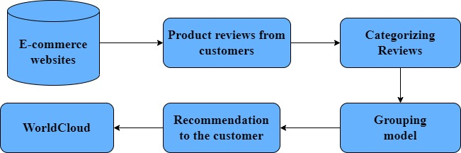

Figure 1.Proposed system design

The following are the steps in proposed system design

**i. E-commerce Websites**

An E-commerce website, by definition, is a website that allows you to buy and sell tangible goods, digital products or services online.

In this research work we are mainly focusing on the major E-Commerce website that is Flipkart.com. The particular product is fetched in these e-commerce websites.

**ii. Product Reviews from Customers**

When the Product is found the next step is to get the ratings and reviews. Here the reviews and ratings that are given by the users on particular products are collected by web scraping using Beautiful Soup.

**iii. Categorizing the reviews**

Here the reviews are categorized based on reviews/ratings as positive and negative reviews and represented accordingly.

**i v. Grouping Model**

Grouping model is the step where all the categorized reviews and ratings on the particular product are grouped together and sentiment analysis on the reviews is done.

v. **Recommendation to the customer**

If the positive reviews are more than sixty percent of the number of reviews analyzed then the product is recommended or else the product is not recommended.

**vi. WordCloud**

Finally, the reviews are visually represented by a concept called WordCloud using NLP.

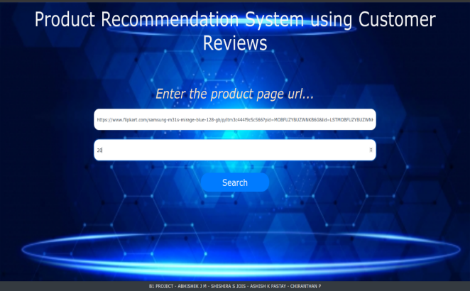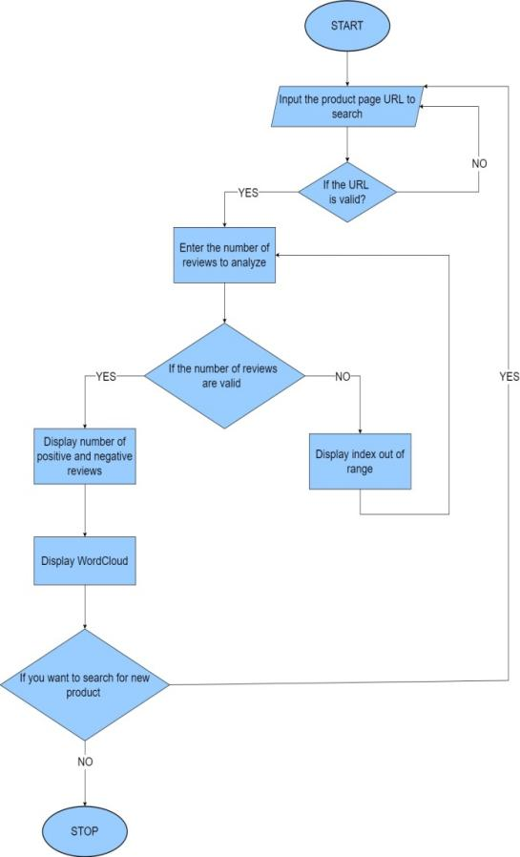

**Figure 2. Flowchart of system design**

Figure 2 shows the system design which is designed for recommendation system using customer’s reviews. The flow starts with the entering of URL of product to be searched, URL is checked to see if its valid or not. On entering valid URL, number of reviews for the product is entered. Again a check is done to see if the reviews entered are valid or not. If the reviews are valid then products positive and negative reviews is displayed and worldcloud, on invalid review a error message is displayed. The same process is repeated for other products.

**IV. RE**SULT ANALYSIS

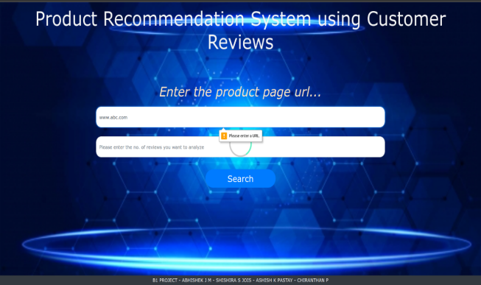In this section experimental setup and different test cases are discussed**.**

**i. Experimental Setup**

The proposed system is implemented using PYTHON with FLASK under the windows and Linux environment. To test the developed system several products and categories are used.

Users Enters Product URL in the search box. The product is searched from the e-commerce websites and the ratings and reviews are scraped using beautiful soup. Ratings and reviews are categorized and recommended accordingly.

The home page of the recommendation system is given in the figure 3.

Figure 3. Home Page of recommendation system

Search page contains two bars where user can enter a product URL and number of reviews to analyze to get a recommendation.

**ii. Test cases**

Three test cases are studied for recommendation system for customer reviews.

1. Invalid entering of URL

2. Valid URLand Invalid Entering of Reviews.

3. Valid URL and valid number of reviews, product recommended.

4. Valid URL and Valid number of reviews , product not recommended

**1. Invalid entering of URL**

Figure 4. Invalid URL.

If the URL wrongly entered in search page a message will pop out displaying the message enter correct URl as shown in the figure 4.

**2. Valid URL and Invalid Entering of Reviews**

If the URL is correctly entered for search the product but the invalid reviews are entered for the product. The figure 5 shows the error page.

Figure 5: Invalid Reviews Number

3. Valid URL and valid number of reviews, product recommended.

On entering URL and number of reviews is valid. Figure 6 and figure 7 contains review report which consists of positive and negative reviews categorized based on ratings and recommended accordingly.

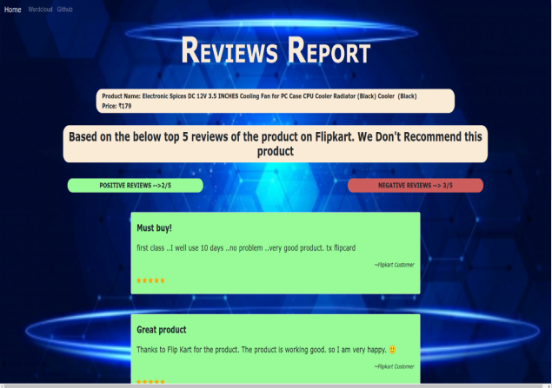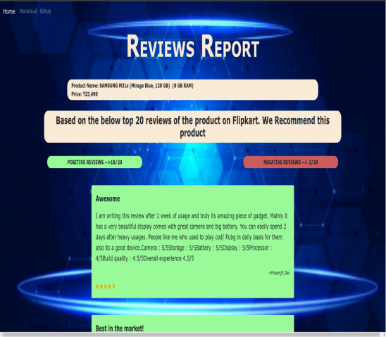

Figure 6. Review Report page 1(Recommended)

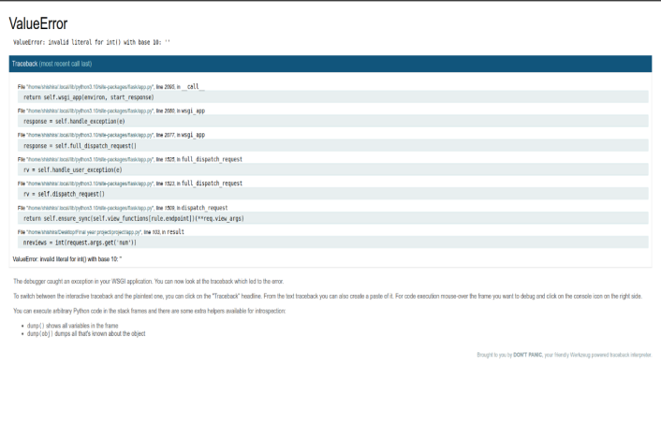. 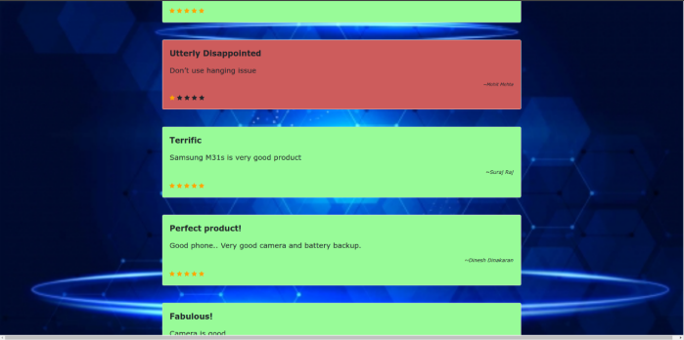

Figure 7: Review Report page 2(Recommended)

In Worldcloud recommended product information is displayed giving the information about the recommended product.

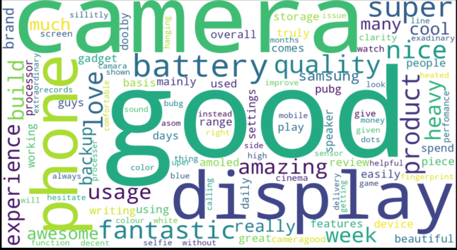

Figure8.WordCloud Recommendation of the product

4. Valid URL and Valid number of reviews , product not recommended

Figure 9 contains review report which consists of positive and negative reviews categorized based on ratings and the product is not recommended

Figure 9.Review Report page (Not Recommended)

Figure10. contains textual representation of reviews using Natural Language Processing for product not recommended.

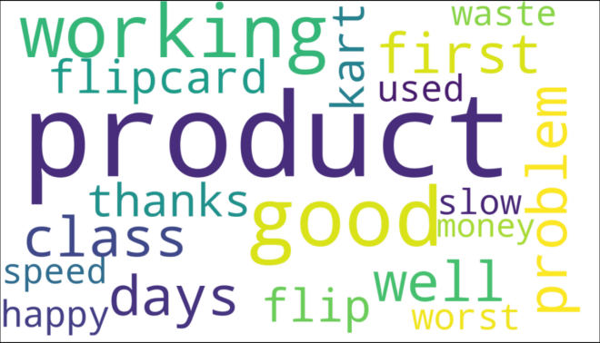

Figure 10. WordCloud not recommending the product

V.CONCLUSION

An evolutionary shift from offline markets to digital markets has increased the dependency of customers on online reviews to a great extent. Online reviews have become a platform for building trust and influencing consumer buying patterns. With such dependency there is a need to handle such a large volume of reviews and present credible reviews before the consumer’s future, the work can be extended to perform multi-class classification of reviews which will provide delineated nature of review to the consumer, hence better judgement of the product. It can also be used to predict the rating of a product from the review. This will provide users with a reliable rating because sometimes the rating received by the product and the sentiment of the review do not provide justice to each other. The proposed extension of work will be very beneficial for the e-commerce industry as it will augment user satisfaction and trust.

1. REFERENCES

**[1]. Karthik.R.V , Sannasi Ganapathy and Arputharaj Kannan, “A Recommendation System for Online Purchase Using Feature and Product Ranking” in Proceedings of Eleventh International Conference on Contemporary Computing (IC3) 2018.**

**[2].** **Pankaj, Prashant Pandey, Muskan and Nitasha Soni, “Sentiment Analysis on Customer Feedback Data: Amazon Product Reviews”, in Proceedings** [**of International Conference on Machine Learning, Big Data, Cloud and Parallel Computing (COMITCon)**](https://ieeexplore.ieee.org/xpl/conhome/8851231/proceeding) **2019.**

**[3] Stephina Rodney D’souza and Kavita Sonawane, “Sentiment Analysis Based on Multiple Reviews by using Machine learning Approaches”, in Proceedings of the Third International Conference on Computing Methodologies and Communication (ICCMC) 2019**.

**[4] Jo mackiewicz, Dave yeats, and Thomas thornton, “The Impact of Review Environment on Review Credibility.” in Proceedings ieee transactions on professional communication, vol. 59, no. 2, june 2016.**

**[5] Thiruni D. Jayasiriwardene, Gamage Upeksha Ganegoda, “Keyword extraction from Tweets using NLP tools for collecting relevant news” in proceedings of International Journal of Computer Applications, vol. 109, no. 2, pp. 18-23, 2015.**

**[6] Reshma V and Ansamma John, “Aspect Based Summarization of Reviews Using Naïve Bayesian Classifier and Fuzzy Logic”, in Proceedings of the 2016 2nd International Conference on Next Generation Computing Technologies (NGCT-2016) Dehradun, India 14-16 October 2016.**

**[7] Ujwal B V S , Bharat Gaind , Abhishek Kundu , Anusha Holla and Mukund Rungta., “Classiﬁcation-based Adaptive Web Scraper”, in Proceedings of the 2017 16th IEEE International Conference on Machine Learning and Applications.**

**[8] Tanya Gera, Deepak Thakur and Jaiteg Singh. “Identifying Deceptive Reviews Using Networking Parameters”, 978-1-4799-7623-2/15/$31.00c 2015 IEEE.**

**[9] Jawad khan, byeong soo jeong. “Summarizing Customer Review based on Product Feature and Opinion”, in Proceedings with 2016 International Conference on Machine Learning and Cybernetics, Jeju, South Korea, 10-13 July, 2016.**