CHURNSHIELD
AI-Driven Customer Retention & Risk Analysis Engine
Project Report • Deliverable 4
Purpose: convert historical telecom customer data into measurable business KPIs, churn trends, model-driven risk scores, and retention actions.

1. Executive Summary & Business Problem
Customer churn is the loss of a subscriber from a recurring-revenue service. For a telecom business, churn directly reduces the active customer base and recurring monthly revenue. ChurnShield is designed to move retention activity from reactive follow-up to proactive, model-assisted intervention.
The application loads a Telco Customer Churn dataset when available and otherwise provides a built-in synthetic fallback. It calculates customer count, historical churn rate, and monthly recurring revenue associated with churned customers. It then trains a Random Forest classifier and exposes an individual customer churn probability, risk tier, and contextual retention recommendations.
The project goal is not simply to predict churn. The intended business workflow is to connect prediction to a decision: identify risk, understand relevant customer attributes, and select a practical retention action.

2. The Business Decision Framework
ChurnShield implements the following decision chain:
DATA | KPIs | TRENDS | DRIVERS | RISK | ACTION

Stage | Implementation
Data | Customer demographics, services, contract, payment, tenure and billing attributes.
KPIs | Total customers, overall churn rate, MRR at risk and model AUC-ROC.
Trends | Contract-level churn, monthly-charge distributions, internet-service churn and tenure patterns.
Drivers | Random Forest feature-importance analysis displayed in the Model Intelligence tab.
Risk | Individual churn probability mapped to Low (<30%), Medium (30–70%), or High (≥70%).
Action | Context-aware retention recommendations generated from risk and selected customer attributes.

3. Dataset Overview & Feature Engineering
The application expects the standard Telco Customer Churn schema with 21 columns: customer identifier, demographic attributes, service attributes, account/billing attributes, and the Churn target. The model uses 16 categorical features plus three numerical features: tenure, MonthlyCharges, and TotalCharges.
Category | Fields
Categorical | gender, SeniorCitizen, Partner, Dependents, PhoneService, MultipleLines, InternetService, OnlineSecurity, OnlineBackup, DeviceProtection, TechSupport, StreamingTV, StreamingMovies, Contract, PaperlessBilling, PaymentMethod
Numerical | tenure, MonthlyCharges, TotalCharges
Target | Churn, normalized to 0/1

Data Preparation
- TotalCharges is coerced to numeric. Missing TotalCharges values are replaced using MonthlyCharges × tenure.
- Duplicate rows are removed and rows missing required numerical fields or the target are dropped.
- SeniorCitizen is normalized when represented as Yes/No.
- Categorical fields are label-encoded before model training.
- A StandardScaler is included in the sklearn Pipeline before the Random Forest classifier.

4. Model Architecture & Evaluation
ChurnShield uses a scikit-learn Pipeline containing StandardScaler followed by RandomForestClassifier. The Random Forest is configured with 200 trees, max_depth=12, min_samples_leaf=5, balanced class weights, and random_state=42. The data is divided using an 80/20 stratified train-test split.
The application calculates AUC-ROC from hold-out churn probabilities and generates a full classification report containing precision, recall, F1-score and support. Feature importance is obtained from the fitted Random Forest and the top 15 features are visualized.
Metric | Value | Source
Accuracy | Generated at application runtime | Classification report
ROC-AUC | Generated at application runtime | Hold-out probabilities
Precision | Generated at application runtime | Classification report
Recall | Generated at application runtime | Classification report
Submission note: the uploaded project does not contain a persisted metrics file or trained model artifact. Therefore, this report does not invent Accuracy, ROC-AUC, Precision, Recall, or feature-importance rankings. The live Streamlit run generates those values from the current dataset/runtime.

5. User Interface & Decision Output
The interface is implemented as a wide-layout Streamlit application with an executive KPI bar, a sidebar customer profile panel, and three principal tabs: Prediction & Decision Engine, Historical Insights, and Model Intelligence.

Placeholder 1 — Executive KPI Dashboard & Macro Analytics
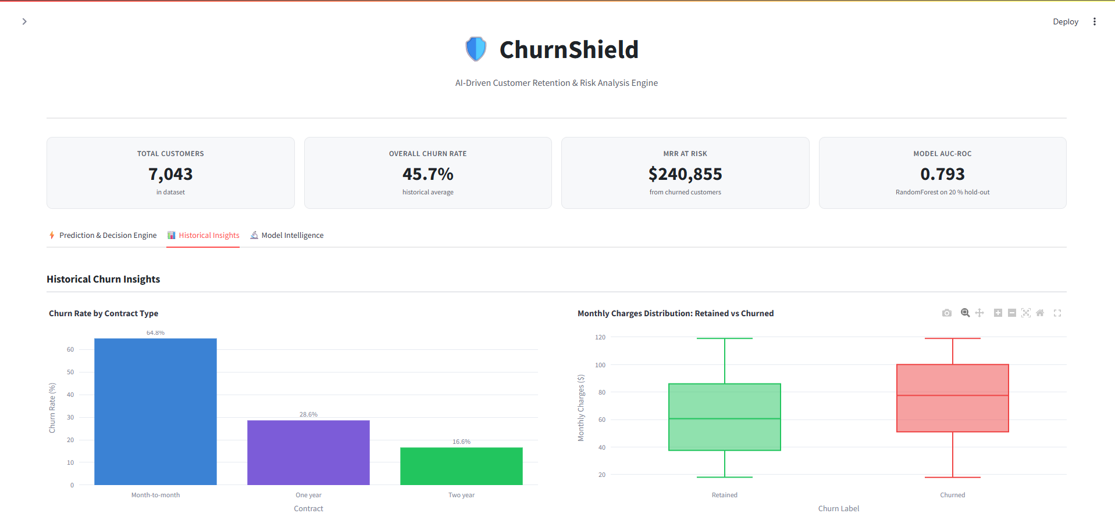

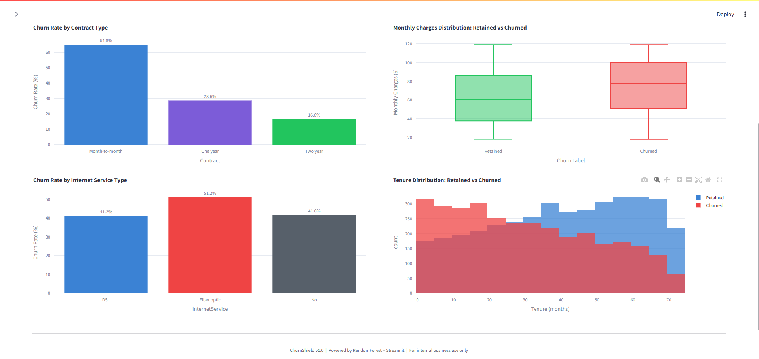

Placeholder 2 — Real-time Churn Prediction & Retention Action Output
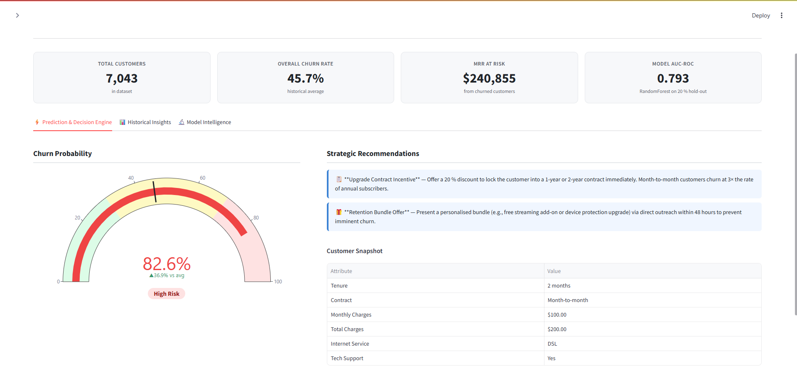

Placeholder 3 — Model Intelligence & Feature Importance
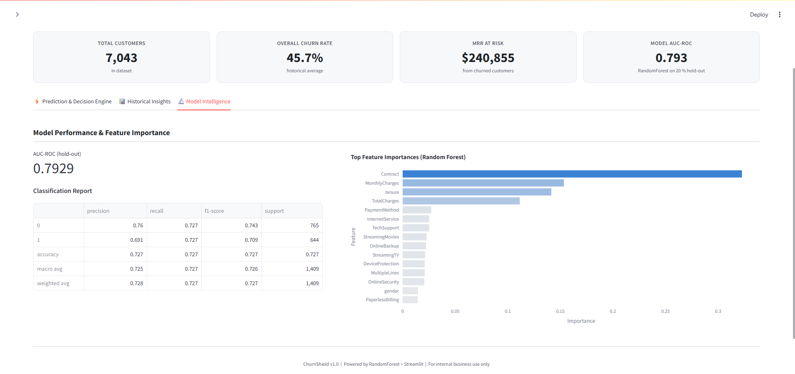

6. Recommended Business Actions & Implementation
The recommendation engine maps risk to practical retention playbooks. These actions are generated from the probability tier and selected customer attributes.
Risk Segment | Suggested Playbook
High Risk | Prioritize immediate outreach. Depending on customer attributes, the application can recommend a contract-upgrade incentive, customer-success support, and a personalized retention bundle.
Medium Risk | Use targeted engagement such as a loyalty discount when monthly charges are high, early-life engagement when tenure is low, and value-added service recommendations.
Low Risk | Focus on relationship growth rather than defensive retention, including referral programs and premium-tier or service upsell opportunities.

Implementation Considerations
- Use the model as a decision-support system rather than an automatic cancellation/retention authority.
- Track intervention outcomes so future versions can measure incremental retention and campaign ROI.
- Re-train and monitor the model as customer behavior, pricing and service offerings change.
- Persist the trained model and preprocessing objects for production deployment rather than training on every fresh deployment.
- Validate the model against the exact production dataset before using risk thresholds operationally.

Technical Stack
Layer | Technology
UI | Streamlit 1.35.0
Machine Learning | scikit-learn 1.4.2 — RandomForestClassifier
Data | Pandas 2.2.2, NumPy 1.26.4
Visualization | Plotly 5.22.0

Conclusion
ChurnShield provides an end-to-end analytical workflow that connects customer data with executive metrics, historical patterns, model drivers, individual risk scoring and retention actions. Its single-file Streamlit architecture makes the prototype straightforward to run, demonstrate and extend.

ChurnShield • Project Report

