1. What is the output of the given code ?

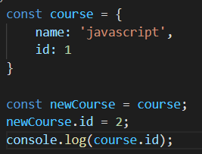

1. 1 b) 2 c) error d) undefined
2. What is the output of the given code ?

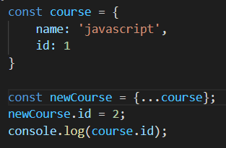

1. 1 b) 2 c) error d) undefined
2. Pure function will return same output if same arguments are passed how many times it executes
3. True b) False
4. The data type which supports pass by reference is
5. String b) Number c) Object d) Boolean
6. What is the output of the given code ?

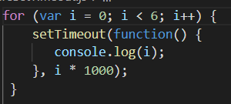

1. 1 b) 6 c) null d) undefined