Computer Networks
Assignment 10

2020-21
Even Semester

Submitted By:
Abhishek Kumar
19ucs241
Lab Batch: C4

Result#1 (Before Deletion)

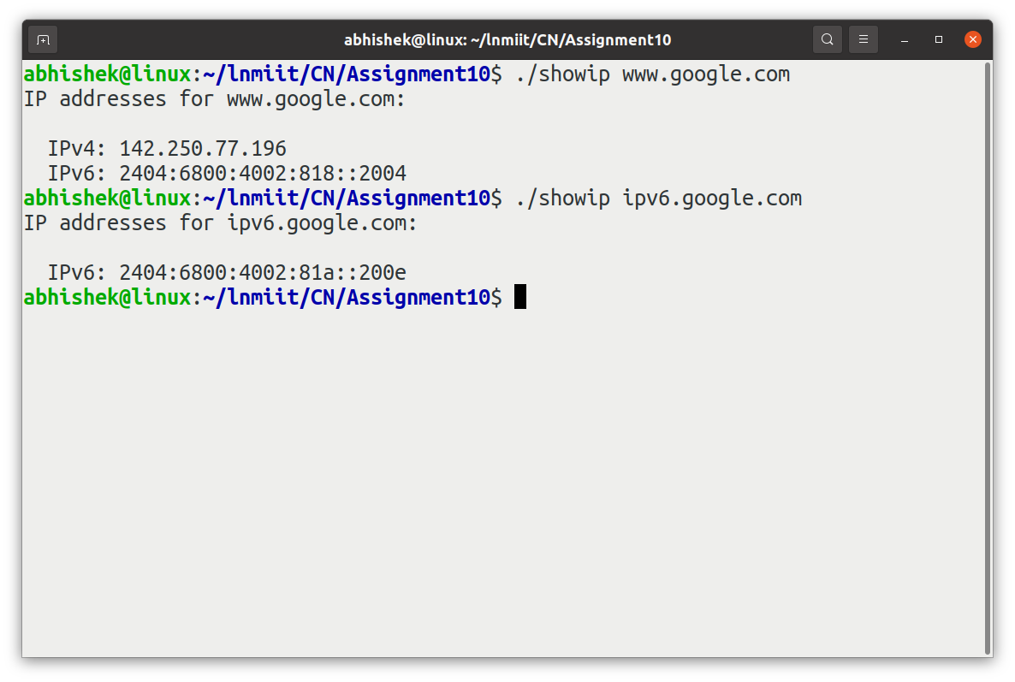
Result#2 (After Deletion)

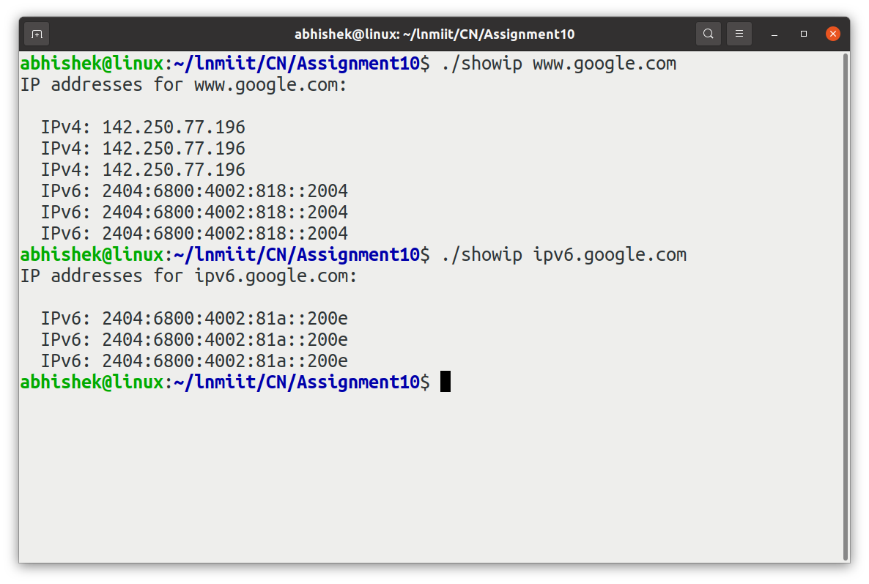
Q. How and why does it impact your program?

Ans.
After removing the given lines, getaddrinfo() returning more addrinfo structures. It is because the linked list may have more than one addrinfo structure, includes that the network host is multihomed, accessible over multiple protocols or the same service is available from multiple socket types i.e. SOCK_STREAM address or another SOCK_DGRAM address. In other words since we have deleted `hints.ai_socktype = SOCK_STREAM`. Now it is showing the IP address for datagram socket, stream socket and Raw socket.

