MarketLens: Consumer Spending and
Engagement Intelligence

Business Intelligence Report

Project Foundation

Prepared by: Rahul Kumar
Tech Stack: MySQL | Tableau | Excel

Executive Summary
MarketLens is a Business Intelligence project developed to analyze consumer spending, product performance, regional purchasing patterns, and coupon engagement using a relational MySQL database and interactive Tableau dashboards. The project transforms raw transactional data into business insights that support evidence-based decision making. It demonstrates the complete analytics workflow from data preparation and SQL analysis to KPI design, dashboard development, and business recommendations.

Business Problem
Retail organizations generate thousands of customer transactions every day. Without a centralized analytics solution, it becomes difficult to identify high-value customers, understand regional performance, evaluate promotional campaigns, and monitor product trends. MarketLens addresses these challenges by providing interactive dashboards and KPI-driven analysis.

Business Objectives
  - Analyze customer spending behaviour across regions and demographics.
  - Measure product and category performance.
  - Evaluate coupon utilization and discount effectiveness.
  - Monitor monthly business trends.
  - Support data-driven managerial decision making.

Technology Stack
Technology Purpose
Excel Data inspection and preparation
MySQL Relational database design and SQL analysis

Tableau Interactive dashboards, KPIs, filters and visualization

Dataset Overview
The project analyzes customer, product and transaction data. Core business entities include customers, products and transactions. Key attributes include customer demographics, location, tenure, product category, SKU, transaction date, quantity, average price, discount percentage, coupon status, GST, delivery charges and calculated product value.

Database Design
The analytical database is organized into three logical entities: Customer, Product and Transactions. Customer information stores demographic and spending attributes. Product stores SKU, description and category. Transactions links customers with purchased products and records pricing, quantity, coupon usage and monetary values. This structure supports efficient joins, aggregation and business reporting.

SQL Workflow
- Create relational database and tables.
- Import and validate transactional data.
- Perform SQL aggregation, filtering, grouping and joins.
- Generate business KPIs and analytical datasets.
- Connect SQL output to Tableau for visualization.

SQL Analysis & KPI Framework

SQL Analysis Methodology
The analytical workflow begins with importing cleaned transactional data into a MySQL database. SQL is used to validate records, aggregate measures, join business entities, calculate KPIs, rank categories, compare customer behaviour, and prepare datasets for Tableau dashboards. This approach ensures consistent calculations and reproducible analysis.

Business Questions Answered Using SQL

Customer Analytics

- What is the distribution of customers across different genders?
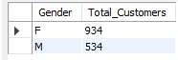

- What is the average customer tenure for each gender?
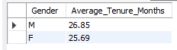

How are customers distributed across different tenure groups?
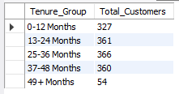

Which customers generate the highest overall spending through online and offline purchase channels?
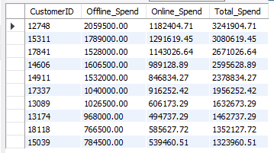

Which customers generate the highest revenue based on their product purchases?
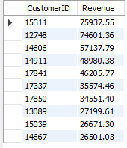

What are the complete purchase and demographic details of a selected customer?
Customer id – 15311

Which product categories are most frequently purchased by a selected high-value

customer?
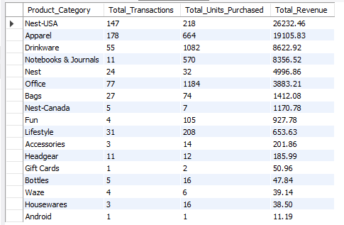

How does customer spending vary across different genders, locations, and tenure groups?

Product Analytics, Sales & Revenue Analytics

Which product categories contribute the highest number of units sold?
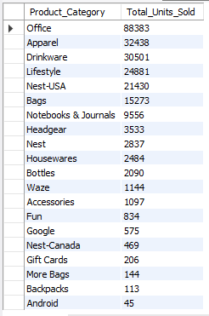

Which product categories contribute the most to total sales volume, and what percentage of overall sales does each category represent?
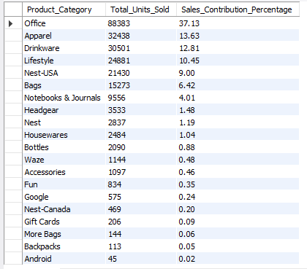

Which products generate the highest revenue and sales volume?
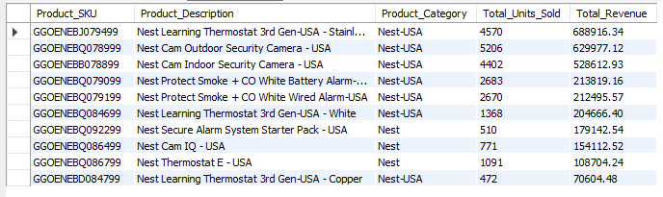

How do product sales and revenue change throughout the year?
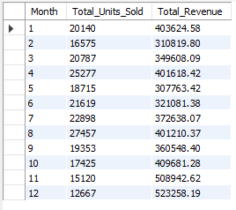

Which locations generate the highest product revenue?
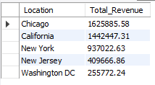

Discount & Coupon Analytics

How do average discount percentages vary across different months?
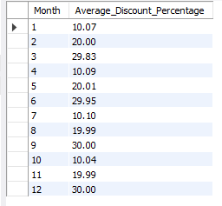

How are customers engaging with available coupons during purchases?

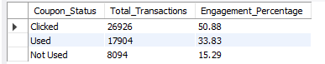

How does coupon engagement change across different months?

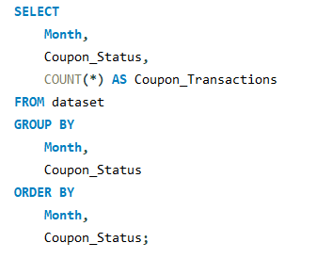

Which product categories receive the highest coupon engagement?

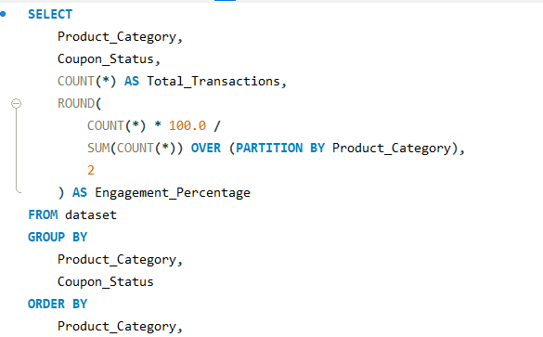

SQL Techniques Used

Technique | Business Purpose
SELECT / WHERE | Retrieve relevant records
GROUP BY | Summarize customer, product and regional performance
SUM() | Calculate total value and spending
AVG() | Calculate average spend, discount and price
COUNT() / COUNT(DISTINCT) | Measure customers and transactions
ORDER BY | Rank locations, products and categories
JOIN | Combine customer, product and transaction data

KPI Framework

KPI | Definition | Business Value
Total Product Value | Overall monetary value generated by all | Business growth and revenue scale.

 | transactions.
Total Units Sold | Total quantity of products purchased. | Demand measurement and inventory planning.
Average Value per Unit | Average monetary value per unit sold. | Pricing and sales efficiency.
Top Product SKU | Highest-performing product. | Product prioritization.
Total Customers | Unique customer base. | Customer reach.
Average Customer Spend | Average spend per customer. | Customer value.
Top Spending Region | Highest-value location. | Regional planning.
Average Customer Tenure | Average relationship duration. | Retention analysis.
Coupon Usage Rate | Share of coupon usage. | Promotion effectiveness.
Average Discount | Average discount percentage. | Pricing strategy.
Average Product Price | Average selling price. | Pricing analysis.
Top Product Category | Best-performing category. | Merchandising decisions.

KPI Governance
Every KPI should have a documented definition, aggregation rule, source field, refresh frequency, and dashboard dependency. Consistent KPI governance prevents conflicting business interpretations and improves trust in dashboard reporting.

Transition to Dashboard Analysis
With the SQL layer validated and KPIs defined, the prepared analytical dataset is connected to Tableau. The next section explains each dashboard, visualization, filter, and business interpretation in detail.

Part 3: Dashboard Analysis S Business Interpretation

Dashboard 1 – Executive Overview

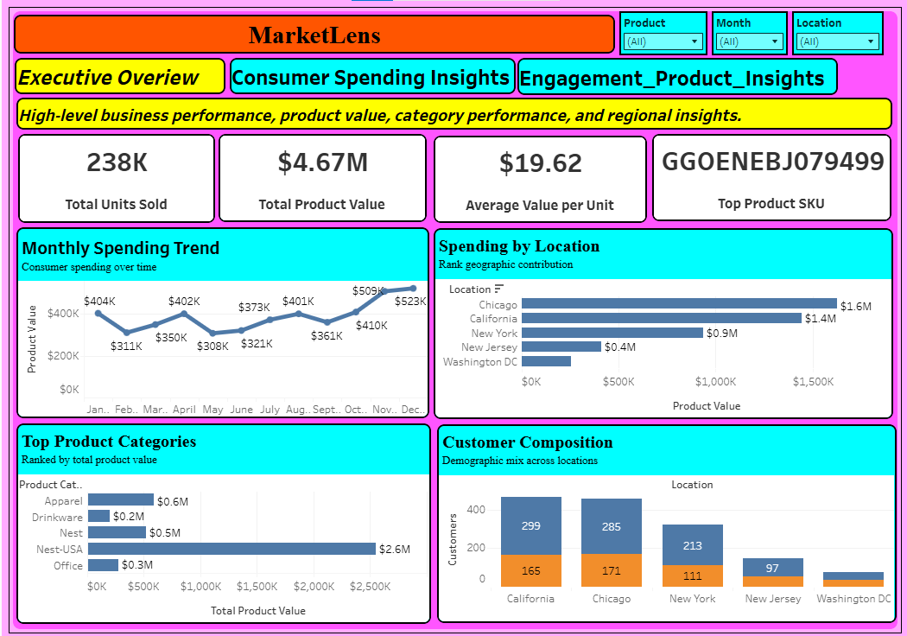

Business Objective
Provide management with a high-level view of business performance, product value, sales volume and regional contribution.

KPIs
KPI | Business Interpretation
Total Product Value | Measures the overall monetary value generated.
Total Units Sold | Shows customer demand.
Average Value per Unit | Evaluates pricing efficiency.
Top Product SKU | Highlights the leading product.

Charts & Insights
- Monthly Transaction Pattern Identifies seasonal business trends.
- Geographic Revenue Distribution Compares contribution across locations.
- Units Contribution by Product Category Ranks demand across categories.
- Spending Distribution by Location S Category Explains where value is generated.

Filters
Month, Location, Product Category

Management Recommendations
- Monitor KPIs regularly to identify performance changes.
- Use filters for regional, monthly and category-level analysis.
- Support data-driven marketing, inventory and pricing decisions.

Dashboard 2 – Consumer Spending Insights

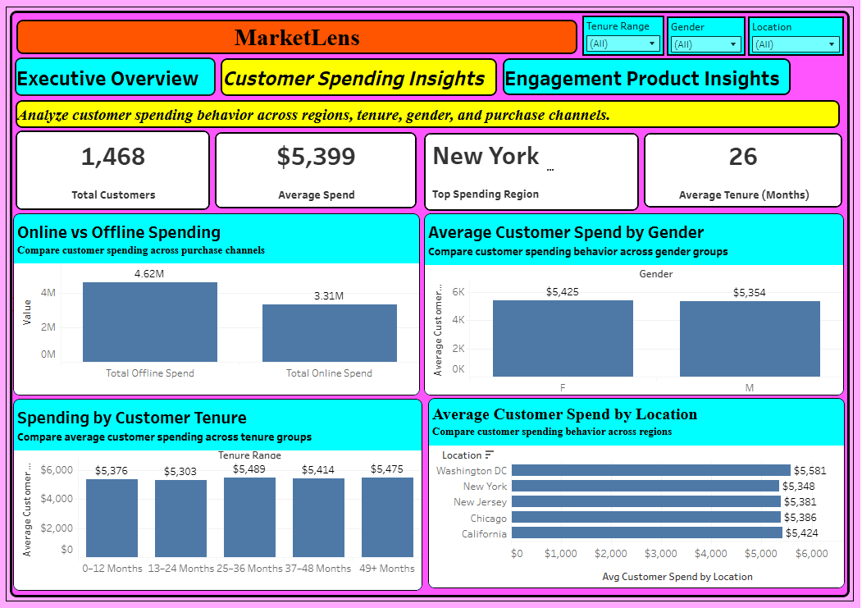

Business Objective
Understand customer behaviour, demographic trends and regional spending patterns.

KPIs
KPI | Business Interpretation
Total Customers | Size of the customer base.
Average Customer Spend | Average monetary contribution per customer.
Top Spending Region | Best-performing location.
Average Customer Tenure | Customer loyalty indicator.

Charts & Insights
- Online vs Offline Spending Compares purchasing channels.
- Average Customer Spend by Location Identifies high-value regions.
- Spending by Customer Tenure
Shows relationship between loyalty and spending.
- Average Customer Spend by Gender Supports demographic segmentation.

Filters
Location, Gender, Tenure Range

Management Recommendations
- Monitor KPIs regularly to identify performance changes.
- Use filters for regional, monthly and category-level analysis.
- Support data-driven marketing, inventory and pricing decisions.

Dashboard 3 – Engagement & Product Insights

Business Objective
Evaluate promotional performance, product pricing and coupon engagement.

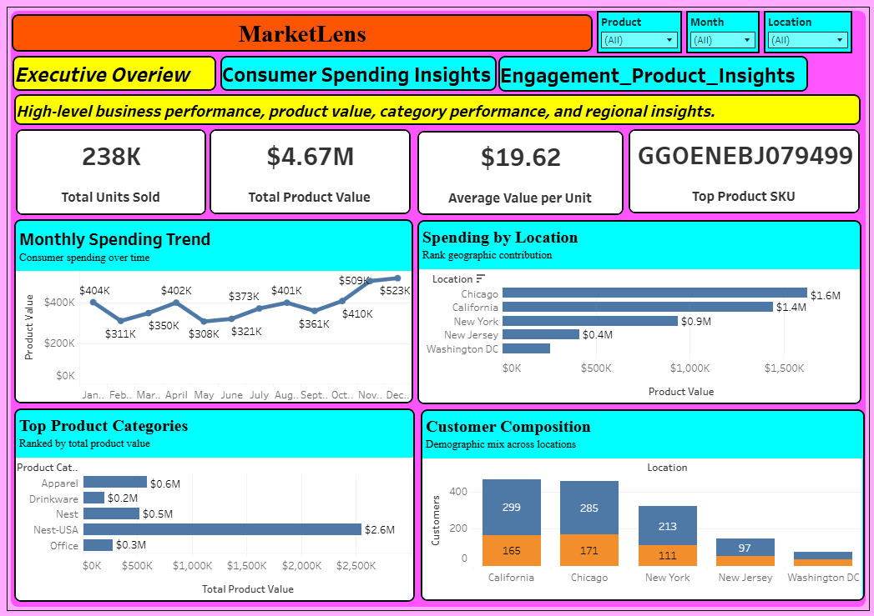

KPIs
KPI | Business Interpretation
Coupon Usage Rate | Measures promotional adoption.

Average Discount | Evaluates discount strategy.
Average Product Price | Tracks pricing.
Top Product Category | Highlights strongest category.

Charts & Insights
- Product Value by Coupon Status
Compares monetary value across coupon behaviour.
- Average Discount by Product Category Measures discount allocation.
- Coupon Engagement Mix by Product Category Shows coupon interaction by category.
- Monthly Coupon Usage Trend
Tracks seasonality in coupon engagement.

Filters
Month, Product Category, Coupon Status

Management Recommendations
- Monitor KPIs regularly to identify performance changes.
- Use filters for regional, monthly and category-level analysis.
- Support data-driven marketing, inventory and pricing decisions.

Overall Business Value
The three-dashboard architecture provides a complete analytical workflow: Dashboard 1 answers what is happening, Dashboard 2 explains who is spending and where, and Dashboard 3 explains how promotions and product strategy influence customer engagement. This layered approach supports executive reporting and operational decision-making.

Business Insights, Recommendations S Conclusion

Key Business Insights
  - Customer spending varies significantly across regions, highlighting opportunities for localized marketing.
  - High-value product categories should be managed separately from high-volume categories.
  - Coupon engagement differs across product categories, indicating that promotions should be targeted rather than universal.
  - Monthly trends reveal seasonality that can guide campaign timing and inventory planning.
  - Average customers spend and tenure together provide a stronger indicator of customer value than either metric alone.
  - Product pricing and discount strategies should be monitored together to protect margins while maintaining engagement.
  - Interactive filters allow managers to investigate performance by month, location, gender, category and coupon status.

Strategic Recommendations
- Prioritize high-value regions with retention campaigns and premium assortments.
- Introduce customer segmentation based on spending and tenure.
- Optimize coupon campaigns for categories with stronger engagement.
- Monitor KPIs monthly to detect emerging trends early.
- Use dashboard insights to support inventory planning and pricing decisions.
- Expand the dashboard with Customer Lifetime Value (CLV) and RFM analysis in future versions.
- Establish KPI governance with documented formulas and refresh schedules.

Conclusion
MarketLens demonstrates an end-to-end Business Intelligence workflow that transforms raw transactional data into actionable business insights. By combining a relational MySQL database, SQL-based analysis, and three interactive Tableau dashboards, the project enables stakeholders to evaluate customer behaviour, regional performance, product trends, pricing strategies and coupon effectiveness. The project illustrates both technical competence and business thinking, making it a strong portfolio project for junior data analyst roles.

