**WEATHER FORECASTING SYSTEM**

**A**

**SYNOPSIS REPORT OF MINI PROJECT**

**WEATHER FORECASTING SYSTEM**

**In partial fulfillment of requirements for the degree of**

**BACHELOR OF TECHNOLOGY**

**IN**

**COMPUTER SCIENCE AND ENGINEERING (AI&ML)**

**SUBMITTED BY:**

**Abhishek kumar & Ujjawal kumar**

**2100331530003 , 2100331530058**

**October 2022(Batch 2022-23)**



**SUBMITTED TO:**

**COMPUTER SCIENCE AND ENGINEERING(AI&ML)**

**RAJ KUMAR GOEL INSTITUTE OF**

**TECHNOLOGY, GHAZIABAD(U.P.)**

# Table of Contents

1. Introduction Page No- 2
2. Project Aim Page No- 3
3. Project Specification Page No- 3
4. Scenario Analysis Page No- 4
5. Deliverables Page No- 5
6. Work Plan Page No- 5-6
7. UseCase Diagram Page No-7
8. UI diagram Page No-8
9. Application Screenshots Page No -9
10. . Reference Page No-10
11. . Limitations Page No- 10
12. . Unimplemented features Page No-11

**WEATHER FORECAST**

**A real time weather app**

# OVERVIEW

**Introduction**

**Weather forecasting** is the application of science and technology to predict the conditions of the [atmosphere](https://en.wikipedia.org/wiki/Earth%27s_atmosphere) for a given location and time.Weather forecasts are made by collecting quantitative [data](https://en.wikipedia.org/wiki/Data) about the current state of the atmosphere at a given place to project how the atmosphere will change. The role of Technology has been remarkable in the field of weather forecasting. Weather data is not only necessary for researchers or scientists, ordinary people can be benefitted from it as well. People nowadays are feeling the necessity of weather data as well.There are a variety of weather mobile apps in Google Play and the App store. Those apps have great features and functionalities to satisfy users. However, only a few of them have friendly user interface and human centered interactions, which means that a lot of them might be difficult to be navigated even though they provide enough functionalities. It is not convenient for new users. Therefore, we would like to do improvements on weather mobile apps. It is basically for Apple smart phones and tablets.

## 2.Project Aim

To make a real time weather application that takes user’s exact location and provides weather forecast for the day and upcoming days also. We also tried to design a simple but visual UI that provides comprehensive data. Also the application provides suggestions to users based on weather conditions. And lastly, user can search and access data for custom locations (string based).

## 3.Project Specification

1. Real time weather forecasting.
2. Takes user’s geolocation as input to provide weather forecast
3. **Hyper-Local Forecast:** App will predict weather changes with a per minute accuracy based on the user current location.
4. Displays detailed weather information for five cities.
5. Can also take custom location as input to provide weather details for that location (Google Manual Search API).
6. RapidAPI is used to fetch data.

## 5.Deliverables

1. A properly working and executable. File that will run in any device.
2. A documentation that will provide details about the requirements, specifications and other information.

## 6.UseCase Diagram

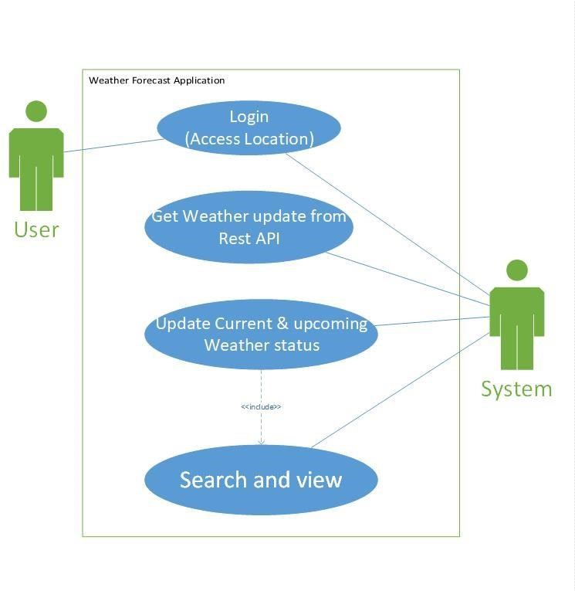

## 8.UI diagram

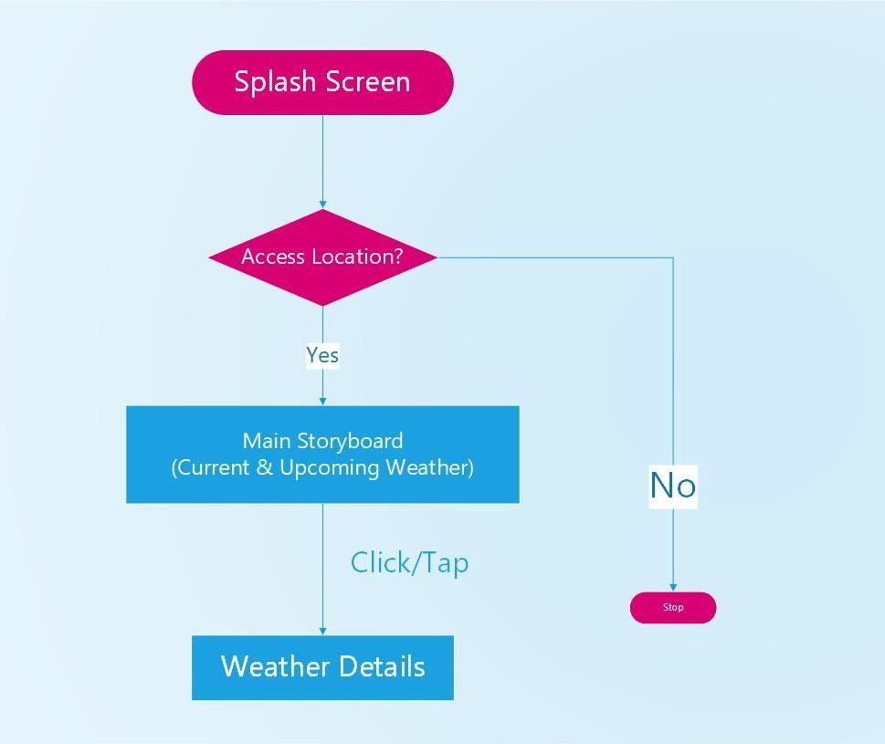

## 9.Application Screenshots

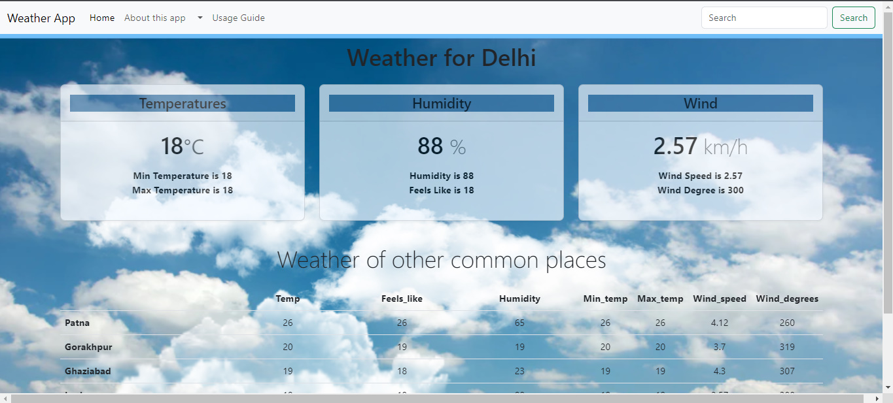

## 10.Reference

Several applications provided us a proper guideline on how to proceed. They are listed as follows:-

a)Dark Sky developed by The DarkSky Company probably has the best visuals.

b)AccuWeather inc. developed the Accuweather app that provides the most comprehensive data comparatively.

c)Haze developed by Robocat & Taptanium is the most simplistic and gorgeous app one will ever find.

## 11.Limitations

a) Unpaid APIs provide incomplete services. Many details cannot be fetched

b) Often, tuples of upcoming days remain empty once again due to free APIs

c)The GMS API ( Google Manual Search) is actually keyword

based that might only provide data of few discrete locations. The data might not be precise and continuous

d)Language diversity could have been implemented. Multilingual apps make it easy for users worldwide

## 12.Unimplemented features

a) We intend to provide more detailed tips based on the age, gender, region and health conditions (Dust allergy, heatstroke tendency etc.) of the user.

b) FAQ section based on detailed data might be quite handy. It will save the user’s efforts and make it more convenient. c)Using paid APIs to fetch more details might make the application more comprehensive and appealing. For example wind speed, precipitation & sea level values can be used to provide more intellectual tips.

d)Mobility of the traveler,their start & end points of the journey,their route of traveling(road,waterway,aerial) shall be strongly focused.The application needs to be an aid for traveling users.

e)Recording User inputs to understand the user preferences and providing them necessary notifications needs to be kept in mind

f)Maybe someday in the near future,we will use AIs for more precision and accuracy.