Ksssseywords:
- unpacking after move
- home organisation
- unpacking tips
- moving-in setup

Permalink- https://www.cbdmovers.com.au/blog/unpacking-after-move-wollongong-homes-functional-guide/

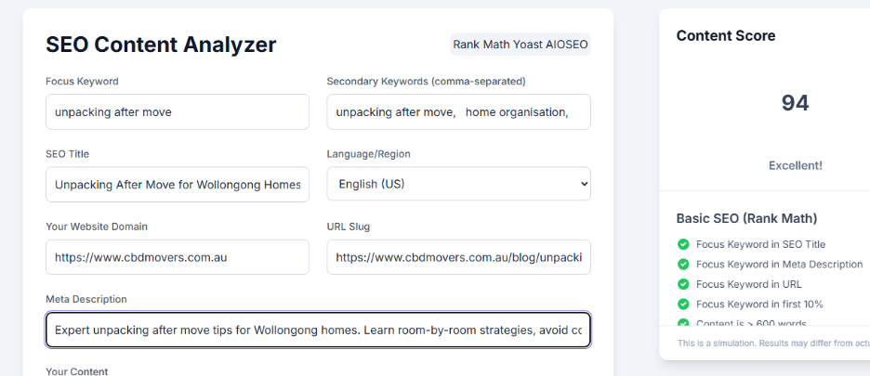

Meta Title (59 characters): Hello Abhishek Unpacking After Move Wollongong Homes: Fast Functional Guide
Meta Description (155 characters): Expert unpacking after move tips for Wollongong homes. Learn room-by-room strategies, avoid common mistakes & make your new space functional fast.

Approved
Helo Abhishek Unpacking After Move for Wollongong Homes: Make Your New Space Functional Fast 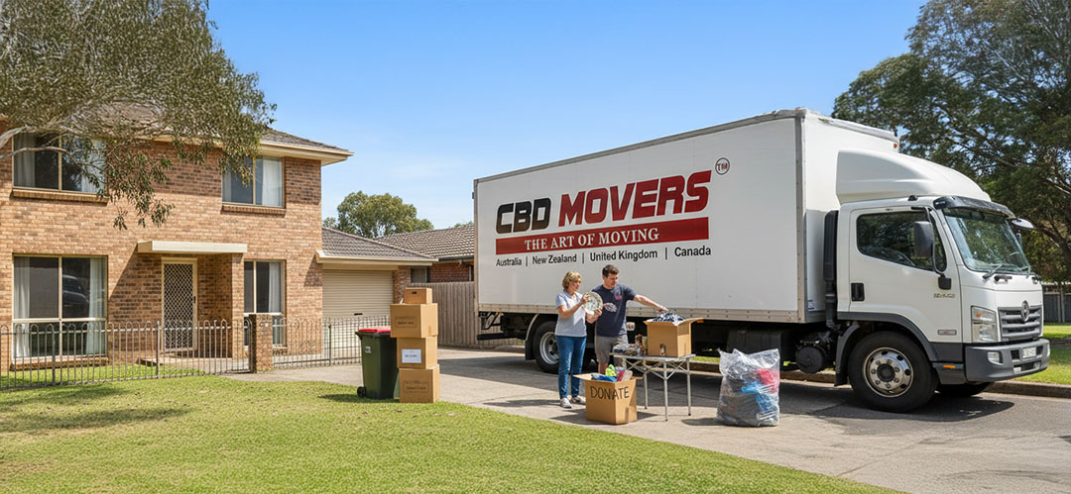
Moving to a new home in Wollongong is exciting. But the boxes piling up can feel overwhelming. The key to settling in quickly is smart unpacking. This guide shows you how to turn your new Wollongong house into a functional home fast.
Why Strategic Unpacking Matters in Wollongong Homes
Unpacking the right way saves time and stress. Many families rush and create more mess. A good plan helps you find what you need when you need it.
Wollongong homes often have unique layouts. Coastal properties may have different storage than hillside houses. Knowing your space before unpacking makes everything easier.
Here's what smart moving-in setup does:
- Gets your kitchen working in hours, not days
- Helps kids settle into bedrooms quickly
- Reduces box clutter blocking hallways
- Prevents damage to belongings and property
Professional unpacking after move services understand local home styles. They know how Wollongong families live and what rooms matter most.
Unpacking Task | Time Required | Priority Level
Kitchen essentials | 2-3 hours | High
Bedrooms setup | 3-4 hours | High
Living areas | 4-5 hours | Medium
Storage spaces | 2-3 days | Low
(CBD Movers Sydney operational data)
Start With Your Moving-In Setup
Your moving inventory list is your unpacking roadmap. It tells you what boxes go where and what's inside each one.
Before moving day ends, check your list against delivered boxes. Mark any missing or damaged items immediately. This protects you and helps movers fix problems fast.
Essential inventory steps:
- Number each box clearly
- Note room destination on the list
- Mark fragile items with red stickers
- Keep one master list on your phone
Rebecca Husseini from Wollongong gave CBD Movers 5 stars, saying: "Best Removalist. Fast, friendly and easy service with an after hours call centre you can book anytime day or night. Amazing."
This shows why choosing experienced movers and packers in Sydney matters for smooth delivery and unpacking.
Using Your Home Packing Planner During Unpacking
Your home packing planner works both ways. It helped you pack, now it helps you unpack efficiently.
Look at your planner notes. They remind you which items you marked as "first night essentials" or "open last." This prevents wasting time opening wrong boxes.
Room-by-Room Unpacking Tips for Wollongong Homes
Not all rooms need unpacking at once. Start with spaces you'll use within 24 hours.
Kitchen and Dining Area First
The kitchen powers your home. You need it for meals, coffee, and keeping energy up during unpacking.
Unpack in this order:
- Coffee maker, kettle, basic mugs
- Plates, bowls, cutlery for family
- Cooking pots, pans, cutting board
- Pantry staples and fridge items
- Cleaning supplies for wiping surfaces
Wollongong's waste collection schedule runs weekly. Break down boxes as you unpack and stack them for recycling. This keeps your new home tidy from day one.
Kitchen Zone | Essential Items | Can Wait
Cooking area | Pots, pans, knives | Specialty appliances
Food storage | Containers, wraps | Extra serving dishes
Cleaning | Dish soap, sponges | Fancy cleaners
Bedrooms and Bathrooms Next
Everyone needs a good night's sleep after moving day. Set up beds before anything else.
Make beds with fresh sheets. Unpack pajamas, toiletries, and tomorrow's clothes. This creates a calm space when exhaustion hits.
Bathroom essentials:
- Shower curtain and bath mat
- Towels for each family member
- Toilet paper and tissues
- Basic toiletries and medications
- Cleaning spray for quick wipes
If you're preparing to vacate your previous property, consider booking end of lease cleaning services to ensure you get your bond back without the stress of cleaning while unpacking at your new place.
Living Areas and Family Spaces
Living rooms can wait a day or two. But having one comfortable space helps everyone relax together.
Set up your TV or entertainment area if it helps kids feel settled. Unpack a few favorite toys or books. Put out couch cushions and throws.
Don't rush to arrange everything perfectly. Live in the space first and see how your family moves through it.
Using Your Relocation Packing Guide in Reverse
Your relocation packing guide told you how to pack safely. Now use those same principles for unpacking after move to protect your belongings and reduce stress. A structured approach to unpacking helps you stay organized and avoid damage.
Fragile items packed carefully need careful unpacking too. Take your time with dishes, glassware, and decorative pieces. For detailed tips, check our guide on packing fragile items.
Safe unpacking tips:
- Clear a clean, soft surface first
- Open boxes from the top carefully
- Remove packing paper layer by layer
- Inspect each item for damage
- Place items directly where they belong
Wollongong homes near the coast may have humidity concerns. Unpack wooden furniture and electronics within 48 hours to prevent moisture damage.
Dealing With Boxes and Packing Materials
Empty boxes multiply fast. Handle them daily or they'll take over your home.
Smart box management:
- Break down empty boxes immediately
- Stack them flat in garage or carport
- Separate cardboard from bubble wrap
- Keep a few boxes for returns or storage
- Schedule recycling pickup or drop-off
The Wollongong City Council offers recycling centers at Whyte Gully and Helensburgh. Both accept cardboard and packing materials for free.
Following Your Comprehensive Moving Checklist
Your comprehensive moving checklist doesn't end at move-in. The final section covers unpacking and settling in.
Review what's left on your checklist. Update your address with important services. Register kids at new schools. Find your local doctor and pharmacy.
Post-move checklist items:
- Update driver's license address
- Register to vote in Wollongong area
- Connect utilities if not done already
- Test smoke alarms and safety devices
- Locate water and gas shut-offs
Professional preparation makes everything smoother. Learn how to prepare your house for movers for your next move.
Task | When to Complete | Who to Contact
Electricity connection | Before move-in day | Energy provider
Internet setup | Within 3 days | NBN provider
Council rates | Within 2 weeks | Wollongong Council
Car registration | Within 14 days | Service NSW
Source: Service NSW relocation requirements
Making Your Wollongong Home Functional Fast
Functionality beats perfection when it comes to smart home organisation. Focus on what makes daily life work smoothly.
Set up your coffee station before hanging artwork. Get the kids' homework spot ready before decorating the living room. Unpack work-from-home essentials if you're remote.
Quick functionality wins:
- Create a mail and keys drop zone
- Set up laundry area completely
- Organize main bathroom fully
- Clear main walkways of boxes
- Establish a family gathering spot
Wollongong families often use outdoor spaces year-round. If you have a deck or patio, set up basics like outdoor seating early. The ocean breeze and views help reduce moving stress.
Storage Solutions for Unpacked Items
Not everything has a permanent home immediately. Use temporary storage smartly.
Stack similar items together in one room. Label these "staging areas" clearly. This beats scattering half-unpacked boxes throughout your home.
Before moving out of your previous home, you might want to get a move out cleaning quote to leave it spotless and avoid last-minute cleaning stress.
Temporary storage tips:
- Use garage for seasonal items
- Stack boxes by priority in one room
- Keep pathways completely clear
- Review staging areas weekly
- Donate items you haven't missed
Smart Unpacking for Wollongong's Climate
Wollongong's coastal location affects how you unpack. Salt air, humidity, and temperature changes matter.
Unpack and air out fabrics quickly. Mold grows fast in sealed boxes in humid conditions. Hang curtains and bedding within the first few days.
Climate-smart unpacking:
- Open boxes with fabrics first
- Wipe down wooden furniture immediately
- Check electronics for condensation
- Air out closets and wardrooms
- Run dehumidifier in storage areas
Metal items packed during winter may have condensation. Dry them completely before putting them away to prevent rust.
Item Type | Unpacking Priority | Special Care
Fabric/bedding | Within 24 hours | Air out completely
Electronics | Within 48 hours | Check for moisture
Wooden furniture | Within 3 days | Wipe and condition
Metal tools | Within 1 week | Dry thoroughly
Getting Help With Unpacking in Wollongong
You don't have to unpack alone. Professional help exists for every budget.
CBD Movers offers unpacking services throughout Wollongong. They know local home layouts and can set up your kitchen in hours.
When to hire unpacking help:
- You're short on time before work starts
- You have mobility or health concerns
- You're unpacking a large family home
- Fragile or valuable items need care
- You want to settle in immediately
Local rates for unpacking services start around $120 per hour for a two-person team. Full-home unpacking typically takes 6-8 hours for a three-bedroom house.
Asking Friends and Family for Support
Local Wollongong friends can provide valuable help. They know the area and can direct you to shops and services while unpacking.
Assign specific tasks to helpers. One person handles the kitchen while another sets up bedrooms. Clear direction prevents confusion and wasted effort.
Friend helper tips:
- Provide lunch and drinks
- Give specific room assignments
- Have cleaning supplies ready
- Accept help gracefully
- Return the favor later
Common Unpacking Mistakes to Avoid
Learning from others' mistakes saves time and frustration.
Don't try to unpack everything in one day. This leads to exhaustion and poor decisions about where things go. Take breaks and pace yourself over several days.
Mistakes that slow you down:
- Opening all boxes at once
- Not labeling keep vs donate piles
- Skipping the cleaning step
- Buying storage before unpacking
- Ignoring what doesn't fit
Many Wollongong homes have less storage than expected. See what you have before buying organizing products. You might need less than you think.
When to Call It Done
Your home doesn't need to be perfect to be functional. Know when to stop and start living.
If you can cook, sleep, shower, and relax comfortably, you're done with essential unpacking. Decorating and organizing can happen over weeks or months.
Signs you can pause unpacking:
- Daily routines work smoothly
- Everyone has their essentials
- Main living areas are clear
- Safety items are in place
- You feel at home

Make Your Wollongong Move Complete
Unpacking transforms a house into your home. Following a clear plan gets you settled fast without the stress.
Start with essentials, work room by room, and don't rush perfection. Your comprehensive moving checklist guides you through each step. Your home packing planner and moving inventory list make finding everything simple.
Wollongong's beautiful coastal lifestyle awaits once you're settled. Take time to enjoy your new neighborhood while unpacking at a comfortable pace.
Need expert help making your Wollongong move smooth from start to finish? Contact CBD Movers for professional packing, moving, and unpacking services tailored to local homes. Our experienced team knows Wollongong properties and helps families settle in quickly and stress-free.

FAQs-
How long should unpacking take in a Wollongong home?
Most families complete essential unpacking in 3-5 days. Full unpacking takes 2-3 weeks. Coastal homes may need faster unpacking due to humidity affecting packed items.
What rooms should I unpack first after moving?
Unpack kitchen, bathrooms, and bedrooms first. These rooms support basic daily needs. Living areas and storage spaces can wait several days.
Should I hire professional unpacking help in Wollongong?
Professional help makes sense for large homes, tight timelines, or physical limitations. Local Wollongong services understand coastal home layouts and climate considerations.
How do I handle unpacking with kids in the house?
Set up kids' bedrooms first for stability. Give them simple unpacking tasks like arranging books or toys. Take breaks for park visits or beach time.
What should I do with empty moving boxes?
Break down boxes immediately after emptying. Recycle through Wollongong Council services at Whyte Gully or Helensburgh. Keep 2-3 boxes for storage or returns.
When should I buy organizing products for my new Wollongong home?
Wait until you've unpacked everything before buying organizers. Live in the space first to see what you actually need. Wollongong homes vary greatly in storage options.

