**Test Yourself: HDFS Command Line**

Problem Statement: Using Command line of HDFS, perform following tasks.

1. Create a directory /hadoop/hdfs/ in HDFS

Answer: 

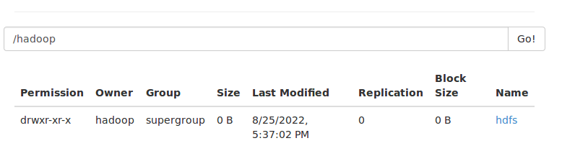

Output:

1. Create a temp directory in Hadoop. Run HDFS command to delete “temp” directory.

Answer: Creating temp file command



Deleting Temp file command and output

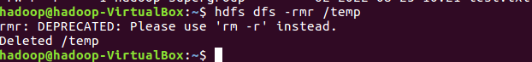

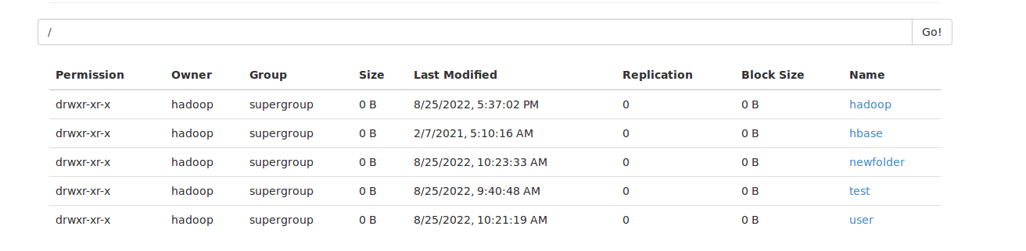

1. List all the files/directories for the given hdfs destination path.

Answer:

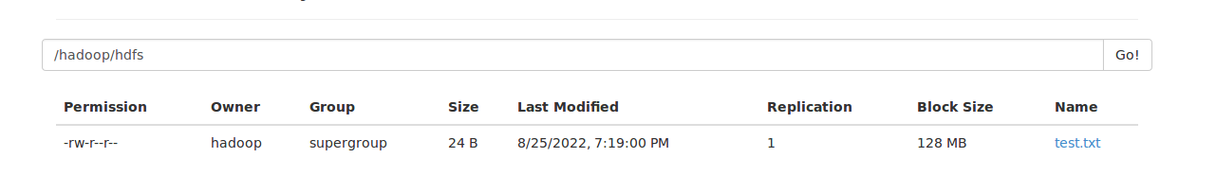

1. Command that will list the directories in /hadoop folder.

Answer: 

1. 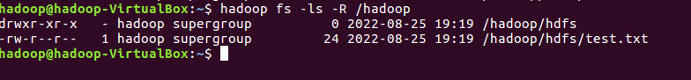Command to list recursively all files in hadoop directory and all subdirectories in hadoop directory.

Answer:

1. 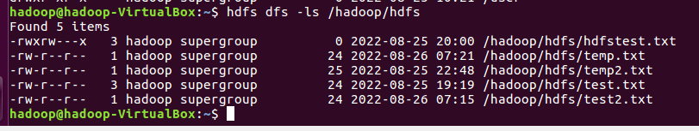List all the files inside /hadoop/hdfs/ directory which starts with 'dir'.

Answer:

1. Create a temp.txt file. Copies this file from local file system to HDFS

Answer: 



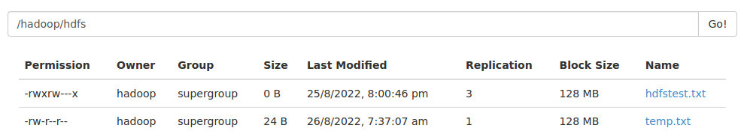

1. Copies the file from HDFS to local file system.

Answer: 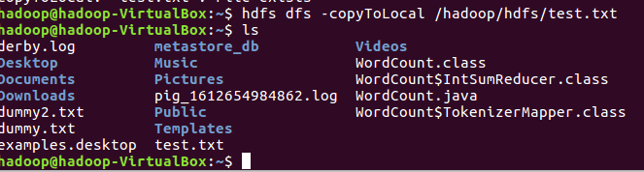

1. Command to copy from local directory with the source being restricted to a local file reference.
2. Command to copies to local directory with the source being restricted to a local file reference.
3. Command to move from local directory source to Hadoop directory.

Answer:

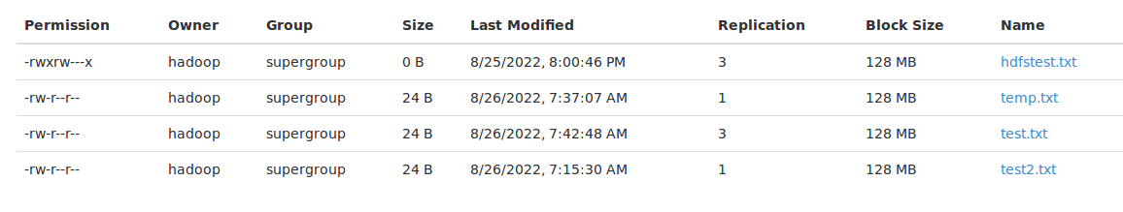



1. Deletes the directory and any content under it recursively.

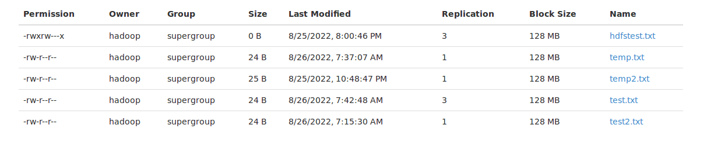Answer:



After deleting temp 2 file

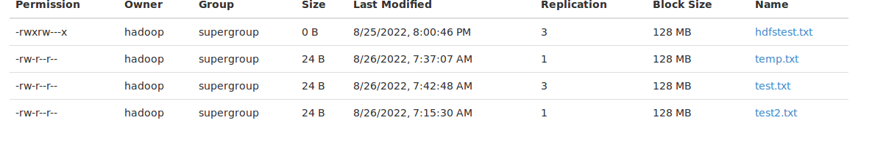

1. List the files and show Format file sizes in a human-readable fashion.
2. Take a source file and outputs the file in text format on the terminal.
3. Display the content of the HDFS file test on your /user/hadoop2 directory.

Answer:

1. Append the content of a local file test1 to a hdfs file test2.

Answer:



1. Show the capacity, free and used space of the filesystem

Answer:

1. Shows the capacity, free and used space of the filesystem. Add parameter Formats the sizes of files in a human-readable fashion.

Answer:



1. Show the amount of space, in bytes, used by the files that match the specified file pattern.

Answer

1. Show the amount of space, in bytes, used by the files that match the specified file pattern. Formats the sizes of files in a human-readable fashion.

Answer: 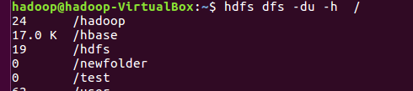

1. Check the health of the Hadoop file system.

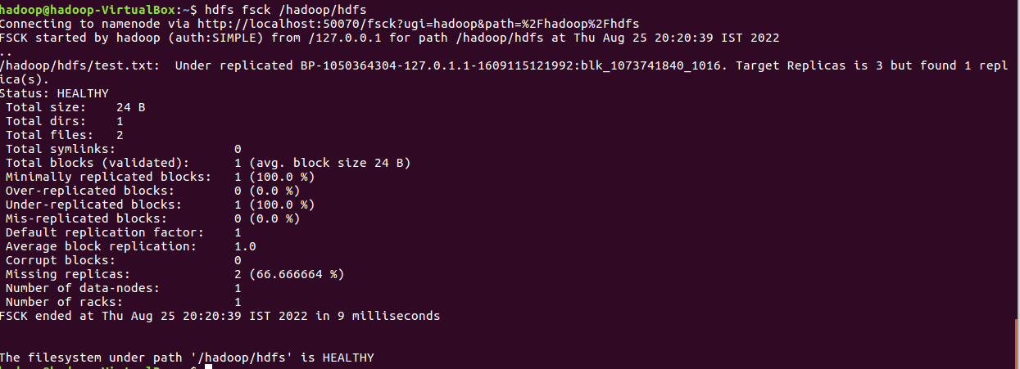

1. Command to turn off the safemode of Name Node.

Answer: 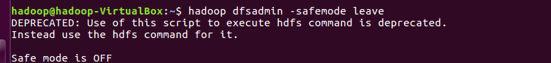

1. HDFS command to format NameNode.

Answer:

1. Create a file named hdfstest.txt and change it number of replications to 3.

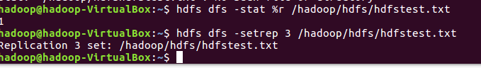Answer:

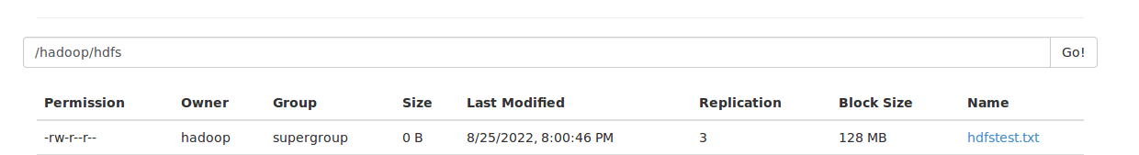

1. Write command to display number of replicas for hdfstest.txt file.

Answer:

1. Write command to Display the status of file “hdfstest.txt” like block size, filesize in bytes.

Answer: check file size of file:



Check Blocksize of file:



aa)Write HDFS command to change file permission from   
 rw – r – r to rwx-rw-x for hdfstest.txt.

Answer:

