**A Smart Embedded System Model for the AC**

**Automation with Temperature Prediction**

**Definition:** Embedded system is defined as a system that has software embedded into computer hardware, which makes the system dedicated to a particular application.

**Principle of Air-conditioner:** Air-conditioners are slowly becoming a popular choice for home appliances, especially during summer Air conditioning can be defined as the treatment of indoor air in order to control certain conditions required for human comfort. The desirable conditions may be temperature, humidity, dust particle level, odor level, and air motion.

It is known that the physical properties of air can be controlled by cooling, heating, humidification, and dehumidification. These processes may be employed to maintain specific conditions desirable for comfort. Thus, simultaneous control of temperature, humidity, air motion, and cleanliness is known as air conditioning.

**Block diagram:**

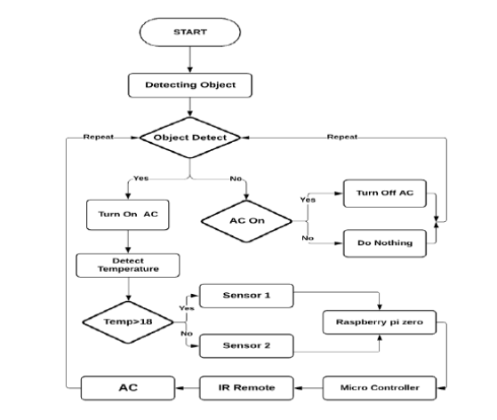

**Fig.1.** *Flowchart Diagram of the Proposed System***.**

we have used python programming with its default library, develop

algorithms, Raspberry pi zero, Thermal sensors, IR sensors, and IR remote. We have

developed an embedded system by using this equipment, which works with object

temperature and automatic on-off depending on whether the object exists in the room or not.

Finally, it produces the result of the temperature dependence of the criteria of number of objects, object value, environment temperature, the object is the environment or not