Name: Abhishek Pardhi

Roll No: 510

Class: M.Sc. CS – 1

Subject: Analysis of Algorithms & Researching Computing

(Paper l)

Practical Journal

**Practical No. 1**

**Aim: Write a Program for Randomized Selection Algorithm**

from random import randrange

def partition(x, pivot_index = 0):

i = 0

if pivot_index !=0: x[0],x[pivot_index] = x[pivot_index],x[0]

for j in range(len(x)-1):

if x[j+1] < x[0]:

x[j+1],x[i+1] = x[i+1],x[j+1]

i +=1

x[0],x[i] = x[i],x[0]

return x,i

def RSelect(x,k):

if len(x) == 1:

return x[0]

else:

xpart = partition(x,randrange(len(x)))

x = xpart[0] #partitioned array

j = xpart[1] #pivot index

if j == k:

return x[j]

elif j > k:

return RSelect(x[:j],k)

else:

k = k - j -1

return RSelect(x[(j+1):], k)

x = [3,1,8,4,7,9]

for i in range(len(x)):

print (RSelect(x,i))

**Output:**

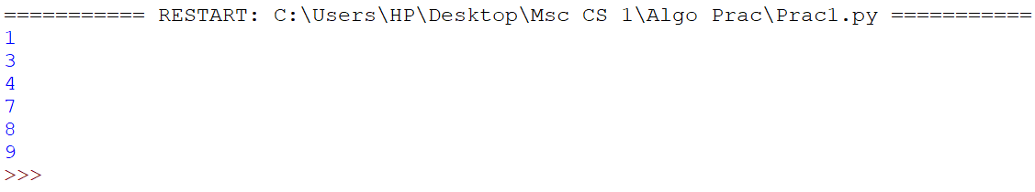

**Practical No.2**

**Aim: Write a Program for Heap Sort Algorithm**

#Python program for implementation of Heap Sort

#To heapify subtree rooted at index i.

#n is size of heap

def heapify(arr,n,i):

largest=i #Initialize largest as root

l=2*i+1 #left+2*i+1

r=2*i+2

#see if left child of root exists and is

#greater than root

if l<n and arr[i]<arr[l]:

largest=l

#see if right child of root exists and is

#greater than root

if r<n and arr[largest]<arr[r]:

largest=r

#change root, if needed

if largest !=i:

arr[i],arr[largest]=arr[largest],arr[i] #swap

#Heapify the root

heapify(arr,n,largest)

#The main function to sort an array of given size

def heapsort(arr):

n=len(arr)

#Build a maxhep.

for i in range(n,-1,-1):

heapify(arr,n,i)

#One by one extract element

for i in range(n-1,0,-1):

arr[i],arr[0]=arr[0],arr[i]

heapify(arr,i,0)

#Driver code to test above

arr=[12,11,13,5,6,7]

heapsort(arr)

n=len(arr)

print("Sorted array is")

for i in range(n):

print("%d" %arr[i])

**Output:**

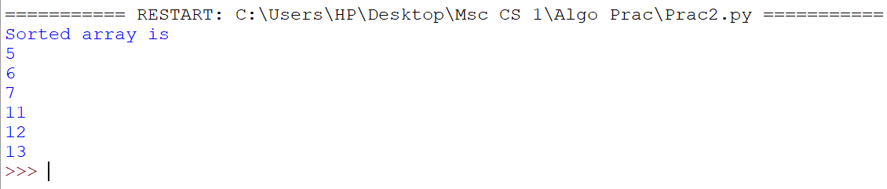

**Practical No.3**

**Aim: Write a Program to perform Radix Sort Algorithm**

def countingSort(arr, exp1):

n = len(arr)

output = [0] * (n)

count = [0] * (10)

for i in range(0, n):

index = arr[i] // exp1

count[index % 10] += 1

for i in range(1, 10):

count[i] +=count[i - 1]

i = n - 1

while i >=0:

index = arr[i] // exp1

output[count[index % 10] - 1] = arr[i]

count[index % 10] -= 1

i -=1

i = 0

for i in range(0,len(arr)):

arr[i] = output[i]

def radixSort(arr):

max1 = max(arr)

exp = 1

while max1/ exp > 1:

countingSort(arr, exp)

exp *=10

arr=[ 170, 45, 75, 90, 802, 24, 2, 66]

radixSort(arr)

for i in range(len(arr)):

print(arr[i],end=" ")

**Output:**



**Practical No.4**

**Aim: Write a Program to Perform Bucket Sort Algorithm**

def insertionSort(b):

for i in range(1, len(b)):

up = b[i]

j = i - 1

while j >=0 and b[j] > up:

b[j + 1] = b[j]

j -= 1

b[j + 1] = up

return b

def bucketSort(x):

arr =[]

slot_num = 10

for i in range(slot_num):

arr.append([])

for j in x:

index_b = int(slot_num * j)

arr[index_b].append(j)

for i in range(slot_num):

arr[i] = insertionSort(arr[i])

k = 0

for i in range(slot_num):

for j in range(len(arr[i])):

x[k] = arr[i][j]

k += 1

return x

x = [0.897, 0.565, 0.656, 0.1234, 0.665, 0.3434]

print("Sorted Array is")

print(bucketSort(x))

**Output:**



**Practical No.5**

**Aim: Write a Program to Perform Folyd-Warshall algorithm**

# Python Program for Floyd Warshall Algorithm

# Number of vertices in the graph

V = 4

# Define infinity as the large enough value. This value will be

# used for vertices not connected to each other

INF = 99999

# Solves all pair shortest path via Floyd Warshall Algorithm

def floydWarshall(graph):

""" dist[][] will be the output matrix that will finally

have the shortest distances between every pair of vertices """

""" initializing the solution matrix same as input graph matrix

OR we can say that the initial values of shortest distances

are based on shortest paths considering no

intermediate vertices """

dist = map(lambda i : map(lambda j : j , i) , graph)

""" Add all vertices one by one to the set of intermediate

vertices.

---> Before start of an iteration, we have shortest distances

between all pairs of vertices such that the shortest

distances consider only the vertices in the set

{0, 1, 2, .. k-1} as intermediate vertices.

----> After the end of a iteration, vertex no. k is

added to the set of intermediate vertices and the

set becomes {0, 1, 2, .. k}

"""

for k in range(V):

# pick all vertices as source one by one

for i in range(V):

# Pick all vertices as destination for the

# above picked source

for j in range(V):

# If vertex k is on the shortest path from

# i to j, then update the value of dist[i][j]

dist[i][j] = min(dist[i][j] ,

dist[i][k]+ dist[k][j]

)

printSolution(dist)

# A utility function to print the solution

def printSolution(dist):

print "Following matrix shows the shortest distances\

between every pair of vertices"

for i in range(V):

for j in range(V):

if(dist[i][j] == INF):

print "%7s" %("INF"),

else:

print "%7d\t" %(dist[i][j]),

if j == V-1:

print ""

# Driver program to test the above program

# Let us create the following weighted graph

"""

10

(0)------->(3)

| /|\

5 | |

| | 1

\|/ |

(1)------->(2)

3 """

graph = [[0,5,INF,10],

[INF,0,3,INF],

[INF, INF, 0, 1],

[INF, INF, INF, 0]

]

# Print the solution

floydWarshall(graph);

**Output:**

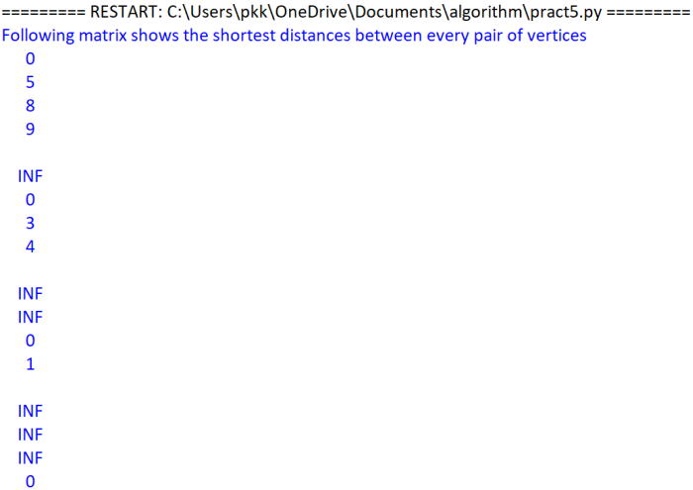

**Practical No.6**

**Aim: Write a Program for Counting Sort Algorithm in python**

#The main function that sort the given string arr in

#alphabetical order

def countSort (arr):

#The output character array that will have sorted arr

output = [0 for i in range(256)]

#Create a count array to store count of individul

#characters and initialize count array as 0

count = [0 for i in range (256)]

#For storing the resulting answer since the string is immutable

ans = ["" for _ in arr]

#Store count of each character

for i in arr:

count[ord (i)] += 1

#Change count [i] so that count[1] now contains actual

#position of this character in output array

for i in range (256) :

count [i] +=count [i-1]

#Build the output character array

for i in range (len (arr)):

output [count[ord (arr[i])]-1] = arr[i]

count [ord (arr[i])] -= 1

#Copy the output array to arr, so that are now

#contains sorted characters

for i in range(len(arr)):

ans[i] = output[i]

return ans

#Driver program to test above function

arr = "test"

ans = countSort (arr)

print ('Sorted character array is:',ans)

**Output:**



**Practical No.7**

**Aim: Write a program for Set Covering Problem**

def set_cover(universe, subsets):

"""Find a family of subsets that covers the universal set"""

elements = set(e for s in subsets for e in s)

# Check the subsets cover the universe

if elements != universe:

return None

covered = set()

cover = []

# Greedily add the subsets with the most uncovered points

while covered != elements:

subset = max(subsets, key=lambda s: len(s - covered))

cover.append(subset)

covered |= subset

return cover

def main():

universe = set(range(1, 11))

subsets = [set([1, 2, 3, 8, 9, 10]),

set([1, 2, 3, 4, 5]),

set([4, 5, 7]),

set([5, 6, 7]),

set([6, 7, 8, 9, 10])]

cover = set_cover(universe, subsets)

print(cover)

if __name__ == '__main__':

main()

**Output:**



**Practical No.8**

**Aim: Write a Program for found a subset with given sum**

# A recursive solution for subset sum

# problem

# Returns true if there is a subset

# of set[] with sun equal to given sum

def isSubsetSum(set,n, sum) :

# Base Cases

if (sum == 0) :

return True

if (n == 0 and sum != 0) :

return False

# If last element is greater than

# sum, then ignore it

if (set[n - 1] > sum) :

return isSubsetSum(set, n - 1, sum);

# else, check if sum can be obtained

# by any of the following

# (a) including the last element

# (b) excluding the last element

return isSubsetSum(set, n-1, sum) or isSubsetSum(set, n-1, sum-set[n-1])

# Driver program to test above function

set = [3, 34, 4, 12, 5, 2]

sum = 9

n = len(set)

if (isSubsetSum(set, n, sum) == True) :

print("Found a subset with given sum")

else :

print("No subset with given sum")

**Output:**

