What is IP address?

An IP address is a numeric identity of an interface. Just like a postal address provides a unique identity to a house, an IP address provides a unique identity to an interface.

Why an interface needs unique IP address?

IP network uses IP address to find the destination interface and delivers the IP packets. In order to receive IP packets, an interface needs a unique IP address. If multiple interfaces have same IP address, IP network will not work.

Let’s understand it with an example. In a city all houses have same house number, suppose 195. If there is mail for house number 195, how mailman will delivery that mail? To deliver the mail at correct house, postal system needs unique address of that house. Exactly same way, to deliver an IP packet at correct interface, IP network needs a unique IP address of that interface.

How IP address works?

IP address works in IP network just like a postal address works in postal system. A postal address is the combination of two addresses, area address and house address. Area address is the group address of all houses which belong to a particular area and house address is the unique address of a specific house in that area. Each area is represented by a unique PIN code number in postal system.

PIN code helps in fast processing of mail. In a central post office where thousands or in some case millions of mail are received, forwarded and delivered daily, processing mail based on complete address is next to impossible. In a busy post office the clerk doesn’t read the complete address of a package to make his decision, he only pays attention on the PIN code. He reads the PIN code and drops the package in the container which will be forwarded to the nearest post office of the area which PIN code represents. Same process is used at next post office and so on and so on until the package reaches at the post office which delivers packages in destination area. At last post office, recipient’s house address is used to deliver the package.

Exact mechanism is used in IP network. An IP address is the combination of two addresses, network address and host address. Network address is the group address of all hosts which belong to a particular network and host address is the unique address of a specific host in that network.

Just like PIN code, network address helps in fast processing of the IP packets. In IP network, routers do exactly what post offices do in postal system. Routers use network address to find the destination network and host address to deliver the packets.

IP address format

An IP address is 32 bits in length. These bits are divided in four parts. Each part is known as octets and contains and 8 bits.

An IP address can be written in three notations; dotted-decimal, binary and hexadecimal. Among these types, dotted-decimal is the most popular and frequently used method for writing an IP address.

In dotted-decimal notation, each byte (8 bits) of the 32 bits IP address is written in decimal equivalent. The four resulting decimal numbers are separated by a dot and written in a sequence. 10.10.10.10, 172.168.10.1, 192.168.1.1 and 200.0.0.1 are some examples of IP address in dotted-decimal notation.

Subnet Mask

Subnet mask is used to separate the network address from the host address in IP address. As we discussed earlier an IP address is the combination of network address and host address, subnet mask helps us and programs which use IP address in identifying the network portion and the host portion.

Just like IP address, subnet mask is also 32 bits in length and uses same notations which IP address uses to present itself.

Subnet mask assigns an individual bit for each bit of IP address. If IP bit belongs to network portion, assigned subnet mask bit will be turned on. If IP bit belongs to host portion, assigned subnet mask bit will be turned off.

In binary notation, 1 (one) represents a turned on bit while 0 (zero) represents a turned off bit. In dotted-decimal notation, a value range 1 to 255 represents a turned on bit while a value 0 (zero) represents a turned off bit.

An IP address is always used with subnet mask. Without subnet mask, an IP address is an ambiguous address in IP network.

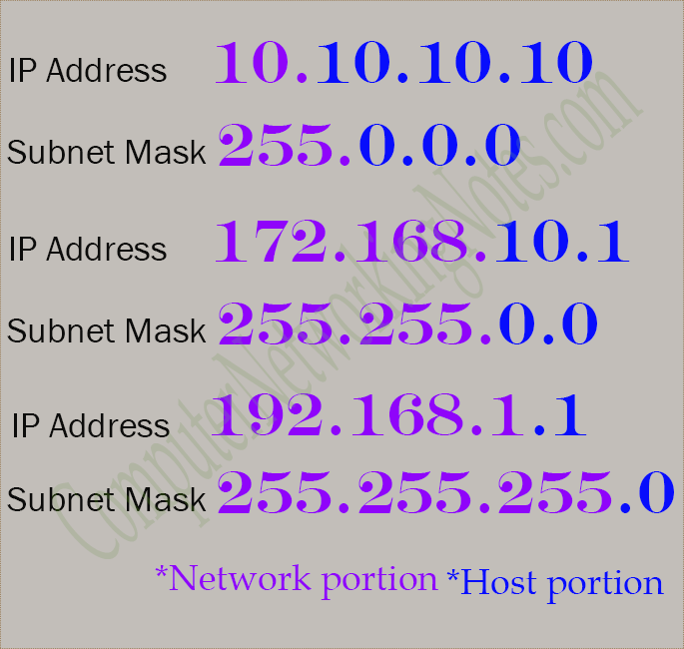

IP address classes

There are 4,294,967,296 IP addresses. Managing all these addresses without any scheme are next to impossible. Let’s understand it with a simple example. If you have to find out a word from a language dictionary, how long will you take? Usually you will take less than five minutes to find out that word. You are able to do this because words in dictionary are organized in alphabetic order. If you have to find out the same word from the dictionary which does not use any sequence or order to organize the words, how long will you take this time? It may take up to one week to find out that specific word from all words. If an unorganized dictionary which roughly contains 1 billion words can turn a five minutes task in a one week task than suppose how nearly 4.3 billion addresses will make a search task complicated if they are unorganized.

For easier management, IP addresses are organized in numeric order and divided in following five classes.

|  |  |  |  |
| --- | --- | --- | --- |
| Class | Starting Address | Ending Address | Subnet mask |
| A | 0.0.0.0 | 127.255.255.255 | 255.0.0.0 |
| B | 128.0.0.0 | 191.255.255.255 | 255.255.0.0 |
| C | 192.0.0.0 | 223.255.255.255 | 255.255.255.0 |
| D | 224.0.0.0 | 239.255.255.255 | 255.255.255.255 |
| E | 240.0.0.0 | 255.255.255.255 | 255.255.255.255 |

As we discussed earlier, an IP address is the combination of network address and host address. In each IP address, few bits are reserved for network address. In class A, B and C first 8, 16 and 24 bits are reserved respectively for network addresses.

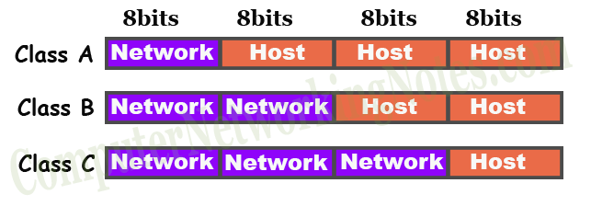

How to find the class of an IP address?

To find the class of an IP address, simply pay attention on the first octet.

If the value of first octet is in range 1 to 127, it’s a class A IP address. Examples of class A IP address are: - **1**.2.3.4, **10**.20.30.45, **125**.234.123.23, **126**.100.200.45, etc.

If the value of first octet is in range 128 to 191, it’s a class B IP address. Examples of class B IP address are: - **128**.200.100.50, **191**.200.100.1, **172**.168.0.1, **175**.45.48.14, etc.

If the value of first octet is in range 192 to 223, it’s a class C IP address. Examples of class C IP address are: - **192**.168.1.1, **200**.0.0.1, **223**.224.127.1, **212**.14.15.56, etc.

Private IP address and Public IP address

Based on accessibility, IP addresses are mainly divided in two categories; private IP addresses and public IP addresses. Differences between private IP addresses and public IP addresses are following.

Private IP addresses

Private IP addresses are the IP addresses which are reserved for local networks and cannot be accessed from a public network such as Internet. Vice versa a public network cannot be accessed from a private IP address.

Following IP ranges are reserved for private IP addresses.

* 10.0.0.0 to 10.255.255.255
* 172.16.0.0 to 172.31.255.255
* 192.168.0.0 to 192.168.255.255

Public IP addresses

Public IP addresses are the IP addresses which are publicly accessible from any public network such as Internet. In order to access a public IP address, we must have to use a public IP address.

Except private IP addresses, all IP addresses of class A, B and C are public IP addresses.

Special IP addresses

Special IP addresses are the IP addresses which are reserved for network testing and troubleshooting. These IP addresses cannot be assigned to an end device or an interface. Following addresses are reserved for special purpose: -

**0.0.0.0**:- This is the first IP address of IP addresses. It represents all networks.

**127.0.0.0 to 127.255.255.255**: - Reserved for IP protocol testing and troubleshooting. Virtual interfaces such as loopback adaptor use this IP range for addressing.

**224.0.0.0 to 239.255.255.255 (*Class D*)**: - Reserved for multicast addresses. A multicast address is an address which has multiple recipients.

**240.0.0.0 to 255.255.255.255 (*Class E*)**: - Reserved for future use. These addresses are not used currently for any purpose.

**255.255.255.255**:- This is the last IP address of IP addresses. It represents all hosts.

That’s all for this tutorial. If you have any comment, suggestion or feedback about this tutorial, please mail me. If you like this tutorial, please don’t forget to share it with your friends through your favorite social platform.