STEP BY STEP Follow
- Activate AWS account & login
- Goto Console
Click on EC2 (Elastic Compute Cloud )
Choose an AMI (Amazon Machine Image)
As per assignment (Deploying a web server in Windows instance USING Ubuntu Server 18.04 LTS (HVM)
Choose AMI - Ubuntu Server 18.04 LTS (HVM)
Choose instance type - General purpose 12 Micro (which available for only free tier)
Configure instance Details
- INSTANCE TYPE - 1(As Per Requirement )
- Auto Assign Public IP- Enable
- Protect Against Accidental Termination
Add storage – As per requirement (Free tier no need to be changed)
Configure security groups
- Traffic Type - All type traffic
- Source –anywhere ( as per requirement)
Review and instance final launch.
Download / Existing KEY Pair for next login.
Your instances launched.
Ready for connect.
Check Instance status
- 2/2 check. (Must)
- Public & Private IP assigned by Server.
Download Mobaxtream for SSH login
Connect the server with mobaxtreame SSH fillout the credential details
Instance launch & log in with existing/ download Encrypted key pair.
Ubuntu Server connected !
Open root Terminal (Ctrl + Alt + T)
Type → Install ngnix web server using bash
when its complete
type → sudo apt-get -y update (the package sources list to get the latest list of available packages in the repositories and “apt-get upgrade” updates all the packages presently installed in your Linux system to their latest versions)
type → sudo apt-get -y install nginx (using for install nginx (open-source, high-performance HTTP and reverse proxy server that powers some of the largest sites on the Internet.))
When its successfully completing at once, reboot the server.
Check your public IP, Which is visible in web.

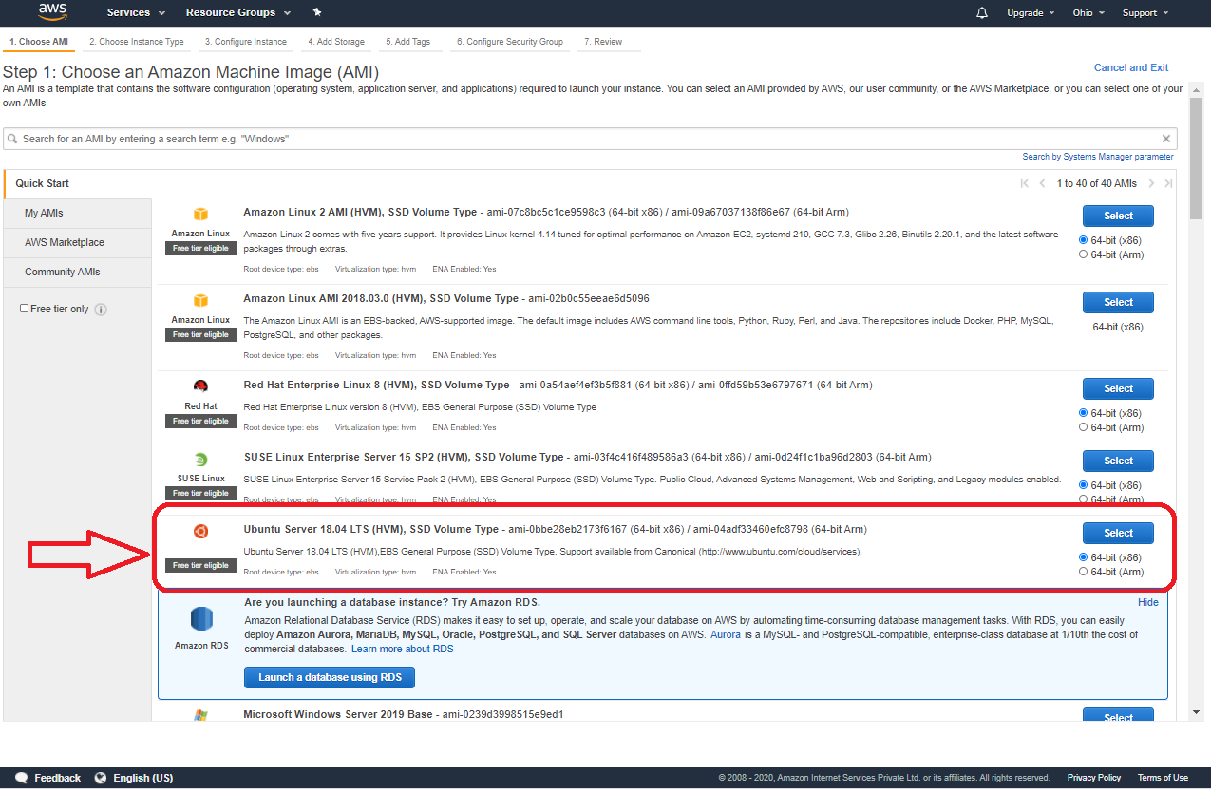

Fsdfsd
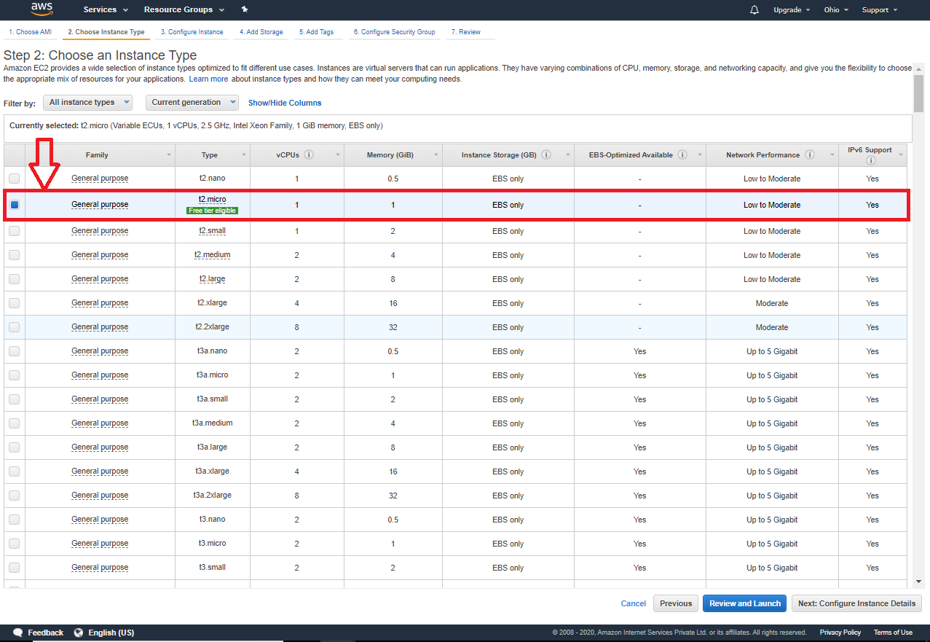
Fsd

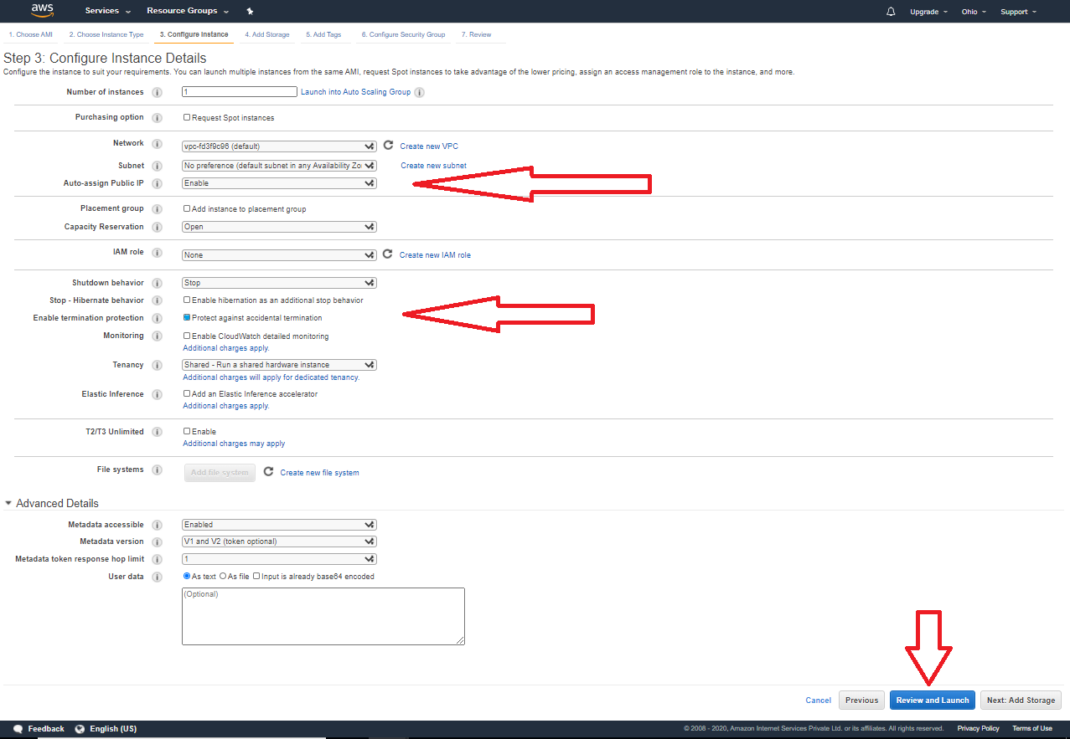
Fsd
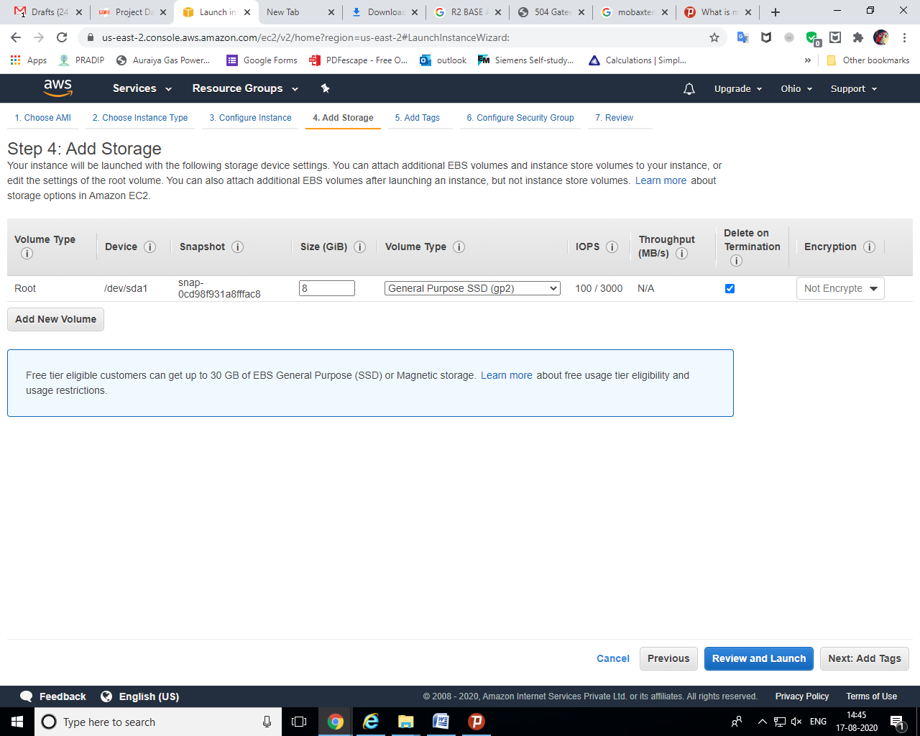
Fsd

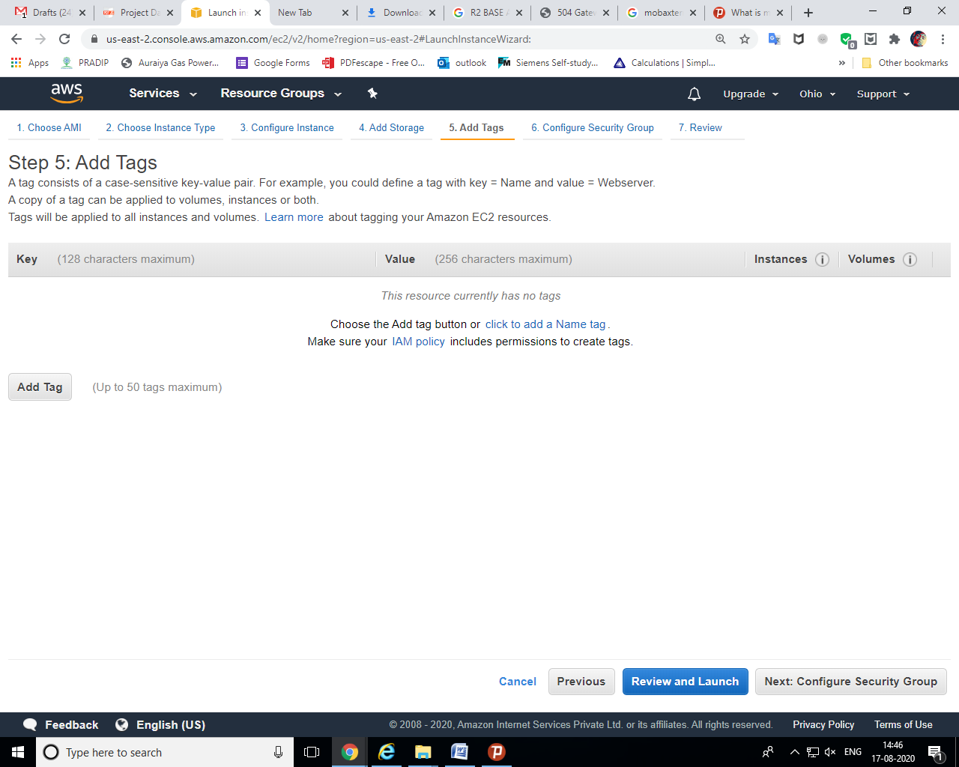
Fssfsdfs
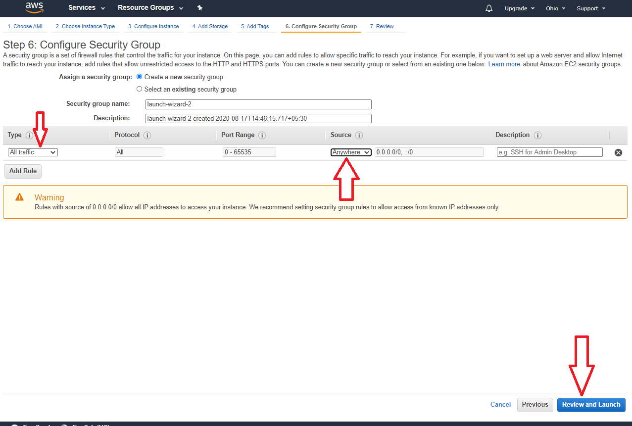
Jghjghj

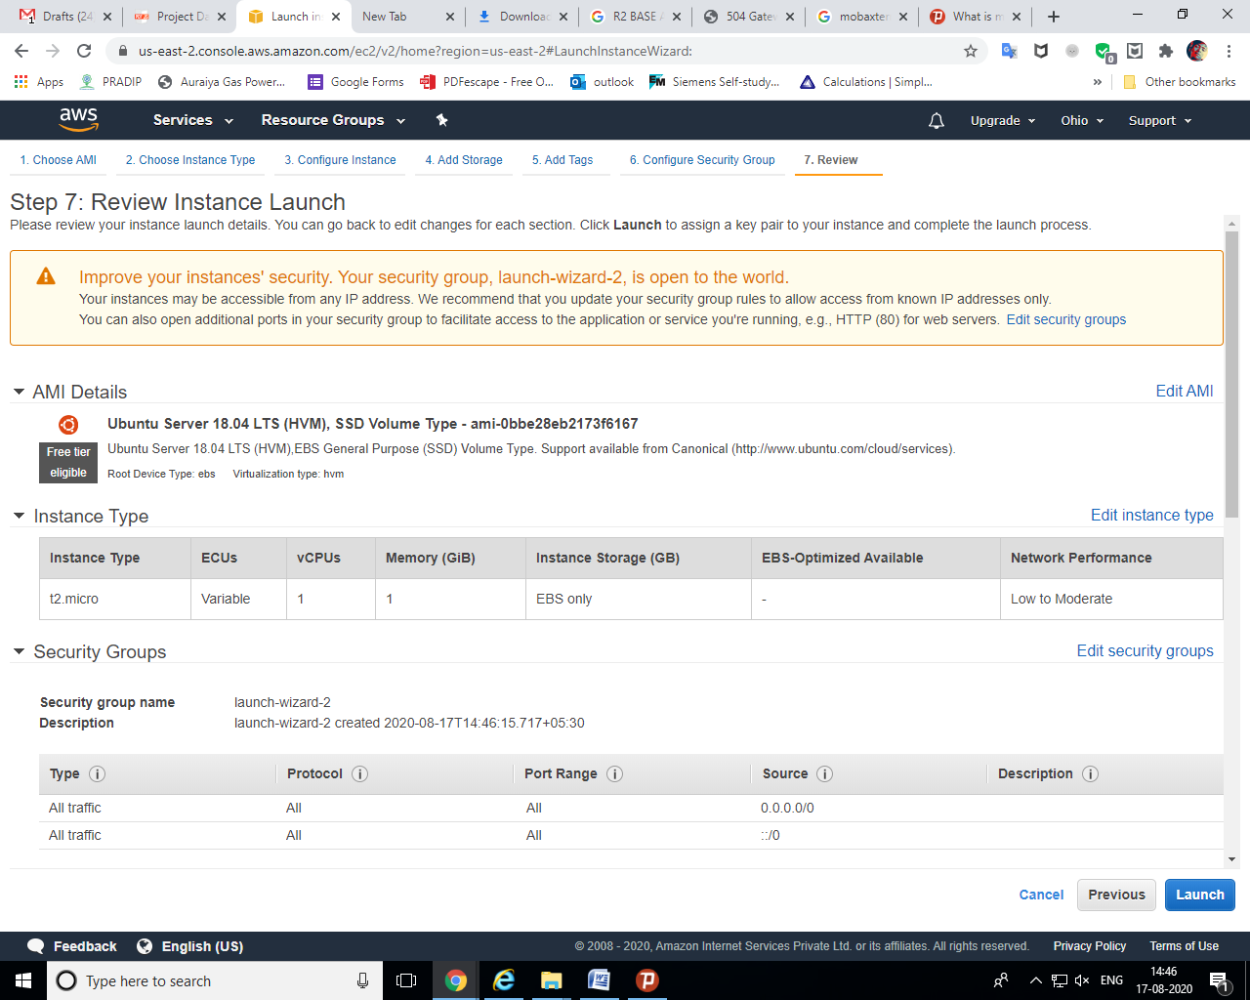
Jgjghj

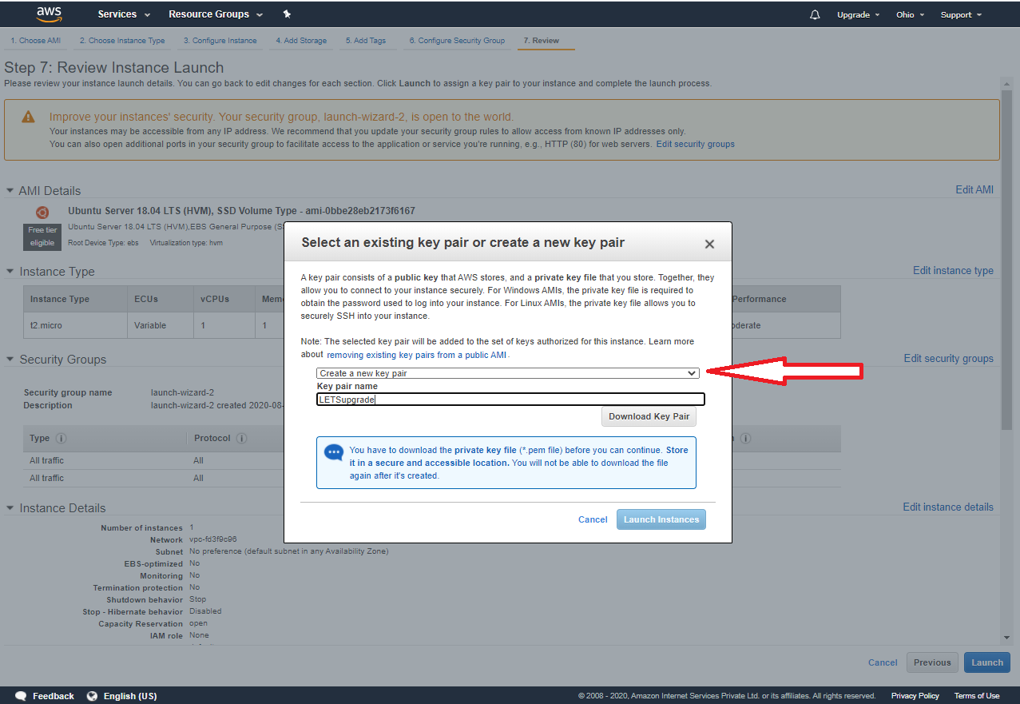
Jgj

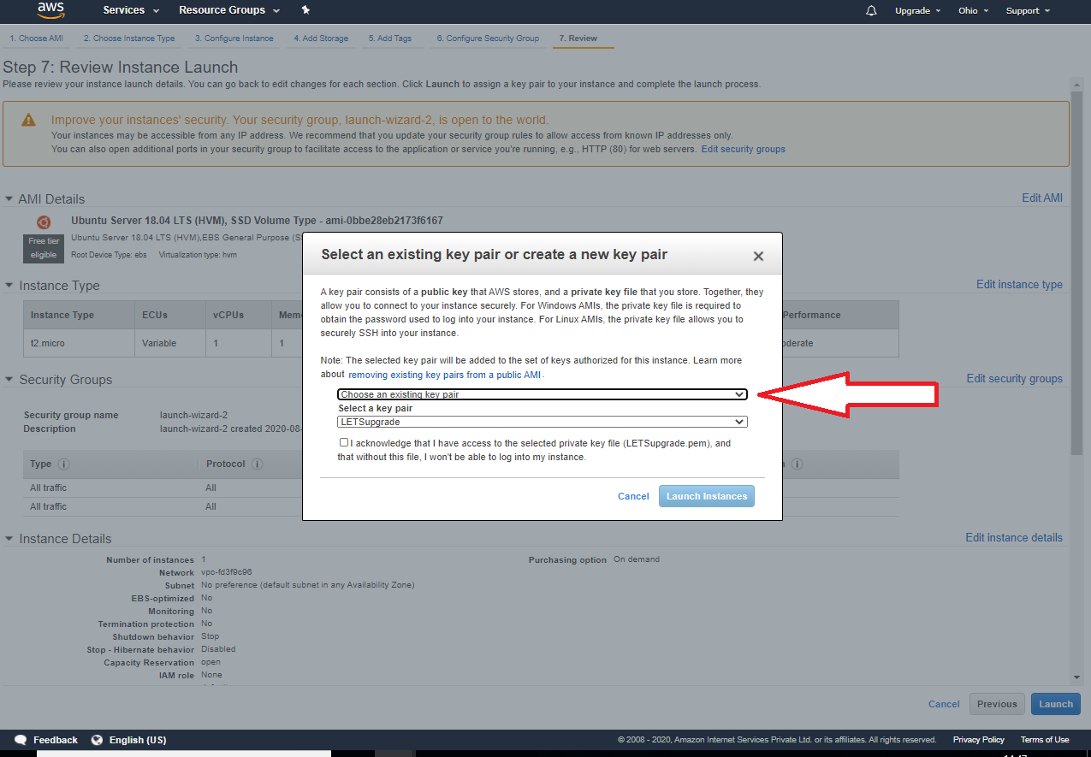
Jg

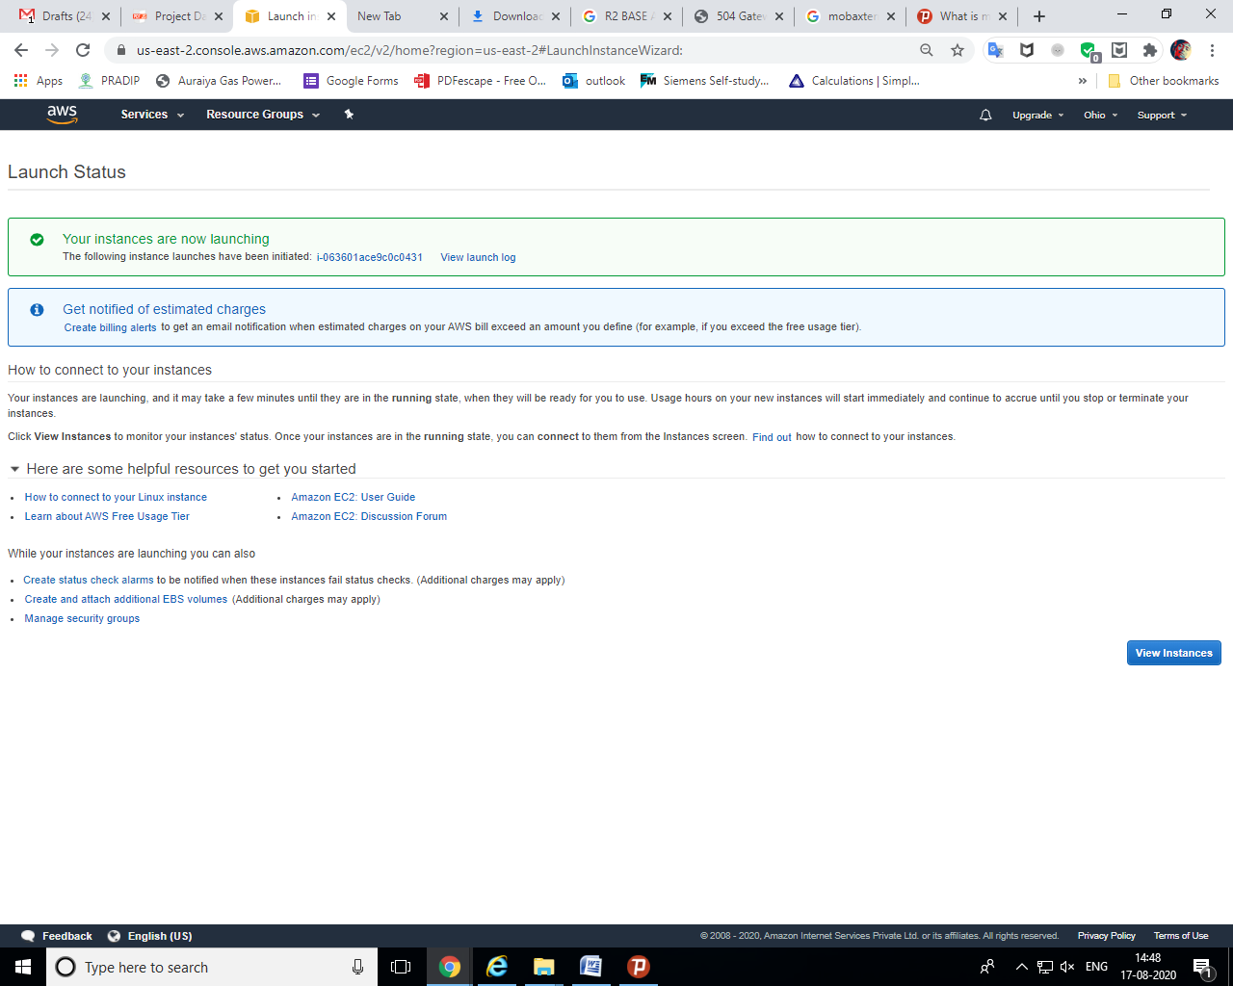
Jgh
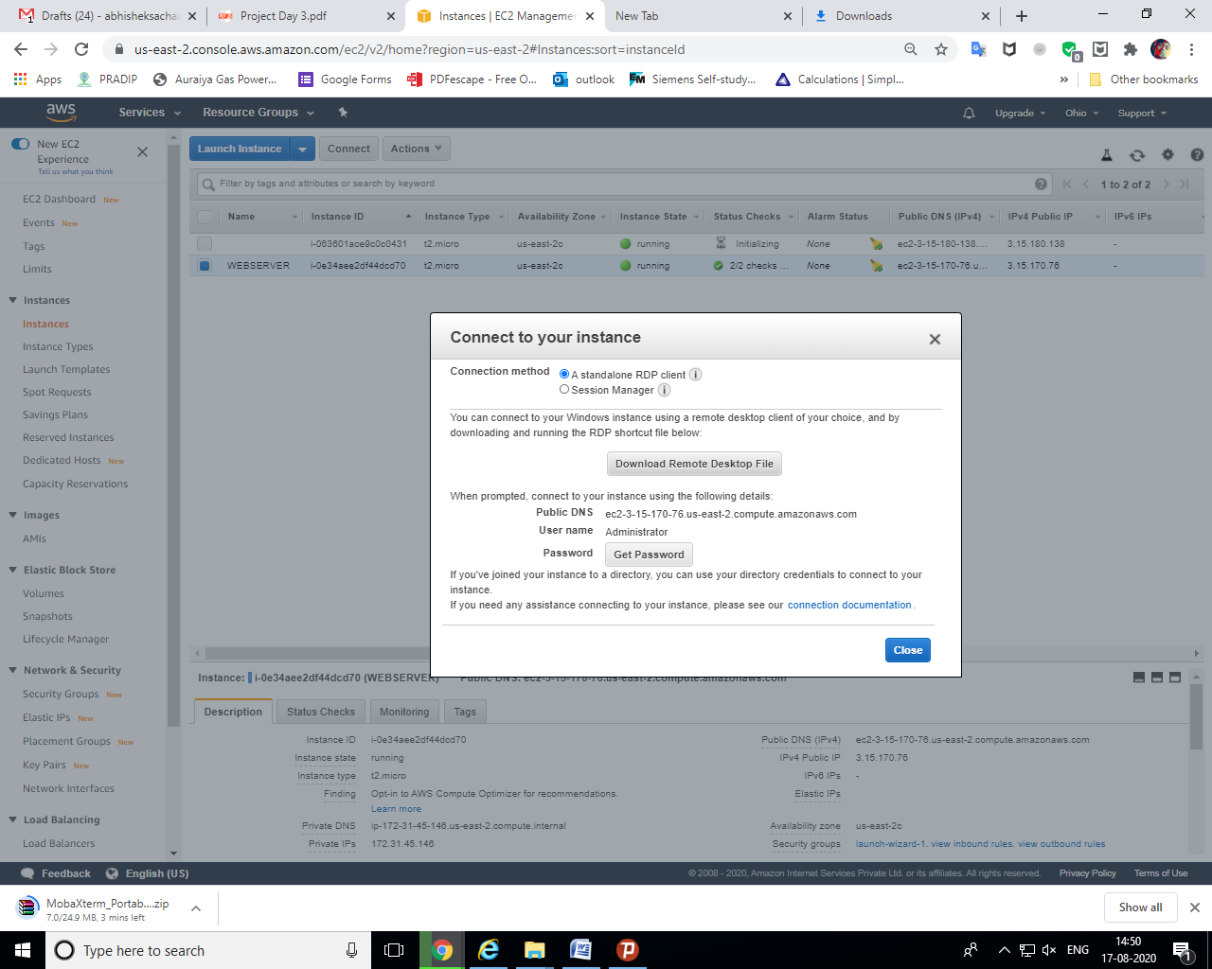
Jghjgh
Jg
Jgh
J
Ghj
ghj

