Deploying a web server in Windows instance
AWS
This step-by-step guide, EC2 configuration will help you understand the Deploying a web server in Windows instance in AWS, You will first activate your AWS account, then setup your EC2 environment where your instance will be launched into.
Abhishek Sachan
Abhisheksachan461@gmail.com
8687511247

8/20/2020
STEP BY STEP Follow
- Activate AWS account & login
- Goto Console

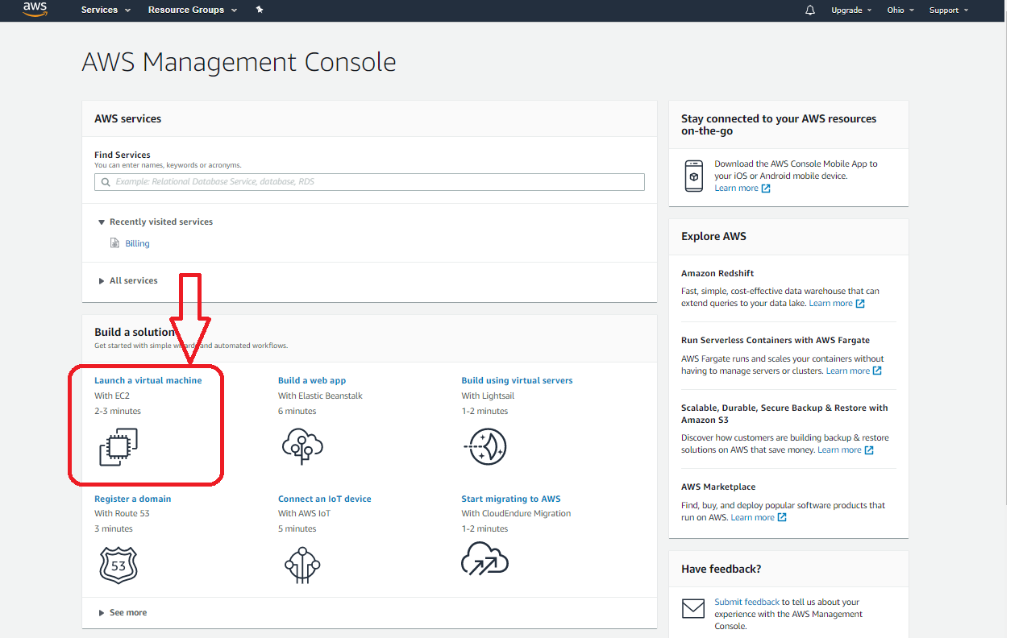
Click on EC2 (Elastic Compute Cloud )
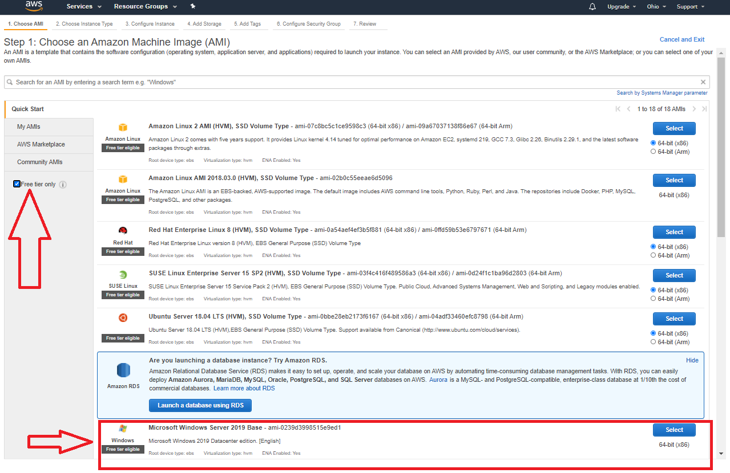
Choose an AMI (Amazon Machine Image)
As per assignment (Windows server 2012 R2 base ) isn’t available for free tier
Choose AMI - WINDOWS server 2019 BASE

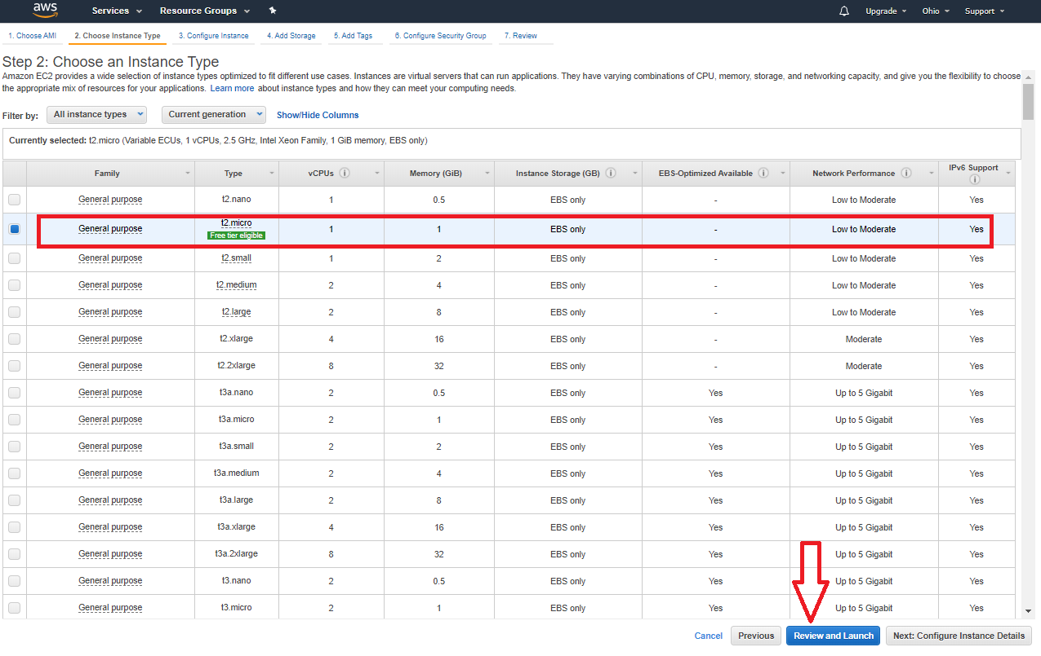
Choose instance type - General purpose 12 Micro (which available for only free tier)
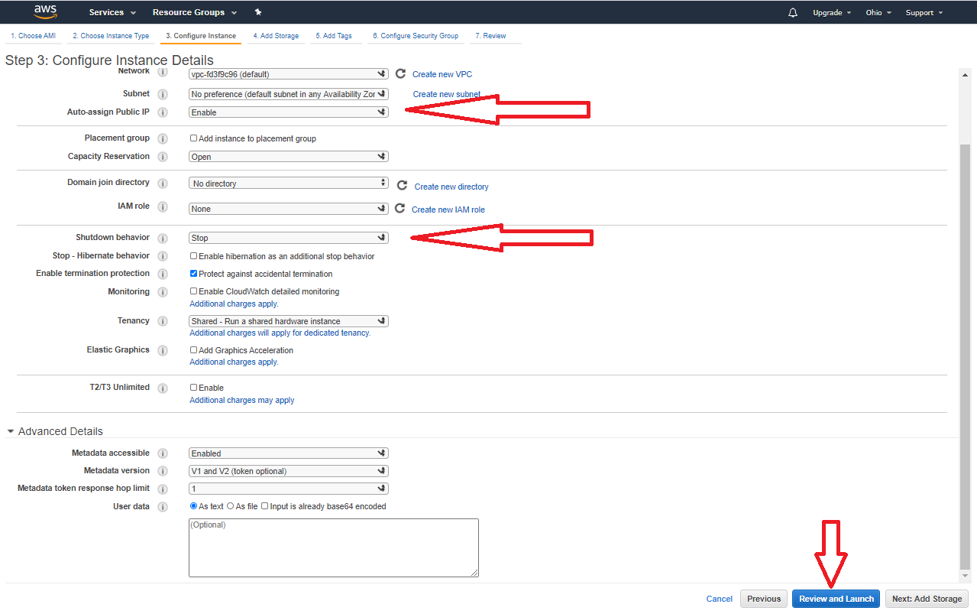
Configure instance Details
- INSTANCE TYPE - 1(As Per Requirement )
- Auto Assign Public IP- Enable
- Protect Against Accidental Termination
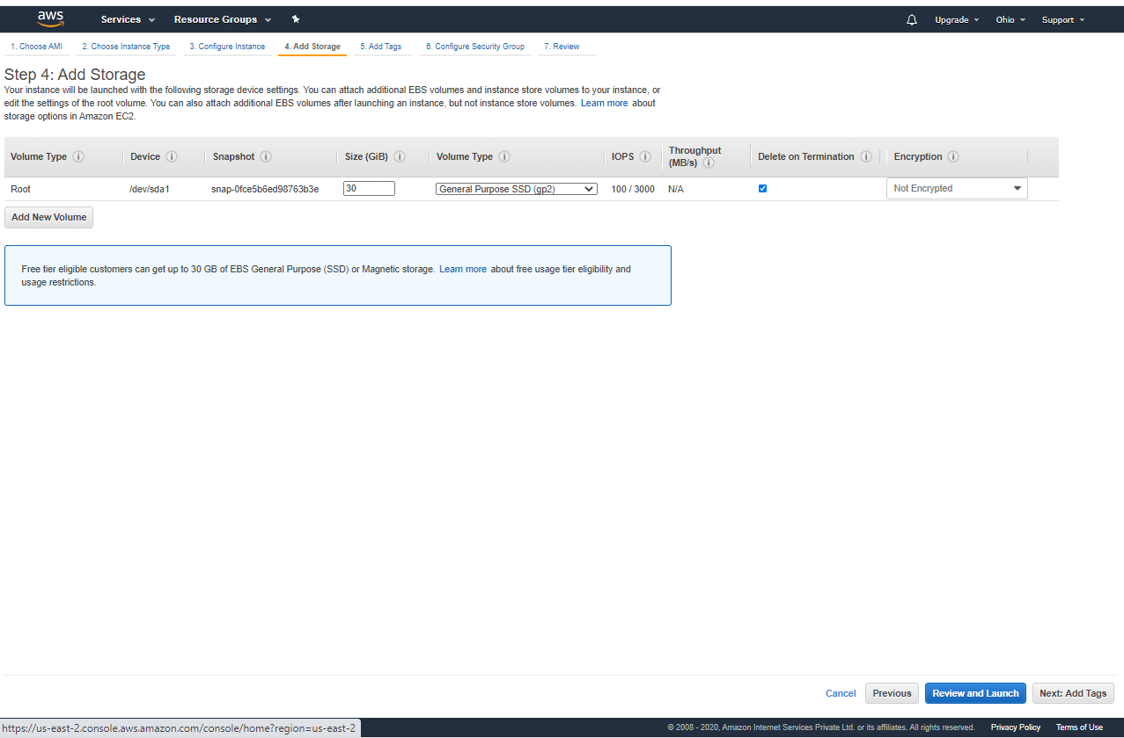
Add storage – As per requirement (Free tier no need to be changed)
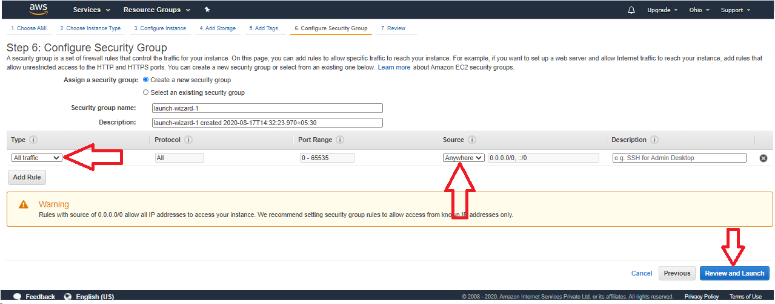
Configure security groups
- Traffic Type - All type traffic
- Source –anywhere ( as per requirement)
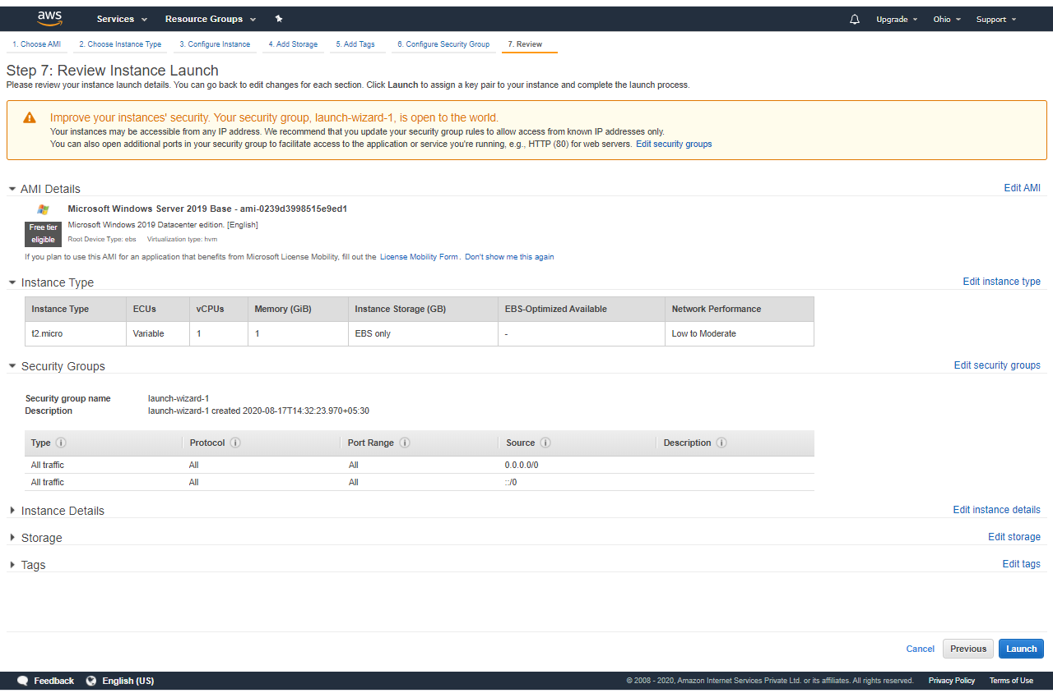
Review and instance final launch.

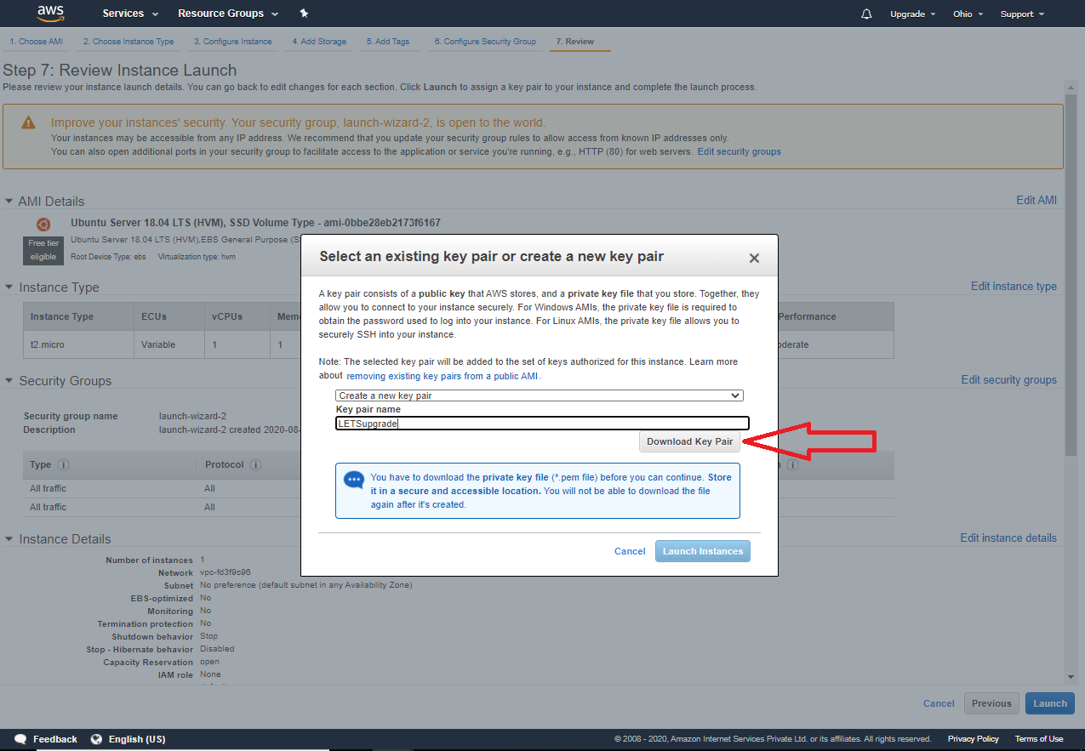
Download KEY Pair for next login.
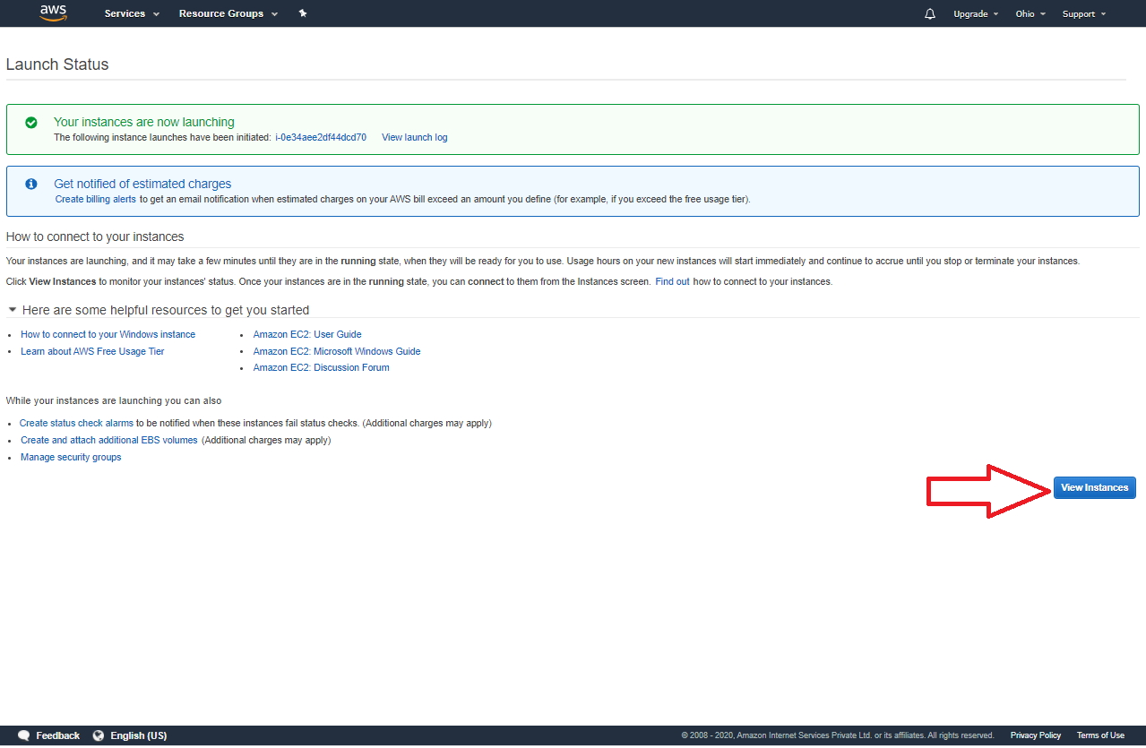
Your instances launched.
Ready for connect.
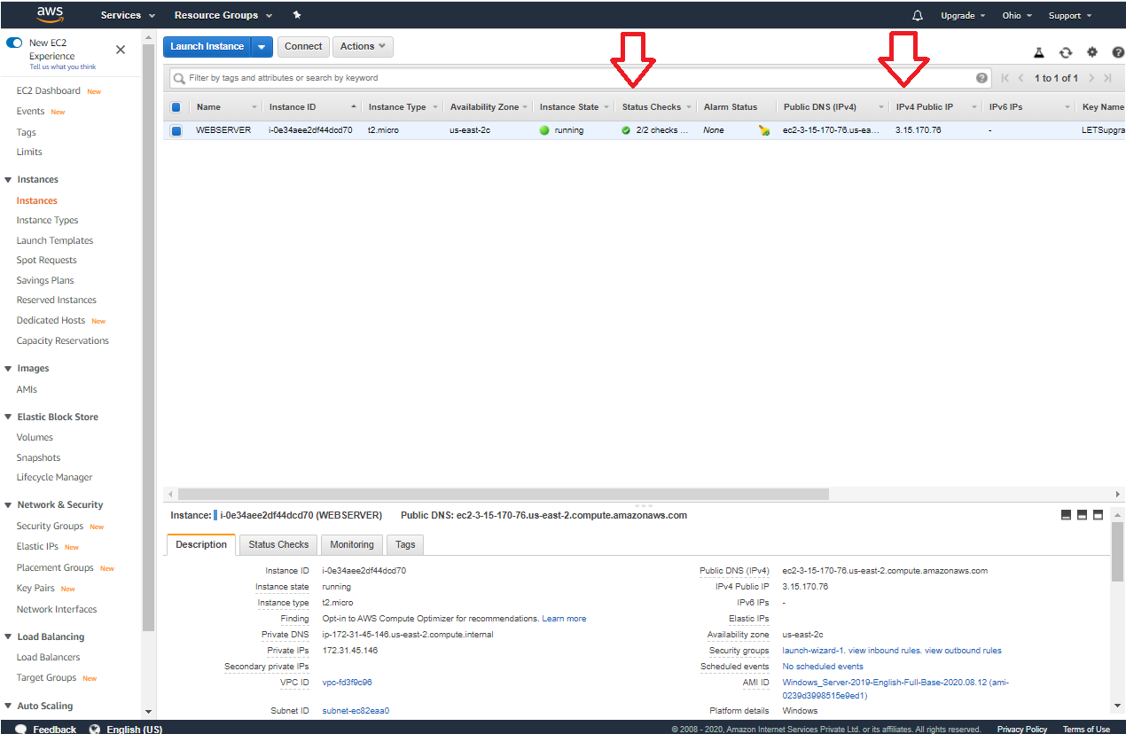
Check Instance status
- 2/2 check. (Must)
- Public & Private IP assigned by Server.
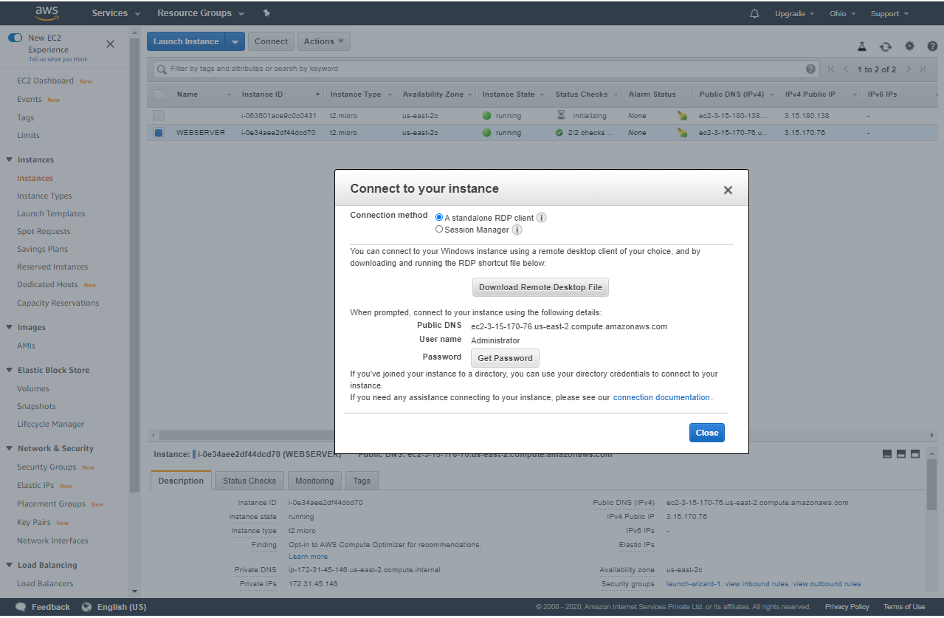
Connect the server with RDP and launch & log in with Encrypted key pair.
Windows Server login
Hit → “win + R”
type → “powershell”
type → Install-WindowsFeature -name Web-Server –IncludeManagementTools
When its successfully completing at once, reboot the server.
Check your public IP, Which is visible in web.

