Q1. Write a program to replace a substring inside a string with other string?
Ans-
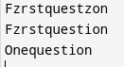
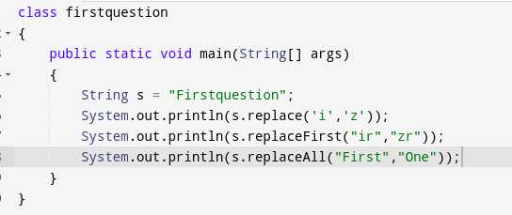

Q2. Write a program to find the number of occurrences of the duplicate words in a string and print them ?
Ans-
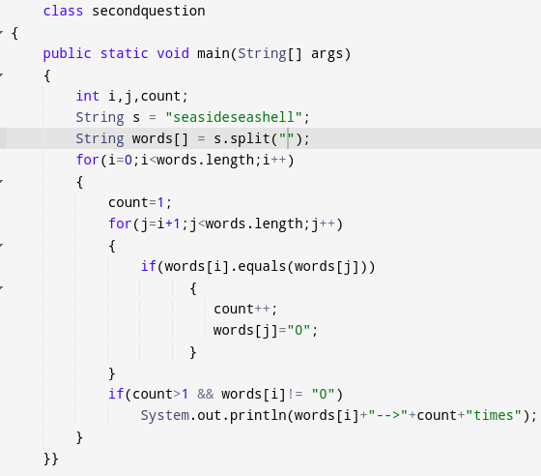

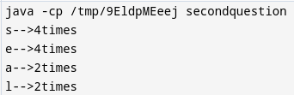

Q3. Write a program to find the number of occurrences of a character in a string without using loop?
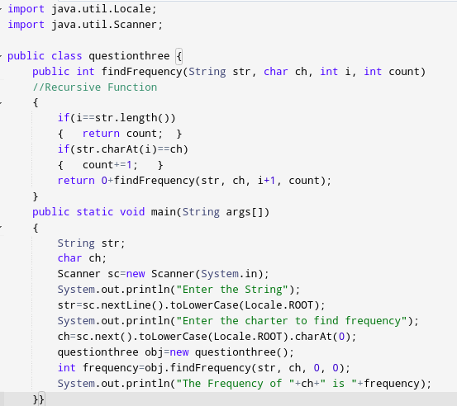
Ans-

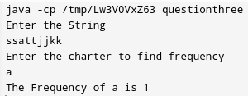
Q4. Calculate the number & Percentage Of Lowercase Letters,Uppercase Letters, Digits And Other Special Characters In A String
Ans-
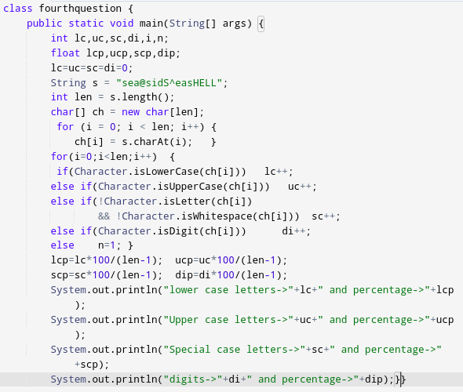
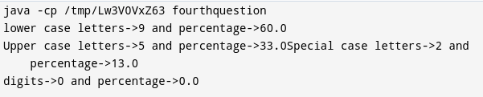
Q5. Find common elements between two arrays.
Ans-
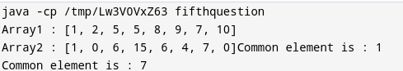
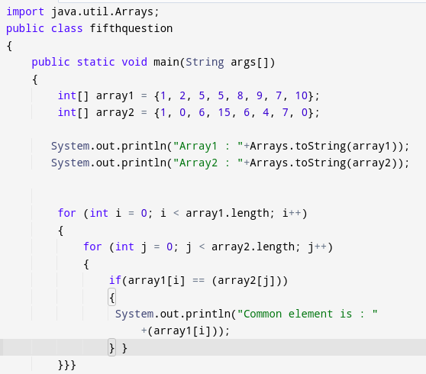

Q6. There is an array with every element repeated twice except one. Find that element.
Ans-
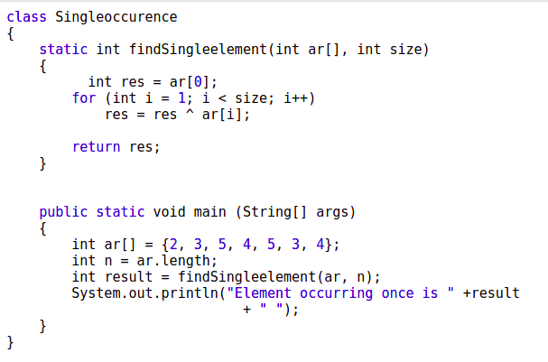
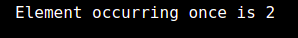

Q7. Write a program to print your Firstname,LastName & age using static block,static method & static variable respectively
Ans-
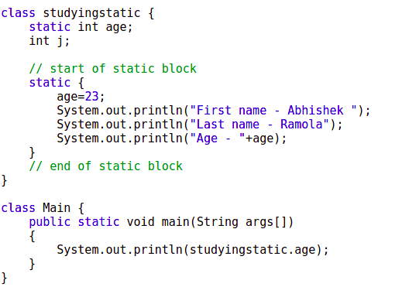

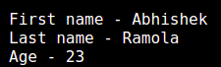

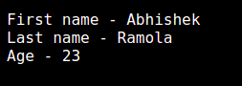

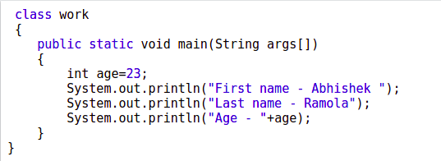

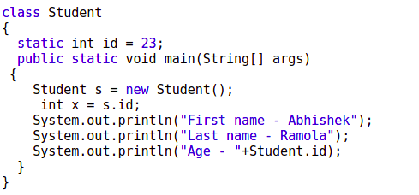

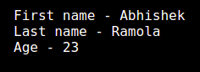

Q8. Write a program to reverse a string and remove character from index 4 to index 9 from the reversed string using String Buffer.
Ans-
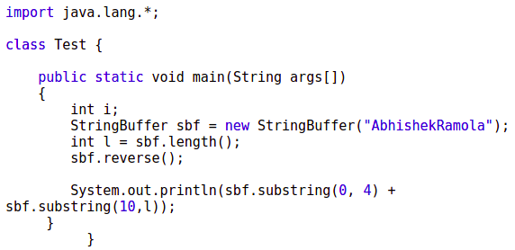
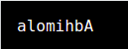

Q9.Write a program to display values of enums using a constructor & getPrice() method (Example display house & their prices).
Ans-

Q10.Write a single program for following operation using overloading
A) Adding 2 integer number
B) Adding 2 double
C) multiplying 2 float
D) multiplying 2 int
E) concate 2 string
F) Concate 3 String
Ans-
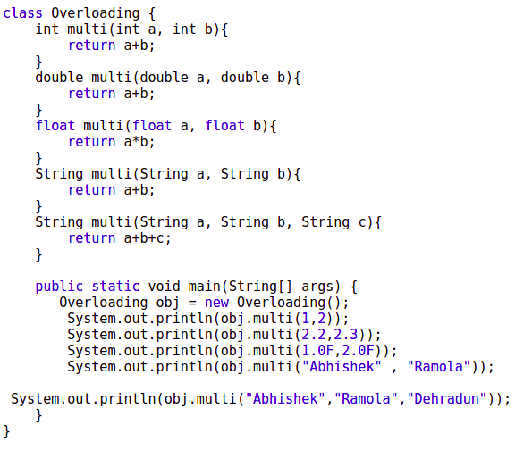

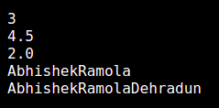

Q11.Create 3 sub class of bank SBI,BOI,ICICI all 4 should have method called getDetails which provide there specific details like rateofinterest etc,print details of every banks
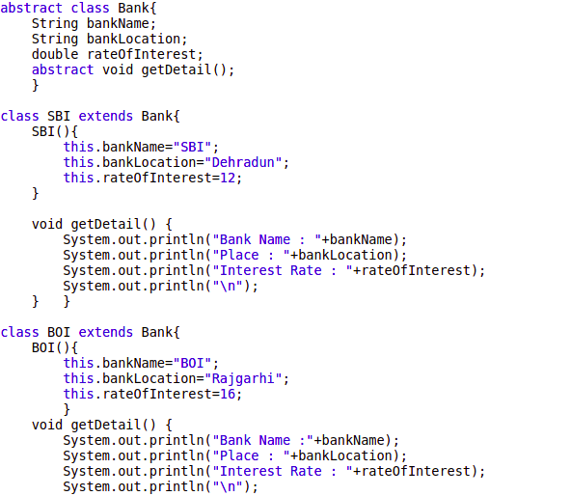
Ans-

