- Create and Run a Thread using Runnable Interface and Thread class.
Ans-
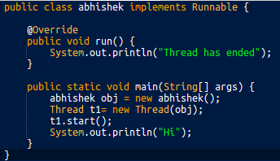

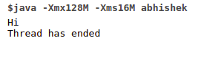

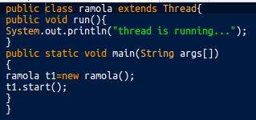

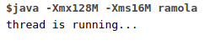

- Use sleep and join methods with thread.
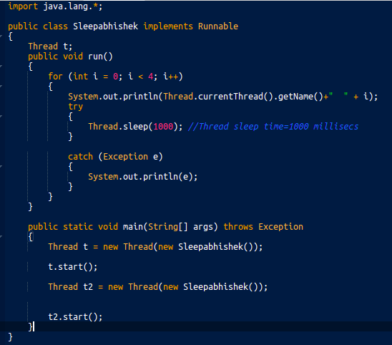
Ans-

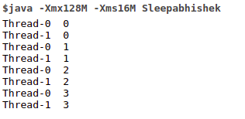

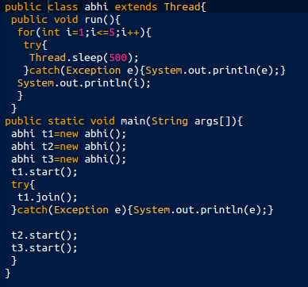

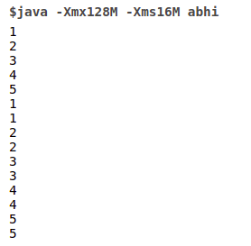

- Use a singleThreadExecutor to submit multiple threads.
Ans-

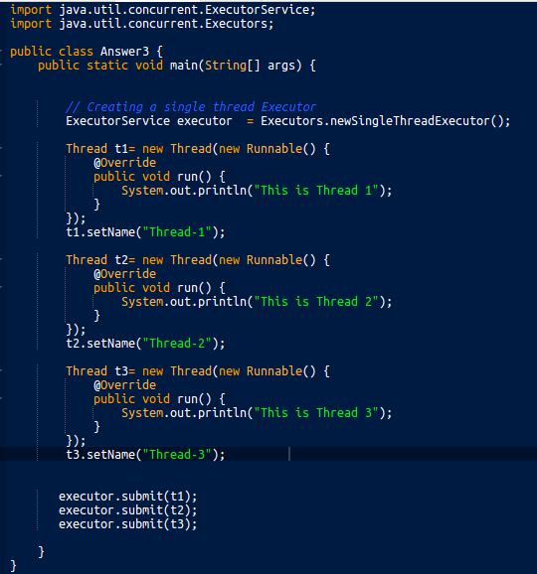

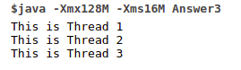

- Try shutdown() and shutdownNow() and observe the difference.
Ans-
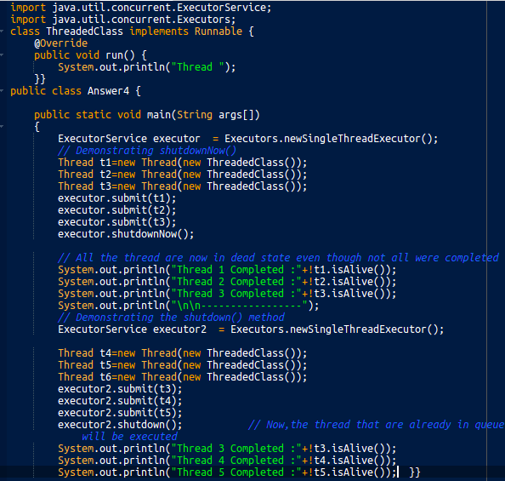

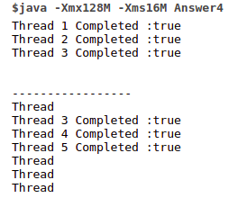

- Use isShutDown() and isTerminated() with ExecutorService.
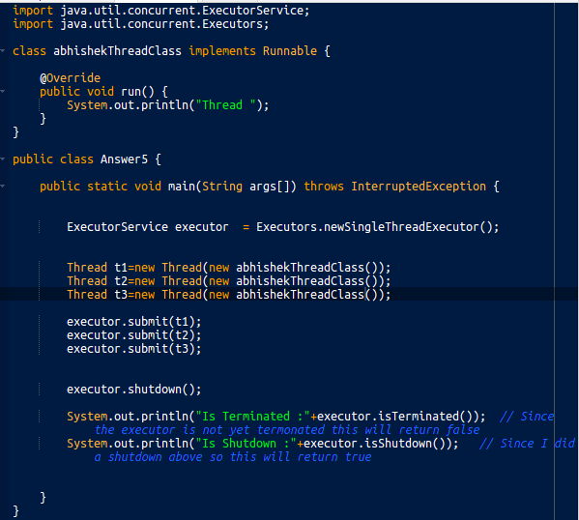
Ans-

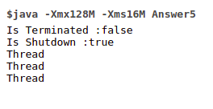

- Return a Future from ExecutorService by using callable and use get(), isDone(), isCancelled() with the Future object to know the status of task submitted.
Ans-
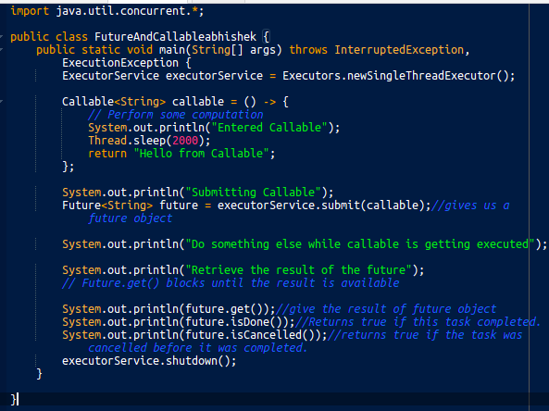

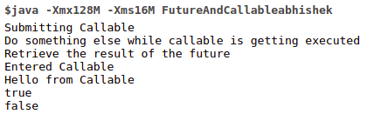

- Submit List of tasks to ExecutorService and wait for the completion of all the tasks.
Ans-
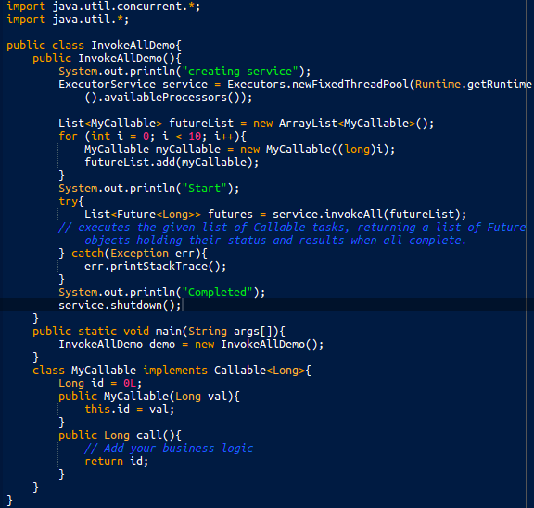

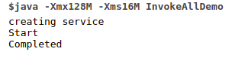

- Schedule task using schedule(), scheduleAtFixedRate() and scheduleAtFixedDelay()
Ans-
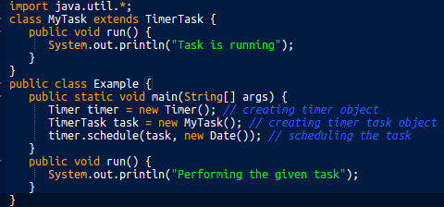

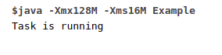

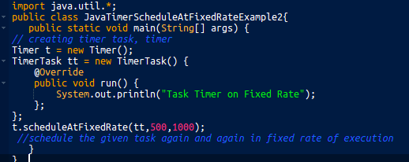

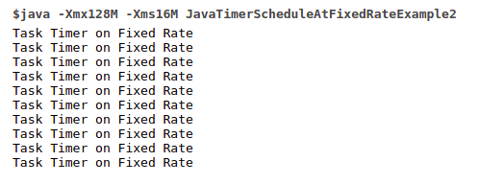

- Increase concurrency with Thread pools using newCachedThreadPool() and newFixedThreadPool().
Ans

- Use Synchronize method to enable synchronization between multiple threads trying to access method at same time.
Ans-
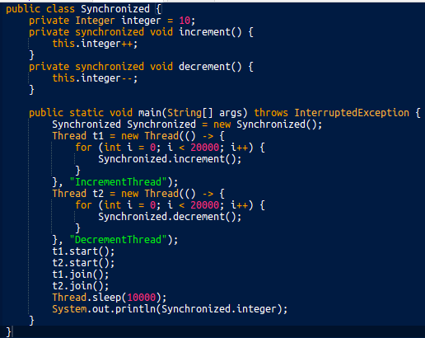

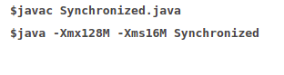

- Use Synchronize block to enable synchronization between multiple threads trying to access method at same time.
Ans-
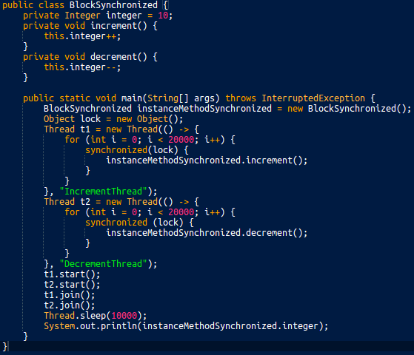

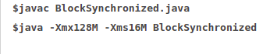

- Use Atomic Classes instead of Synchronize method and blocks.
Ans-
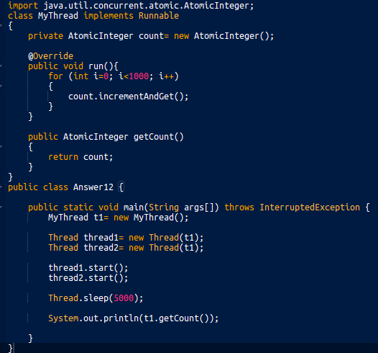

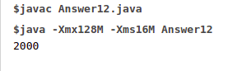

- Coordinate 2 threads using wait() and notify().
Ans-

- Coordinate mulitple threads using wait() and notifyAll()
Ans-
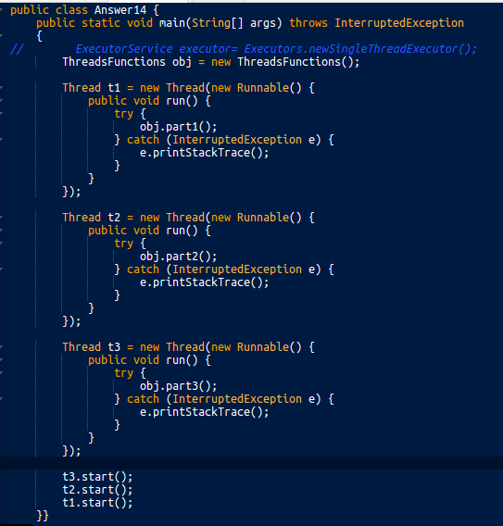

- Use Reentract lock for coordinating 2 threads with signal(), signalAll() and wait().
Ans-

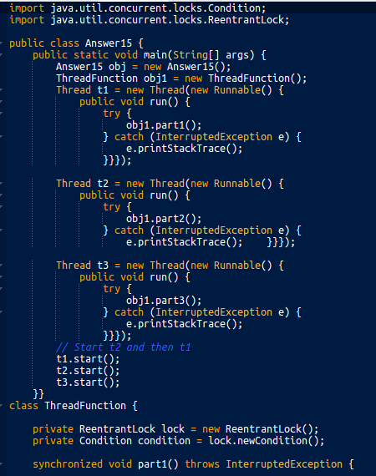

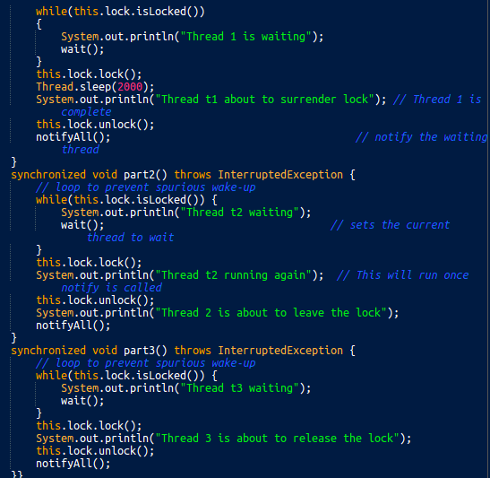

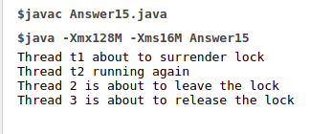

- Create a deadlock and Resolve it using tryLock().
Ans-

