- Write Java code to define List . Insert 5 floating point numbers in List, and using an iterator, find the sum of the numbers in List.
Ans
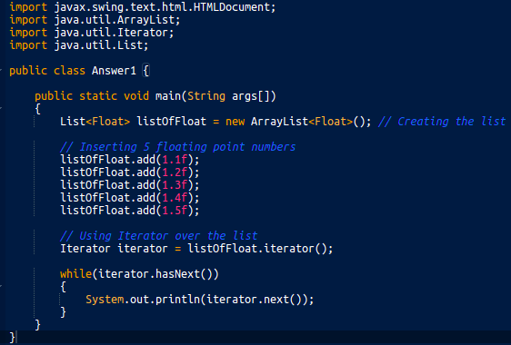

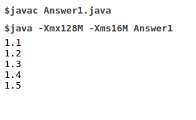

- Write a method that takes a string and returns the number of unique characters in the string.
Ans-

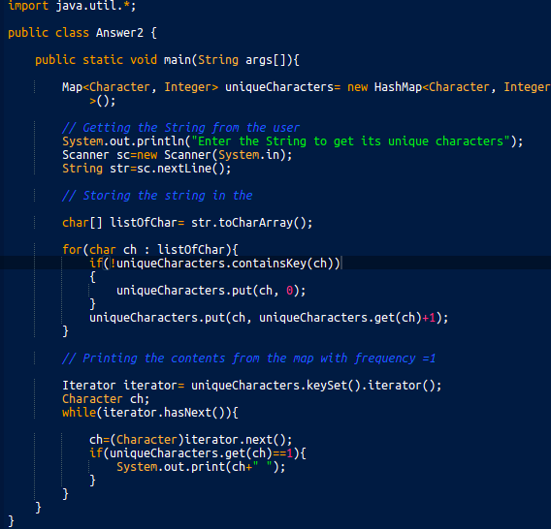

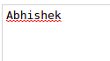

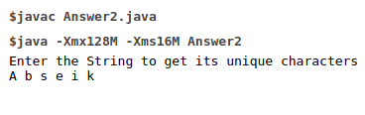

- Write a method that takes a string and print the number of occurrence of each character characters in the string.
Ans-
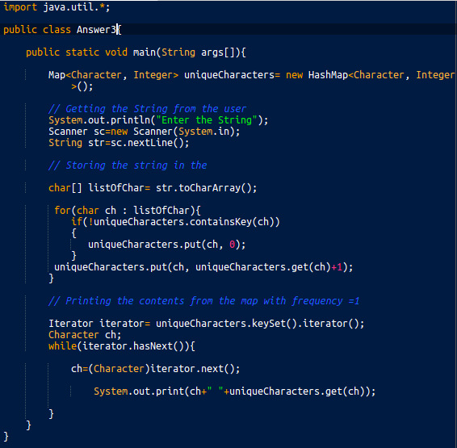

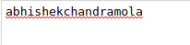

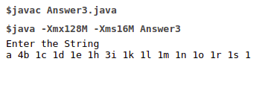

- Write a program to sort Employee objects based on highest salary using Comparator. Employee class{ Double Age; Double Salary; String Name.
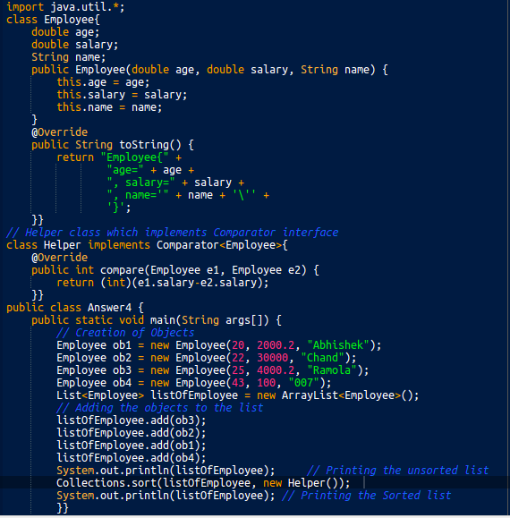
Ans-

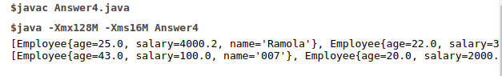
- Write a program to sort the Student objects based on Score , if the score are same then sort on First Name . Class Student{ String Name; Double Score; Double Age
Ans-
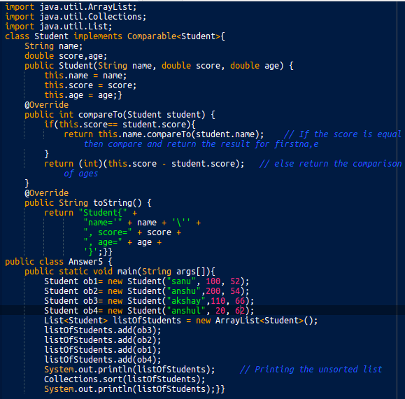

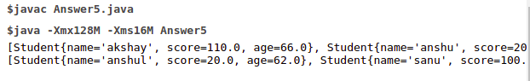
- Print the elements of an array in the decreasing frequency if 2 numbers have same frequency then print the one which came first.
Ans-
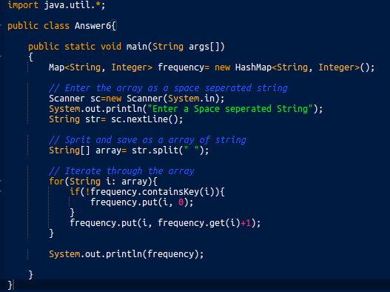

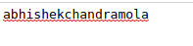

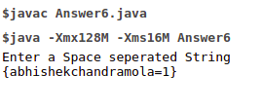

8.Write a program to format date as example "21-March-2016"
Ans
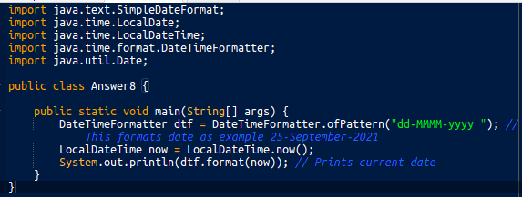

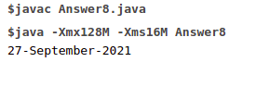

9.Write a program to display times in different country format.
Ans-

