1. Console "Hello Word" in document.ready function.
Ans:
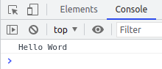
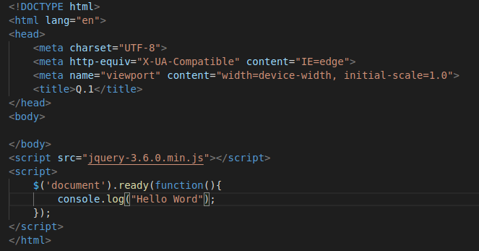

2. Select a ID name "#test" and add class "load" when DOM is
loaded.
Ans:
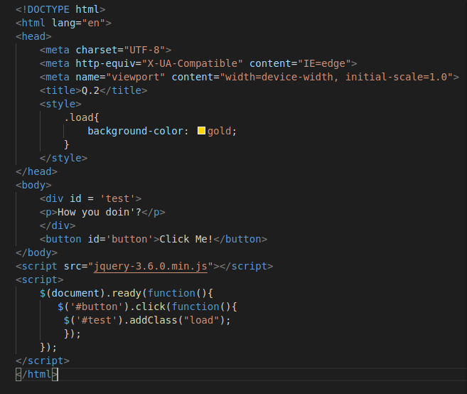
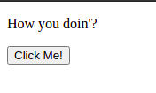

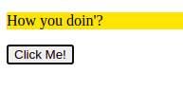
3. Change the color of element which class name end with "-new".
Ans:

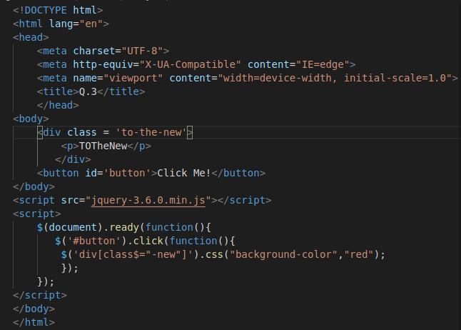
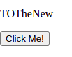
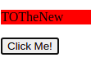

4. Disable submit button using jquery attr method.
Ans:
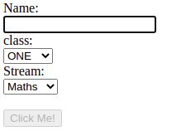
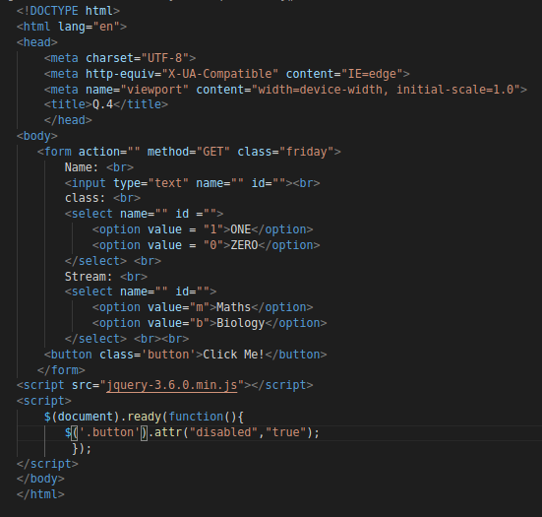
5. Change the font size of ".target" which has parent element with
id name "#main".
Ans:

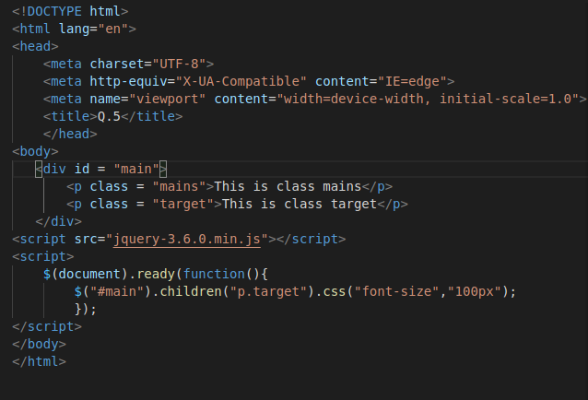

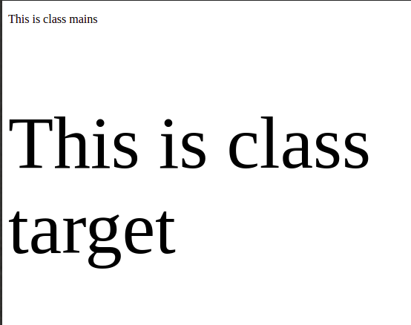
6. After page load change the HTML of div element with "p"
element.
Ans:
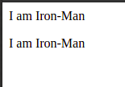
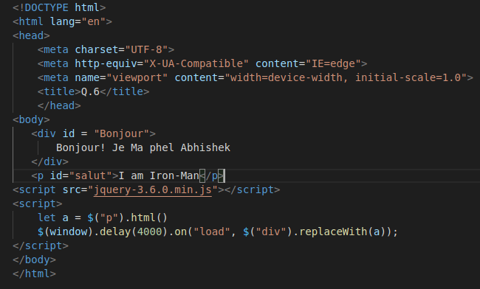
7. Bind a click function to an "click" element and append next
"click" next to it.
Ans
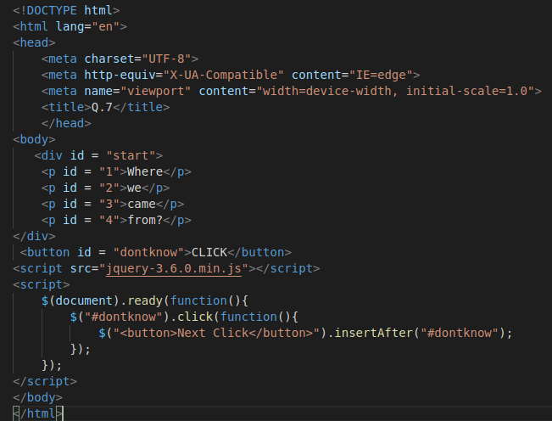
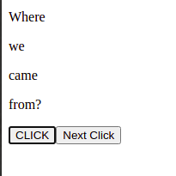
8. Click event not working on element which added dynamicly or
via script, make it work using .on method
Ans:

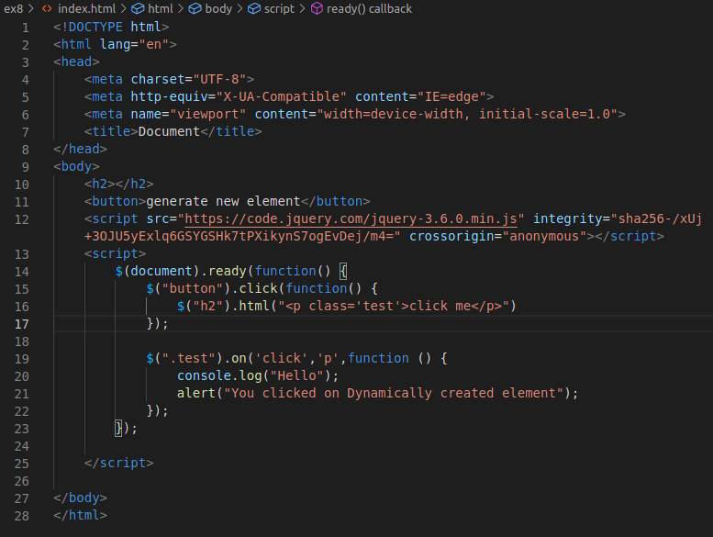

9. Get dropdown selected value on onchanage event and append in
div container
Ans:

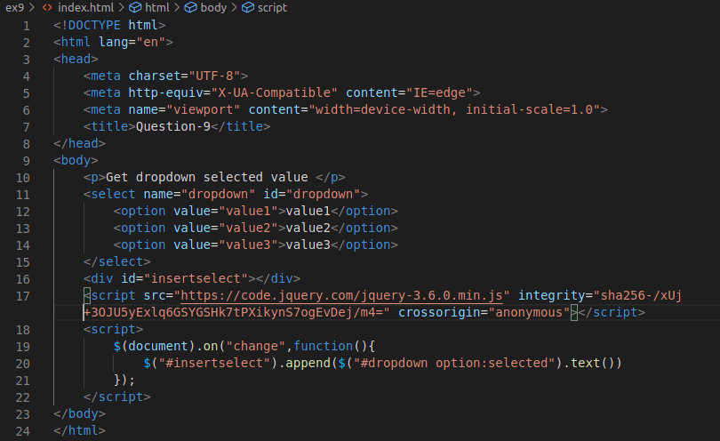

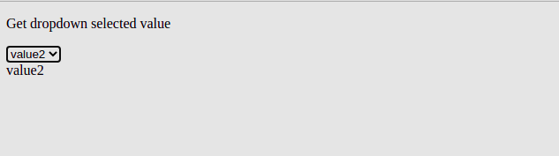

10. Create a dropdown menu using hover method in jquery.
Ans:

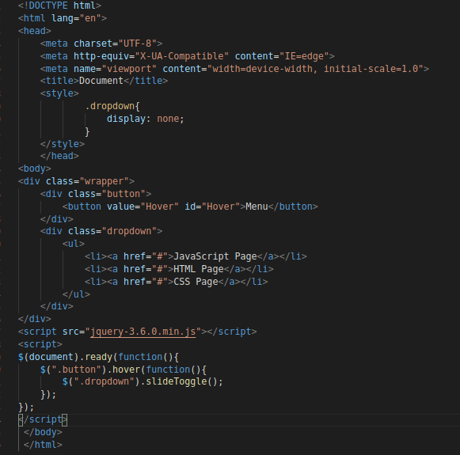

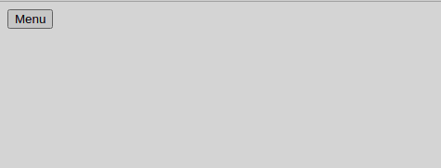

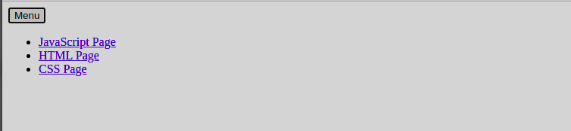

11. On clicking on "google" tag. It is taking us to google home
page. Stop it from happening.
Ans
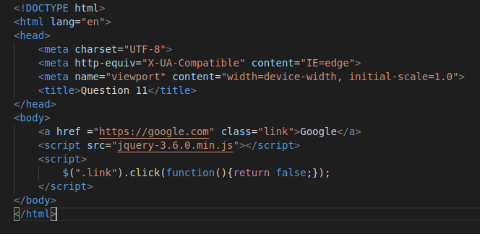

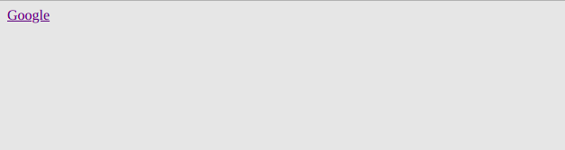

12. We have bind a click funtion to parent div but we want stop it
from performing when user clicks on its child li.
Ans

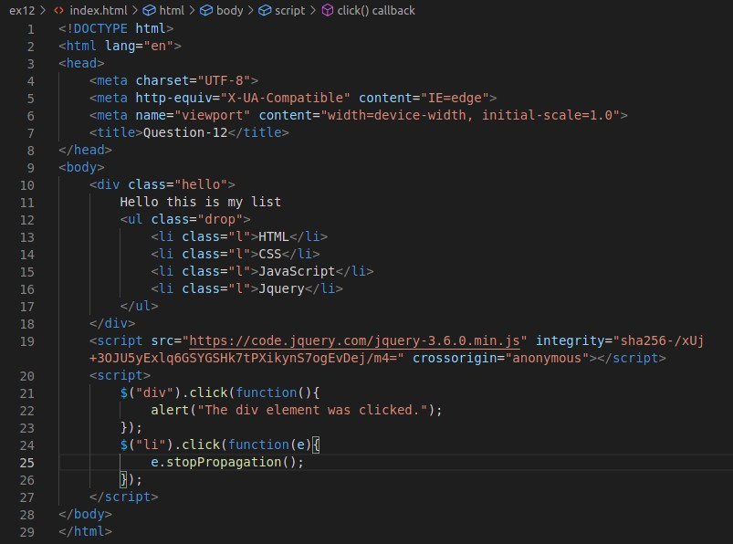
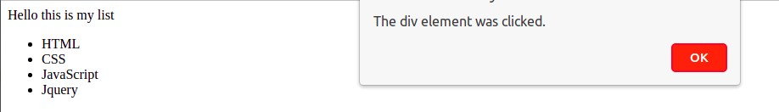

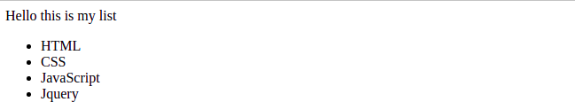

13. Get the max height of elements using jquery each method.
Ans:
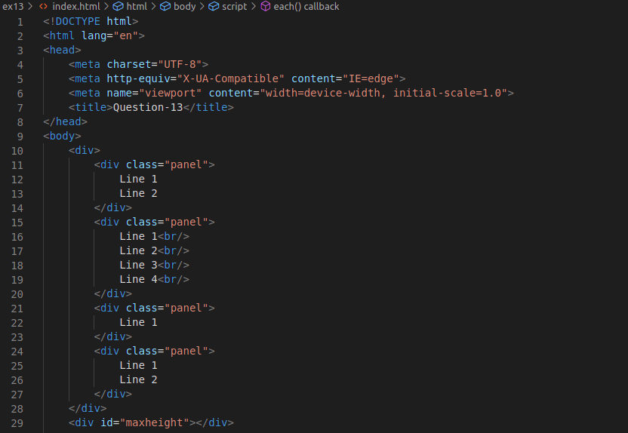

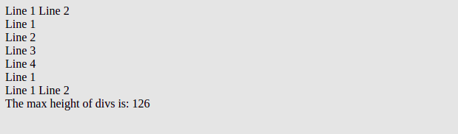

14. Change color of every cell which has numberl larger than 10.
Ans
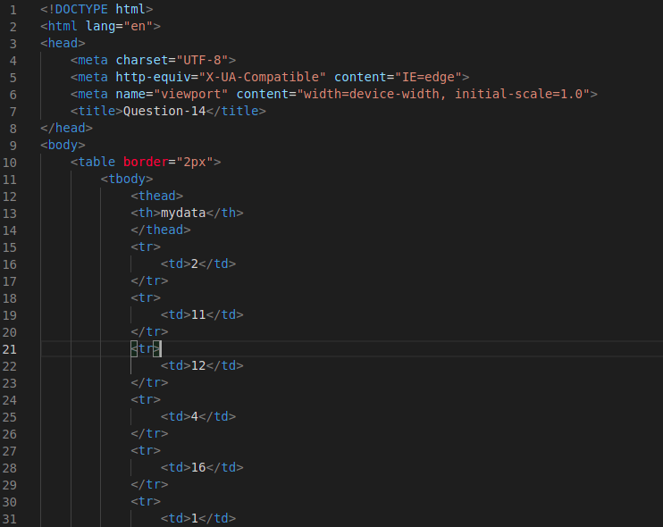
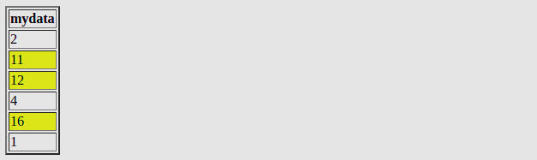

15. Retrive the data from server using ajax get call
Ans
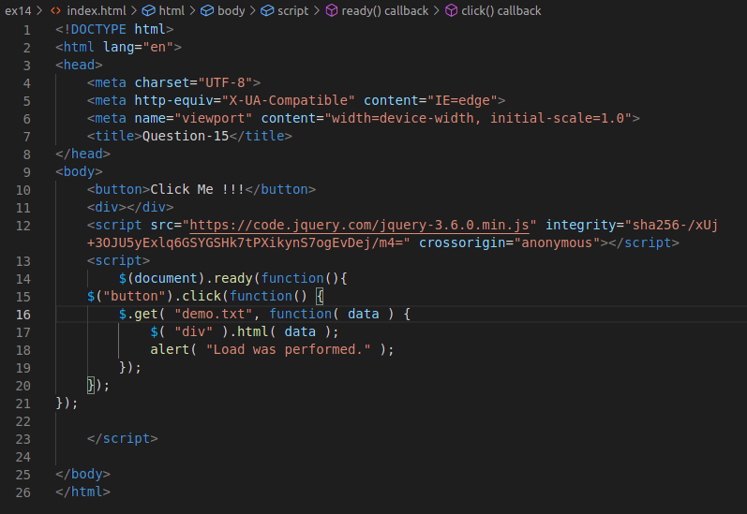



16. Add cross button on row and bind click function which make a
delete request to server, after success event remove the row from
dom
Ans
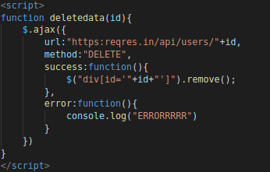
17. Create a image array and in div create a slide show to animate
images of delay of 500ms.
Ans

