AI Scientific Research Collaboration Lab

Project Description:
AI Scientific Research Collaboration Lab is an Agentic AI system that supports the end-to-end scientific research process. Instead of relying on one AI model to do everything, it assigns research activities to seven specialised agents: the Research Lead, Literature Agent, Data Agent, Hypothesis Agent, Experiment Agent, Critic Agent, and Report Agent. The agents work through a structured workflow to investigate a research question, analyse evidence, generate hypotheses, run statistical experiments, critique the findings, and synthesise a final report.
The platform follows the research journey Investigate → Analyze → Hypothesize → Experiment → Critique → Synthesize. A FastAPI backend coordinates the agents with a LangGraph workflow, runs real statistical analysis with pandas, SciPy, and statsmodels, and stores projects, agent runs, results, and reports in SQLite. A Next.js frontend with React Flow and Recharts streams live agent activity through Server-Sent Events (SSE) and presents the literature, datasets, hypotheses, experiments, peer review, and final report for each research project.

Scenarios
Scenario 1: A researcher creates a project titled "Urban Heat Island Dynamics and Surface Albedo Mitigation", selects the Environmental Science area, and asks which microclimate factors correlate with reduced heat intensity. The Research Lead builds a plan, the Literature Agent retrieves related studies, the Data Agent profiles the urban climate dataset, the Hypothesis Agent proposes testable hypotheses, and the Experiment Agent fits regression models whose results are shown in the workspace.
Scenario 2: A student studying smartphone use and sleep uploads a CSV dataset for the project. The Data Agent uses the uploaded file instead of generated data, infers the outcome and predictor variables from the research question, and the Experiment Agent tests each hypothesis with an ordinary least squares (OLS) regression, reporting coefficients, p-values, R-squared, and confidence intervals.
Scenario 3: After the experiments finish, the Critic Agent reviews the evidence. It scores rigor, statistical validity, literature alignment, and methodological robustness, lists strengths, weaknesses, and contradictions, and returns PASS or REVISE. A REVISE decision is routed back to the Hypothesis Agent by the workflow graph until the revision limit is reached, and a PASS goes to the Report Agent.
Scenario 4: While a run is in progress, the researcher watches the agent pipeline on the project workspace. Each agent's progress arrives as a live SSE event, the progress bar advances, and when the run completes the Report Agent's structured report, with executive summary, methodology, results, limitations, future work, and bibliography, is saved and displayed.

Technical Architecture:
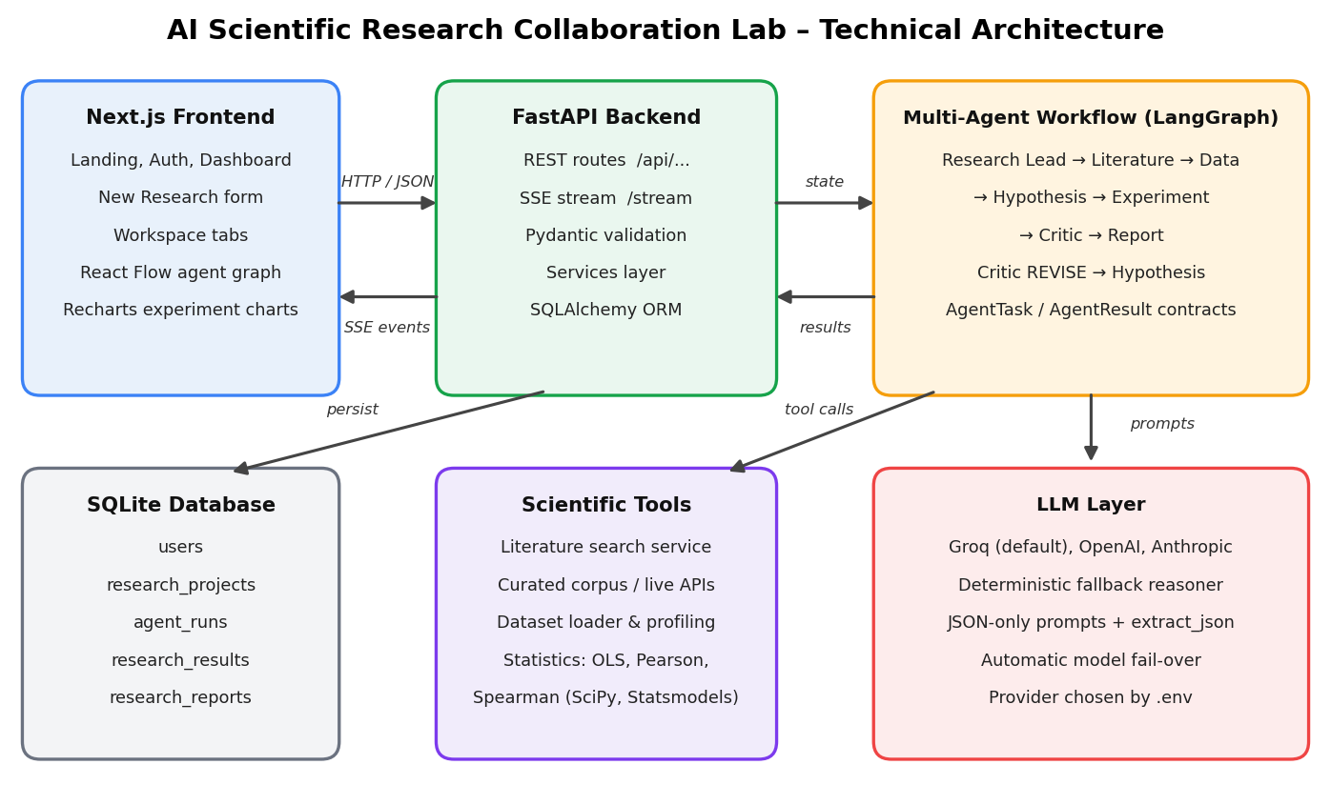

Description:
The system uses a three-tier architecture. The Next.js frontend provides the research workspace and talks to the FastAPI backend over REST and an SSE stream. The backend validates requests with Pydantic, manages data through services and SQLAlchemy, and runs the multi-agent workflow. The agents call scientific tools for literature search, dataset loading, and statistics, and use a pluggable LLM client (Groq by default, with OpenAI and Anthropic options and a built-in offline fallback) for planning, synthesis, and critique. Results are persisted in a SQLite database.
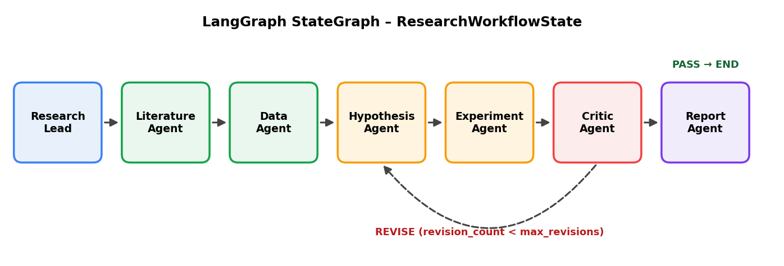
The workflow graph above shows the agent order. The Research Lead plans first, followed by the Literature, Data, Hypothesis, and Experiment agents. The Critic then either passes the research to the Report Agent or sends it back to the Hypothesis Agent for revision.

Entity Relationship (ER) Diagram:
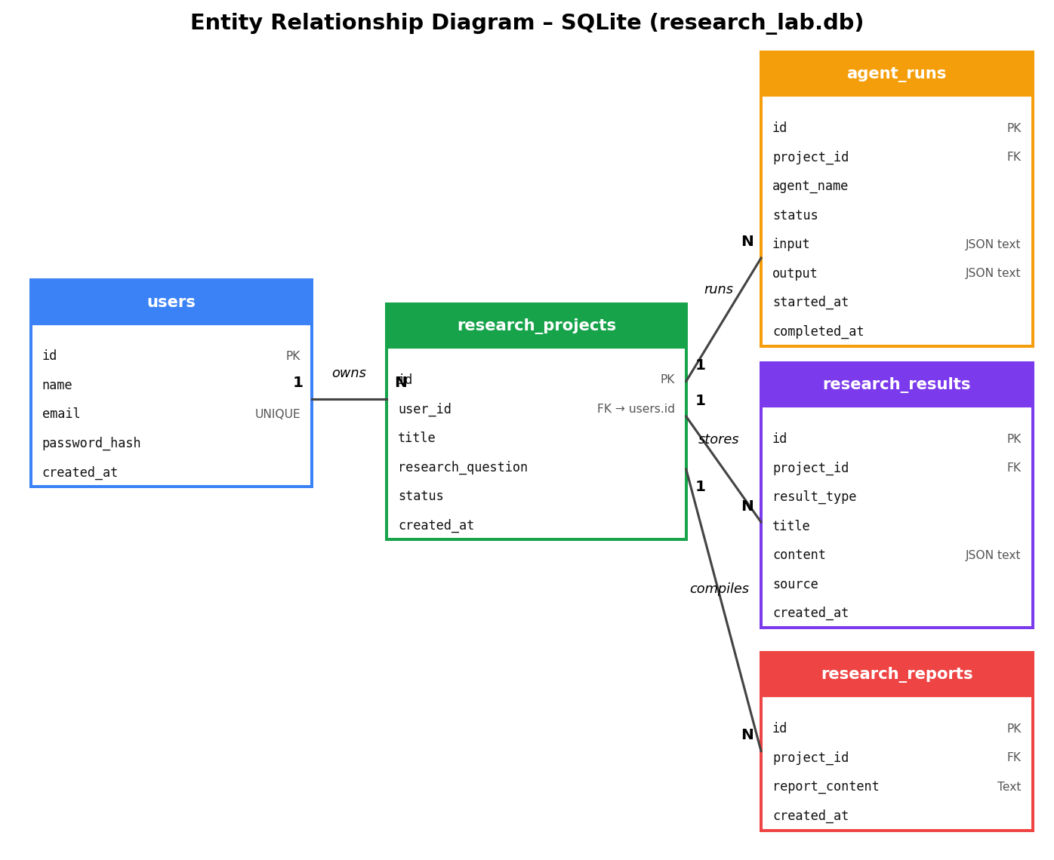
The application stores its data in SQLite using five tables. One user owns many research projects. Each research project can have many agent runs (the input and output of each agent, saved as JSON text), many research results (typed records such as literature, dataset, hypothesis, experiment, and critique), and many research reports. Foreign keys on project_id link every child table to research_projects, and deleting a project removes its related records.

Pre-requisites:
- Python Programming Proficiency: Python Documentation
- FastAPI Framework Knowledge: FastAPI Documentation
- LangGraph and Agentic AI Concepts: LangGraph Documentation
- LLM API Familiarity (Groq): Groq API Documentation
- Statistics with Python: statsmodels Documentation
- SQL and SQLAlchemy: SQLAlchemy Documentation
- Next.js, React, and TypeScript: Next.js Documentation
- Tailwind CSS: Tailwind CSS Documentation
- Version Control with Git: Git Documentation
- Docker for Deployment: Docker Documentation

Project Workflow:

Milestone 1: Architecture and Environment Setup
- Activity 1.1: Generate a Groq API key and configure the backend environment file.
- Activity 1.2: Select the LLM provider and model strategy for the agents.
- Activity 1.3: Define the architecture of the frontend, backend, agents, tools, and database.
- Activity 1.4: Set up the Python and Node.js development environments.

Milestone 2: Scientific Data and Tools
- Activity 2.1: Develop the literature search service and the curated research corpus.
- Activity 2.2: Develop dataset loading, upload handling, and variable profiling.
- Activity 2.3: Implement statistical analysis tools: descriptive statistics, correlation, and OLS regression.
- Activity 2.4: Define the MCP-style tool servers and the A2A message contracts.

Milestone 3: Multi-Agent Workflow Development
- Activity 3.1: Build the LLM client with provider selection, fail-over, and JSON extraction.
- Activity 3.2: Define the shared research state and Pydantic schemas.
- Activity 3.3: Develop the seven specialised agents.
- Activity 3.4: Build the workflow graph and the critic routing logic.

Milestone 4: Backend and Database Development
- Activity 4.1: Create the SQLAlchemy models and initialise the SQLite database.
- Activity 4.2: Develop the services and REST API routes.
- Activity 4.3: Develop the SSE workflow streaming service.

Milestone 5: Frontend Development
- Activity 5.1: Set up the Next.js application, API client, and layout.
- Activity 5.2: Build the landing, dashboard, and new research pages.
- Activity 5.3: Build live agent streaming and the React Flow pipeline graph.
- Activity 5.4: Build the results tabs, charts, and report view.

Milestone 6: Testing and Deployment
- Activity 6.1: Run the backend and frontend locally.
- Activity 6.2: Test the complete research workflow end to end.
- Activity 6.3: Containerise the backend with Docker.

Milestone 7: Conclusion

Milestone 1: Architecture and Environment Setup
In this milestone we prepare the foundation of the platform: the LLM provider and its API key, the choice of model strategy, the overall architecture, and the development environment for both the backend and the frontend.

Activity 1.1: Generate a Groq API Key
The agents use a large language model for planning, literature synthesis, hypothesis generation, conclusions, critique, and report writing. Groq is the default provider. Follow the steps below to create a key and connect it to the project.
- Step 1 — Create a Groq AccountVisit https://console.groq.com and sign up with your Google account or email.
- Step 2 — Open the API Keys pageFrom the console menu select API Keys.
- Step 3 — Create the keyClick Create API Key, give it a name such as research-lab-key, and copy the key immediately, because it is shown only once.

- Step 4 — Create the .env fileIn the backend folder, copy .env.example to .env and add the key.
LLM_PROVIDER=groq
GROQ_API_KEY=your_copied_api_key_here

- Step 5 — Review all settingsThe application loads these values with pydantic-settings (app/core/config.py).
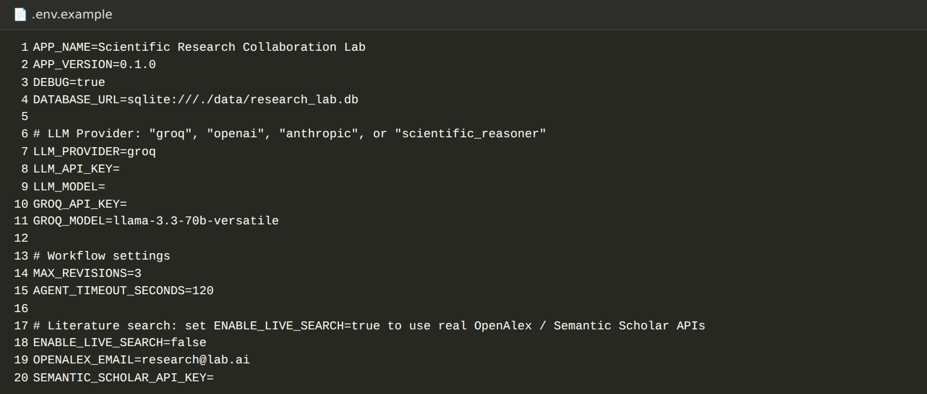
Variable | Purpose
DATABASE_URL | SQLite database location (sqlite:///./data/research_lab.db)
LLM_PROVIDER | groq, openai, anthropic, or scientific_reasoner (offline fallback)
GROQ_API_KEY / GROQ_MODEL | Groq credentials and model name
LLM_API_KEY / LLM_MODEL | Key and model for the OpenAI or Anthropic providers
MAX_REVISIONS / AGENT_TIMEOUT_SECONDS | Workflow revision limit and agent timeout
ENABLE_LIVE_SEARCH | true uses the OpenAlex and Semantic Scholar APIs, false uses the local curated corpus
OPENALEX_EMAIL / SEMANTIC_SCHOLAR_API_KEY | Contact email and optional key for the literature APIs

Important: never commit the .env file. Add it to .gitignore so the API key is not pushed to a public repository.
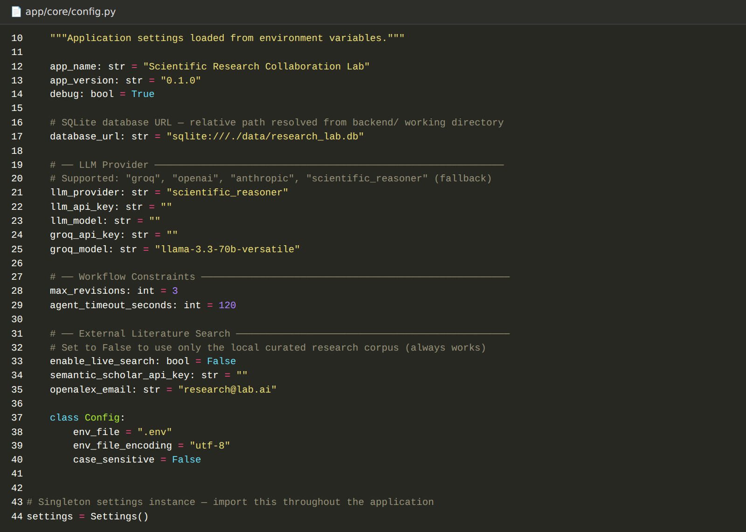

Activity 1.2: Select the LLM Provider and Model Strategy
- Pluggable providers: The factory function get_llm_client() reads the settings and returns a Groq, OpenAI, or Anthropic client, so the provider can be changed from .env without touching agent code.
- Groq with fail-over: The Groq client sends requests to the Groq chat completions endpoint and automatically fails over to alternate models if the first model returns an error.
- Offline fallback: If no API key is configured, the system uses an offline scientific reasoner. It returns an empty response, and every agent then falls back to its own deterministic logic, so the whole workflow still runs.
- Structured output: Agents request JSON-only answers at a low temperature (0.2, up to 2000 tokens), and the extract_json() helper parses the response even when it is wrapped in a markdown code block.

Activity 1.3: Define the Architecture of the Application
- Frontend: Next.js pages for the landing page, dashboard, new research form, and a project workspace with tabs for each research stage.
- Backend: FastAPI routes for users, research projects, agents, results, reports, health, and the SSE stream, with CORS enabled for the local frontend on ports 3000 and 3001.
- Agents: Seven agents registered in an agent registry and executed as workflow nodes that share a single research state.
- Tools: Literature search, dataset loading and profiling, statistics, and chart-data helpers used by the agents.
- Database: SQLAlchemy models stored in a SQLite file, as shown in the ER diagram.

Activity 1.4: Set Up the Development Environment
- Install prerequisites: Python 3.11 (used by the Dockerfile), pip, and Node.js 18 or later with npm.
- Backend environment: Create a virtual environment in the backend folder and install the dependencies:
python -m venv .venv
.venv\Scripts\activate # Windows
source .venv/bin/activate # macOS / Linux
pip install -r requirements.txt

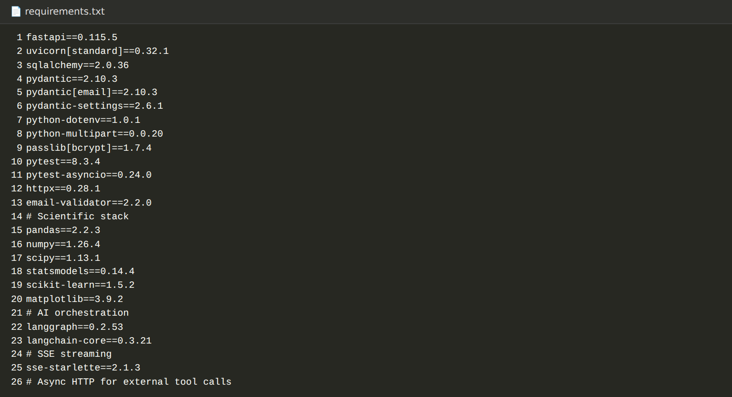
- Backend dependencies: The requirements install FastAPI, Uvicorn, SQLAlchemy, Pydantic, pandas, NumPy, SciPy, statsmodels, scikit-learn, Matplotlib, LangGraph, httpx, sse-starlette, and pytest.
- Frontend environment: In the Frontend folder, install the packages and copy .env.local.example to .env.local (NEXT_PUBLIC_API_URL=http://localhost:8000):
npm install

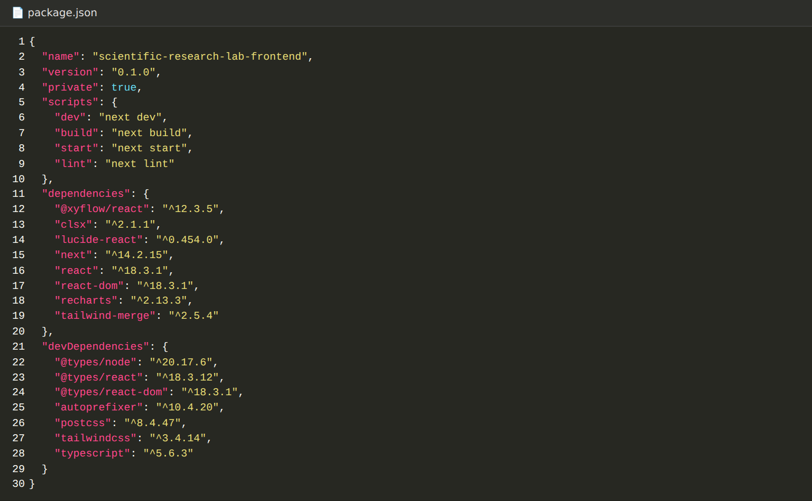
- Project structure: The project has two top-level folders: backend (FastAPI app with agents, graph, llm, tools, mcp, a2a, services, schemas, database, and api packages) and Frontend (Next.js app, components, and lib folders).
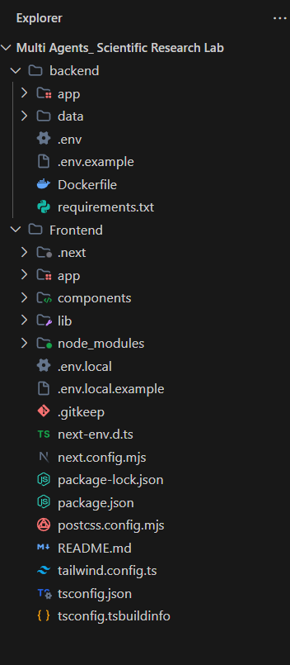

Milestone 2: Scientific Data and Tools
This milestone builds the research tools that connect the agents to evidence: a literature search service, dataset loading and profiling, and statistical analysis functions.

Activity 2.1: Develop the Literature Search Service
The LiteratureService in app/tools/literature/service.py returns a list of Paper objects (title, authors, year, abstract, DOI, journal, citation count, methodology, and key findings) for a search query.
- Live search: When ENABLE_LIVE_SEARCH is true, the service queries the Semantic Scholar API first and then the OpenAlex API.
- Curated corpus fallback: When live search is off or an API call fails, the service searches a local curated corpus of urban heat island and remote sensing papers by keyword.
- Last-resort records: If the corpus has no keyword match, the service creates placeholder scholarly records based on the query so the workflow can continue. Use a real search or your own corpus for genuine literature review.
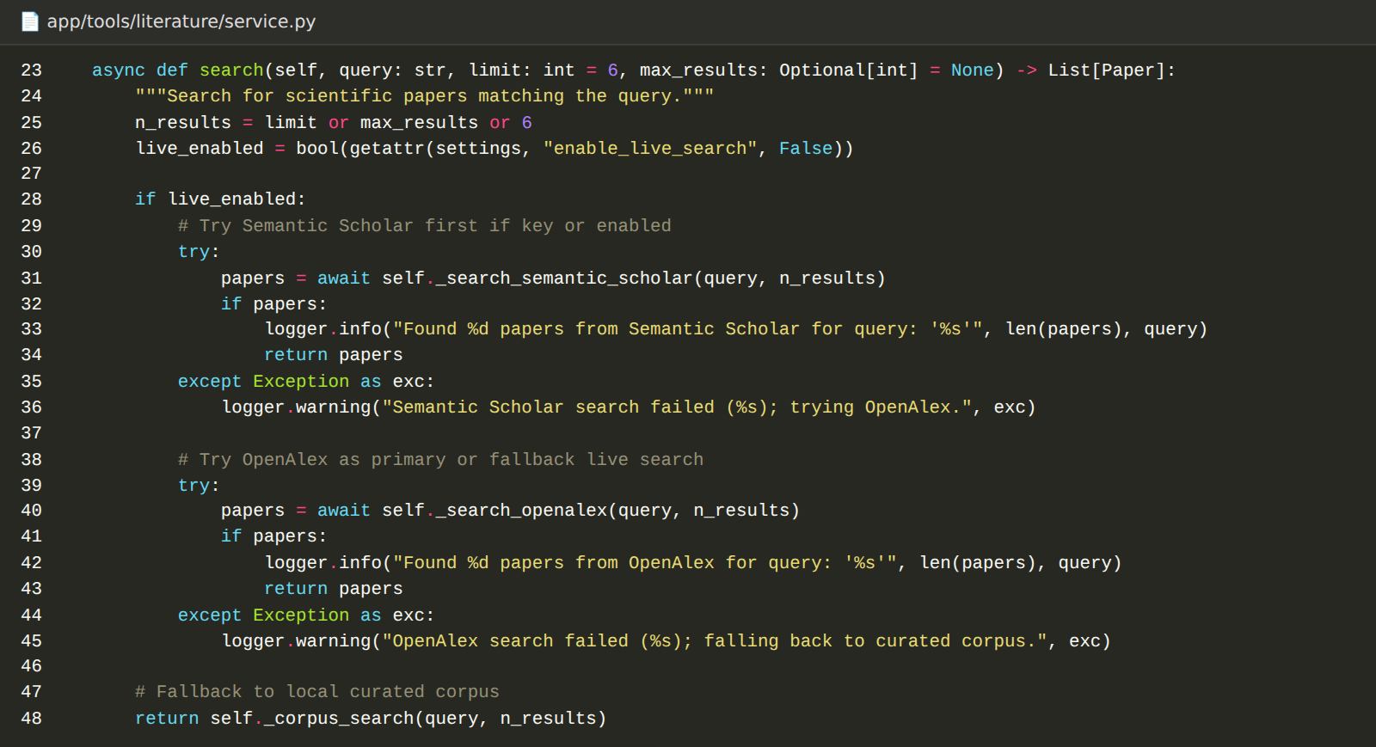

Activity 2.2: Develop Dataset Loading and Profiling
The Data Agent needs a table of observations. The get_dataset() function in app/tools/data/datasets.py supplies it in two ways.
- Uploaded dataset: If the researcher uploaded a CSV for the project (stored as data/uploads/project_<id>.csv), that file is loaded. The upload route accepts only .csv files with rows and at least two numeric columns.
- Generated dataset: Otherwise a dataset is generated from the research question and area, using AI/ML, biomedical, urban climate, or a generic keyword-driven template.
The profiling module (app/tools/data/profiling.py) then compares the column names with the words in the research question to infer which column is the outcome variable and which columns are predictors.
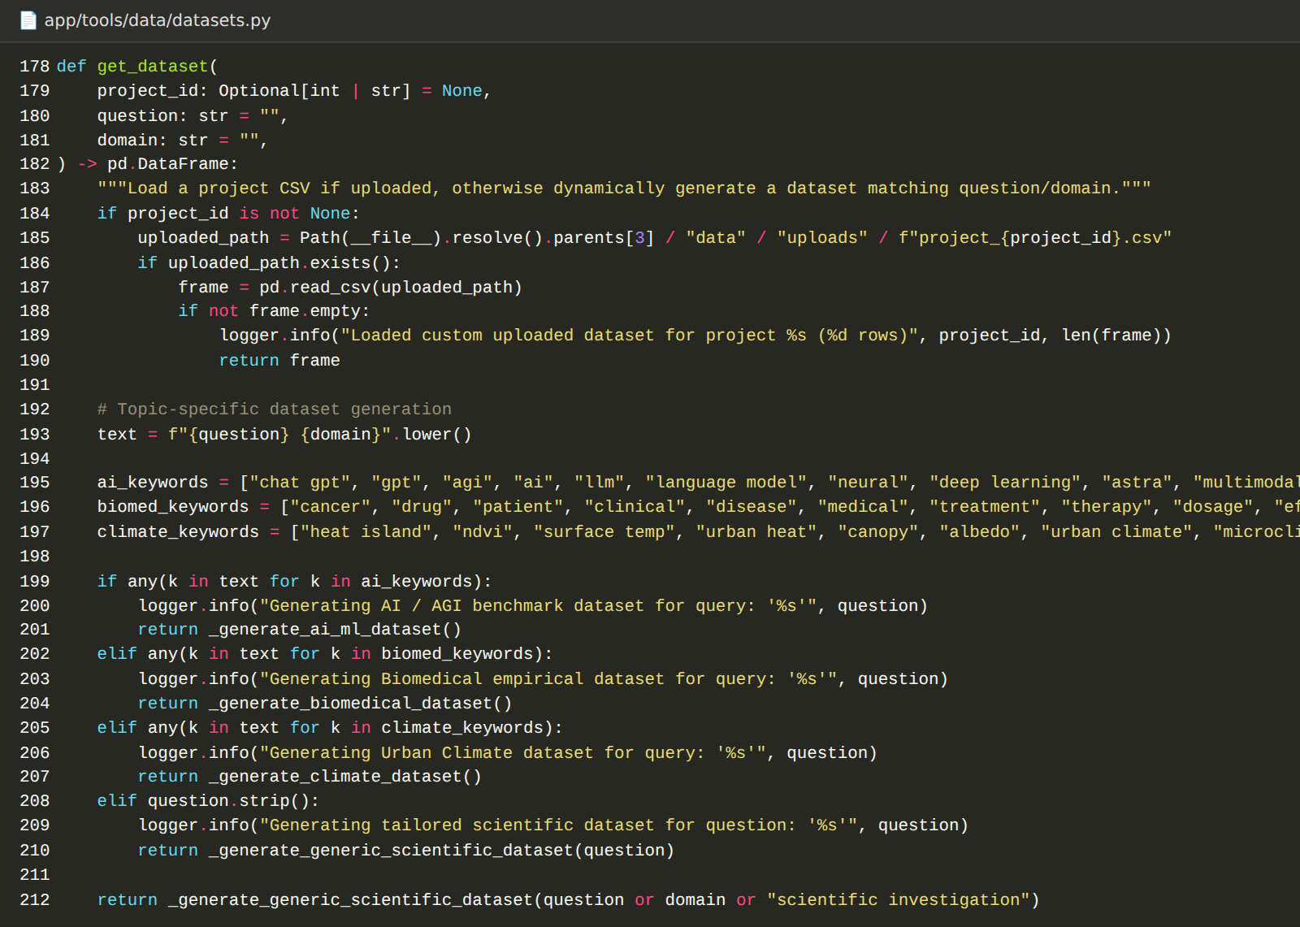

Activity 2.3: Implement Statistical Analysis Tools
app/tools/statistics/analysis.py provides the computations used by the Data and Experiment agents.
- Descriptive statistics: Mean, standard deviation, minimum, maximum, median, and count for each numeric column.
- Correlation: Pearson r and Spearman rho with their p-values and sample size (SciPy).
- OLS regression: OLS regression with statsmodels, returning R-squared, adjusted R-squared, F-statistic and its p-value, coefficients, p-values, standard errors, and confidence intervals.
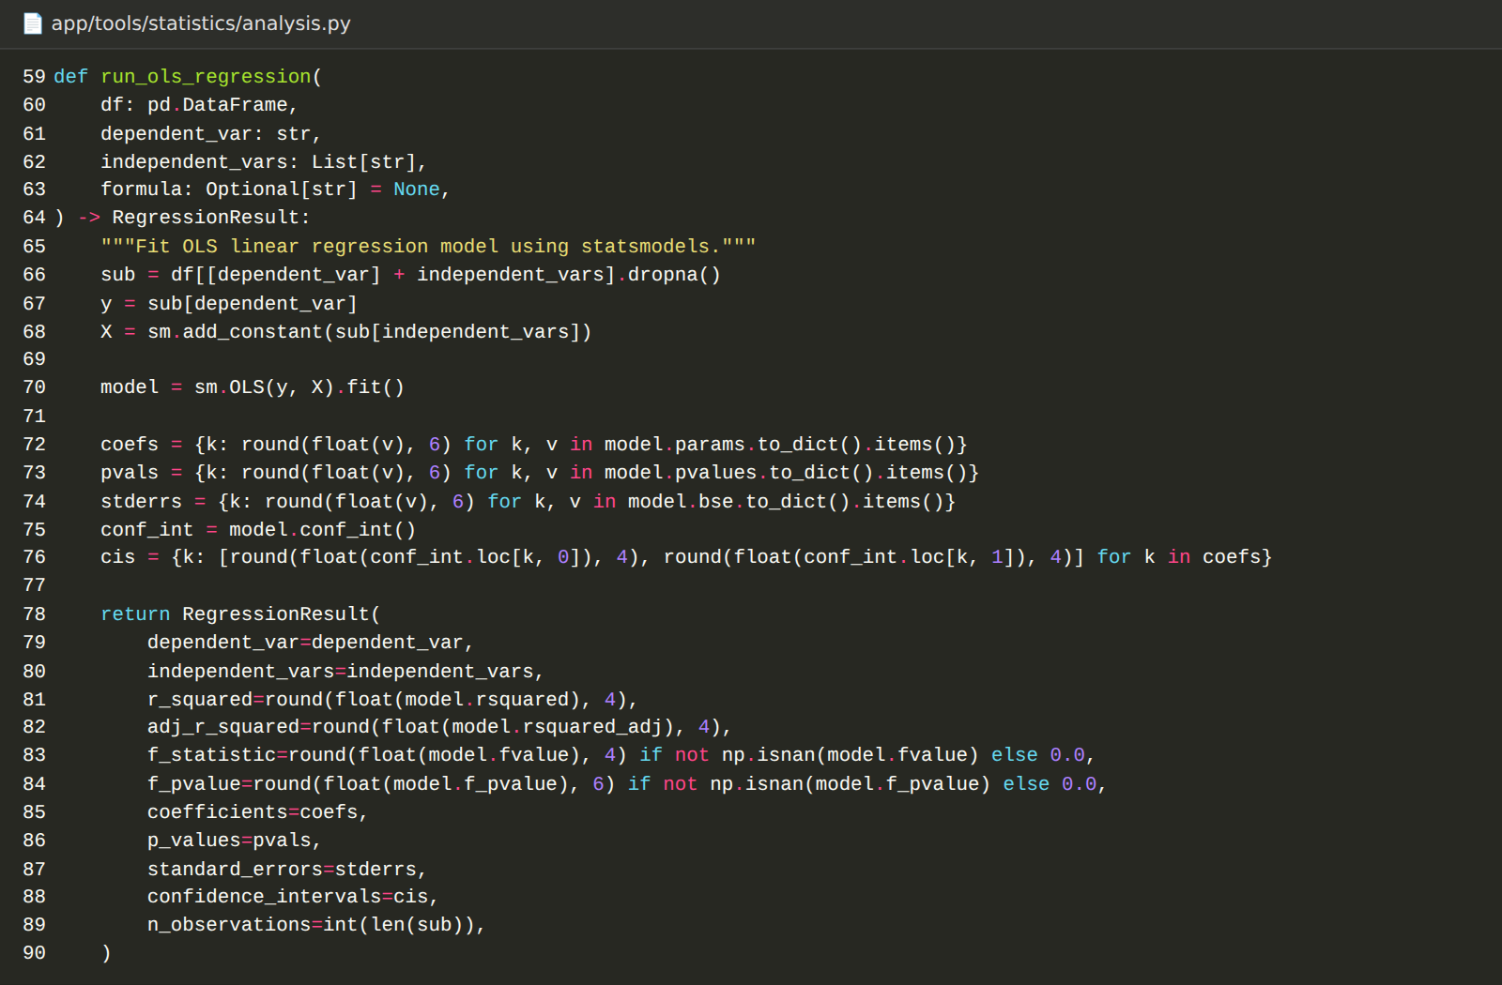

Activity 2.4: Define the MCP-Style Tool Servers and A2A Contracts
To prepare for tool-calling and agent-to-agent communication, the project defines these components in the mcp and a2a packages.
Component | Contents
scientific_search_server | search_papers: searches the literature service
data_tools_server | describe_dataset, run_correlation, run_regression
research_knowledge_server | get_literature_baselines: expected correlation directions and ranges for urban heat island variables
A2AMessage / A2AResponse | Message envelopes with sender, receiver, priority, payload, and status
AgentTask / AgentResult | Standard input and output contracts used by every agent

These servers run inside the same FastAPI process. In the current workflow the agents call the tools directly, and the server definitions are available for registration through setup_default_mcp_servers().
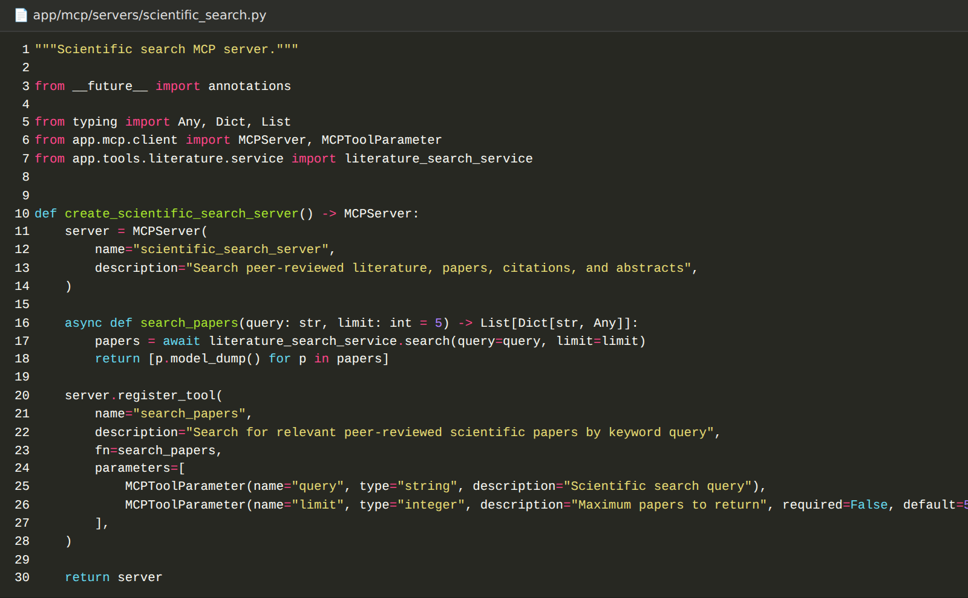
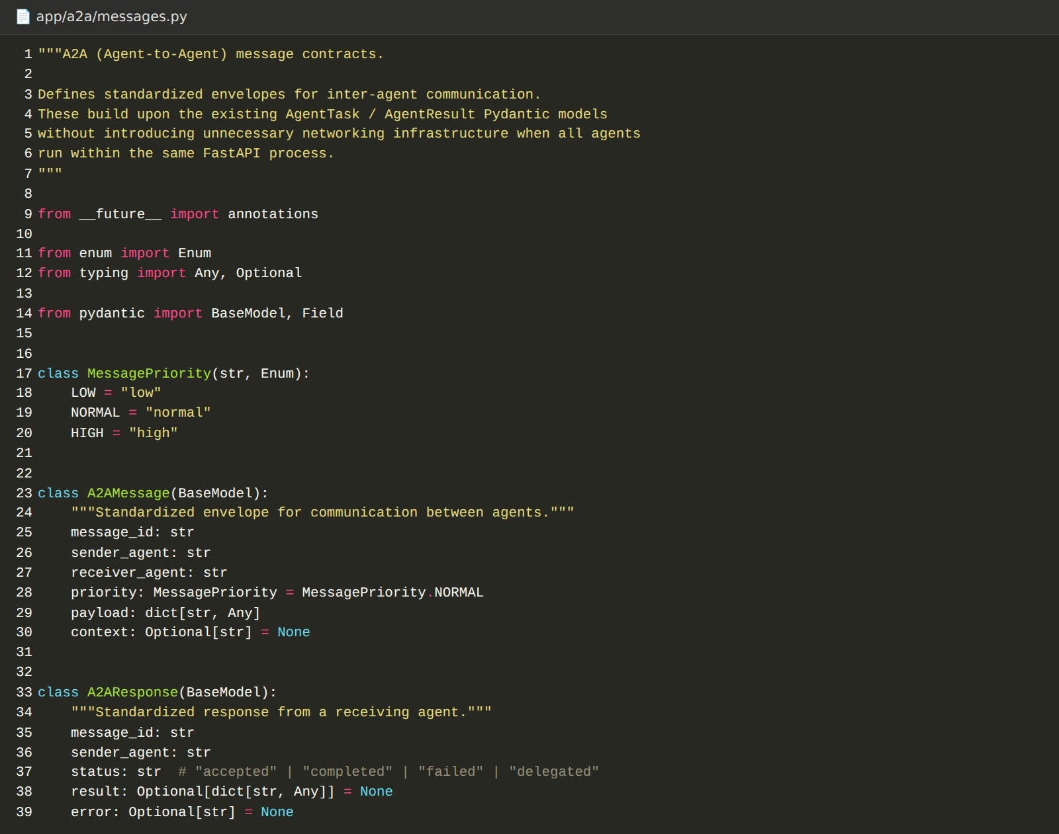

Milestone 3: Multi-Agent Workflow Development
Milestone 3 develops the intelligence of the platform: the LLM client, the shared research state, the seven specialised agents, and the graph that connects them.

Activity 3.1: Build the LLM Client
app/llm/client.py implements BaseLLMClient with a complete() method for each provider (Groq, OpenAI, Anthropic, and the offline reasoner). The Groq client tries a list of models in order and raises an error only if all of them fail.
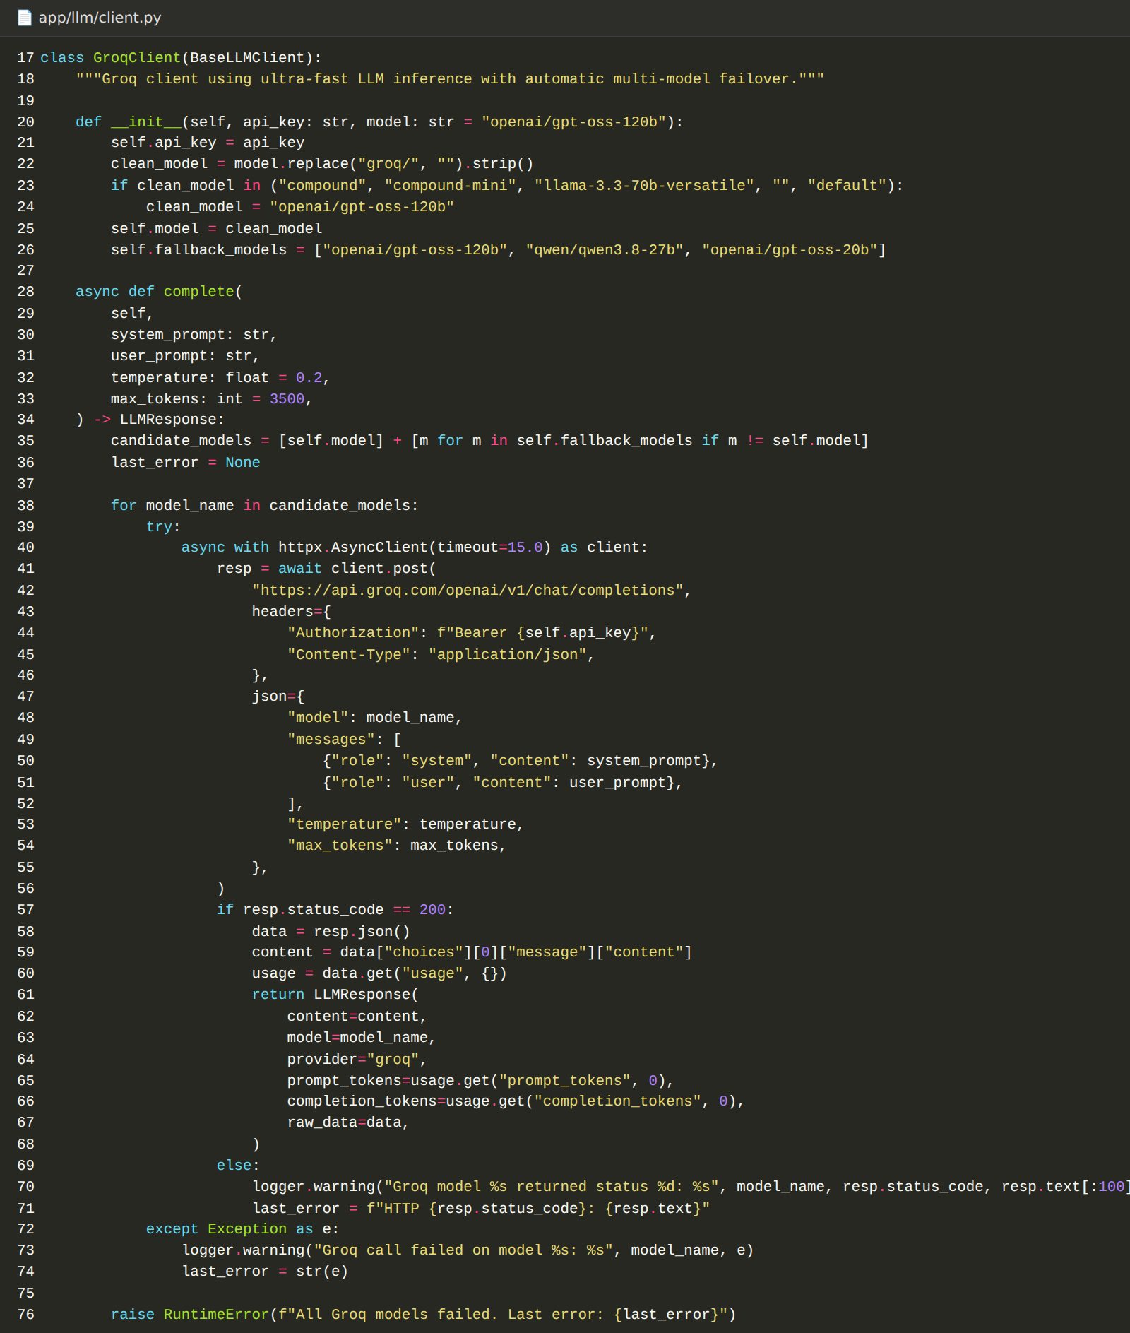

Activity 3.2: Define the Shared Research State
All agents read from and write to one state object. The schemas in app/schemas/research_state.py (Pydantic) and the LangGraph TypedDict in app/graph/state.py define the research plan, papers, literature findings, data analysis, hypotheses, experiments, critic reviews, report, agent activity, and errors, plus the revision counter and the revision limit.
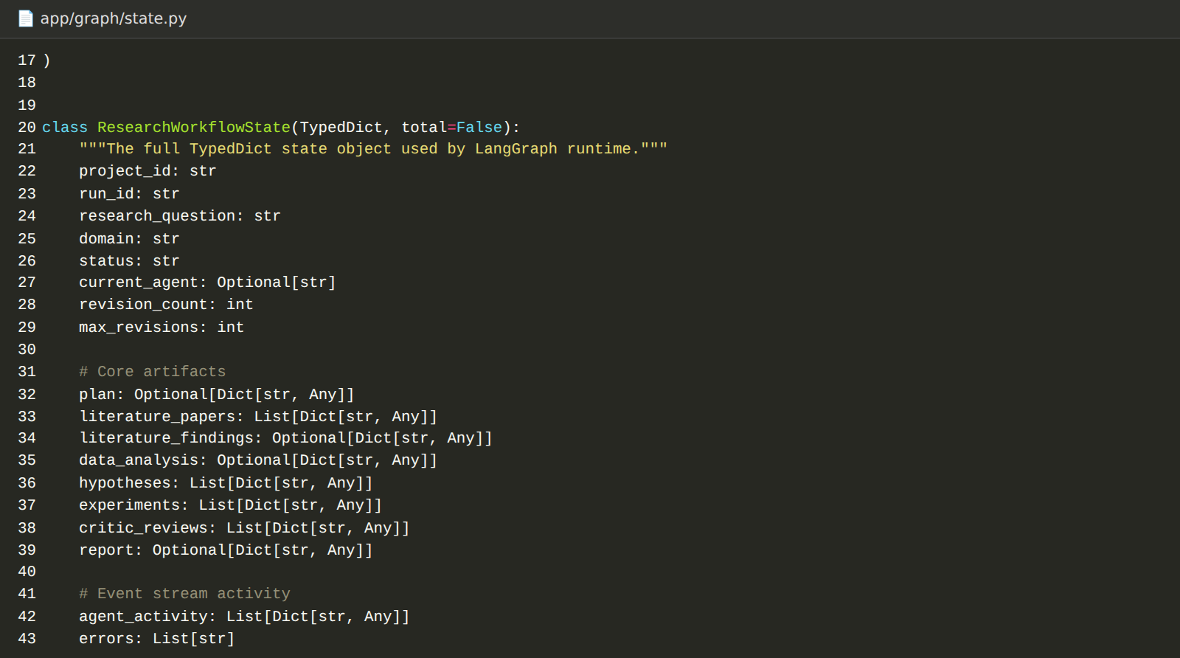

Activity 3.3: Develop the Seven Agents
Each agent extends BaseResearchAgent, has a unique name, and exposes an execute_state() method that turns the shared state into a state update. Each agent asks the LLM for structured JSON and uses a deterministic fallback if the LLM is unavailable or returns an unusable answer.
Agent | Responsibility
Research Lead | Decomposes the question into objectives, phases, target variables, 3-4 search queries, and a required sample size.
Literature Agent | Runs the plan's search queries, removes duplicate papers, and synthesises key claims, consensus points, gaps, and common methodologies.
Data Agent | Loads the dataset, computes descriptive statistics and the correlation matrix, scores data quality, and writes key insights.
Hypothesis Agent | Creates testable hypotheses with independent and dependent variables, expected direction, test method, and rationale.
Experiment Agent | Runs an OLS regression for every hypothesis, marks a hypothesis supported when the primary predictor has p below 0.05, and writes a conclusion with chart data.
Critic Agent | Scores rigor, statistical validity, literature alignment, and robustness, lists strengths, weaknesses, and contradictions, and decides PASS or REVISE.
Report Agent | Compiles the title, executive summary, literature review, methodology, results, discussion, conclusions, limitations, future work, and bibliography.

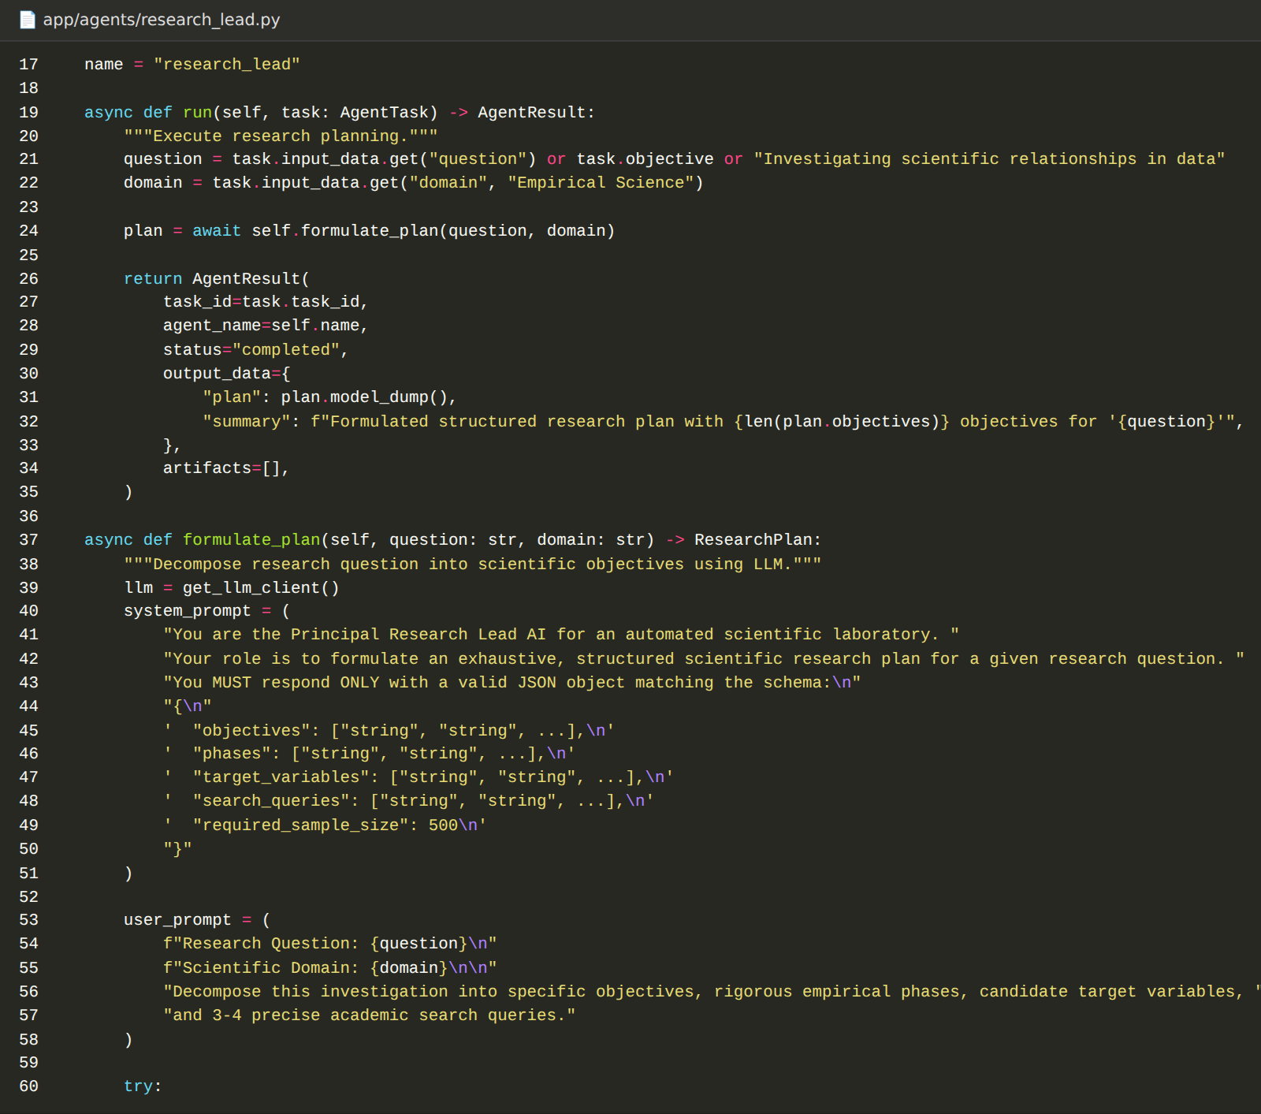
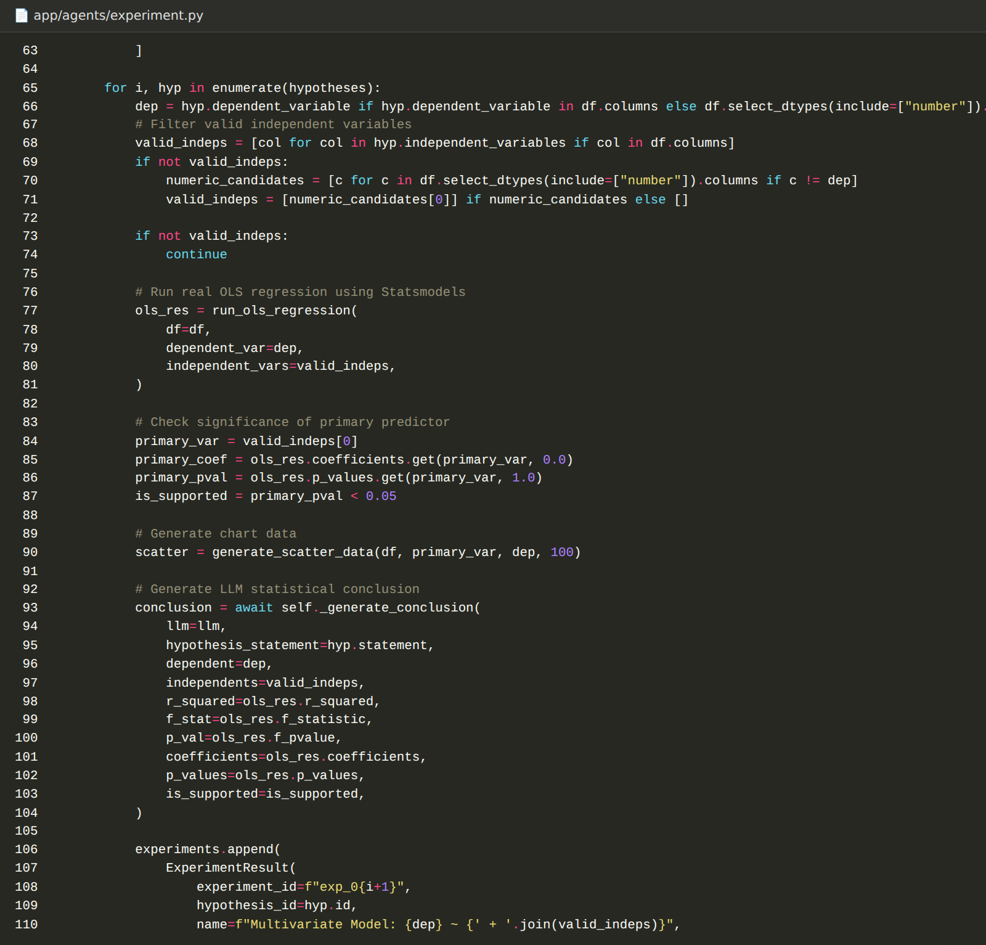
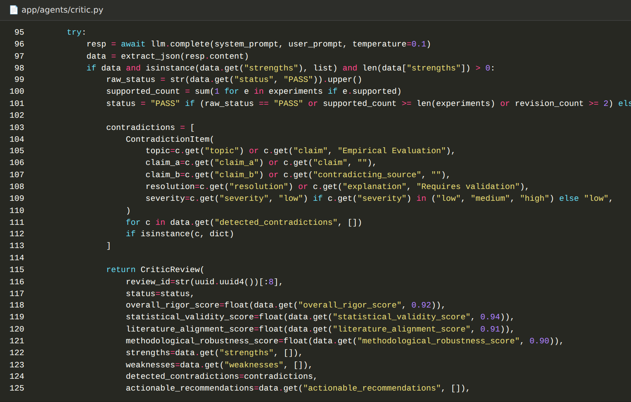

Activity 3.4: Build the Workflow Graph and Routing
app/graph/workflow.py builds a LangGraph StateGraph with a node for each agent. The edges run from START through the Research Lead, Literature, Data, Hypothesis, Experiment, and Critic nodes. A conditional edge after the Critic uses route_critic_decision(): it returns to the Hypothesis node when the latest review is REVISE and the revision count is below the limit, and otherwise goes to the Report node, which ends the workflow.
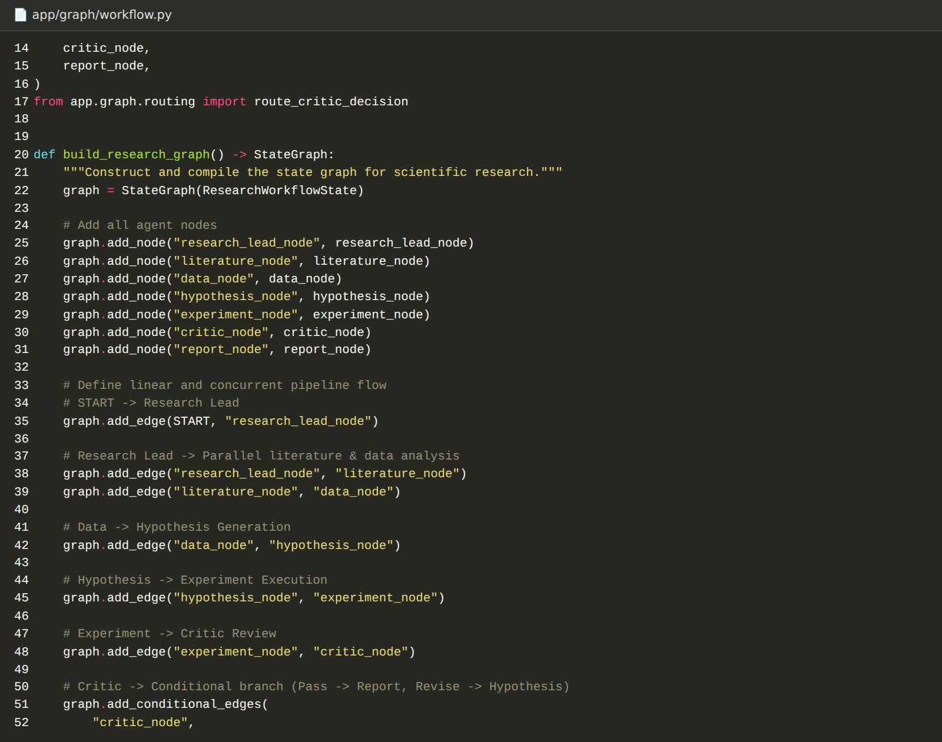
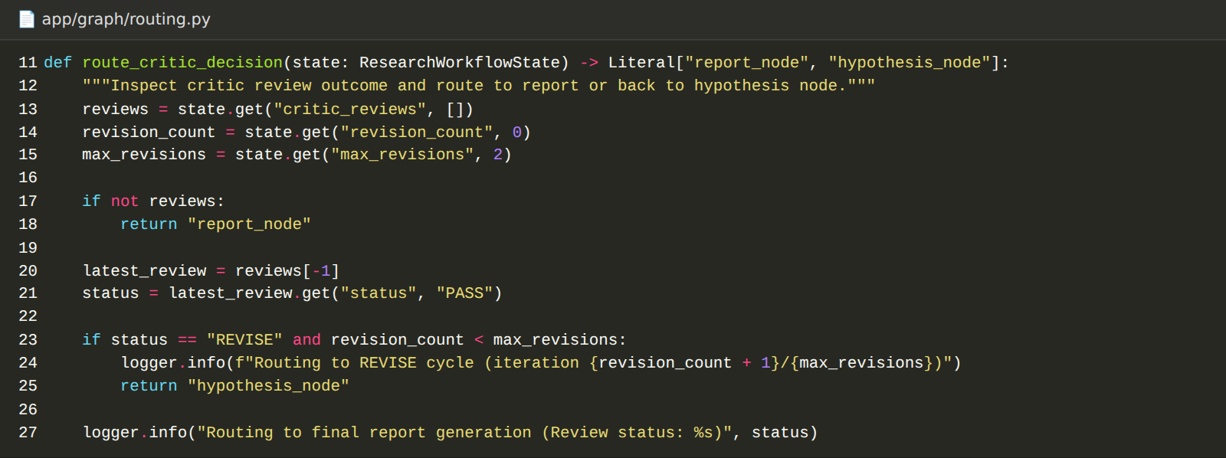

Milestone 4: Backend and Database Development
Milestone 4 builds the FastAPI backend, the SQLite database layer, and the streaming service that runs the agents and reports their progress.

Activity 4.1: Create the Database Models
app/database defines the declarative base, the SQLite engine (with check_same_thread disabled for FastAPI), the session factory, and five models: User, ResearchProject, AgentRun, ResearchResult, and ResearchReport. init_db() creates the tables when the application starts. Passwords are hashed with bcrypt before they are stored.
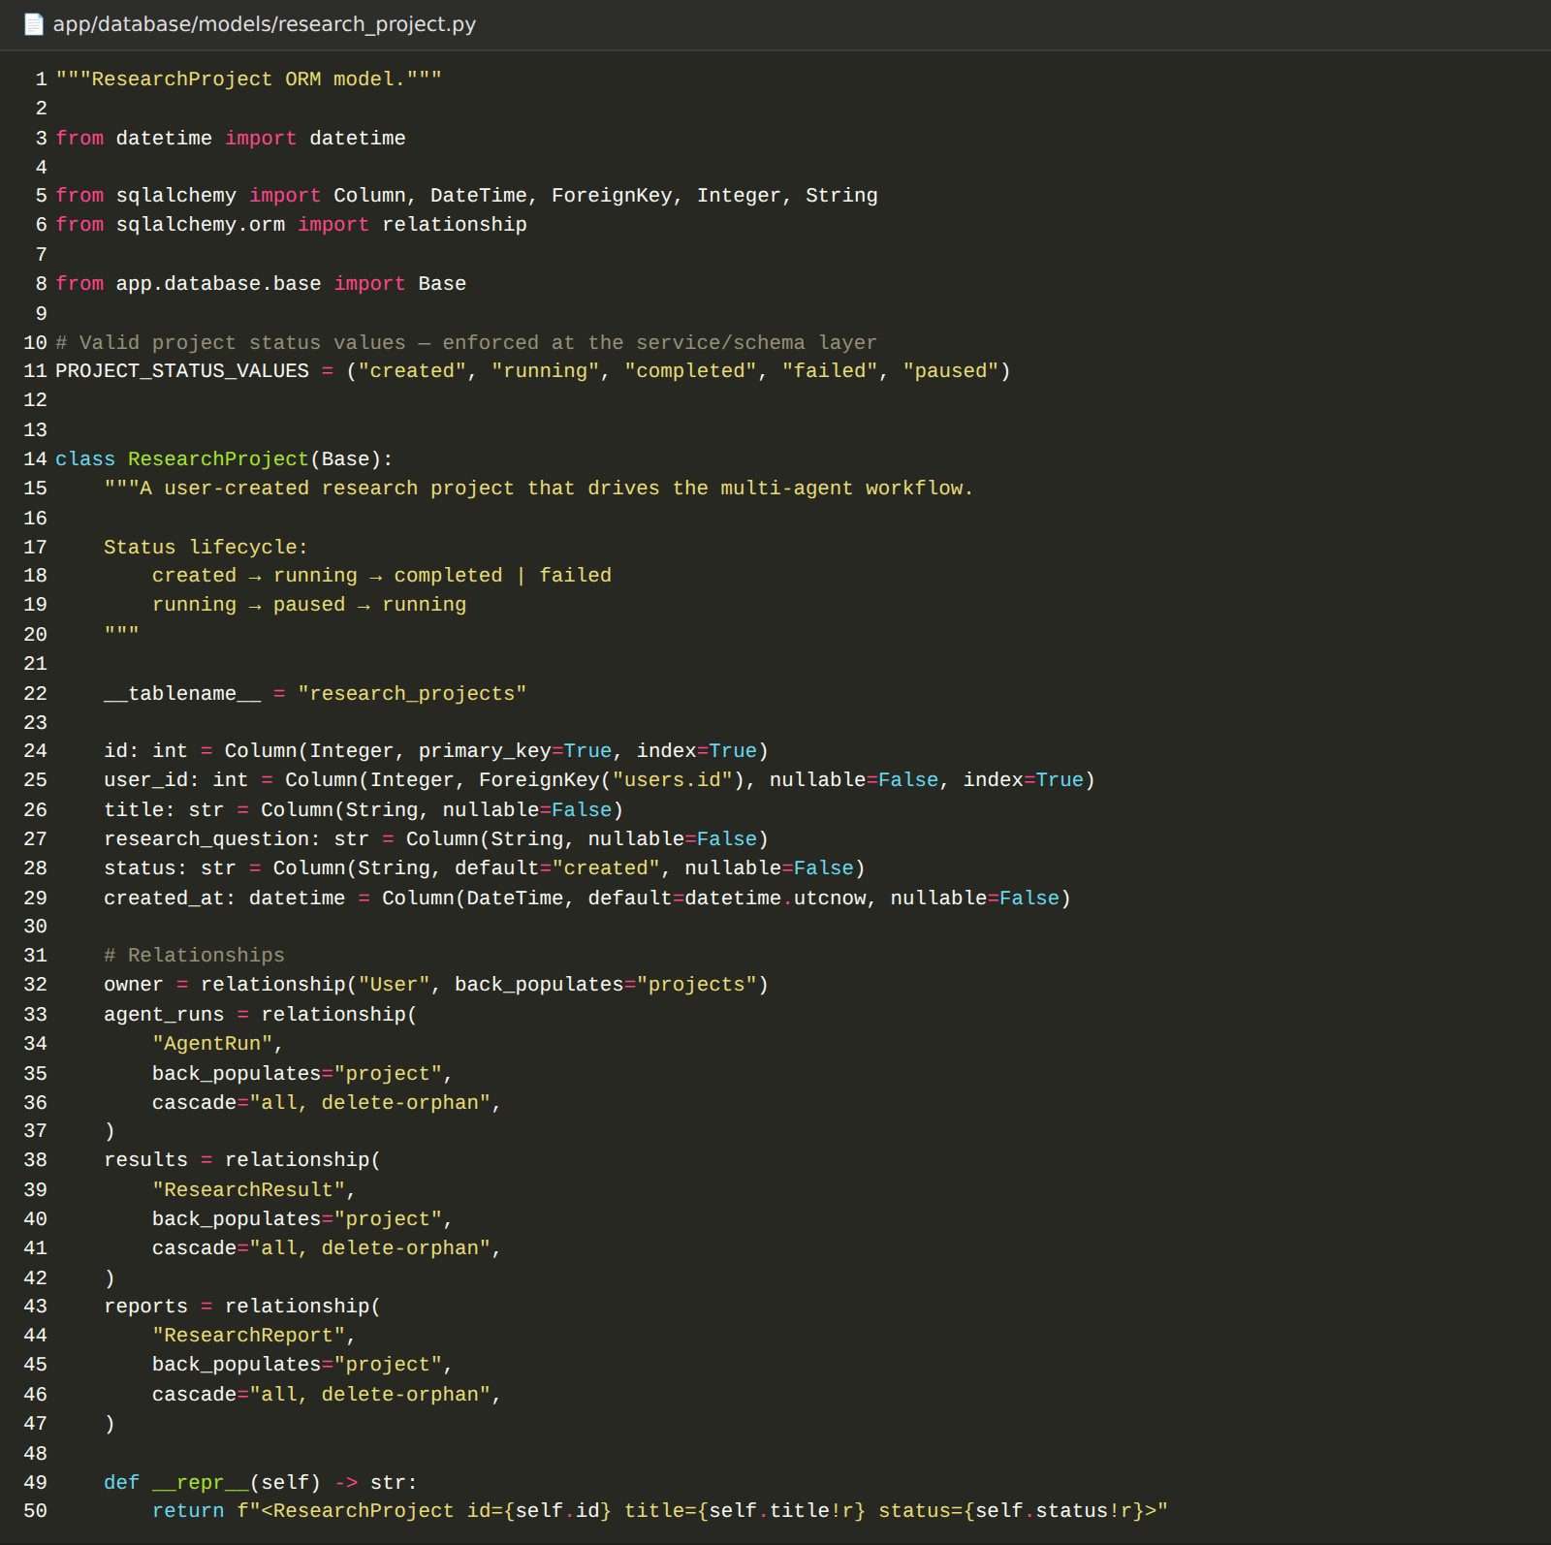

Activity 4.2: Develop the Services and API Routes
Service classes (user, research, agent, result, report) hold the database logic, and routers expose them under the /api prefix. Domain errors such as ProjectNotFoundError are converted into consistent JSON error responses without stack traces.
Route | Purpose
POST /api/users, GET and PATCH /api/users/{id} | Create, read, and update a user
POST and GET /api/research | Create and list research projects
GET, PATCH, DELETE /api/research/{id} | Read, update, or delete a project
POST /api/research/{id}/dataset | Upload a CSV dataset (CSV only, at least two numeric columns)
GET /api/research/{id}/stream | Run the agent workflow and stream SSE events
POST /api/research/{id}/run | Trigger the research pipeline
GET /api/research/{id}/agents | List agent runs, or filter by agent name
POST and GET /api/research/{id}/results | Store and list research results
POST and GET /api/research/{id}/reports | Store and list research reports
GET /api/health | Health check

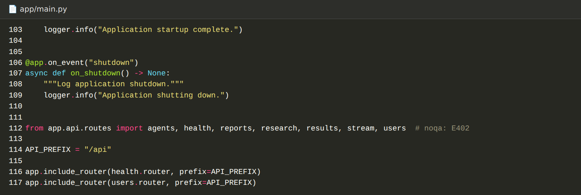

Activity 4.3: Develop the SSE Workflow Streaming Service
The WorkflowService (app/services/workflow_service.py) creates the initial research state, runs the agent nodes in order, and yields an SSE message after every agent. For each agent it saves an AgentRun record, and when the run finishes it persists the literature, dataset, hypothesis, experiment, and critique results and the final report to the database.
SSE event | When it is sent
workflow_start | The run begins (run ID, project ID, question)
agent_event | An agent finishes (agent name, action, message, and counts of papers, hypotheses, experiments, and reviews)
workflow_complete | All agents finish and the final state is saved
workflow_error | An agent raises an error

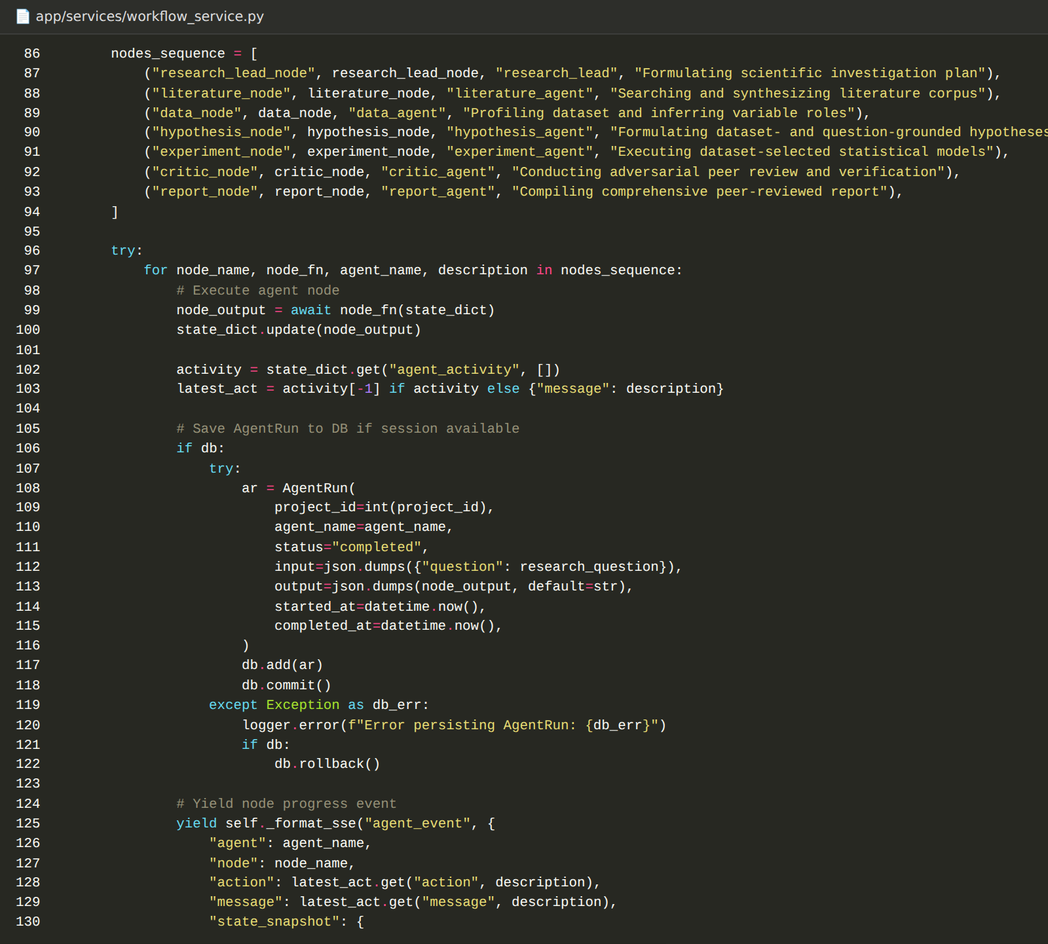
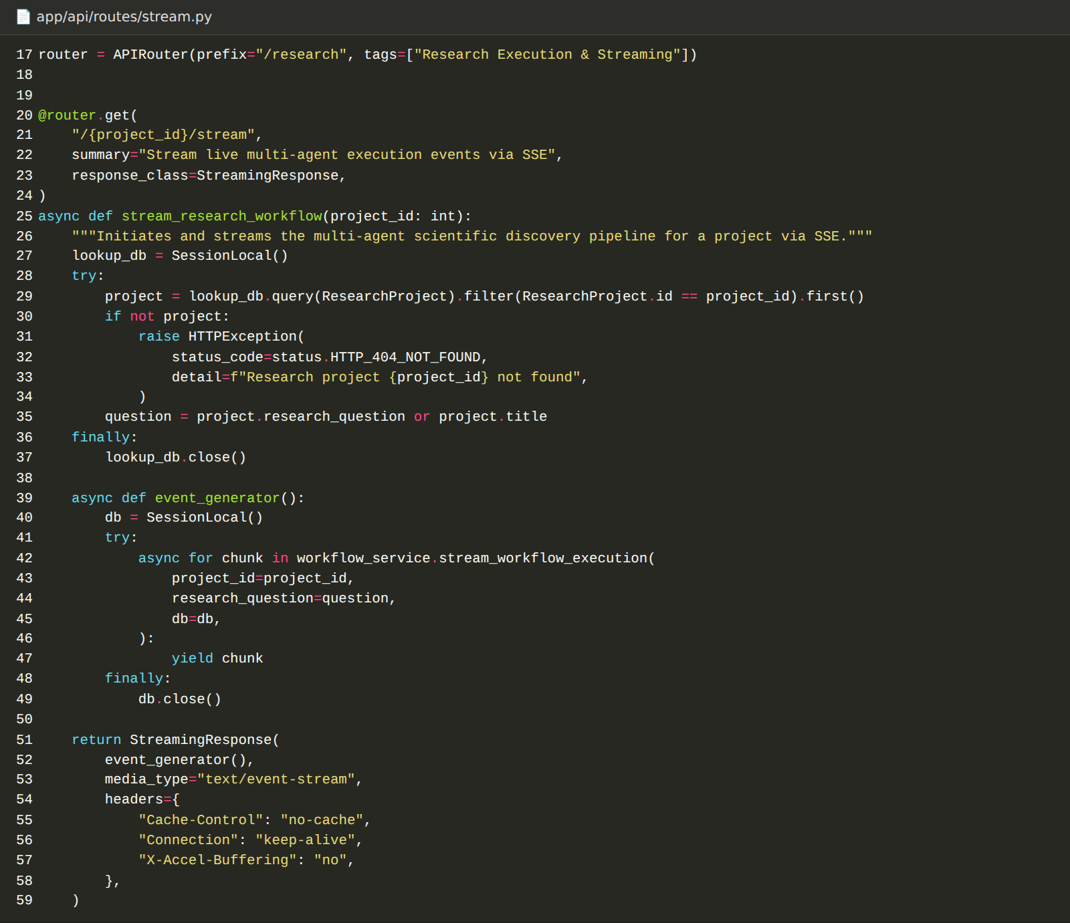

Milestone 5: Frontend Development
Milestone 5 builds the Next.js (TypeScript) interface with Tailwind CSS for researchers to create projects, watch the agents work, and read the results.

Activity 5.1: Set Up the Application, API Client, and Layout
- Stack: Next.js 14 App Router with React 18, TypeScript, Tailwind CSS, lucide-react icons, React Flow (@xyflow/react), and Recharts.
- API client: The lib/api folder wraps the backend endpoints (users, research, agents, results, reports) using the NEXT_PUBLIC_API_URL address, and lib/types holds the matching TypeScript types.
- Layout and components: AppShell, Header, Sidebar, and PageContainer provide the layout, and reusable Button, Card, Badge, Input, Label, and Textarea components provide the interface elements, along with loading, empty, and error states.

Activity 5.2: Build the Landing, Dashboard, and New Research Pages
- Landing page: A landing page with a hero section, capabilities, the agent team, the workflow, and a call to start research.
- Authentication pages: Sign up and log in pages. The forms are prepared for an authentication API, and the current build moves straight to the dashboard and uses a default researcher profile.
- Dashboard: The Your Research page lists project cards with their status and allows a project to be deleted.
- New research form: A form with the project title, the research question, the research area (Environmental Science, Biomedicine & Health, Materials Science, Computer Science & AI, Climate & Earth Systems, or Physics & Engineering), and optional context.

Activity 5.3: Build Live Agent Streaming and the Pipeline Graph
The useResearchStream hook opens an EventSource connection to the stream endpoint. It handles workflow_start, agent_event, workflow_complete, and workflow_error, keeps the list of agent activities, and maps each agent to a progress value (15% for the Research Lead up to 98% for the Report Agent). The ResearchGraph component draws the seven agents as nodes with React Flow and colours each node by status.
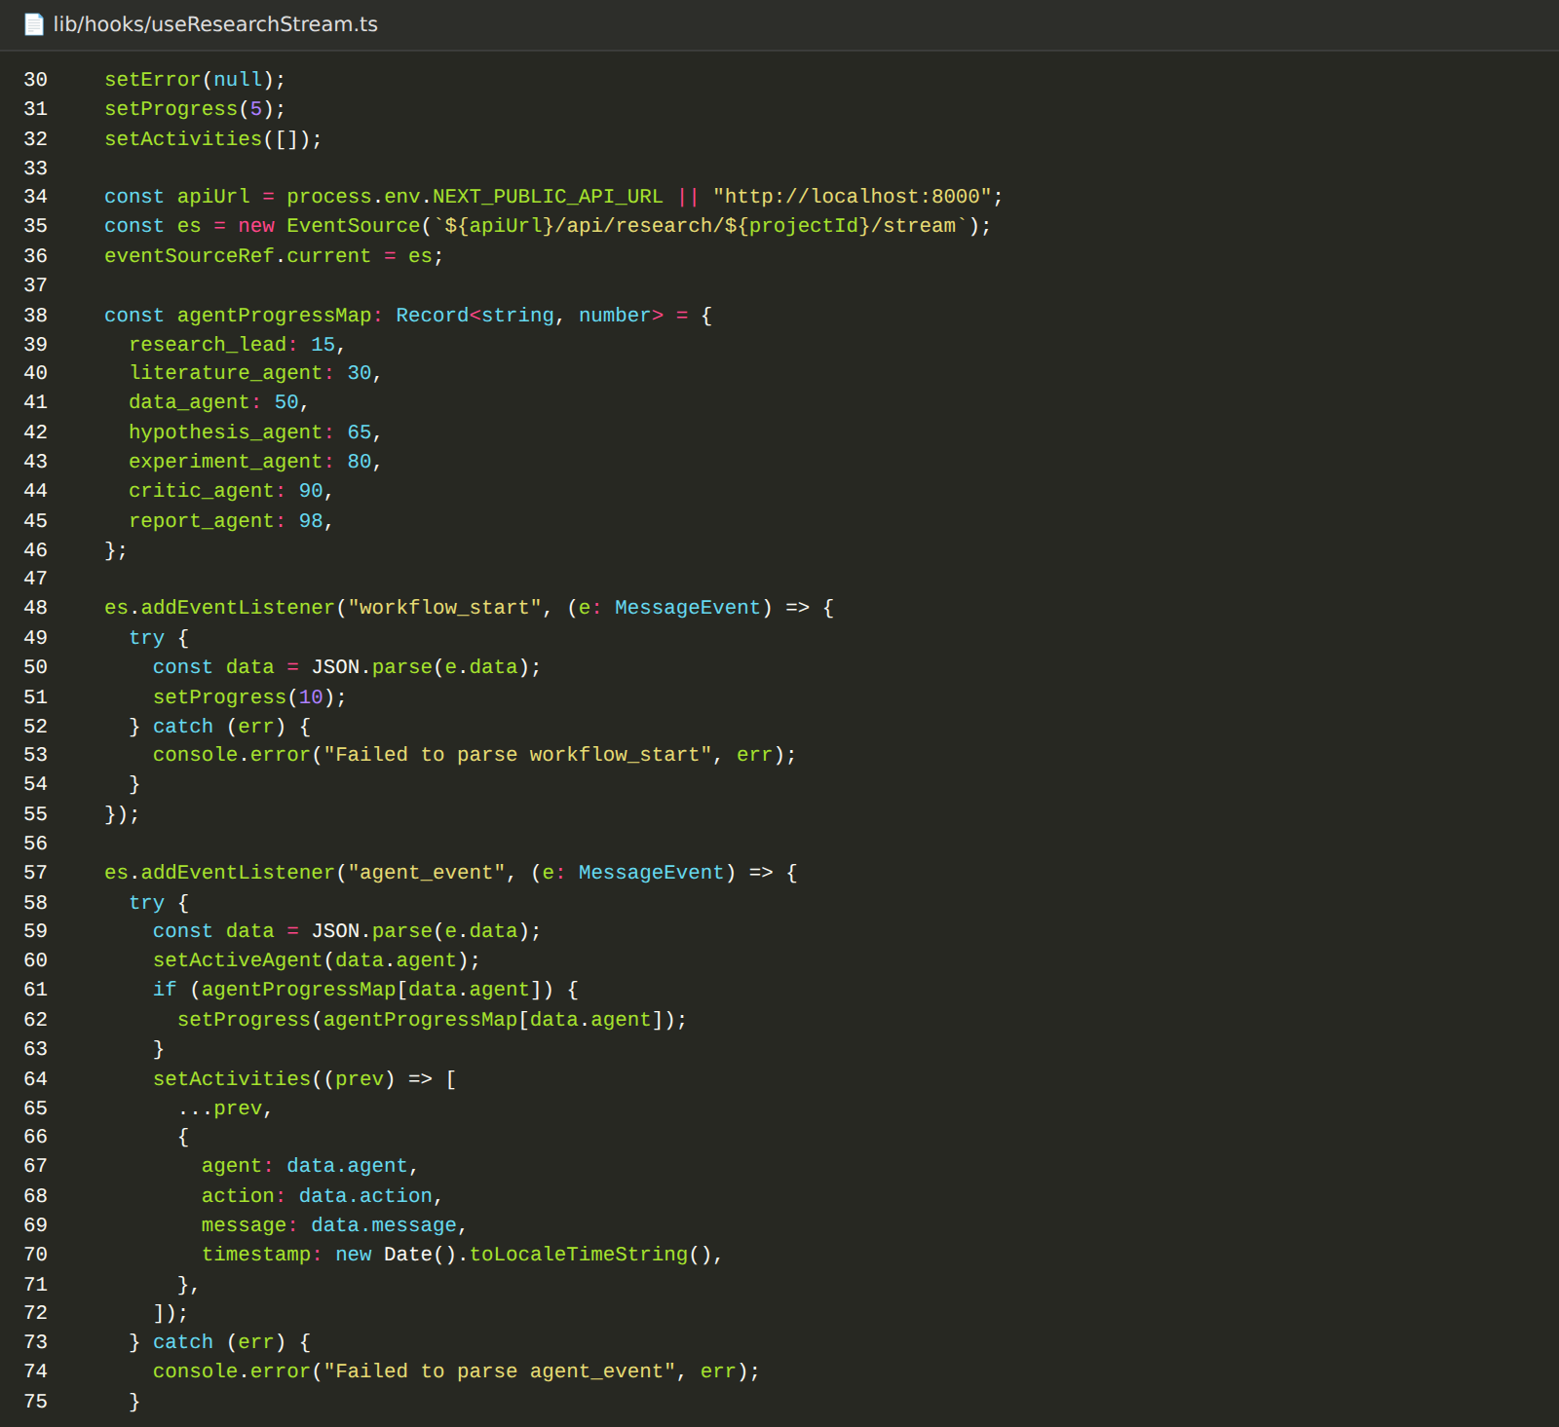
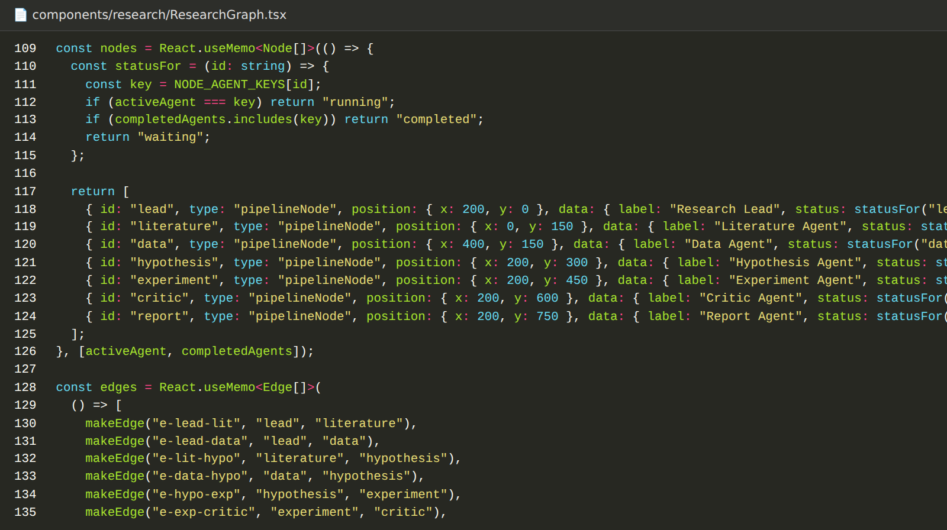

Activity 5.4: Build the Results Tabs, Charts, and Report View
Each project has a workspace layout with tabs: Overview, Agents, Literature, Datasets, Hypotheses, Experiments, Review, and Report. Each tab reads the stored results for the project and shows an empty state until the agents produce them. The Experiments tab uses Recharts to plot the experiment chart data, the Review tab shows the critic scores and findings, and the Report tab shows the compiled research report.

Milestone 6: Testing and Deployment
In Milestone 6 we run the platform locally, test the full workflow from a research question to a final report, and containerise the backend.

Activity 6.1: Run the Backend and Frontend Locally
- Start the backend: From the backend folder, with the virtual environment active:
uvicorn app.main:app --reload --port 8000

- Verify the API: Open http://localhost:8000/docs for the interactive Swagger UI and http://localhost:8000/api/health for the health check.

- Start the frontend: From the Frontend folder:
npm run dev

- Open the application: Open http://localhost:3000 in the browser.

Activity 6.2: Test the Complete Research Workflow
- Create a project: Open New Research, enter a title and a research question, choose a research area, and create the project.
- Upload data (optional): Optionally upload a CSV file with at least two numeric columns to use your own data.
- Run the agents: Start the run and watch the agents progress on the workspace. In the browser developer tools you can see the SSE events arrive.

- Verify the results: Open the Literature, Datasets, Hypotheses, Experiments, Review, and Report tabs and confirm each contains results. Test with and without an API key to confirm the offline fallback also completes.
- Automated tests: The backend includes pytest and pytest-asyncio in its requirements for automated tests.

Activity 6.3: Containerise the Backend with Docker
The backend Dockerfile uses python:3.11-slim, installs the dependencies, copies the app folder, creates the data directory for SQLite, exposes port 8000, and starts Uvicorn.
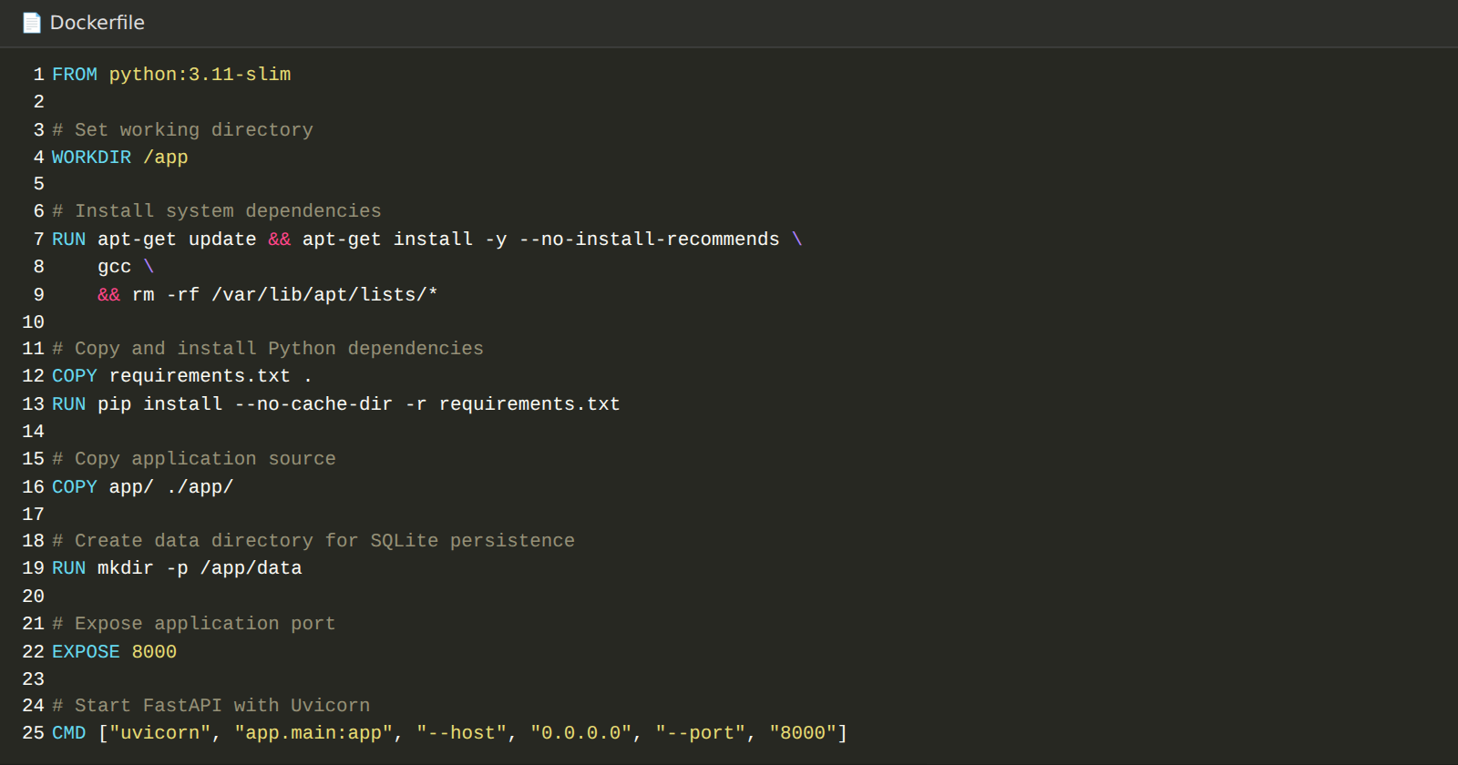
docker build -t research-lab-backend .
docker run -p 8000:8000 --env-file .env research-lab-backend

Exploring the Website’s Web Pages:

Landing Page:
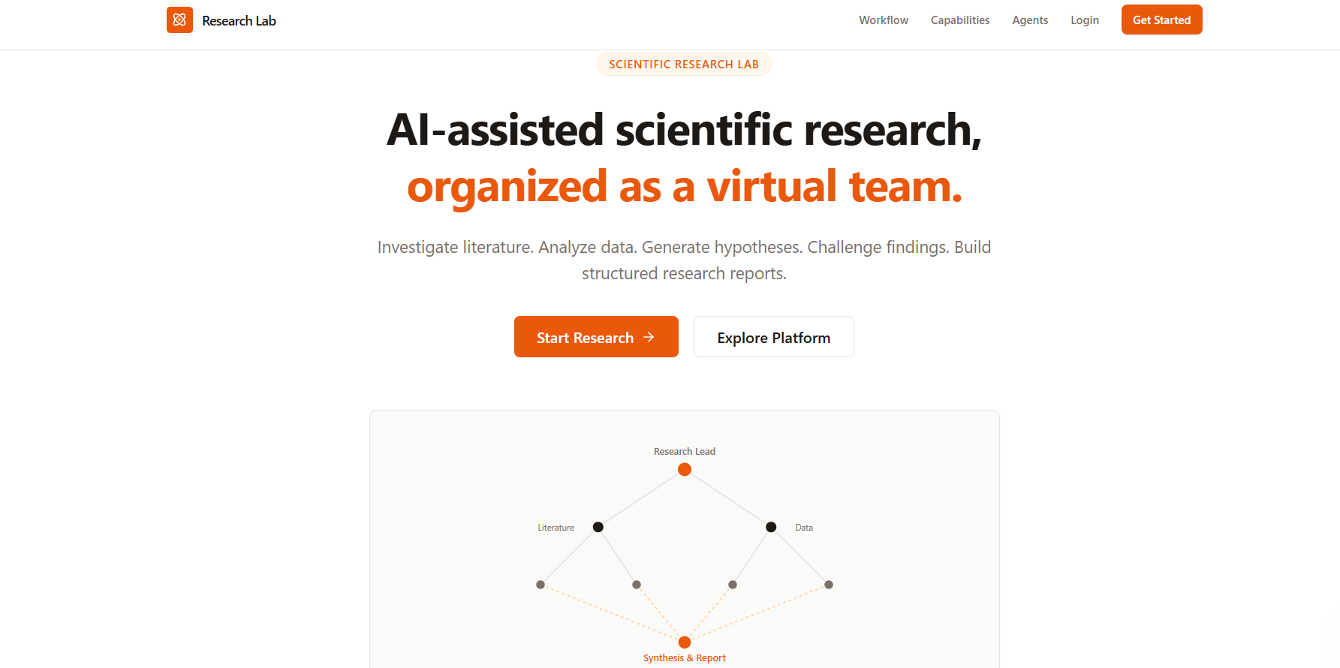
Description: The landing page introduces the platform with a hero section, the agent team, the capabilities, and the research workflow, with a Start Research button that leads to sign up.

Sign Up and Log In:
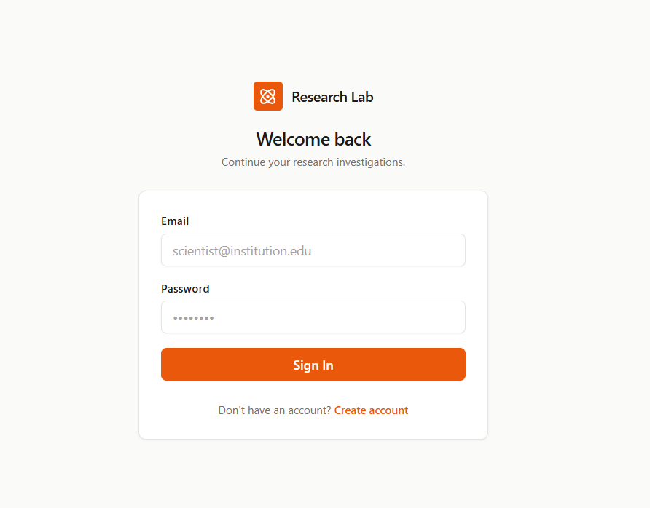
Description: The authentication pages collect a name, email, and password and take the researcher to the dashboard.

Dashboard:
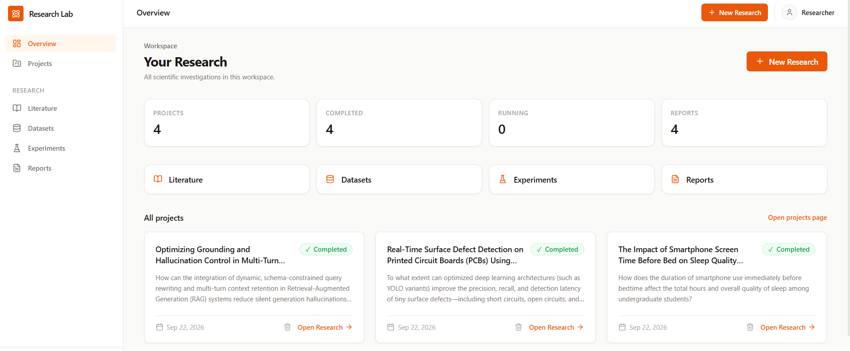
Description: The Your Research page lists every research project as a card with its title, question, and status, and provides actions to open or delete a project.

New Research:
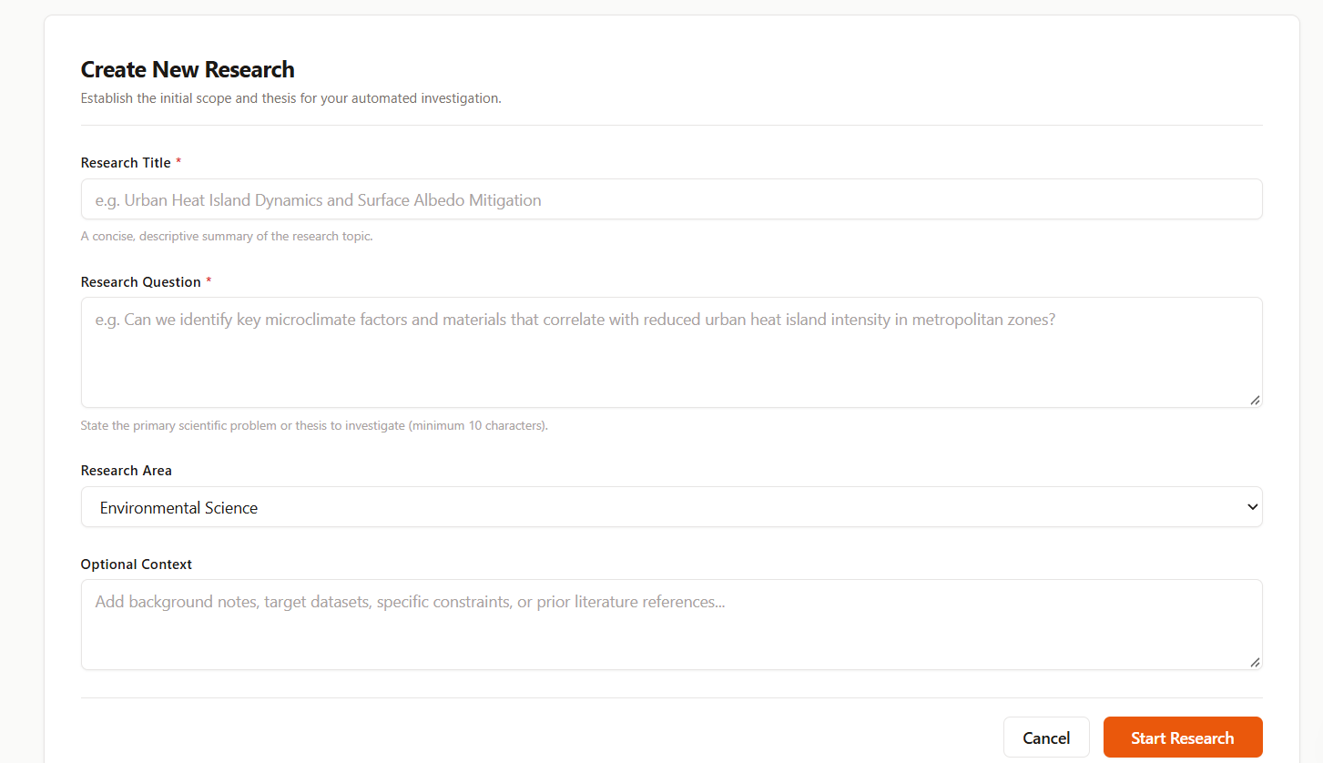
Description: The researcher enters a project title, the research question, a research area, and optional context, and creates the project.

Research Workspace and Agent Pipeline:
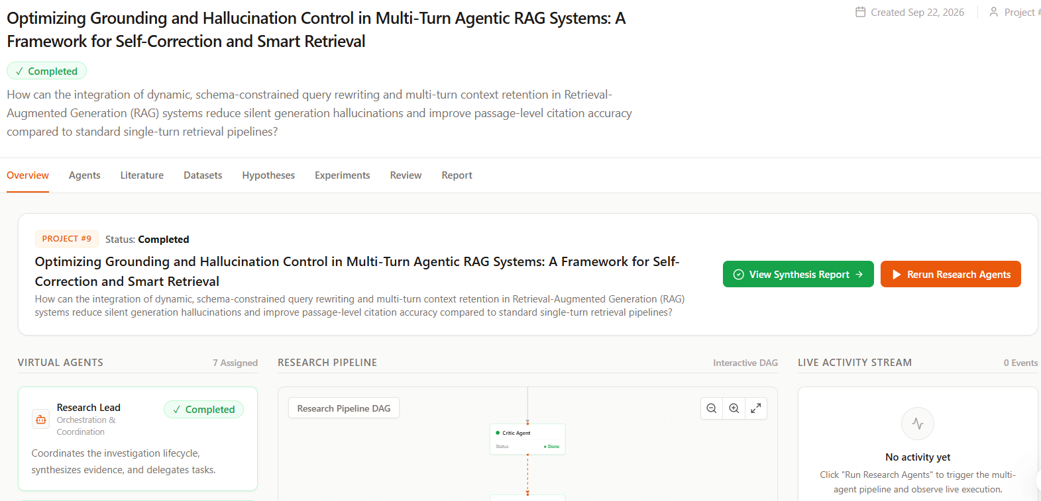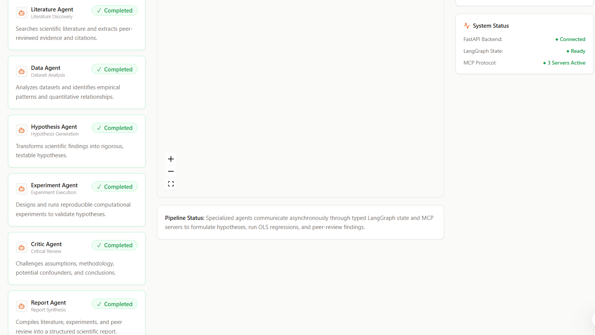
Description: The workspace shows the project header, the tabs for each research stage, and the React Flow pipeline of the seven agents with live status, a progress bar, and the agent activity feed while the run streams.

Experiments and Review Tabs:
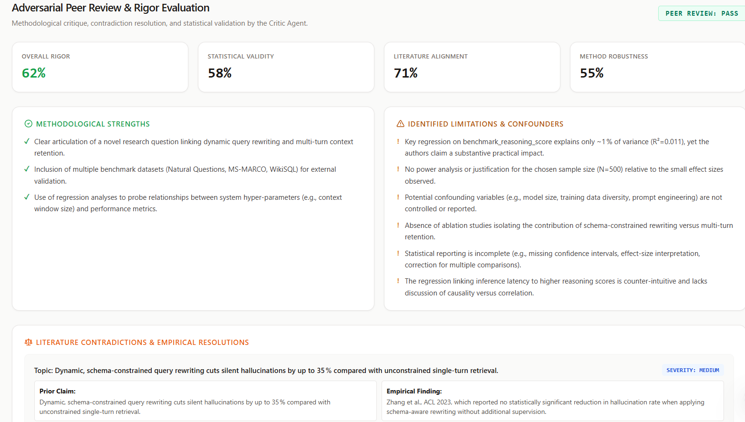
Description: The Experiments tab lists each regression model with its R-squared, F-statistic, p-values, conclusion, and chart. The Review tab shows the critic's rigor scores, strengths, weaknesses, contradictions, and recommendations.

Research Report:
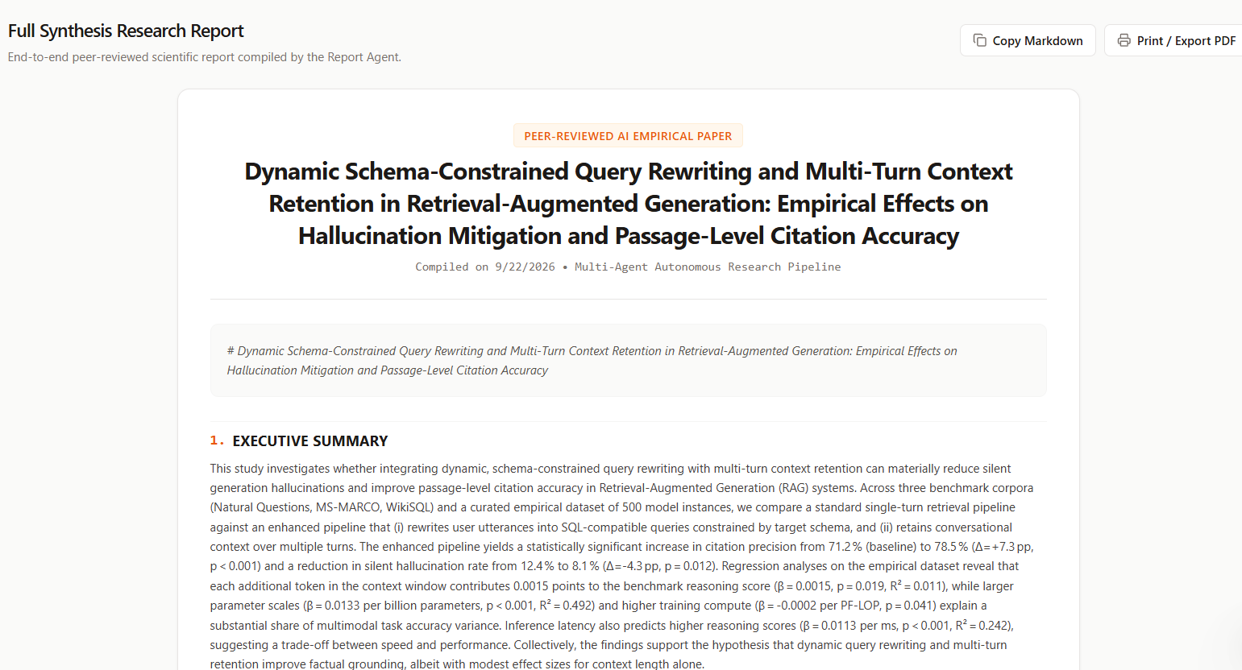
Description: The Report tab presents the final report with the executive summary, literature review, methodology, results, discussion, conclusions, limitations, future work, and bibliography.

Conclusion:
AI Scientific Research Collaboration Lab turns an open-ended research question into a structured, evidence-driven investigation using seven specialised agents. The Research Lead plans the study, the Literature and Data agents gather evidence, the Hypothesis agent proposes testable ideas, the Experiment agent tests them with OLS regression, the Critic agent reviews the quality of the evidence, and the Report agent synthesises the findings into a report.
The platform combines a FastAPI backend, a LangGraph workflow definition, a pluggable LLM layer (Groq, OpenAI, Anthropic, or an offline fallback), a scientific Python stack (pandas, SciPy, statsmodels), a SQLite database, and a Next.js frontend that streams live agent progress with React Flow and Recharts. Every agent run, result, and report is stored per project, so findings can be reviewed later.
Possible future enhancements include running the Literature and Data agents in parallel, following the Critic's REVISE route in the live run, calling the tools through the registered MCP servers, adding the Crossref API, real user authentication, and automated test coverage.

