AI Course Advisor – Generative AI – Multi-Agent RAG System

Project Description:
AI Course Advisor is an intelligent multi-agent system that recommends suitable courses based on a learner's educational background, existing skills, interests, experience level, and career goals. It uses Retrieval-Augmented Generation (RAG) to retrieve relevant course information from a curated knowledge base containing course descriptions, categories, difficulty levels, prerequisites, skills, and learning outcomes.
Specialised AI agents work together: a Profile Analysis Agent studies the learner, a Course Research Agent retrieves relevant courses through RAG, a Prerequisite Analysis Agent finds missing skills, a Recommendation Agent ranks the courses, and a Learning Path Agent builds an ordered roadmap. An Orchestrator Agent coordinates the workflow, and a Streamlit dashboard presents the recommendations, prerequisite gaps, explanations, and the personalised learning roadmap. The whole system runs locally using open-source models served through Ollama, so no learner data leaves the machine.

Scenarios
Scenario 1: A B.Tech ECE graduate who knows Python, basic SQL, and basic cloud wants to become an AI/ML Engineer. The system analyses the profile, retrieves AI-related courses from the knowledge base, ranks them by career relevance, and returns a roadmap that starts with the courses the learner is ready for.

Scenario 2: A learner selects Machine Learning Fundamentals but lacks Basic Mathematics and Basic Statistics. The Prerequisite Analysis Agent lists the satisfied and missing prerequisites, marks the learner as Partially Ready, and the roadmap places the missing foundations before the course.

Scenario 3: A learner interested in cloud computing chooses Cloud Engineer as the career goal. The Recommendation Agent detects the cloud career direction and prioritises AWS Cloud Foundations, AWS Solutions Architect Fundamentals, and DevOps courses instead of AI courses.

Scenario 4: A learner already knows Python. The system skips Python for Beginners in the recommendations and roadmap, and the AI explanation panels describe why each remaining course was selected and in what order to study it.

Technical Architecture:
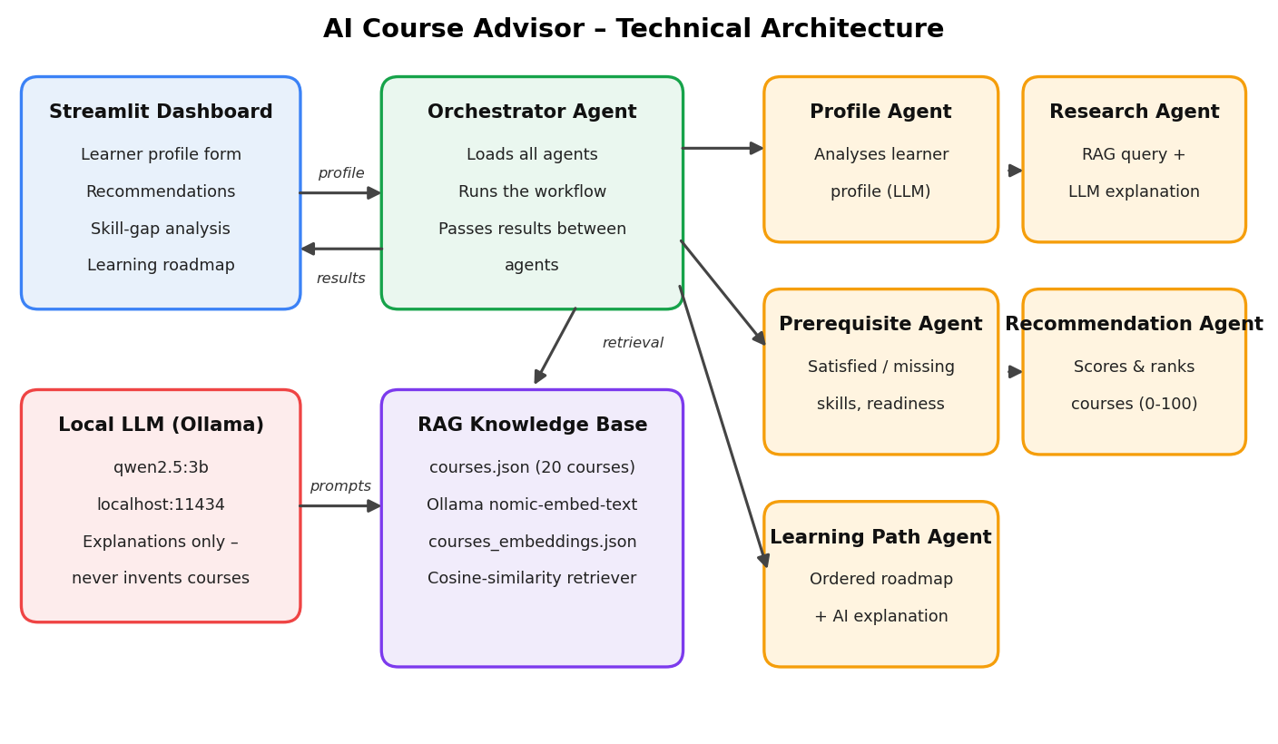

Pre-requisites:
- Python Programming Proficiency: Python Documentation
- Large Language Models and Prompting: Prompt design for explanation and analysis tasks
- RAG Concepts: Embeddings, vector similarity, and retrieval-augmented generation
- Multi-Agent System Concepts: Specialised agents and orchestration
- Ollama: Running open-source models locally (qwen2.5:3b and nomic-embed-text)
- Streamlit Framework: Streamlit Documentation
- JSON and Data Handling: Structured course data in JSON
- Development Environment Setup: Python virtual environment, pip, and .env configuration

Project Workflow:
Activity 1: Environment and Knowledge Base Setup
- Activity 1.1: Set up the Python environment and install the dependencies.
- Activity 1.2: Install Ollama and pull the qwen2.5:3b and nomic-embed-text models.
- Activity 1.3: Prepare the course dataset (courses.json) with 20 courses.
- Activity 1.4: Run RAG ingestion to create course embeddings.
Activity 2: RAG Retrieval and Core Agents
- Activity 2.1: Implement the cosine-similarity course retriever.
- Activity 2.2: Develop the Profile Analysis Agent.
- Activity 2.3: Develop the Course Research Agent that combines RAG with LLM explanation.
Activity 3: Prerequisite, Recommendation, and Learning Path Agents
- Activity 3.1: Develop the Prerequisite Analysis Agent.
- Activity 3.2: Develop the Recommendation Agent with career-aware scoring.
- Activity 3.3: Develop the Learning Path Agent with dependency resolution.
Activity 4: Orchestration and Dashboard
- Activity 4.1: Develop the Orchestrator Agent.
- Activity 4.2: Build the Streamlit profile input form.
- Activity 4.3: Build the results dashboard: recommendations, skill gaps, RAG retrieval, roadmap, and explanations.
Activity 5: Testing and Deployment
- Activity 5.1: Run the application locally.
- Activity 5.2: Run the 18-point end-to-end validation suite.
- Activity 5.3: Run the code-issue checker and the Streamlit AppTest script.
Activity 6: Conclusion

Milestone 1: Environment and Knowledge Base Setup
This milestone prepares everything the agents depend on: the Python environment, the local language and embedding models, the course dataset, and the vector store that supports retrieval.

Activity 1.1: Set Up the Python Environment
The project runs in an isolated virtual environment. Dependencies are listed in requirements.txt, and runtime settings such as the Ollama address and model names are kept in a .env file created from .env.example.
- Step 1 - Create and activate a virtual environment.
python -m venv .venv
.venv\Scripts\activate # Windows
source .venv/bin/activate # macOS/Linux
- Step 2 - Install the dependencies.
pip install -r requirements.txt

- Step 3 - Review the requirements file.
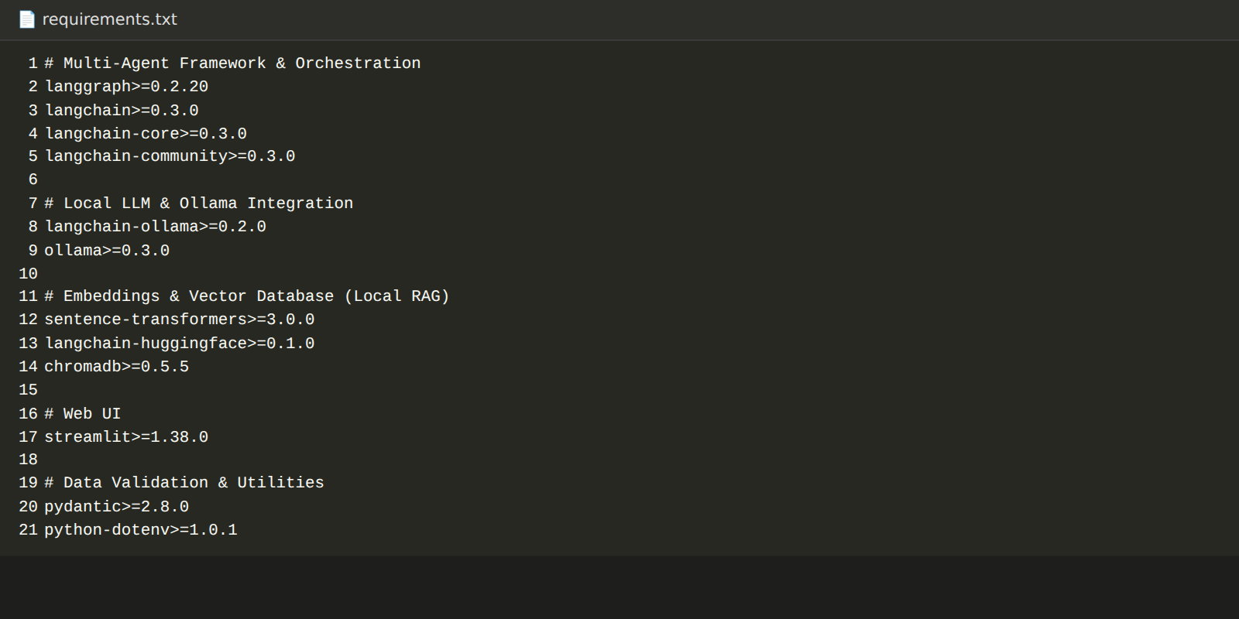
- Step 4 - Create the .env file from .env.example.
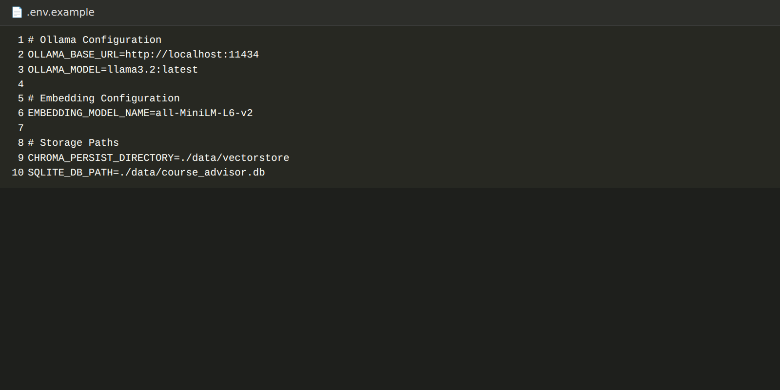
The agents in this project call Ollama directly through its REST API using Python's built-in urllib module, so the core RAG and agent logic does not depend on the heavier framework packages listed in requirements.txt.

Activity 1.2: Install Ollama and Pull the Models
Ollama serves open-source models locally on http://localhost:11434. Two models are used:
- qwen2.5:3b: Text generation model used by the agents to write analyses and explanations.
- nomic-embed-text: Embedding model used to convert course text and learner queries into vectors.
ollama pull qwen2.5:3b
ollama pull nomic-embed-text
ollama list
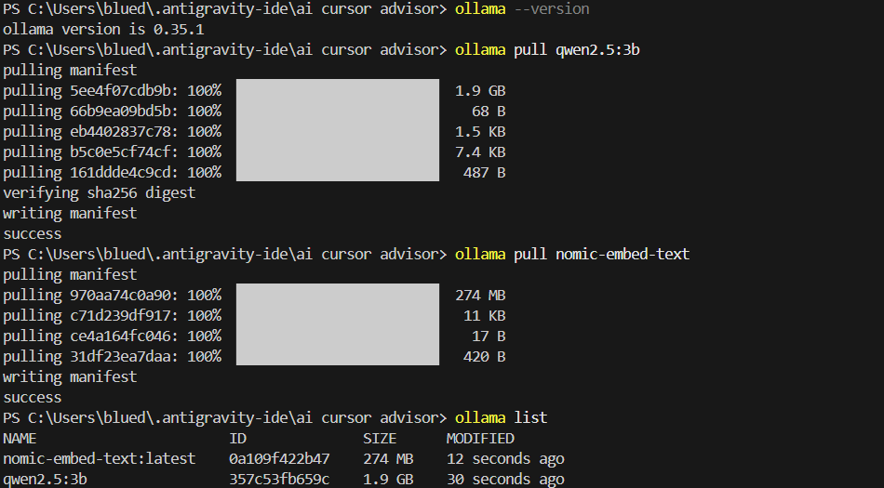

Activity 1.3: Prepare the Course Dataset
The knowledge base is a curated JSON file, data/raw/courses.json, containing 20 courses across Programming, Artificial Intelligence, Generative AI, Data Science, Cloud Computing, DevOps, Web Development, and Cybersecurity. Each record has a course ID, name, category, difficulty, prerequisites, skills, and learning outcomes.
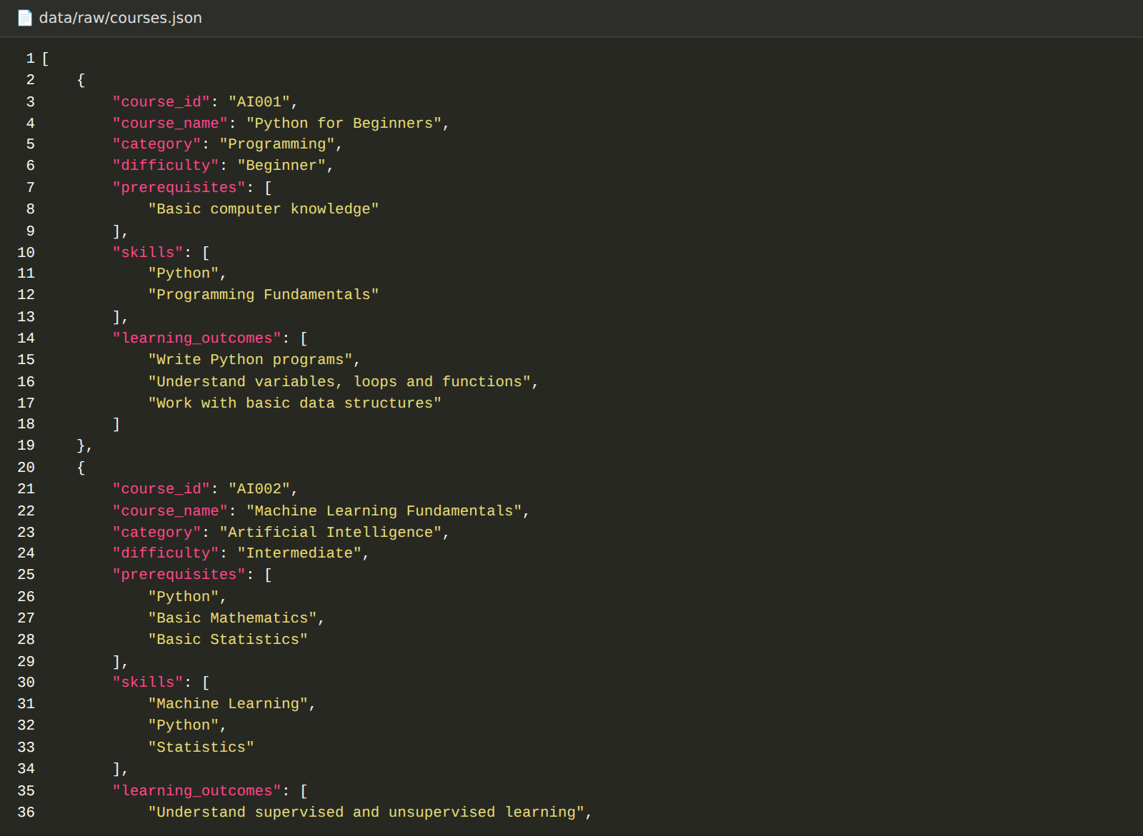
ID | Course Name | Category | Difficulty
AI001 | Python for Beginners | Programming | Beginner
AI002 | Machine Learning Fundamentals | Artificial Intelligence | Intermediate
AI003 | Deep Learning with Neural Networks | Artificial Intelligence | Intermediate
AI004 | Generative AI and LLMs | Generative AI | Advanced
AI005 | Natural Language Processing Fundamentals | Artificial Intelligence | Advanced
AI006 | Computer Vision Fundamentals | Artificial Intelligence | Advanced
AI007 | Data Science Fundamentals | Data Science | Intermediate
AI008 | LLM Application Development | Generative AI | Advanced
CL001 | AWS Cloud Foundations | Cloud Computing | Beginner
CL002 | AWS Solutions Architect Fundamentals | Cloud Computing | Intermediate
CL003 | DevOps Fundamentals | DevOps | Intermediate
CL004 | Docker and Container Fundamentals | DevOps | Intermediate
CL005 | Kubernetes Fundamentals | DevOps | Advanced
CL006 | AWS DevOps Fundamentals | DevOps | Advanced
DS001 | SQL and Database Fundamentals | Data Science | Beginner
DS002 | Data Analytics with Python | Data Science | Intermediate
WEB001 | Web Development Fundamentals | Web Development | Beginner
WEB002 | Backend Development with Python | Web Development | Intermediate
CY001 | Cybersecurity Fundamentals | Cybersecurity | Beginner
CY002 | Cloud Security Fundamentals | Cybersecurity | Intermediate

The dataset has 5 Beginner, 9 Intermediate, and 6 Advanced courses. Prerequisites form a dependency chain, for example Python → Machine Learning Fundamentals → Deep Learning → Generative AI and LLMs, and AWS Cloud Foundations → DevOps Fundamentals → Docker → Kubernetes.

Activity 1.4: Run RAG Ingestion
The script rag/ingest.py converts every course into a text document, requests an embedding for it from Ollama (nomic-embed-text), and saves all documents with their vectors into data/vectorstore/courses_embeddings.json.
- Step 1 - Each course is flattened into text containing its name, category, difficulty, prerequisites, skills, and learning outcomes.
- Step 2 - The text is sent to the Ollama /api/embed endpoint to obtain its embedding vector.
- Step 3 - The course ID, name, text, and embedding are stored in the vector store file.
File paths are resolved from the project root, so the script works from any working directory. Each embedding request has a 120-second timeout, and a progress line such as [OK] Embedded: <course name> is printed for every course.
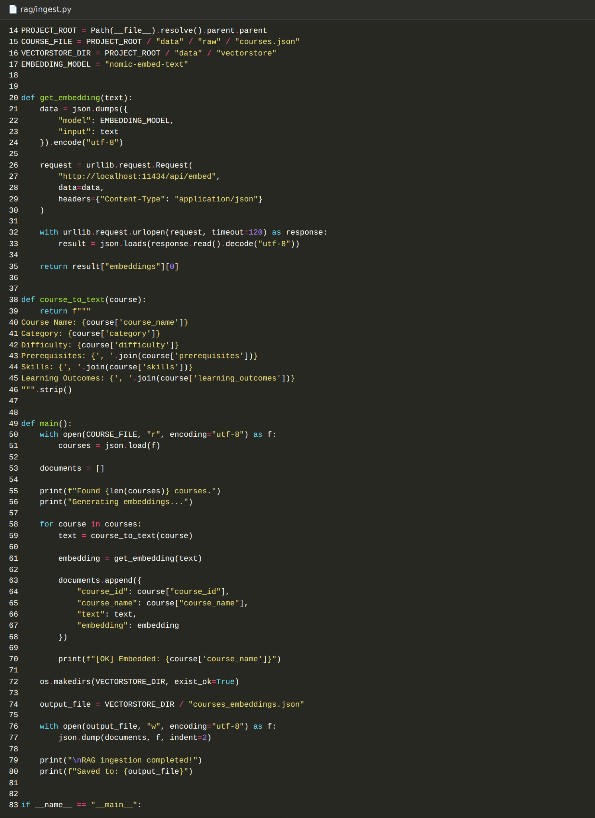
python rag/ingest.py

Milestone 2: RAG Retrieval and Core Agents
This milestone builds the retrieval layer and the first two agents. Together they understand the learner and fetch the most relevant courses from the knowledge base.

Activity 2.1: Implement the RAG Retriever
rag/retriever.py loads the stored course embeddings, embeds the learner's query with the same model, and ranks the courses by cosine similarity. The top_k most similar courses are returned with their similarity scores.
- Embed the query using nomic-embed-text.
- Compute cosine similarity between the query vector and every course vector.
- Sort in descending order of similarity and return the top results.
- Fallback behaviour: If the vector store file is missing or unreadable, the retriever prints a warning and returns an empty list. If the embedding request fails (for example Ollama is not running, 30-second timeout), it falls back to a keyword-overlap score between the query and the course text so the workflow can continue.
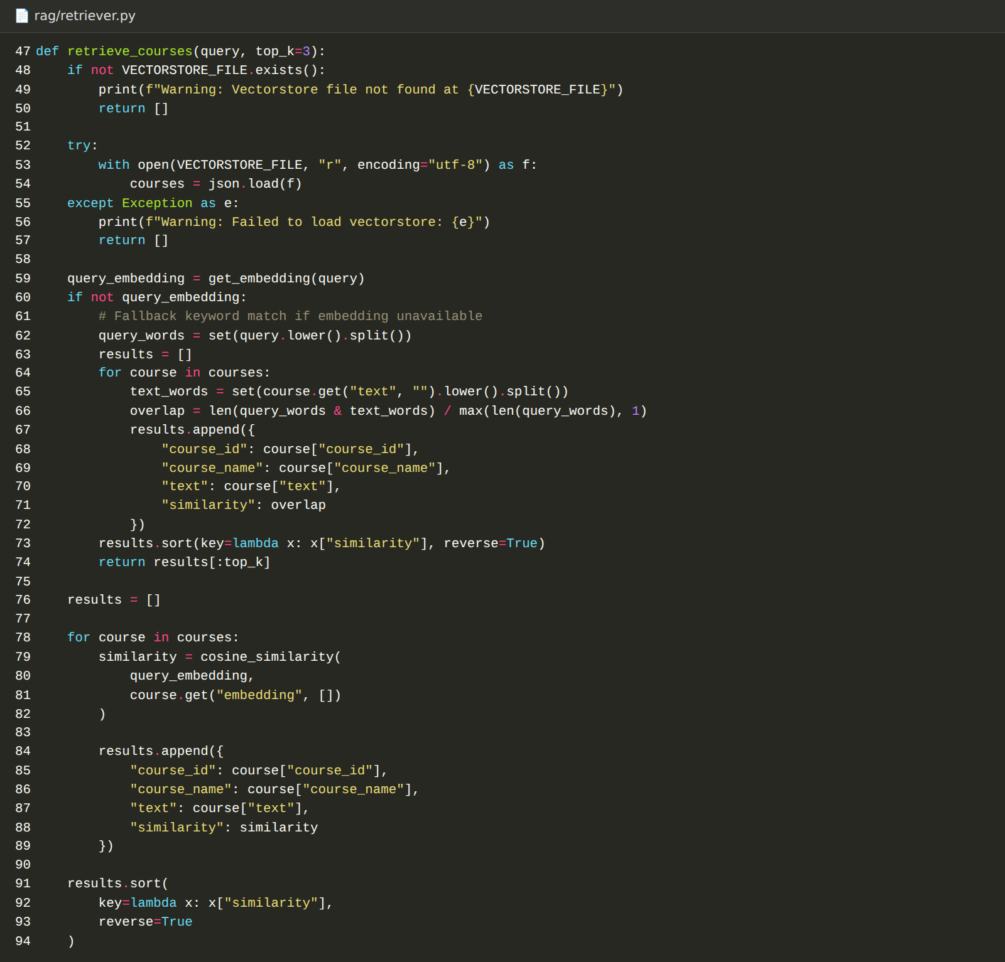
python rag/retriever.py
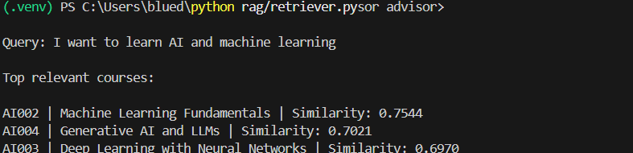

Activity 2.2: Develop the Profile Analysis Agent
The Profile Analysis Agent (agents/profile_agent.py) takes the learner profile (education, skills, experience, interests, and career goal) and asks the local LLM to identify current skills, education background, experience level, interests, career goal, missing or weak skills, and a suitable learning direction.
If the Ollama request fails or times out (120 seconds), the agent returns a readable message beginning "AI profile analysis unavailable" instead of stopping the workflow.
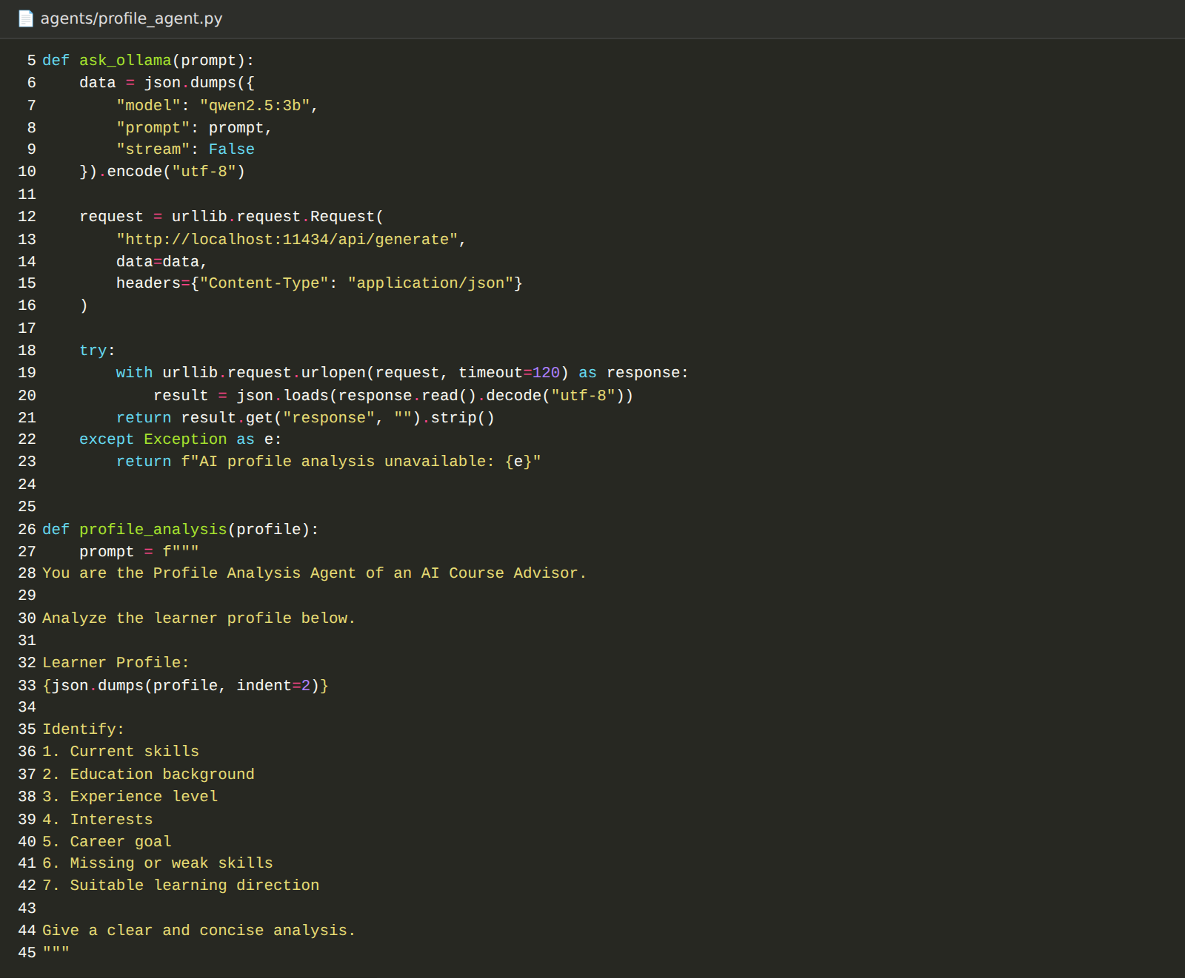

Activity 2.3: Develop the Course Research Agent
The Course Research Agent (agents/course_research_agent.py) connects the learner profile to the knowledge base. It builds a natural-language query from the profile, retrieves the top 6 courses through RAG, removes duplicates, and passes the retrieved course information to the LLM to explain why each course is relevant.
The prompt explicitly instructs the model not to invent courses, prerequisites, or skills and not to change the retrieved information. The course facts therefore always come from the knowledge base, and the LLM only explains them. If RAG returns nothing, the agent reports that and the recommendation stage continues from the structured course data.
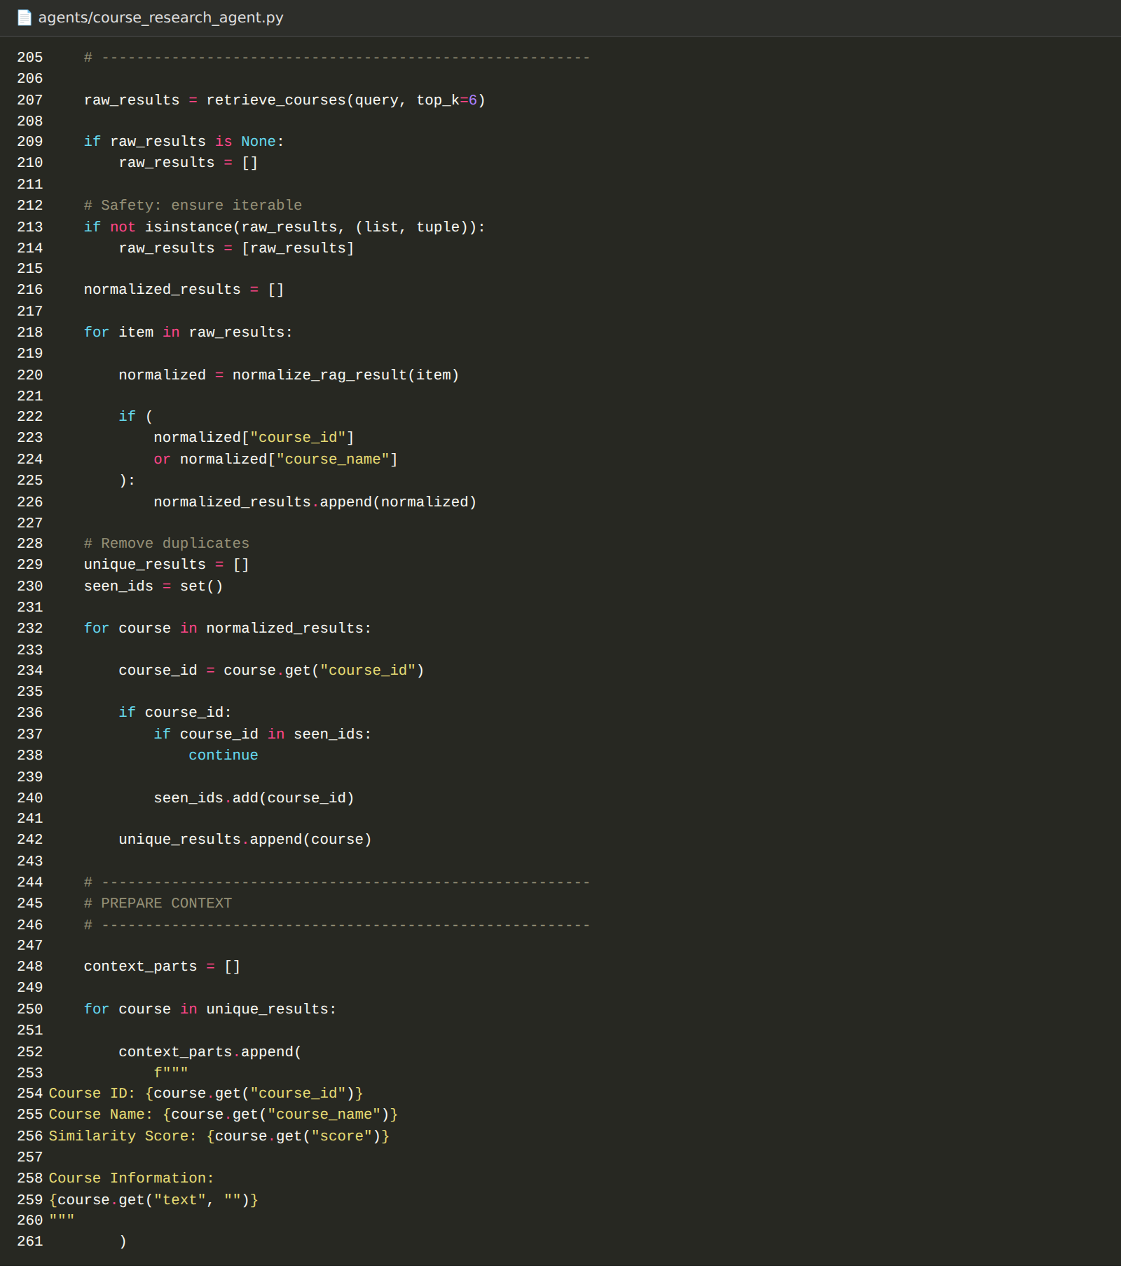

Milestone 3: Prerequisite, Recommendation, and Learning Path Agents
This milestone adds the decision-making agents. Prerequisite checks and course ranking are deterministic so that results are consistent, and the LLM is used to explain the outcome.

Activity 3.1: Develop the Prerequisite Analysis Agent
The Prerequisite Analysis Agent (agents/prerequisite_agent.py) compares a course's prerequisites with the learner's skills and returns the satisfied prerequisites, the missing prerequisites, and a readiness level.
- Skills are normalised before comparison.
- Baseline: "Basic computer knowledge" is treated as satisfied for every learner.
- Equivalents: Common equivalents are recognised, such as AWS for AWS Cloud Foundations or Machine Learning for Machine Learning Fundamentals.
- Readiness: Ready when nothing is missing, Partially Ready when some prerequisites are met, otherwise not ready.
- Graceful degradation: The AI explanation is optional. If Ollama is unavailable the agent returns an "AI prerequisite explanation unavailable" message and still reports the satisfied and missing prerequisites. Console output marks them with [OK] and [X].
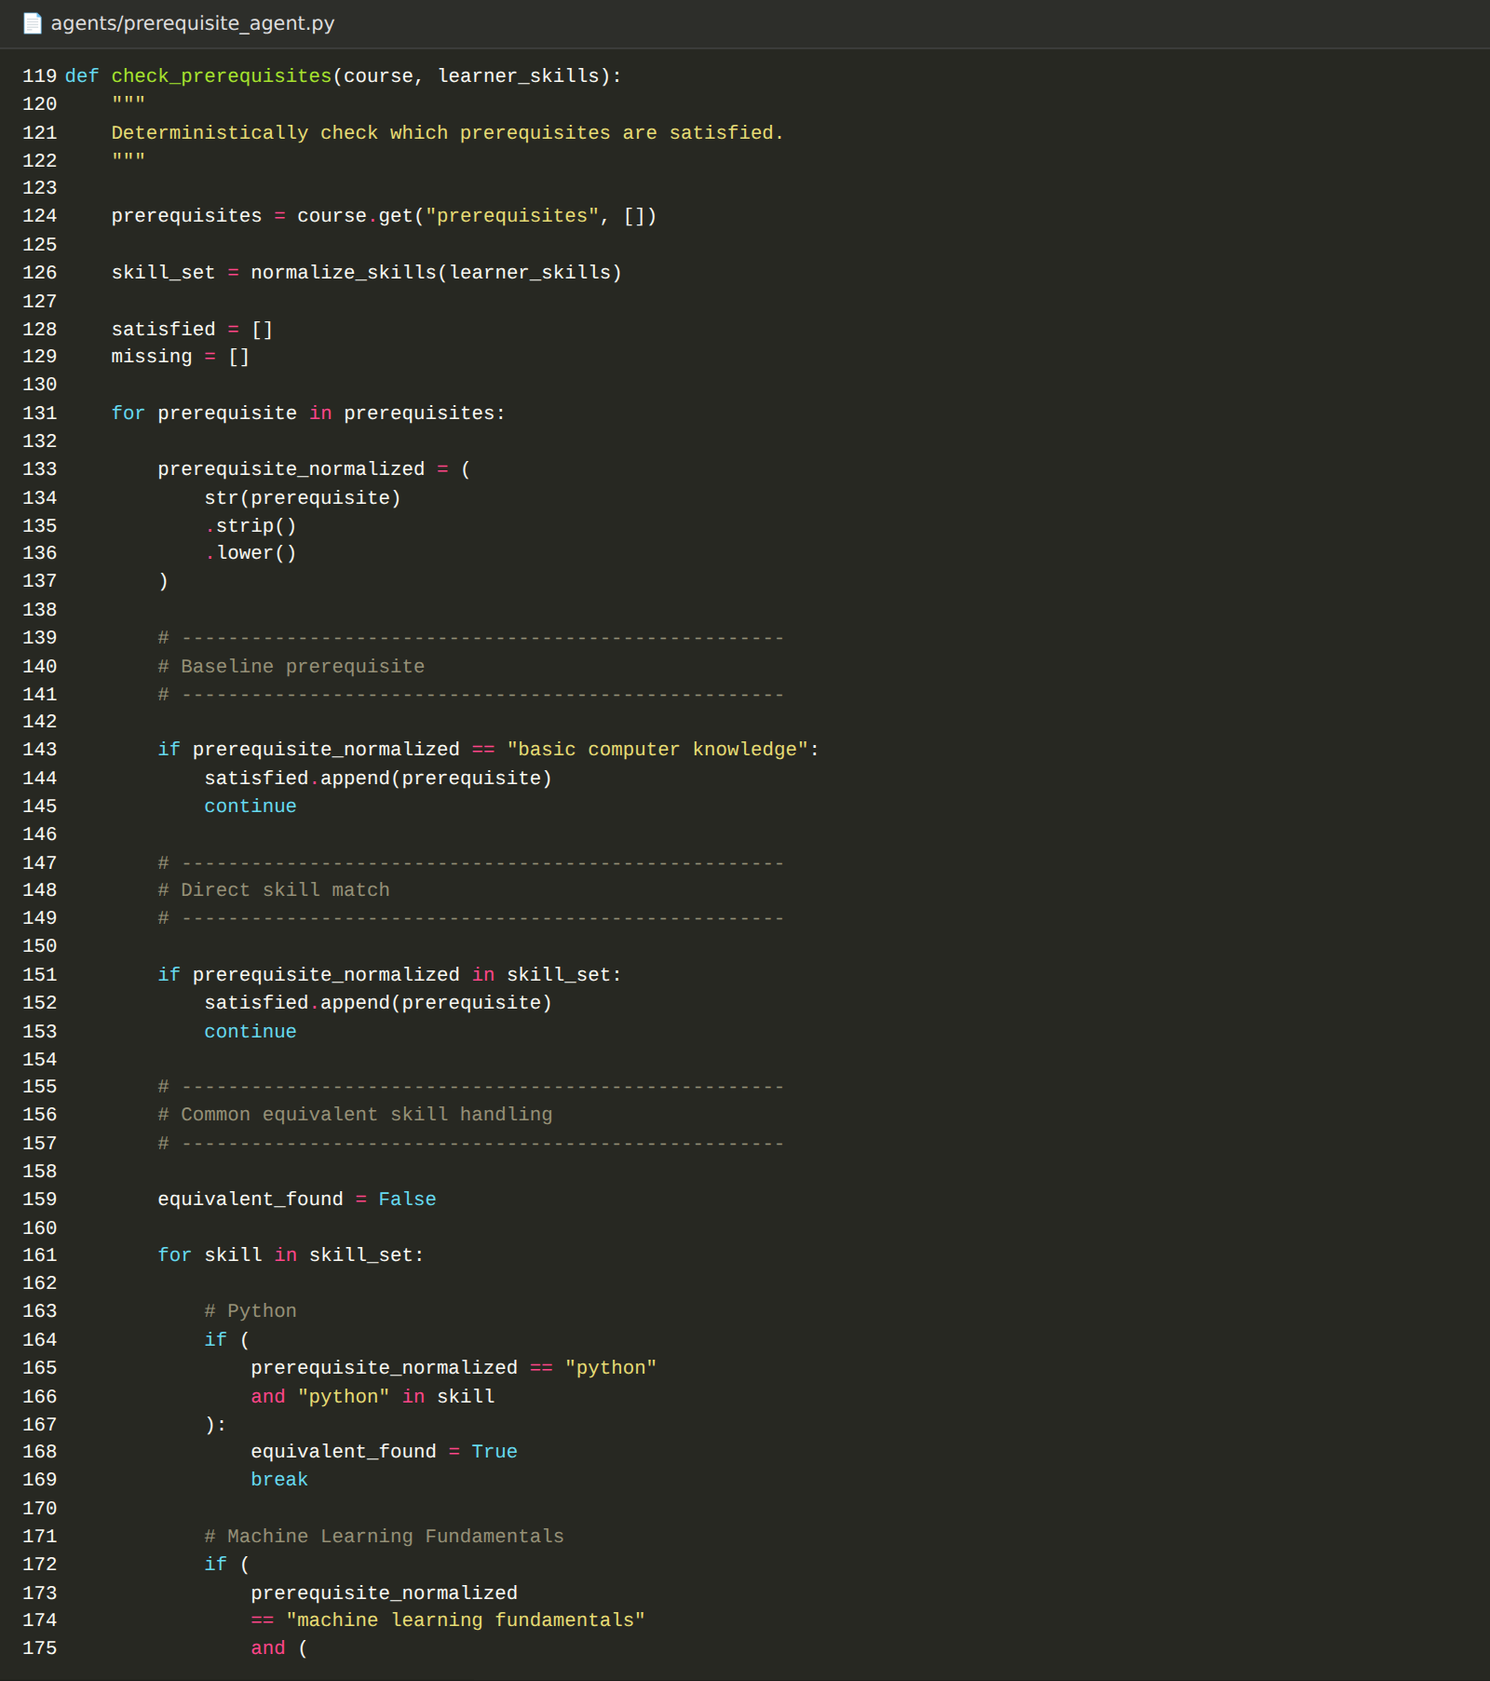

Activity 3.2: Develop the Recommendation Agent
The Recommendation Agent (agents/recommendation_agent.py) is the core ranking engine. It first detects the learner's career direction from the career goal (cloud, devops, generative_ai, ai_ml, data_science, or general), retrieves candidate courses through RAG, and then scores every course out of 100.
Score component | How it is calculated
Career relevance | Fixed priority per course for the detected career direction (for example 55 points for Machine Learning Fundamentals on the AI/ML path)
Category relevance | Priority of the course category for the career direction
Skill match | Share of the course's skills the learner already has, scaled to 15 points
Interest match | 5 points per matching interest, capped at 10
Difficulty fit | 5 points when the course level suits the learner's experience

The total is capped at 100. Courses the learner already has the skills for, such as Python for Beginners for a Python user, are skipped. The agent then returns the ranked recommendations, the best course, and a recommendation explanation.
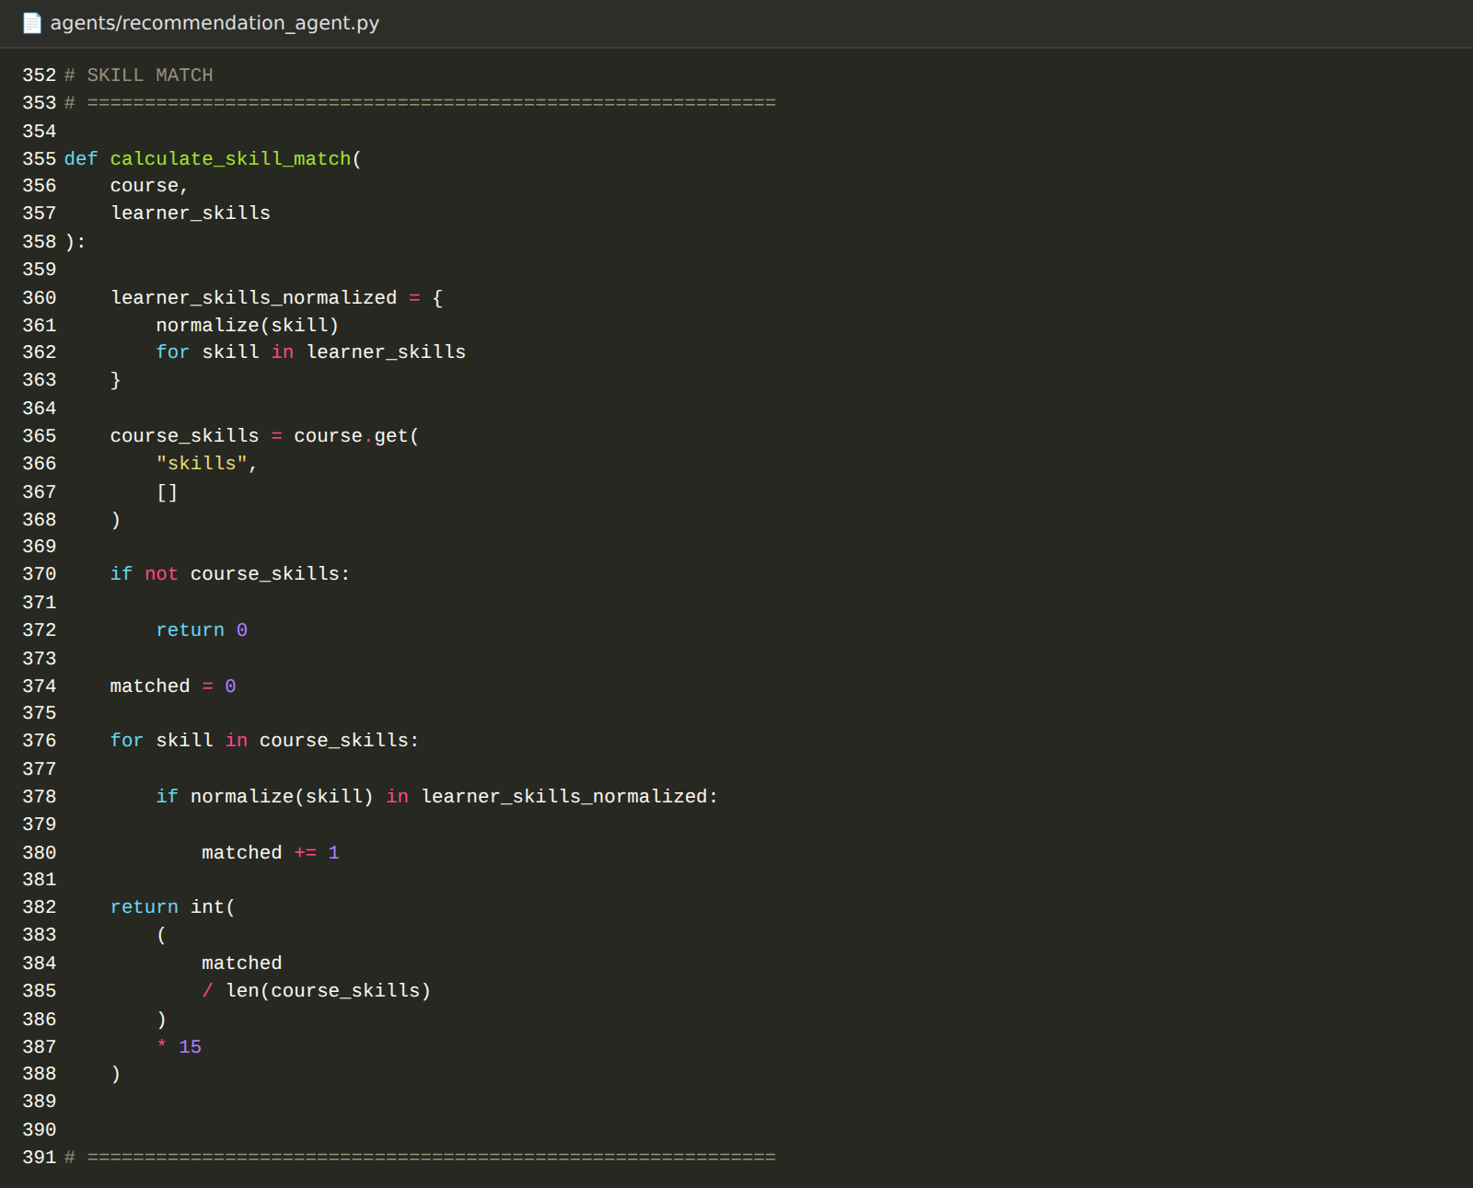

Activity 3.3: Develop the Learning Path Agent
The Learning Path Agent (agents/learning_path_agent.py) turns the recommendations into an ordered roadmap. The ordering relies on a dependency graph built from the course prerequisites and a recursive resolver that places every prerequisite before the course that needs it, with protection against circular dependencies. The agent skips courses the learner already has (status Skip - Skill Already Present, or a score of 0). After the dependency-ordered courses, it also appends the remaining top recommendations until the roadmap has up to 7 steps, so every career goal receives a complete roadmap. The LLM then writes a short explanation of the path.
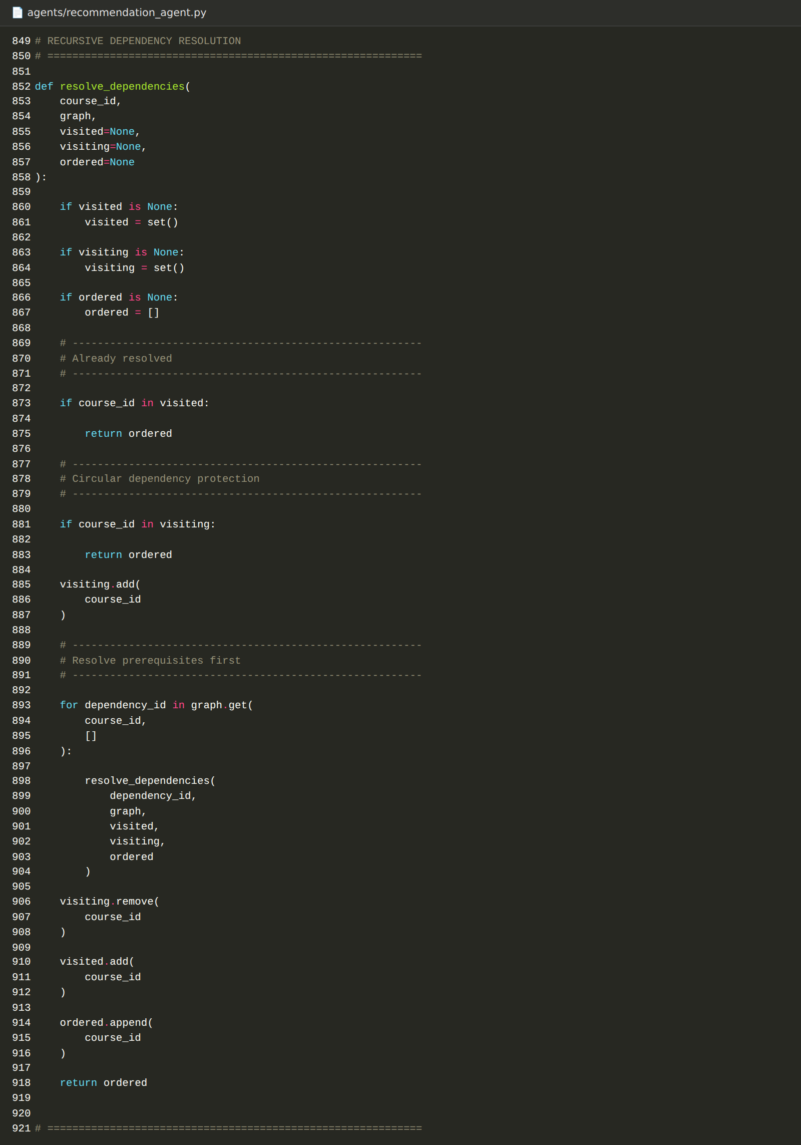
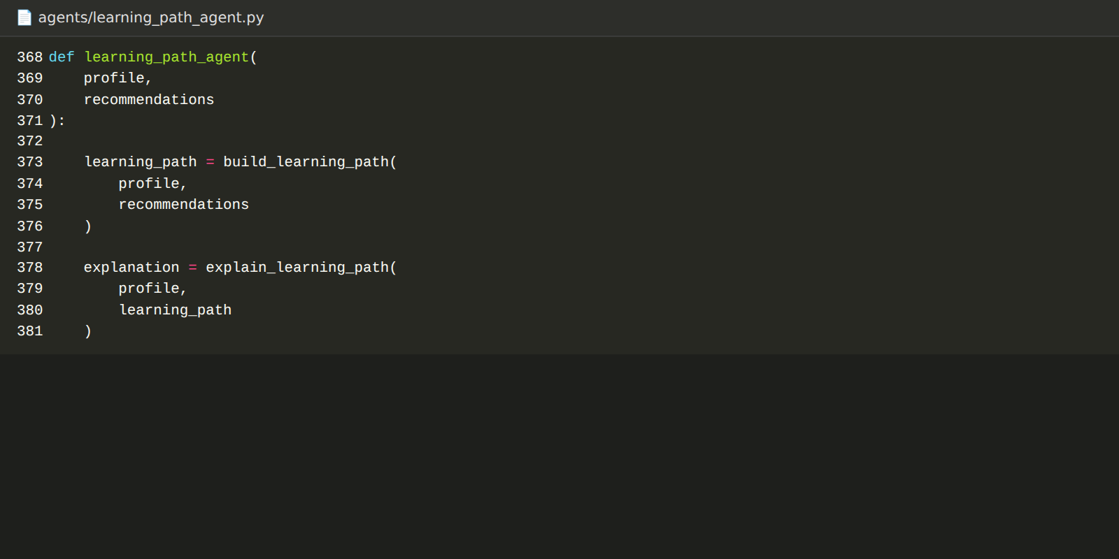

Milestone 4: Orchestration and Dashboard Development
Milestone 4 connects the agents into one workflow and provides the Streamlit interface that learners use.

Activity 4.1: Develop the Orchestrator Agent
The Orchestrator Agent (agents/orchestrator_agent.py) loads each agent dynamically, checks that it is available, and runs the workflow in order: Profile Analysis, Course Research with RAG, Prerequisite Analysis, Recommendation, and Learning Path. It prints a status line for each agent ([OK] when loaded, [X] when unavailable) and the result of each stage. Console output is switched to UTF-8 so the script runs cleanly in a Windows terminal.
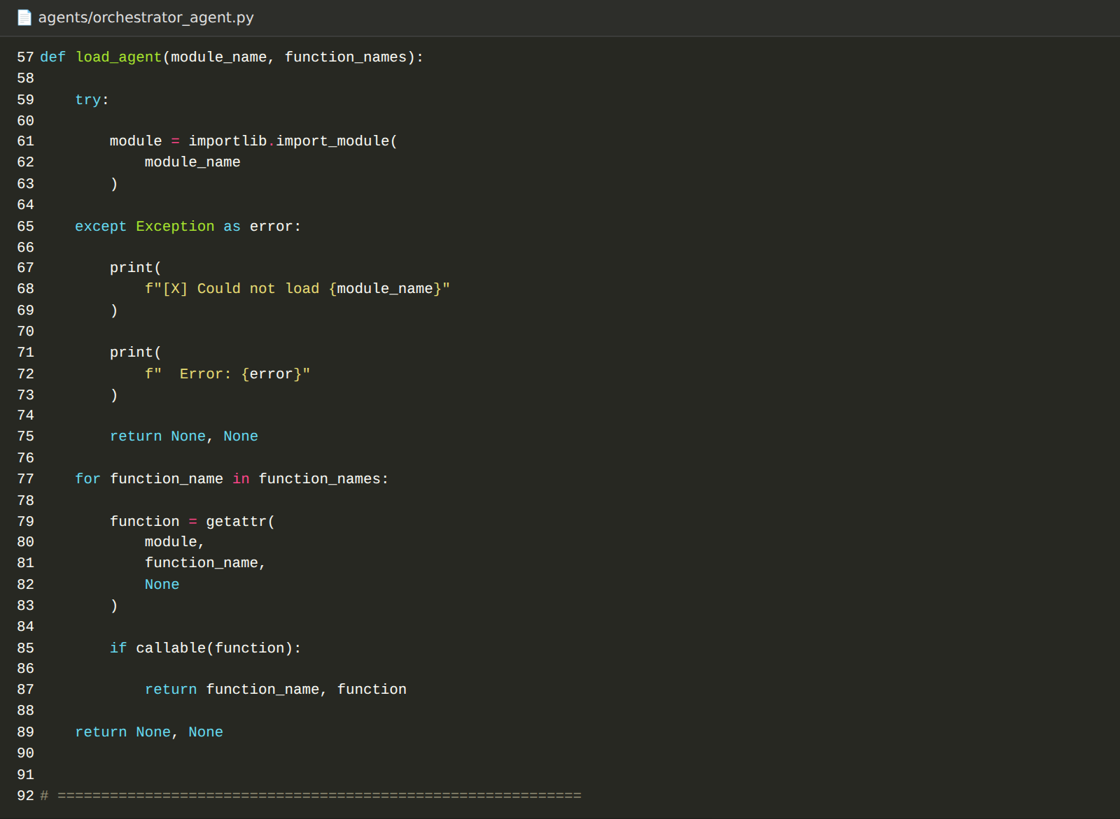
python agents/orchestrator_agent.py

Activity 4.2: Build the Profile Input Form
app/app.py is a wide-layout Streamlit application titled AI Course Advisor. The sidebar and main form collect the learner's information.
Input | Control | Options
Education | Text box | Free text, for example B.Tech ECE
Experience level | Select box | Beginner, Intermediate, Advanced
Target career goal | Select box | Cloud Engineer, AI/ML Engineer, Generative AI Engineer, Data Scientist, DevOps Engineer, Data Analyst, Backend Developer, Web Developer, Cybersecurity Engineer, Other (custom role)
Current skills | Multi-select plus custom text | 38 predefined skills such as Python, SQL, AWS, Docker, Machine Learning, plus custom skills
Interests | Multi-select plus custom text | 13 predefined interests such as AI, Cloud Computing, Data Science, DevOps, plus custom interests

A profile readiness meter shows how complete the profile is, and Reset and Edit Profile controls let the learner start again or change the details.
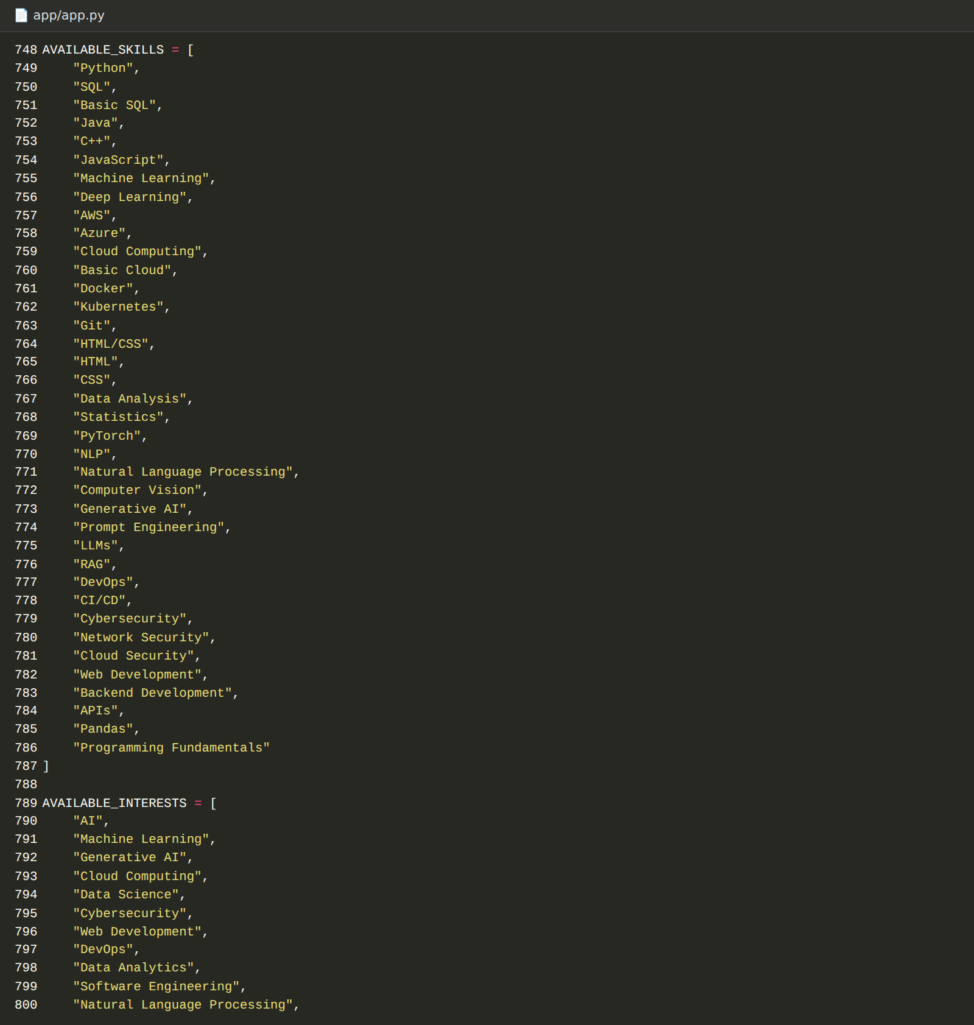

Activity 4.3: Build the Results Dashboard
When the learner clicks Generate, the app calls the agents and displays the results in dedicated sections. Agent calls are wrapped in Streamlit's cache (one-hour time to live), so repeating the same profile returns instantly. The app computes the satisfied and missing prerequisites for each course with its own calculate_skill_gaps function, and reads agent results defensively (using default values for missing fields) so an incomplete result never crashes the page.
- Learner Profile: Summary of the submitted profile.
- Course Recommendations: Ranked course cards with scores and the reason for each recommendation.
- Prerequisite and Skill Gap Analysis: Satisfied and missing prerequisites for each recommended course.
- RAG Knowledge Retrieval: The courses retrieved from the knowledge base with similarity scores.
- Recommended Learning Roadmap: The ordered sequence of courses toward the career goal.
- AI Explanations: Learning path explanation, profile analysis, and recommendation explanation.
- Multi-Agent System Status: Status tiles confirming that the Profile, Course Research, RAG Retrieval, Recommendation, Prerequisite, and Learning Path components are working.
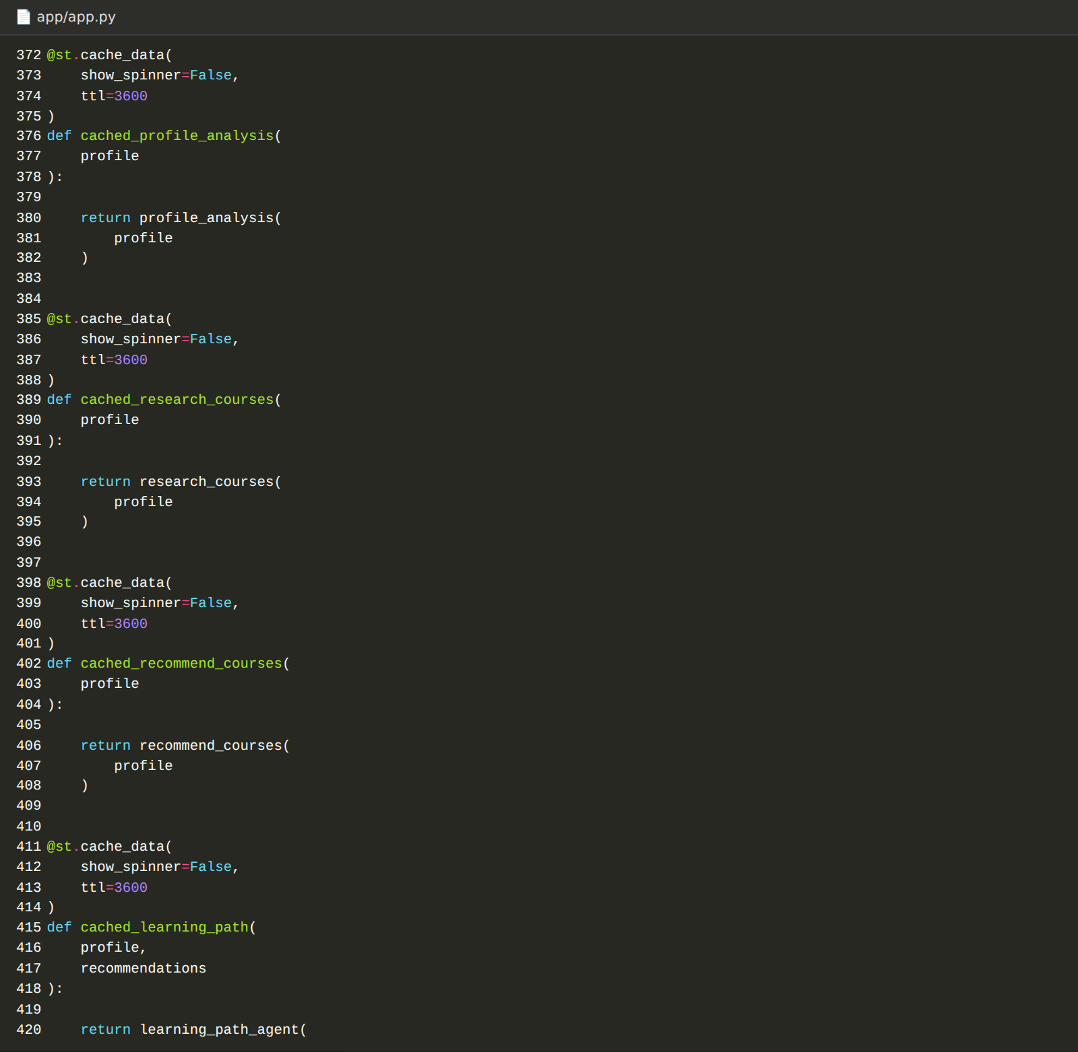

Milestone 5: Testing and Deployment
Milestone 5 runs the application locally and verifies the whole system with an automated validation suite.

Activity 5.1: Run the Application Locally
- Make sure Ollama is running and both models are installed.
- Run RAG ingestion once to create the vector store.
- Start the Streamlit application:
streamlit run app/app.py
- Open the application in a browser at:
http://localhost:8501

Activity 5.2: End-to-End Validation
The scratch/run_full_validation.py script runs a comprehensive suite of 18 criteria and prints PASS or FAIL for each one, followed by an overall project status.
# | Validation criterion
1 | Python environment (version 3.10 or later)
2 | Required packages available
3 | Ollama availability
4 | qwen2.5:3b model availability
5 | nomic-embed-text model availability
6 | courses.json is valid JSON
7 | Exactly 20 courses
8 | RAG ingestion
9 | Vector store exists and is non-empty
10 | RAG retrieval
11 | Profile Agent
12 | Course Research Agent
13 | Prerequisite Agent
14 | Recommendation Agent
15 | Learning Path Agent
16 | Orchestrator Agent integrity (all 5 agents resolved)
17 | Streamlit application (no exceptions, unique widgets)
18 | End-to-end course roadmap generation

python scratch/run_full_validation.py

Activity 5.3: Additional Test Scripts
Script | What it checks
scratch/check_code_issues.py | Detects duplicate Streamlit widget keys and verifies that every Python file in the project parses without syntax errors.
scratch/deep_test_app.py | Uses Streamlit's AppTest framework to render the dashboard and verify there are no exceptions on initial render, after the Reset Profile button, with a custom career goal, and with empty or minimal inputs.

python scratch/check_code_issues.py
python scratch/deep_test_app.py

Exploring the Website’s Web Pages:

Dashboard Home and Sidebar:
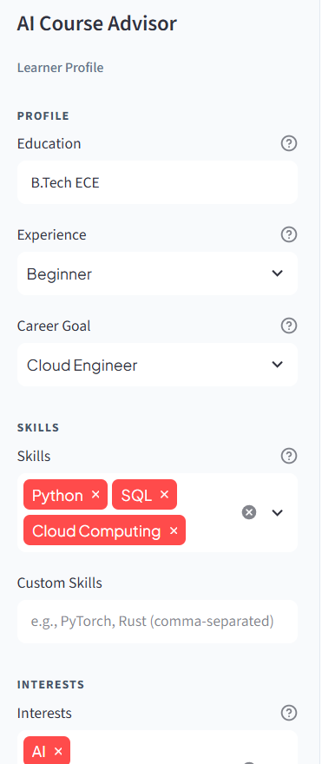
Description: The application opens with the AI Course Advisor title and the subtitle Personalized Course Recommendation & Learning Path System. The sidebar holds the learner profile controls and the Generate button.

Learner Profile Input:
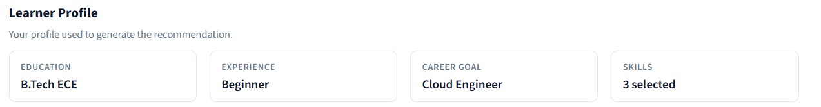
Description: The learner enters education, experience level, career goal, skills, and interests. Predefined options are provided and custom skills, interests, or a custom career role can be added.

Course Recommendations:
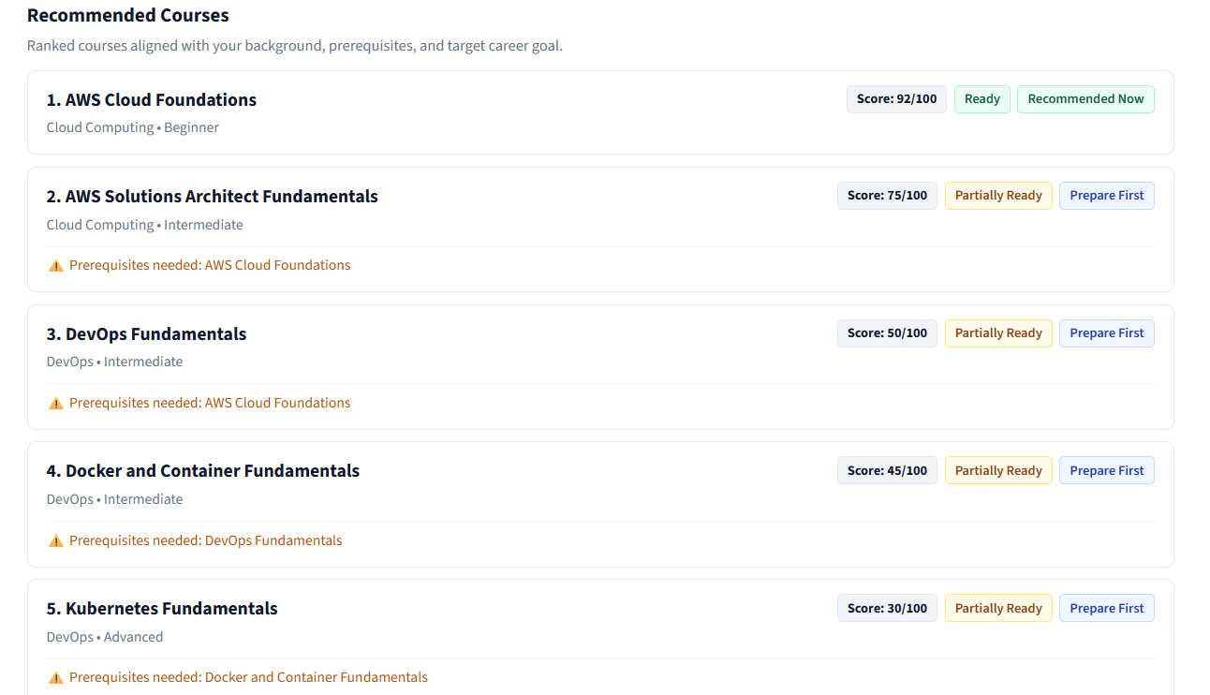
Description: Recommended courses are listed in ranked order with their scores and an explanation of why each course suits the learner's career goal.

Prerequisite and Skill Gap Analysis:
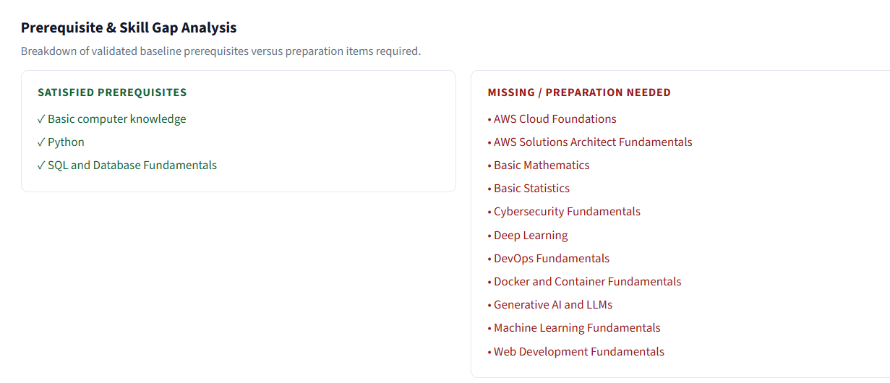
Description: For each recommended course, the page separates satisfied prerequisites from missing ones so the learner can see exactly what to learn first.

RAG Knowledge Retrieval:
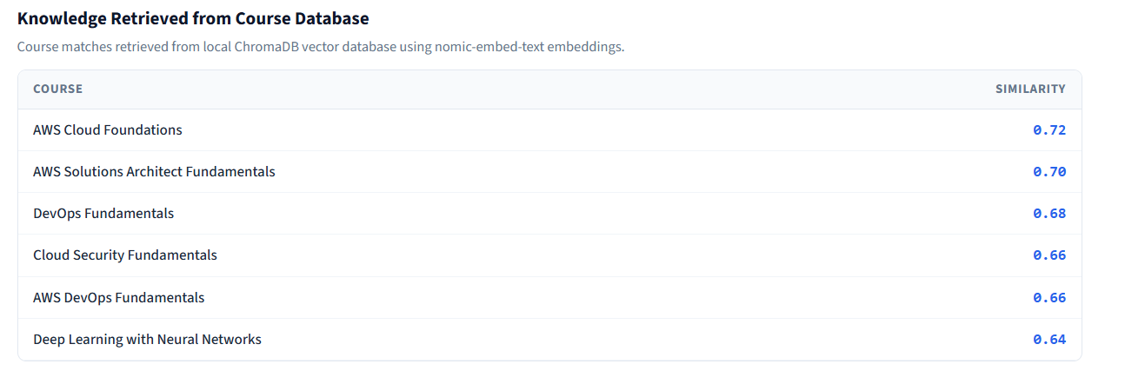
Description: This section shows the courses retrieved from the knowledge base for the learner's query, together with their similarity scores, which makes the recommendations explainable.

Recommended Learning Roadmap:
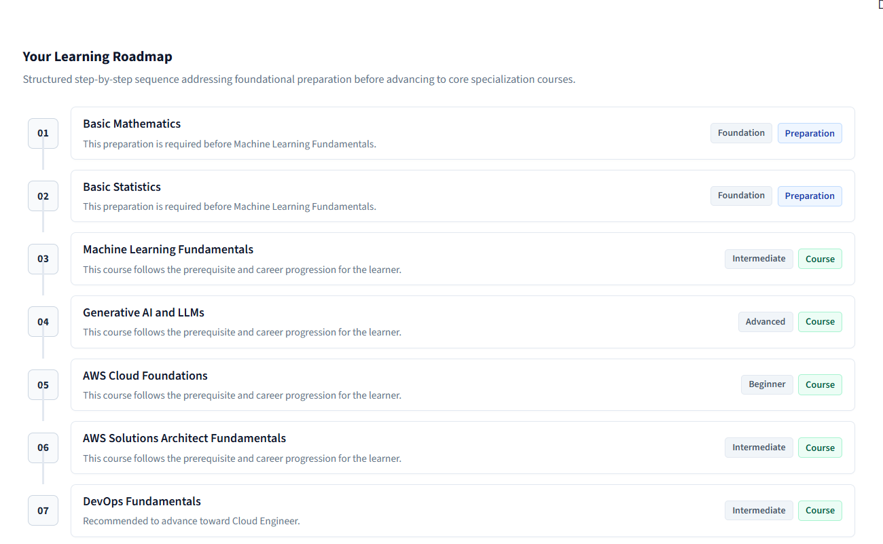
Description: The roadmap lists the courses in the order they should be studied, with prerequisites placed before the courses that depend on them.

AI Explanations:
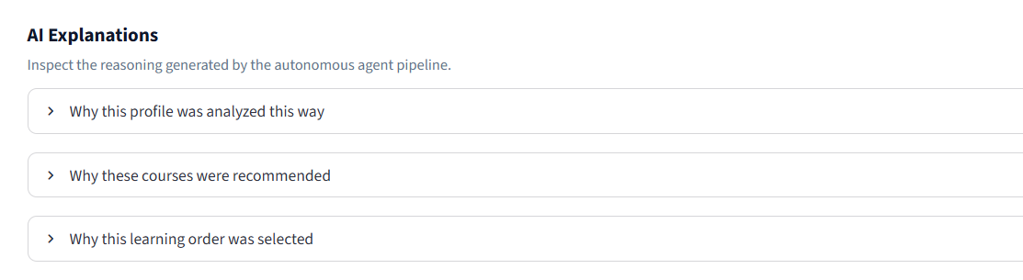
Description: The AI explanation panels present the learning path explanation, the profile analysis, and the recommendation explanation generated by the local LLM.

Multi-Agent System Status:
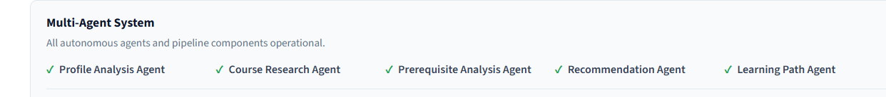
Description: Status tiles confirm that the Profile Agent, Course Research Agent, RAG Retrieval, Recommendation Agent, Prerequisite Engine, and Learning Path Agent are all working.

Conclusion:
AI Course Advisor is an explainable, locally run recommendation system that combines Retrieval-Augmented Generation with a team of specialised agents. It replaces generic course lists with recommendations tailored to a learner's background, skills, interests, experience level, and career goal.
RAG grounds every recommendation in the curated course knowledge base, while deterministic prerequisite checking and scoring keep the results consistent. The local LLM (qwen2.5:3b) is used only to explain results, which prevents invented courses or prerequisites. The system also identifies skill gaps and builds a dependency-aware learning roadmap.
The project integrates Python, Ollama, nomic-embed-text embeddings, a cosine-similarity retriever, a plain-Python orchestrator, and a Streamlit dashboard. The 18-point validation suite confirms that the environment, models, RAG pipeline, all five agents, the orchestrator, and the end-to-end workflow operate correctly.
Possible future enhancements include moving the vector store to FAISS or ChromaDB, adding LangGraph-based orchestration, persisting learner profiles and history in SQLite, expanding the course catalogue, and adding progress tracking.

