

## **Atma Ram Sanatan Dharma College**

University of Delhi



**MICROPROCESSOR**

Practical File for Paper Code 32347504

**Submitted By**

Deepali

College Roll No. 21/18076

BSc (Hons) Computer Science

**Submitted To**

Mr Mahesh Bhandari

Department of Computer Science

**QUES 5.** **Write a program to add and subtract two array.**

Solution:-

Addition of Two Array:

.model small ; contain two segment data and code

.data ; start of data segment

mat1 db 12h, 11h, 12h, 10h, 11h, 12h, 10h, 11h, 12h ; defined variable mat2 db 13h, 02h, 02h, 02h, 02h, 02h, 02h, 02h, 02h

res3 dw 9 dup(?); Declaring an array with garbage

.code ; start of code segment

mov ax, @data ; loading starting address of data segment in ax

mov ds, ax mov cx, 09h

mov di, offset mat1 mov bx, offset mat2 mov si, offset res3

back : mov ah, 0 mov al, [di]

add al, [bx] adc ah, 00 mov [si], ax inc di

inc bx inc si inc si

loop back

mov si, offset res3 mov dh, 9

l10: mov ch, 04h mov cl, 04h

mov bx, [si]

l2: rol bx, cl ; rotates the bits within the destination operand to the left mov dl, bl

and dl, 0fh cmp dl, 09 jbe l4

add dl, 07

l4: add dl, 30h

mov ah, 02 int 21h dec ch

jnz l2

mov dl, ' ' ;This is a whitespace int 21h

inc si inc si dec dh jnz l10

mov ah, 4ch

int 21h ; causes the current process to terminate

end

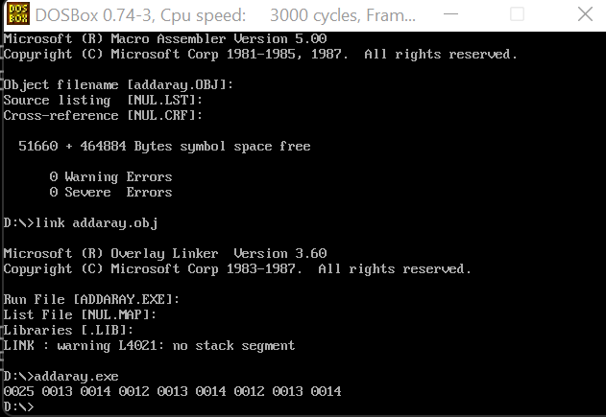

Subtraction of two array:-

.model small ; contain two segment data and code

.data ; start of data segment

mat1 db 12h, 11h, 12h, 10h, 11h, 12h, 10h, 11h, 12h ; defining byte size variable

mat2 db 13h, 02h, 02h, 02h, 02h, 02h, 02h, 02h, 02h res3 dw 9 dup(?); Declaring an array with garbage

.code ; start of code segment

mov ax, @data ;loading starting address of data segment in ax mov ds, ax

mov cx, 09h

mov di, offset mat1 mov bx, offset mat2 mov si, offset res3 back : mov ah, 0 mov al, [di]

sub al, [bx] adc ah, 00 mov [si], ax inc di

inc bx inc si inc si

loop back

mov si, offset res3 mov dh, 9

l10: mov ch, 04h mov cl, 04h

mov bx, [si]

l2: rol bx, cl ; rotates the bits within the destination operand to the left mov dl, bl

and dl, 0fh cmp dl, 09

jbe l4

add dl, 07

l4: add dl, 30h mov ah, 02

int 21h ; display single character as ah = 2 dec ch

jnz l2

mov dl, ' ' ;This is a whitespace int 21h

inc si inc si dec dh jnz l10

mov ah, 4ch

int 21h ; causes the current process to terminate

end

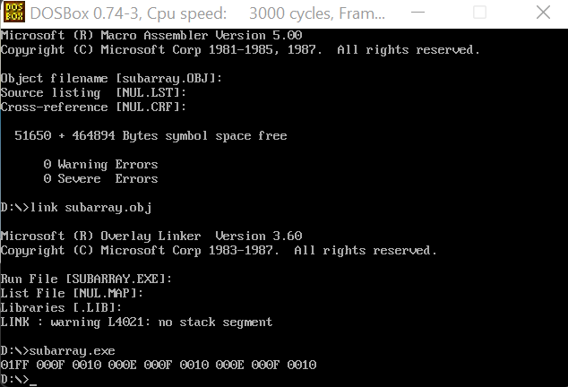

mov ah, 02 int 21h dec ch

jnz l2

mov dl, ' ' ;This is a whitespace int 21h

inc si inc si dec dh jnz l10

mov ah, 4ch

int 21h ; causes the current process to terminate

end



Subtraction of two array:-

.model small ; contain two segment data and code

.data ; start of data segment

mat1 db 12h, 11h, 12h, 10h, 11h, 12h, 10h, 11h, 12h ; defining byte size variable

mat2 db 13h, 02h, 02h, 02h, 02h, 02h, 02h, 02h, 02h res3 dw 9 dup(?); Declaring an array with garbage

.code ; start of code segment

mov ax, @data ;loading starting address of data segment in ax mov ds, ax

mov cx, 09h

mov di, offset mat1 mov bx, offset mat2 mov si, offset res3 back : mov ah, 0 mov al, [di]

sub al, [bx] adc ah, 00 mov [si], ax inc di

inc bx inc si inc si

loop back

mov si, offset res3 mov dh, 9

l10: mov ch, 04h mov cl, 04h

mov bx, [si]

l2: rol bx, cl ; rotates the bits within the destination operand to the left mov dl, bl

and dl, 0fh cmp dl, 09

jbe l4

add dl, 07

l4: add dl, 30h mov ah, 02

int 21h ; display single character as ah = 2 dec ch

jnz l2

mov dl, ' ' ;This is a whitespace int 21h

inc si inc si dec dh jnz l10

mov ah, 4ch

int 21h ; causes the current process to terminate

end

