HEALTHCARE ANALYTICS PLATFORM
USING AZURE DATABRICKS MEDALLION ARCHITECTURE
An End-to-End Data Engineering Solution using Azure Data Lake Storage Gen2, Azure Databricks, PySpark, Delta Lake, Unity Catalog, and Databricks SQL
Prepared by
[Your Name]
Data Engineering

Table of Contents
1. Abstract
2. Introduction
3. Problem Statement
4. Objectives
5. Technology Stack
6. System Architecture
7. Azure Infrastructure
8. Project Implementation
9. Results and Dashboards
10. Challenges Faced
11. Future Enhancements
12. Conclusion

1. Abstract
This report documents the design and build of a Healthcare Analytics Platform on Microsoft Azure, following the Medallion (Landing–Bronze–Silver–Gold) pattern. The platform takes in raw operational extracts from a multi-branch healthcare provider — patients, appointments, doctors, billing, and treatments — and pushes them through a series of Azure Databricks notebooks that progressively clean, validate, and aggregate the data into governed Delta tables ready for analysis.
The implementation relies on Azure Data Lake Storage Gen2 for layered object storage, Azure Databricks and PySpark for distributed processing, Delta Lake for transactional table storage, and Unity Catalog for centralized governance. The curated Gold-layer tables feed a Databricks SQL dashboard that surfaces revenue, doctor-performance, and operational KPIs, giving a single certified view of the business — the Patient 360 table — that replaces what used to be several disconnected spreadsheets and extracts.

2. Introduction
Healthcare providers typically run several independent operational systems — patient registration, appointment scheduling, billing, and treatment logging — each generating its own extract in its own format and on its own schedule. Without a common layer to reconcile them, anyone trying to answer a business question has to stitch the extracts together manually, which is slow and hard to verify.
This project builds a cloud-native platform on Azure that ingests each extract independently, validates it on its own terms, and then joins everything into one analytical model. It follows the Medallion architecture, where data quality and business value increase as records move from a raw Landing zone through Bronze (typed and audited), Silver (cleaned and conformed), and Gold (aggregated and business-ready) layers. Because each layer is kept separate, any KPI in Gold can be traced back through the Silver logic that produced it and, further back, to the original Bronze record and source file.
The sections that follow cover the problem being solved, the platform architecture, the Azure resources that were provisioned, how each notebook in the pipeline was built, the resulting dashboards, the issues encountered along the way, and the roadmap for extending the platform.

3. Problem Statement
The provider works with five separate data extracts — Patients, Appointments, Doctors, Billing, and Treatments — each coming from a different system as a flat CSV file. In their raw state these extracts create a few recurring problems:
- No table links a patient to their appointments, treatments, and billing history, so patient-level analysis has to be done by hand.
- The extracts carry duplicate rows, inconsistent handling of missing values, and foreign keys that don't always resolve (appointments pointing at doctors who don't exist in the Doctors extract, for example).
- There's no governed, access-controlled place for analytics-ready data — business users query the flat files directly, with no lineage or audit trail behind the numbers.
- Core KPIs such as revenue per doctor, no-show rate, and billing accuracy get recalculated differently by different teams because there's no single certified source for them.
The platform in this report was built to close these gaps through automated ingestion, layered validation, and a governed semantic layer that both technical and business users can query with confidence.

4. Objectives
- Provision an Azure Data Lake Storage Gen2 account with a Landing–Bronze–Silver–Gold container layout.
- Build a Bronze ingestion notebook that loads all five source extracts with consistent audit metadata (source file, batch ID, ingestion timestamp, pipeline version).
- Write per-entity Silver notebooks that deduplicate, handle nulls, validate schema, and derive business flags such as no-show and high-value-bill indicators.
- Build a Patient 360 Gold table by joining Patients, Appointments, Doctors, Billing, and Treatments into a single analytical model.
- Register every Bronze, Silver, and Gold table in Unity Catalog so access can be governed at the schema level.
- Expose the Gold-layer KPIs through a Databricks SQL dashboard for day-to-day and executive reporting.

5. Technology Stack
Category | Technology / Role
Cloud Platform | Microsoft Azure — hosts all storage, compute, and governance resources
Storage | Azure Data Lake Storage Gen2 — hierarchical namespace storage for Landing, Bronze, Silver, and Gold containers
Compute | Azure Databricks — managed Spark clusters for ingestion and transformation notebooks
Processing Engine | PySpark — distributed cleansing, validation, and aggregation logic
Table Format | Delta Lake — ACID transactions, schema enforcement, and time travel across every layer
Governance | Unity Catalog — centralized catalog, schema, and table-level access control
Analytics Compute | Databricks SQL Warehouse (Serverless) — powers the SQL dashboard
Languages | Python and SQL — notebook logic and dashboard queries

6. System Architecture
The pipeline moves data forward through progressively refined layers rather than overwriting anything in place. Each layer has a clear contract with the one above it, which keeps failures contained and makes reprocessing safe.

6.1 Landing Layer
The landing container holds the raw CSV extracts exactly as received, with no transformation applied. It acts as an immutable capture point — if a downstream issue is found, the whole pipeline can be replayed from Landing without going back to the source systems.

6.2 Bronze Layer
The Bronze layer turns each Landing extract into a Delta table with an enforced schema and a standard set of audit columns (source file, batch ID, ingestion timestamp, pipeline version). No business logic runs here — the goal is a faithful, typed, traceable copy of the source data.

6.3 Silver Layer
Silver is where data quality is actually enforced. Each entity has its own notebook that removes duplicates, resolves nulls according to entity-specific rules, checks referential integrity against related entities, and derives simple flags — a No_Show_Flag on appointments or a High_Value_Bill flag on billing, for example. Silver tables are the first layer considered safe for cross-team use.

6.4 Gold Layer
Gold aggregates and joins Silver tables into business-facing datasets, most importantly the Patient 360 table plus a set of revenue, doctor-performance, and treatment-analysis tables. Gold is what the dashboard connects to directly; it is never queried by upstream layers, which keeps the dependency graph one-directional.

6.5 Unity Catalog and Delta Lake
Unity Catalog sits across all three layers and provides a single metastore for the workspace, so every table is registered under a catalog/schema hierarchy and access can be granted at the schema level rather than per-notebook. Every table, in every layer, is stored in Delta format, which gives the pipeline ACID transactions, schema enforcement, and time travel — all of which were relied on while building and debugging the pipeline.

7. Azure Infrastructure
All resources for the platform sit inside a single Azure resource group, which keeps lifecycle management, cost tracking, and access control simple.

7.1 Resource Group and Databricks Workspace
The resource group rg-medallion-project hosts the Azure Databricks workspace (db_healthcare) and the storage account used by the pipeline. The workspace runs on the Premium pricing tier with role-based access controls enabled and no public IP exposure, and it manages its own dependent resource group for cluster and networking resources.
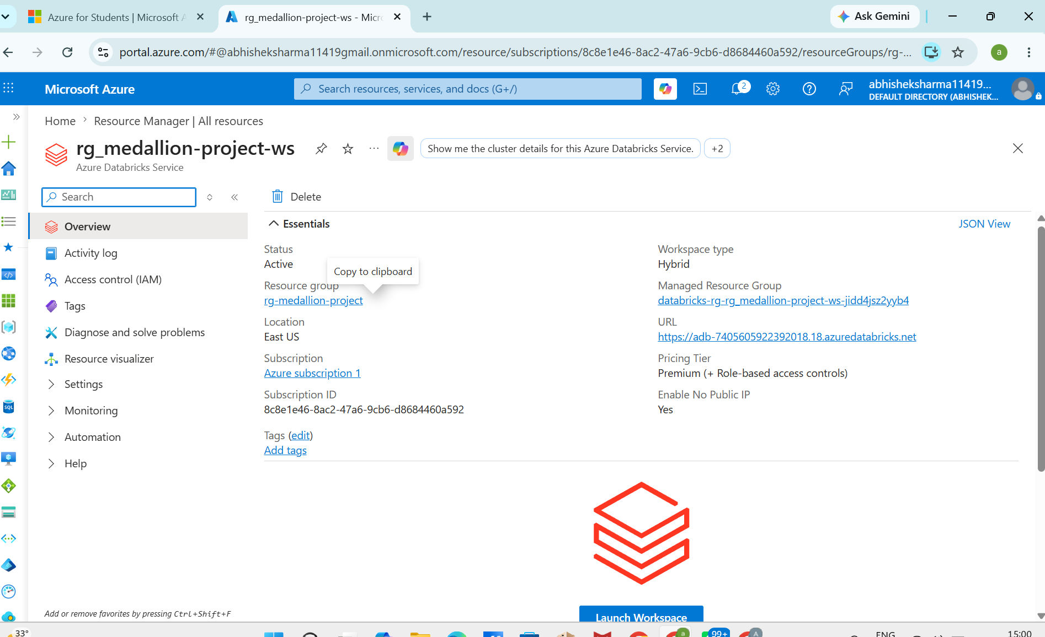
Figure 1: Azure Databricks workspace overview, showing the resource group, managed resource group, region, and workspace URL

7.2 Storage Account and ADLS Gen2 Containers
A single storage account, medallionhealthdata03, provides the Data Lake Storage Gen2 capability with the hierarchical namespace feature enabled. It is deployed in the East US region with Standard performance and read-access geo-redundant storage (RA-GRS) for resiliency.
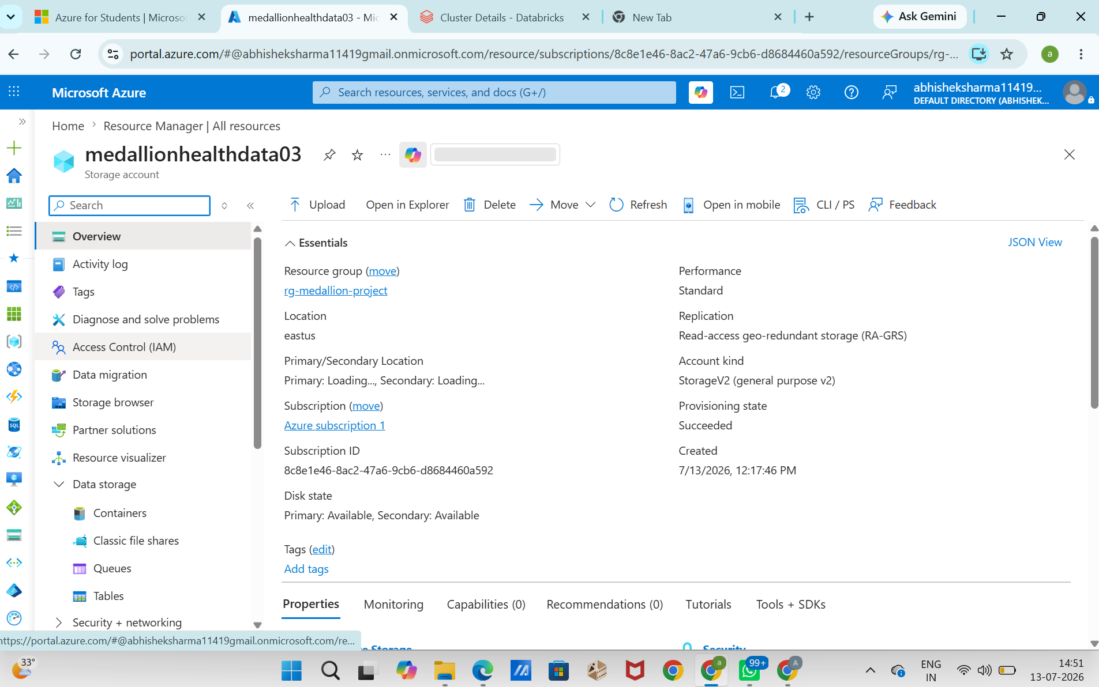
Figure 2: Storage account properties — StorageV2, RA-GRS replication, hierarchical namespace enabled
Five containers are provisioned within the account, four of which correspond directly to the Medallion layers, plus the automatically created $logs container:
Container | Purpose
landing | Immutable copy of the raw CSV extracts as received from source systems
bronze | Typed Delta tables with ingestion audit columns, one folder per source entity
silver | Cleansed, validated, business-rule-enriched Delta tables
gold | Aggregated, join-ready analytical tables consumed by the dashboard
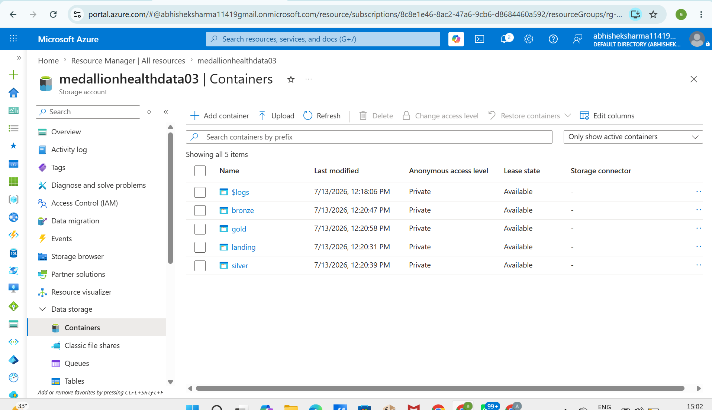
Figure 3: ADLS Gen2 containers under medallionhealthdata03 — landing, bronze, silver, and gold

7.3 Bronze Container
The bronze container holds one folder per ingested entity, plus an audit_log folder and a metadata_config folder used by the ingestion notebook to track batch metadata.
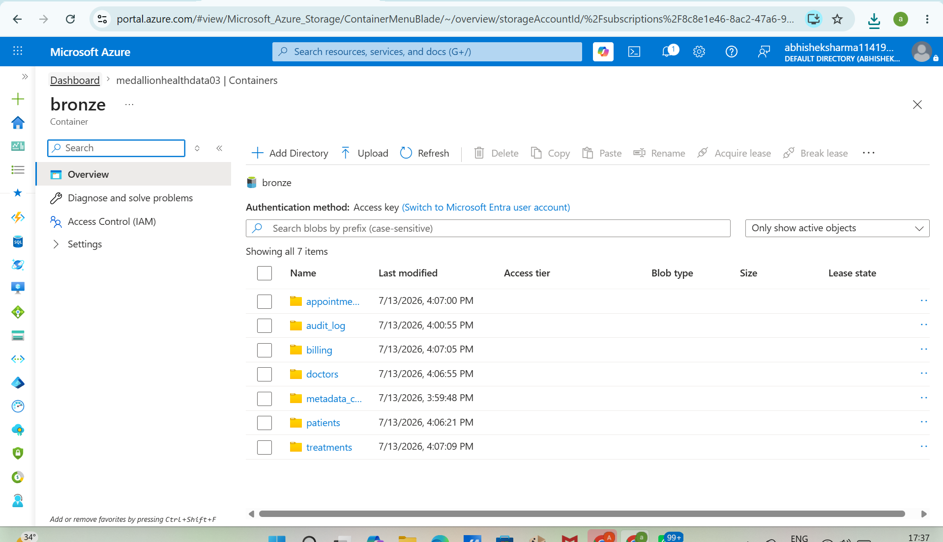
Figure 4: Bronze container — appointments, audit_log, billing, doctors, metadata_config, patients, and treatments

7.4 Silver Container
The silver container holds the five cleansed, entity-level Delta tables produced by the Silver notebooks.
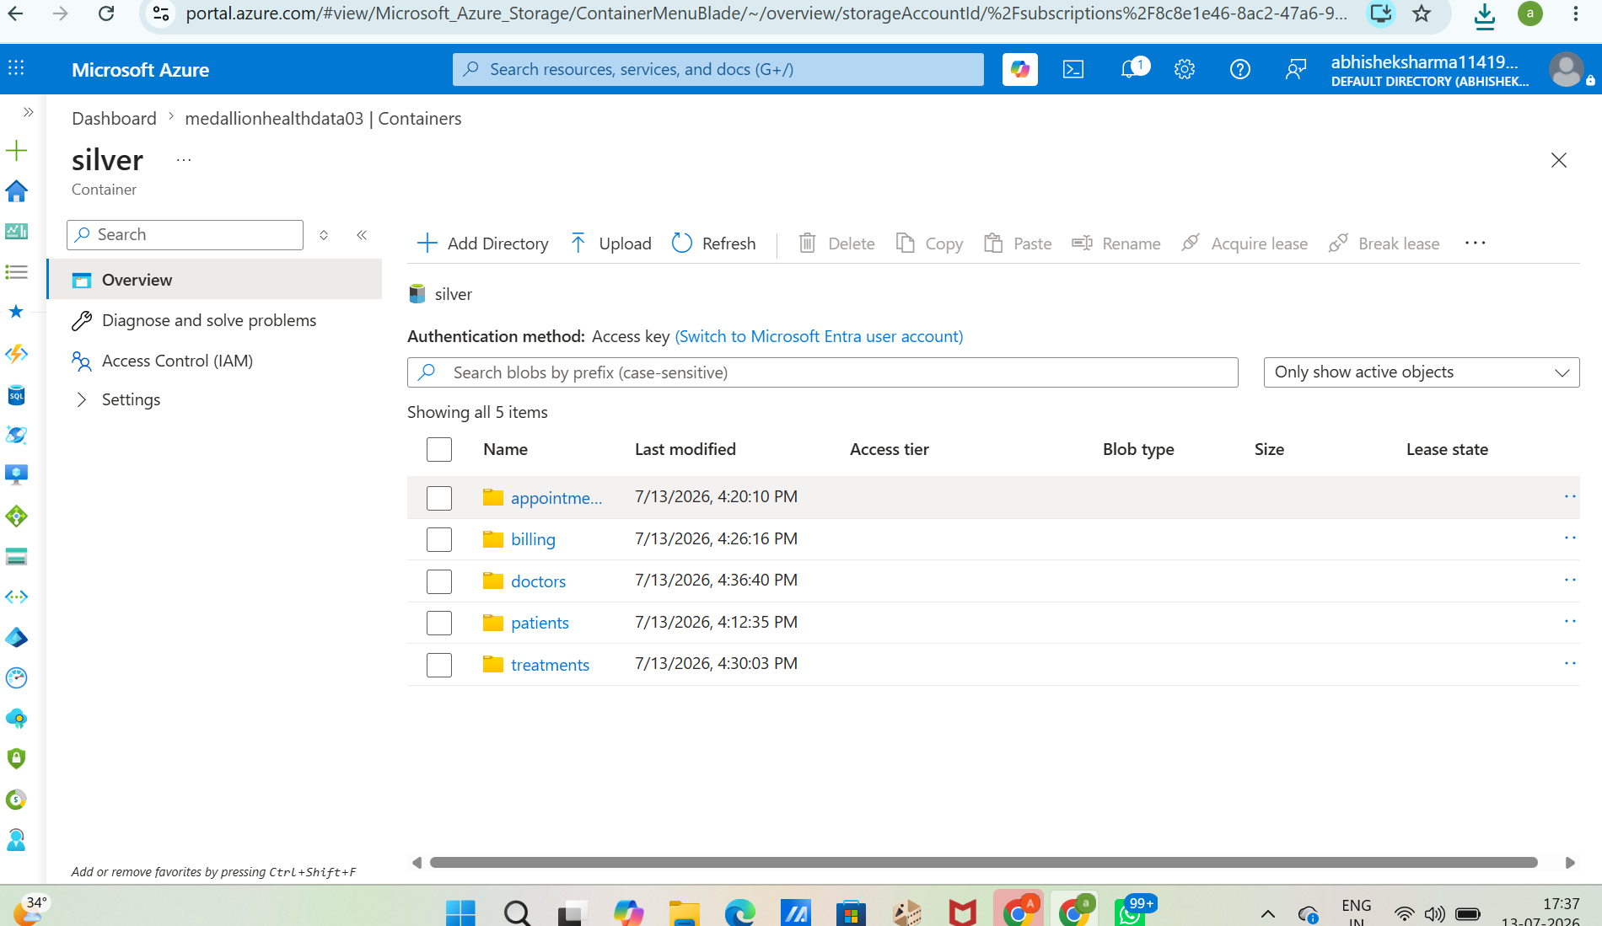
Figure 5: Silver container — validated, entity-level Delta tables

7.5 Gold Container
The gold container holds the full set of curated analytical tables — Patient 360, the KPI tables, and the performance and summary tables consumed by the dashboard.
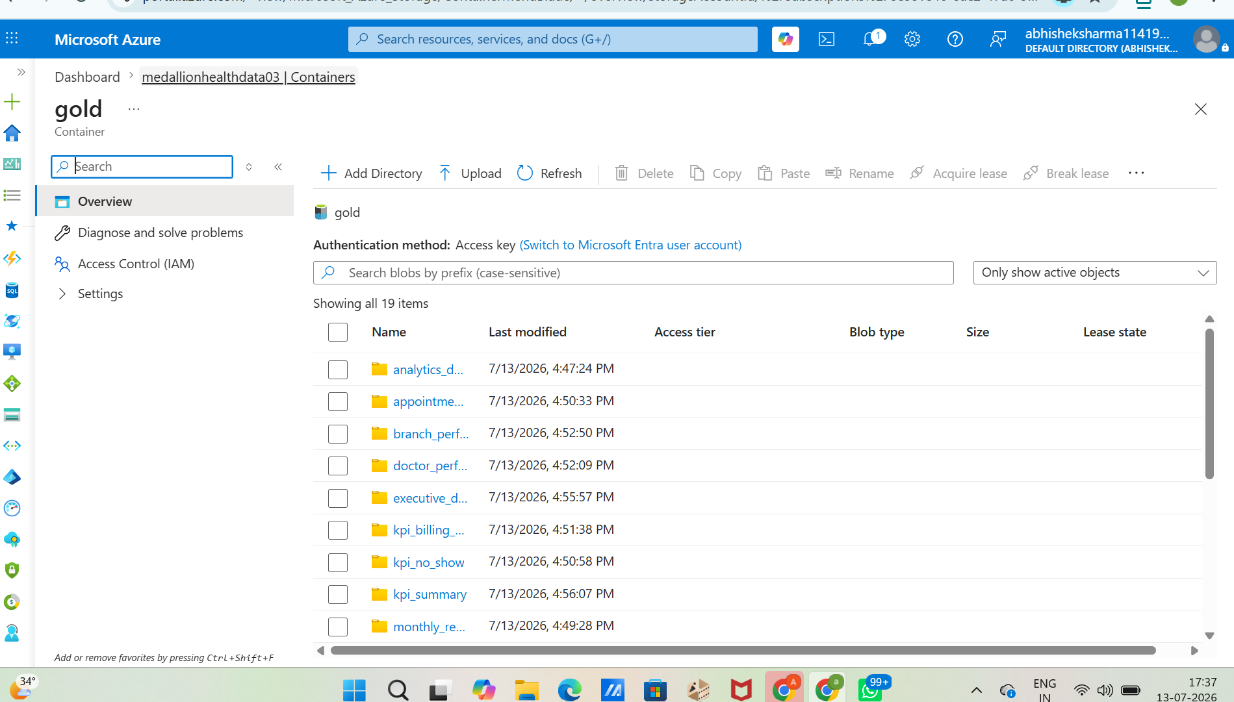
Figure 6: Gold container — Patient 360 and the full set of KPI and performance tables

7.6 Compute — Databricks Cluster
An all-purpose cluster, healthcare_cluster, was used for development and notebook execution. It runs on Databricks Runtime 17.3 LTS (Apache Spark 4.0.0, Scala 2.13) with Photon acceleration enabled, 16 GB of memory and 4 cores, and Unity Catalog set as its data access mode.
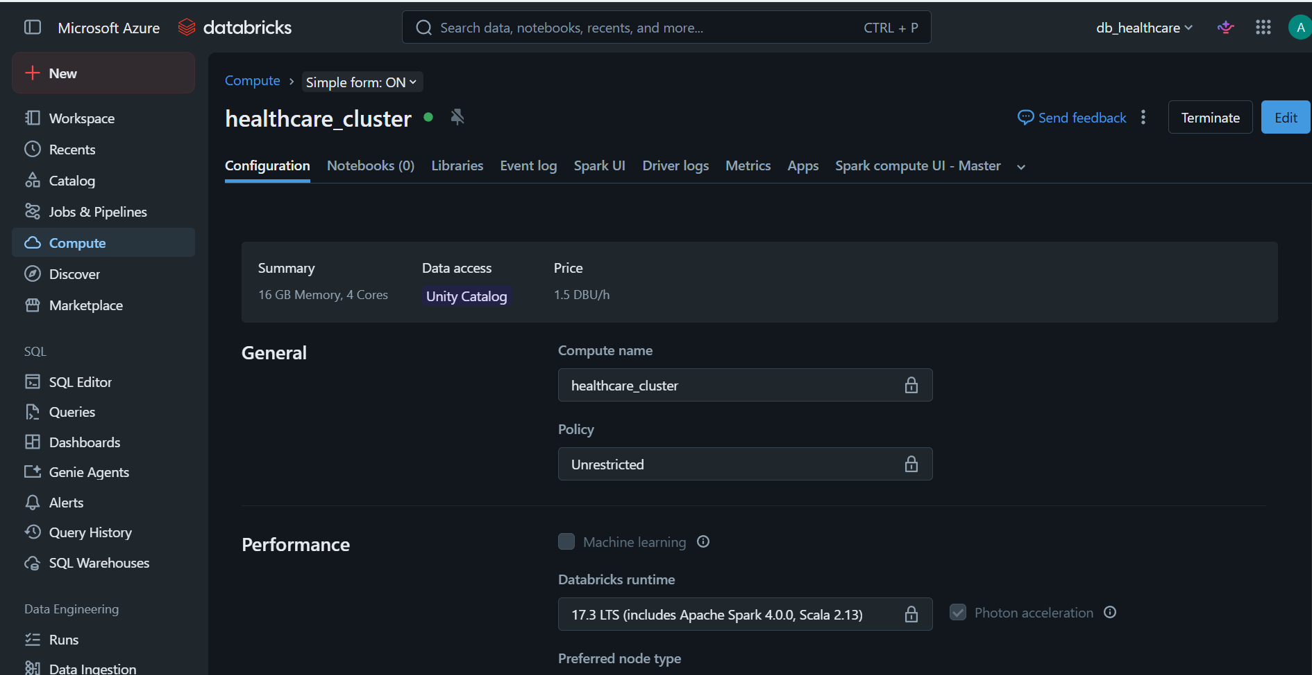
Figure 7: Databricks cluster configuration — healthcare_cluster, Unity Catalog access, Photon acceleration enabled

8. Project Implementation
The pipeline runs as a sequence of Databricks notebooks executed in order, each with a single responsibility. That separation keeps failures isolated to one layer and makes the pipeline easy to re-run from any point:
- Setup/config — centralizes ADLS paths, the active catalog and schema, and Spark session settings used by every other notebook.
- Bronze ingestion — reads each Landing CSV with an explicit schema and writes it to Bronze as a Delta table with audit columns.
- Silver notebooks (patients, appointments, billing, doctors, treatments) — deduplicate, validate, and enrich each entity with business flags.
- Gold / KPI notebook — joins the Silver tables into Patient 360 and derives the revenue, doctor-performance, and branch-performance tables.
- Audit notebook — compares row counts across Landing, Bronze, Silver, and Gold, and checks for residual duplicates before a run is considered safe to publish to the dashboard.

9. Results and Dashboards

9.1 Patient 360
The Patient 360 table is the analytical center of the platform. It joins Patients, Appointments, Doctors, Billing, and Treatments on their respective keys into a single row-per-patient view carrying demographics, visit history, assigned doctors, billing outcomes, and treatment history. Every downstream Gold table is derived either from Patient 360 directly or from the same Silver sources used to build it, which keeps KPI definitions consistent everywhere they're used.

9.2 Business KPIs
KPI | Definition
Total Revenue | Sum of completed billing amounts across all branches
Revenue Per Patient | Total revenue divided by the distinct patient count
Revenue Per Doctor | Revenue attributed to a doctor's treatments divided by their patient count
Billing Accuracy | Share of bills with no payment-status mismatch against the linked treatment
Patient No-Show Rate | Share of appointments flagged No_Show_Flag out of total scheduled appointments
Most Used Payment Method | Mode of Payment_Method across completed bills

9.3 Databricks SQL Dashboard
The operational dashboard is built directly against the Gold schema through the Databricks SQL Warehouse. It brings together revenue, patient, doctor, and appointment KPI tiles with breakdown visuals — revenue by branch, revenue by doctor, payment-method mix, and appointment status — into one view.
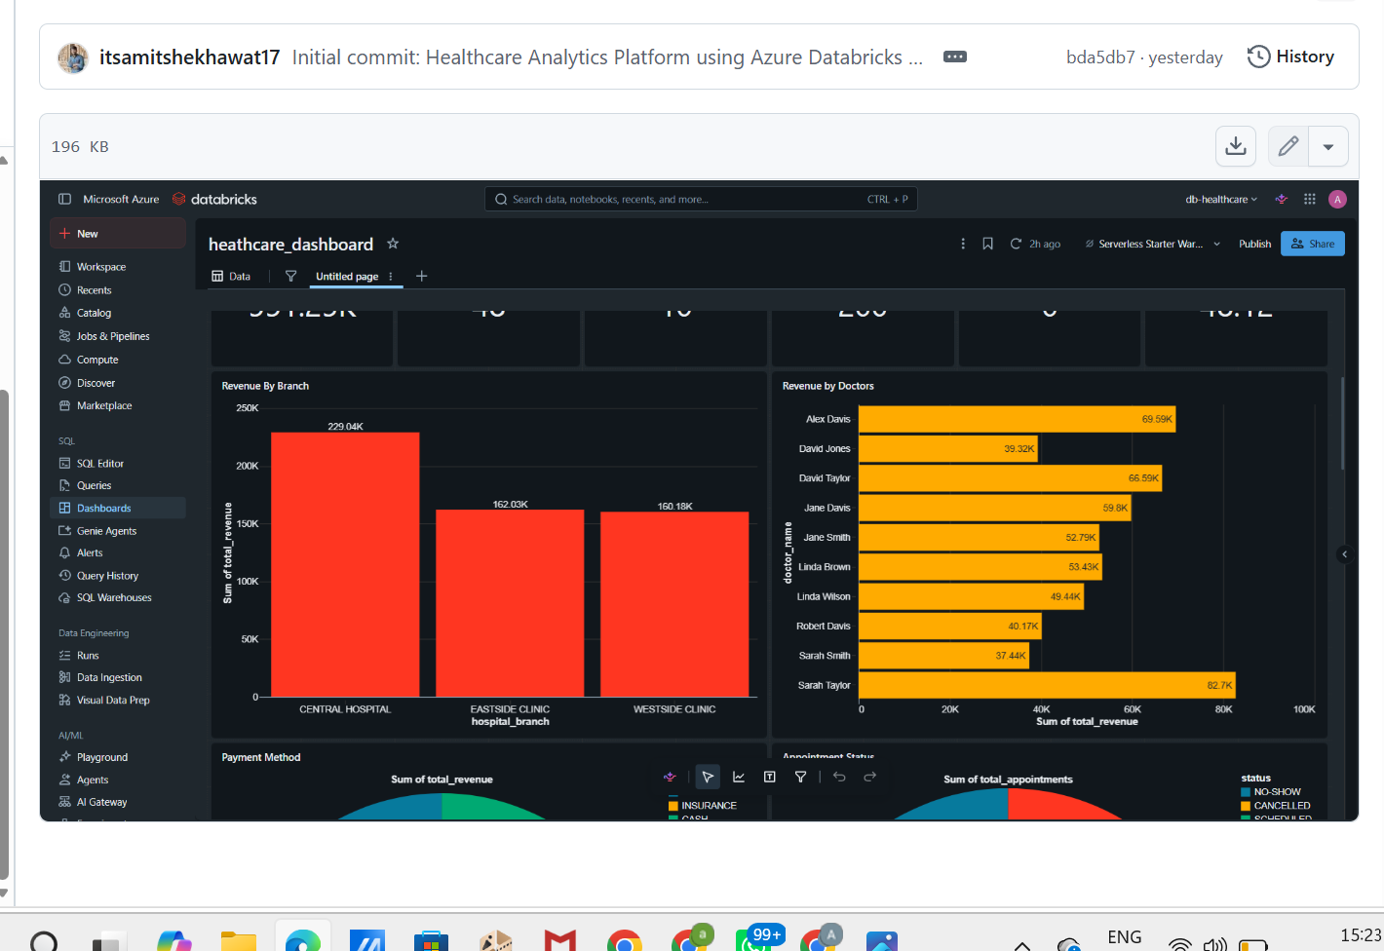
Figure 8: Healthcare dashboard — revenue by branch and revenue by doctor, built on the Gold layer

10. Challenges Faced

10.1 Storage Access and Authentication
Getting the Databricks workspace to read from and write to ADLS Gen2 took a few attempts to get the access scope right — the access key and container-level permissions needed to line up before notebooks could reliably read from Landing and write to Bronze.

10.2 Schema Consistency
Because the Bronze notebook uses an explicit schema rather than inferring one, a source file with an unexpected column shape failed the job loudly instead of silently corrupting downstream tables, which made it straightforward to catch and fix.

10.3 Unity Catalog Registration
A few Silver tables were initially created without being properly registered in Unity Catalog, which meant the SQL Warehouse behind the dashboard couldn't see them. Qualifying every CREATE TABLE statement with the full catalog.schema.table path resolved this.

10.4 Orphaned and Null Records
Some Appointments rows referenced Doctor_ID values missing from the Doctors extract, and some Billing rows had null Treatment_ID values. Rather than silently dropping these, the Silver notebooks route them aside with the failing validation rule attached, so they stay auditable without polluting the certified Silver tables.

11. Future Enhancements
- Streaming ingestion — move from a batch Landing drop to Structured Streaming so appointment and billing events reach Bronze within minutes rather than on a daily schedule.
- Auto Loader — adopt Databricks Auto Loader for Bronze so schema evolution and new file discovery are handled automatically.
- Azure Data Factory orchestration — move scheduling and dependency management from ad hoc notebook runs into an ADF pipeline with retries and alerting.
- Incremental (merge-based) loading — replace full-table overwrites in Silver and Gold with Delta MERGE operations as data volume grows.
- Real-time dashboards — extend the Databricks SQL dashboard to read from streaming Gold tables for closer-to-real-time visibility.

12. Conclusion
This project implements the Medallion architecture on Azure end to end, taking five disconnected healthcare extracts through a governed, auditable pipeline into one certified analytical layer. Each layer is a Delta table that can be partitioned, streamed, or incrementally merged without redesigning the pipeline, and the Landing-to-Gold separation means the whole dataset can be safely reprocessed from raw source files at any time.
Azure Data Lake Storage Gen2, Databricks, and Delta Lake keep storage and compute independently scalable, while Unity Catalog provides the governance needed to expose Bronze, Silver, and Gold assets under consistent access control. On the business side, the Patient 360 table and the standardized KPI set give the dashboard a single agreed-upon definition of revenue, doctor performance, and treatment outcomes — removing the inconsistencies that motivated the project in the first place.

