COMP1817 Information visualisation and Big Data Coursework

Abhishek Soni - 001344975

Task A – Big Data Project Analysis

A.1 – Data Lake vs Data Warehouse
The PA organization confronts unprecedented challenges in managing more than 600 petabytes of data emanating from heterogeneous streams such as IoT sensors, drones, satellites, social media, and market feeds. Such data epitomize the "three Vs" of big data—volume, variety, and velocity—conditions under which traditional data warehouses can no longer keep up. The latter relies on schema-on-write, necessitating strict upfront modelling, resulting in higher costs and reduced adaptability as source formats change (Alation, 2024). Conversely, data lakes rely on schema-on-read, which allows the raw intake of structured, semi-structured, and unstructured data, thus supporting exploratory analytics and futureproofing against evolving agricultural IoT formats (Gartner, 2024).
However, data lakes provide no governance and transactional guarantees that are so critical at enterprise scale for analytics. To this end, the PA firm should adopt a Lakehouse architecture, such as Delta Lake, which integrates ACID transactions, schema enforcement, and unified batch-stream processing atop low-cost, elastic storage (Databricks, 2025). This hybrid model preserves scalability while ensuring analytic reliability to facilitate business intelligence and machine learning workloads without requiring pipeline duplication (Carlo, 2025). By incorporating governance into scalable infrastructure and transforming raw agricultural data into useful insights, the Lakehouse paradigm enhances sustainability, operational efficiency, and innovation across the farming ecosystem.

A.2 – Analytical Store for Causal Queries
The question "find all cotton diseases directly or indirectly caused by nitrogen deficiency" requires tracing complex, multi-step relationships between different entities, including plants, nutrients, pests, and diseases. A property graph database like Neo4j, which stores data as nodes and relationships and supports flexible, multi-hop pattern matching through its Cypher query language, is perfect for this task (v5, n.d.). This enables the quick identification of both direct and indirect causal links and removes the performance overhead of traditional relational joins.
RDF triple stores with SPARQL property paths work best when you need formal inference or need to handle open ontologies. They can manage semantic reasoning too (Fionda, 2015). But if you're building and querying an agronomic knowledge graph for PA, and you care about speed, easy modelling, and developer-friendly tools, Neo4j’s graph-based approach stands out. It’s just a smoother experience in those engineering settings.

A.3 – Real-Time Analytics and MapReduce
MapReduce just can’t keep up with the PA company’s need for real-time predictions—think water-stress alerts or pest-risk notifications. It’s built for batch jobs, not for quick reaction. With all that disk I/O and task scheduling, MapReduce lags, sometimes by minutes or even hours (Dean, n.d.). That’s too slow. In contrast, stream-processing frameworks like Apache Spark Structured Streaming and Apache Flink step up. They deliver continuous, low latency, stateful computations (Documentation, n.d.). Spark uses a micro-batch model, while Flink runs on a true streaming engine. Both handle event-time windows, guarantee exactly-once processing, and offer solid fault tolerance. They’re built for second-level response times—the kind PA’s sensor-driven systems demand. So, MapReduce belongs in the background, handling offline ETL or digging through historical data. For anything that needs real-time analysis, especially in PA’s environment, Spark and Flink pipelines are the right choice (Databricks, 2025).
Task B: Information Visualisation Report

Here’s a look at the hotel reservations dataset, where I dig into how people book, who they travel with, what changes they make, and how things differ from one hotel to another. The dataset isn’t huge — it tracks seven things: when people booked, how many adults and kids came, how often bookings changed, special requests, total reservations, and which hotel each booking went to. Still, there’s enough here to spot some interesting trends. I built five visuals to help make sense of the data. They start with a big-picture timeline, then zoom in on differences between hotels, check out how the numbers connect, and finally get into what guests change or ask for during their stay. Each step digs a little deeper, showing how different factors play off each other.

Figure 1 – Reservations Over Time
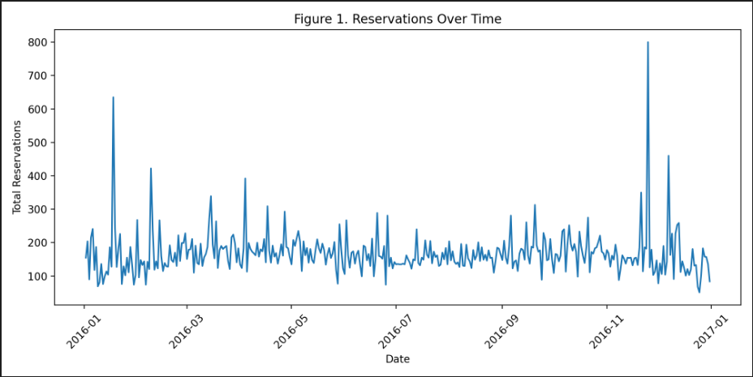

Justification :
This chart shows you how reservation numbers change over time. Hotels live and breathe by the calendar. Holidays, busy weekends, and travel season all shape booking patterns, so you need to see that timeline up front. When you plot daily totals, you get a big-picture view that’s easy to follow. It won’t drown you in detail, but you’ll still spot the little bumps and dips—maybe a sudden spike before a holiday, or a quiet stretch after New Year’s. Line charts really shine here. They make trends and turning points obvious, much more so than bars or scatter plots.
Interpretation :
Now, if you look at the line plot, you’ll notice some days jump out—they’re busier, with more bookings. Other days, things slow down. You can start to tell if demand stays steady, or if it bounces around, or if there are pockets of high activity. This first look matters because it sets the stage for comparing different hotels later. Sometimes, what looks like a big difference between hotels is just everyone riding the same seasonal wave. In the end, this kind of visual isn’t just helpful—it’s the best way to get a feel for how reservations ebb and flow over time.

Figure 2 – Total Reservations by Hotel
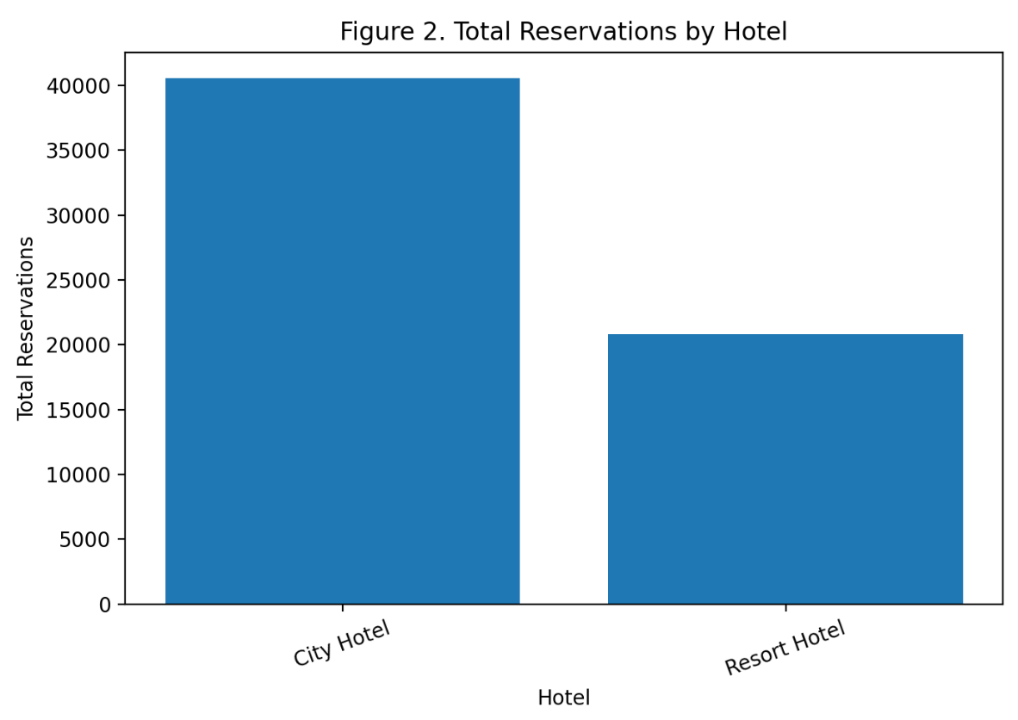
Justification :
Comparing total reservations by hotel isn’t just busywork—it tells you exactly where guests are choosing to stay. When you line up those numbers, patterns pop out fast. Maybe one hotel’s pulling in way more bookings, or maybe things look balanced across the board. Throw the data on a bar chart and the differences stare right back at you; no need to squint. This isn’t just interesting trivia. These numbers drive real decisions—who you need on staff, which property needs a marketing boost, even how you gear up for the next busy stretch.

Interpretation :
The bar chart makes it clear—some hotels pull in a lot more reservations than others. That tells us a few things right away. Maybe those places are just more popular, or they’ve got more rooms, a better spot in town, or they’re running deals people like. On the flip side, the hotels with fewer bookings could be smaller, more specialized, or just not as in demand. Keep this in mind when you look at the next set of visuals. Hotels with wildly different reservation numbers probably attract different kinds of guests and show different booking patterns.

Figure 3 – Correlation Heatmap of Numerical Features
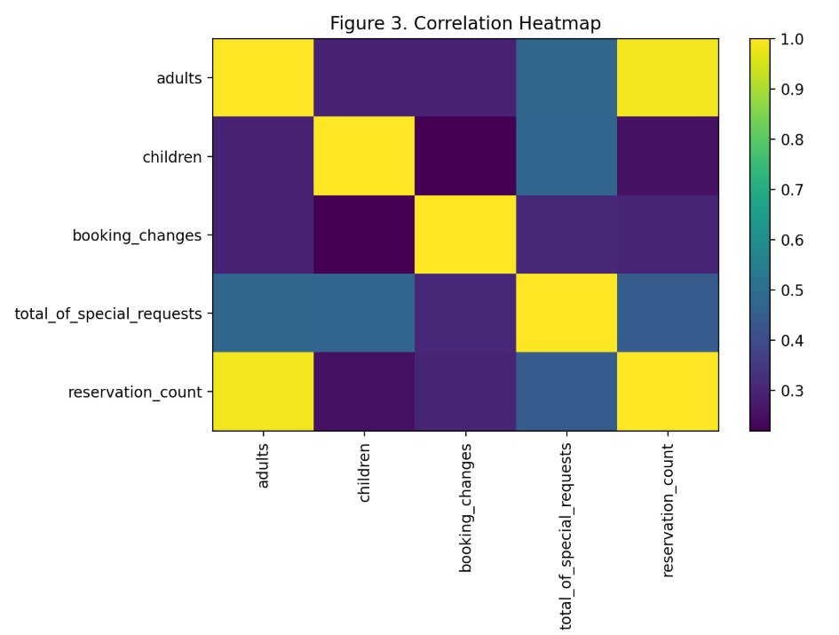
Justification :
A correlation heatmap gives you a quick look at how different numerical variables relate to each other. You can spot strong links, weak ties, or even variables that don’t really affect each other at all. In hotel analytics, things like the number of adults, children, booking changes, and special requests don’t always act alone. They interact in ways that aren’t always obvious at first glance. By looking for these correlations, you figure out which factors actually influence one another and which ones might need more attention in your models. The heatmap pulls all this information together into one place, making it easy to scan lots of relationships at once. It speeds up analysis and helps you see the bigger picture.
Interpretation :
The heatmap highlights a few interesting patterns. Reservation count climbs as the number of adults goes up, so bigger groups really push up bookings. There’s also a moderate link between children and reservations—families seem to book often. Booking changes and special requests don’t tie strongly to guest numbers, but they do connect with each other. Guests who change their bookings often want extra services, too. These trends show up later in the visualizations and point to spots where handling changes and special requests tends to overlap.

Figure 4 – Adults Per Booking by Hotel (Boxplot)
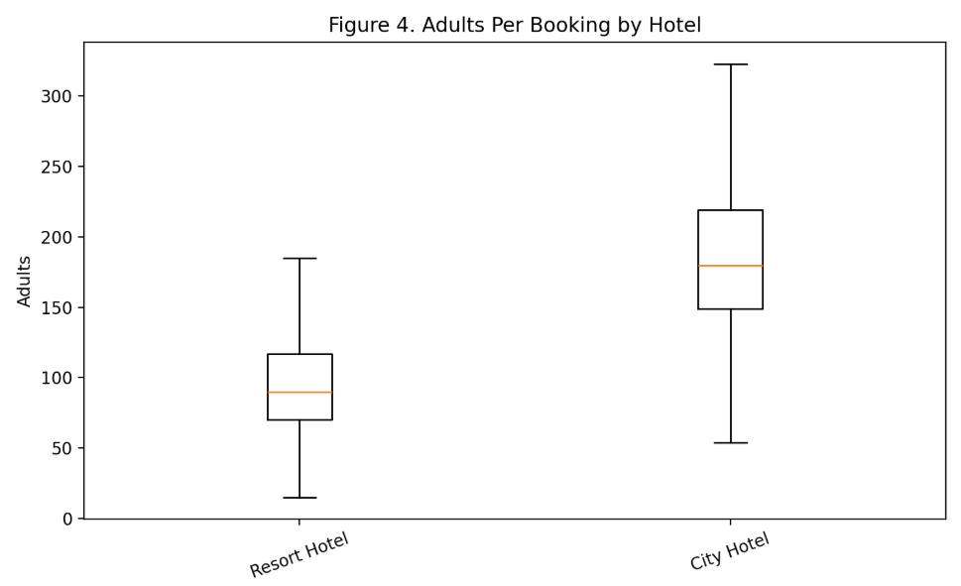
Justification :
A boxplot quickly shows you the spread of group sizes—median, range, and those odd outliers that sometimes pop up. When you line up adult group sizes across different hotels, patterns jump out: one place pulls in bigger crowds, another seems to attract mostly couples or solo business travellers. Boxplots make this kind of comparison straightforward; you see at a glance which hotels serve what kinds of groups. It takes the reservation count analysis further, so now you’re not just seeing booking numbers, but also the makeup of the guests each hotel usually hosts.

Interpretation :
The boxplot shows that hotels don’t all attract the same kind of guests. At some hotels, the typical group size is bigger, with more adults and a lot of variation—clearly, they draw in families or larger groups more often. Other hotels see mostly solo travellers or couples, with smaller, more consistent numbers. Those outliers? They’re probably big groups coming in for events or large family gatherings. These patterns line up with the differences in reservation numbers and really highlight how each hotel caters to its own unique crowd.

Figure 5 – Booking Changes vs Special Requests (Scatter Plot)
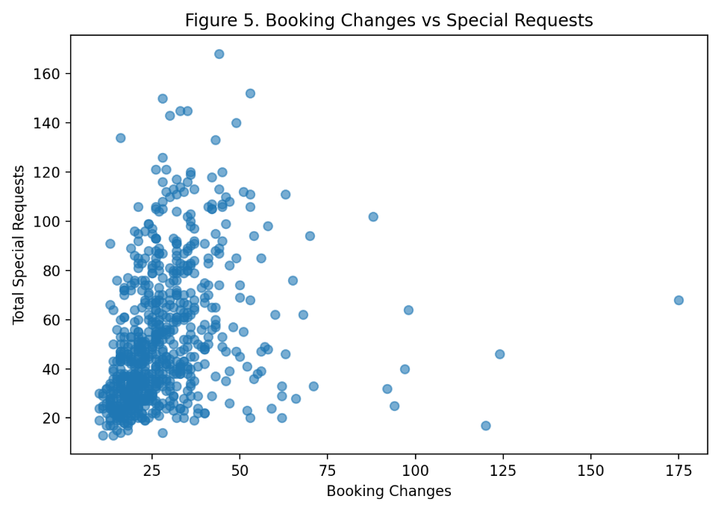
Justification :
Scatter plots make it easy to spot connections between two behavioral variables. Here, booking changes and special requests reveal how customers think and what they need from the service. By looking at these variables side by side, you can see if guests who often tweak their bookings also ask for more extras. The scatter plot lays out any clusters or patterns—or shows when there’s nothing obvious going on. This gives a real window into different customer types and helps gauge the workload staff might face.
Interpretation :
The scatter plot tells a clear story. Most bookings go smoothly—hardly any changes, not many special requests. But there’s a noticeable group that stands out. Some guests pile on the changes and have a long list of requests. These are likely high-engagement bookers, maybe families organizing complicated trips or guests with needs. Clusters like this point straight to trouble spots for the team, especially in customer service and managing reservations.
Conclusion :
This task really drove home how much the choice of visualization depends on the dataset’s shape and limits. Since we didn’t have data on cancellations, pricing, or room types, I had to rethink the usual approach you’d take with hotel analytics and work with what was there. I leaned on information visualization basics: line charts to show how things change over time, bar charts to compare categories, heatmaps when I needed to see how multiple variables play together, and boxplots or scatter plots to dig into distributions and behaviour patterns. I kept each graphic simple, clear, and directly tied to a real analytical question—no extra clutter. The main drawback will be the dataset just doesn’t go deep in some areas, so you can’t really explore revenue or cancellation trends. Still, by focusing on what’s strong—guest makeup, booking patterns, differences between hotels—the visualizations stay sharp and make sense. In the end, this whole process proves how much good visual analysis depends not just on the right tools, but also on understanding the context you’re working in.

