**Project Name: Solar Products**

**Project Members:**

|  |  |
| --- | --- |
| **PRN No.** | **Name** |
| **210943120005** | **Abhishek Verma(PM)** |
| **210943120069** | **Pooja Ekbote** |
| **210943120042** | **Pratik Khopade** |
| **210943120029** | **Divya Bonde** |

**Technology:**

Frontend- ReactJs

Middleware- Express/NodeJS

Database- Mongo DB

Others – Payment Gateway Stripe, Hosting platform Heroku

**Introduction: -** Our Topic is Solar Products It is A web-based E-commerce Application we took this project topic because

there is no such online platform is available which provide a complete one stop-solution for solar products

such as solar cooked food, solar equipment as well as solar home appliance

our goal to develop web application where use can look search and purchase the solar products online track the order status etc

**Data Flow Diagram (DFD):**

**Modules:**

**Admin-: Login**

**Admin Dashboard:-**

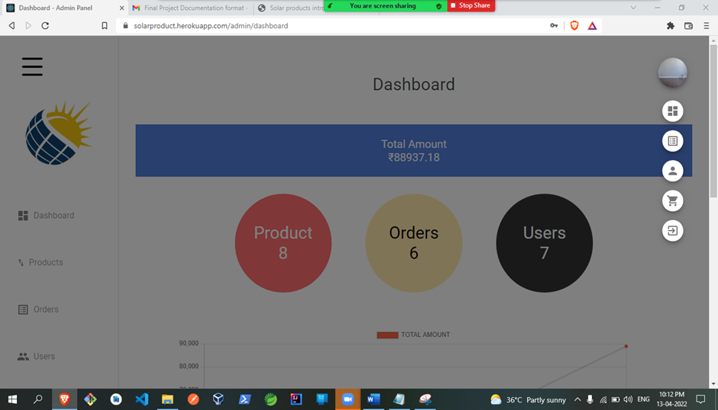

**

**

**Update Product:-**

**

**Order Status-:**

**

**

**Review Management:-**

**User Module:-**

**

**

**Homepage:-**

**Product Search:-**

**Add to cart:-**

**

**

**

**User Order’s:-**

**Future scope: -**

1. **Currently our Web Application is Single seller based in future we will make it multi seller**
2. **Return Product functionality will add.**