<https://uscdatafest.org/datafest-2023>  
  
  
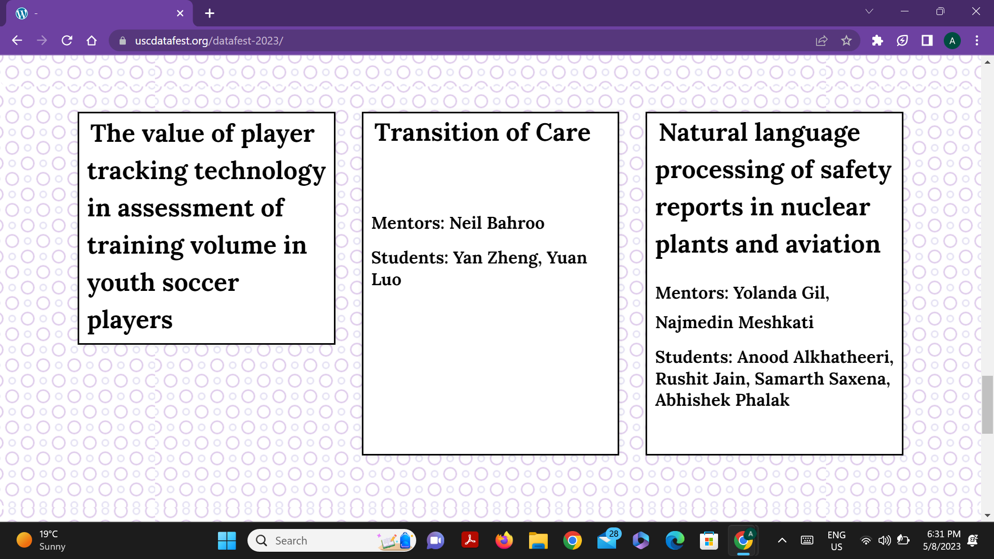  
  
**Ckids Recording** - <https://usc.zoom.us/rec/play/r8_YlYiAmE5OLUcP6Szwds9czhGuohJNjWM-Toin3IbJPl4JHJaF7w0yvsPivEE_wUJncw44xSeiKp8i.SbnkGm3GyInOrzR4?canPlayFromShare=true&from=share_recording_detail&startTime=1682725835000&componentName=rec-play&originRequestUrl=https%3A%2F%2Fusc.zoom.us%2Frec%2Fshare%2FqoRlQi1MeNZxLR5FRUWUh2TxTiM7ddkf2hrAvWZN7UJS_apIk95xv0EaRAFexBus.0LmlSJbThyPjpzn4%3FstartTime%3D1682725835000>